**DUYTAN UNIVERSITY**

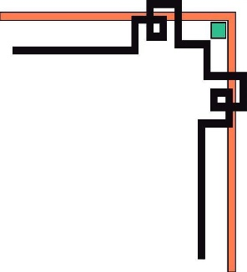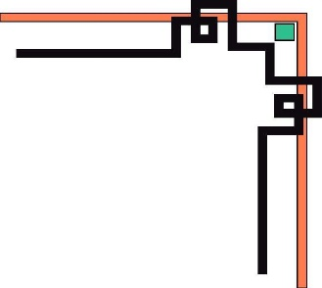

**INTERNATIONAL SCHOOL**

**--------------🙖🙐✰🙖🙐-------------**



**CMU-SE 100**

**INTRODUCTION TO SOFTWARE ENGINEERING**

**SYNTHESIS REPORT GROUP PROJECT**



**Mentor: Msc. Huy Nguyen Dang Quang**

***Team Member*:**

**Long, Dao Phuoc**

**Luu, Van Duc**

**Hieu, Tran Thanh**

**Nghia, Huynh Huu**

**Hung, Ta Duc**

**Dat, Pham Bao**

**Group Project - Mentor: Self-Restaurant Management System**

Name Signature Date

Da nang, 12/2023

**PROJECT INFORMATION**

|  |  |
| --- | --- |
| **Project Acronym** | SRMS |
| **Project Title** | Self-Restaurant Management System | | | |
| **Start Date** | 02/12/2023 | **End Date** | 25/12/2023 | |
| **Lead Institution** | International School, Duy Tan University | | | |
| **Team Member** | **Name** | **Email** | | **Phone** |
|  | Long, Dao Phuoc | daophuoclong@dtu.edu.vn | | 0563730648 |
|  | Hieu, Tran Thanh | tranthanhhieu4@dtu.edu.vn | | 0935092531 |
|  | Luu, Van Duc | vanducluu@dtu.edu.vn | | 0364725623 |
|  | Nghia, Huynh Huu | huynhhuunghia@dtu.edu.vn | | 0368490905 |
|  | Hung, Ta Duc | taduchung@dtu.edu.vn | | 0916327041 |
|  | Dat, Pham Bao | phambaodat@dtu.edu.vn | | 0794710341 |

**DOCUMENT NAME**

|  |  |  |  |
| --- | --- | --- | --- |
| **Document Title** | **Synthesis Report Group Project Document** | | |
| **Reporting Period** | 02 – Dec – 2023 | | |
| **Author(s)** | Dao Phuoc Long | | |
| **Role** | Leader | | |
| **Date** | 02/12/2023 | **Filename** | Group_01_SRMS |

**SIGNATURE**

***Document Approvals:*** *The following signatures are required for approval of this document.*

|  |  |  |  |
| --- | --- | --- | --- |
| **Mentor** | Huy, Nguyen Dang Quang | **Signature:** |  |
| **Date:** |  |
| **Team Lead** | Long, Dao Phuoc | **Signature:** |  |
| **Date:** |  |
| **Team member(s)** | Hieu, Tran Thanh | **Signature:** |  |
| **Date:** |  |
| Luu, Van Duc | **Signature:** |  |
| **Date:** |  |
| Nghia, Huynh Huu | **Signature:** |  |
| **Date:** |  |
| Hung, Ta Duc | **Signature:** |  |
| **Date:** |  |
| Dat, Pham Bao | **Signature:** |  |
| **Date:** |  |

**REVISION HISTORY**

|  |  |  |
| --- | --- | --- |
| **Version** | **Date** | **Description** |
| **1.0** | 02/12/2023 | **Make Synthesis Report Group Project Document** |
| **1.1** | 24/12/2023 |  |
|  |  |  |

**Table of Contents**

1. INTRODUCTION 7

2. DESCRIBE BUSINESS PROCESSES OF RESTAURANT 7

2.1 FOR CUSTOMERS: 7

2.2 FOR EMPLOYEE: 7

2.3 FOR SYSTEM: 7

3. LIST OF PARTICIPANTS TO REQUIREMENTS GATHERING 8

4. THE TECHNICALS USING TO REQUIREMENTS GATHERING 8

5. ASSIGNMENT TEAM MEMBER TO REQUIREMENTS GATHERING 8

6. INTRODUCTION PROJECT 9

6.1. Project Objectives 9

6.2. Project Scope 9

6.3 Identify the Functional Requirement & Non-Functional Requirement 9

**a) High level Functional Requirement (FR)** 9

**b) List of Non-Functional Requirement** 11

7.1 Business Function Diagram 12

7.2 Context Model 13

**a) Context Model** 13

**b) System Context Description** 13

7.3 List of Actor 13

8. PROJECT PLAN 14

9. TECHNICAL CONSTRAINTS 14

9.1 Technical to develop: 14

9.2 Environment: 15

9.3 Another: 15

10. ANALYSIS & MODELING REQUIREMENT 15

10.1. Use Case Diagram 15

10.2. List of Business Rule 15

10.3. Activity Diagram 15

**10.3.1. Function Update Cost** 15

**10.3.2. Function Choose Drinks** 16

**10.3.3. Function Order Party** 17

**10.3.4. Function Payment System** 18

**10.3.5. Function See the Bill** 19

11. INTERFACE DESIGN 20

11.1. Introduction tool design 20

11.2 User Interface Design for Function Menu Management 20

12. CONFIGURATION MANAGEMENT 21

a) Introduction the tool Source Code Management 21

b) Introduction Key Functional 21

c) The Screen Shot apply Source Code Management of team 21

13. TESTING 21

13.1 Introduction to method testing apply of this project 21

13.2 Test Cases 22

**13.2.1 Test Case Order** 22

**13.2.2 Test Case View the Bill** 23

**13.2.3 Test Case Payment** 24

**13.2.4 Test Case Invoicing** 25

**13.2.5 Test Case Employee Management** 26

14. CONTRIBUTION 27

# **1. INTRODUCTION**

Name: Fil’s Coffee

Address: 225/3 Dong Da, Thach Quang Ward, Hai Chau District, Da Nang

Phone Number: 0905888136

Business Area: Audio Vintage Cafe & Restaurant

# **2. DESCRIBE BUSINESS PROCESSES OF RESTAURANT**

## **2.1 FOR CUSTOMERS:**

* Customers can order dishes at the payment counter or by sitting at a table where a staff member will provide the menu. If regular customers wish to order a special dish not listed in the menu, the establishment may consider preparing it for them.
* Customers can view the current bill, including the number of items, the total amount for the ordered items, time, Wi-Fi password, etc.
* For those interested in booking a table for an event, they can contact the establishment in advance and proceed with a deposit.
* Customers can pay in advance or afterward. In the case of preferring to pay beforehand, they can settle the payment directly at the counter after placing their order, or if not, they can pay afterward at the counter once the meal is completed.

## **2.2 FOR EMPLOYEE:**

* Staff members can add or remove items from the list of dishes that can be served during the day.
* Regular customers may place their orders themselves, whereas new customers can be guided on how to place their orders.
* After taking the order, staff members input information about the dishes and the quantities needed into the system.
* Using the customer's identification number, the cashier informs the amount due, inputs the payment, and calculates the change to be returned to the customer.
* Upon completing the payment calculation, the staff member prints the bill and hands it to the customer for confirmation of the information on the bill.
* At the end of the work shift, the staff member calculates the total revenue for the shift, inputs it into the system, confirms the completion of the shift, and leaves for the day.

## **2.3 FOR SYSTEM:**

* Dishes may have price changes on special occasions but within limits. If there are any changes, the admin will update the prices in the system.
* The restaurant's payment system is divided into Offline and Online modes. The Online payment system encompasses all functionalities. The Offline payment system also includes functionalities similar to the online system but cannot print bills like the Online system. In case of network or power loss, the restaurant will use the Offline system to manage operations.

# **3. LIST OF PARTICIPANTS TO REQUIREMENTS GATHERING**

* Customers
* Manager
* Leader: Dao Phuoc Long
* Team Member: Van Duc Luu, Pham Bao Dat

# **4. THE TECHNICALS USING TO REQUIREMENTS GATHERING**

For this project, we opted to use the technique of **Direct Income Gathering**, primarily through conducting face-to-face interviews. With this method, we directly visited specific locations and selected suitable times to gather requirements that couldn't be found on websites or social media pages.

To efficiently collect these requirements, we formulated a set of questions before conducting the direct interviews. These questions helped us steer the conversation towards the focal points and prevent unnecessary information from skewing the project. As a result, we were able to gather a substantial amount of crucial information for this project.

# **5. ASSIGNMENT TEAM MEMBER TO REQUIREMENTS GATHERING**

|  |  |  |  |
| --- | --- | --- | --- |
| Member | Question | Answer | Category |
| Dao Phuoc Long,  Van Duc Luu | Luu: “What’s your name?” | Long: “My name’s Long” |  |
| Dao Phuoc Long, Pham Bao Dat | Dat: “Can I ask about the cafe’s information?” | Long: “The coffe’s name is Fil’s Cafe at 225/3 Dong Da, Da Nang” |  |
| Van Duc Luu, Dao Phuoc Long | Luu: “So can you tell me the process of order for customers?” | Long: “They can order at the payment counter or my employee provide a menu for them.” | Functional Requirement |
| Pham Bao Dat, Dao Phuoc Long | Dat: “How do you want to manage your employees?” | Long: “I want a system that have employee’s information, shift works,... and they can allow managers editable. | Functional Requirement |
| Van Duc Luu, Dao Phuoc Long | Luu: “So what requirements do you want a website to have?” | Long: “I want they have a good design, easy to use, fast and security.” | Non-Functional Requirement |

# **6. INTRODUCTION PROJECT**

## **6.1. Project Objectives**

With the world's rapid development alongside the increasing demand for studying and working in coffee shops, Fil’s Cafe has created a cafe space that caters to these needs of its customers. Offering a comfortable, serene ambiance with soft music for a day of effective studying and work.

For this reason, Fil’s Cafe requires an application to efficiently and swiftly manage their cafe. They seek an application with a beautiful interface, easy accessibility, and user-friendly features to further enhance the growth of their establishment.

## **6.2. Project Scope**

For this project, we have carefully calculated and considered the objectives, tasks, as well as potential risks that may occur during the project implementation. Therefore, we have decided on the project scope with the following criteria:

* Time: approximately 2-3 months from the contract signing date.
* Budget: around $15 for one function. If there are modifications to existing functions, we will charge an additional $5 per function. If there's a request to add an entirely new function, we will charge an additional $20 per function. Hence, the total cost will fall between $300 to $500 for this project.
* Personnels: we will have one Team Leader along with 5 Team Members for this project.

## **6.3 Identify the Functional Requirement & Non-Functional Requirement**

### **a)** **High level Functional Requirement (FR)**

|  |  |  |
| --- | --- | --- |
| FR1.1 | Title | Order |
| Stakeholder | Customer |
| Description | Employee must choose foods, drinks and amount of them or they can let employee choose them |
| FR 1.2 | Title | **See the Bill** |
| Stakeholder | Customer |
| Description | Customers can view the current bill, including the number of items, total amount, order time, Wi-Fi password, or any other information present on the bill. |
| FR 1.3 | Title | **Booking** |
| Stakeholder | Customer |
| Description | Customers can choose the date, time, table number they need to reserve, and make a deposit in advance on the website. |
| FR 1.4 | Title | **Payment** |
| Stakeholder | Customer |
| Description | The customer will pay the printed invoice, which can be paid by cash or banking |
| FR 2.1 | Title | **Confirmation** |
| Stakeholder | Employee |
| Description | The staff will confirm the invoice when the customer places a food order. |
| FR 2.2 | Title | **Invoicing** |
| Stakeholder | Employee |
| Description | The staff will enter customer requests into the invoice |
| FR 2.3 | Title | **Print Invoice** |
| Stakeholder | Employee |
| Description | After recording the order, the staff will print the invoice, ensuring it includes all the detailed information and translating the details into English |
| FR 2.4 | Title | **Calculate the invoice** |
| Stakeholder | Employee |
| Description | After recording the order, the staff will calculate the invoice, ensuring accuracy |
| FR 2.5 | Title | **Calculate Revenue** |
| Stakeholder | Employee, System |
| Description | Employees can calculate the total revenue for a shift and input it into the system. The system provides revenue reports for a shift on a daily basis. |
| FR 2.6 | Title | **Revenue Repor**t |
| Stakeholder | Employee |
| Description | revenue reporting staff after calculating revenue, providing a comprehensive and detailed report |
| FR 3.1 | Title | **Employee Management** |
| Stakeholder | Manager |
| Description | The manager can view employee profiles, their shifts, add or remove employees, and update their work schedules |
| FR 3.2 | Title | **Menu Management** |
| Stakeholder | Manager |
| Description | Managers will add or remove dishes from the menu |
| FR 3.3 | Title | **See revenue** |
| Stakeholder | Manager |
| Description | Managers view revenue reports and reviews |
| FR 3.4 | Title | **Cost Update** |
| Strakeholder | Manager |
| Description | Managers will update prices according to their preferences |
| FR 4.1 | Title | **Online Management** |
| Strakeholder | System |
| Description | The system undergoes changes and updates website information |

**b) List of Non-Functional Requirement**

**N-FR 01: Interface**

- User-friendly for users

- Aligned with customer preferences

**N-FR 02: Security**

- Ensuring the safety of customers' personal information and business data

- Authentication for employees and administrators

**N-FR 03: Performance**

- High system performance to handle multiple orders and payments simultaneously

- Quick response time from the website

**N-FR 04: Online and Offline**

- Ability to easily switch between Online and Offline modes

- Data synchronization upon reconnecting to the network

**N-FR 05: Maintenance and Update**

- Easy system updates to add new items, adjust prices, or modify other information

- Administrators should be able to conveniently update system information

**N-FR 06: Cross-Platform Compatibility**

- Website compatibility with various web browsers and different mobile devices

**N-FR 07: Cost-Effectiveness**

- Deployment and maintenance of the system must be cost-effective

**7. THE USER REQUIREMENT ANALYSIS**

## **7.1 Business Function Diagram****7.2 Context Model**

Confirmation

Invoicing

Order

See the Bill

Booking

Payment

**Employee**

**Manager**

**System**

Caculate Revenue

Online Management

**Customer**

**Self-Restaurant Management System**

Print Invoice

Calculate the invoice

Calculate Revenue

Revenue Report

Employee Management

Menu Management

Revenue report

Cost Update

### **a) Context Model**

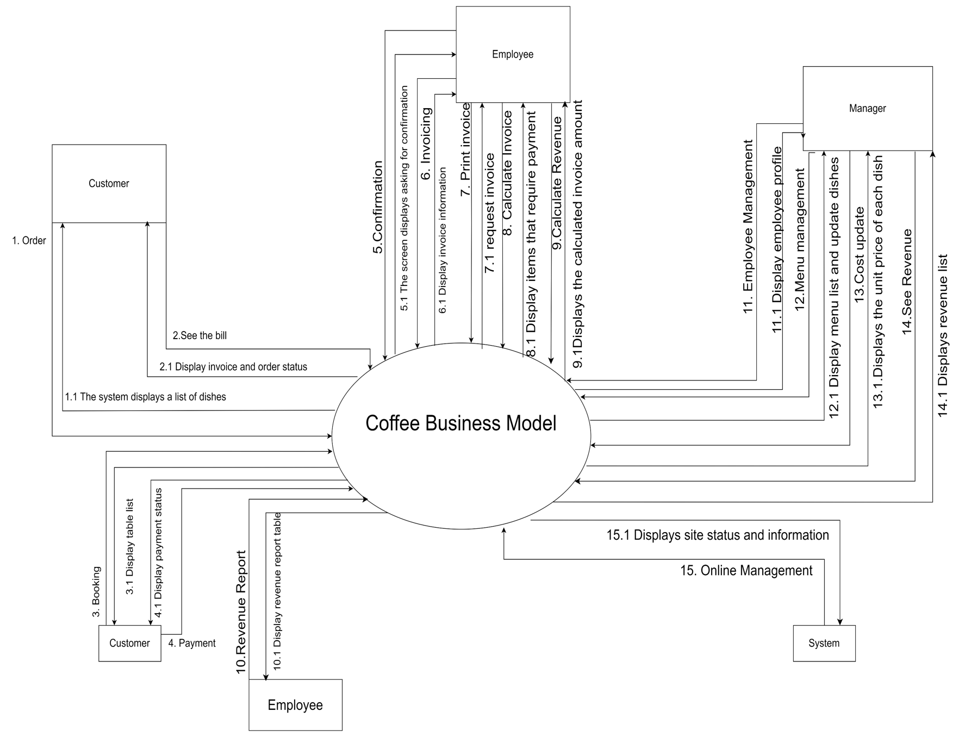

### **b) System Context Description**

## **7.3 List of Actor**

**Actor 01:** Customers

**Actor 02:** Employee

**Actor 03:** Manager

**Actor 04:** System

**7.4. List of Use Cases**

|  |  |  |
| --- | --- | --- |
| Use case ID | Use case name | Functional Req. |
| *UC.01* | *Order* | *FR1.1* |
| *UC.02* | *View the Bill* | *FR1.2* |
| *UC.03* | *Booking* | *FR1.3* |
| *UC.04* | *Payment* | *FR1.4* |
| *UC.05* | *Confirmation* | *FR2.1* |
| *UC.06* | *Invoicing* | *FR2.2* |
| *UC.07* | *Print Invoice* | *FR2.3* |
| *UC.08* | *Calculate the Invoice* | *FR2.4* |
| *UC.09* | *Calculate Revenue* | *FR2.5* |
| *UC.10* | *Revenue Report* | *FR2.6* |
| *UC.11* | *Employee Management* | *FR3.1* |
| *UC.12* | *Menu Management* | *FR3.2* |
| *UC.13* | *Cost Update* | *FR3.3* |
| *UC.14* | *Revenue Report* | *FR3.4* |
| *UC.15* | *Online Management* | *FR4.1* |

# 

# **8. PROJECT PLAN**

|  |  |  |  |  |  |
| --- | --- | --- | --- | --- | --- |
| **No.** | **Task Name** | **Durations (Days)** | **Start** | **Finish** | **Assign to** |
|  |
| **1** | **Intial** | **21** | **12/2/23** | **12/24/23** | **Long,Luu,Dat,Hieu,Hung,**  **Nghia** |  |
| 1.1 | Project Kick-off Meeting | 1 | 12/2/23 | 12/2/23 | Long,Luu,Dat,Hieu,Hung,  Nghia |  |
| 1.2 | Discuss about project ideal | 1 | 12/2/23 | 12/2/23 | Long,Luu,Dat,Hieu,Hung,  Nghia |  |
| 1.3 | Prepare questions | 1 | 12/4/23 | 12/4/23 | Dat. |  |
| 1.4 | Collect requirements | 1 | 12/5/23 | 12/5/23 | Long,Luu,Dat. |  |
| 1.5 | Identify business processes | 1 | 12/6/23 | 12/6/23 | Long. |  |
| 1.6 | Write functional requirements | 1 | 12/7/23 | 12/7/23 | Hieu. |  |
| 1.7 | Edit functional requirements | 3 | 12/7/23 | 12/10/23 | Hieu,Long. |  |
| 1.8 | Draw a functional diagram | 1 | 12/11/23 | 12/11/23 | Nghia. |  |
| 1.9 | Edit functional diagram | 1 | 12/11/23 | 12/11/23 | Nghia. |  |
| 1.10 | Draw the context diagram | 1 | 12/12/23 | 12/12/23 | Hieu,Dat. |  |
| 1.11 | Edit the context diagram | 4 | 12/13/23 | 12/17/23 | Hieu,Dat. |  |
| 1.12 | Second project meeting | 1 | 12/15/23 | 12/15/23 | Long,Luu,Dat,Nghia. |  |
| 1.13 | Write test cases | 5 | 12/15/23 | 12/20/23 | Long,Hieu,Dat,Nghia |  |
| 1.14 | Third project meeting | 1 | 12/20/23 | 12/20/23 | Long,Luu,Dat,Hieu |  |

# 

# **9.** **TECHNICAL CONSTRAINTS**

## **9.1 Technical to develop:**

* ***Languages****: HTML, JavaScript*
* ***Server:*** *Socket.io*

## **9.2 Environment:**

* ***Web browsers****: Google Chrome, Molliza Firefox, Apple Safari, Cốc Cốc, Microsoft Edge.*
* ***Environment:*** *Microsoft windows, Mac Os, Android, iOS,..*

## **9.3 Another:**

* ***Management tool****: Trello, Slack*
* ***Design tool****: Balsamiq Mockup*
* ***Manage Source code tool****: Git,Github*
* ***Test tool*** *: Katalon Studio*

# **10. ANALYSIS & MODELING REQUIREMENT**

## **10.1. Use Case Diagram**

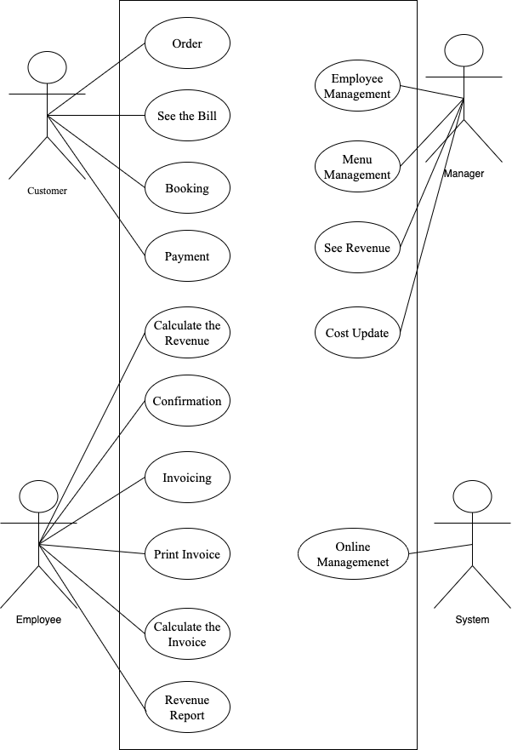

## **10.2.** **List of Business Rule**

|  |  |  |
| --- | --- | --- |
| Code | Business rules | Use case |
| *BR1* | *Customer must choose the foods, drinks and amount of them or they can let employee choose them* | *UC.01* |
| *BR2* | *Customer can choose times, days, numbers of table and deposit* | *UC.03* |
| *BR3* | *For user booking more than 10 tables:*  *- Can have discount 15% the bill*  *- Can use the piano*  *- Can have a cake if they have birthday* | *UC. 03* |
| *BR4* | *If ingredient increase, they can increase price about 2 thousand ~ 4 thounsand dong* | *UC.12* |
| *BR5* | *If holidays, they can increase price about 1 thounsand dong ~ 3 thousand dong* | *UC.12* |

## **10.3. Activity Diagram**

### **10.3.1. Function Update Cost**

#### **a) The steps performed of function Update Cost**

|  |  |
| --- | --- |
| **Actor Action** | **System Response** |
| **1.** Manager selections in the price list. | **2.** Displays the price list. |
| **3.** Remove old prices and input new prices |  |
| **4.** Save action | **5.** Save the price list |

#### **b) Activity Diagram of function Update Cost**

Choose the price

Delete old price and update new price

Show the price

Click save button

Saved

Manager System

### **10.3.2. Function Choose Drinks**

#### **a) The steps performed of function Choose Drinks**

|  |  |
| --- | --- |
| **Actor Action** | **System Response** |
| **1.** User selects a beverage. | **2.** System checks the availability of the selected item. |
|  | **2.1.** If the item is out of stock, the system notifies the user and returns to step 1. |
|  | **2.2.** If the item is available, the system notifies the user. |
| **3.** User confirms the order. | **4.** System saves the customer's order. |
|  | **5.** System sends the selected items to the preparation department. |

#### **b) Activity Diagram of function Choose Drinks**

Choose Drinks

Confirmation

Check Drinks

Annouce this one still available

Announce out of stocks

Run out of

Available

Saved

Send to beverage department

Customer System

### **10.3.3. Function Order Party**

#### **a) The steps performed of function Order Party**

|  |  |
| --- | --- |
| **Actor Action** | **System Response** |
| **1.** User selects the number of banquet tables they want to reserve. | **2.** System checks the availability of tables. |
|  | **2.1.** If there are no available tables, the system notifies the user and returns to step 1. |
|  | **2.2.** If there are available tables, the system notifies the user. |
| **3.** User confirms the table reservation. | **4.** System saves customer information and the number of reserved tables. |
|  | **5.** System notifies the staff to prepare the banquet tables. |

#### **b) Activity Diagram of function Order Party**

Choose amount of tables

Confirmation

Check the quantity

Annouce still available

Annouce out of stocks

run out of

Available

Saved

Annouce employee to prepare the banquet table

Customer System

### **10.3.4. Function Payment System**

#### **a)The steps performed of function Payment System**

|  |  |
| --- | --- |
| **Actor Action** | **System Response** |
| **1.** User Requests payment | **2.** System checks the invoice. |
| **4.** User reviews the invoice and makes the payment. | **3.** System sends the invoice to the customer. |
|  | **5.** System receives the payment and updates the cash. |

#### **b) Activity of function Payment System**

Request for Payment

Check and Payment

Check the Bill

Send the Bill

Received Money

Customer System

### **10.3.5. Function See the Bill**

#### **a) The steps performed of See the Bill**

|  |  |
| --- | --- |
| **Actor Action** | **System Response** |
| **1.** User requests to view the invoice. | **2.** System checks the invoice. |
| **4.** User reviews the invoice. | **3.**System sends the invoice to the customer. |

#### **b) Activity of function See the Bill**

Request for Payment

Seeing Bill

Check the Bill

Send the Bill

Customer System

# **11. INTERFACE DESIGN**

## **11.1. Introduction tool design**

**Balsamiq Mockup** is a user interface design tool for creating wireframes (sometimes called mockups or low-fidelity prototypes).

## **11.2 User Interface Design for Function Menu Management**

# **12. CONFIGURATION MANAGEMENT**

## **a) Introduction the tool Source Code Management**

GitHub is a web-based interface that uses Git, the open source version control software that lets multiple people make separate changes to web pages at the same time. As Carpenter notes, because it allows for real-time collaboration, GitHub encourages teams to work together to build and edit their site content.

## **b) Introduction Key Functional**

* GitHub Responsitory: it is a storage space or directory that holds all your project’s files and each file’s revision history.
* Issues: were created to track ideas, feedbacks, tasks or bugs for work.
* Pull Requests: a request for changes made to a branch to be pulled into another branch. Allows multiple users to see, discuss and review work being suggested.
* Merge: after a pull request is approved, the commit will be pulled in (or merged) from one branch to another and then, deployed on the live site.
* And Others...

## **c) The Screen Shot apply Source Code Management of team**

# **13. TESTING**

## **13.1 Introduction to method testing apply of this project**

In this project, we use white-box testing. White-box testing is a method testing focus on understanding the code’s internal logic, structure, and flows. The advantages of this method is the one of reason we choose this:

* **Thoroughness:** Provides comprehensive coverage of code paths, conditions, and statements, ensuring a high level of testing completeness.
* **Bug Identification:** Helps in early identification of coding errors, logical flaws, and missing functionalities within the software.
* **Optimization:** Allows optimization of code structure and performance based on insights gained during testing.
* **Integration Testing:** Facilitates integration testing, as it involves testing individual components that are later combined.
* **Enhanced Code Quality:** Leads to higher code quality by ensuring that the code adheres to standards and best practices.

## **13.2 Test Cases**

### **13.2.1 Test Case Order**

|  |  |  |  |  |  |  |  |  |
| --- | --- | --- | --- | --- | --- | --- | --- | --- |
| STT | Test Case ID | Requirements ID | Test Case description | Pre-Condition | Step | Excepted Result | Actual Result | Assign to |
| 1 | Or - 1 | Order | Access the ordering system | Ensure successful access to the system | The user visits the restaurant's website or app. | The system displays the restaurant's website or application | **PASS** | Pham Bao Dat |
| 2 | Or - 2 | Order | "Order" on the interface. | Must order successfully on the interface | 1.The user visits the restaurant's website or app. 2.The user selects "Order" on the interface. | The system must display the ordering function on the interface | **PASS** | Pham Bao Dat |
| 3 | Or - 3 | Order | Select a restaurant and view the list of available dishes. | Must display the restaurant and see the list of available dishes. | 1.The user visits the restaurant's website or app. 2.The user selects "Order" on the interface. | The system displays the restaurant and views the list of available dishes. | **PASS** | Pham Bao Dat |
| 4 | Or - 4 | Order | Select a restaurant and see a list of unavailable dishes. | Displays the message that the dish is not available | 1.The user visits the restaurant's website or app.  2.The user selects "Order" on the interface. | The system displays the message that the dish is not available | **PASS** | Pham Bao Dat |
| 5 | Or - 5 | Order | Select the desired dish by pressing the "Add to Cart" button | Show more desired dishes by clicking the "Add to cart" button successfully | 1.The user visits the restaurant's website or app.  2.The user selects "Order" on the interface. | The system successfully displays the desired dish by clicking the "Add to cart" button. | **PASS** | Pham Bao Dat |
| 6 | Or - 6 | Order | Enter delivery address information, including name, phone number, and full address. | Enter complete shipping address information | 1.The user visits the restaurant's website or app.  2.The user selects "Order" on the interface. | The system confirms delivery address information, including name, phone number, and address | **PASS** | Pham Bao Dat |
| 7 | Or - 7 | Order | The user entered missing delivery address information, including name, phone number, and full address. | Enter complete shipping address information | 1.The user visits the restaurant's website or app.  2.The user selects "Order" on the interface. | The system displays a message requiring the user to enter delivery address information, including name, phone number, and full address. | **PASS** | Pham Bao Dat |
| 8 | Or - 8 | Order | User selects payment method | Confirm successful payment | 1.The user visits the restaurant's website or app.  2.The user selects "Order" on the interface. | The system confirms successful payment | **PASS** | Pham Bao Dat |
| 9 | Or - 9 | Order | Review your order to ensure the information entered is correct. | Make sure the information entered is correct. | 1.The user visits the restaurant's website or app.  2.The user selects "Order" on the interface. | The system confirms that the information entered is correct. | **PASS** | Pham Bao Dat |
| 10 | Or - 10 | Order | The user checks the order again to make sure the information entered is not correct. | Make sure the information entered is correct. | 1.The user visits the restaurant's website or app.  2.The user selects "Order" on the interface. | The system confirms that the information entered is incorrect | **PASS** | Pham Bao Dat |
| 11 | Or - 11 | Order | Successful order and provide information about delivery time | Confirm successful order and provide information about expected delivery time. | 1.The user visits the restaurant's website or app.  2.The user selects "Order" on the interface. | The system displays a notification confirming a successful order and providing information about the expected delivery time. | **PASS** | Pham Bao Dat |
| 12 | Or - 12 | Order | User pays for the order | payment confirmation | 1.The user visits the restaurant's website or app.  2.The user selects "Order" on the interface. | The system confirms that the customer has paid | **PASS** | Pham Bao Dat |
| 13 | Or - 13 | Order | The customer has not yet paid | payment confirmation | 1.The user visits the restaurant's website or app.  2.The user selects "Order" on the interface. | The system displays a message that the user has not paid | **PASS** | Pham Bao Dat |

### **13.2.2 Test Case View the Bill**

|  |  |  |  |  |  |  |  |  |
| --- | --- | --- | --- | --- | --- | --- | --- | --- |
| STT | Test Case ID | Requirements ID | Test Case description | Pre-Condition | Step | Excepted Result | Actual Result | Assign to |
| 1 | VI - 1 | View Invoice | View Invoice with Valid Invoice Number | 1. There is an existing invoice with a valid invoice number in the coffee shop management system. | 1.Navigate to the "View Invoice" feature. 2.Enter the valid invoice number (2022001). 3.Confirm or click "View Invoice." | The detailed invoice is displayed accurately. | **PASS** | Tran Thanh Hieu |
| 2 | VI-2 | View Invoice | View Invoice with Nonexistent Invoice Number | 1. There is no invoice associated with the entered invoice number. | 1.Navigate to the "View Invoice" feature. 2.Enter a nonexistent invoice number (999999). 3.Confirm or click "View Invoice." | Display an error message "Invoice does not exist." | **PASS** | Tran Thanh Hieu |
| 3 | VI-3 | View Invoice | View Invoice with Invalid Format | 1. There is an existing invoice with a valid invoice number in the coffee shop management system. | 1.Navigate to the "View Invoice" feature. 2.Enter an invoice number with an invalid format (ABC123). 3.Confirm or click "View Invoice." | Display an error message "Invalid invoice format." | **PASS** | Tran Thanh Hieu |
| 4 | VI-4 | View Invoice | View Invoice with Error Message when the System Encounters Issues | 1.The coffee management system is configured to simulate errors when accessing invoice information. | 1.Navigate to the "View Invoice" feature. 2.Enter a valid invoice number (2022004). 3.Confirm or click "View Invoice." | Display a general error message when the system cannot access invoice information. | **PASS** | Tran Thanh Hieu |
| 5 | VI-5 | View Invoice | View Invoice with Empty Invoice Data | 1. An invoice with a specific invoice number exists, but it has no associated data. | 1.Navigate to the "View Invoice" feature. 2.Enter a valid invoice number (2022005). 4.Confirm or click "View Invoice." | Display a message stating "Empty Invoice." | **PASS** | Tran Thanh Hieu |
| 6 | VI-6 | View Invoice | View Invoice with Large Detailed Data | 1. The invoice contains extensive detailed data and numerous products in the system. | 1.Navigate to the "View Invoice" feature. 2.Enter a valid invoice number : 2022004. 5.Confirm or click "View Invoice." | Display the entire invoice details accurately | **PASS** | Tran Thanh Hieu |
| 7 | VI-7 | View Invoice | View Invoice with a Large Number of Invoice Value | 1. The invoice comprises a large number of products in the system | 1.Navigate to the "View Invoice" feature. 2.Enter a valid invoice number : 2022009. 6.Confirm or click "View Invoice." | Display the entire invoice details accurately. | **PASS** | Tran Thanh Hieu |
| 8 | VI-8 | View Invoice | View Invoice with a Large Total Invoice Value | 1.The invoice contains extensive detailed data and numerous products in the system. | 1.Navigate to the "View Invoice" feature. 2.Enter a valid invoice number : 2022010. 7.Confirm or click "View Invoice." | Display the correct total value of the invoice, ensuring the proper currency format. | **PASS** | Tran Thanh Hieu |

### **13.2.3 Test Case Payment**

|  |  |  |  |  |  |  |  |  |
| --- | --- | --- | --- | --- | --- | --- | --- | --- |
| STT | Test Case ID | Requirements ID | Test Case description | Pre- Condition | Step | Excepted Result | Actual Result | Assign to |
| 1 | PM - 01 | Payment | Customers pay by credit card | Choose the right type of card you want to pay for | 1.Access to payment systems  2.Select the correct card information  3.Payment confirmation | Successful payment confirmation system | Pass | Van Duc Luu |
| 2 | PM - 02 | Payment | Customers pay by credit card | Choose the right type of card you want to pay for | 1.Access to payment systems  2.Select wrong card information  3.Payment confirmation | Payment confirmation system failed | Pass | Van Duc Luu |
| 3 | PM - 03 | Payment | Customers pay by e-wallet | Fill in the information of the e-wallet | 1.Access to payment systems  2.Fill in the correct wallet information  3.Payment confirmation | Successful payment confirmation system | Pass | Van Duc Luu |
| 4 | PM - 04 | Payment | Customers pay by e-wallet | Fill in the information of the e-wallet | 1.Access to payment systems  2.Fill in the wrong wallet information  3.Payment confirmation | Payment confirmation system failed | Pass | Van Duc Luu |
| 5 | PM - 05 | Payment | Customers pay by bank transfer | Enter the correct bank card number | 1.Access to payment systems 2.Enter the correct bank card number  3.Payment confirmation | Successful payment confirmation system | Pass | Van Duc Luu |
| 6 | PM - 06 | Payment | Customers pay by bank transfer | Enter the correct bank card number | 1.Access to payment systems  2.Enter wrong bank card number  3.Payment confirmation | Payment confirmation system failed | Pass | Van Duc Luu |
| 7 | PM - 07 | Payment | Customers pay in cash | Have cash | 1.View invoice  2.Confirm the amount to be paid  3.Payment | Staff successfully confirms payment | Pass | Van Duc Luu |
| 8 | PM - 08 | Payment | Customers pay by QR code | Valid QR Code | 1.Customer scans the code  2.Confirm amount and payment information  3.Payment | Successful payment confirmation system | Pass | Van Duc Luu |

### **13.2.4 Test Case Invoicing**

|  |  |  |  |  |  |  |  |  |
| --- | --- | --- | --- | --- | --- | --- | --- | --- |
| STT | Test Case ID | Requirements ID | Test Case description | Pre-Condition | Step | Excepted Result | Actual Result | Assign to |
| 1 | TT-01 | Calculate the bill | Employee Creates Invoice Correctly | Employee logs into the system. | 1. Employee selects to create an invoice. 2. Employee adds items and quantities to the invoice. 3. Employee calculates the total amount. | Ensure that an employee can create an invoice accurately. | Pass | Huỳnh Hữu Nghĩa |
| 2 | TT-02 | Calculate the bill | Customer Views Invoice | The customer is logged into the system. | 1. Customer selects to view the invoice. | The customer can view their invoice. | Pass | Huỳnh Hữu Nghĩa |
| 3 | TT-03 | Calculate the bill | Employee Edits Invoice | The employee is logged into the system. | 1. Employee selects the invoice to edit. 2. Employee adds or reduces the quantity of items in the invoice. 3. Employee recalculates the total amount. | The invoice is successfully edited, and the total amount is updated correctly. | Pass | Huỳnh Hữu Nghĩa |
| 4 | TT-04 | Calculate the bill | Final Payment Calculation for Customer | Employee has created and edited the invoice. | 1. Customer views the invoice and confirms the payment. | The final total is correctly calculated, and the customer successfully confirms the payment. | Pass | Huỳnh Hữu Nghĩa |
| 5 | TT-05 | Calculate the bill | Employee Removes an Item from the Invoice | Employee has created the invoice. | 1. Employee selects to remove an item from the invoice. | The item is successfully removed, and the total amount is updated correctly. | Pass | Huỳnh Hữu Nghĩa |
| 6 | TT-06 | Calculate the bill | Applying Discounts for Customers | Employee has created the invoice. | 1. Employee applies a discount to the invoice. | The discount is successfully applied, and the total amount is updated correctly. | Pass | Huỳnh Hữu Nghĩa |
| 7 | TT-07 | Calculate the bill | Calculating Total with VAT | Employee has created the invoice. | 1. The invoice includes items with VAT. 2. Employee calculates the total amount. | The total amount including VAT is correctly calculated. | Pass | Huỳnh Hữu Nghĩa |
| 8 | TT-08 | Calculate the bill | Payment with Multiple Payment Methods | Employee has created the invoice. | 1. Customer selects to pay using various payment methods (e-wallet, credit card, cash). | Payment is successfully processed using different payment methods. | Pass | Huỳnh Hữu Nghĩa |
| 9 | TT-09 | Calculate the bill | Handling Payment Failure | Customer has selected to pay. | 1. The system encounters an issue while processing the payment. | The system displays an error message, and the payment is not processed. | Pass | Huỳnh Hữu Nghĩa |
| 10 | TT-10 | Calculate the bill | Confirming and Printing the Invoice | Customer confirms the payment. | 1. The system provides an option to print the invoice. | The invoice is confirmed, and printing is successful. | Pass | Huỳnh Hữu Nghĩa |
| 11 | TT-11 | Calculate the bill | Employee Cancels Invoice Creation | The employee is logged into the system. | 1. Employee selects to create an invoice. 2. During the invoice creation process, the employee decides to cancel. 3. Employee confirms the cancellation. | The invoice creation process is successfully canceled, and no invoice is created. | Pass | Huỳnh Hữu Nghĩa |

### **13.2.5 Test Case Employee Management**

|  |  |  |  |  |  |  |  |  |
| --- | --- | --- | --- | --- | --- | --- | --- | --- |
| STT | Test Case ID | Requirements ID | Test Case description | Pre-Condition | Step | Excepted Result | Actual Result | Assign to |
| 1 | EDM-01 | Employee Documents Management | Check User Interface | Manager | 1. Login to website 2. Show website 3. Click [Quản lý nhân viên] button | Show Employee Documents Management Page | Pass | Dao Phuoc Long |
| 2 | EDM-02 | Employee Documents Management | Enter wrong employee's information | Manager | 1. Go to [Quản lý nhân viên] website 2. Click Finder 3. Type the wrong name  4.Click Enter | Display a message "Nhân viên không tồn tại" | Pass | Dao Phuoc Long |
| 3 | EDM-03 | Employee Documents Management | Enter employee's information | Manager | 1. Go to [Quản lý nhân viên] website 2. Click Finder 3. Type the employee name  4.Click Enter | Display employee's information | Pass | Dao Phuoc Long |
| 4 | EDM-04 | Employee Documents Management | Edit Information | Manager | 1. Go to one employee's information 2. Proceed editting information 3. Click [Lưu] button to save information | Display new employee's information | Pass | Dao Phuoc Long |
| 5 | EDM-05 | Employee Documents Management | Create new employee's information | Manager | 1. Go to [Quản lý nhân viên] website 2. Click [Thêm mới nhân viên] button 3. Proceed to add new employee's information 4. Click [Lưu] button to save information | Display new employee | Pass | Dao Phuoc Long |
| 6 | EDM-06 | Employee Documents Management | View the work shifts | Manager | 1. Go to [Quản lý nhân viên] website 2. Click [Ca làm] button 3. Click one employee | Display the work shifts of that employee | Pass | Dao Phuoc Long |
| 7 | EDM-07 | Employee Documents Management | Update work shifts | Manager | 1. Go to [Quản lý nhân viên] website 2. Click [Ca làm] button 3. Click one employee 4. Proceed Update new work shifts 5. Click [Lưu] button | Display new work shifts | Pass | Dao Phuoc Long |

# **14. CONTRIBUTION**

|  |  |  |  |  |
| --- | --- | --- | --- | --- |
| **No.** | **Participant** | **Role** | **Responsibilities** | **%** |
| **01** | Dao Phuoc Long | Leader | Write Document, Do Test Case **Employee Management**, Requirements Gathering, Process Monitoring, | **25%** |
| **02** | Van Duc Luu | Team Member | Interface Design, Test Case Payment, Requirements Gathering | **18%** |
| **03** | Pham Bao Dat | Team Member | Requirements Gathering, Context Model, Test Case Order, Write Project Plan | **21%** |
| **04** | Tran Thanh Hieu | Team Member | Context Model, Test Case See the Bill, Functional & Non-Functional Requirements | **18%** |
| **05** | Huynh Huu Nghia | Team Member | BFD, Activity Diagram, Test Case Invoicing | **17%** |
| **06** | Ta Duc Hung | Team Member | Use Case | **1%** |