Software Requirements Specification

for

UIC Teamwork Contribution Assessment System

Version 1.0 approved

Prepared by YuePeng LONG, YiTao QIU, HongYue SHEN and RongKai LIU

AIR

Friday, March 6, 2020

Table of Contents

Table of Contents ii

Revision History ii

1. Introduction 1

1.1 Purpose 1

1.2 Document Conventions 1

1.3 Intended Audience and Reading Suggestions 1

1.4 Project Scope 1

1.5 References 1

2. Overall Description 2

2.1 Product Perspective 2

2.2 Product Features 2

2.3 User Classes and Characteristics 3

2.4 Operating Environment 3

2.5 Design and Implementation Constraints 3

2.6 User Documentation 3

2.7 Assumptions and Dependencies 3

3. System Features 3

3.1 Login 3

3.2 Import students’ info and generate students’ accounts 4

3.3 Edit submission item 5

4. External Interface Requirements 6

4.1 User Interfaces 6

4.2 Hardware Interfaces 10

4.3 Software Interfaces 11

4.4 Communications Interfaces 11

5. Other Nonfunctional Requirements 11

5.1 Performance Requirements 11

5.2 Safety Requirements 11

5.3 Security Requirements 11

5.4 Software Quality Attributes 11

6. Other Requirements 12

Appendix A: Glossary 12

Appendix B: Analysis Models 12

Appendix C: Issues List 12

Revision History

|  |  |  |  |
| --- | --- | --- | --- |
| **Name** | **Date** | **Reason For Changes** | **Version** |
| YuePeng LONG, YiTao QIU, HongYue SHEN, RongKai LIU | 2020-03-06 | The first version | 1.0 |
| YuePeng LONG, YiTao QIU, HongYue SHEN, RongKai LIU | 2020-03-14 | Update System Feature 3.1-3.3 and User Interface for 3.1-3.3 | 1.1 |

# Introduction

## Purpose

This document is for the project named “UIC Teamwork Contribution Assessment System” which is developed by Group AIR. The document will cover the introduction of the document, overall description, external requirements, main features and other non-functional requirements of the product.

This document aims to help developers to conveniently develop the application. And for developers, it specifies the major features this product will provide.

## Document Conventions

This document will use “Times New Roman” as font for both first-level and second-level titles, of which the font sizes are 18 and 14 respectively. And titles will be highlighted by bold.

The main body of this document is written in the font “Arial” with the font size 11. Also, this document will use **bold text** to emphasize the important content when necessary, and Italic text to indicate those company names and product names mentioned.

For the acronyms mentioned in this document, please refer to Appendix A for details.

## Intended Audience and Reading Suggestions

The document is mainly written for clients, developers and testers.

* For developers, please read the whole document
* For clients, we suggest that they can refer to the content in **part 2** and **main features of the product** in **part 3**
* For testers, the content in **part 2** and **non-functional requirements** in **part 5** are recommended

## Project Scope

This product aims to bring UIC staffs and students a better and more convenient platform to do the record, management and assessment about teamwork contribution. With this application, teachers can easily specify the group allocation, manage the statistics uploaded by students and get the reference of teamwork contribution for grading students, while students can do submission of each assignment or group project, and assess their classmates’ work clearly.

## References

**TBD**

# Overall Description

## Product Perspective

The system should be used as an assistant tool for grade assessment. User accounts can be imported from other systems such as an account management system. Teamwork contribution can be exported and be used in another grading system.

## Product Features

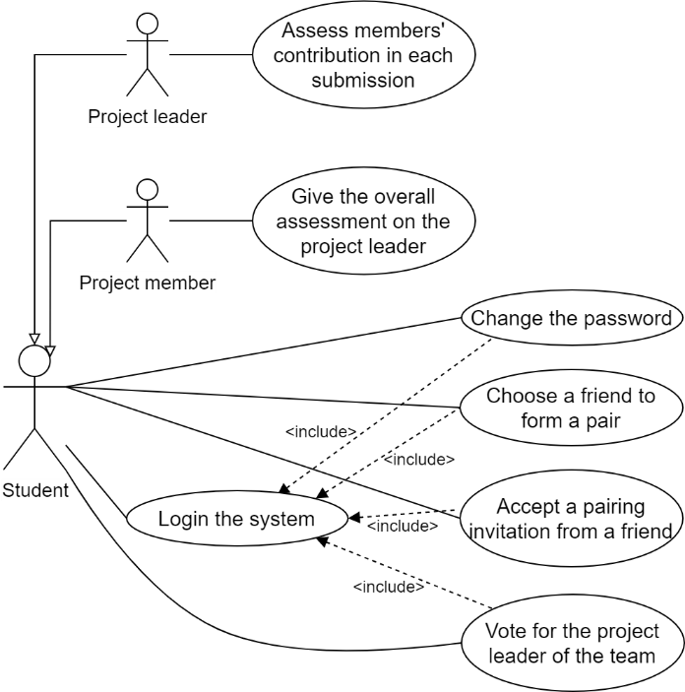The use case diagrams are shown below.

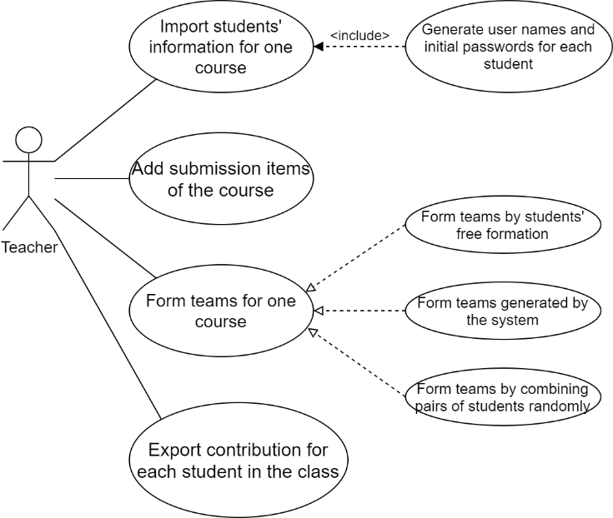

For the Teacher user case diagram:

Actors: Teacher

* Teacher can import students’ information for a course.
* Teacher can generate students’ basic information (including usernames and passwords).
* Teacher can add the submission items of a course.
* Teacher can form teams for a course.
* Teacher can export a file which lists the contribution.

For the Student user case diagram:

Actors: Student (including Project leader and Project member)

* Student can login the system.
* Student can change the password, send a pairing invitation, accept a pairing invitation and vote for the team leader.
* Project leader can assess members’ contribution.
* Project member can give an assessment to the leader.

## User Classes and Characteristics

There are two kinds of user classes. One class is teachers and the other class is students. Teachers and students are both members in the same university and they need to use this system to finish their work with higher quality and efficiency. Additionally, they all have some basic knowledge about computer and Internet. For example, they know how to use browser in Windows, Mac or Linux desktop to open and use our web application.

## Operating Environment

The application is based on web browser. The application is able to run on Linux-based operating system or Microsoft Windows.

## Design and Implementation Constraints

Language requirements: Web application uses English as the language of the user interface.

Other constrains are TBD.

## User Documentation

An independent user manual is needed to provide for users. This manual should be written in English version. The user manual will also be placed on the application's web page for user to read online.

## Assumptions and Dependencies

Users should have a device that can connect to the Internet and use a browser.

# System Features

## Login

3.1.1 Description and Priority

Users can use this feature to login to the system with corresponding role. This is the highest priority feature in the system because only if the user has logged in, can he/she use other features in the system.

3.1.2 Stimulus/Response Sequences

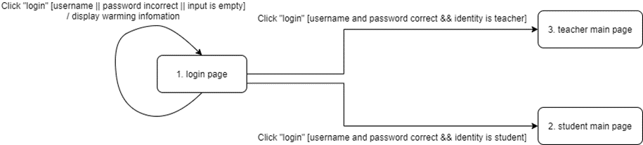

3.1.3 Functional Requirements

REQ-1: The student’s username is according to the student e-mail and cannot be changed.

REQ-2: The student initial passwords are all the same when they are generated. Students can change the initial password after their login. There is no special requirement for the password.

REQ-3: If any of the user’s input is empty, the system will ask the user to complete the form.

REQ-4: If what user inputs does not match in the database, the system will display the warming information and ask the user to retry.

## Import students’ info and generate students’ accounts

3.2.1 Description and Priority

Teachers can import students’ information for a course into the system by an excel file and generate username and initial password for each student whose name is in the students’ information. The excel file should follow the provided format or the system will give warning. This is a high priority feature in the system.

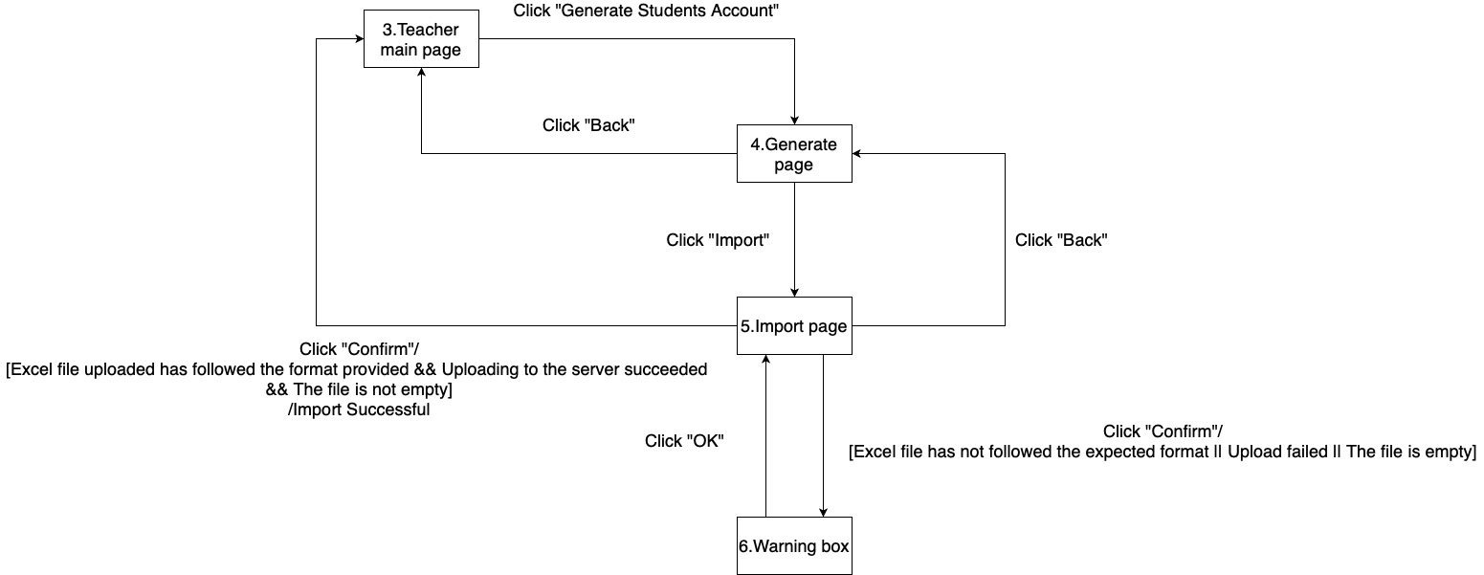3.2.2 Stimulus/Response Sequences

3.2.3 Functional Requirements

REQ-1: The system will check whether the excel file uploaded is empty or not. If empty, it will ask the user to retry.

REQ-2: The system will check whether the file is uploaded successfully, if not, it will give the warning

REQ-3: The system will check whether the content in excel file follows the format provided (name, id, email, GPA (optional)). If the request is not met, the system will reject the submission.

## Edit submission item

3.3.1 Description and Priority

The user can add, delete, modify the submission item in the system. This is a high priority feature in the system.

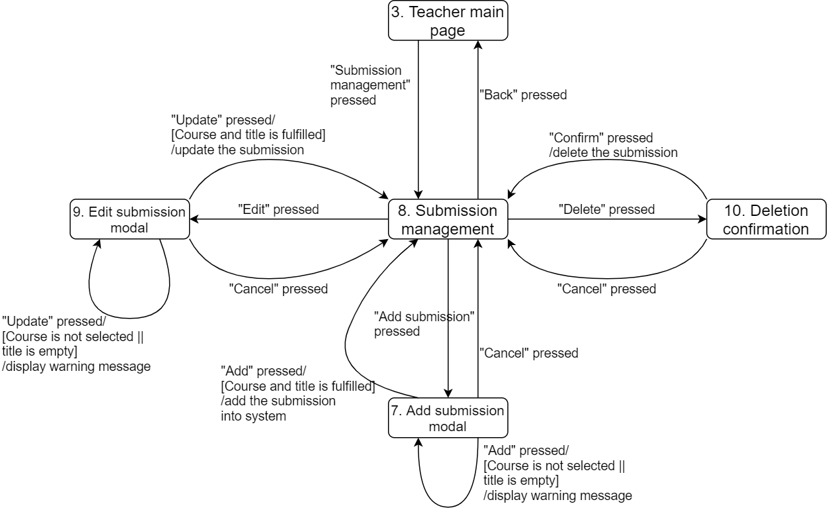3.3.2 Stimulus/Response Sequences

3.3.3 Functional Requirements

REQ-1: There are 3 attributes of the submission: belonging course, title and assessment percentage.

REQ-2: The belonging course of a submission should be selected in the existing courses of the teacher.

REQ-3： The system will check whether the belonging course is unset, the title is empty, or the assessment percentage is empty, for a submission. If it is, the system will warn the teacher before adding or modifying a submission.

REQ-4: The total percentage of submissions in the same course should be 100%. The system will notice the teacher but will not validate it. This constraint will be validated in other system features.

# External Interface Requirements

## User Interfaces

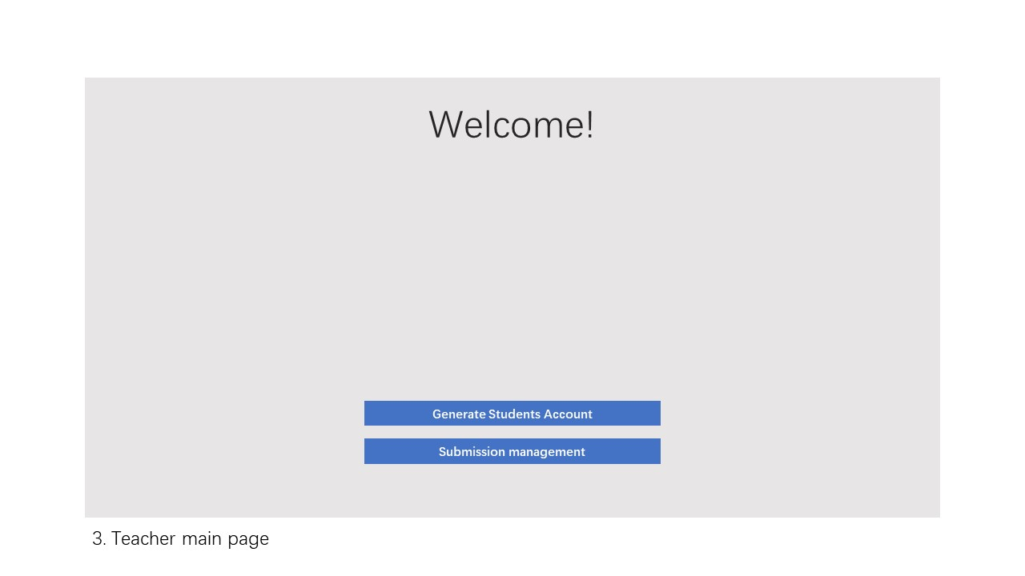

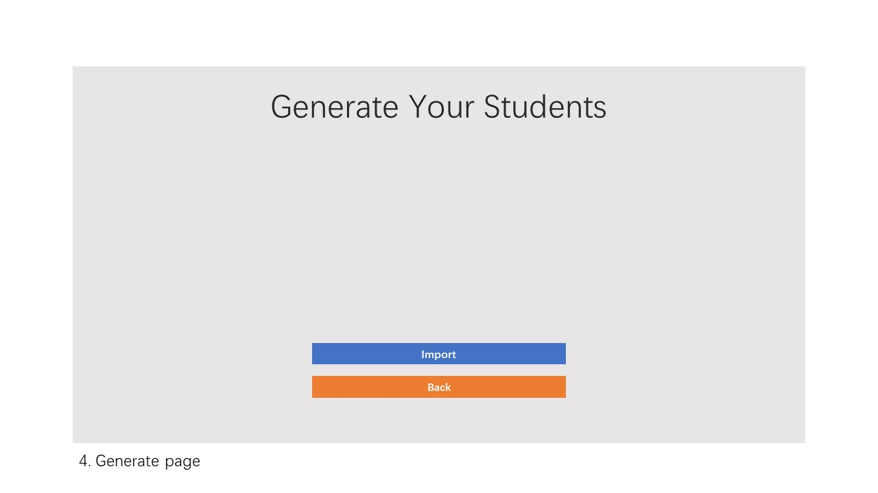

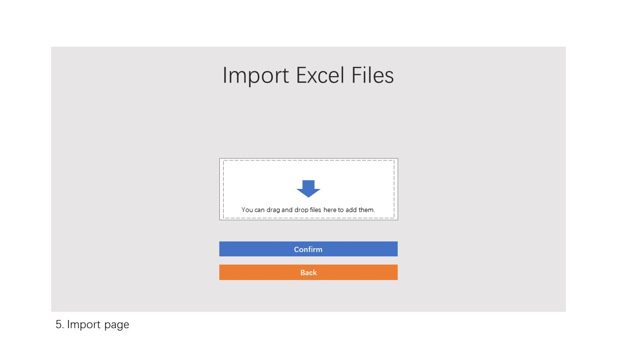

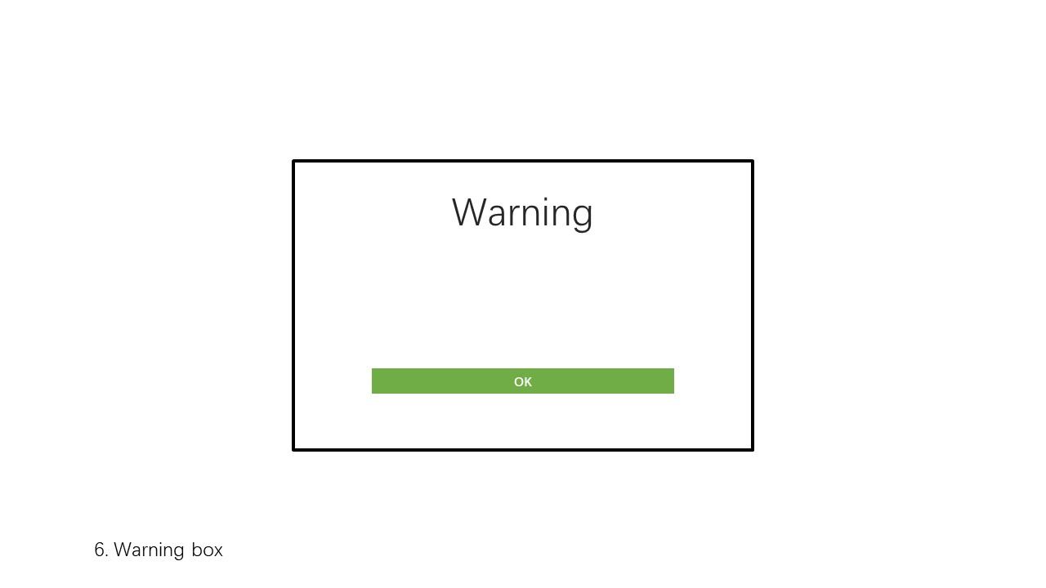

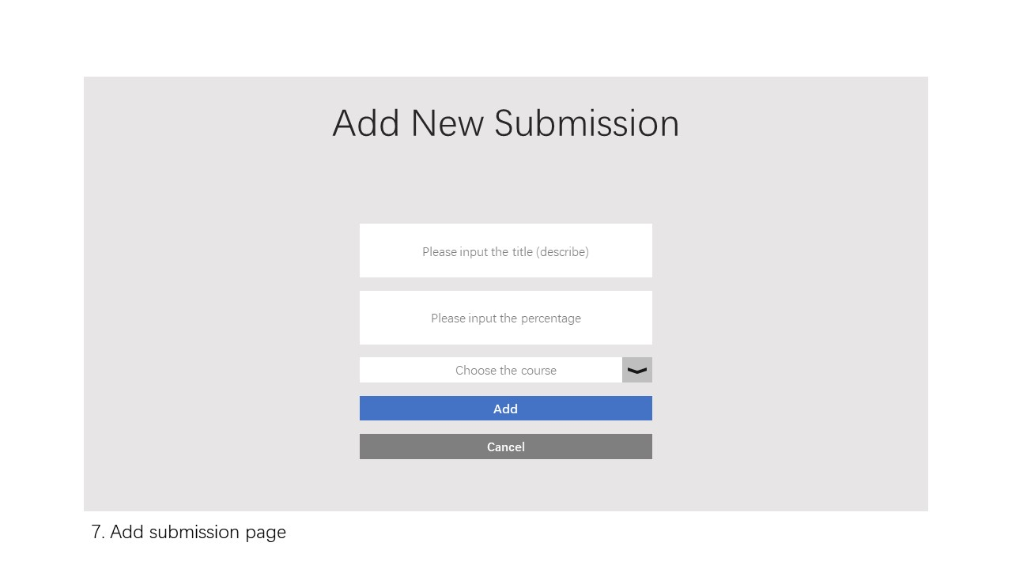

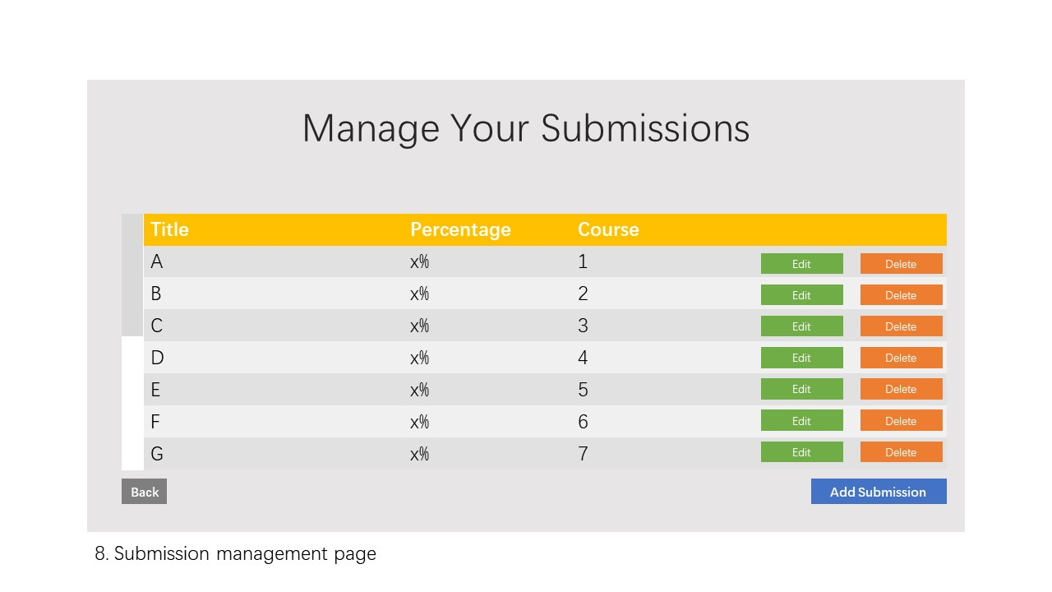

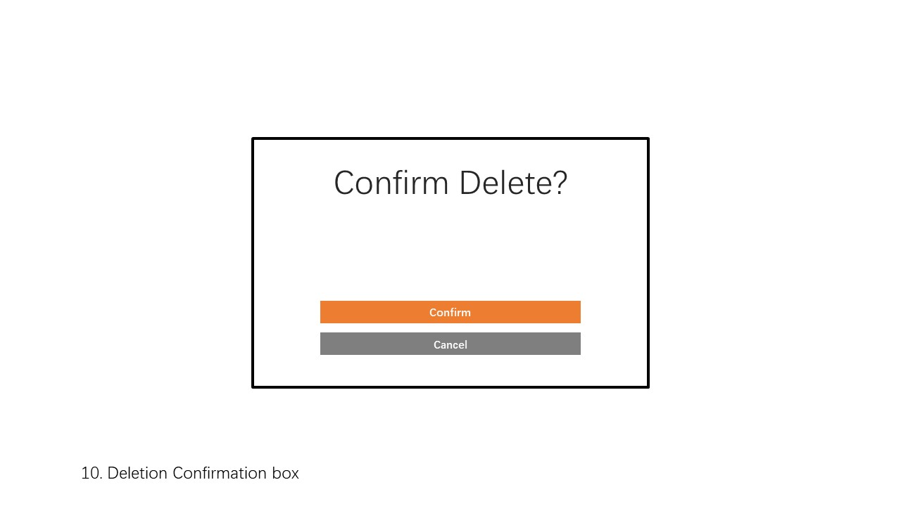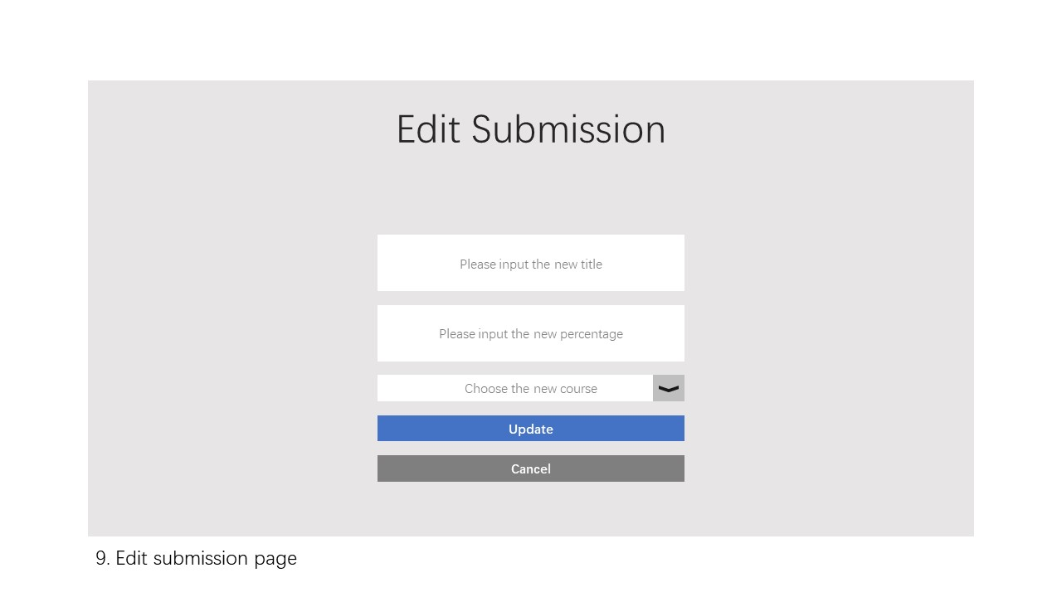

## Hardware Interfaces

The software does not have the ability of controlling the hardware.

## Software Interfaces

* **Database**

The software needs MySQL-like database (we recommend MariaDB) to store all the information. Typically, the software queries the database to display the information (account information, courses, assignments, assessment, etc.) on the user interface; all the users can operate the user interface (web pages) to perform database-level operations, such as database addition, deletion, queries and modification.

* **Web server**

A web server, Nginx, is needed to proxy all the information between users and the backend of the software. Typically, when users send requests to Nginx, Nginx directs the requests to the correct interface of the backend; when the backend sends back responses according to the requests, Nginx directs the responses and sends them back to the corresponding users.

## Communications Interfaces

The software interacts with users on web browsers using HTTPS protocol. Modern web browsers (we recommend Google Chrome) are required.

# Other Nonfunctional Requirements

## Performance Requirements

The response time of each inquiry operation should be less than one second and other operation’s response time should be less than two seconds.

## Safety Requirements

This system does not concern any safety issues.

## Security Requirements

The system will the keep the privacy of the user safe. The teacher can only view and manage the data of students from his/her own class. The password protection is not provided in the system, so the user should carefully keep his/her password. Other security requirements are TBD.

## Software Quality Attributes

Maintainability: Some documents should be written to maintain the system in the future. There should be comments to help other developer to understand the system.

Usability: The GUI should be easy to learn and use by the user of any technical background. A concise documentation should be provided to the administrator.

Portability: the website will ensure to support latest versions of the web browsers.

Security: The information should be available to user according to their identities.

Robustness: The system has a Mean time to Failures (MTTF) for 3000 hours per failure.

Reusability: some functions of the system could be reused on other websites, such as being part of iSpace.

# Other Requirements

TBD

Appendix A: Glossary

* TBD: To be determined
* T.C.A.S.: Teamwork Contribution Assessment System
* MTTF: Mean time to Failures

Appendix B: Analysis Models

class diagram

Appendix C: Issues List

TBD