Test Report
for
UIC Teamwork Contribution Assessment System
Prepared by YuePeng LONG, YiTao QIU, HongYue SHEN and RongKai LIU
AIR
Wednesday, May 13, 2020
Contents
1. Brief description 1
2. Test date and performer 1
3. References 1
4. Error report 1
5. Appendix 1

Brief description
The test costs about an hour in total, 30 minutes each on TestComplete and LoadRunner. In their respective test times, 10 minutes approximately is spent recording and generating scripts, and the remaining 20 minutes are spent examining and replaying scripts. None of the test cases produced errors. Thus, there was no difficulty in this test.

Test date and performer
The test date is May 13th, 2020 and the tester is YuePeng LONG, YiTao QIU, HongYue SHEN and RongKai LIU.

References
Y. P. Long, et al., “Software Requirements Specification for UIC Teamwork Contribution Assessment System v1.4” Sunday, April 5, 2020.
Y. P. Long, et al., “Test Plan for UIC Teamwork Contribution Assessment System v1.0” Monday, May 11, 2020.

Error report
The test is run without error thus there is no error report.

Appendix
The Vuser script copy from the use of LoadRunner:

Action()
{
web_add_auto_header("DNT",
"1");
web_add_header("Origin",
"http://localhost:8000");
web_url("info",
"URL=http://192.168.1.3:8000/sockjs-node/info?t=1589372442080",
"Resource=0",
"RecContentType=application/json",
"Referer=http://localhost:8000/user/login?redirect=%2F",
"Snapshot=t21.inf",
"Mode=HTML",
LAST);
web_add_auto_header("Upgrade-Insecure-Requests",
"1");
web_url("iframe.html",
"URL=http://192.168.1.3:8000/sockjs-node/iframe.html",
"Resource=0",
"RecContentType=text/html",
"Referer=http://localhost:8000/user/login?redirect=%2F",
"Snapshot=t22.inf",
"Mode=HTML",
LAST);
web_url("htmlfile",
"URL=http://192.168.1.3:8000/sockjs-node/409/sh52q0ab/htmlfile?c=_jp.aawqp1n",
"Resource=0",
"RecContentType=text/html",
"Referer=http://192.168.1.3:8000/sockjs-node/iframe.html",
"Snapshot=t23.inf",
"Mode=HTML",
LAST);
web_url("htmlfile_2",
"URL=http://192.168.1.3:8000/sockjs-node/409/sh52q0ab/htmlfile?c=_jp.ajn3idv",
"Resource=0",
"RecContentType=text/html",
"Referer=http://192.168.1.3:8000/sockjs-node/iframe.html",
"Snapshot=t24.inf",
"Mode=HTML",
LAST);
web_revert_auto_header("Upgrade-Insecure-Requests");
web_add_header("Origin",
"http://localhost:8000");
web_url("info_2",
"URL=http://192.168.1.3:8000/sockjs-node/info?t=1589372447290",
"Resource=0",
"RecContentType=application/json",
"Referer=http://localhost:8000/user/login?redirect=%2F",
"Snapshot=t25.inf",
"Mode=HTML",
LAST);
web_add_auto_header("Upgrade-Insecure-Requests",
"1");
web_url("iframe.html_2",
"URL=http://192.168.1.3:8000/sockjs-node/iframe.html",
"Resource=0",
"RecContentType=text/html",
"Referer=http://localhost:8000/user/login?redirect=%2F",
"Snapshot=t26.inf",
"Mode=HTML",
LAST);
lr_think_time(5);
web_url("iframe.html_3",
"URL=http://192.168.1.3:8000/sockjs-node/iframe.html",
"Resource=0",
"RecContentType=text/html",
"Referer=http://localhost:8000/mainpage",
"Snapshot=t27.inf",
"Mode=HTML",
EXTRARES,
"Url=948/yipdc3g5/jsonp?c=_jp.a2qu3ky", "Referer=http://localhost:8000/", ENDITEM,
LAST);
web_revert_auto_header("Upgrade-Insecure-Requests");
web_add_header("Origin",
"http://localhost:8000");
web_url("info_3",
"URL=http://192.168.1.3:8000/sockjs-node/info?t=1589372456612",
"Resource=0",
"RecContentType=application/json",
"Referer=http://localhost:8000/submission",
"Snapshot=t28.inf",
"Mode=HTML",
EXTRARES,
"Url=https://gw.alipayobjects.com/zos/rmsportal/LCkqqYNmvBEbokSDscrm.svg", "Referer=http://localhost:8000/", ENDITEM,
"Url=https://gw.alipayobjects.com/zos/rmsportal/jpRkZQMyYRryryPNtyIC.svg", "Referer=http://localhost:8000/", ENDITEM,
"Url=https://gw.alipayobjects.com/zos/rmsportal/JopDzEhOqwOjeNTXkoje.svg", "Referer=http://localhost:8000/", ENDITEM,
"Url=https://gw.alipayobjects.com/zos/rmsportal/JiqGstEfoWAOHiTxclqi.png", "Referer=http://localhost:8000/", ENDITEM,
"Url=https://gw.alipayobjects.com/zos/rmsportal/KDNDBbriJhLwuqMoxcAr.svg", "Referer=http://localhost:8000/", ENDITEM,
"Url=https://zos.alipayobjects.com/rmsportal/ODTLcjxAfvqbxHnVXCYX.png", "Referer=http://localhost:8000/", ENDITEM,
LAST);
web_set_sockets_option("SSL_VERSION", "AUTO");
web_add_auto_header("Upgrade-Insecure-Requests",
"1");
lr_think_time(7);
web_url("iframe.html_4",
"URL=http://192.168.1.3:8000/sockjs-node/iframe.html",
"Resource=0",
"RecContentType=text/html",
"Referer=http://localhost:8000/submission",
"Snapshot=t29.inf",
"Mode=HTML",
LAST);
web_url("htmlfile_3",
"URL=http://192.168.1.3:8000/sockjs-node/580/gztjkivu/htmlfile?c=_jp.a5mxiqc",
"Resource=0",
"RecContentType=text/html",
"Referer=http://192.168.1.3:8000/sockjs-node/iframe.html",
"Snapshot=t30.inf",
"Mode=HTML",
LAST);
web_url("htmlfile_4",
"URL=http://192.168.1.3:8000/sockjs-node/580/gztjkivu/htmlfile?c=_jp.ab24kcq",
"Resource=0",
"RecContentType=text/html",
"Referer=http://192.168.1.3:8000/sockjs-node/iframe.html",
"Snapshot=t31.inf",
"Mode=HTML",
LAST);
web_revert_auto_header("Upgrade-Insecure-Requests");
web_add_header("Origin",
"http://localhost:8000");
web_url("info_4",
"URL=http://192.168.1.3:8000/sockjs-node/info?t=1589372474566",
"Resource=0",
"RecContentType=application/json",
"Referer=http://localhost:8000/submission",
"Snapshot=t32.inf",
"Mode=HTML",
LAST);
web_add_auto_header("Upgrade-Insecure-Requests",
"1");
web_url("iframe.html_5",
"URL=http://192.168.1.3:8000/sockjs-node/iframe.html",
"Resource=0",
"RecContentType=text/html",
"Referer=http://localhost:8000/submission",
"Snapshot=t33.inf",
"Mode=HTML",
LAST);
web_url("htmlfile_5",
"URL=http://192.168.1.3:8000/sockjs-node/244/0twlxllc/htmlfile?c=_jp.abmpki0",
"Resource=0",
"RecContentType=text/html",
"Referer=http://192.168.1.3:8000/sockjs-node/iframe.html",
"Snapshot=t34.inf",
"Mode=HTML",
LAST);
web_url("htmlfile_6",
"URL=http://192.168.1.3:8000/sockjs-node/244/0twlxllc/htmlfile?c=_jp.aufoqka",
"Resource=0",
"RecContentType=text/html",
"Referer=http://192.168.1.3:8000/sockjs-node/iframe.html",
"Snapshot=t35.inf",
"Mode=HTML",
LAST);
web_revert_auto_header("Upgrade-Insecure-Requests");
web_add_header("Origin",
"http://localhost:8000");
web_url("info_5",
"URL=http://192.168.1.3:8000/sockjs-node/info?t=1589372478207",
"Resource=0",
"RecContentType=application/json",
"Referer=http://localhost:8000/submission",
"Snapshot=t36.inf",
"Mode=HTML",
LAST);
web_add_auto_header("Upgrade-Insecure-Requests",
"1");
web_url("iframe.html_6",
"URL=http://192.168.1.3:8000/sockjs-node/iframe.html",
"Resource=0",
"RecContentType=text/html",
"Referer=http://localhost:8000/submission",
"Snapshot=t37.inf",
"Mode=HTML",
LAST);
web_url("htmlfile_7",
"URL=http://192.168.1.3:8000/sockjs-node/331/it0uhb3s/htmlfile?c=_jp.ao5ug4k",
"Resource=0",
"RecContentType=text/html",
"Referer=http://192.168.1.3:8000/sockjs-node/iframe.html",
"Snapshot=t38.inf",
"Mode=HTML",
LAST);
web_url("htmlfile_8",
"URL=http://192.168.1.3:8000/sockjs-node/331/it0uhb3s/htmlfile?c=_jp.amqjik0",
"Resource=0",
"RecContentType=text/html",
"Referer=http://192.168.1.3:8000/sockjs-node/iframe.html",
"Snapshot=t39.inf",
"Mode=HTML",
LAST);
web_revert_auto_header("Upgrade-Insecure-Requests");
web_add_header("Origin",
"http://localhost:8000");
web_url("info_6",
"URL=http://192.168.1.3:8000/sockjs-node/info?t=1589372480869",
"Resource=0",
"RecContentType=application/json",
"Referer=http://localhost:8000/submission",
"Snapshot=t40.inf",
"Mode=HTML",
LAST);
web_add_header("Upgrade-Insecure-Requests",
"1");
web_url("iframe.html_7",
"URL=http://192.168.1.3:8000/sockjs-node/iframe.html",
"Resource=0",
"RecContentType=text/html",
"Referer=http://localhost:8000/submission",
"Snapshot=t41.inf",
"Mode=HTML",
LAST);
web_add_auto_header("Origin",
"http://localhost:8000");
web_custom_request("xhr",
"URL=http://192.168.1.3:8000/sockjs-node/104/ckbhzeq1/xhr?t=1589372484585",
"Method=POST",
"Resource=0",
"RecContentType=application/javascript",
"Referer=http://localhost:8000/submission",
"Snapshot=t42.inf",
"Mode=HTML",
"EncType=",
LAST);
/* Added by Async CodeGen.
ID=Poll_0
ScanType = Recording
The following URLs are considered part of this conversation:
http://192.168.1.3:8000/sockjs-node/104/ckbhzeq1/xhr?t=1589372484791
http://192.168.1.3:8000/sockjs-node/104/ckbhzeq1/xhr?t=1589372484993
http://192.168.1.3:8000/sockjs-node/104/ckbhzeq1/xhr?t=1589372510110
http://192.168.1.3:8000/sockjs-node/104/ckbhzeq1/xhr?t=1589372535252
http://192.168.1.3:8000/sockjs-node/104/ckbhzeq1/xhr?t=1589372560368
http://192.168.1.3:8000/sockjs-node/104/ckbhzeq1/xhr?t=1589372585484
TODO - The following callbacks have been added to AsyncCallbacks.c.
Add your code to the callback implementations as necessary.
Poll_0_RequestCB
Poll_0_ResponseCB
*/
web_reg_async_attributes("ID=Poll_0",
"Pattern=Poll",
"URL=http://192.168.1.3:8000/sockjs-node/104/ckbhzeq1/xhr?t=1589372484791",
"PollIntervalMs=25100",
"RequestCB=Poll_0_RequestCB",
"ResponseCB=Poll_0_ResponseCB",
LAST);
web_custom_request("xhr_2",
"URL=http://192.168.1.3:8000/sockjs-node/104/ckbhzeq1/xhr?t=1589372484791",
"Method=POST",
"Resource=0",
"RecContentType=application/javascript",
"Referer=http://localhost:8000/submission",
"Snapshot=t43.inf",
"Mode=HTML",
"EncType=",
LAST);
/* Removed by Async CodeGen.
ID = Poll_0
*/
/*
web_custom_request("xhr_3",
"URL=http://192.168.1.3:8000/sockjs-node/104/ckbhzeq1/xhr?t=1589372484993",
"Method=POST",
"Resource=0",
"RecContentType=application/javascript",
"Referer=http://localhost:8000/submission",
"Snapshot=t44.inf",
"Mode=HTML",
"EncType=",
LAST);
*/
/* Removed by Async CodeGen.
ID = Poll_0
*/
/*
web_custom_request("xhr_4",
"URL=http://192.168.1.3:8000/sockjs-node/104/ckbhzeq1/xhr?t=1589372510110",
"Method=POST",
"Resource=0",
"RecContentType=application/javascript",
"Referer=http://localhost:8000/submission",
"Snapshot=t45.inf",
"Mode=HTML",
"EncType=",
LAST);
*/
/* Removed by Async CodeGen.
ID = Poll_0
*/
/*
web_custom_request("xhr_5",
"URL=http://192.168.1.3:8000/sockjs-node/104/ckbhzeq1/xhr?t=1589372535252",
"Method=POST",
"Resource=0",
"RecContentType=application/javascript",
"Referer=http://localhost:8000/submission",
"Snapshot=t46.inf",
"Mode=HTML",
"EncType=",
LAST);
*/
/* Removed by Async CodeGen.
ID = Poll_0
*/
/*
web_custom_request("xhr_6",
"URL=http://192.168.1.3:8000/sockjs-node/104/ckbhzeq1/xhr?t=1589372560368",
"Method=POST",
"Resource=0",
"RecContentType=application/javascript",
"Referer=http://localhost:8000/submission",
"Snapshot=t47.inf",
"Mode=HTML",
"EncType=",
LAST);
*/
lr_think_time(125);
/* Removed by Async CodeGen.
ID = Poll_0
*/
/*
web_custom_request("xhr_7",
"URL=http://192.168.1.3:8000/sockjs-node/104/ckbhzeq1/xhr?t=1589372585484",
"Method=POST",
"Resource=0",
"RecContentType=application/javascript",
"Referer=http://localhost:8000/submission",
"Snapshot=t48.inf",
"Mode=HTML",
"EncType=",
LAST);
*/
/* Added by Async CodeGen.
ID = Poll_0
*/
web_stop_async("ID=Poll_0",
LAST);
return 0;
}
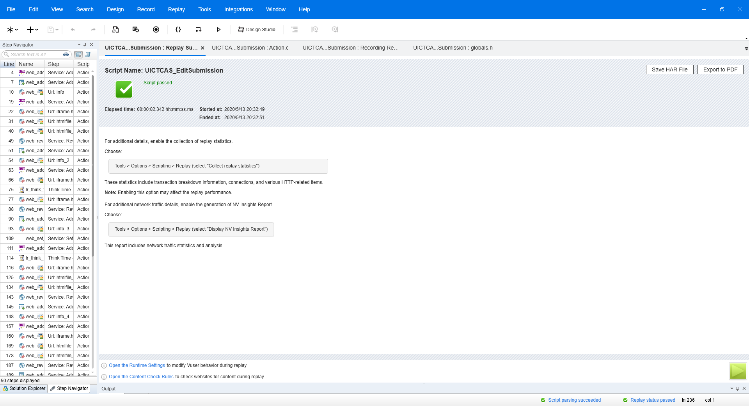
Figure 1 – Testing result for Edit Submission in LoadRunner
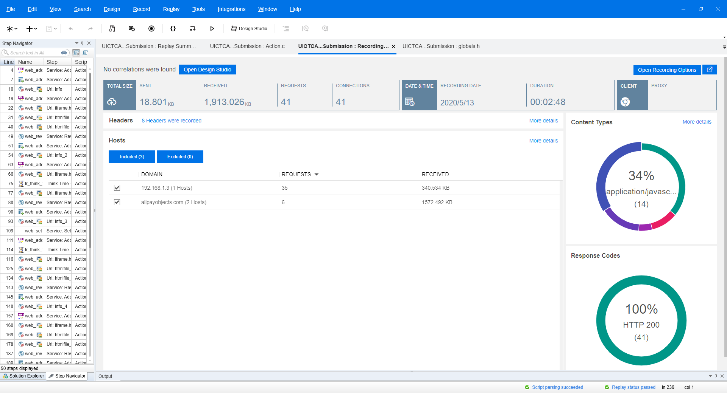
Figure 2 – Testing report for Edit Submission in LoadRunner

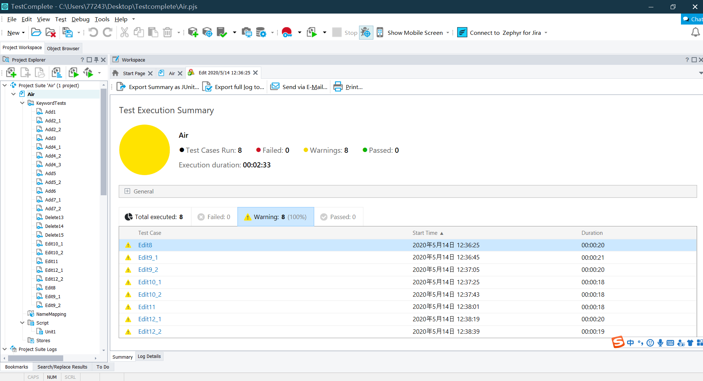
Three screenshots when we use TestComplete to test the chosen use case:
Figure 3 – Testing for editing submission

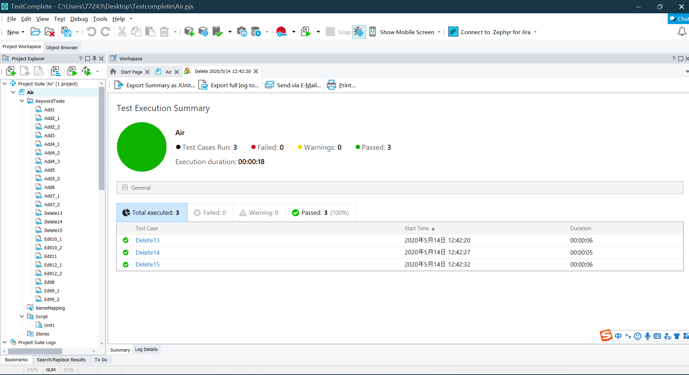
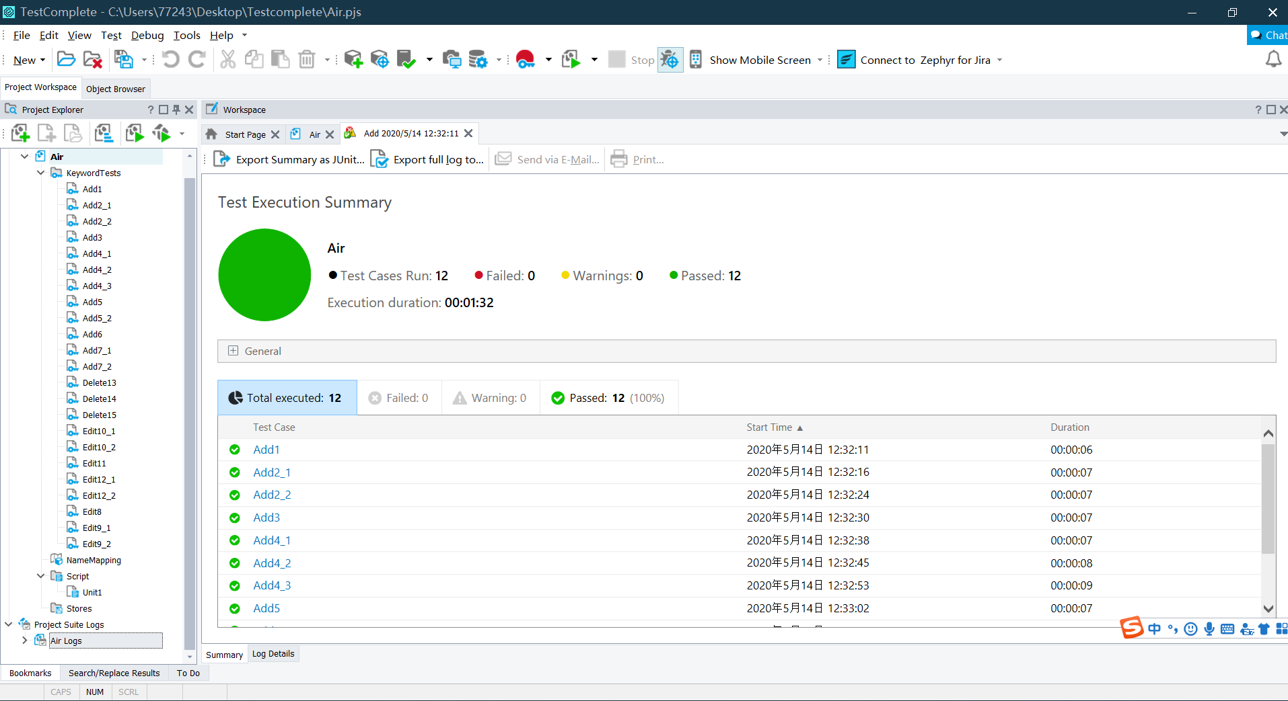
Figure 4 – Testing for adding submission
Figure 5 – Testing for deleting submission

