МИНИСТЕРСТВО НАУКИ И ВЫСШЕГО ОБРАЗОВАНИЯ
РОССИЙСКОЙ ФЕДЕРАЦИИ

Федеральное государственное автономное
образовательное учреждение высшего образования
«НАЦИОНАЛЬНЫЙ ИССЛЕДОВАТЕЛЬСКИЙ УНИВЕРСИТЕТ ИТМО»

ЛАБОРАТОРНАЯ РАБОТА №1
по
БАЗАМ ДАННЫХ

Выполнила:
Умарова Амина
P3117

Санкт-Петербург
2026
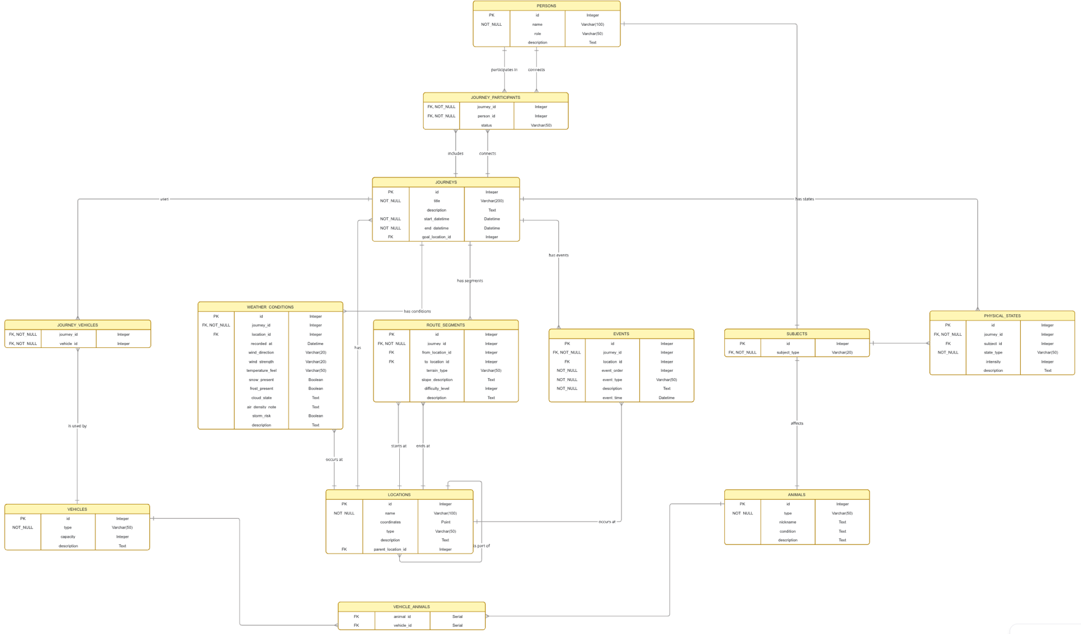
create table locations(
id serial primary key, name varchar(100) not null,
coordinates point, type varchar(50),
parent_location_id int,
constraint fk_locations_parent_location foreign key (parent_location_id) references locations(id)
);

create table journeys(
id serial primary key,
title varchar(200) not null, start_datetime timestamp,
end_datetime timestamp, goal_location_id int,
constraint fk_journeys_goal_location foreign key (goal_location_id) references locations(id)
);

Create table route_segments (
id serial primary key,
journey_id int not null, from_location_id int,
to_location_id int,
terrain_type varchar(50),
difficulty_level integer check (difficulty_level between 1 and 10), description text,
constraint fk_route_segments_journey foreign key (journey_id) references journeys(id),
constraint fk_route_segments_from_location foreign key (from_location_id) references locations(id),
constraint fk_route_segments_to_location foreign key (to_location_id) references locations(id)
);

CREATE TABLE subjects (
id serial PRIMARY KEY,
subject_type VARCHAR(20) NOT NULL
);

CREATE TABLE animals (
id int PRIMARY KEY REFERENCES subjects(id),
type VARCHAR(50) NOT NULL, nickname TEXT
);

CREATE TABLE persons (
id int PRIMARY KEY REFERENCES subjects(id),
first_name VARCHAR(100),
last_name VARCHAR(100)
);

CREATE TABLE physical_states ( id serial PRIMARY KEY,
journey_id BIGINT NOT NULL,
subject_id BIGINT REFERENCES subjects(id),
state_type VARCHAR(50) NOT NULL,
intensity INTEGER,
description TEXT,
constraint fk_physical_state_journey_id foreign key (journey_id) references journeys(id)
);

create table journey_participant (
person_id int not null references persons(id),
journey_id int not null references journeys(id),
status text
);

create table events (
id serial primary key,
journey_id int not null references journeys(id),
location_id int references locations(id),
event_type varchar(50) not null, description text,
event_time timestamp
);

create table vehicles (
id serial primary key,
type varchar(50),
description text,
capacity int
);

create table vehicle_animals (
vehicle_id int not null references vehicles(id),
animal_id int not null references animals(id)
);

create table vehicle_journey (
vehicle_id int not null references vehicles(id),
journey_id int not null references journeys(id)
);

INSERT INTO locations (name, coordinates, type, parent_location_id) VALUES
('Russia', '(55.7558,37.6173)', 'country', NULL),
('Mongolia', '(46.8083,103.8467)', 'country', NULL),
('China', '(39.9042,116.4074)', 'country', NULL),
('Kazakhstan', '(51.1694,71.4491)', 'country', NULL),

('Moscow', '(55.7558,37.6173)', 'city', 1),
('Saint Petersburg', '(59.9311,30.3609)', 'city', 1),
('Irkutsk', '(52.2802,104.2671)', 'city', 1),
('Vladivostok', '(43.1056,131.8535)', 'city', 1),
('Altai Region', '(51.2544,85.9485)', 'region', 1),

('Ulaanbaatar', '(47.9064,106.8835)', 'city', 2),
('Darkhan', '(49.4695,105.9155)', 'city', 2),
('Erdenet', '(49.0247,104.0761)', 'city', 2),

('Beijing', '(39.9042,116.4074)', 'city', 3),
('Shanghai', '(31.2304,121.4737)', 'city', 3),
('Xi An', '(34.3416,108.9398)', 'city', 3),

('Almaty', '(43.2381,76.9453)', 'city', 4),
('Astana', '(51.1694,71.4491)', 'city', 4),

('Lake Baikal', '(53.5,104.8)', 'landmark', 7),
('Gobi Desert', '(42.5, 101.5)', 'landmark', 2),
('Great Wall of China', '(40.4319,116.5704)', 'landmark', 3),
('Tian Shan Mountains', '(43.0,77.5)', 'landmark', 4),
('Arshan Resort', '(51.9, 102.4)', 'resort', 9),
('Mongolian Steppe', '(48.0, 102.0)', 'landmark', 2);

INSERT INTO subjects (subject_type) VALUES
('animal'), ('animal'), ('animal'), ('animal'), ('animal'), ('animal'), ('animal'), ('animal'), ('animal'), ('animal'),
('person'), ('person'), ('person'), ('person'), ('person'), ('person'), ('person'), ('person'), ('person'), ('person');

INSERT INTO animals (id, type, nickname) VALUES
(1, 'Horse', 'Thunder'),
(2, 'Horse', 'Swift'),
(3, 'Horse', 'Storm'),
(4, 'Camel', 'Desert King'),
(5, 'Camel', 'Sandy'),
(6, 'Donkey', 'Stubborn Jack'),
(7, 'Donkey', 'Steady'),
(8, 'Dog', 'Wolf'),
(9, 'Dog', 'Scout'),
(10, 'Eagle', 'Sky Master');

INSERT INTO persons (id, first_name, last_name) VALUES
(11, 'Alexander', 'Petrov'),
(12, 'Maria', 'Smirnova'),
(13, 'Ivan', 'Volkov'),
(14, 'Anastasia', 'Kuznetsova'),
(15, 'Dmitry', 'Orlov'),
(16, 'Olga', 'Sokolova'),
(17, 'Mikhail', 'Novikov'),
(18, 'Elena', 'Pavlova'),
(19, 'Sergey', 'Lebedev'),
(20, 'Victoria', 'Mikhailova');

INSERT INTO journeys (title, start_datetime, end_datetime, goal_location_id) VALUES
('Trans-Siberian Expedition', '2023-06-01 08:00:00', '2023-08-15 18:00:00', 15),
('Silk Road Adventure', '2023-09-01 07:00:00', '2023-11-30 19:00:00', 13),
('Lake Baikal Expedition', '2023-07-10 06:00:00', '2023-07-25 20:00:00', 15),
('Desert Crossing', '2023-10-01 05:00:00', '2023-10-20 17:00:00', 16),
('Mountain Trek', '2023-08-15 08:00:00', '2023-09-10 16:00:00', 17),
('Royal Mongolia Tour', '2023-06-15 07:00:00', '2023-07-05 18:00:00', 11),
('Northern Route', '2023-05-20 09:00:00', '2023-06-30 15:00:00', 6),
('Eastern Passage', '2023-11-01 08:00:00', '2023-12-15 17:00:00', 8);

INSERT INTO route_segments (journey_id, from_location_id, to_location_id, terrain_type, difficulty_level, description) VALUES
(1, 5, 7, 'forest', 5, 'Through Siberian forests to Irkutsk'),
(1, 7, 15, 'mountain', 7, 'Alpine terrain around Lake Baikal'),
(1, 15, 8, 'taiga', 6, 'Dense taiga forests to Vladivostok'),

(2, 5, 9, 'steppe', 4, 'Flat terrain through Russian steppe'),
(2, 9, 11, 'desert', 8, 'Challenging desert crossing through Gobi'),
(2, 11, 12, 'mountain', 6, 'Mountain passes to Erdenet'),
(2, 12, 13, 'steppe', 5, 'Highland steppe to Great Wall'),
(2, 13, 14, 'mountain', 7, 'Wall of China to Ancient Xi An'),

(3, 7, 15, 'mountain', 7, 'Direct route to Lake Baikal'),
(3, 15, 7, 'taiga', 6, 'Return through scenic routes'),

(4, 2, 16, 'desert', 9, 'Epic desert crossing through Gobi'),
(4, 16, 18, 'mountain', 8, 'Tian Shan mountain passages'),

(5, 9, 18, 'mountain', 8, 'Challenge to high altitude mountains'),
(5, 18, 19, 'mountain', 7, 'Descent through scenic valleys'),

(6, 5, 11, 'steppe', 4, 'Pleasant steppe journey to Ulaanbaatar'),
(6, 11, 20, 'steppe', 5, 'Mongolian wilderness exploration'),
(6, 20, 11, 'steppe', 4, 'Return journey through grasslands'),

(7, 5, 6, 'road', 2, 'Highway to Saint Petersburg'),
(7, 6, 1, 'sea', 3, 'Coastal route along Baltic'),

(8, 8, 4, 'mixed', 6, 'Complex route to Eastern regions'),
(8, 4, 14, 'mountain', 7, 'High altitude passages to China');

INSERT INTO journey_participant (person_id, journey_id, status) VALUES
(11, 1, 'leader'),
(12, 1, 'participant'),
(13, 1, 'participant'),
(14, 1, 'medic'),

(15, 2, 'leader'),
(16, 2, 'participant'),
(17, 2, 'navigator'),
(18, 2, 'participant'),

(11, 3, 'leader'),
(19, 3, 'participant'),
(20, 3, 'guide'),

(12, 4, 'leader'),
(13, 4, 'participant'),
(14, 4, 'participant'),

(15, 5, 'leader'),
(16, 5, 'mountaineer'),
(17, 5, 'guide'),

(11, 6, 'participant'),
(18, 6, 'participant'),
(19, 6, 'leader'),

(12, 7, 'leader'),
(20, 7, 'guide'),

(13, 8, 'leader'),
(14, 8, 'navigator'),
(15, 8, 'participant'),
(16, 8, 'medic');

INSERT INTO vehicles (type, description, capacity) VALUES
('Horse Carriage', 'Traditional wooden carriage pulled by horses', 4),
('Camel Caravan', 'Multiple camels carrying cargo', 8),
('Wagon', 'Heavy duty wagon for supplies', 6),
('Sleigh', 'Winter transportation', 4),
('Raft', 'For river crossings', 6),
('Pack Animal Transport', 'Horses and donkeys with packs', 5),
('Boat', 'River and lake transport', 8),
('Cart', 'Light cart for supplies', 3);

-- Заполнение таблицы vehicle_animals (животные в транспорте)
INSERT INTO vehicle_animals (vehicle_id, animal_id) VALUES
(1, 1), (1, 2),
(2, 4), (2, 5),
(3, 3), (3, 7),
(6, 1), (6, 2), (6, 6), (6, 7),
(4, 1),
(7, 10);

INSERT INTO vehicle_journey (vehicle_id, journey_id) VALUES
(1, 1), (2, 1), (3, 1), (6, 1),
(2, 2), (4, 2), (6, 2),
(1, 3), (7, 3),
(2, 4), (3, 4),
(6, 5), (1, 5),
(1, 6), (2, 6),
(1, 7), (7, 7),
(3, 8), (6, 8);

INSERT INTO events (journey_id, location_id, event_type, description, event_time) VALUES
(1, 5, 'departure', 'Expedition officially starts from Moscow', '2023-06-01 08:30:00'),
(1, 7, 'arrival', 'Team reaches Irkutsk, rest day', '2023-06-20 14:00:00'),
(1, 15, 'landmark', 'Arrived at Lake Baikal, swimming and research', '2023-06-28 10:00:00'),
(1, 15, 'celebration', 'Birthday party at Lake Baikal camp', '2023-07-02 18:00:00'),
(1, 8, 'arrival', 'Reached Vladivostok, expedition ends', '2023-08-15 18:00:00'),

(2, 5, 'departure', 'Silk Road journey begins', '2023-09-01 07:00:00'),
(2, 9, 'checkpoint', 'Supply replenishment at Ulaanbaatar', '2023-09-18 11:00:00'),
(2, 16, 'challenge', 'Difficult desert sandstorm encountered', '2023-10-05 14:30:00'),
(2, 13, 'landmark', 'Team visits Great Wall of China', '2023-10-25 09:00:00'),
(2, 14, 'celebration', 'Successfully reached Xi An', '2023-11-30 16:00:00'),

(3, 7, 'departure', 'Baikal expedition begins', '2023-07-10 06:00:00'),
(3, 15, 'landmark', 'Scientific research begins at Lake', '2023-07-12 08:00:00'),
(3, 15, 'discovery', 'New species of fish documented', '2023-07-18 13:00:00'),
(3, 7, 'arrival', 'Return to Irkutsk', '2023-07-25 15:00:00'),

(4, 2, 'departure', 'Desert expedition starts', '2023-10-01 05:00:00'),
(4, 16, 'challenge', 'Lost water supply, emergency measures', '2023-10-10 16:00:00'),
(4, 16, 'rescue', 'Found oasis, team recovered', '2023-10-12 08:00:00'),
(4, 18, 'arrival', 'Reached Tian Shan mountains', '2023-10-20 17:00:00'),

(5, 9, 'departure', 'Mountain trek starts', '2023-08-15 08:00:00'),
(5, 18, 'summit', 'Team reaches peak at high altitude', '2023-08-28 11:00:00'),
(5, 19, 'injury', 'One climber suffers altitude sickness', '2023-09-02 14:00:00'),
(5, 19, 'arrival', 'Team safely descends', '2023-09-10 16:00:00'),

(6, 5, 'departure', 'Mongolia tour begins', '2023-06-15 07:00:00'),
(6, 11, 'cultural', 'Visit Mongolian nomad camps', '2023-06-25 10:00:00'),
(6, 20, 'landmark', 'Explore Mongolian Steppe wilderness', '2023-07-01 08:00:00'),
(6, 11, 'arrival', 'Return to Ulaanbaatar', '2023-07-05 18:00:00'),

(7, 5, 'departure', 'Northern route expedition', '2023-05-20 09:00:00'),
(7, 6, 'arrival', 'Reach Saint Petersburg', '2023-06-05 15:00:00'),
(7, 1, 'cultural', 'Museum visits and cultural events', '2023-06-15 10:00:00'),
(7, 6, 'departure', 'Start coastal journey', '2023-06-20 08:00:00'),

(8, 8, 'departure', 'Eastern Passage begins', '2023-11-01 08:00:00'),
(8, 4, 'checkpoint', 'Supply stop at Almaty', '2023-11-20 12:00:00'),
(8, 14, 'arrival', 'Reached Ancient Xi An', '2023-12-15 17:00:00');

INSERT INTO physical_states (journey_id, subject_id, state_type, intensity, description) VALUES
(1, 11, 'fatigue', 6, 'Leader tired but motivated'),
(1, 12, 'fatigue', 7, 'Exhausted from long days'),
(1, 13, 'injury', 3, 'Minor knee pain'),
(1, 14, 'health', 8, 'Excellent physical condition'),

(1, 1, 'fatigue', 8, 'Horse exhausted from travel'),
(1, 2, 'health', 7, 'Horse in good condition'),
(1, 3, 'fatigue', 9, 'Very tired donkey'),

(2, 15, 'altitude_sickness', 5, 'Mild symptoms'),
(2, 16, 'fatigue', 8, 'Desert heat exhaustion'),
(2, 17, 'health', 9, 'Navigator in excellent shape'),
(2, 18, 'dehydration', 6, 'Mild dehydration'),

(2, 4, 'stress', 6, 'Camel stressed by heat'),
(2, 5, 'dehydration', 7, 'Camel needs water'),

(3, 11, 'health', 9, 'Excellent condition for research'),
(3, 19, 'fatigue', 5, 'Minor tiredness'),

(3, 1, 'health', 8, 'Well-rested horse'),

(4, 12, 'heat_exhaustion', 8, 'Severe in desert'),
(4, 13, 'dehydration', 7, 'Critically dehydrated'),

(4, 4, 'stress', 9, 'Camel suffering in extreme heat'),

(5, 15, 'altitude_sickness', 7, 'Acute mountain sickness'),
(5, 16, 'fatigue', 8, 'Mountain climbing exhaustion'),

(6, 11, 'excitement', 7, 'Happy to explore Mongolia'),
(6, 18, 'health', 8, 'Enjoying the journey'),

(7, 12, 'health', 9, 'Excellent throughout trip'),

(8, 13, 'fatigue', 6, 'Long journey fatigue'),
(8, 14, 'alert', 8, 'Navigator focused and alert'),
(8, 15, 'health', 7, 'Good condition');

