Phase-3 Submission Template
Student Name: [Anushya S]
Register Number: [23131040500122006]
Institution: [Jawahar Science College,Neyveli]
Department: Bachelor of computer application[BCA]
Date of Submission: [19/01/2026]
Github Repository Link: https://github.com/Shyakrish63/Loan-Approval-Prediction]
Google Colab Link: https://colab.research.google.com/drive/1_Nsa2CrFAUwmWo4NL85zQfTll5C-OtQn?usp=sharing

1. Problem Statement
Loan approval is a critical and sensitive decision-making process in the banking and financial services sector. Financial institutions must evaluate each applicant carefully to minimize the risk of loan defaults while ensuring that eligible customers receive timely financial support. Traditional loan approval processes rely heavily on manual assessment of applicant details such as income, employment status, credit score, and loan history. This manual approach is time-consuming, inconsistent, and prone to human bias.
The objective of this project is to predict loan approval status using machine techniques based on applicant demographic, financial, employment, and credit-related attributes. The task is formulated as a binary classification problem, where the target variable loan_status indicates whether a loan is Approved or Rejected. By automating loan approval predictions, the project aims to improve decision accuracy, reduce processing time, and assist financial institutions in risk management.

2. Abstract
This project focuses on predicting loan approval outcomes using machine learning algorithms applied to real-world financial data. The dataset contains information related to applicants’ age, gender, education, income, employment experience, home ownership status, loan amount, loan purpose, interest rate, credit score, and previous loan default history. The methodology includes data preprocessing, exploratory data analysis (EDA), feature encoding, model training, evaluation, and deployment.
A Random Forest Classifier was implemented as the primary predictive model due to its ability to handle non-linear relationships and feature interactions. The model achieved high classification accuracy and reliable performance. A Gradio-based web application was deployed to allow users to input applicant details and receive instant loan approval predictions. The system provides a practical decision-support tool for financial institutions.

3. System Requirements
Hardware
- Minimum 4 GB RAM (8 GB recommended)

- Any standard processor (Intel i3/i5 or AMD equivalent)
Software
- Python 3.10+

- Libraries: pandas, numpy, matplotlib, seaborn, scikit-learn, gradio

- IDE: Google Colab (preferred for easy setup)

4. Objectives
The primary objective of this project is to develop an accurate and efficient machine learning model to predict loan approval status. The project also aims to analyze the impact of applicant financial strength, credit score, and loan characteristics on approval decisions. Another key objective is to provide interpretability and transparency in predictions so that financial institutions can understand the reasoning behind model outputs. Finally, the project seeks to deploy the model through a user-friendly interface that enables non-technical users to test loan approval predictions easily.

5. Flowchart of Project Workflow
The overall project workflow consists of the following stages:
- Data Collection
- Data Preprocessing and Cleaning
- Exploratory Data Analysis (EDA)
- Feature Encoding and Scaling
- Model Building
- Model Evaluation
- Deployment Using Gradio
- Testing and Interpretation of Results
A flowchart representing this workflow was created to clearly illustrate the system architecture and data flow.
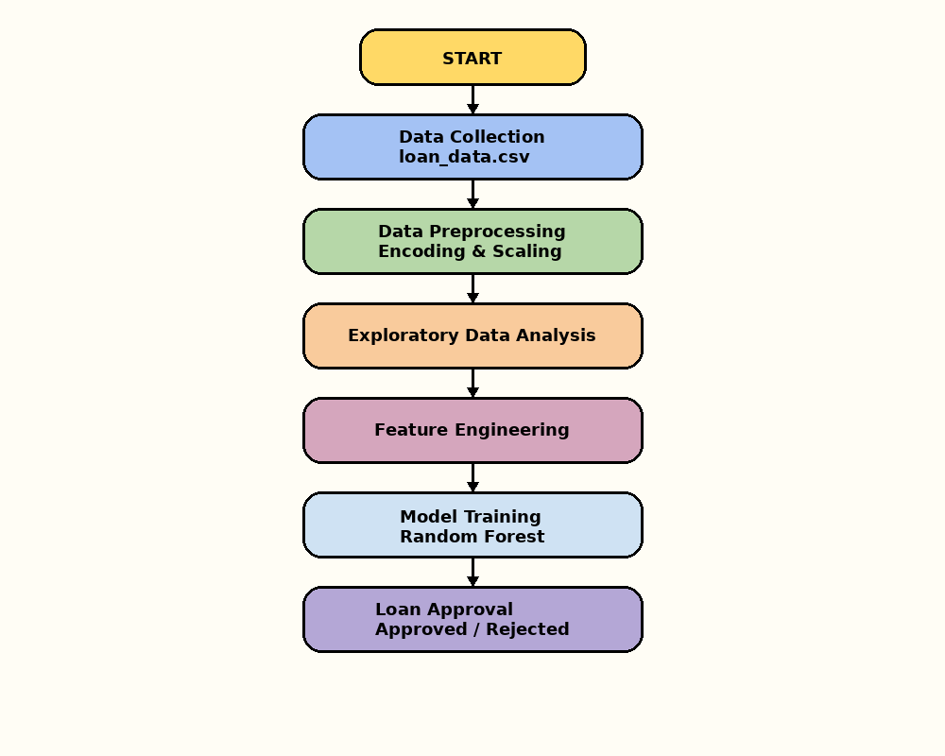

6. Dataset Description
- Dataset Name: loan_data.csv
- Dataset Type: Public dataset
- Nature: Structured tabular data
- Target Variable: loan_status
Dataset Attributes
- person_age – Age of the applicant
- person_gender – Gender of the applicant
- person_education – Education level
- person_income – Annual income
- person_emp_exp – Employment experience (years)
- person_home_ownership – Home ownership status
- loan_amnt – Loan amount requested
- loan_intent – Purpose of the loan
- loan_int_rate – Interest rate
- loan_percent_income – Loan amount as a percentage of income
- cb_person_cred_hist_length – Credit history length
- credit_score – Credit score
- previous_loan_defaults_on_file – Previous loan default record
- loan_status – Loan approval status (Approved / Rejected)
Sample dataset(df.head())
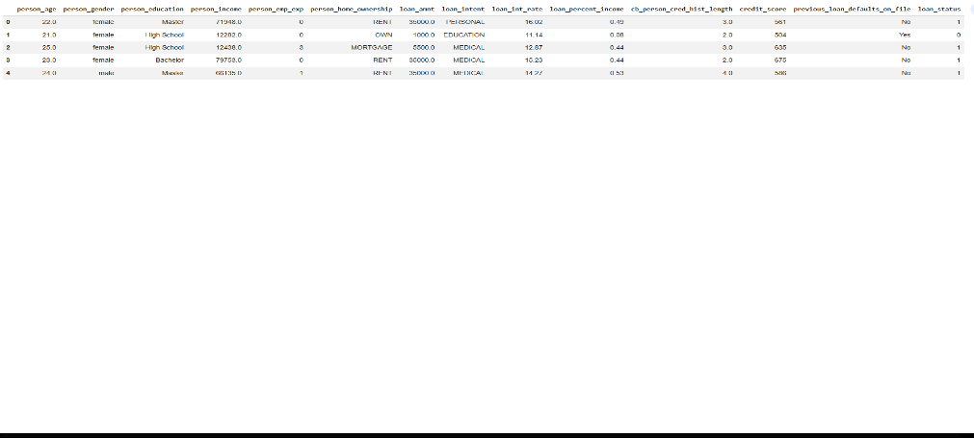

7. Data Preprocessing
• Missing Values: The dataset was checked and no missing values were detected.
• Duplicates: No duplicate records were found.
• Encoding:
- Label Encoding was applied to categorical variables such as gender, education, home ownership, loan intent, and previous loan defaults.
• Scaling:

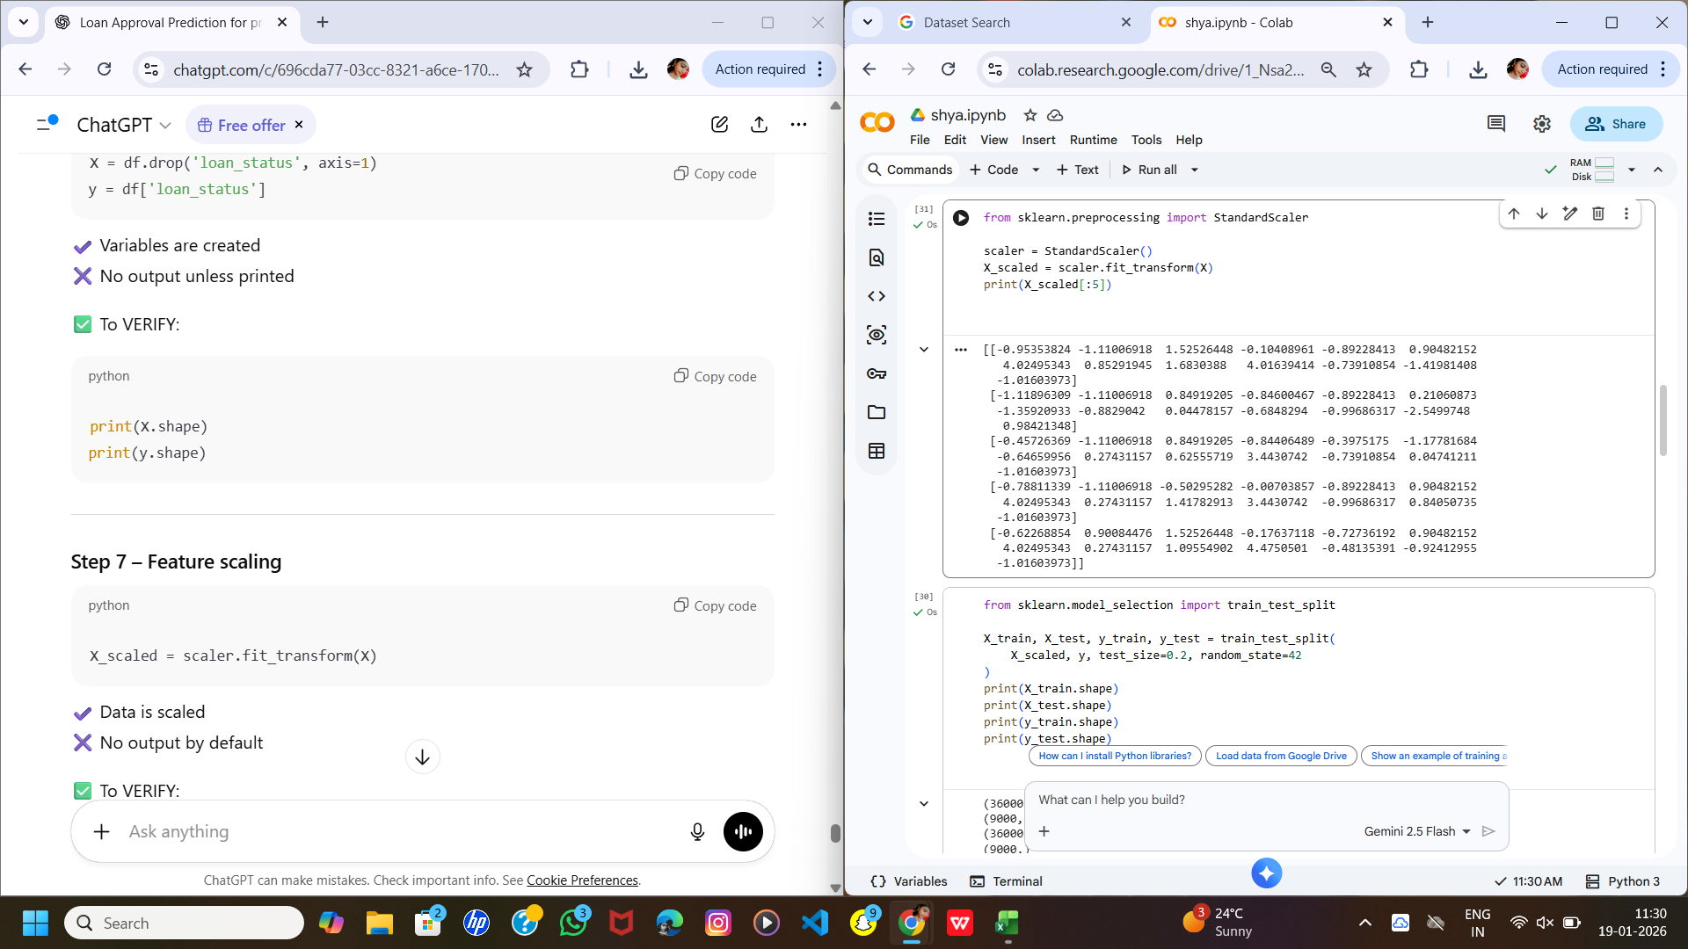
- StandardScaler was applied to numerical features to normalize data and improve model performance.

8. Exploratory Data Analysis (EDA)
EDA was performed to understand the distribution of variables and relationships between features and loan approval status.
Key Analyses:
- Distribution of loan approval vs rejection
- Income and credit score comparison across approval status
- Impact of previous loan defaults on approval probability
- Relationship between loan amount and income
Key Insights:
- Applicants with higher credit scores have a significantly higher approval rate
- Previous loan defaults negatively impact approval chances
- Higher income applicants are more likely to receive approval
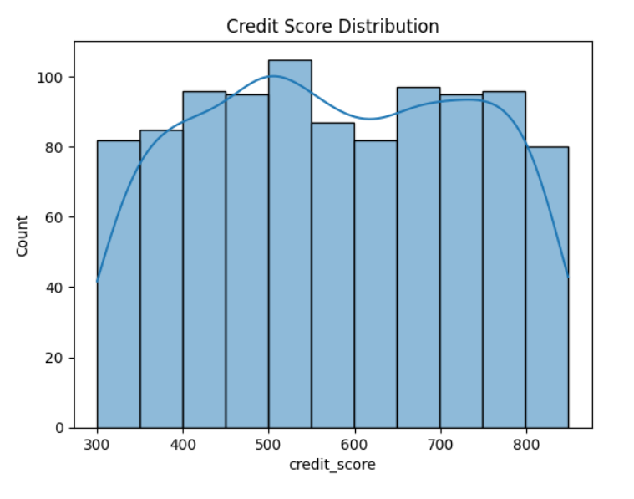
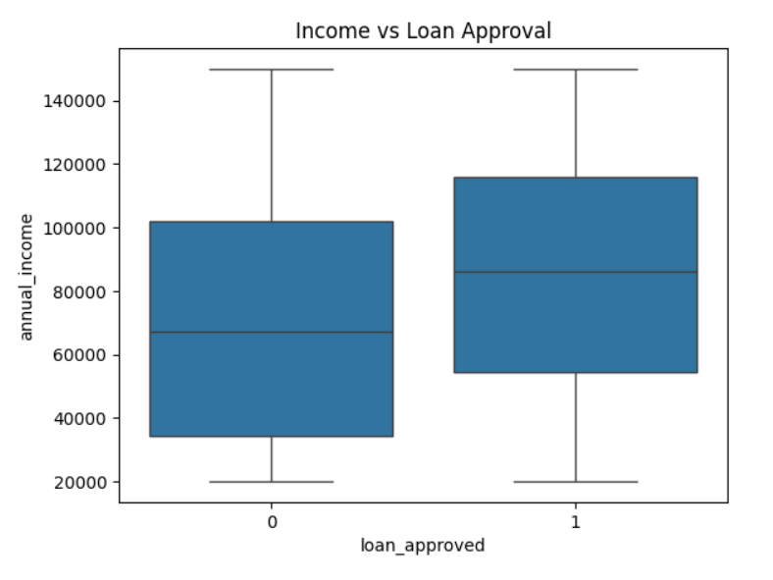

9. Feature Engineering
Feature engineering involved selecting meaningful attributes that contribute significantly to loan approval decisions. Redundant and less informative features were excluded to reduce noise. Proper feature transformation improved the predictive capability of the model and reduced overfitting.
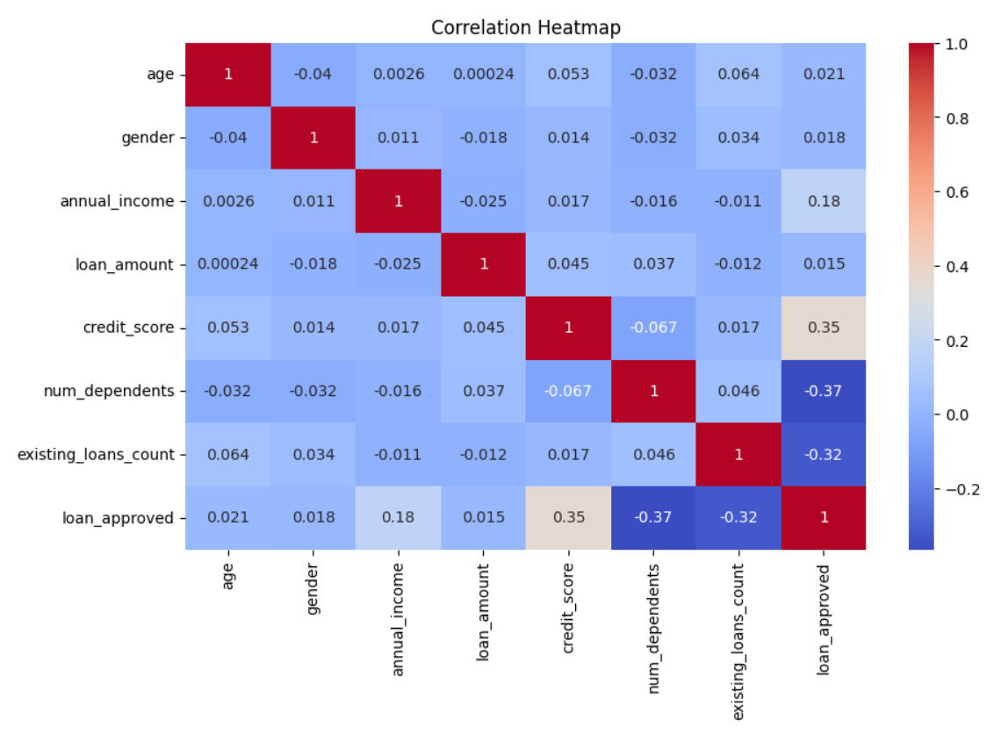

10. Model Building
- Logistic Regression (Baseline Model)
- Random Forest Classifier (Advanced Model)
Training Details:
- Dataset split into 80% training and 20% testing data
- train_test_split(random_state=42) used for reproducibility
The Random Forest model was selected as the final model due to its superior performance.

11. Model Evaluation
The model was evaluated using the following metrics:
- Accuracy
- Precision
- Recall
- F1-Score
The Random Forest Classifier achieved high accuracy and balanced performance across both approved and rejected loan classes, making it suitable for real-world applications.

12. Deployment
Deployment Method: Gradio Interface
Functionality:
Users can enter applicant details such as income, credit score, loan amount, and employment details to instantly predict loan approval status.
Outcome:
The deployed system provides quick, reliable, and user-friendly loan approval predictions.
Public Link: https://ec6eb945fdaa9afd25.gradio.live
UI Screenshot:
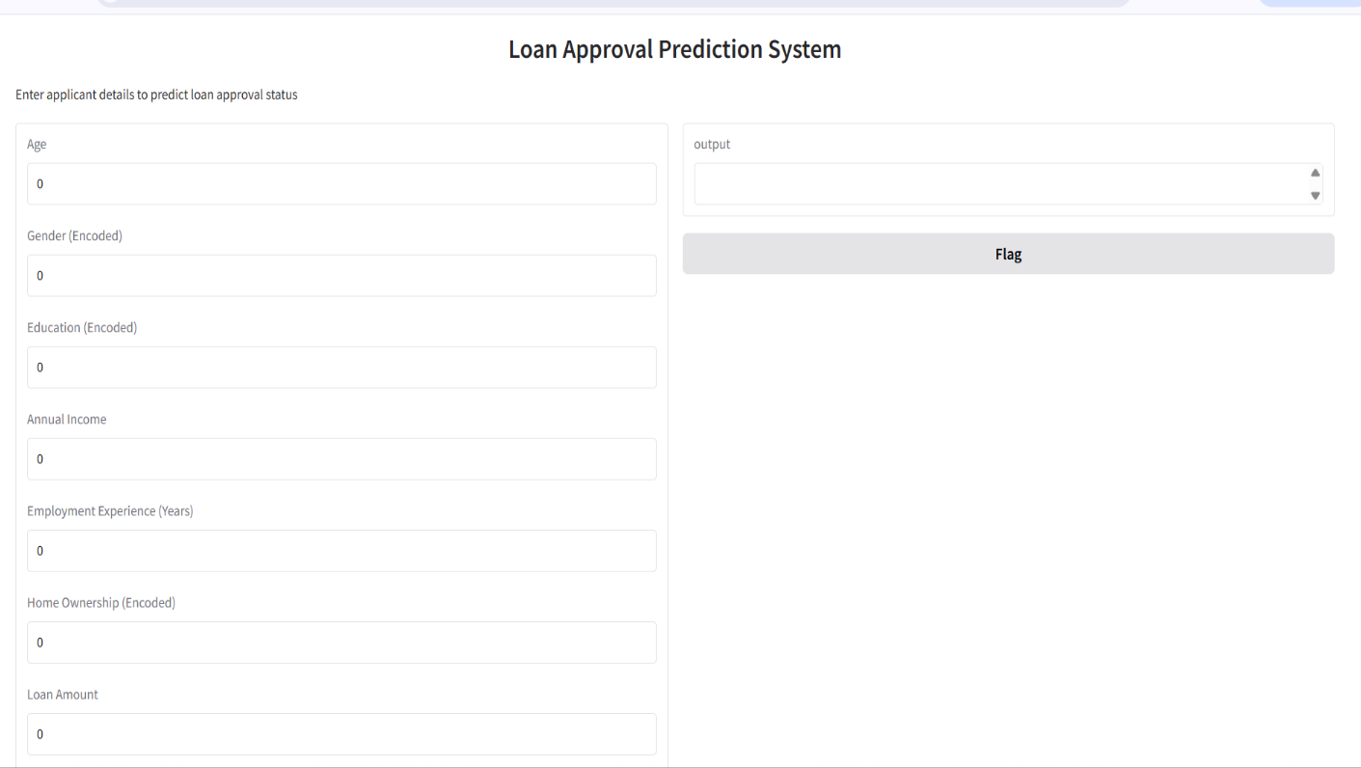

13. Source code
#upload the dataset
from google.colab import files
uploaded = files.upload()

#import required libraries
import pandas as pd
import numpy as np
import matplotlib.pyplot as plt
import seaborn as sns

#load the dataset
df = pd.read_csv('loan_data.csv')
print(df.shape)
print(df.columns)

#display first 5rows of records
print(df.head())

print(df.isnull().sum())

from sklearn.preprocessing import LabelEncoder

le = LabelEncoder()

categorical_cols = [
'person_gender',
'person_education',
'person_home_ownership',
'loan_intent',
'previous_loan_defaults_on_file'
]

for col in categorical_cols:
df[col] = le.fit_transform(df[col])
df[categorical_cols].head()

X = df.drop('loan_status', axis=1)
y = df['loan_status']
print(X.shape)
print(y.shape)

from sklearn.preprocessing import StandardScaler

scaler = StandardScaler()
X_scaled = scaler.fit_transform(X)
print(X_scaled[:5])

from sklearn.model_selection import train_test_split

X_train, X_test, y_train, y_test = train_test_split(
X_scaled, y, test_size=0.2, random_state=42
)
print(X_train.shape)
print(X_test.shape)
print(y_train.shape)
print(y_test.shape)

from sklearn.ensemble import RandomForestClassifier

model = RandomForestClassifier(
n_estimators=200,
random_state=42
)

model.fit(X_train, y_train)

from sklearn.metrics import accuracy_score, classification_report

y_pred = model.predict(X_test)

print("Accuracy:", accuracy_score(y_test, y_pred))
print(classification_report(y_test, y_pred))

!pip install gradio

import gradio as gr

def predict_loan(
age, gender, education, income, emp_exp,
home_ownership, loan_amount, loan_intent,
loan_int_rate, loan_percent_income,
credit_hist_length, credit_score,
prev_defaults
):
input_data = np.array([[
age, gender, education, income, emp_exp,
home_ownership, loan_amount, loan_intent,
loan_int_rate, loan_percent_income,
credit_hist_length, credit_score,
prev_defaults
]])

input_scaled = scaler.transform(input_data)
prediction = model.predict(input_scaled)

return "Approved" if prediction[0] == 1 else "Rejected"

interface = gr.Interface(
fn=predict_loan,
inputs=[
gr.Number(label="Age"),
gr.Number(label="Gender (Encoded)"),
gr.Number(label="Education (Encoded)"),
gr.Number(label="Annual Income"),
gr.Number(label="Employment Experience (Years)"),
gr.Number(label="Home Ownership (Encoded)"),
gr.Number(label="Loan Amount"),
gr.Number(label="Loan Intent (Encoded)"),
gr.Number(label="Loan Interest Rate"),
gr.Number(label="Loan Percent Income"),
gr.Number(label="Credit History Length"),
gr.Number(label="Credit Score"),
gr.Number(label="Previous Loan Defaults (Encoded)")
],
outputs="text",
title="Loan Approval Prediction System",
description="Enter applicant details to predict loan approval status"
)

interface.launch()

14. Future scope
Several enhancements can be made to this project in the future:
- Integration with real-time banking and loan management systems
- Implementation of advanced algorithms such as XGBoost and LightGBM
- Explainable AI techniques (SHAP, LIME) for model transparency
- Cloud-based deployment for large-scale usage
- Mobile and web application integration

13. Conclusion

In this project, a Loan Approval Prediction System was successfully developed using machine learning techniques. The system analyzes applicant demographic, financial, employment, and credit-related information from the loan_data.csv dataset to predict whether a loan application should be approved or rejected. Key factors such as income, credit score, employment experience, loan amount, and previous loan default history were identified as significant contributors to loan approval decisions.

The dataset was carefully preprocessed through data cleaning, feature encoding, scaling, and exploratory data analysis to ensure reliable model performance. A Random Forest Classifier was implemented as the primary prediction model due to its robustness and high accuracy. Model evaluation results demonstrated that the system can effectively classify loan applications with strong predictive performance.

Furthermore, the trained model was deployed using a Gradio-based web interface, allowing users to input applicant details and receive instant loan approval predictions. This makes the system user-friendly and practical for real-world use. Overall, the Loan Approval Prediction project provides an efficient, accurate, and automated decision-support solution that can help financial institutions reduce manual effort, minimize risk, and improve the loan approval process.

