Home page

HTML

<html> <head> <title>Food Lover</title>

<link rel="stylesheet" href="style.css" /> </head>

<body> <div class="menu">

<input type="checkbox" id="check" />

<label for="check" class="checkbtn">

<ion-icon name="grid-outline"></ion-icon> </label>

<label class="logo">FastFeast</label>

<ul> <li><a href="#hero-section" class="active">Home</a></li>

<li><a href="#about">About</a></li>

<li><a href="#donate">Donate</a></li>

<li><a href="#setting">Setting</a></li>

<li><a href="#privacy">Privacy</a></li> </ul> </div>

<div class="section flex" id="hero-section">

<div class="text">

<h1 class="primary"> It's Not Just Food, <br /> It's an <span>Experience</span> </h1>

<a href="#menu" class="btn">Explore Menu</a> </div> <div class="visual">

<img src="https://raw.githubusercontent.com/programmercloud/foodlover/main/img/home-banner.png" alt="" /> </div> </div> </body> </html>

CSS

:root { --clr-primary: #fe5722; --clr-secondary: #272d36; }

\*::after,\*::before {

box-sizing: border-box; padding: 0; margin: 0; font-family: "Josefin Sans", sans-serif; }

body { background: #fff; color: var(--clr-secondary); overflow-x: hidden; }

.section { width: 100%; padding: 40px 0;}

.flex { display: flex; align-items: center; justify-content: center;}

.container { padding: 0 30px;}

.primary { font-size: 64px; font-weight: 700; margin-bottom: 20px;}

.secondary { font-size: 44px; font-weight: 700; margin-bottom: 20px;}

.tertiary { font-size: 24px; font-weight: 400; margin-bottom: 20px;}

.btn { padding: 14px 20px; background: var(--clr-primary);

border-radius: 4px; color: #fff; text-decoration: none; font-size: 22px;

display: inline-block; margin: 20px 0; }

nav { height: 80px; width: 100%; position: fixed; top: 0; background: #fff5f2;

box-shadow: 0 1px 1px -1px rgba(0, 0, 0, 0.22); z-index: 22; }

label.logo { font-size: 35px; line-height: 80px; padding: 0 30px; font-weight: 700; }

nav ul { float: right; margin-right: 20px; }

nav ul li { display: inline-block; line-height: 80px; margin: 0 5px;}

nav ul li a { font-size: 18px; padding: 7px 13px;

text-decoration: none; color: var(--clr-secondary); }

.menu a.active, .menu a:hover { border-bottom: 2px solid var(--clr-primary); transition: 0.3s; }

.checkbtn { font-size: 30px; color: #fff;

float: right; line-height: 80px; margin-right: 40px;

cursor: pointer; display: none; }

#check { display: none;}

#hero-section { background: #fff5f2; margin-top: 60px; }

.text, .visual { width: 50%; }

.text { margin: 0 20px;}

.visual img { width: 80%; height: auto; display: block; }

#hero-section .text { margin-left: 30px; }

#hero-section .visual img { margin-left: auto; }

#how-it-works { width: 80%; margin: 0 auto; text-align: center; }

.box { border: 1px solid #b2b2b2;

padding: 25px 5px; margin: 0 10px; border-radius: 8px;

font-size: 18px; transition: 0.3s ease; cursor: pointer; }

.box ion-icon { font-size: 35px;

color: var(--clr-primary); margin: 15px 0; }

.box.active, .box:hover { color: #fff;

border-color: var(--clr-primary);

background: var(--clr-primary);}

.box.active ion-icon, .box:hover ion-icon { color: #fff; }

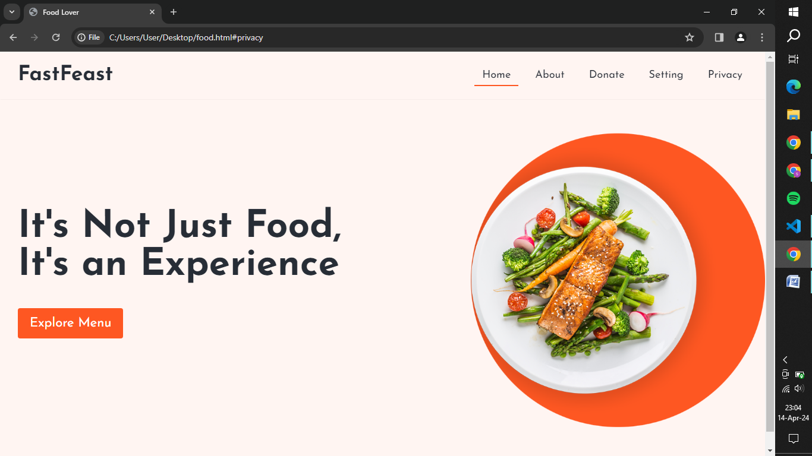

Donate

<html> <head> <title>donate food to needy</title>

<style> body { font-size: larger; background-image:url("image.img");

background-color:rgb(0, 225, 255); text-align: center;

font-family: 'Franklin Gothic Medium', 'Arial Narrow', Arial, sans-serif;

text-decoration: dotted; } </style> </head>

<body> <h1>donate the food to nearby area</h1>

<select name="" id="">

<label for="">select a foood...</label>

<option value="0" selected disabled>choose the food you need donate</option>

<option value="1">hyderabadhi biriyani</option>

<option value="2">madurai bun parotta</option>

<option value="3">delhi special chole bhature</option>

<option value="4">bombay vadapaav,paav paaji</option>

<option value="5">kolkatta rasagulla</a></option> </select>

<img src="C:\Users\varsh\Downloads\istockphoto-1044077878-1024x1024.jpg" height="200" width="300">rasagulla</img>

<img src="C:\Users\varsh\Downloads\istockphoto-618764348-1024x1024.jpg" height=200 width="300">parotta</img>

<img src="C:\Users\varsh\Downloads\istockphoto-1716346259-1024x1024.jpg" height=200 width="300">biriyani</img>

<img src="C:\Users\varsh\Downloads\istockphoto-873539518-1024x1024.jpg" height=200 width="300">chole bhature</img>

<button style="border: 1px";align:bottom>submit</button> </body> </html>

3D

<html> <head> <style>

body{ background-image: url("https://images.unsplash.com/photo-1478369402113-1fd53f17e8b4?q=80&w=1920&auto=format&fit=crop&ixlib=rb-4.0.3&ixid=M3wxMjA3fDB8MHxwaG90by1wYWdlfHx8fGVufDB8fHx8fA%3D%3D");

text-align: center; text-overflow: unset; } </style>

<title> 3d visualization </title>

</head> <h1>get a visual treat of your food before tasting it</h1>

<body bgcolor="blue">

<img src="C:\Users\varsh\Downloads\istockphoto-547202460-1024x1024.jpg" height="500" width="500">

<select> <option value="0" selected disabled>select your food</option>

<option value="1">biriyani</option>

<option value="2">parotta</option>

<option value="3">pizza</option></select>

<h1 text align="centre">happy and healthy eating with fasting and feasting</h1> </body> </html>

Login

<html> <head> <title>Login</title>

<link rel="stylesheet" type = "text/css" href="login.css"> </head>

<body> <div class="form">

<form action=""> <label for="">Login</label><br> <br><label for=""></label>

<select > <option value="">+91</option> </select>

<input type="number" placeholder="Enter Phone number"><br><br>

<button type="button" class="">send otp</button><br><br> <p>OR</p><br>

<button type="button" class="">sign in with google</button><br><br>

<button type="button" class="">continue with e-mail</button><br><br>

</form> </div> </body> </html>

CSS

form{ padding: 35px; padding-left: 175px; margin: 75px; margin-left: 300px;

margin-right: 250px; border-radius: 9px; border-top-left-radius: 25px;

border-style: solid; border-color: darkgreen; }

p{ padding-left: 140px; }

label{ font-weight: bold; font-size: xx-large; }

button{ padding-left: 135px; padding-right: 95px; font-size: larger; }

input, select { font-size: larger; }

.form1 { border-style: hidden; border-color: hotpink; margin: 20px; padding: 3mm; }

