GIT – ASSIGNMENT
TASK 1: Repository Setup
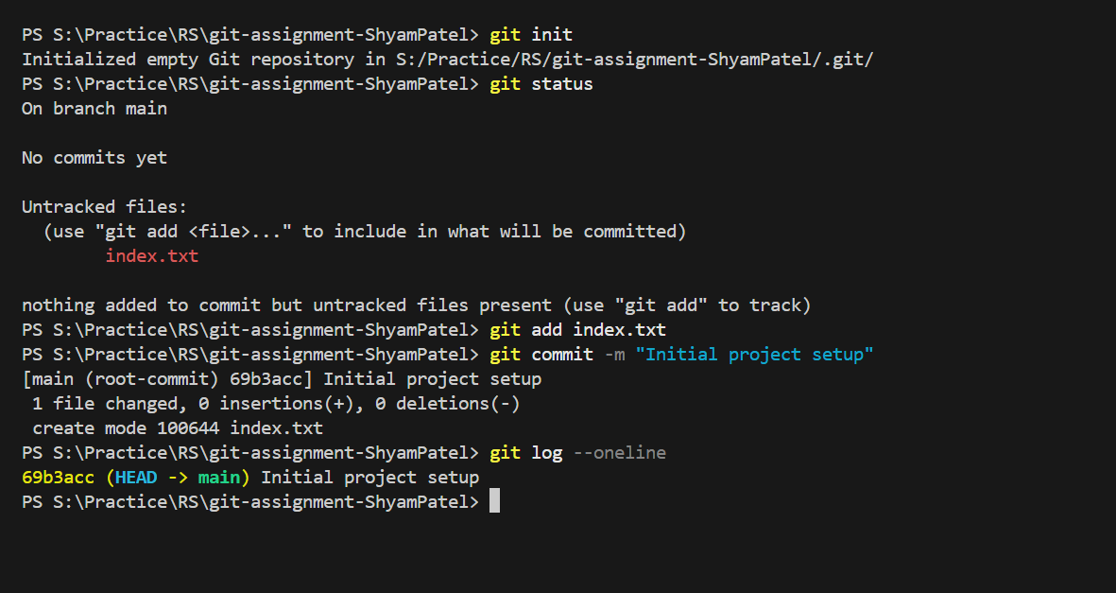

TASK 2: Branch Creation & Work
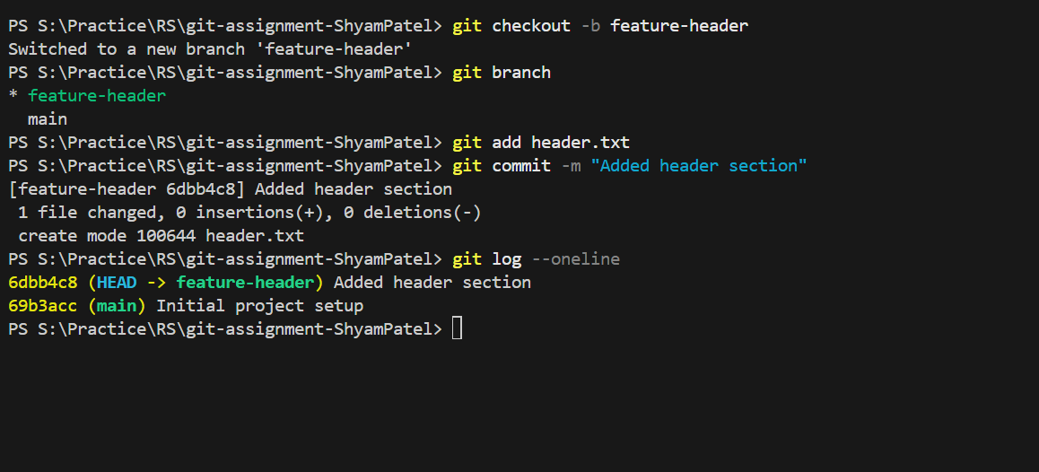

TASK 3: Branch Switching Observation

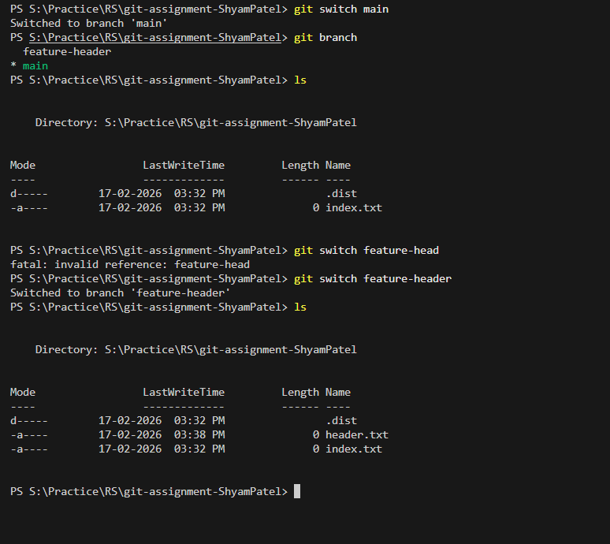

TASK 4: Undo a Mistake

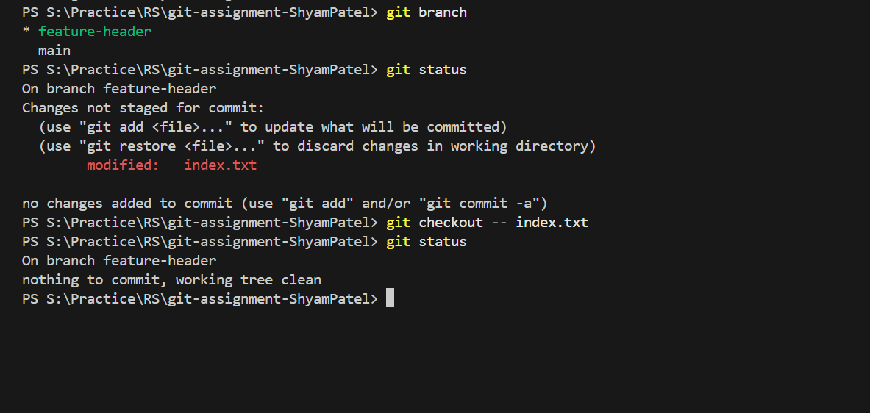

TASK 5: Merge Feature Branch

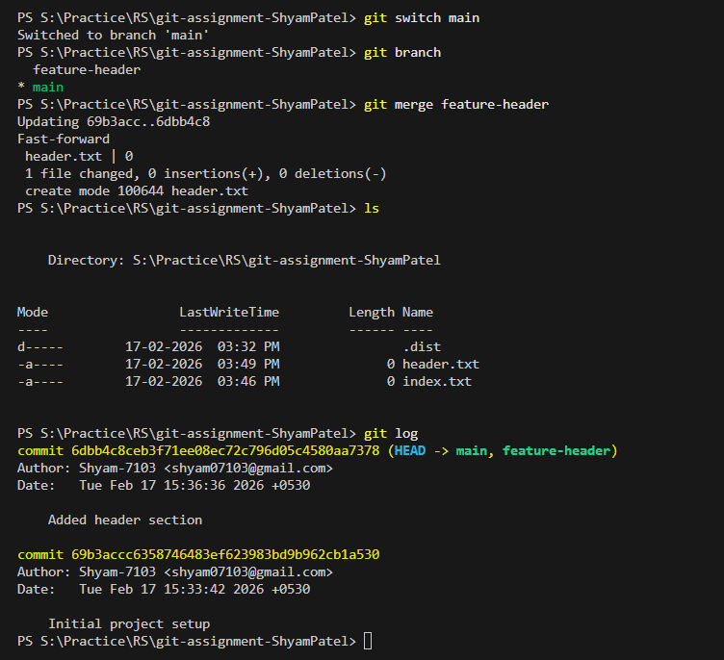

TASK 6: Checkout a Commit (Detached HEAD)

