GIT -Assignment-2
TASK 1: Local Repository Setup

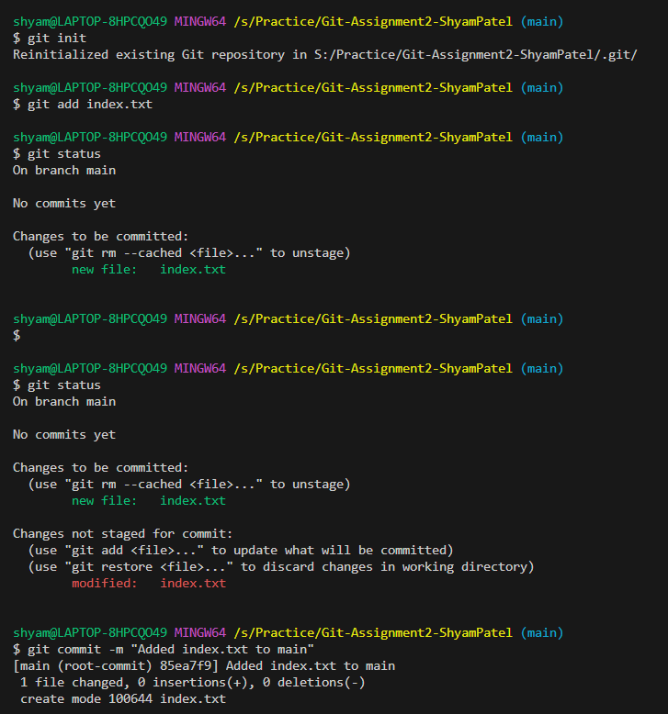

TASK 2: Remote Repository Creation
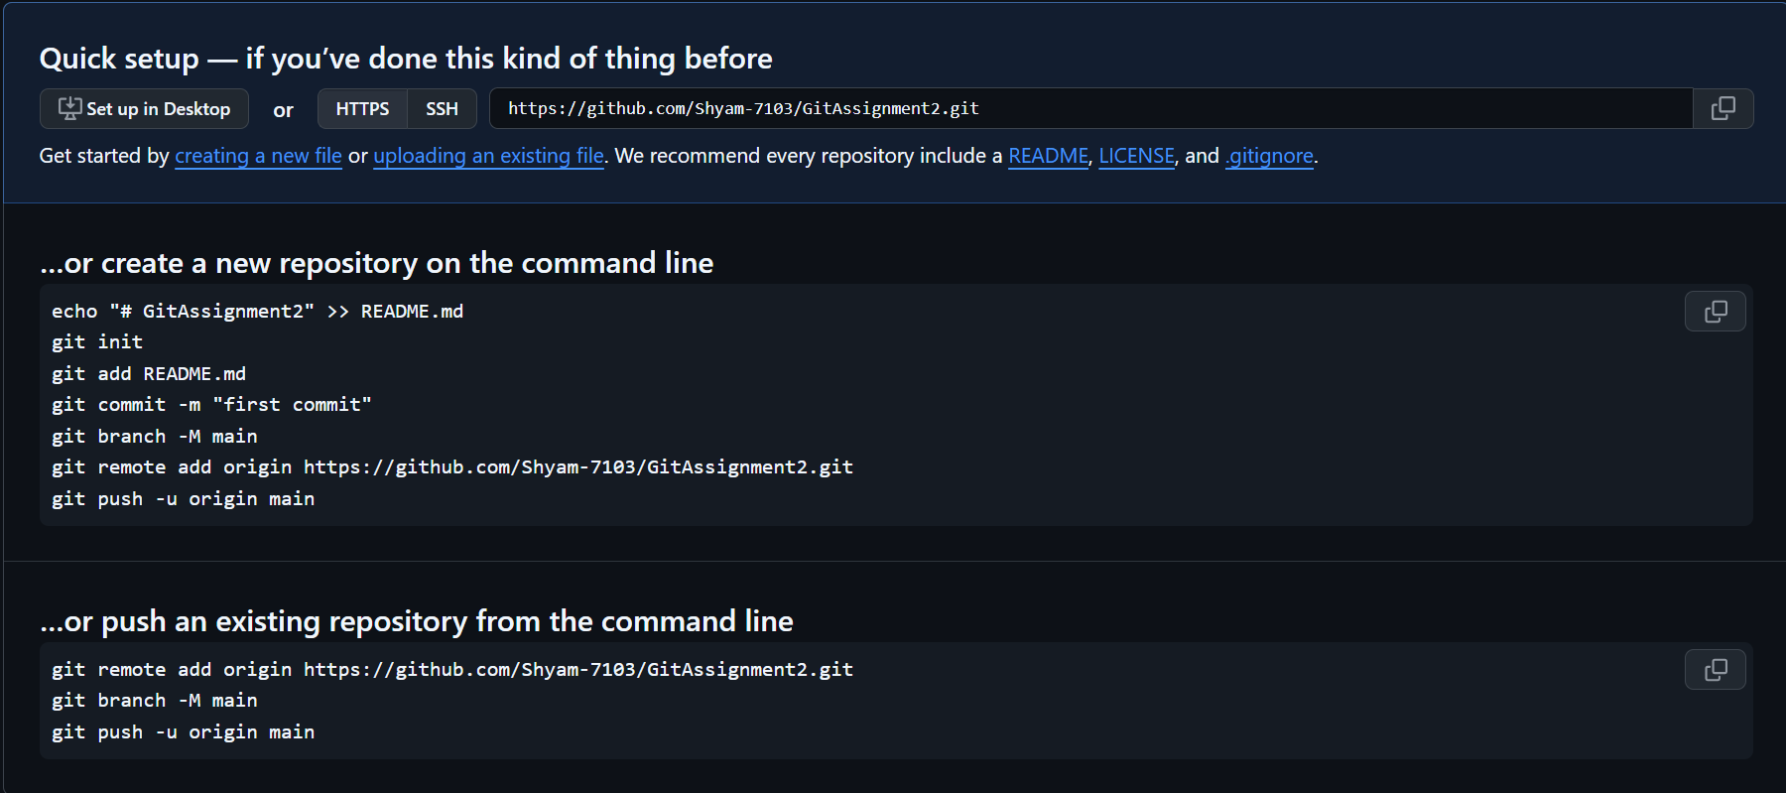

TASK 3: Connect Local Repository to Remote
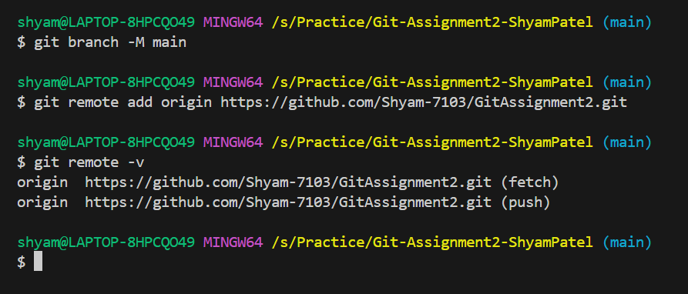

TASK 4: Push Local Changes to Remote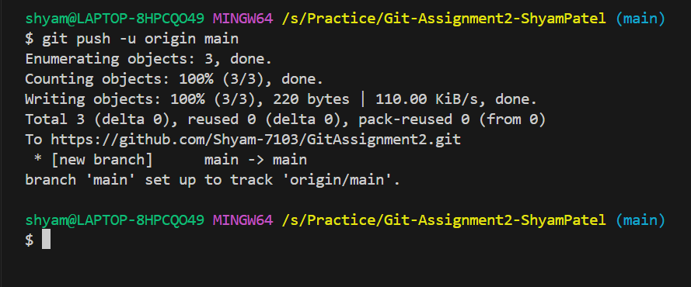

TASK 5: Branch Creation and Work
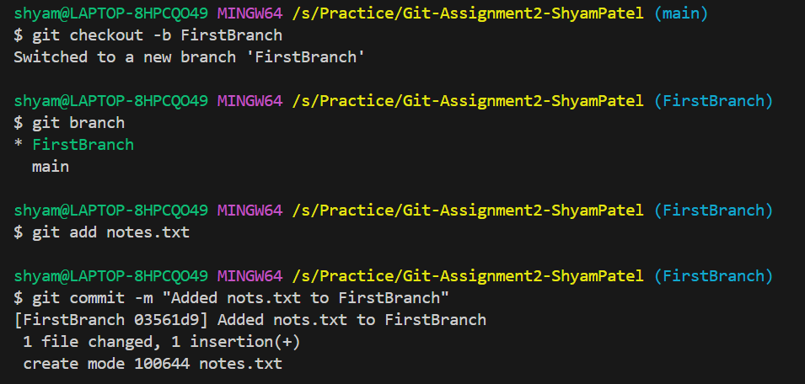

TASK 6: Merge Branch into Main
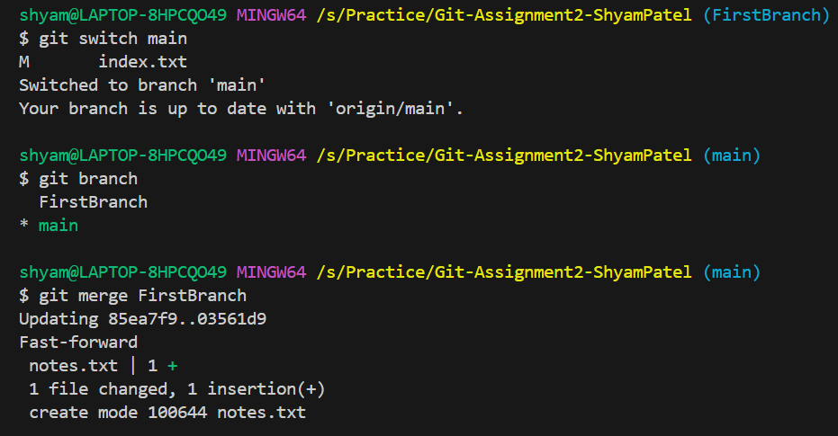

TASK 7 – Final Sync with Remote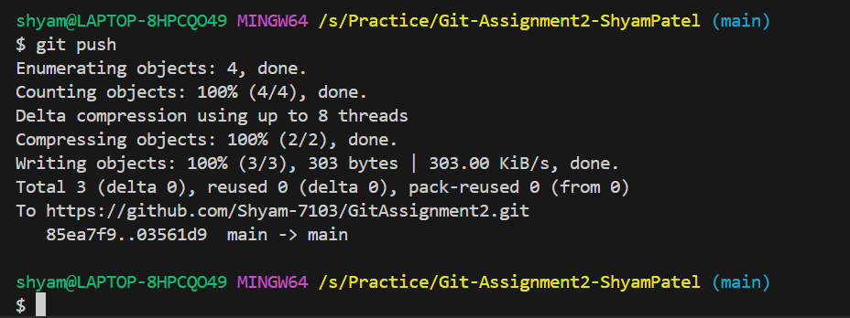

TASK 8 – Simple Pull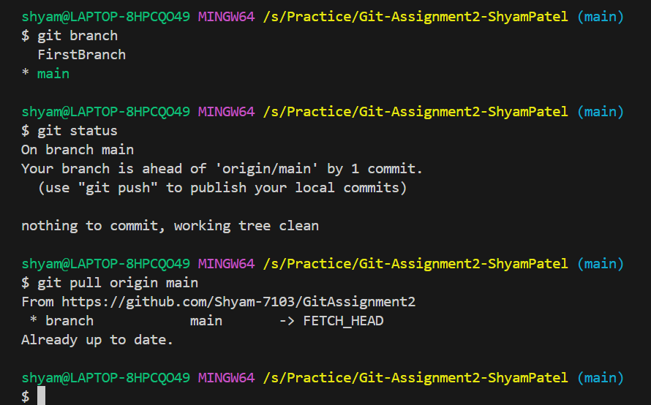

TASK 9 – Push and Pull with Conflict Resolution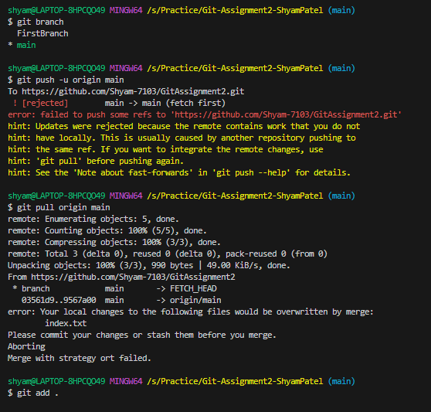

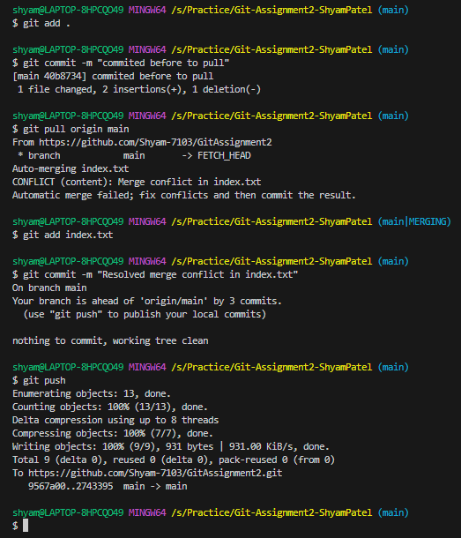

TASK 10 - Clone an Existing Repository
