Answer 1:

**Static:** "Static is the default position for HTML elements. Elements with **position: static** are positioned based on the normal flow of the page, as you would expect them to be without any CSS styling. They are not affected by the top, right, bottom, or left properties. Z-index also does not apply to static elements."

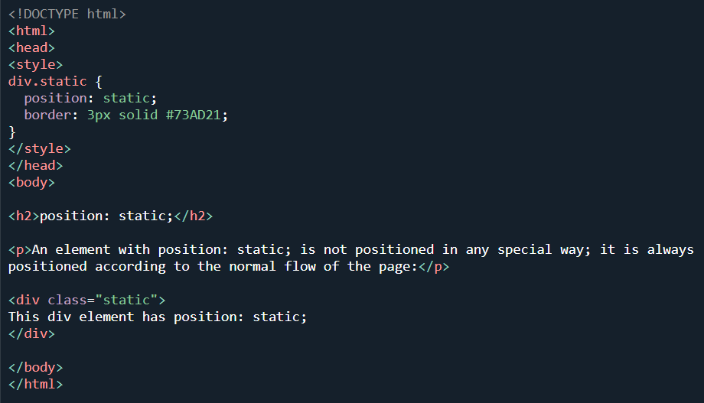

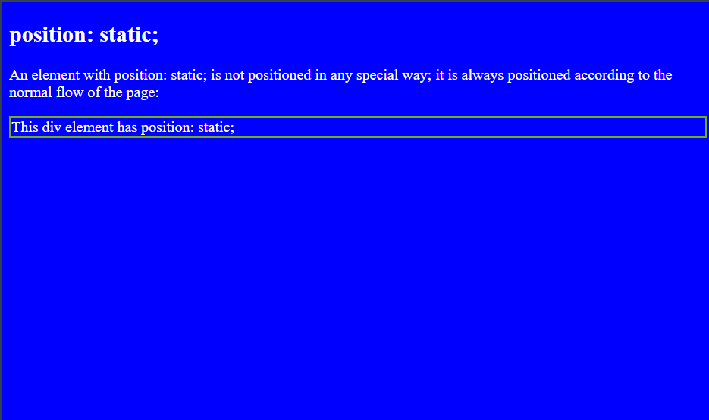

**Fixed:** A fixed position element is positioned relative to the viewport, or the browser window itself. The viewport doesn’t change when the window is scrolled, so a fixed positioned element will stay right where it is when the page is scrolled.

This might be used for something like a navigation bar that you want to remain visible at all times regardless of the pages scroll position.

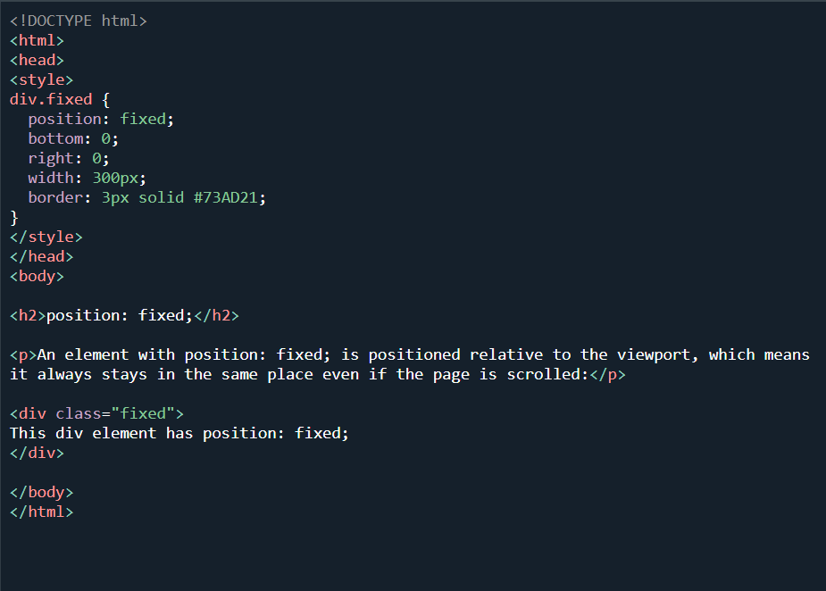

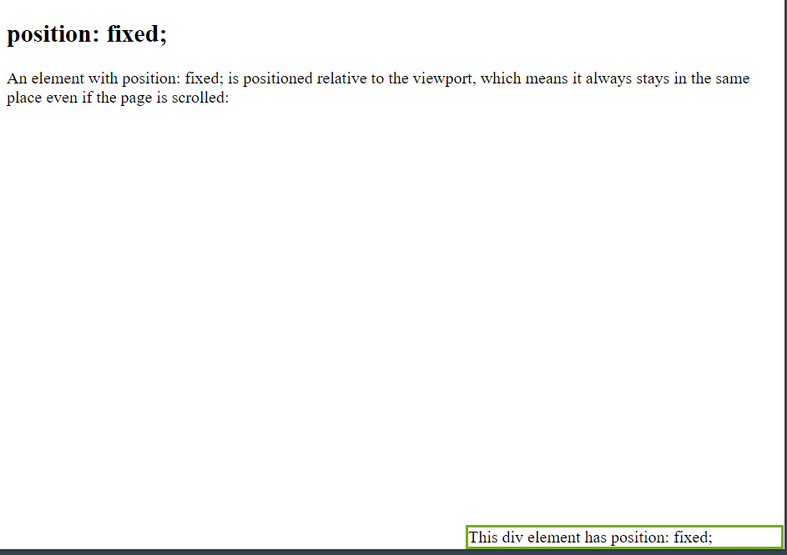

**Sticky:** The CSS position property is used to set the position for an element. It is also used to place an item behind another element and also useful for the scripted animation effect. The "position: sticky;" is used to position the element based on the scroll position of the user.

This CSS property allows the elements to stick when the scroll reaches to a certain point. Depends upon the scroll position, a sticky element toggles in between fixed and relative. The element will be positioned relative until the specified position of offset is met in the viewport. Then, similar to position: fixed, the element sticks in one place.

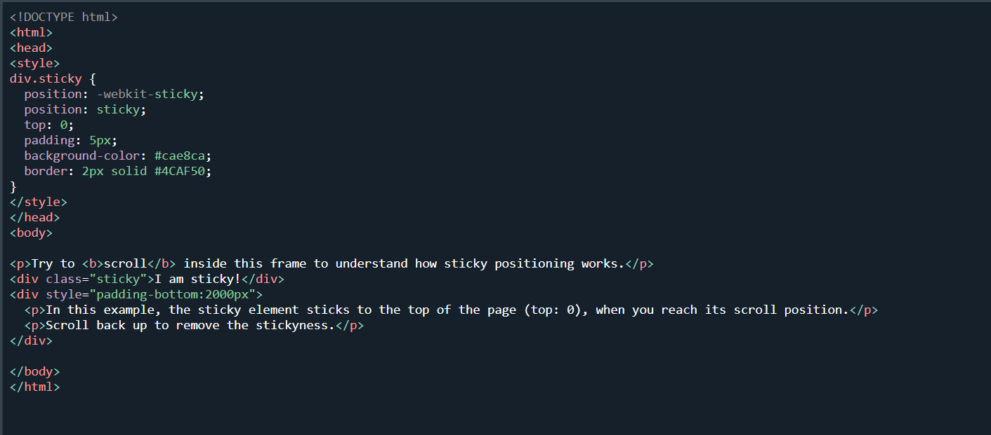

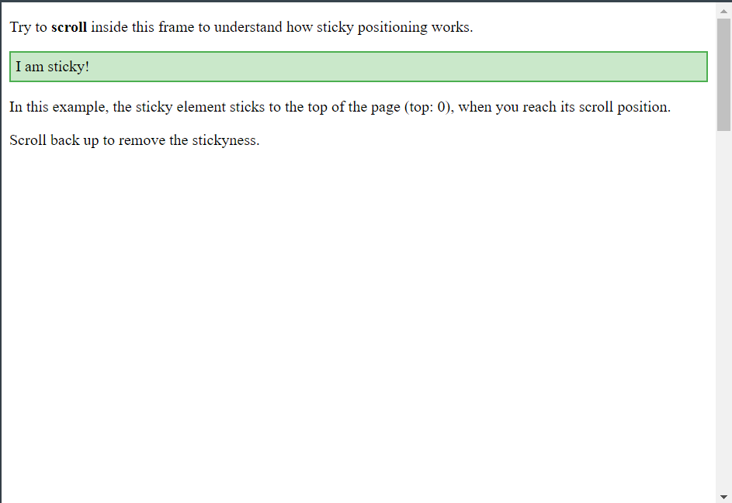

**Relative:** appears as the declared flow but can be repositioned with respect to the default position.

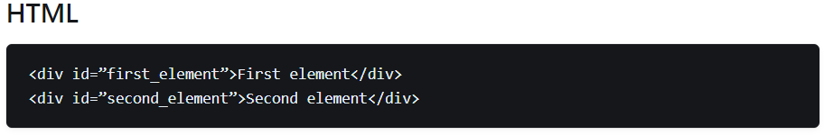

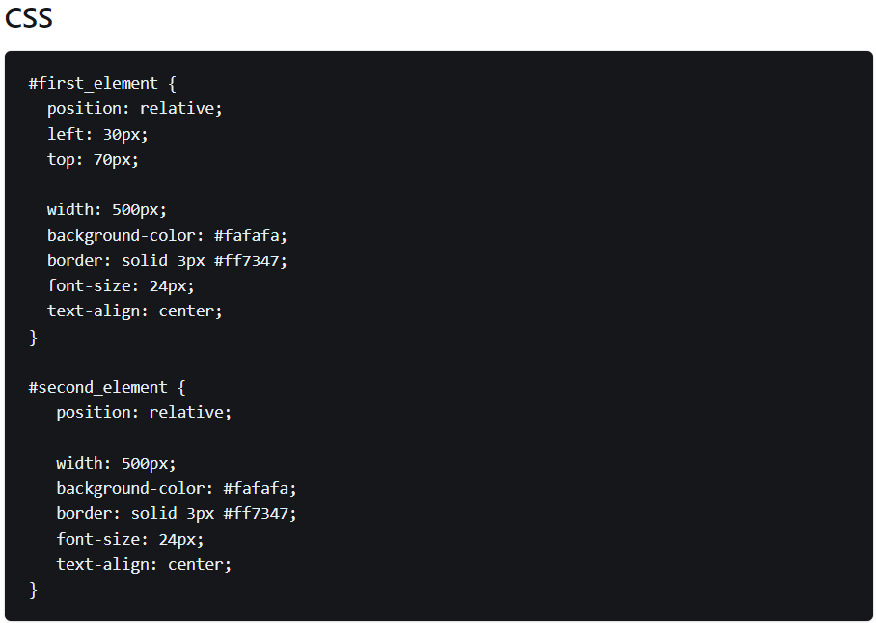

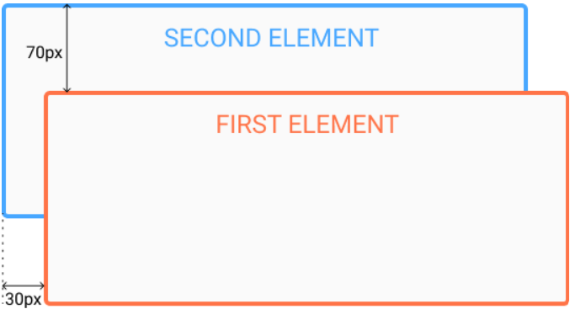

**Absolute:** leaves the flow, and another element occupies the default position. It can be repositioned with respect to the closest relative element if available; else, the viewport

