Here the outputs of the final result.

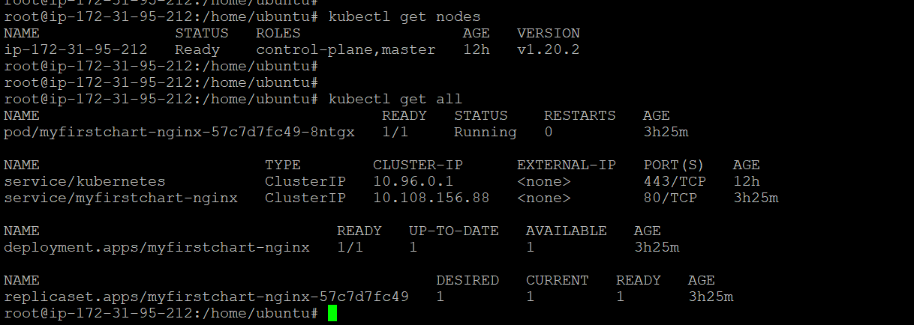

Some snippets during Jenkins pipeline creation.

