SQL Data Script Generator
Purpose:
Provide QA engineers with SQL scripts containing existing and synthesized sample data without altering source databases.
Generate realistic INSERT scripts for selected SQL Server tables and seeding empty tables with synthetic sample rows to support test data setup, and dependency-aware export ordering.
Key Functional Features:
- Server/Database Discovery
- Windows integrated security connection to a specified SQL Server instance.
- Lists online databases. Inline search/filter. Displays canonical database name (strips version prefix patterns).
- Table Loading & Display
- Retrieves table list with per-table row counts (via sys.tables + sys.partitions).
- Optional schema filter combobox.
- Bulk select / clear all tables.
- Dependency Ordering
- Builds ordering using:
- a) Saved manual/global relationships (parent → child).
- b) Inferred column dependency hints (column name reuse logic) only for ordering, not auto-inclusion of parents.
- Topological sort ensures parents appear before dependent children in export.
- Relationship Management
- Add ForeignKeys dialog: define Parent/Child table + columns + relationship type (One-to-One, One-to-Many, etc.).
- Suggested ForeignKeys dialog: scans int/bigint columns with identical names across different tables, prechecks existing saved relationships, lets user select new ones.
- FK Graph view: visual directed graph of native foreign keys plus manual relationships (manual edges dashed).
- Global relationship persistence per canonical database plus shared “GLOBAL” entries in a single JSON file.
- Sample Data Generation
- For empty selected tables: creates synthetic rows (default 10 unless using First/Last modes with a limit).
- Skips identity, computed, timestamp/rowversion columns and “system-like” names (id, iid, rowversion, description, etc.).
- Generates type-appropriate literals (GUIDs, incremental ints, decimal patterns, timestamps, truncated text).
- Export Script Generation
- Modes: All Data, FirstN (First10/100/1000), LastN (Last10/100/1000).
- For First/Last modes applies LIMIT logic using TOP or ROW_NUMBER window.
- Each row emitted as a standalone INSERT with a blank line after it for readability.
- Sample rows emitted first (if generated), then real data rows.
- Properly quoted identifiers ([schema].[table]) and value literal formatting (strings escaped, binary → hex, DateTime precise, GUID, numeric invariant culture).
- Progress UI with percentage and per-table status.
- Automatic Parent Inclusion Prompt
- Before export, prompts to include any missing parent tables referenced in saved relationships (inferred dependencies excluded per recent change).
- If approved, auto-adds those tables and checks them in the UI.

Typical Workflow:
- Enter server, connect.
- Select database; optionally filter by schema.
- (Optional) Manage or Suggest ForeignKeys; save relationships.
- Select tables (or rely on auto-add parents when prompted at export).
- Choose rows mode.
- Click Export; review prompt for missing parents.
- Inspect output folder: individual .sql files.

Technical Architecture: Platform: .NET 8, C# 12, Windows Forms (desktop). Primary Components:
- MainForm: orchestrates UI, state, DB interactions.
- Models: GlobalRelationship (manual FK metadata), TableEntry, ForeignKeyEdge, ExportResult. Persistence:
- Relationships stored in single JSON file (_GlobalRelationships.json) in application base directory.
- Case-insensitive matching for canonical database grouping and “GLOBAL” fallback. Database Interaction:
- Uses Microsoft.Data.SqlClient.
- MultipleActiveResultSets enabled for flexibility.
- System catalogs (sys.tables, sys.schemas, sys.columns, sys.types, sys.partitions, sys.foreign_keys, sys.foreign_key_columns) for metadata & FK discovery. Dependency Inference Logic:
- Reuses first owner of a non-ignored column name across tables to infer possible parent-child relationships.
- Filters columns by name patterns and type restrictions; excludes identity/computed/timestamp. Ordering Algorithm:
- Builds edge list for FK-Graph from saved relationships + inferred column ownership edges.

Error Handling & Resilience:
- Most DB and file operations wrapped in try/catch with silent fallback where non-fatal.
- User-facing MessageBox only for actionable failures (connect, export, inference, graph build).

Performance Considerations:
- Streaming data export via SqlDataReader sequential access.
- Avoids loading entire result sets in memory.
- Simple per-row StringBuilder assembly for INSERT lines.

Security Notes:
- Uses Integrated Security & TrustServerCertificate=true (appropriate for internal environments; review for production hardening).
- No user-supplied SQL concatenation besides trusted catalog names; identifiers quoted.

Known Limitations / Trade-offs:
- Does not generate DELETE/TRUNCATE preamble or constraint disabling.
- Does not validate referential integrity of generated sample rows.
- Inferred dependencies rely only on repeating column names and only with int/long type analysis.

Next Steps / Extensibility Ideas:
- Creating real time synthetic data for empty tables by seeding the mock data from the existing databases.
- Add multiple DB support

Disclaimer:
Generated sample data is simplistic and intended for functional only, not for performance or production seeding.
Working screenshots:
1. Connect to the Server and load all databases, select any db and load all the tables with the records count.
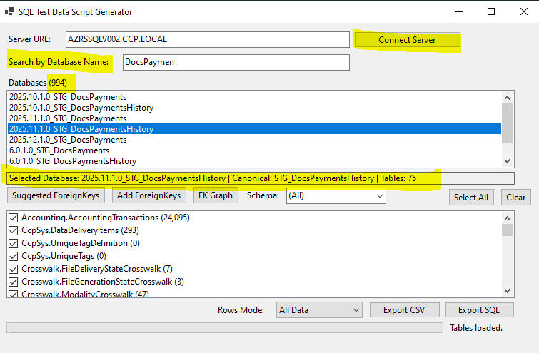
2. Click on Suggested FK button and see all the suggested relationships after analyzing the common columns from table to table. Click check box and save if those tables require the relation.
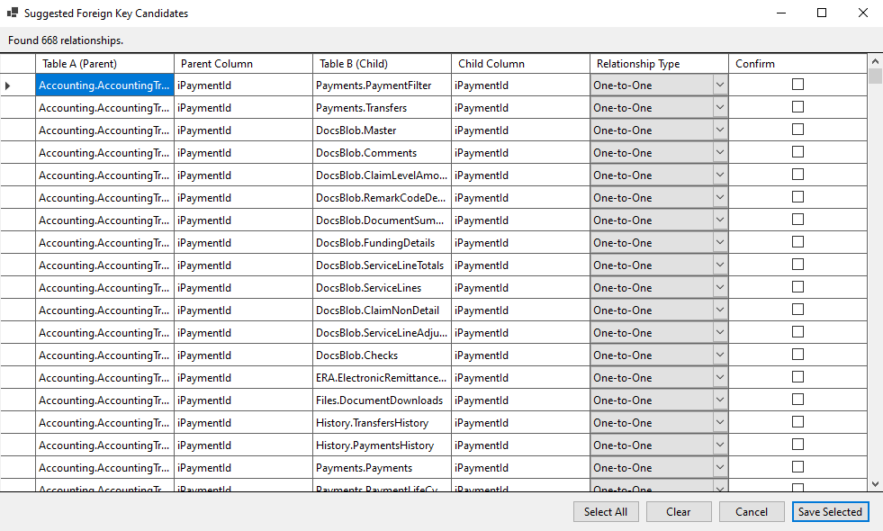
3. Click on Add ForeignKeys button to add the FK manually by table by table.
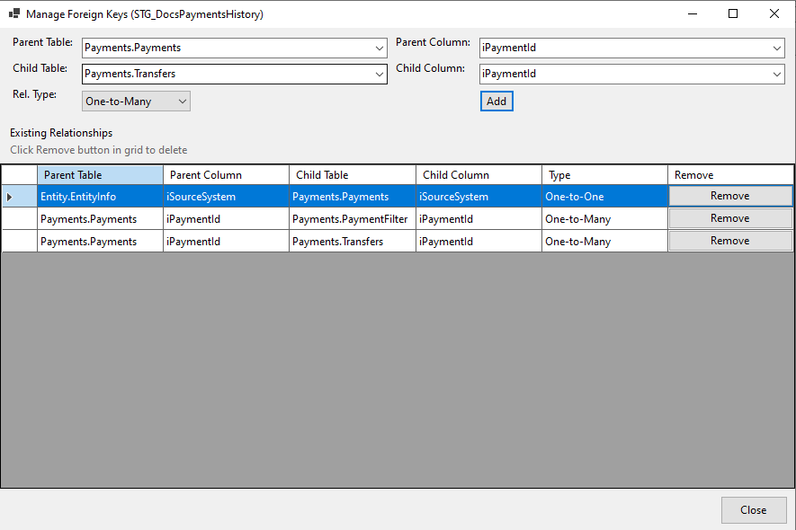
4. Click on FKGraph – to see the Foreign Key graph between the tables.
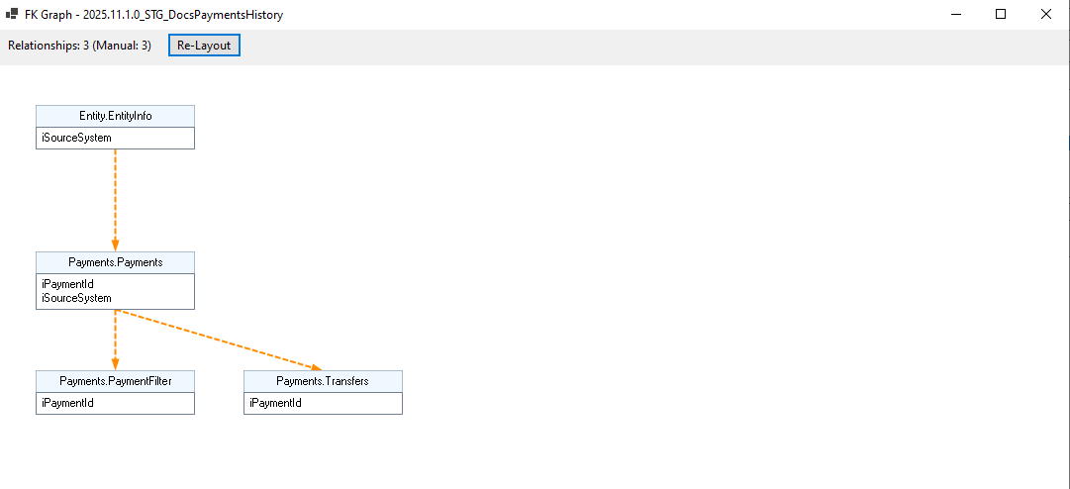
5. Filter by Schema and Select the required tables for the export. Click Select all to select all the tables or click on Clear button to uncheck all the tables
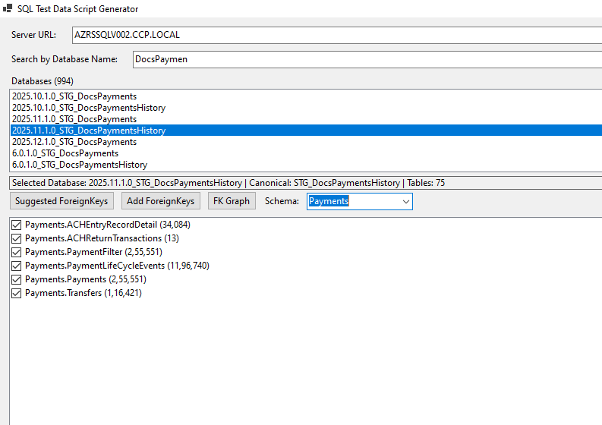
6. Select Rows Mode , Click on Export CSV to export it in in the excel / CSV. Click on Export SQL to export it as the .SQL files with all the INSERT statements.
