**Work Status Roster**

Requirements:

1. Roster presently maintained in Excel to be migrated to a web-based dashboard (Full-Stack app)
2. Dashboard shall authenticate users attesting to profiles in the database.
   1. Dashboard view defaults to user’s cluster.
   2. User able to modify status for members of their cluster only.
   3. Log maintenance is made possible.
3. Dashboard shall allow users to update status for a given date (s) for self or anybody belonging to the same cluster.
   1. Status is set by default to General Shift for all working days.
4. Dashboard shall be open to future extensions.

Prospects:

1. Roster functions with SAP SSO instead of user login. (Vengad says will reject and costly)
2. Once leave applied for and approved, Roster automatically updates. (API access not allowed)
3. Access Control? (Where and how?)
4. Analytics (What kind?)
5. Beyond DLM?

Features:

1. Defaults – User’s cluster view, User’s ID in Add Status Form, Present month in dashboard.
2. Infinite scroll left and right (months).
3. Simple 4-digit pin instead of long password.
4. Logs visible only of user’s cluster.
5. Documentation.

Notes:

1. Admin role and normal role.
2. Separate tabs for managers.
3. Display public holidays - fetch from table.
4. Select multiple employees in add status form.
5. Calendar weeks select - need not be continuous.
6. Search/Filter logs.

Design: 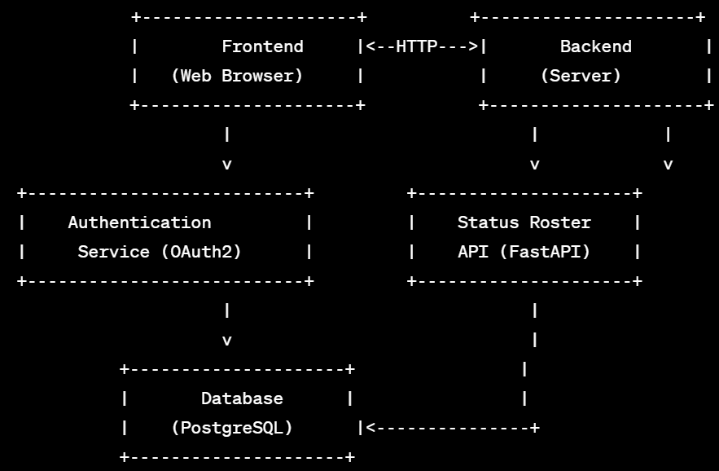

Wireframe:

1. Dashboard

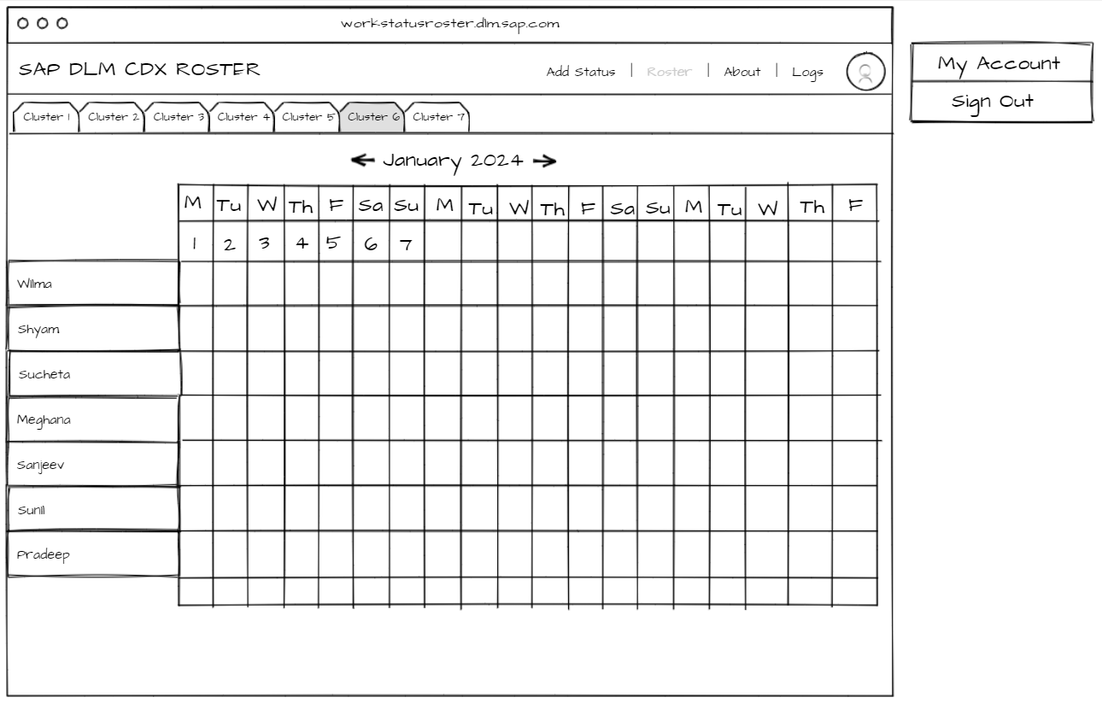

1. Forms

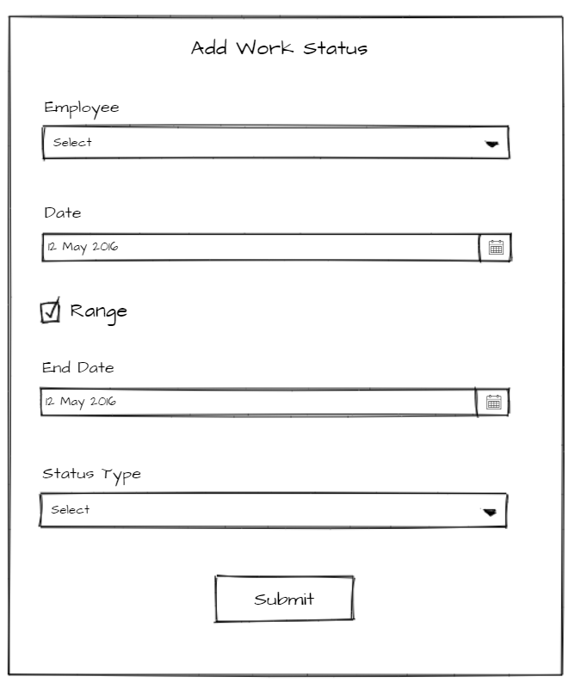

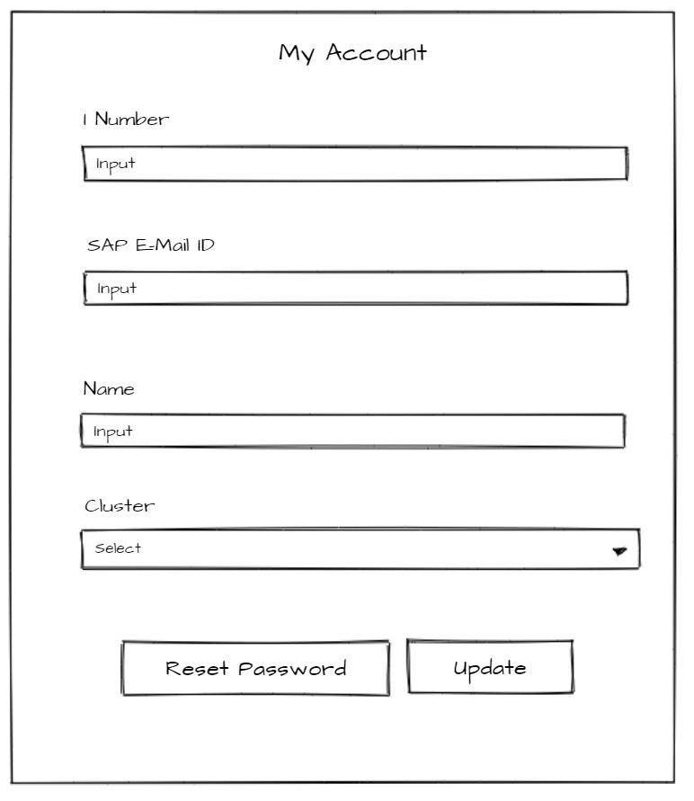

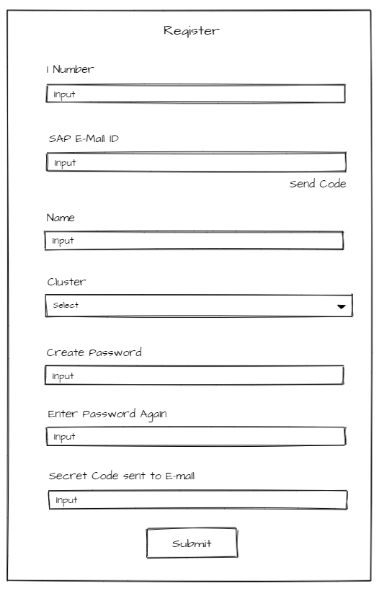

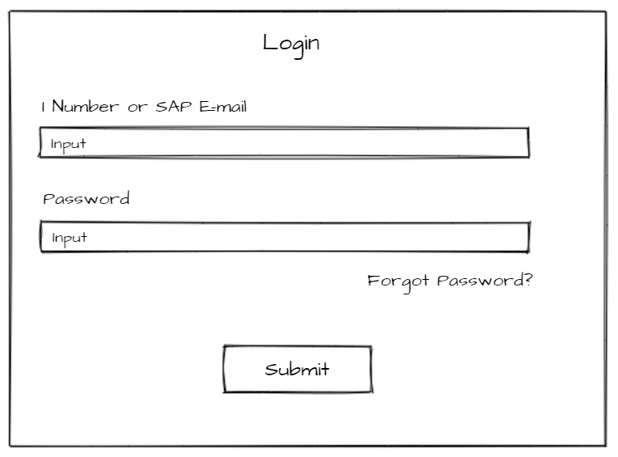

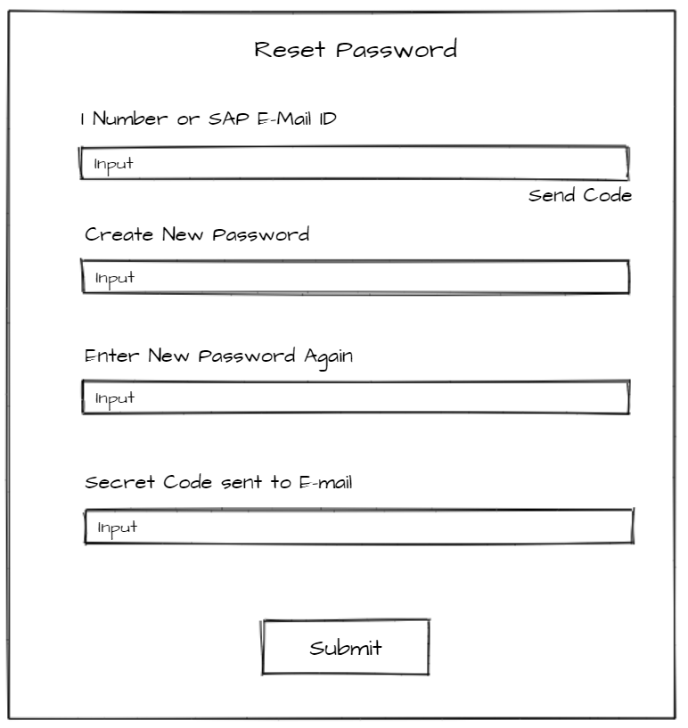

1. Logs (How to display?)
2. About (Where to have index of status types?)

Database

| **Table Name** | **Fields** | **Description** |
| --- | --- | --- |
| Teams | team_id (PK), team_name, description, creation_date | Stores information about teams. |
| Employees | employee_id (PK), team_id (FK), employee_name, sap_id, ...additional employee details | Stores information about individual employees. |
| UserProfiles | user_id (PK), employee_id (FK), username (SAP ID), password, email, role, creation_date | Stores user profiles for authentication. |
| StatusRoster | roster_id (PK), employee_id (FK), status_date, status_type_id (FK), comments, ...additional status details | Records the status of each employee for each date. |
| StatusTypes | status_type_id (PK), status_name | Stores predefined status types. |
| PasswordResetCodes | reset_code_id (PK), user_id (FK), code, expiration_time | Stores password reset codes. |
| Logs | log_id (PK), user_id (FK), action_type, action_timestamp, details | Logs changes made to the status roster. |

API Endpoints

| **Endpoint** | **HTTP Method** | **Description** |
| --- | --- | --- |
| **/api/register** | POST | Allows a user to register by providing SAP ID, name, team, and setting a password. |
| **/api/login** | POST | Authenticates a user and returns an access token for subsequent requests. |
| **/api/status/update** | POST | Allows a user to update their own status or another team member's status for a specified date or date range. |
| **/api/status/view** | GET | Retrieves the status for a specific date range. |
| **/api/logs** | GET | Retrieves logs of edits for the logged-in user's team. |
| **/api/team/members** | GET | Retrieves a list of team members for a given team. |
| **/api/user/profile** | GET, PATCH | GET: Retrieves the user profile information for the currently logged-in user. PATCH: Updates the user's name or password. |
| **/api/logout** | POST | Logs out the user from the application. |
| **/api/forgot-password** | POST | Initiates the 'Forgot Password' process by sending a one-time code to the user's email. |
| **/api/reset-password** | POST | Resets the user's password based on the provided one-time code. |

Tech

1. SAP Build Apps
2. FastAPI
3. PostreSQL
4. SQLAlchemy
5. Python

Documentation

Style?