**Data Cleaning:**

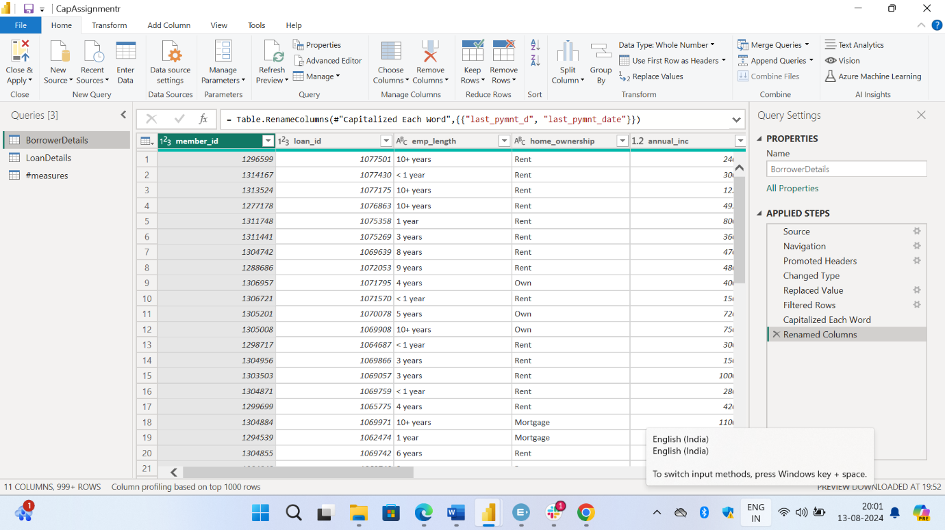

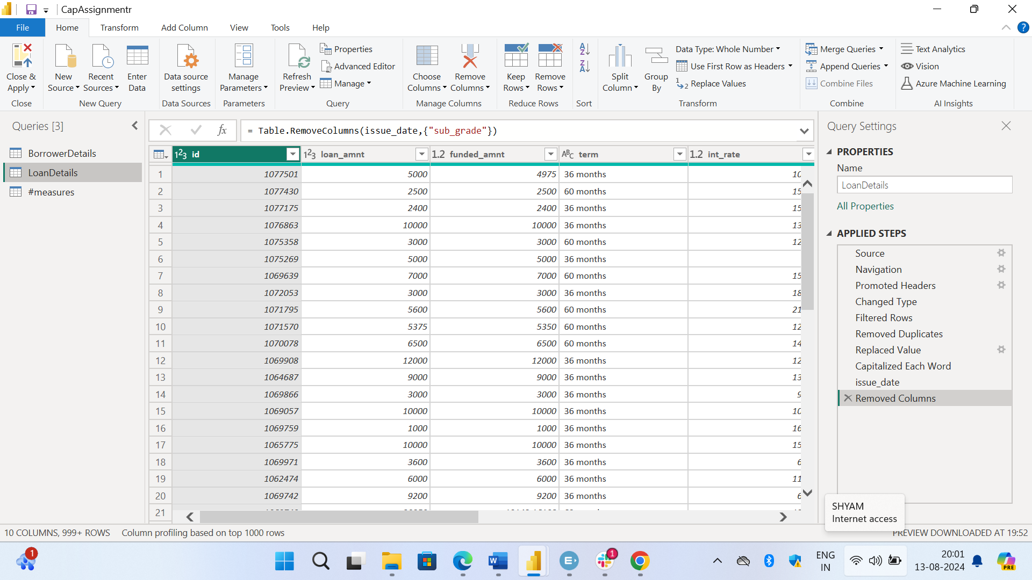

**Data Transformation:**

**Creating New Columns:**

1. total_amount_paid = BorrowerDetails[total_pymnt] - BorrowerDetails[out_prncp]
2. delinquency_status = if(BorrowerDetails[delinq_2yrs]> 0,"Delinquent","Not Delinquent")

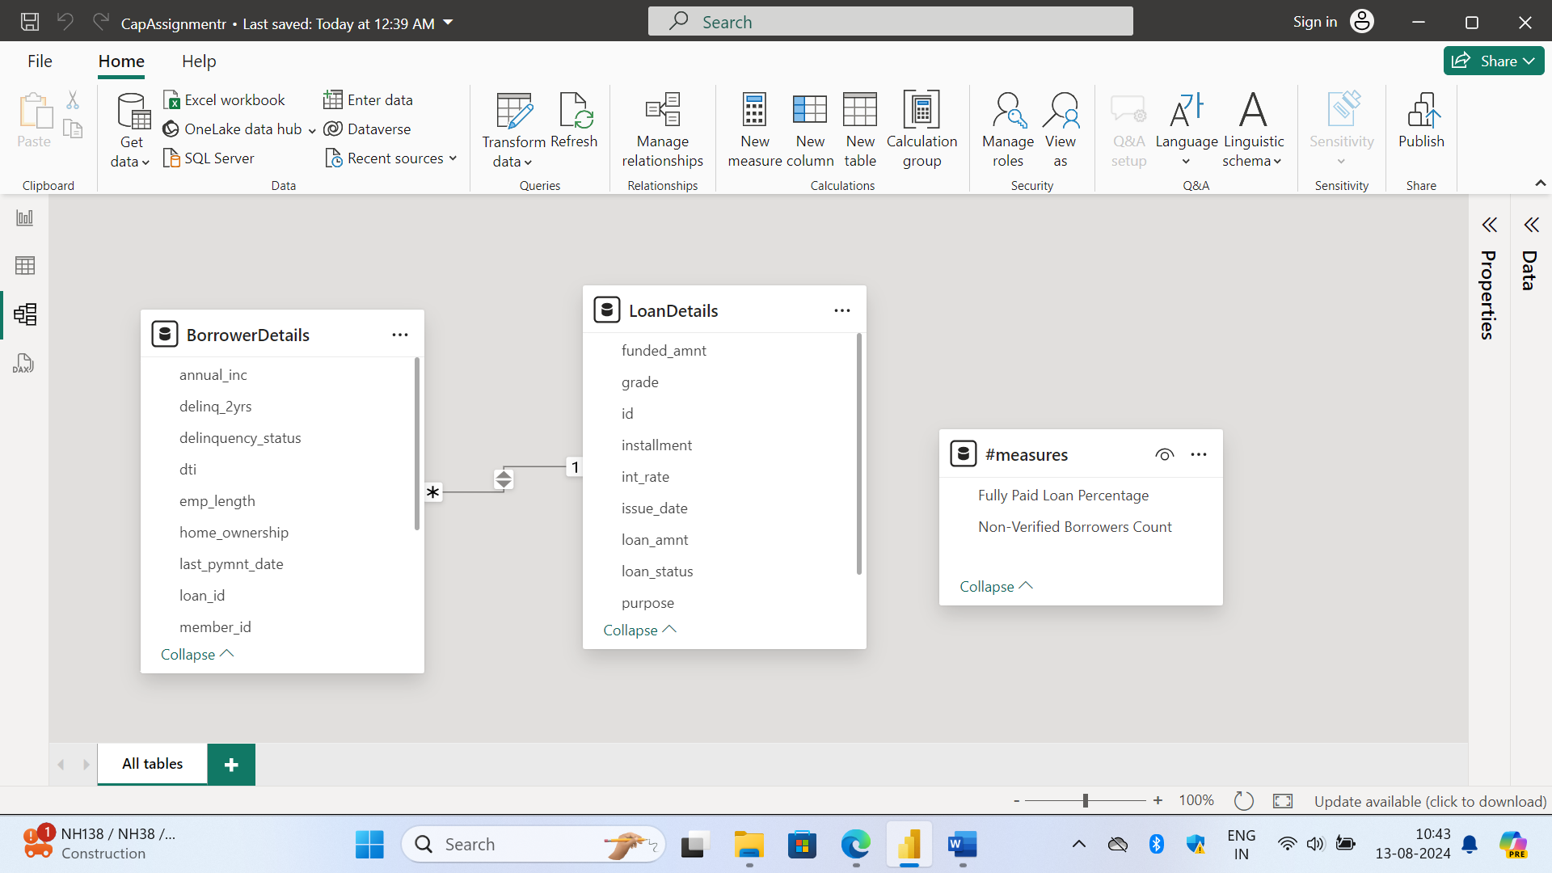**Data Modeling:**

**Creating Measures and Calculated Columns using DAX:**

1. remaining_installments = CEILING((BorrowerDetails[out_prncp] / RELATED(LoanDetails[installment])),1)
2. Non-Verified Borrowers Count = COUNTROWS(FILTER(BorrowerDetails,BorrowerDetails[verification_status]="Not Verified"))
3. Fully Paid Loan Percentage = DIVIDE(COUNTROWS(FILTER(LoanDetails,LoanDetails[loan_status]="Fully Paid")),COUNTROWS(LoanDetails))

**Creating Comprehensive Reports:**

**Report 1: Loan Performance Analysis**

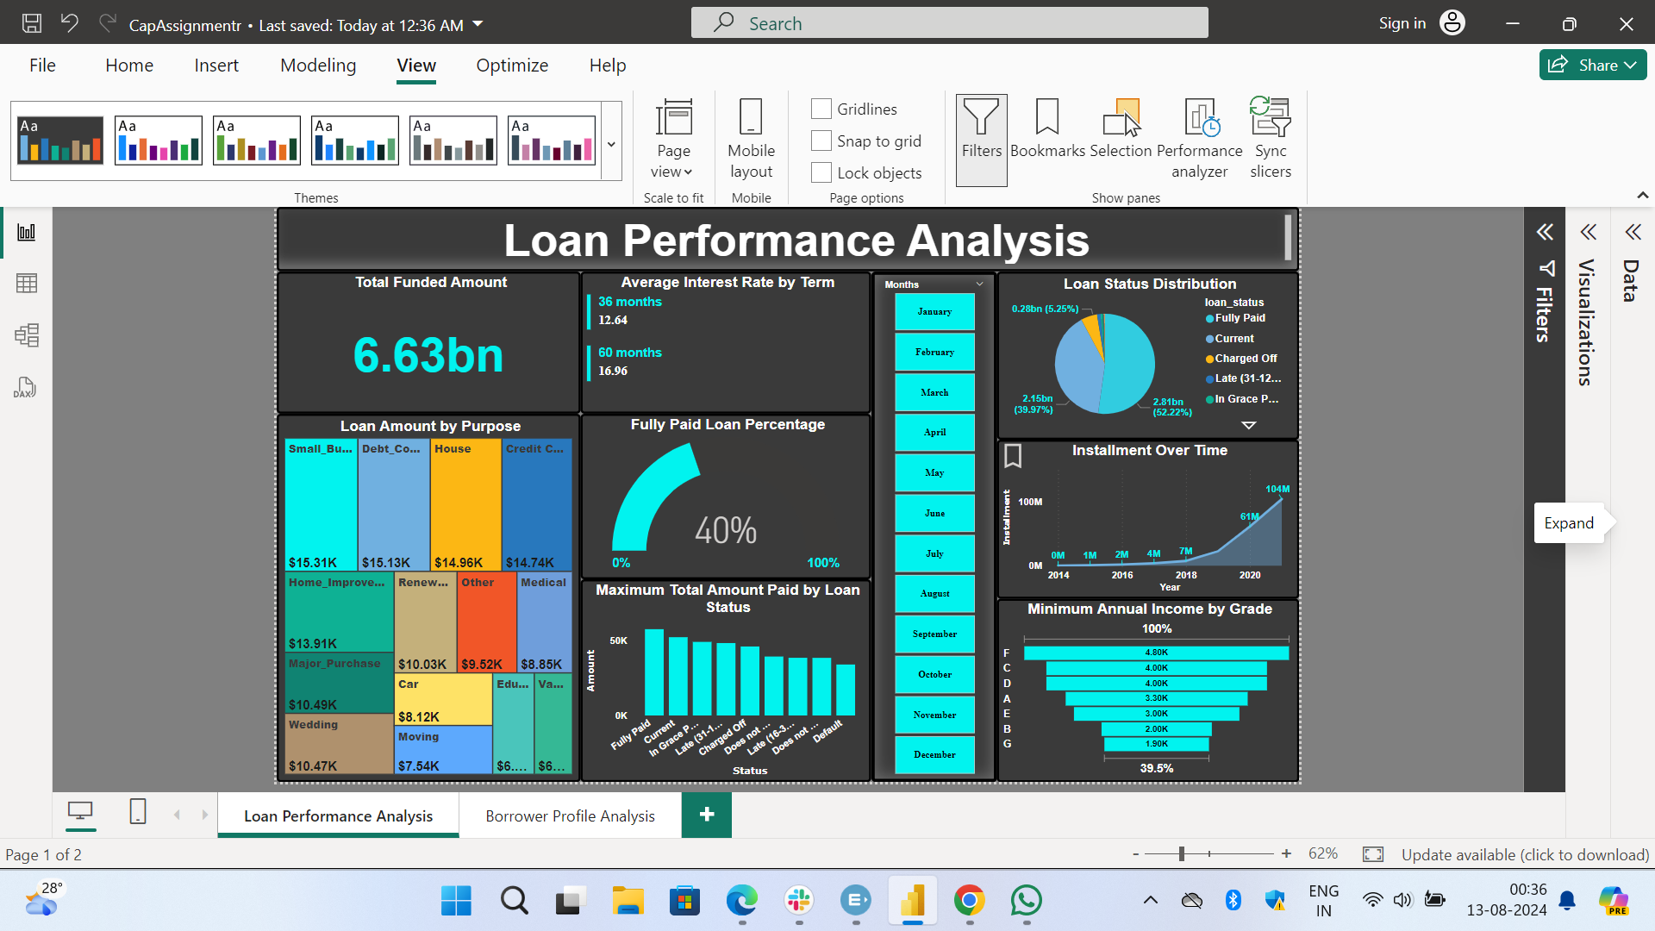

**Report 2: Borrower Profile Analysis:**

