HTML - HTML stands for Hypertext Markup Language.It is the standard markup language used to create web pages.

Structure of HTML:

<!Doctype html>
<html>
<head>
<title>........</title>
<link>
<style>.......</style>
</head>
<body>
.
.
</body>
</html>

Note: Always save your html file with .html extension.

- The<!DOCTYPE html>declaration defines this document to be HTML5
- The <html>element is the root element of an HTML page
- The <head> element contains meta information about the document
- The <title> element specifies a title for the document
- The <body> element specifies the content which will display on the screen

Example..
<!Doctype html>
<html>
<head><title>My Page</title></head>
<body>
My First Page
</body>
</html>

CSS – CSS stands for Cascading Style Sheets. Cascading Style Sheets (CSS) is a stylesheet language used to describe the presentation of a document written in HTML.

CSS Style Rule:

Selector {
property1 : value1 ; property2 : value2;
}

For Class Selector

.class{
property: value;
}

For ID Selector

#id{
property: value;
}

For Element Selector

element{
property:value;
}

Note: Here element can be any HTML tag element such as body, p, hr, b etc..
All css files are saved using .css extension

Example..

body{
text-align: center;
color: blue;
font-size: 20px;
}
Types Of CSS Declarations

For Inline

<element style=“property: value; ”>

For Internal

<style>
Selector {
property : value;
}
</style>

For External

Selector {
property:value;
}

Note: Using external css you have to add link of your css in your attached html file.

<head>
<link rel=”stylesheet” href=”css file path” >
</head>

Note: css file path represents the path of your css file in your system.
For eg.. <link rel=”stylesheet” href=”your filename.css”>

Note: your file name is the name of your file.

960 Grid System- The 960 Grid System is simply a way to lay out websites using a grid that is 960 pixels wide.

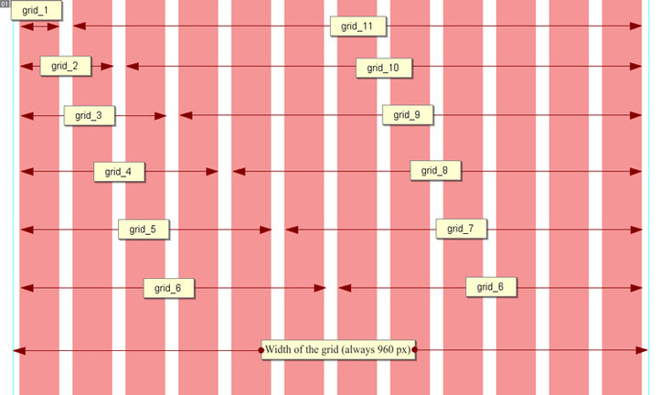

Example..

<div class=”container_12”>
<div class=”grid_4”>
<p>Column 1</p>
</div>
<div class=”grid_4”>
<p>Column 2</p>
</div>
<div class=”grid_4”>
<p>Column 3</p>
</div>
</div>

