**ONLINE AUCTION SYSTEM**

**MAJOR PROJECT REPORT**

Submitted by

**SHYAM SUNDAR S**

**17BCT046**

Under the Guidance of

**Mrs. Sridevi V** MCA, M.Phil., NET, SET

Assistant Professor

Department of Computer Technology

In partial fulfillment of the requirements for the award of the degree of

**BACHELOR OF SCIENCE IN COMPUTER TECHNOLOGY**

Of Bharathiar University





**DEPARTMENT OF COMPUTER TECHNOLOGY**

**PSG COLLEGE OF ARTS & SCIENCE**

An Autonomous College-Affiliated to Bharathiar University

Accredited with ‘A’ grade by NAAC (3rd Cycle)

College with Potential for Excellence

(Status Awarded by the UGC)

Star College Status Awarded by DBT - MST

An ISO 9001:2015 Certified Institution

Coimbatore -641 014

**APRIL 2020**

**DEPARTMENT OF COMPUTER TECHNOLOGY**

**PSG COLLEGE OF ARTS & SCIENCE**

An Autonomous College-Affiliated to Bharathiar University

Accredited with A grade by NAAC (3rd Cycle)

College with Potential for Excellence

(Status Awarded by the UGC)

Star College Status Awarded by DBT - MST

An ISO 9001:2015 Certified Institution

Civil Aerodrome Post

Coimbatore -641 014

**CERTIFICATE**

This is to certify that this Project work entitled **“ONLINE AUCTION SYSTEM”** is a bonafide record of work done by **SHYAM SUNDAR S (17BCT046)** in partial fulfillment of the requirements for the award of Degree of **Bachelor of Science in Computer Technology** of Bharathiar University.

Faculty Guide Head of the Department

###### Submitted for Viva-Voce Examination held on ____________________

Internal Examiner External Examiner

**DECLARATION**

I, **SHYAM SUNDAR S (17BCT046)** hereby declare that this Project work entitled **“ONLINE AUCTION SYSTEM”**, is submitted to PSG College of Arts & Science (Autonomous), Coimbatore in partial fulfillment for the award of Bachelor of Science in Computer Technology, is a record of original work done by me under the supervision and guidance of **Mrs. Sridevi V** MCA, M.Phil., NET, SET Assistant Professor in Department of Computer Technology, PSG College of Arts & Science, Coimbatore.

This Project work has not been submitted by me for the award of any other Degree/ Diploma/ Associate ship/ Fellowship or any other similar degree to any other university.

PLACE : Coimbatore **SHYAM SUNDAR S**

DATE : **17BCT046**

**ACKNOWLEDGEMENT**

My venture stands imperfect without dedicating my gratitude to a few people who have contributed a lot towards the victorious completion for my project work.

I would like to thank **Mr. L. Gopalakrishnan**, **Managing Trustee, PSG & Sons Charities**, for providing me a prospect and surroundings that made the work possible.

I take this opportunity to express my deep sense of gratitude to **Dr. T. Kannaian,** Secretary of PSG College of Arts and Science, Coimbatore for permitting and doing the needful towards the successful completion of this project.

I express my deep sense of gratitude and sincere thanks to our Principal **Dr. D. Brindha MSc, MPhil, PhD,** for her valuable advice and concern on students.

I am very thankful to **Dr. A Anguraj, MSc, MPhil, PhD, Vice Principal**, **Prof. M Umarani, MCom, MPhil, Faculty-In-Charge (Student Affairs)** for their support.

I kindly and sincerely thank **Dr. S. Geetharani MCA, MPhil, PhD, Head of the**

**Department of Computer Technology** for her whole hearted help to complete this project successfully by giving valuable suggestions.

I convey my heartiest and passionate sense of thankfulness to my project guide **Mrs. Sridevi V** MCA, M.Phil., NET, SET Assistant Professor, Department of Computer Technology, for her timely suggestion which had enable me in completing the project successfully.

This note of acknowledgement will be incomplete without paying my heartful devotion to my parents, my friends and other people, for their blessings, encouragement, financial support and the patience, without which it would have been impossible for me to complete the job.

**SYNOPSIS**

Auctionsare among the oldest economic institutions in place and they are still in use. In this dissertation, we explore the efficiency of common auctions when values are interdependent. The value to a particular bidder may depend on information available only to others and asymmetric. In this setting, it is well known that sealed-bid auctions do not achieve efficient allocations in general since they do not allow the information held by different bidders to be shared. With the point and click of the mouse, one may bid on an item they may need or just want, and in moments they find that either they are the top bidder or someone else wants it more, and you’re outbid! , while meeting the needs of its users.

**Online Auction System** project is used to bid from the comfort of ones owns preferred place has seen a change like never seen before. **Online Auction System** provides the complete information related to products for sale and the buyers can bid for the products and can own them all this has to be provided. Sellers want a place where seller can sale their products at a higher price and get maximum benefit out of that. The people always want different things to purchase but in the local market they can have local products only but in this application buyer can buy any product from any part of the world at a very best competitive price and own the product.

**TABLE OF CONTENTS**

**CONTENTS**  **PAGE NO.**

1. **INTRODUCTION**
   1. Company Profile 1
   2. Project Overview 2

1.3. Module Description 3

1. **SYSTEM SPECIFICATION**
   1. Hardware Specification 4
   2. Software Specification 4
   3. Software Description 5
2. **SYSTEM ANALYSIS**
   1. Existing System 7
   2. Proposed System 7
3. **SYSTEM DESIGN** 
   1. Data Flow Diagram 9
   2. ER Diagram 11
   3. Table Design 12
   4. Form Design 14
4. **SYSTEM TESTING & IMPLEMENTATION**  16
5. **SCOPE FOR FUTURE ENHANCEMENTS**  19
6. **CONCLUSION**  20

**BIBLIOGRAPHY** 22

**APPENDICES** 21

A. SCREEN SHOTS 21

B. SAMPLE CODING 26

1. **INTRODUCTION**

**1. 1 COMPANY PROFILE**

**REVVOLT TECHNOLOGIES**

188**,** sathi road,

Saravanampatti,

Coimbatore-641022

**REVVOLT TECHNOLOGIES** acts as a gateway to provide a wide range of services like Software Development, Internship Training, HR Outsourcing, Recruitment, Consulting, Training, Event management and BPO Services. We are a dedicated team of professionals join hands in offering top range of services.

We have professionals with extensive understanding of various aspects in multinational and local business and industry´s specific demands, with our objective to be specialized and focused and expanding across similar growing markets where top-line recruitment services are the need of the hour.

* 1. **. PROJECT OVERVIEW**

The World Wide Web is a vast and a popular media through which many of the transactions take place. It has a lot of valuable information that can easily be accessed to a person with the right knowledge. With the increasing number of electronic commerce sites popping up every day, we are very concerned with the security of transactions. This became possible only when the websites are trusted and when the people felt the website is so easy to understand and use it. We are interested to show the easy way of bidding through our project. The process of an online auction is much the same as a live auction. This means that users place bids for items, and the goods get sold to the highest bidder.

**1.3. MODULE DESCRIPTION**

**User registration**

This module allows user to register themselves giving their details, which is used to sell or buy the products in the auction.

**Wallet**

This module can add money into the account to bid. And stores in wallet database table.

**Sell**

This module is used to sell their products in the live auction. And it has a form contains item, category, summary, initial price, increment price, item description, end date, upload image.

**Buy**

In this module we can see the items we bidden in the auction and status of the bidden item.

**New Items**

We can view the items in this module. And user to buy a product in the auction through bid the products using current price of the product and increment price of the product.

**Closing Items**

In this module we can see the closing items today which are the items are ending today.

**Sold Items**

This module is used to see the sold items which has been already in the auction with current bidding amount.

**2. SYSTEM SPECIFICATION**

**2.1 HARDWARE CONFIGURATION**

**Processor** **:** Intel i3

**CPU Clock Speed** **:** 1.08GHz

**RAM** **:** 1 GB

**Hard Disk Drive**  **:** 500MB

**Hardware**  **:** Mouse & Keyboard

**2.2 SOFTWARE CONFIGURATION**

**Operating System**  **:** Windows 7 and above

**Front End** **:** JSP

**Back End** **:** MySql

**Tool :** NetbeansIDE, Macromedia Dreamweaver, SQLyog

**2.3 SOFTWARE DESCRIPTION**

**Front End**

**Java Server Pages (JSP)**

Java server Pages is a simple, yet powerful technology for creating and maintaining dynamic-content web pages. Based on the Java programming language, Java Server Pages offers proven portability, open standards, and a mature re-usable component model .The Java Server Pages architecture enables the separation of content generation from content presentation. This separation not eases maintenance headaches; it also allows web team members to focus on their areas of expertise. Now, web page designer can concentrate on layout, and web application designers on programming, with minimal concern about impacting each other’s work.

**Portability**

Java Server Pages files can be run on any web server or web-enabled application server that provides support for them. Dubbed the JSP engine, this support involves recognition, translation, and management of the Java Server Page lifecycle and its interaction components.

**Components**

It was mentioned earlier that the Java Server Pages architecture can include reusable Java components. The architecture also allows for the embedding of a scripting language directly into the Java Server Pages file. The components current supported include Java Beans, and Servlets.

**Processing**

A Java Server Pages file is essentially an HTML document with JSP scripting or tags. The Java Server Pages file has a JSP extension to the server as a Java Server Pages file. Before the page is served, the Java Server Pages syntax is parsed and processed into a Servlet on the server side. The Servlet that is generated outputs real content in straight HTML for responding to the client.

**Access Models**:

A Java Server Pages file may be accessed in at least two different ways. A client’s request comes directly into a Java Server Page. In this scenario, suppose the page accesses reusable Java Bean components that perform particular well-defined computations like accessing a database. The result of the Beans computations, called result sets is stored within the Bean as properties. The page uses such Beans to generate dynamic content and present it back to the client.

In both of the above cases, the page could also contain any valid Java code. Java Server Pages architecture encourages separation of content from presentation.

**Back End**

**MySQL**

MySQL is one of the most popular database solutions available at our disposal. With the availability of extensive documentation, developing an application around MySQL is something many developers familiar with MySQL can do. However, managing MySQL instances while ensuring their performance, availability, and security is something only competent and responsible MySQL database administrators can do with elegance.

**SQLyog**

SQLyog is the most powerful manager, admin and GUI tool for MySQL, combining the features of MySQL Query Browser, Administrator, phpMyAdmin and other MySQL Front Ends and MySQL GUI tools in a single intuitive interface. SQLyog is a fast, easy to use and compact graphical tool for managing your MySQL databases. SQLyog was developed for all who use MySQL as their preferred RDBMS. Whether you enjoy the control of handwritten SQL or prefer to work in a visual environment, SQLyog makes it easy for you to get started and provides you with tools to enhance your MySQL experience.

MySQL manager and admin tool. SQLyog provides you with powerful means to manage your MySQL databases. It features the simplicity of MySQL Front, with the power of EMS MySQL Admin. SQLyog provides detailed profile information for every SQL statement executed. Session Restore. SQLyog is a powerful MySQL manager that restores your previous session the way you left it. Be it a system crash or accidentally closing your MySQL client. Schema and Data Sync. Find and fix schema mismatching while syncing.

**Java Database Connectivity**

What Is JDBC?

JDBC is a Java API for executing SQL statements. (As a point of interest, JDBC is a trademarked name and is not an acronym; nevertheless, JDBC is often thought of as standing for Java Database Connectivity. It consists of a set of classes and interfaces written in the Java programming language. JDBC provides a standard API for tool/database developers and makes it possible to write database applications using a pure Java API.

**3. SYSTEM ANALYSIS**

**3.1 EXISTING SYSTEM**

There are many online auction websites are available these days but these are not very much concerned about the user friendly environment for the people who are least bothered about the technical terms as well as some of the difficulties which they face while registration and auction process.

**3.2 PROPOSED SYSTEM**

The opportunity to shop from the comfort of ones owns preferred place has seen a change like never seen before. Within the span of a few short years, what may have began as an experimental idea has grown to an immensely popular event, and in some cases, a means of livelihood, the on-line auction gathers tremendous response everyday, all day. With the point and click of the mouse, one may bid on an item they may need or just want, and in moments they find that either they are the top bidder or someone else wants it more, and you’re outbid!. The excitement of an auction all from the comfort of home.

With this opportunity to buy sight unseen also comes the opportunity to be scammed sight unseen as well. There are over 30 million ‘hits’ each month on the online auction sites [ref 1.0], and that is opportunity waiting to be taken for those with the criminal intent of defrauding others since huge scope of malpractice in online transactions.

However with a little care and caution, one can have a positive experience doing business on an online auction, and each party can leave satisfied with their ‘deal’, whether they are the buyer, the seller, or the conveyance that brought it all together.

**Features of the proposed system:**

* User friendly.
* User can get the Timely Information from the database without any regarding the query.
* This reduces the delay of response given to the Customer.
* User can generate reports very easily.

**Advantages of the proposed system:**

* The proposed system is automated that is faster than the existing manually maintained system and can handle data easily.
* Computerization of the details of the buyers and sellers.
* Maintenance time and cost are greatly reduced.
* Accurate information can be generated easily and quickly at different levels.
* Report can be generated easily and quickly.

**4. SYSTEM DESIGN**

**4.1 DATA FLOW DIAGRAM**

A data flow diagram (DFD) is a graphical representation of the "flow" of data through an [information system](https://en.wikipedia.org/wiki/Information_system), modeling its process aspects. A DFD is often used as a preliminary step to create an overview of the system without going into great detail, which can later be elaborated. DFDs can also be used for the [visualization](https://en.wikipedia.org/wiki/Data_visualization) of [data processing](https://en.wikipedia.org/wiki/Data_processing).

**-** Entity (A source of data or destination of data)

**-** Process (A process or task that is performed by the system)

- Data Store (Data at rest being stored for later use)

**-** Data Flow (Data flowing from place to place such as input or

Output to a process)

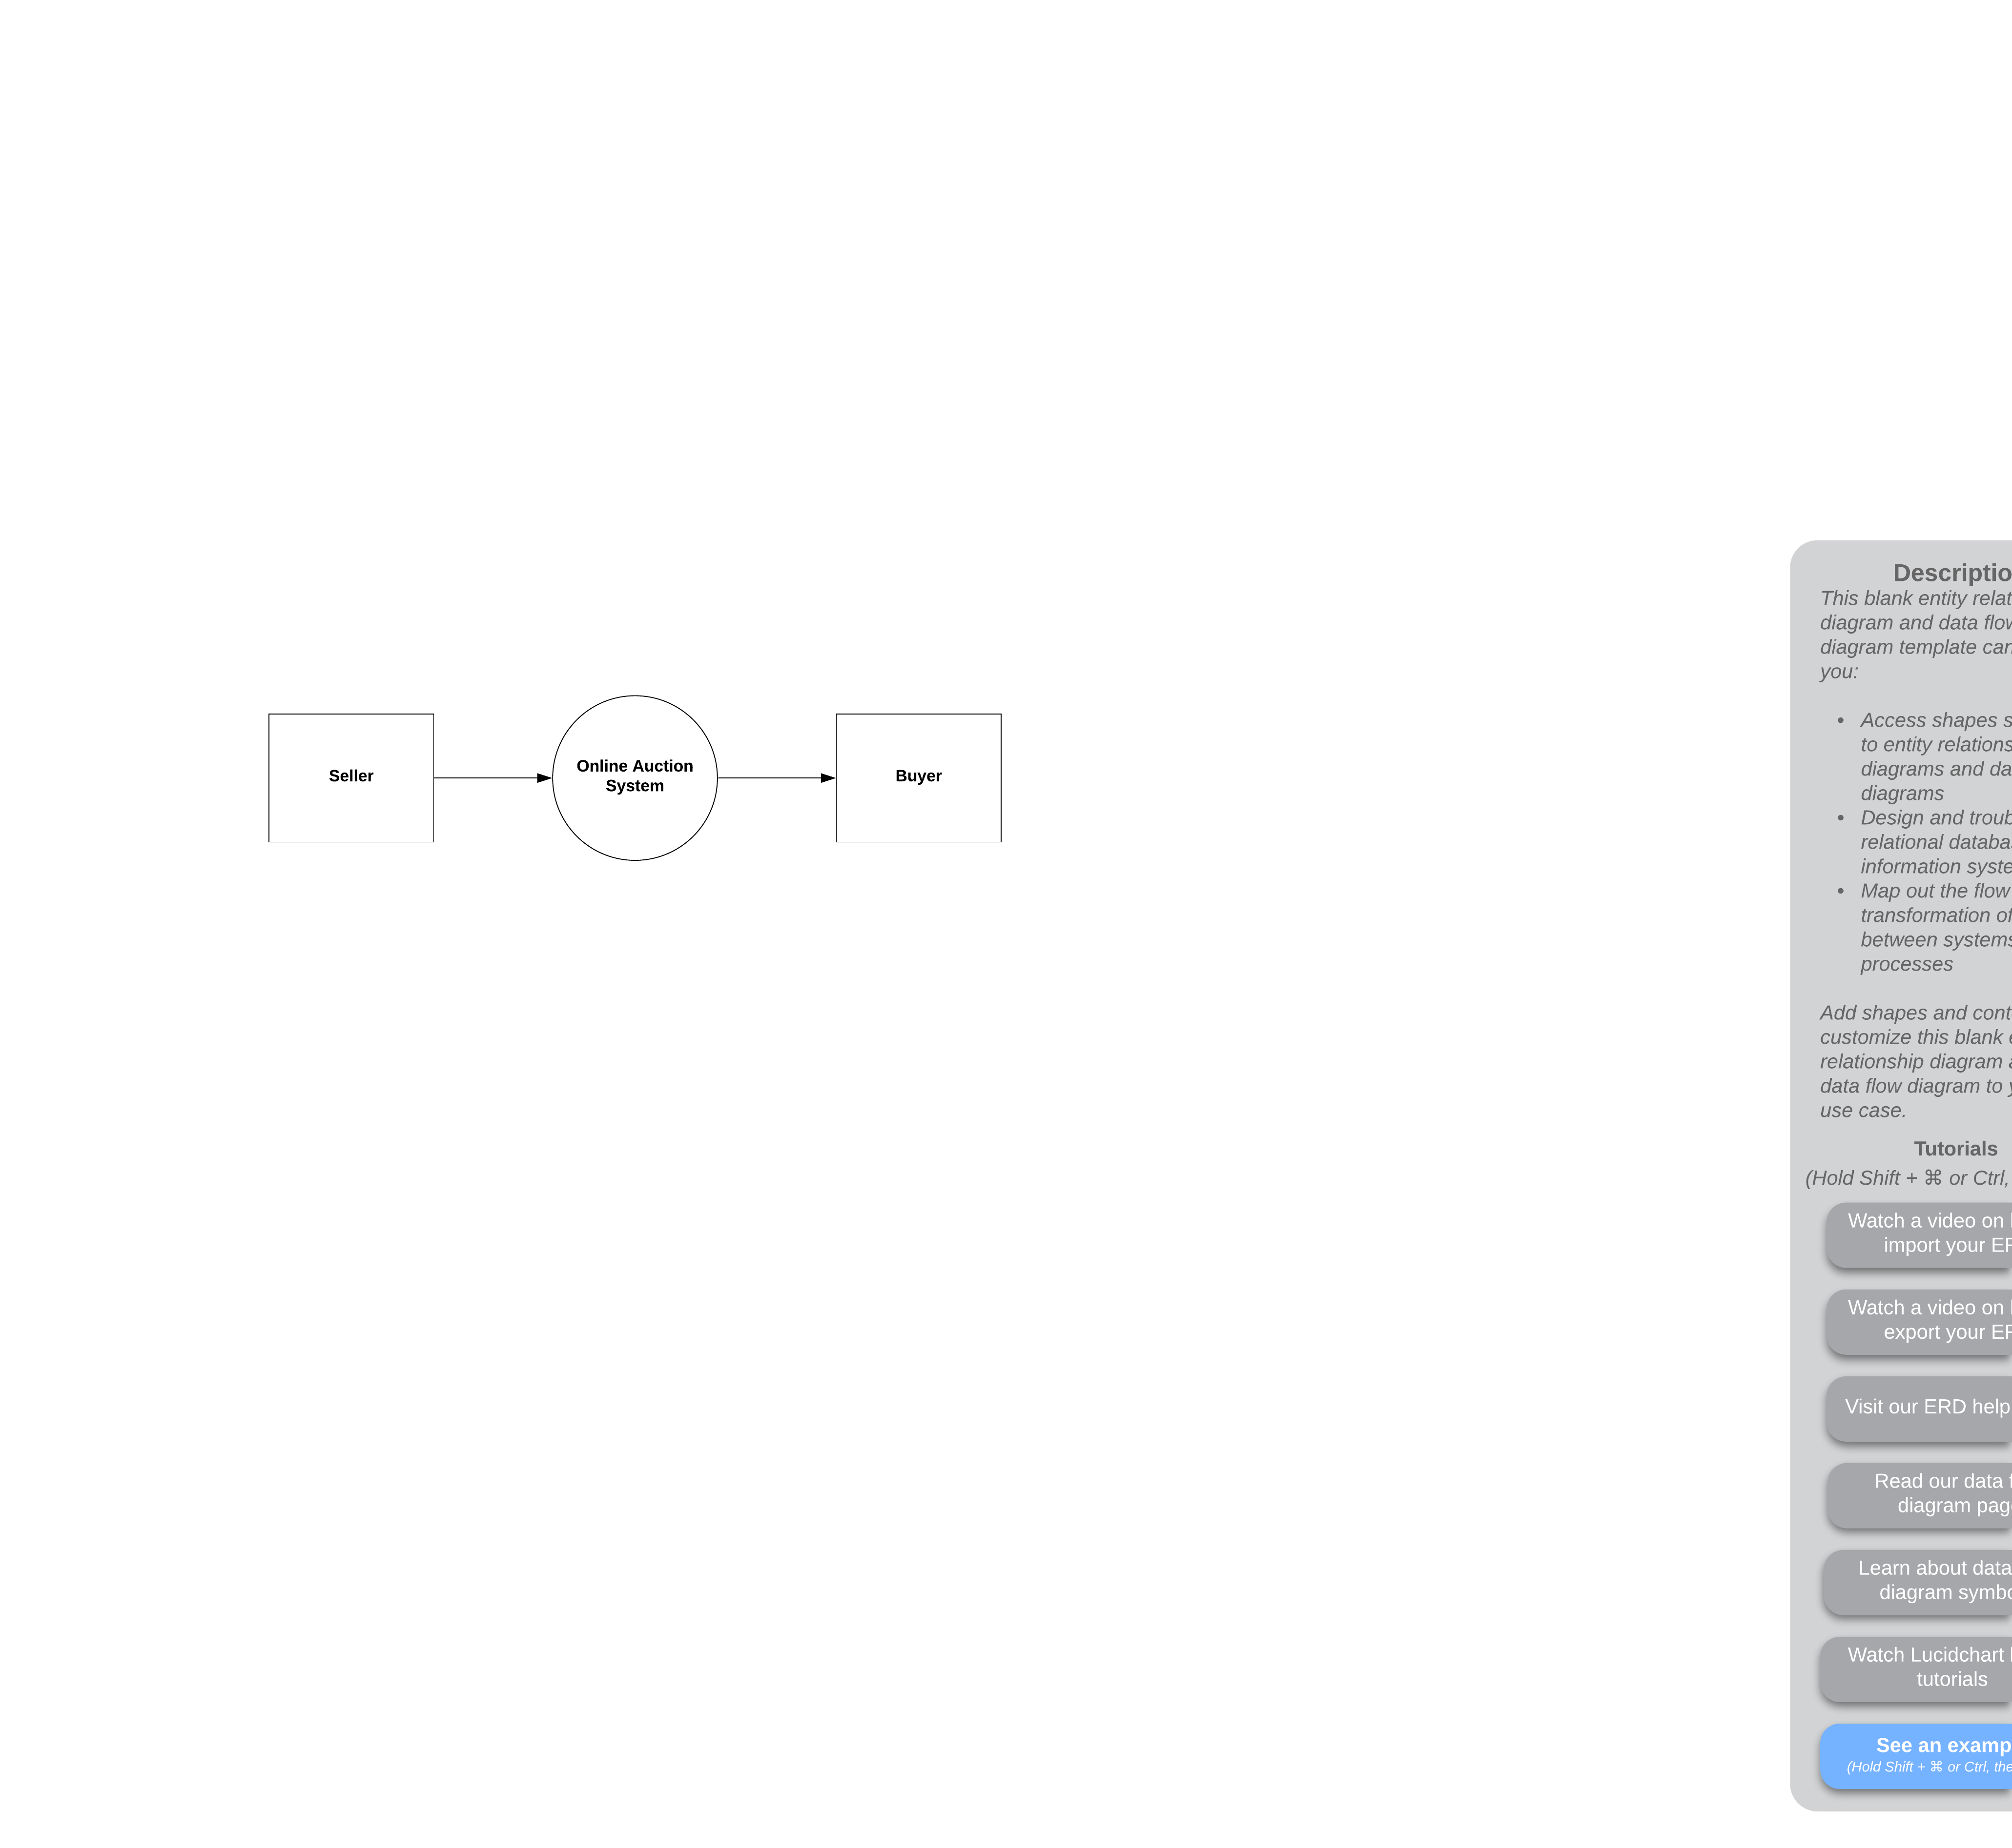

Data Flow Diagram – Level 0

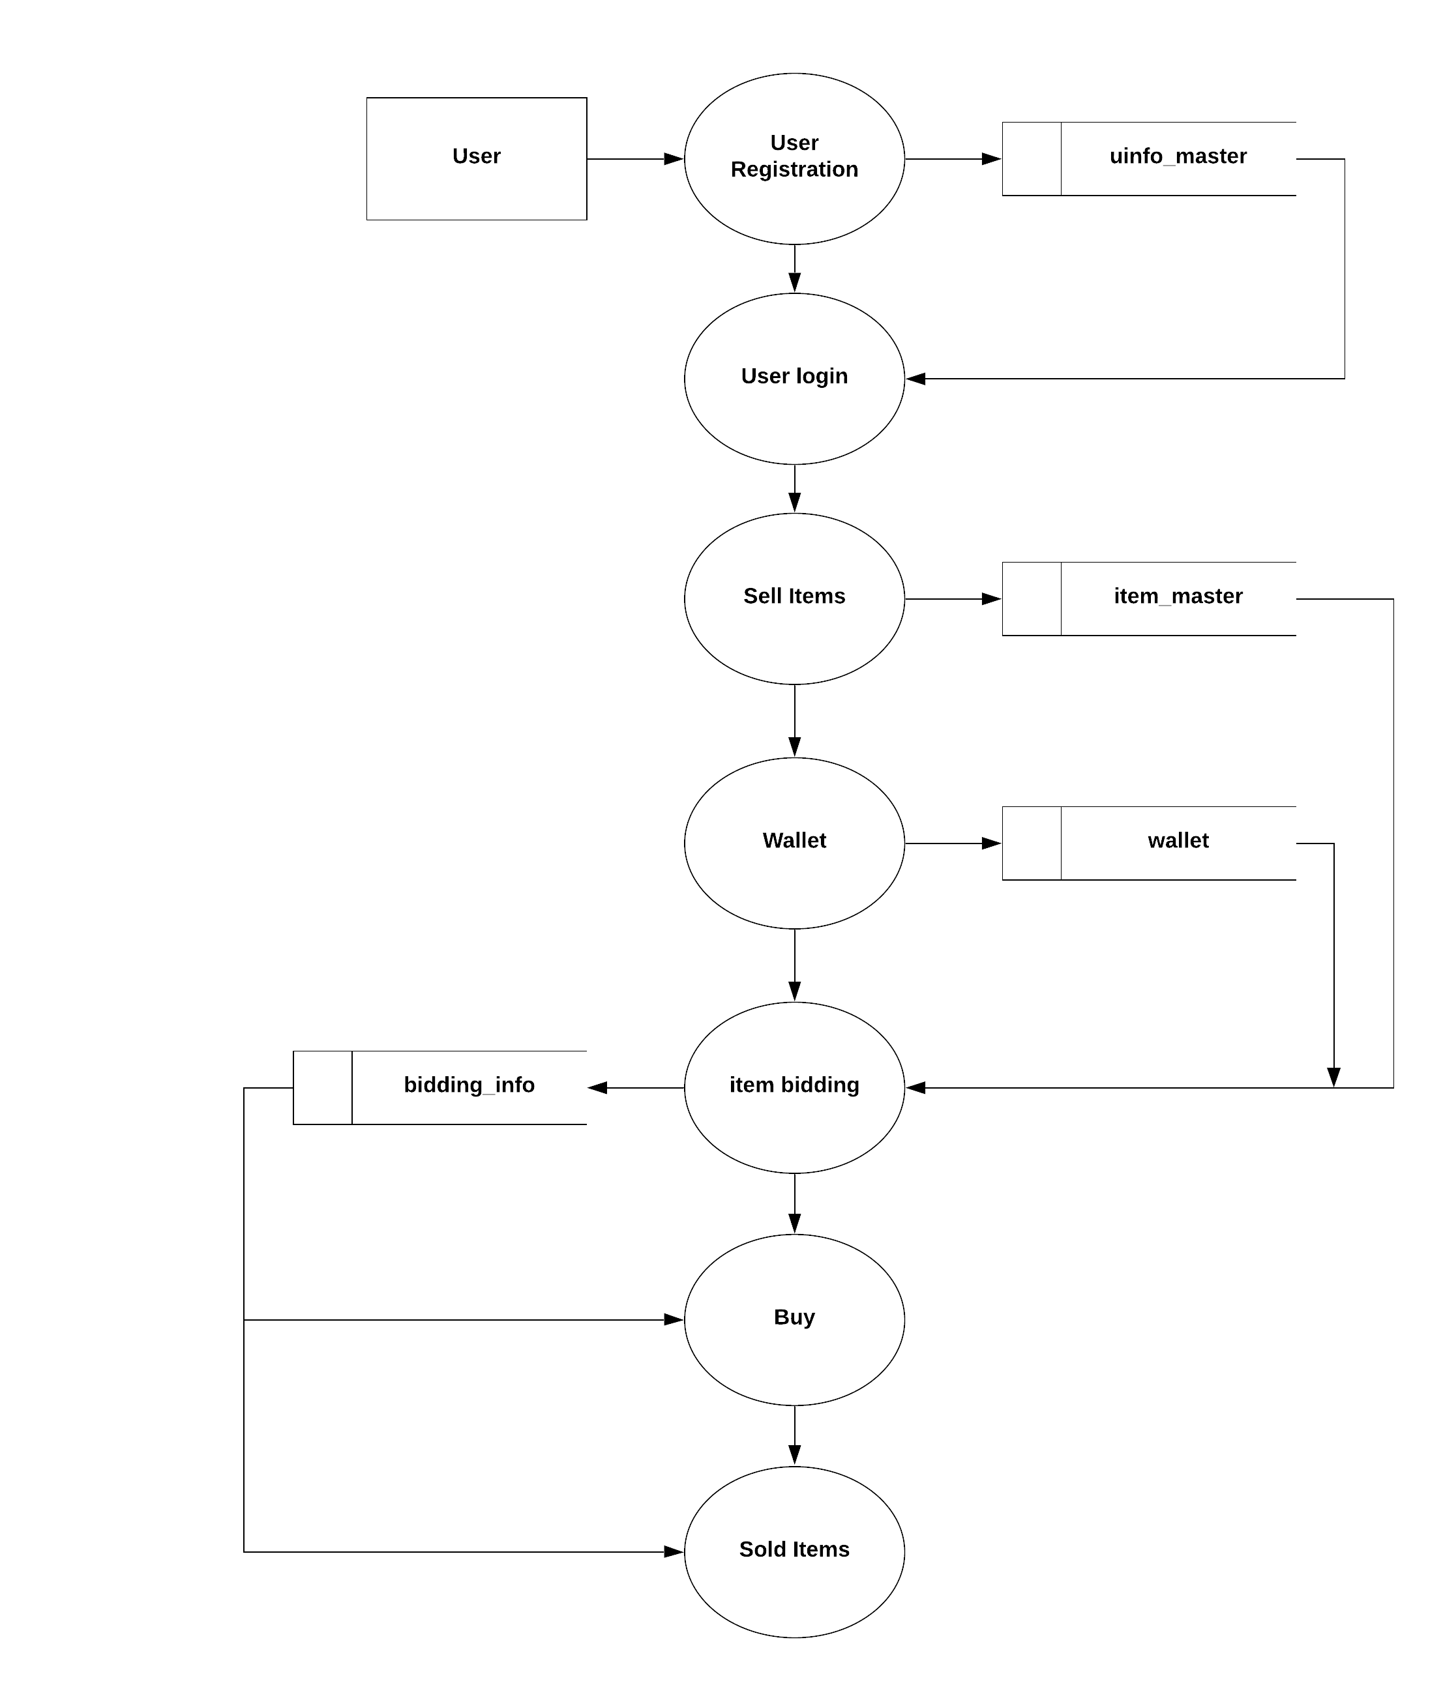

Data Flow Diagram – Level 1

**4.2. ER DIAGRAM**

LEGEND

Primary key: _______________

Foreign key: _ _ _ _ _ _ _ _ _ _

User

wallet

bids

**Category_master**

registers

**Bidding_info**

Item_master

Integrate with

Uinfo_master

**4.3 TABLE DESIGN**

**Table name:** uinfo_master

**Description:** This table stores the data about the user such as name, contact details and the address.

|  |  |  |  |  |
| --- | --- | --- | --- | --- |
| **Column Name** | **Data Type** | **Size** | **Constraint Type** | **Description** |
| Uname | Varchar2 | 50 | Primary key | username |
| Pwd | Varchar2 | 50 | Not null | password |
| fname | Varchar2 | 50 | Not null | First name |
| lname | Varchar2 | 50 | Not null | Last name |
| email | Varchar2 | 50 | Not null | Email |
| Phno | Varchar2 | 50 | Not null | Phone number |
| address | Varchar2 | 200 | Not null | Address |
| City | Varchar2 | 50 | Not null | City |
| State | Varchar2 | 50 | Not null | State/province |
| Pin | Varchar2 | 50 | Not null | pincode |
| Country | Varchar2 | 50 | Not null | country |

**Table name:** category_master

**Description:** This table stores category name and category ID.

|  |  |  |  |  |
| --- | --- | --- | --- | --- |
| **Column Name** | **Data Type** | **Size** | **Constraint Type** | **Description** |
| Catid | Number | 14 | Primary key | Category ID |
| Cat_name | Varchar2 | 50 | Not null | Category name |

**Table name:** item_master

**Description:** This table stores details about item such as item ID, item name, description, starting price and increment price, start date and end date.

|  |  |  |  |  |
| --- | --- | --- | --- | --- |
| **Column Name** | **Data Type** | **Size** | **Constraint Type** | **Description** |
| Itemid | Number | 10 | Primary key | Item ID |
| Catid | Number | 10 | Foreign Key | Category ID |
| Itemname | Varchar2 | 50 | Not null | Item name |
| Desc | Varchar2 | 50 | Not null | Item description |
| Summary | Varchar2 | 50 | Not null | Summary |
| Startprice | Number | 15 | Not null | Starting price |
| Incrprice | Number | 15 | Not null | Increment price |
| Stdate | Date |  | Not null | Start date |
| Enddate | Date |  | Not null | End date |
| Seller | Varchar2 | 50 | Not null | Seller |
| Bidcnt | Number | 15 | Not null | Bid count |
| filename | Varchar2 | 100 | Not null | Item picture |

**Table name:** item_master

**Description:** This table stores the data about biding information of the user such as bidder ID, amount, date and status of the bid.

|  |  |  |  |  |
| --- | --- | --- | --- | --- |
| **Column Name** | **Data Type** | **Size** | **Constraint Type** | **Description** |
| Bidderid | Varchar2 | 50 | Foreign key | Bidder ID |
| Bamt | Number | 15 | Not null | Bidding amount |
| Itemid | Number | 10 | Foreign key | Item ID |
| biddate | Date |  | Not null | Bidding |
| Status | Number | 2 | Not null | Bidding status |

**Table name:** wallet

**Description:** This table stores amount that user added into the account.

|  |  |  |  |  |
| --- | --- | --- | --- | --- |
| **Column Name** | **Data Type** | **Size** | **Constraint Type** | **Description** |
| uname | Varchar2 | 50 | Foreign key | username |
| amount | Number | 15 | Not null | Money in the wallet |

**4.4 FORM DESIGN**

**User Registration:**  this form used to register the user details like username, password, address details, contact details.

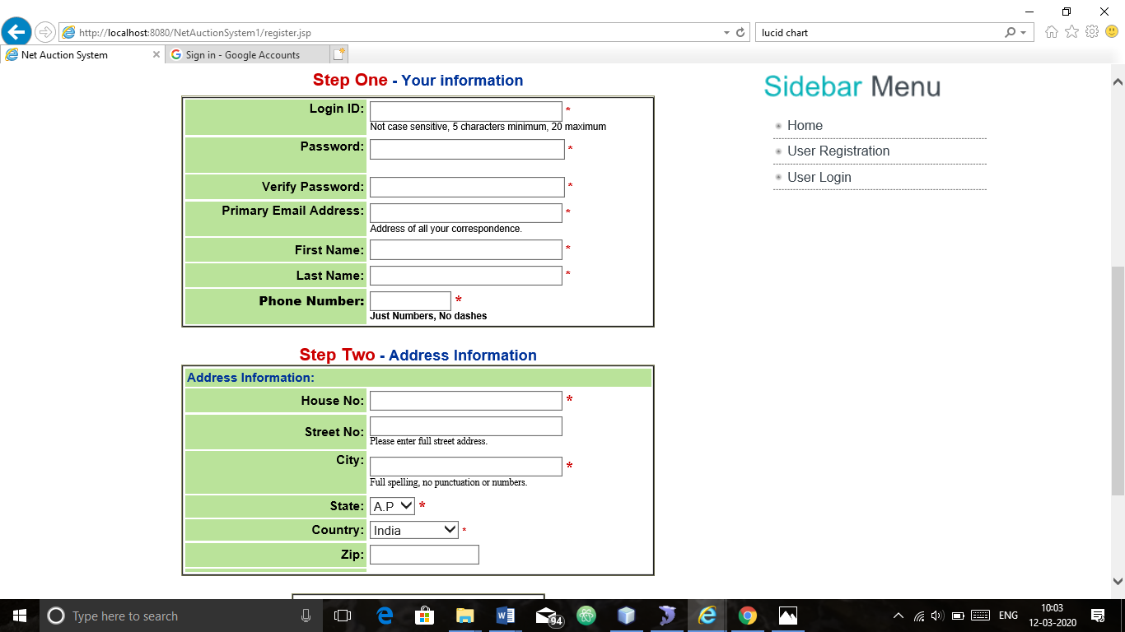

**User Login:**  This is a user login form which is used to logging into auction system.

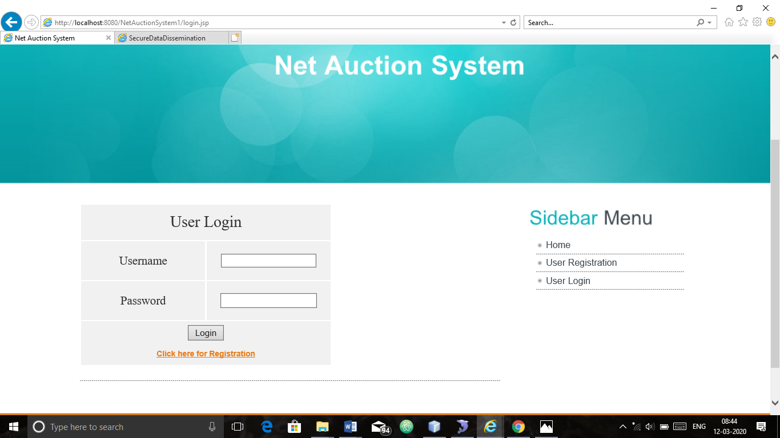

**Sell Items :**  This form is used to add the items in to the auction with item details like item name, description, end date and image.

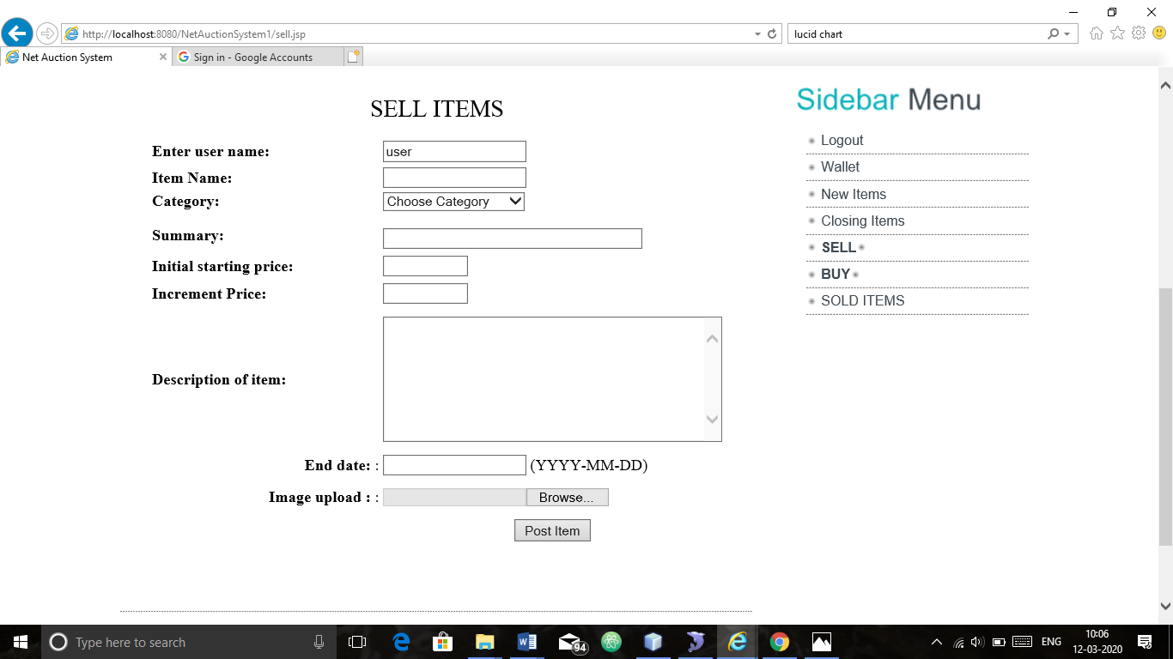

**Add money :**  This form is used to add money into the wallet.

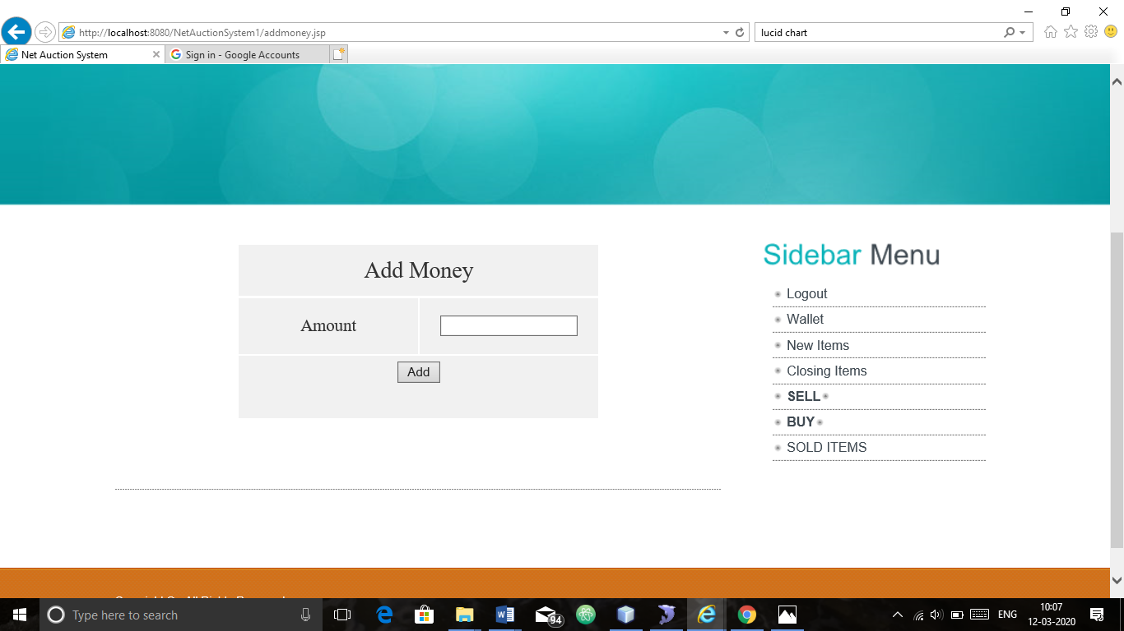

**5. SYSTEM TESTING AND IMPLEMENTATION**

The system testing verifies the whole set of programs that hang together. Before the system is acceptable by the user, testing is very important, it eliminates communicational problem, programmer’s negligence or time constraints, which causes error. The strategies for testing include unit testing, integration testing, system testing, implementation testing.

**SYSTEM TESTING**

Testing is a series of different tests that whose primary purpose is to fully exercise the computer based system. Although each test has a different purpose, all work should verify that all work should verify that all system element have been properly integrated and performed allocated function. Testing is the process of checking whether the developed system works, According to the actual requirement and objectives of the system.

The philosophy behind testing is to find the errors. A good test is one that undiscovered error. Test cases are devised with this purpose in mind. Test cases are is a set of data that the system will process as an input. However the data are created with the intent of determining whether the system will process them correctly without any errors to produce the required output.

Testing could be viewed as destructive rather than constructive. It is the process of executing a programmed with the intend of finding errors. The testing is one that will uncover different classes of errors with minimum amount of time and effort. In the proposed system testing is done. Testing is performed to ensure that software function appear to be working according to the specifications and that the performance requirement of the system.

**TESTING METHODOLOGIES**

**Black Box Testing**

Black box testing also called behavioral testing focuses on the functional requirements of the software. That is black box testing enables the software engineer to derive sets of input conditions that will fully exercise all functional requirements for a program. Black box testing attempts to find errors in the following categories. Incorrect or missing functions. Interface errors. Errors in data structures or external data base access Behavior or performance errors. Initialization and termination errors.

Functional Testing and black box type testing geared to functional requirements of an application. This type of testing should be done by testers. Our project does the functional testing of what input given and what output should be obtained.

System Testing-black box type testing that is based on overall requirements specifications; covers all combined parts of a system. The system testing to be done here is that to check with all the peripherals used in the project.

**WHITE BOX TESTING**

White box testing sometimes called glass box testing is a test case design method that uses the control structure of the procedural design to derive test cases. Using white box testing methods, the software engineer can derive test cases that guarantee that all independent paths within a module have been exercised at least once. Exercise all logical decisions on their true and false sides. Execute all loops at their boundaries and within their operational bounds. Exercise internal data structures to ensure their validity.

**UNIT TESTING**

The most „micro‟ scale of testing to test particular functions or code modules. Typically, it is done by the programmer and not by tester, as it requires detailed knowledge of the internal program design and code. Not always easily done unless the application has a well-designed architecture with tight code; may require developing test modules or test harnesses.

**QUALITY ASSURANCE**

Software Quality Assurance involves the entire software development process monitoring and improving the process, making sure that any agreed-upon standards and procedures are followed, and ensuring that problems are found and deal with. It is oriented to „prevention‟.

**SOFTWARE LIFE CYCLE**

The life cycle begins when an application is first conceived and ends when it is no longer in use. It includes aspects such as initial concept, requirements analysis, functional design, internal design, documentation planning, test planning, coding, document preparation, integration, testing, maintenance, updates, retesting, phase-out, and other aspects.

**VERIFICATION AND VALIDATION**

Verification refers to the set of activities that ensure that software correctly implements a specific function. Validation refers to a different set of activities that ensures that the software has been built is traceable to customer requirements.

Verification and validation encompasses a wide array of SQA activities that include formal technical reviews, quality and configuration audits, performance monitoring, simulation, feasibility study, documentation review, database review, algorithm analysis, development testing, qualification testing and installation testing.

**SYSTEM IMPLEMENTATION**

System implementation is a stage in a stage in the project where the where the theoretical designs turned into working system. The most crucial stage the user confidence that the new system will work effectively and efficiently.

The performance of reliability of the system was tested and it gained acceptance. The system was implemented successfully. Implementation is a process that means converting a new system into operation.

Proper implementation is essential to provide a reliable system to meet organization requirements. During the implementation stage a live demon was undertaken and made in front of end-users.

**IMPLEMENTATION**

Implementation is the stage in the paper where the theoretical design is turned into a working system. The implementation phase constructs, installs and operates the new system. The most crucial stage in achieving a new successful system is that it will work efficiently and effectively.

**6. SCOPE FOR FUTURE ENHANCEMENTS**

In future it is a possible one to add new features without any problem with enhanced. As the technology used is a good one it is flexible for future enhancement and it is also possible to alter the front-end and back-end without any problem.

This project currently used for scanning viruses. In future we can add some additional features also based on the user requirements.

This application software has been computed successfully and was also tested successfully by taking “test cases”. It is user friendly, and has required options, which can be utilized by the user to perform the desired operations.

It is not possible to develop a system that makes all the requirements of the user. User requirements keep changing as the system is being used. Some of the future enhancements that can be done to this system are:

* As the technology emerges, it is possible to upgrade the system and can be adaptable to desired environment.
* Because it is based on object-oriented design, any further changes can be easily adaptable.

Based on the future security issues, security can be improved using emerging technologies

**7. CONCLUSION**

This application software has been computed successfully and was also tested successfully by taking “test cases”. It is user friendly, and has required options, which can be utilized by the user to perform the desired operations.

The software is developed using Java as front end and Oracle as back end in Windows environment. The goals that are achieved by the software are:

* Instant access.
* Improved productivity.
* Optimum utilization of resources.
* Efficient management of records.
* Simplification of the operations.
* Less processing time and getting required information.
* User friendly.
* Portable and flexible for further enhancement.

**BIBILOGRAPHY**

The following books were referred during the analysis and execution phase of the project.

**REFERENCES**

|  |  |  |  |
| --- | --- | --- | --- |
| **S.NO** | **AUTHOR** | **BOOK** | **PUBLISHER & YEAR** |
| 1. | Herbert Schildt | The Complete Reference  Java 2, 5th Edition | Tata McGrwa-Hilll 2002  Publishing Company Ltd |
| 2. | George Koch,  Kevin Loney | ORACLE  The Complete Reference  3rd edition | Tata McGrw-Hill 1997  Publishing Company Ltd |
| 3. | Ivan Bay Ross | SQL, PL/SQL The Programming Language  Of Oracle, 2nd Edition | BPB Publications 2002 |

**WEBSITES**

* <http://java.sun.com/products/servlet>
* <http://www.dba-oracle.com/t_learn_oracle.htm>
* <http://www.w3schools.com/Html/default.asp>
* <http://www.w3schools.com/JS/default.asp>

**APPENDICES:**

**SCREENSHOTS**



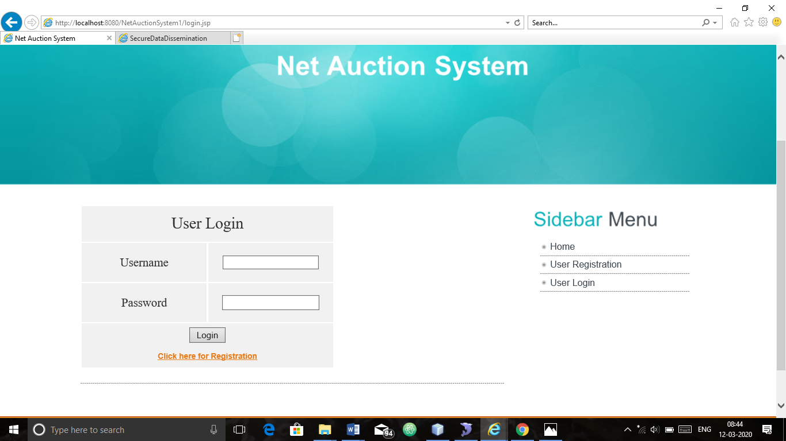

 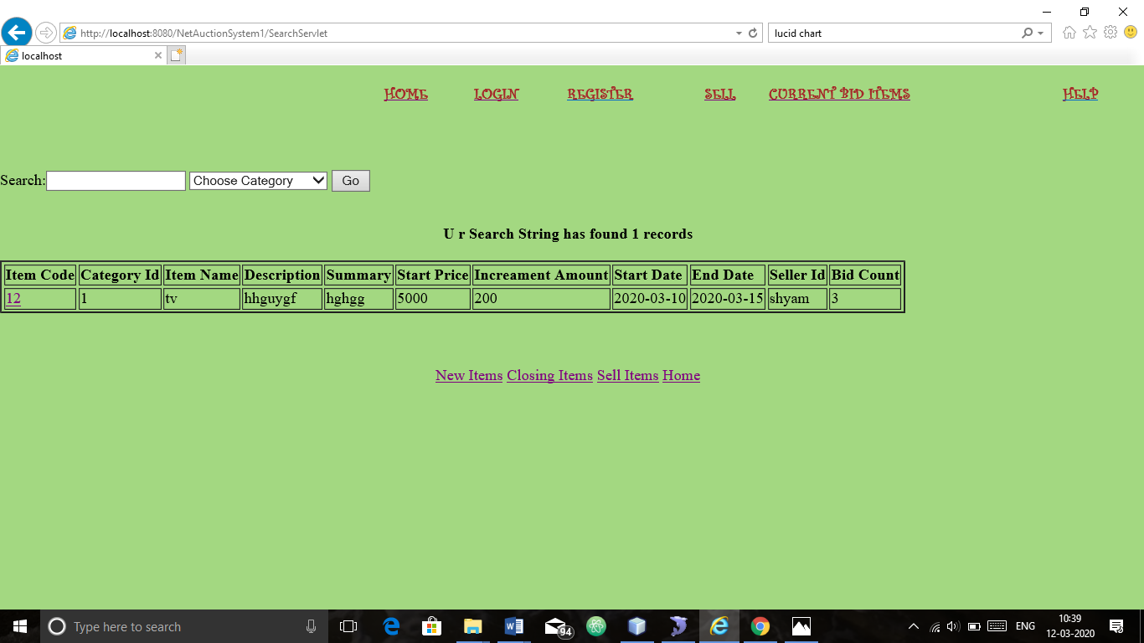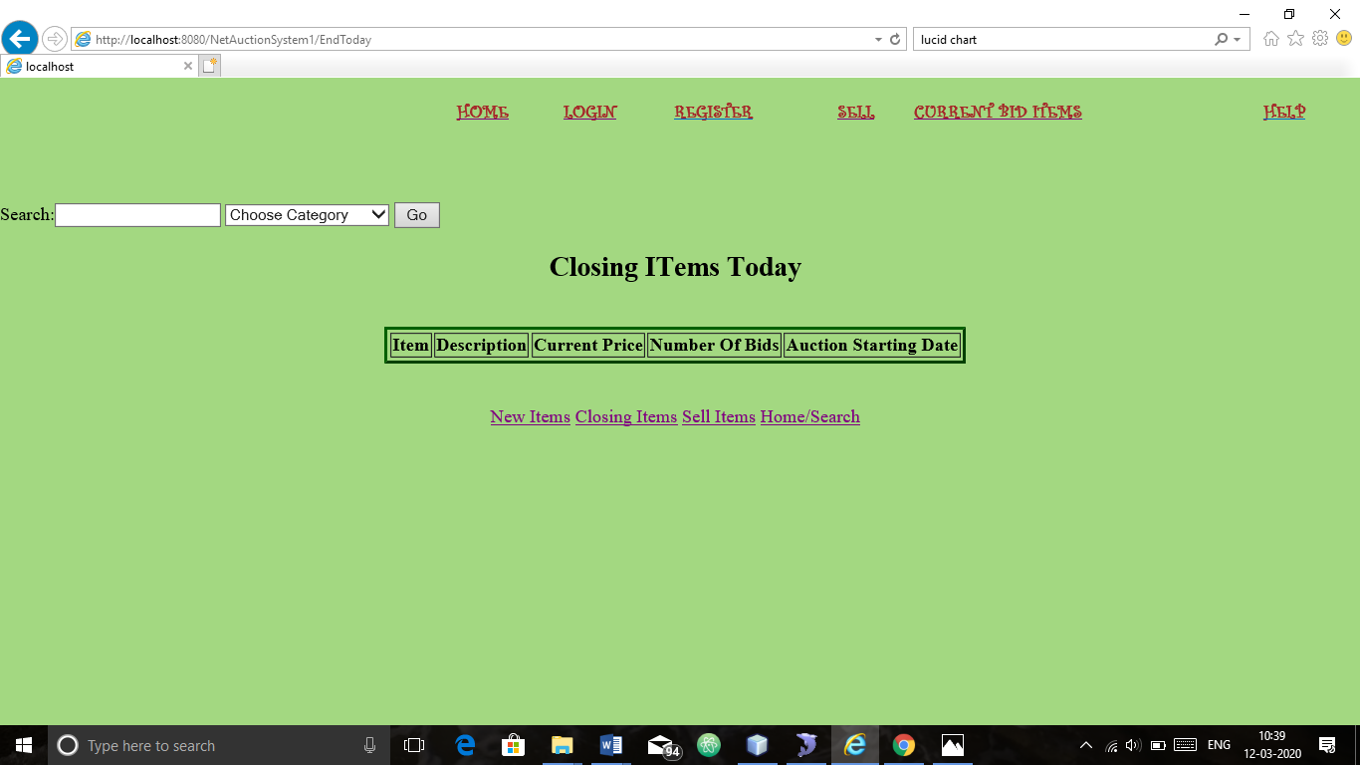 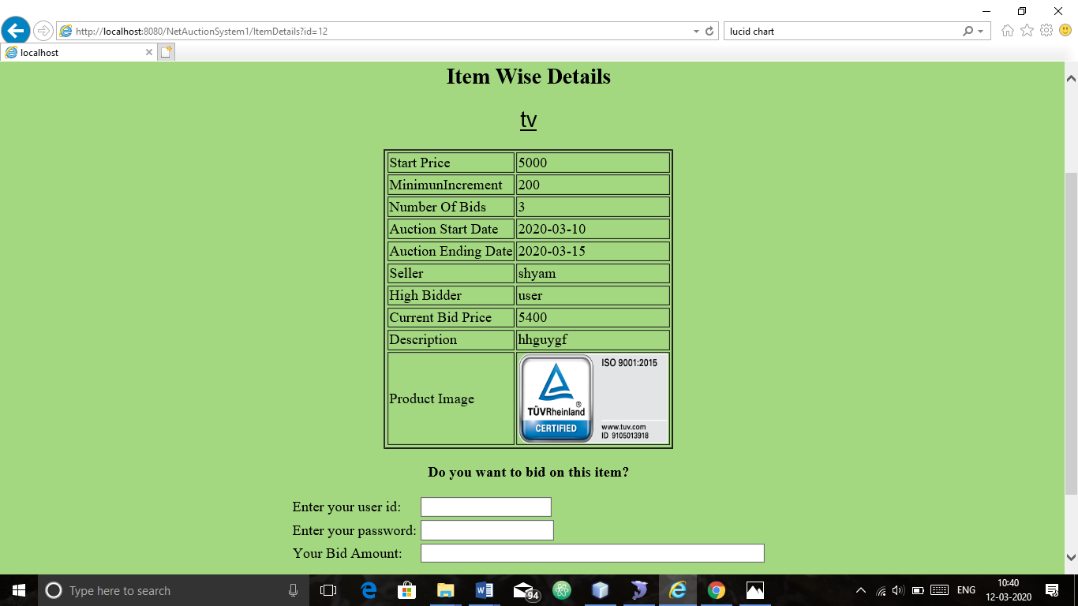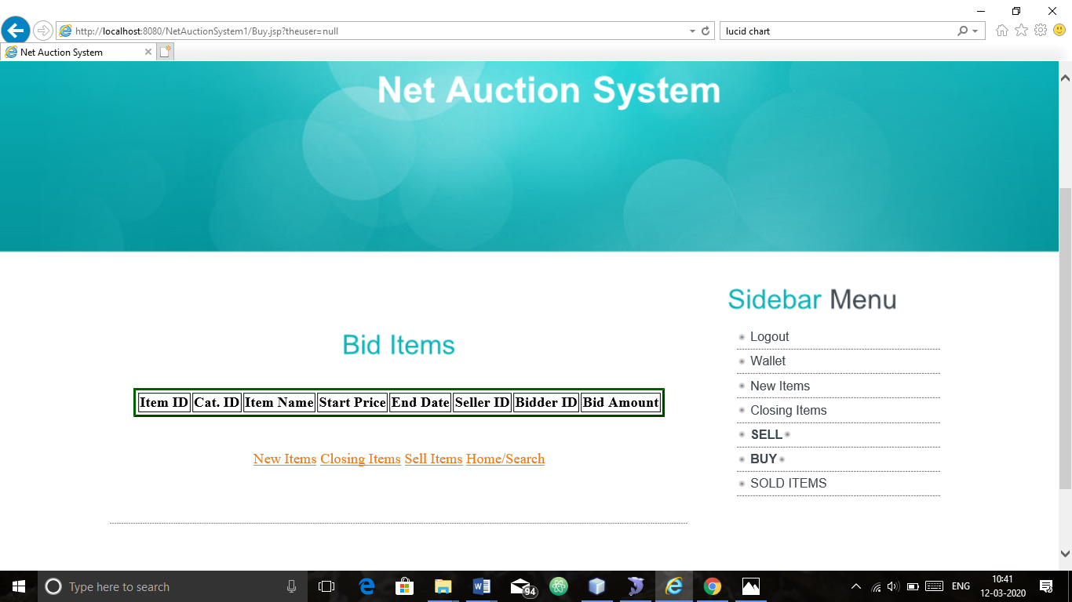

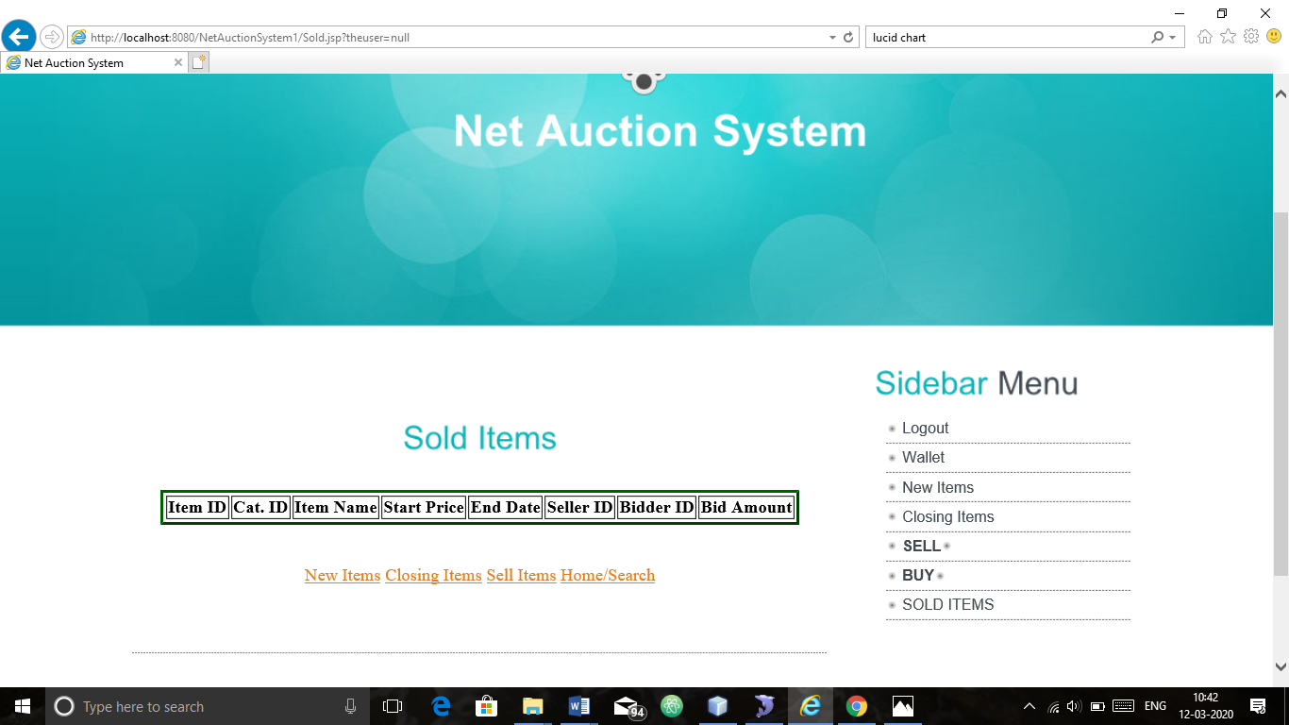

**SAMPLE CODING**

**JSP**

<!DOCTYPE html PUBLIC "-//W3C//DTD XHTML 1.0 Transitional//EN" "http://www.w3.org/TR/xhtml1/DTD/xhtml1-transitional.dtd">

<html xmlns="http://www.w3.org/1999/xhtml">

<head>

<title>Net Auction System</title>

<meta http-equiv="content-type" content="text/html; charset=utf-8" />

<link href="style.css" rel="stylesheet" type="text/css" />

<script type="text/javascript" src="js/cufon-yui.js"></script>

<script type="text/javascript" src="js/arial.js"></script>

<script type="text/javascript" src="js/cuf_run.js"></script>

<style type="text/css">

<!--

.style24 {

font-size: 14px;

font-weight: bold;

color: #000000;

font-family: Arial, Helvetica, sans-serif;

}

.style25 {

font-weight: bold;

font-family: Geneva, Arial, Helvetica, sans-serif;

}

.style28 {font-weight: bold}

.style29 {font-size: large}

.style30 {font-weight: bold; font-family: Geneva, Arial, Helvetica, sans-serif; font-size: large; }

.style31 {font-weight: bold}

.style32 {font-size: large; font-weight: bold; }

.style33 {font-weight: bold}

-->

</style>

<script type="text/javascript">

<!--

// Form validation code will come here.

function validate()

{

var mailformat = /^\w+([\.-]?\w+)*@\w+([\.-]?\w+)*(\.\w{2,3})+$/;

var numbers = /^[0-9]+$/;

var letters = /^[a-zA-Z]+$/;

var usecase = /^[0-9a-zA-Z]+$/;

if( document.myForm.username.value == "" )

{

alert( "Please provide your username!" );

document.myForm.username.focus() ;

return false;

}

if( document.myForm.password.value == "" )

{

alert( "Please provide your password!" );

document.myForm.password.focus() ;

return false;

}

if( document.myForm.fullname.value == "" )

{

alert( "Please provide your fullname!" );

document.myForm.fullname.focus() ;

return false;

}

if( document.myForm.age.value == "" || !document.myForm.age.value.match(numbers) )

{

alert( "Please provide your age!" );

document.myForm.age.focus() ;

return false;

}

if( document.myForm.prof.value == "" )

{

alert( "Please provide your profession!" );

document.myForm.prof.focus() ;

return false;

}

if( document.myForm.city.value == "" )

{

alert( "Please provide your city!" );

document.myForm.city.focus() ;

return false;

}

if( document.myForm.state.value == "" )

{

alert( "Please provide your state!" );

document.myForm.state.focus() ;

return false;

}

if( document.myForm.country.value == "" )

{

alert( "Please provide your country!" );

document.myForm.country.focus() ;

return false;

}

if( document.myForm.mobileno.value == "" || !document.myForm.mobileno.value.match(numbers) || document.myForm.mobileno.value.length < 10 || document.myForm.mobileno.value.length > 10)

{

alert( "Please provide your mobileno!" );

document.myForm.mobileno.focus() ;

return false;

}

if( document.myForm.emailid.value == "" || !document.myForm.emailid.value.match(mailformat))

{

alert( "Please provide your emailid!" );

document.myForm.emailid.focus() ;

return false;

}

return( true );

}

//-->

</script>

</head>

<body>

<!-- START PAGE SOURCE -->

<div class="main">

<div class="header">

<div class="header_resize">

<div class="menu">

<ul>

<li><a href="index.jsp" class="active"><span> Home </span></a></li>

<li><a href="register.jsp"></a></li>

<li><a href="userlogin.jsp"><span> User Logout </span></a></li>

</ul>

</div>

<div class="search">

<form id="form1" name="form1" method="post" action="#">

</form>

</div>

<div class="clr"></div>

<div class="logo">

<h1><a href="index.html"><span>Net Auction System </span><br />

</a></h1>

</div>

<div class="clr"></div>

</div>

</div>

<div class="body">

<div class="body_resize">

<div class="left">

<table width="642" height="249" border="0">

<tr>

<td><div align="center">

<p><span class="style29"><span class="style31"><a

href="./NewToday">New Items</a></span></span></p>

<p class="style32">&nbsp;</p>

<p class="style32"><span class="style33"><a

href="./EndToday">Closing Items</a> </span></p>

<p class="style32">&nbsp;</p>

<p class="style32"> <a href="./sell.jsp"><strong>SELL</strong></a></p>

<p class="style32">&nbsp;</p>

<p class="style32"><strong><a href='./Buy.jsp?theuser=<%=session.getAttribute("user")%>'>BUY</a></strong></p>

<p class="style32">&nbsp;</p>

<p><span class="style30"><a

href="Sold.jsp?theuser=<%=session.getAttribute("user")%>">SOLD ITEMS </a></span></p>

<p></p>

</div></td>

</tr>

</table>

<h2 align="center">&nbsp;</h2>

<div class="bg"></div>

</div>

<div class="right">

<h2>Sidebar<span> Menu</span></h2>

<ul>

<li><a href="login.jsp">Logout</a></li>

<li><a

href="wallet.jsp">Wallet</a></li>

<li><a

href="./NewToday">New Items</a></li>

<li><a

href="./EndToday">Closing Items</a></li>

<li><a href="./sell.jsp"><strong>SELL</strong></a><a href="register.jsp"></a></li>

<li><a href='./Buy.jsp?theuser=<%=session.getAttribute("user")%>'><strong>BUY</strong></a><a href="userlogin.jsp"></a></li>

<li class="style24"><span class="style25"><a

href="Sold.jsp?theuser=<%=session.getAttribute("user")%>">SOLD ITEMS </a></span></li>

</ul>

<p>&nbsp;</p>

<h2>&nbsp;</h2>

<div class="search2 style28">

<form id="form2" method="post" action="#">

</form>

</div>

</div>

<div class="clr"></div>

</div>

</div>

<div class="FBG">

<div class="FBG_resize">

<div class="clr"></div>

</div>

</div>

<div class="footer">

<div class="footer_resize">

<p class="lf">Copyright &copy; - All Rights Reserved</p>

<div class="clr"></div>

</div>

</div>

</div>

</body>

</html>

JAVA

/* */ import java.io.IOException;

/* */ import java.io.PrintStream;

/* */ import java.io.PrintWriter;

/* */ import java.sql.Connection;

/* */ import java.sql.Date;

/* */ import java.sql.DriverManager;

/* */ import java.sql.ResultSet;

/* */ import java.sql.Statement;

/* */ import javax.servlet.ServletConfig;

/* */ import javax.servlet.ServletContext;

/* */ import javax.servlet.ServletException;

/* */ import javax.servlet.http.HttpServlet;

/* */ import javax.servlet.http.HttpServletRequest;

/* */ import javax.servlet.http.HttpServletResponse;

/* */

/* */ public class ItemDetails extends HttpServlet

/* */ {

/* */ Connection con;

/* */ PrintWriter pw;

ResultSet localObject;

/* */

/* */ public void init(ServletConfig paramServletConfig)

/* */ throws ServletException

/* */ {

/* */ try

/* */ {

/* 15 */ super.init(paramServletConfig);

/* 16 */ Class.forName("com.mysql.jdbc.Driver");

/* 14 */ this.con = DriverManager.getConnection("jdbc:mysql://localhost:3306/netauction","root","password"); } catch (Exception localException) {

/* 18 */ localException.printStackTrace();

/* */ }

/* */ }

/* */

/* */ public void doGet(HttpServletRequest paramHttpServletRequest, HttpServletResponse paramHttpServletResponse) throws ServletException, IOException {

/* */ try { paramHttpServletResponse.setContentType("text/html");

/* 24 */ this.pw = paramHttpServletResponse.getWriter();

/* */

/* 26 */ this.pw.println("<BODY bgColor=#a3d881 leftMargin=0 topMargin=0 MARGINHEIGHT=0 MARGINWIDTH=0><!-- ImageReady Slices (Untitled-1) -->");

/* */

/* 29 */ this.pw.println("<p align=right><TABLE cellSpacing=0 cellPadding=0 width=781 border=0><TBODY><BR><TR><TD><A href='./home.jsp'><STRONG><FONT COLOR='BROWN' FACE='CURLZ MT'>HOME</STRONG></A> </TD> <TD> <A href='./login.jsp'><STRONG> <FONT COLOR='BROWN' FACE='CURLZ MT'>LOGIN</STRONG> </A></TD> <TD> <A href='./registration.jsp'><STRONG><FONT COLOR='BROWN' FACE='CURLZ MT'>REGISTER</STRONG></A></TD> <TD> <A href='./sell.jsp'><STRONG><FONT COLOR='BROWN' FACE='CURLZ MT'>SELL</STRONG> </A></TD> <TD> <A href='./ForSale.jsp'><STRONG><FONT COLOR='BROWN' FACE='CURLZ MT'>CURRENT BID ITEMS</STRONG> </A></TD> <TD> <A href='./help.jsp'><STRONG><FONT COLOR='BROWN' FACE='CURLZ MT'>HELP</STRONG> </A></TD></TR><TD></TD> </TBODY></TABLE></p><br><br>");

/* 30 */ this.pw.println("<p align=right><FORM name=form1 action='./SearchServlet' method=post >Search:<INPUT name=sstring> ");

/* 31 */ this.pw.println("<SELECT name=category > <option >Choose Category</option>");

/* */ try

/* */ {

/* 34 */ Statement localStatement1 = this.con.createStatement();

/* 35 */ localObject = localStatement1.executeQuery("select cat_name from category_master");

/* 36 */ while (((ResultSet)localObject).next())

/* 37 */ this.pw.println("<OPTION>" + ((ResultSet)localObject).getString(1) + "</OPTION>");

/* */ } catch (Exception localException1) {

/* */ }

/* 40 */ this.pw.println("</SELECT> <INPUT type=submit value=Go > ");

/* 41 */ this.pw.println("</FORM></p><!-- End ImageReady Slices -->"); this.pw.println("<h2><center>Item Wise Details</h2>");

/* */

/* 43 */ String str1 = paramHttpServletRequest.getParameter("id");

/* 44 */ System.out.println(str1);

/* 45 */ Object localObject = this.con.createStatement();

/* 46 */ ResultSet localResultSet1 = ((Statement)localObject).executeQuery("select itemname from item_master where itemid=" + str1);

/* 47 */ localResultSet1.next();

/* 48 */ String str2 = localResultSet1.getString(1);

/* 49 */ this.pw.println("<center><font size=+2 face=Arial ><u>" + str2 + "</u></font></center><br>");

/* 50 */ Statement localStatement2 = this.con.createStatement();

/* 51 */ ResultSet localResultSet2 = localStatement2.executeQuery("select bidderid,bamt from bidding_info where itemid=" + str1 + " and bamt=(select max(bamt) from bidding_info where itemid=" + str1 + ")");

/* 52 */ String str3 = "No Bidder Till now";

/* 53 */ int i = 0;

/* 54 */ if (localResultSet2.next()) {

/* 55 */ str3 = localResultSet2.getString(1);

/* 56 */ i = localResultSet2.getInt(2);

/* */ }

/* 58 */ Statement localStatement3 = this.con.createStatement();

/* 59 */ ResultSet localResultSet3 = localStatement3.executeQuery("select * from item_master where itemid=" + str1);

/* 60 */ this.pw.println("<center><table border=2>");

/* 61 */ String str4 = "";

/* 62 */ String str5 = "";

/* 63 */ while (localResultSet3.next())

/* */ {

/* 65 */ String str6 = localResultSet3.getString(4);

/* 66 */ str4 = localResultSet3.getString(6);

/* 67 */ str5 = localResultSet3.getString(7);

/* 68 */ Date localDate1 = localResultSet3.getDate(8);

/* 69 */ Date localDate2 = localResultSet3.getDate(9);

/* 70 */ String str7 = localResultSet3.getString(10);

/* 71 */ String str8 = localResultSet3.getString(11);

String str9 = localResultSet3.getString(12);

/* 72 */ if (i == 0)

/* 73 */ i = Integer.parseInt(str4);

/* 74 */ this.pw.println("<TR><TD>Start Price</TD><td>" + str4 + "</td></tr>");

/* 75 */ this.pw.println("<TR><TD>MinimunIncrement</TD><td>" + str5 + "</td></tr>");

/* 76 */ this.pw.println("<TR><TD>Number Of Bids</TD><td>" + str8 + "</td></tr>");

/* 77 */ this.pw.println("<TR><TD>Auction Start Date</TD><td>" + localDate1 + "</td></tr>");

/* 78 */ this.pw.println("<TR><TD>Auction Ending Date</TD><td>" + localDate2 + "</td></tr>");

/* 79 */ this.pw.println("<TR><TD>Seller</TD><td>" + str7 + "</td></tr>");

/* 80 */ this.pw.println("<TR><TD>High Bidder</TD><td>" + str3 + "</td></tr>");

/* 81 */ this.pw.println("<tr><td>Current Bid Price</td><td>" + i + "</td></tr>");

/* 82 */ this.pw.println("<TR><TD>Description</TD><td>" + str6 + "</td></tr>");

this.pw.println("<TR><TD>Product Image</TD><td><img src=\"productimages/"+ str9 +"\" alt=\"1\" width=\"165\" height=\"99\" /></td></tr>");

/* */ }

/* */

/* 85 */ this.pw.println("</table><center>");

/* 86 */ this.pw.println("<P><STRONG>Do you want to bid on this item?</STRONG>");

/* 87 */ this.pw.println("<form action=./AuctionServlet>");

/* 88 */ this.pw.println("<input type=hidden name=id value=" + paramHttpServletRequest.getParameter("id"));

/* 89 */ this.pw.println("><input type=hidden name=hbid value=" + i);

/* 90 */ this.pw.println("><input type=hidden name=min value=" + str5);

this.pw.println("><input type=hidden name=startprice value=" + str4);

/* 91 */ this.pw.println("><TABLE><TR><TD>Enter your user id:</TD><TD><INPUT TYPE=\"TEXT\" SIZE=20 NAME=\"bidder\"></TD></TR>");

/* 92 */ this.pw.println("<TR><TD>Enter your password:</TD><TD><INPUT TYPE=PASSWORD SIZE=20 NAME=password></TD>");

/* 93 */ this.pw.println("</TR><TR><TD>Your Bid Amount:</TD><TD><INPUT TYPE=\"TEXT\" SIZE=60 NAME=\"amount\" onBlur=f()></TD></TR></TABLE><br><br><input type=submit value=\"Bid for Item\"></form>");

/* */

/* 95 */ this.pw.println("<CENTER><STRONG></STRONG>");

/* 96 */ this.pw.println("<A href=./NewToday>New Items</A><STRONG></STRONG>");

/* 97 */ this.pw.println("<A href=./EndToday>Closing Items</A>");

/* 98 */ this.pw.println("<STRONG></STRONG><A href=./sell.jsp>Sell Items</A>");

/* 99 */ this.pw.println("<STRONG></STRONG><A href=./home.jsp>Home</A>");

/* */ } catch (Exception localException2) {

/* 101 */ localException2.printStackTrace();

/* */ }

/* */ }

/* */ }

**SYNOPSIS**

Auctionsare among the oldest economic institutions in place and they are still in use. In this dissertation, we explore the efficiency of common auctions when values are interdependent. The value to a particular bidder may depend on information available only to others and asymmetric. In this setting, it is well known that sealed-bid auctions do not achieve efficient allocations in general since they do not allow the information held by different bidders to be shared. With the point and click of the mouse, one may bid on an item they may need or just want, and in moments they find that either they are the top bidder or someone else wants it more, and you’re outbid! , while meeting the needs of its users.

**Online Auction System** project is used to bid from the comfort of ones owns preferred place has seen a change like never seen before. **Online Auction System** provides the complete information related to products for sale and the buyers can bid for the products and can own them all this has to be provided. Sellers want a place where seller can sale their products at a higher price and get maximum benefit out of that. The people always want different things to purchase but in the local market they can have local products only but in this application buyer can buy any product from any part of the world at a very best competitive price and own the product.



I am **SHYAM SUNDAR S** (17BCT046) doing final year Computer Technology in PSG College of Arts and Science, Batch 2017 – 2020.