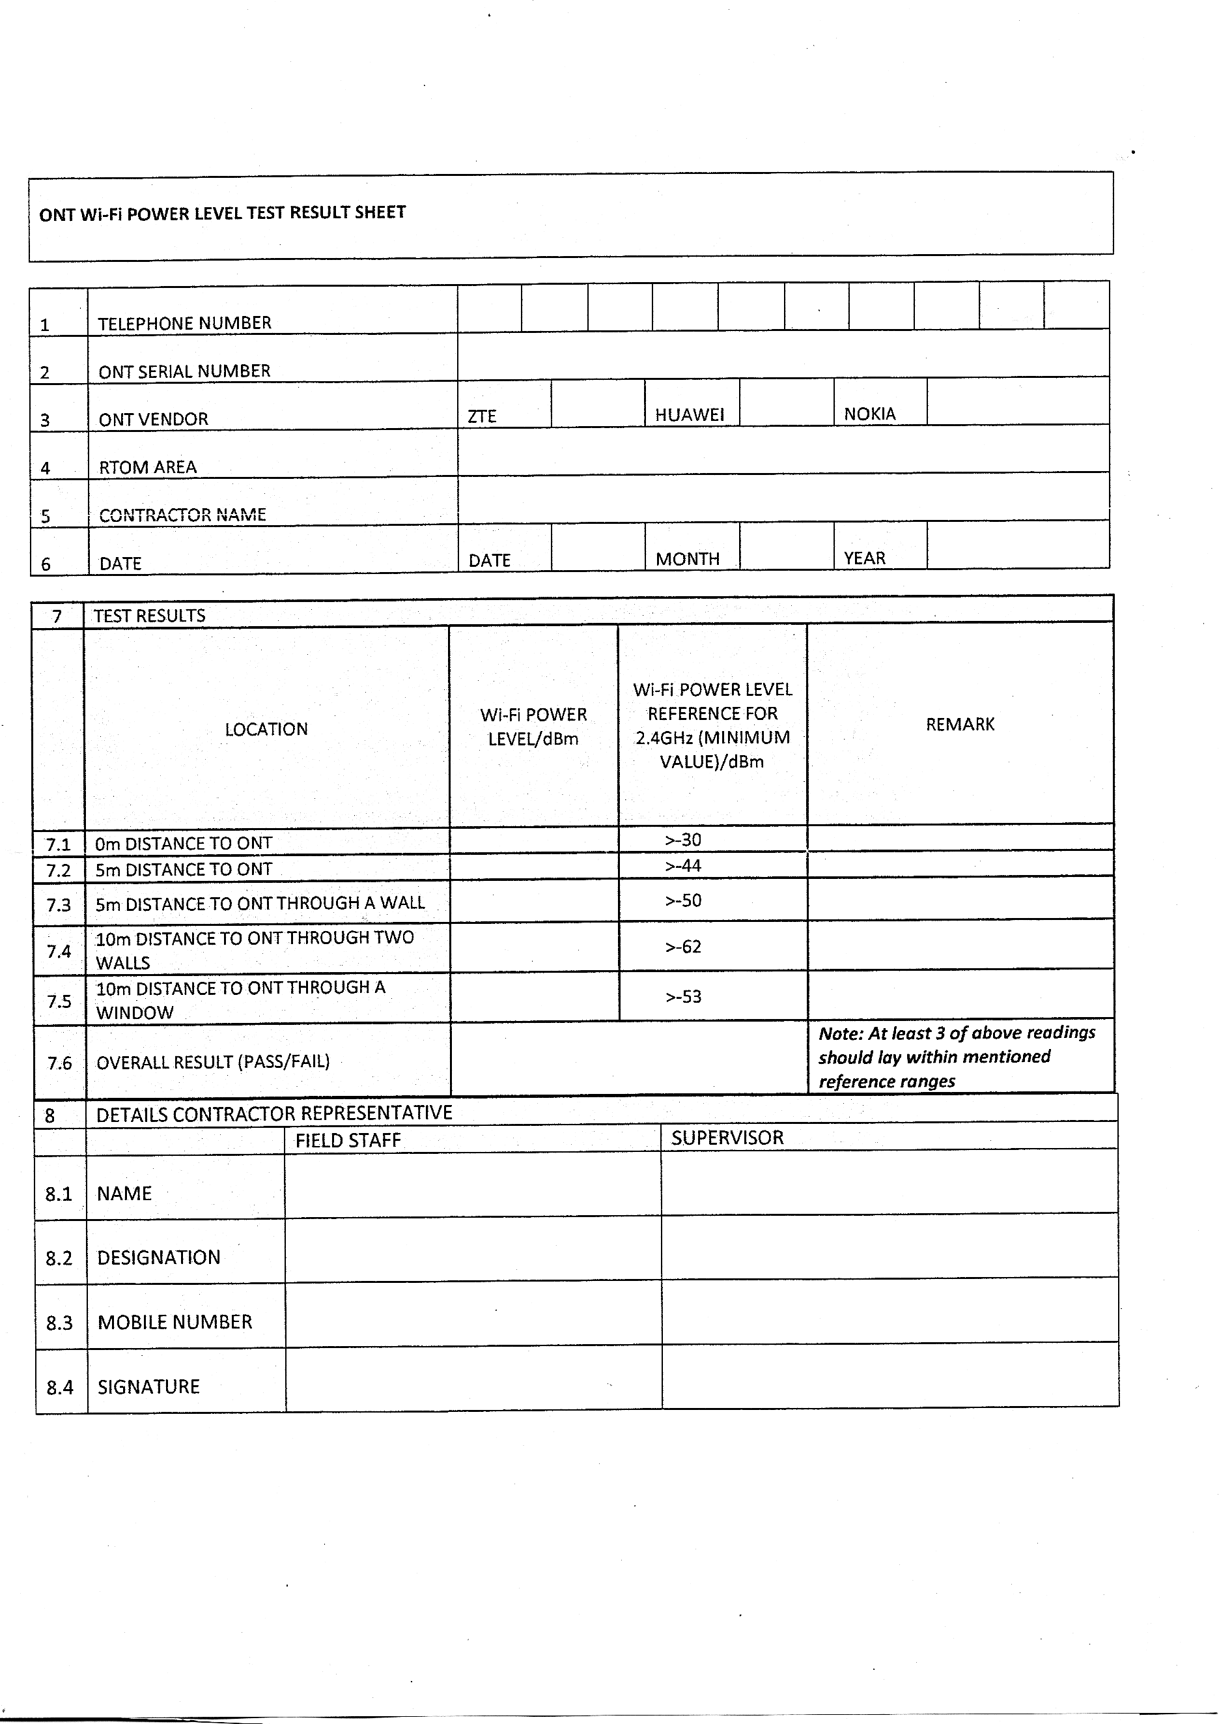

Cont name

Rtom_area

Ont_ser_num

Tel_num

Fs_num

Fs_desig

Fs_name