PORTSWIGGER-LAB

LAB SOLVED

SHYAM BAIJU | 22-09-2024

# SQL INJECTION-LOGIN BYPASS

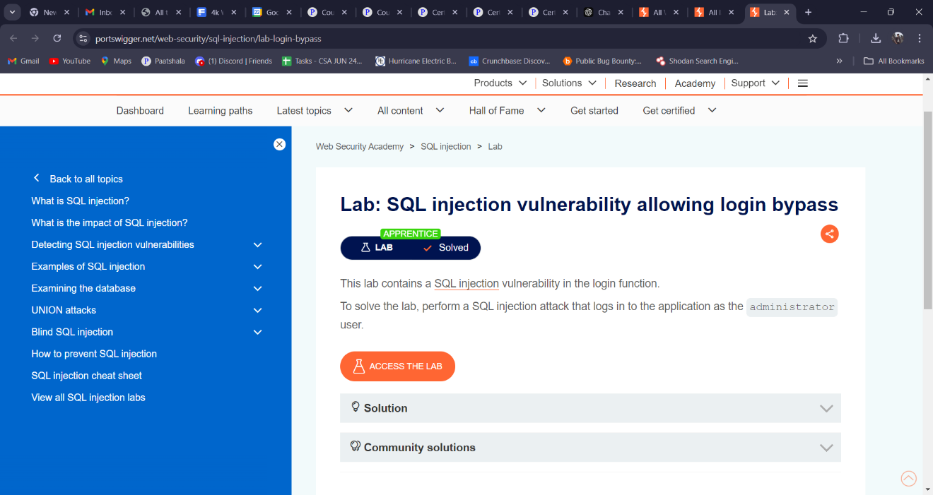

# CSRF

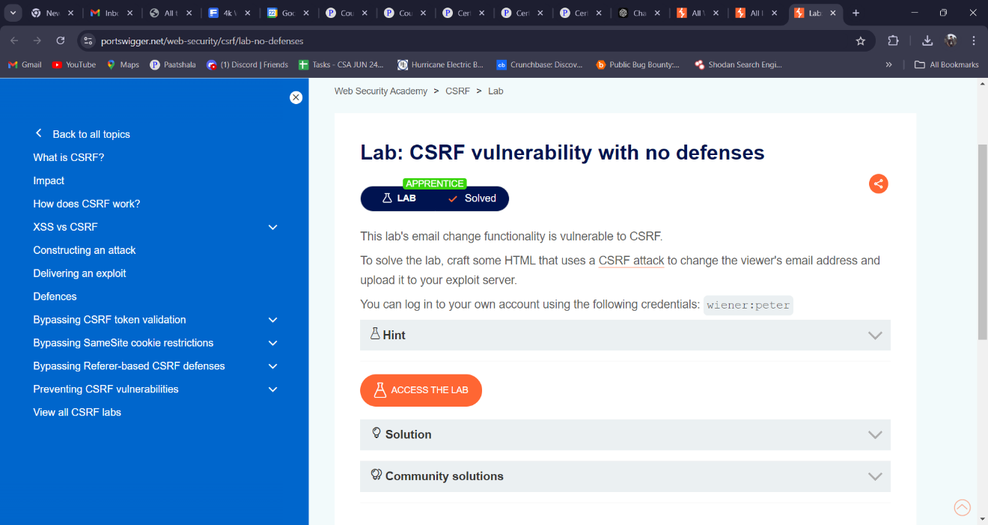

# DOM-BASED

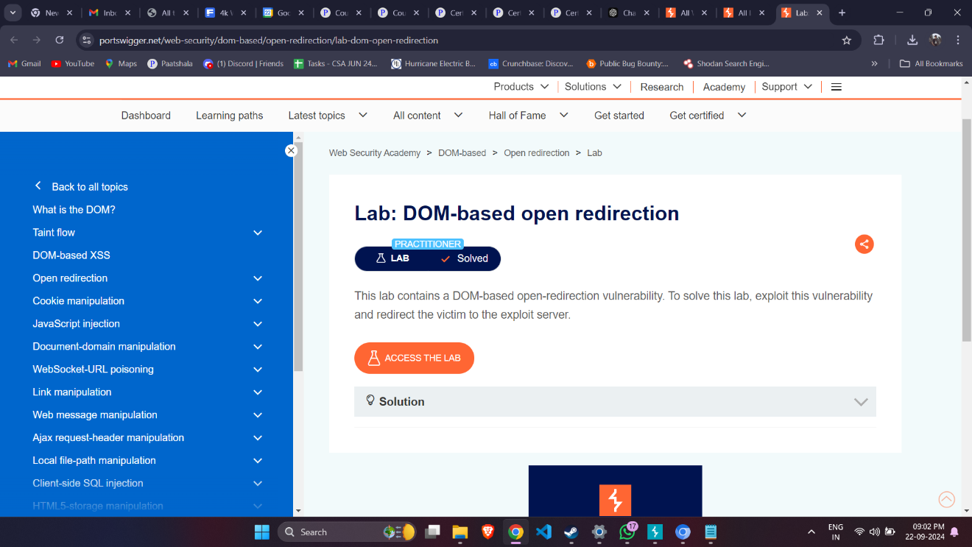

# BASIC SSRF

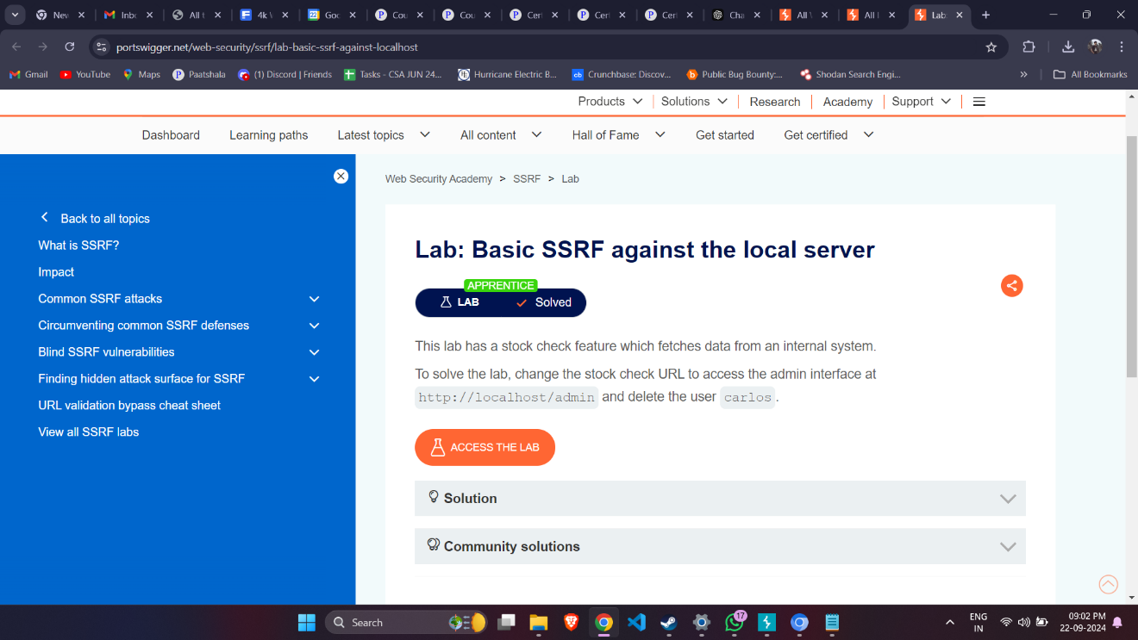

# OS COMMAND INJECTION

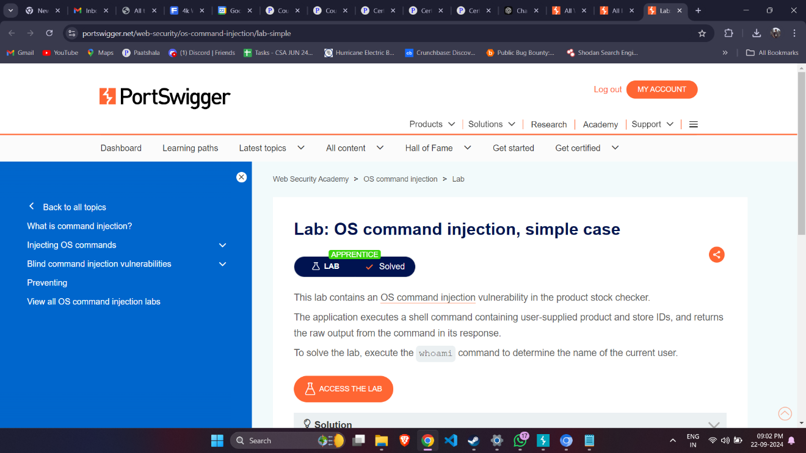

# BASIC SERVER-SIDE INJECTION

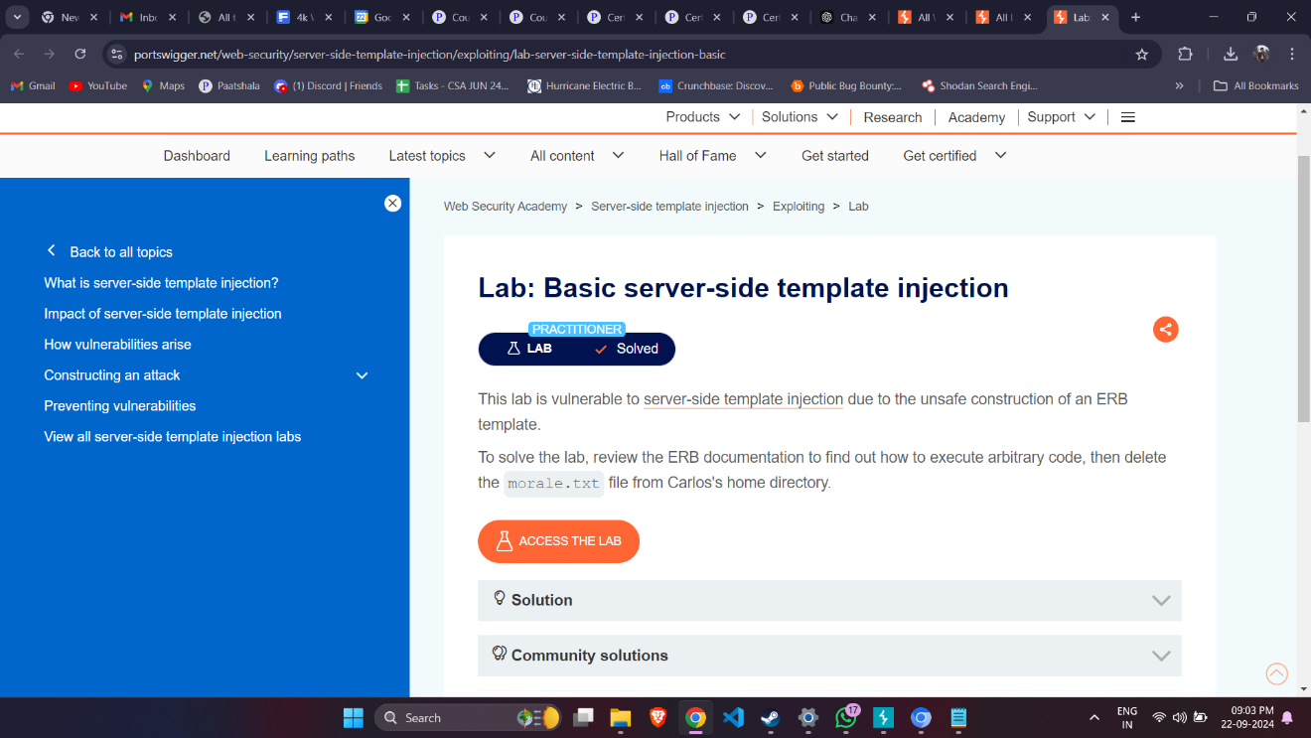

# FILE PATH TRAVERSAL

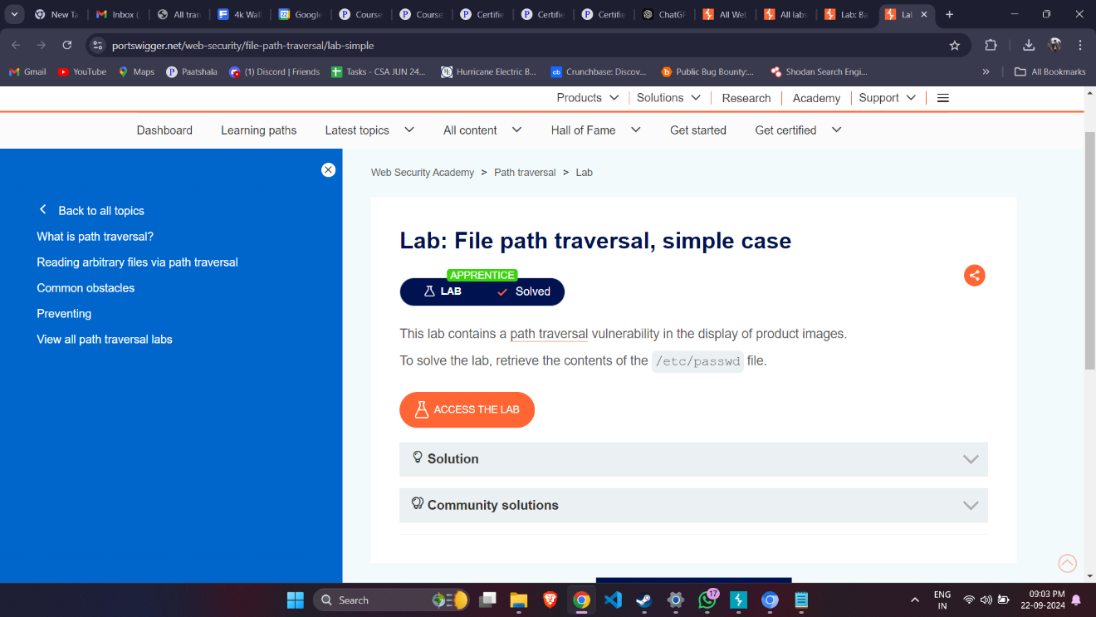

# BYPASS TWO-FACTOR AUTHENTICATION

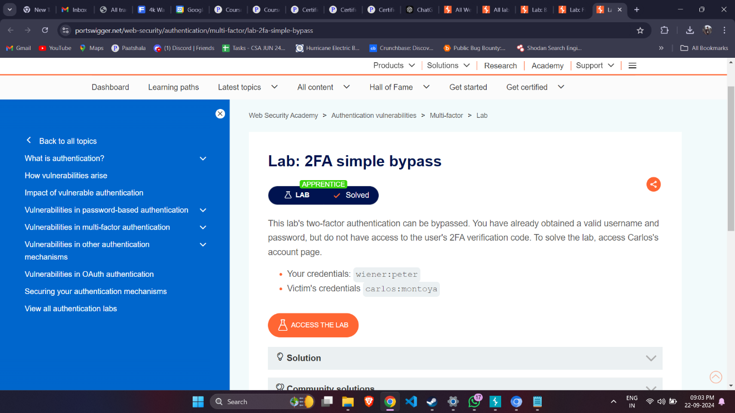

# BYPASS PASSWORD RESET POISONING

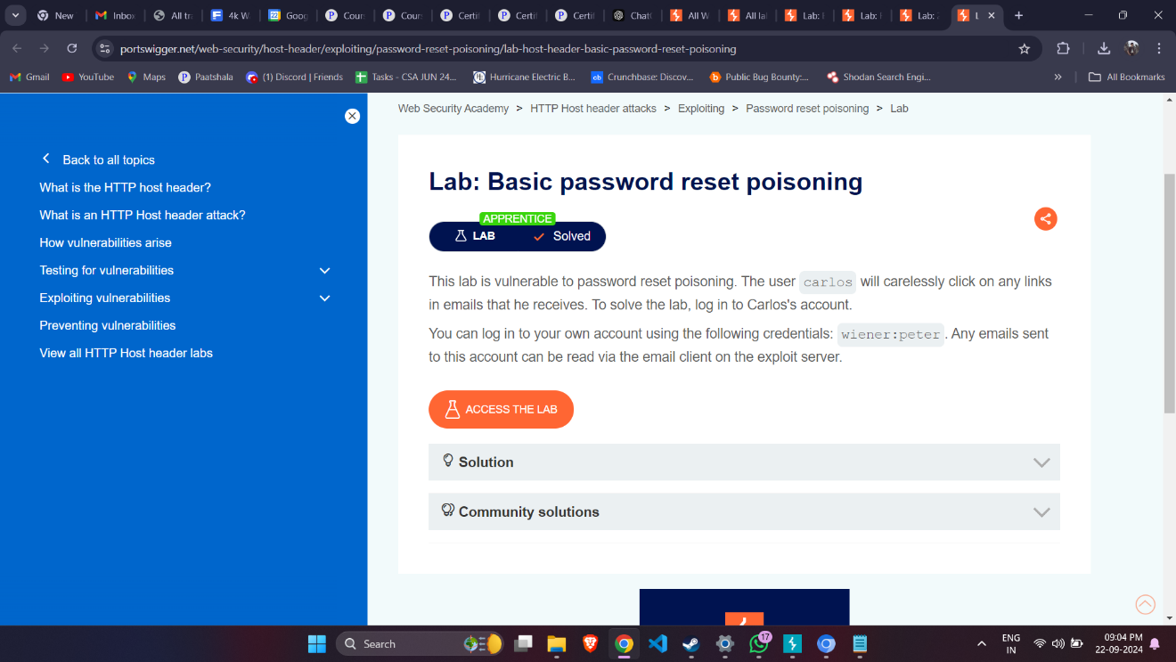

# REMOTE CODE EXECUTION

