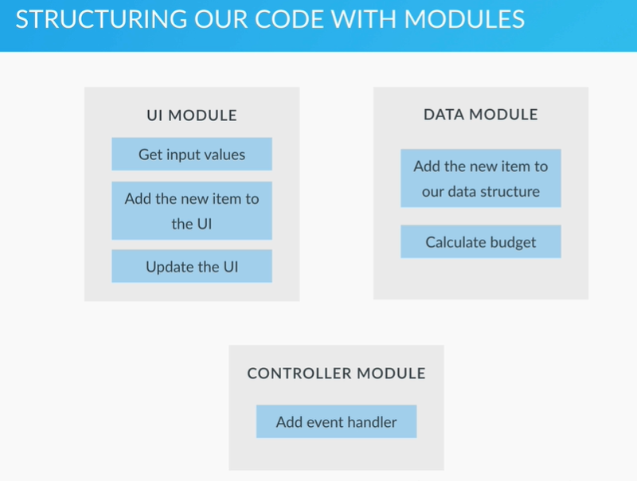

Event bubbling: when event if fired on a element, it is then fired on all its parent elements
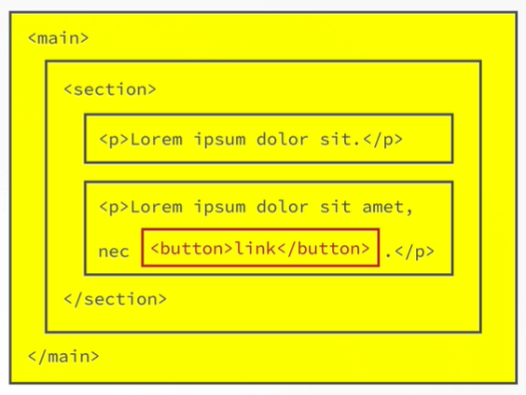

Event bubbling
All events are passed to parents so put bubble on parent so that if event is triggered it can be captured by parent and can remove the element
- So no need to attach to all item
- The item which are not present in DOM, for them
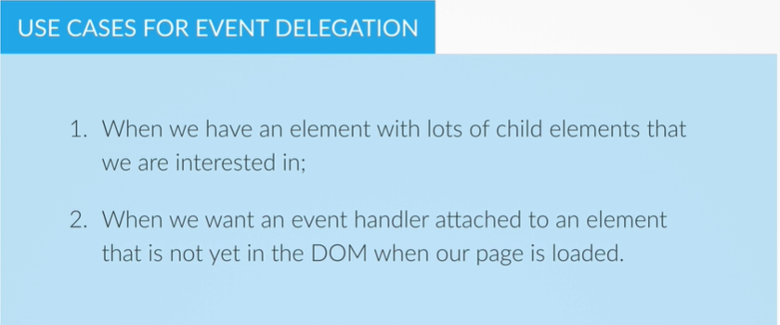

DOM traversing

Moving up in the DOM child parent

ASYNC JS

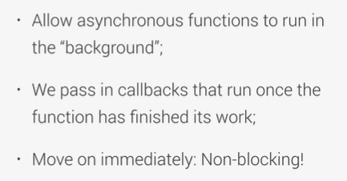
Set timeout is not part of javascript but can be included at runtime and it is part of web apis

Lec 121
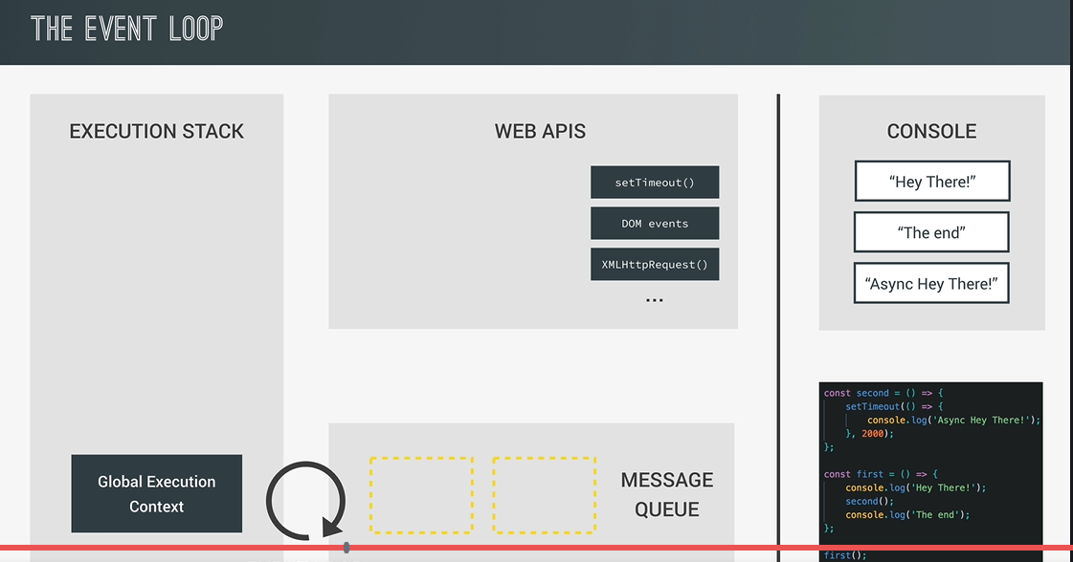

Callback hell: callback inside call back inside callback …
To remove this in es6 promised were introduces
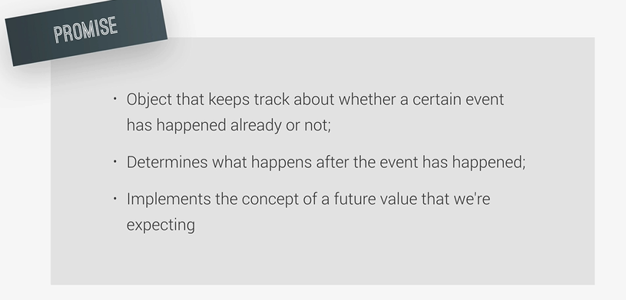
Read |cors mozilla developer
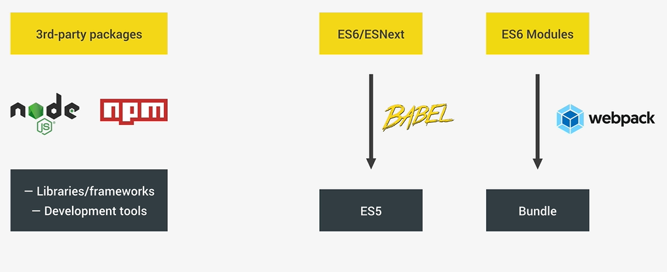
Tree shaking? algorithme
Lecture 130 about description
Lecture 132 about Node js and npm and webpack download
2 types of nodejs packages
- Libraries
- Development tools
First npm init
Save webpack as a dev dependency
Npm install webpack –save-dev
Jquery as a dependancy
Npm install jquery –save

All dependencies are stored in node_module for webpack and jquery
To share remove nodemodule folder and share
To install write npm install

Npm uninstall jquery –save
These are locally installed

To make them use globally using liveserver
Sudo npm install live-server –global

Create webpack config and export , webpack to use all js in other js using import export
4 core concepts of webpack
- Entry point
- Output
- Loader
- Plugin
Webpack.config.js
module.exports = {
};
In webpack 4 we have production and development mode
Then change package.json script
Also add webpack command line interface
Npm install webpack-cli –save-dev

Launch
Npm run dev ( script name given in package.json file )
In package.json
Script “dev”: “webpack –mode development”
“build”: “webpack –mode production”

Webpack dev server which saves all our code and converts it to bundle.js
Npm install webpack-dev-server –save-dev
Webpack.package.js
Devserver : { contentbase : ‘dir’ }
Add script in package.json
“start”: “webpack-dev-server –mode development –open”
Lec 135 issue output was not working with live server
So update webpack.config.js and make output path same as devserver contentbase
Plugin
Src is for development
Dist is for client
Plugin html-webpack-plugin
Npm install html-webpack-plugin –save-dev
Change webpack.config.js
Plugins : []
BABEL
To convert es6 to es5 and sass to css
Npm install babel-core babel-preset-env babel-loader –save-dev
Add loader to webpack.js
It also needs a babel congif
Something which cannot be converted as they were not present , like promise
Use polyfill
Npm install babel-polyfill –save
Add all babel add config add polyfil

Babel has been upgraded so @babel/core @babel/preset-env and in babel confir file change env to @babel/preset-env
MVC architecture
Model to define logic and data
View to change UI and all
Controller to produced result to main page
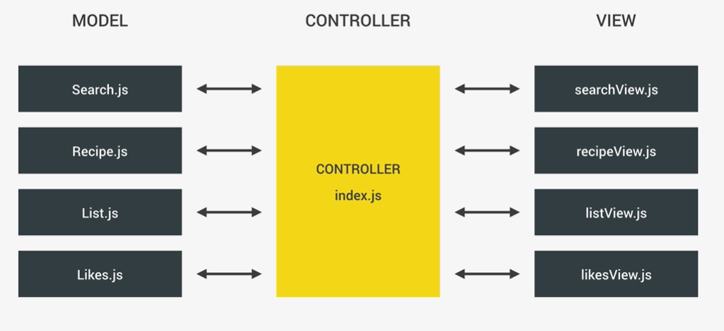

How es6 model works
Using default and export
Uppercase for models file name
For many exports it should be named export
Fetch issues does not work with all browsers
Axios is better with error handling
Download axios

Search controller :- concept of application state and
All current values are stored in a state like shopping list, all recipes, all results , all likes , etc
An object for all data in same, redux a state management library for react
All eventlistener in controller
Index.js is controller
NOTE: on submit the page reloads so to stop it, e.preventdefault() is used
Lec 143
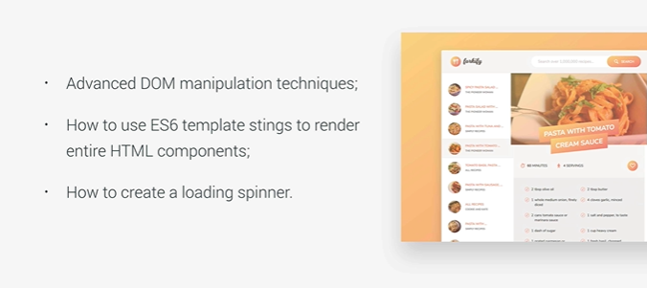

Array.foreach(FUNCTION NAME) will directly pass values to function one by one and perform

Pagination:
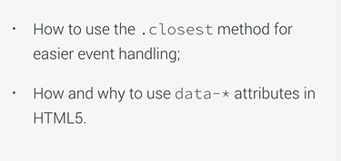

Button click is varied as we can click on span button and svg
So to get the main closest method is used.
-----------------------------------------------------------
Controller for recipe lec 48
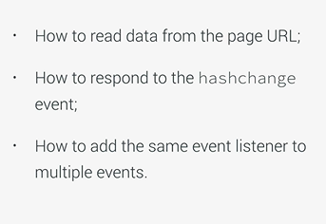
hashChange event
lec 149
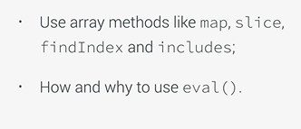

Join is a method of array not for strings
So in lecture 150 while rendering, we should first map the vals and then join them as the map returns array and in out case array of string containing each ingi element
Fraction .js
Check recipeview
Lecture 152 :
New method of event delegation matches

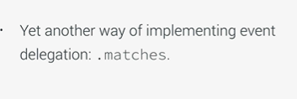
Lec 153 shopping list
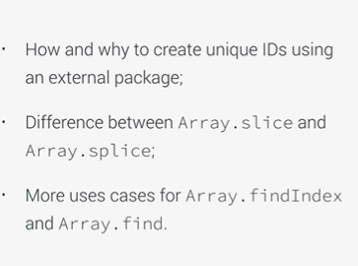

uniqueID package

lec 159
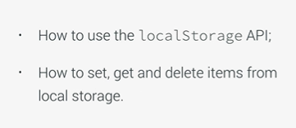

To do
