**Soda Vendor App**

**< Shyam Karla >**

**Implementation method:**

**Operating steps:**

Soda Vendor App will serve the users with different flavours of Soda and same App can be used by Admin team to maintain the inventory.Below is the welcome page of our App.

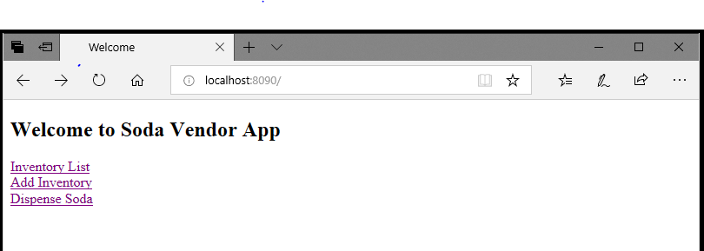

The hyperLinks **Inventory List** and **Add Inventory** is usefuel for Admin team to maintain the inventory .Dispense Soda hyper link is useful for end users to get their faviorate flavour of soda.

**Add Inventory :**

This view is useful to create inventory.

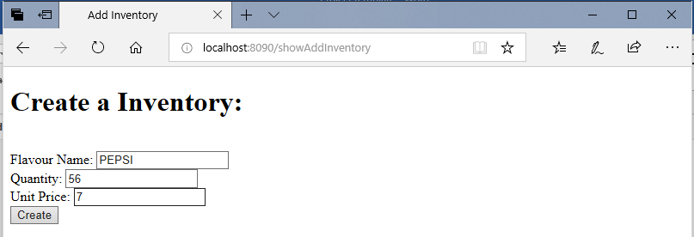

**Inventory List:** This view is useful to see the all inventory in the system.

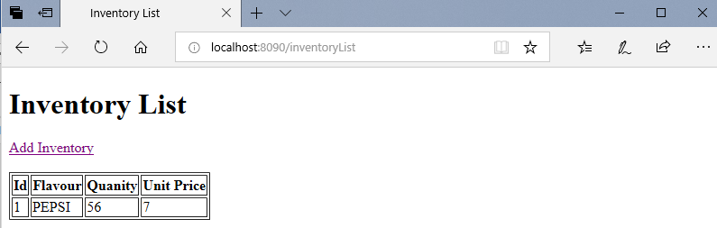

**Dispense Soda:**

This view is used to dispnse the soda of use choice.

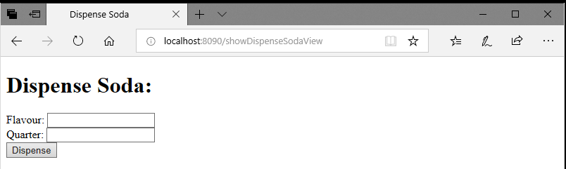

Once the user enters the Flavour and amount and click on Submit

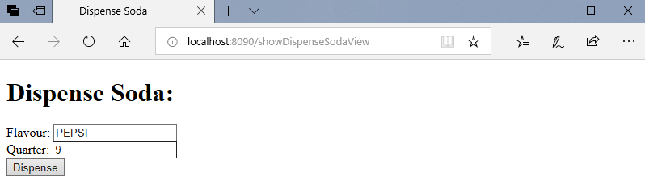and if evything is success then you will get below view with message saying amount to b returned.

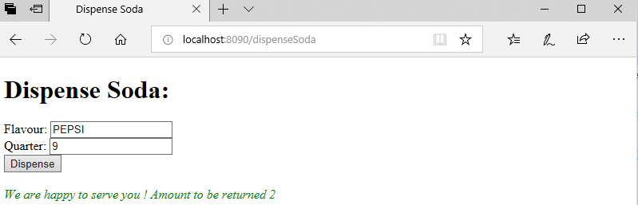

And now if you see the **Inventory List** page the quantity will be updated with orders served.

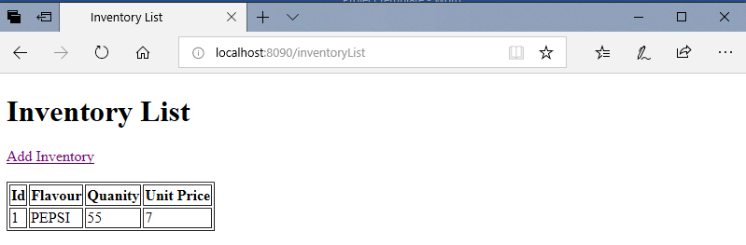and the Soda_Transaction table will have the transacion peformed by each user.

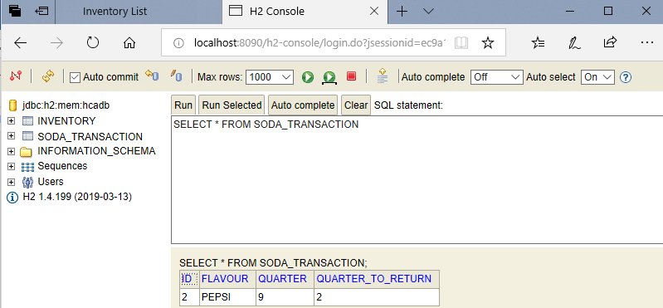

If the end user enters the Less amount than the unit price of particular soda then user willl get below error message

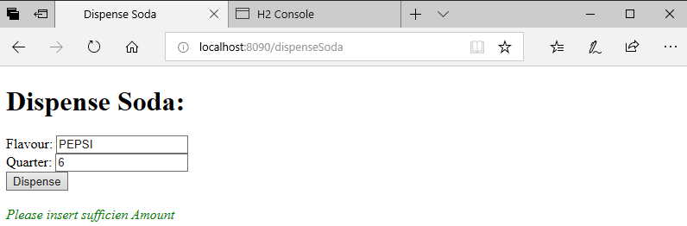

And one more scenario where qunatity of Falvour ordered by user is zero then user will get below message.

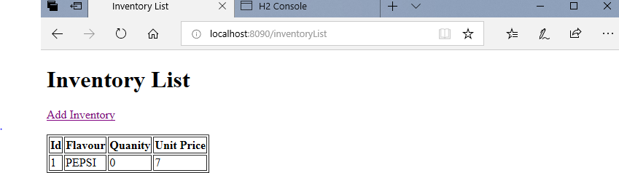

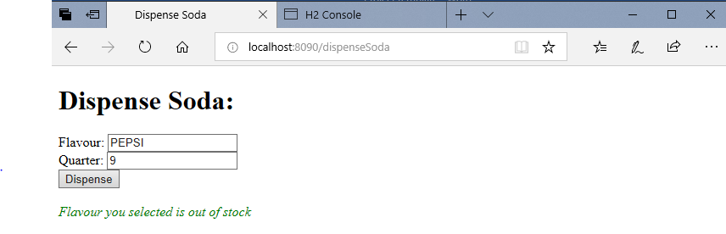

1. **Design Considerations:**

**Technical Considerations:**

This App is built on top of the below technologies

Spring Boot

Spring MVC -Controller

H2 Database-In-memory Database

Thyme leaf –UI

1. **Technical Architecture Design:**

1. Web Development

2 .Spring Core Support

3. Admin Features

4. Externalized Configuration

5. Embedded Web container

6. Security

7. Thyme leaf Template for UI

8. H2 In-memory Database