**Wolf Inns Database System**

For Wolf Inns Hotel Chain

CSC 540: Database Management Concepts and Systems

Project Report #1 Corrections

Project Team # 7:

   Sachin Kumar

   Shubhankar Reddy Katta

   Shyam Prasad Katta

   Qaiss Khan Alokozai

**5) Application Program Interfaces**

Information Processing

Correction : way of customer to get preferred room type explained

Note: we are assuming the category of the room to be only type of preference, hence we allow checking based on it.

checkAvailability(Hid,category)

return a list of all available room numbers in the current hotel which belong to the category specified, one of the room numbers in the result will in turn be used to assign the room to the customer.

Maintaining Billing Accounts

Correction:explanation of total amount and itemized receipt included

generateBill(reservation, billingAddress, paymentType)

returns an itemized receipt (which includes the total, and component wise breakdown of it)

* prints the itemized receipt of services used ,room stay,discount and total

**7) Local E/R Diagrams**

In the below E/R diagrams and throughout the document  is equivalent to  (as the software didn’t permit us to draw the curved arrow).

Corrections:

* Room category included in diagram
* Correct pointers used in Service Staff ER

Executive Manager:

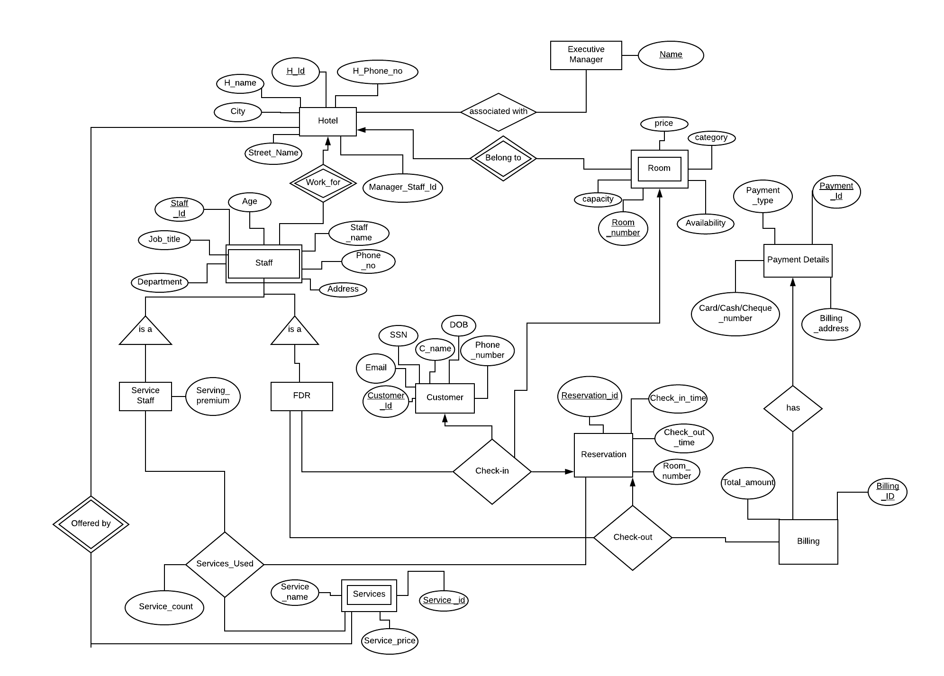

Manager

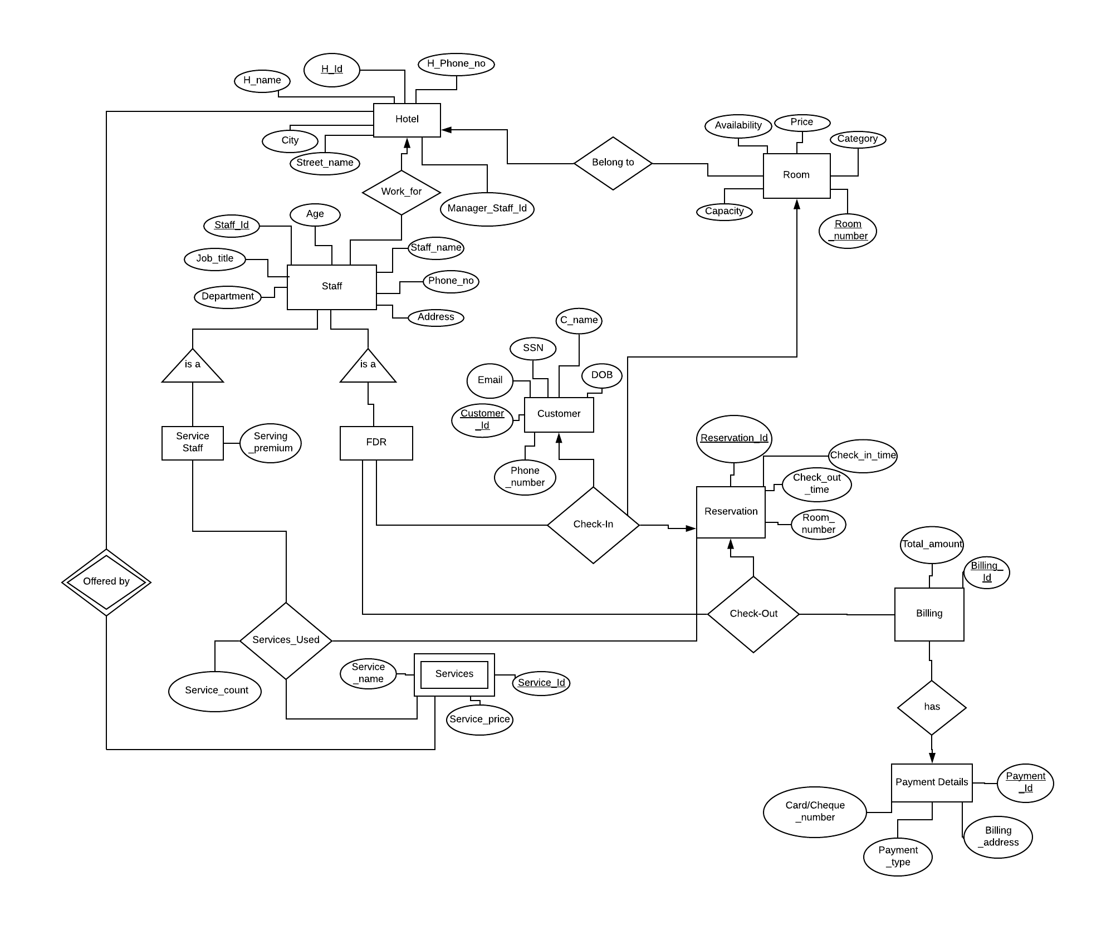

Front Desk Representatives



Service Staff

Note: In below diagram Yellow arrow indicates the change made

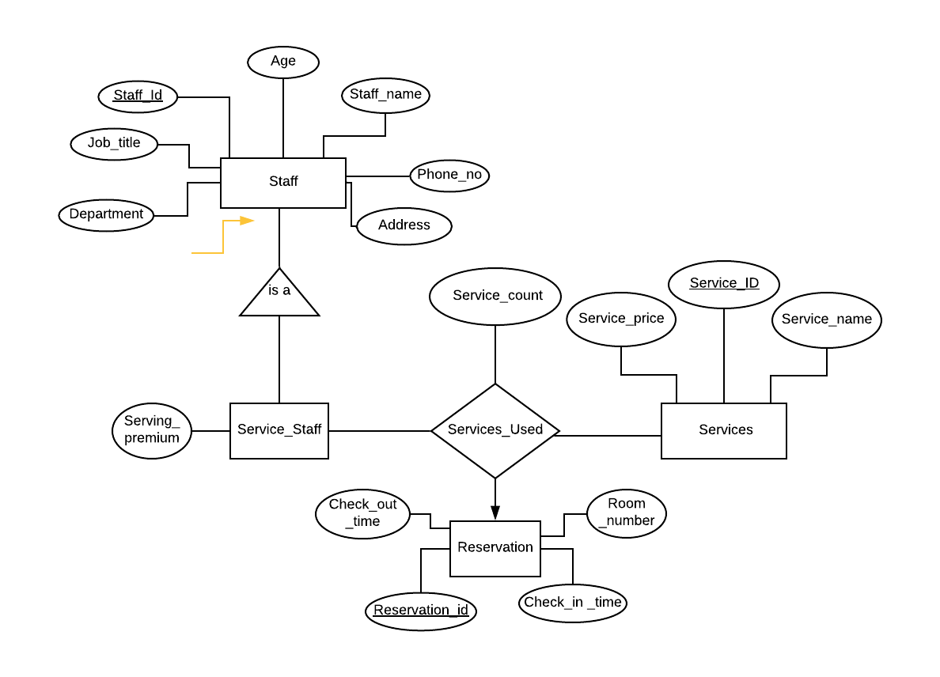

**9) Local Relational Schemas**

Executive Manager:

Executive_Manager(Name)

associated_with(H_Id,EM_Name)

Hotel(H_ID, H_name, Manager_Staff_Id, H_Phone_no, City, Street_Name)

Staff(Staff_Id, H_Id, Staff_name, Age, Address, Department, Job_title, Phone_no)

Service_staff(H_Id, Staff_Id, Serving_premium)

FDR(H_Id, Staff_Id)

Customer(Customer_ID, Email, SSN, C_Name, DOB, Phone_Number)

Reservation(Reservation_ID, Check_in_time, Check_out_time, Room_number)

Room(Room_number, H_Id,Price, Category, Capacity, Room_Number,Availability)

Billing(Billing_ID, Total_amount)

Payment_details(Payment_Id, Billing_address, Payment_type, Cash/Card/Cheque_number)

has(Billing_ID, Payment_ID)

CheckIn(Staff_ID, Hotel_Id, Customer_ID, Room_number, Reservation_ID)

CheckOut(Staff_ID, Hotel_Id,Reservation_ID,Billing_ID )

Services(Service_name, Service_price, Service_Id, H_Id)

Services_Used(Staff_Id, H_Id, Service_count, Reservation_Id, Service_Id)

Manager:

Hotel(H_ID, H_name, Manager_Staff_Id, H_Phone_no, City, Street_Name)

Staff(Staff_Id, H_Id, Staff_name, Age, Address, Department, Job_title, Phone_no)

Service_staff(H_Id, Staff_Id, Serving_premium)

FDR(H_Id, Staff_Id)

Customer(Customer_ID, Email, SSN, C_Name, DOB, Phone_Number)

Reservation(Reservation_ID, Check_in_time, Check_out_time, Room_number)

Room(Room_number, H_Id,Price, Category, Capacity, Room_Number,Availability)

Billing(Billing_ID, Total_amount)

Payment_details(Payment_Id, Billing_address, Payment_type, Cash/Card/Cheque_number)

has(Billing_ID, Payment_ID)

CheckIn(Staff_ID, Hotel_Id, Customer_ID, Room_number, Reservation_ID)

CheckOut(Staff_ID, Hotel_Id,Reservation_ID,Billing_ID )

Services(Service_name, Service_price, Service_Id, H_Id)

Services_Used(Staff_Id, H_Id, Service_count, Reservation_Id, Service_Id)

Front Desk Representatives:

Hotel(H_ID, H_name, Manager_Staff_Id, H_Phone_no, City, Street_Name)

Staff(Staff_Id, H_Id, Staff_name, Age, Address, Department, Job_title, Phone_no)

Service_staff(H_Id, Staff_Id, Serving_premium)

FDR(H_Id, Staff_Id)

Customer(Customer_ID, Email, SSN, C_Name, DOB, Phone_Number)

Reservation(Reservation_ID, Check_in_time, Check_out_time, Room_number)

Room(Room_number, H_Id,Price, Category, Capacity, Room_Number,Availability)

Billing(Billing_ID, Total_amount)

Payment_details(Payment_Id, Billing_address, Payment_type, Cash/Card/Cheque_number)

has(Billing_ID, Payment_ID)

CheckIn(Staff_ID, Hotel_Id, Customer_ID, Room_number, Reservation_ID)

CheckOut(Staff_ID, Hotel_Id,Reservation_ID,Billing_ID )

Services(Service_name, Service_price, Service_Id, H_Id)

Services_Used(Staff_Id, H_Id, Service_count, Reservation_Id, Service_Id)

Service Staff:

Staff(Staff_Id, Staff_name, Age, Address, Department, Job_title, Phone_no)

Service_Staff(Staff_Id, Serving_premium)

Services(Service_price, Service_Id, Service_name)

Reservation(Reservation_Id, Room_number, Check_in_time, Check_out_time)

Services_used(Service_count, Reservation_Id, Service_Id, Staff_Id)