**Wolf Inns Database System**

For Wolf Inns Hotel Chain

CSC 540: Database Management Concepts and Systems

Project Report #1

Project Team # 7:

Sachin Kumar

Shubhankar Reddy Katta

Shyam Prasad Katta

Qaiss Khan Alokozai

**1) Assumptions and Problem Statement**

Assumptions

1. Executive Manager is administrator of all the hotels belonging to WolfInn chain of hotels.
2. There is only one Executive Manager for WolfInn chain of hotels.
3. We will be having a global Services table with services description defined for service id used in the project.
4. Each hotel has only one manager.
5. Manager is uniquely identified by manager_staff_id provided in hotel entity.
6. For all the local ER diagrams except that of Executive Manager, the diagram is represented for single hotel only.
7. Reports are not shown in the ER diagrams as we will be generating reports by joins across multiple tables ,so since there is no dedicated table associated with it,hence it is not worthwhile showing it on ER diagram.
8. In every local ER diagram we are just showing functionality applicable to that user and other detailed functionalities are shown in respective local diagrams.
9. Manager is the administrator of a particular hotel records, to which he is associated with.
10. Every relation will have a table associated with it storing keys of entities to the relations.
11. A master list of Services offered by a particular hotel and their associated prices is created.
12. All Services are offered only during the office hours and the customer has to explicitly avail the service by requesting the associated service staff personnel.
13. Dedicated Staff means that staff is assigned to a reservation for its entire duration of existence,with that particular staff is unable to serve other reservations for that duration. However non-dedicated staff can serve more than one reservations.
14. There will be a flat rate fee for service availed charged on the day that service was availed,so you can avail this service many times on a particular day but a flat rate will be added to your reservation when you use for first time on that day. ??
15. A flag (Serving_premium) column will be maintained in service staff table to keep track of people who’re assigned to the presidential suite.
16. Prices vary by location and type of services offered. We maintain two global tables price_by_location and price_by_room_class.
17. A room unit prices is calculated by summation of price by its location and class of the services of a room.
18. Executive manager can add entries in the prices tables by region and category. In case of price absence we use default prices.
19. It is assumed that these two tables( price_by_location and price_by_room_class) are global tables and are not represented in any ER diagrams.

Problem Statement

The WolfInns database will be used for the WolfInns Hotel Chain. The database system is going to be used by the management of WolfInns. The database will maintain information about hotel, customers,staff,rooms,billing,services,check-in and check-out. Each of the respective users of the database will have specific tasks and operations that they can perform.

When all the information for the hotel is managed by the database, it is a good idea because of the following reasons:

* Efficient retrieval of indexed records from database as compared to data stored on file system.
* Data analysis is faster and easier due to convenient accessibility of database.
* Conflicts and transactions management is easily handled in database as compared to file system.
* Reports can be easily generated for any time-frame and varied data sources as compared to file system.
* Updation of records is easier and free from anomalies in database.

**2) User Classes**

We believe that the four tasks listed in the Project Narrative reflect perfectly the three classes of users that our system will need to support.

**Executive Managers** are users who can generate and analyze reports on various aspects of all the hotels of WolfInn Chain. They are also administrators with access to all the records of all the hotels associated with WolfInn chain.

**Managers** are users who can generate and analyze reports on various aspects of hotel. They are also administrators with access to all the records of the hotel they are associated with.

**Front-desk Representatives** are users that can register customers , process check-ins and check-outs, assign customers and bill customers.

**Service Staff** are users that are responsible for entering and updating the services availed by customers.

**3) The Main Entities**

The five entities that are the most relevant to the tasks and operations required by our clients are the following.

**Hotels** – Location of the hotel along with the manager responsible for the hotel.

**Staff** –Store details of staff and which customers they currently serve or have served in case an issue arises.

**Rooms** –As prices change with respect to location and not all rooms are available at all hotels, we also need to keep a track of the rooms available at each hotel.

**Customers** –List and details of prospective/current customers in case the hotel wants to send out promotions, generate customized suggestions for their most frequently visiting customers.

**Payments/Reservations** –Calculate revenue and keep a track of which rooms were booked when and for what duration(Long term data analysis for expansion).

**4) A Usage Situation**

Information Processing: Mr Tom is just visiting the city for a conference and wanted to check-in into deluxe room of Wolf-inn hotel for two days,when he arrives on front-desk,representatives there just checked rooms availability and find out deluxe rooms are not available in the hotel for two days but economy room is available,so they assigned him economy room with his permission.

Reports: The hotel manager Mr.Brown wants to analyze customer trend on a seasonal basis to ensure that the hotel hires additional staff if there is a sudden increase in the number of customers visiting the hotel during the vacation/holiday season. Mr.Brown also wants to generate revenue/service usage reports on an annual basis to convince the stakeholders to invest in features which customers may require but the hotel isn’t providing right now.

**5) Application Program Interfaces**

Information Processing

newHotel(phone, street, city)

return HId or Failure for error

* a default managerid will be inserted for this hotel which can be updated later with actual managerid

editHotel(HId, phone, manager, street, city)

return confirmationMessage

deleteHotel(HId)

return confirmationMessage

newRoom(HId,capacity,price,category,availability=1)

return roomid or failure for error

editRoom(roomId,capacity,price,category,HId,availability)

return confirmationMessage

deleteRoom(roomId)

return roomid or failure for error

newCustomer(ssn, name, address,phoneNo , emailId)

return customerId or failure for error

editCustomer(customerId,ssn, name, address, phoneNo, emailId )

return confirmationMessage

deleteCustomer(ssn)

return confirmationMessage

newStaff(staffId, name,age, jobtitle, department,age,phoneno,address,hotelid)

return staffId or failure for error

editStaff(staffId, name,age, jobtitle, department,age,phoneno,address,hotelid)

return confirmationMessage

deleteStaff(staffId)

return confirmationMessage

checkIn(Hid,customerId,roomId,checkin,checkout)

returns reservation ID

* assigns the particular room to the customer and fills in details in reservation table

releaseRoom(roomId,HId)

return ConfirmationMessage

* sets availability to 1

Note: we are assuming the category of the room to be only type of preference, hence we allow checking based on it.

checkAvailability(Hid,category)

return a list of all available room numbers in the current hotel which belong to the category specified, of the room numbers in the result will in turn be used to assign the room to the customer.

Maintaining service records

addServiceto(reservationId,serviceId)

return confirmationMessage

addService(HID,serviceName,servicePrice)

return confirmationMessage

* updates the global service table to accomodate service provided by a branch of the hotel

updateService(reservationId,serviceId)

return confirmationMessage

Maintaining Billing Accounts

generateBill(reservation, billingAddress, paymentType)

returns an itemized receipt (which includes the total, and component wise breakdown of it)

* prints the itemized receipt of services used and stay

Reports

generateLocalReport(reportType, criteria,start_date, end_date)

return reportData

* criteria in input arguments can be either of customerid or Room_type (or) StaffId
* local report generated by hotel manager for his hotel
* can contain occupancy by hotel room,d
* for reporttype occupancy it will return occupancy for the criteria which can be roomtype for the provided date range
* for reporttype totaloccupancy it will return total occupancy and percentage of rooms occupied for the specified date range.
* for reporttype staff it will return staff for the hotel or roomid(to know the staff serving the customer in that room) provided as criteria.
* for reporttype revenue,it will return revenue earned for the date range provided.

generateGlobalReport(reportType,criteria,start_date,end_date)

return reportData

* criteria in input arguments can be either of HotelID (or) Room_type (or) city
* for reporttype occupancy it will return occupancy for the criteria which can be hotelid or roomtype or city for the provided date range
* for reporttype totaloccupancy and hotelid it will return total occupancy and percentage of rooms occupied for the specified date range.
* for reporttype staff it will return staff for the hotelid or roomid(to know the staff serving the customer in that room) provided as criteria.
* for reporttype revenue,it will return revenue earned for the hotelid and date range provided.

**6) Data Views**

Executive Manager

We are considering Executive Manager as administrator of all the hotels with access to all the functionalities of every hotel of WolfInn chain of hotels. To be specific, following are the concrete data the executive manager have access to

* Add/Update Hotel details
* Generate reports for all the Hotels or some particular Hotel and their further details like occupancy,staff details,rooms and services details.
* View list of rooms.
* View/Add/Remove the room from this system for that particular hotel.
* View/Add/Remove staff details for that particular hotel.
* View/Edit Billing information of customers.

Manager

We are considering Manager of a hotel to be administrator of a particular hotel with access to all the functionalities within the scope of that particular hotel. To be specific, following are the concrete data the manager have access to

* Generate reports for Hotel, occupancy, staff details,rooms and services details.
* View list of rooms.
* View/Add/Remove the room from this system for that particular hotel.
* View/Add/Remove staff details for that particular hotel.
* View/Edit Billing information of customers.

Front-Desk Representatives

Front-desk representative is designed to view and edit all the details related to rooms and customers. Specifically they can do the following:

* Check rooms availability.
* Check in and check out customers.
* Generate a detailed bill of services used and staff who’ve served the customer during the day.
* Book or Cancel reservations for customers.
* View/Edit/Generate Bills for Customers.

Service Staff

Service Staff shall be able to view or edit all the data related to services available and services availed by customers.Specifically they will be able to do following:

* Add Services details
* View/Edit Services availed by customer.

**7) Local E/R Diagrams**

In the below E/R diagrams and throughout the document  is equivalent to  (as the software didn’t permit us to draw the curved arrow).

Executive Manager:

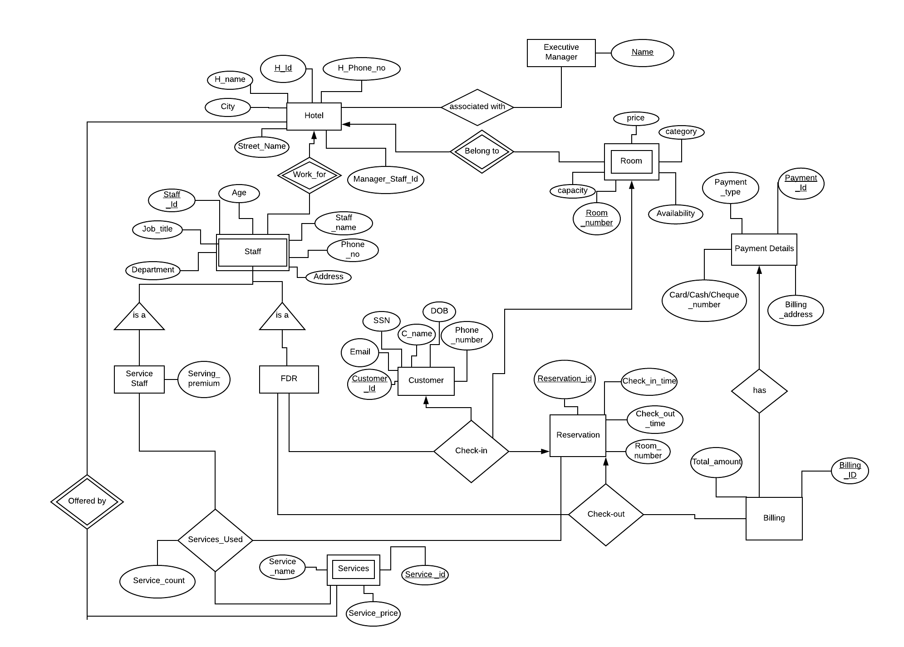

Manager

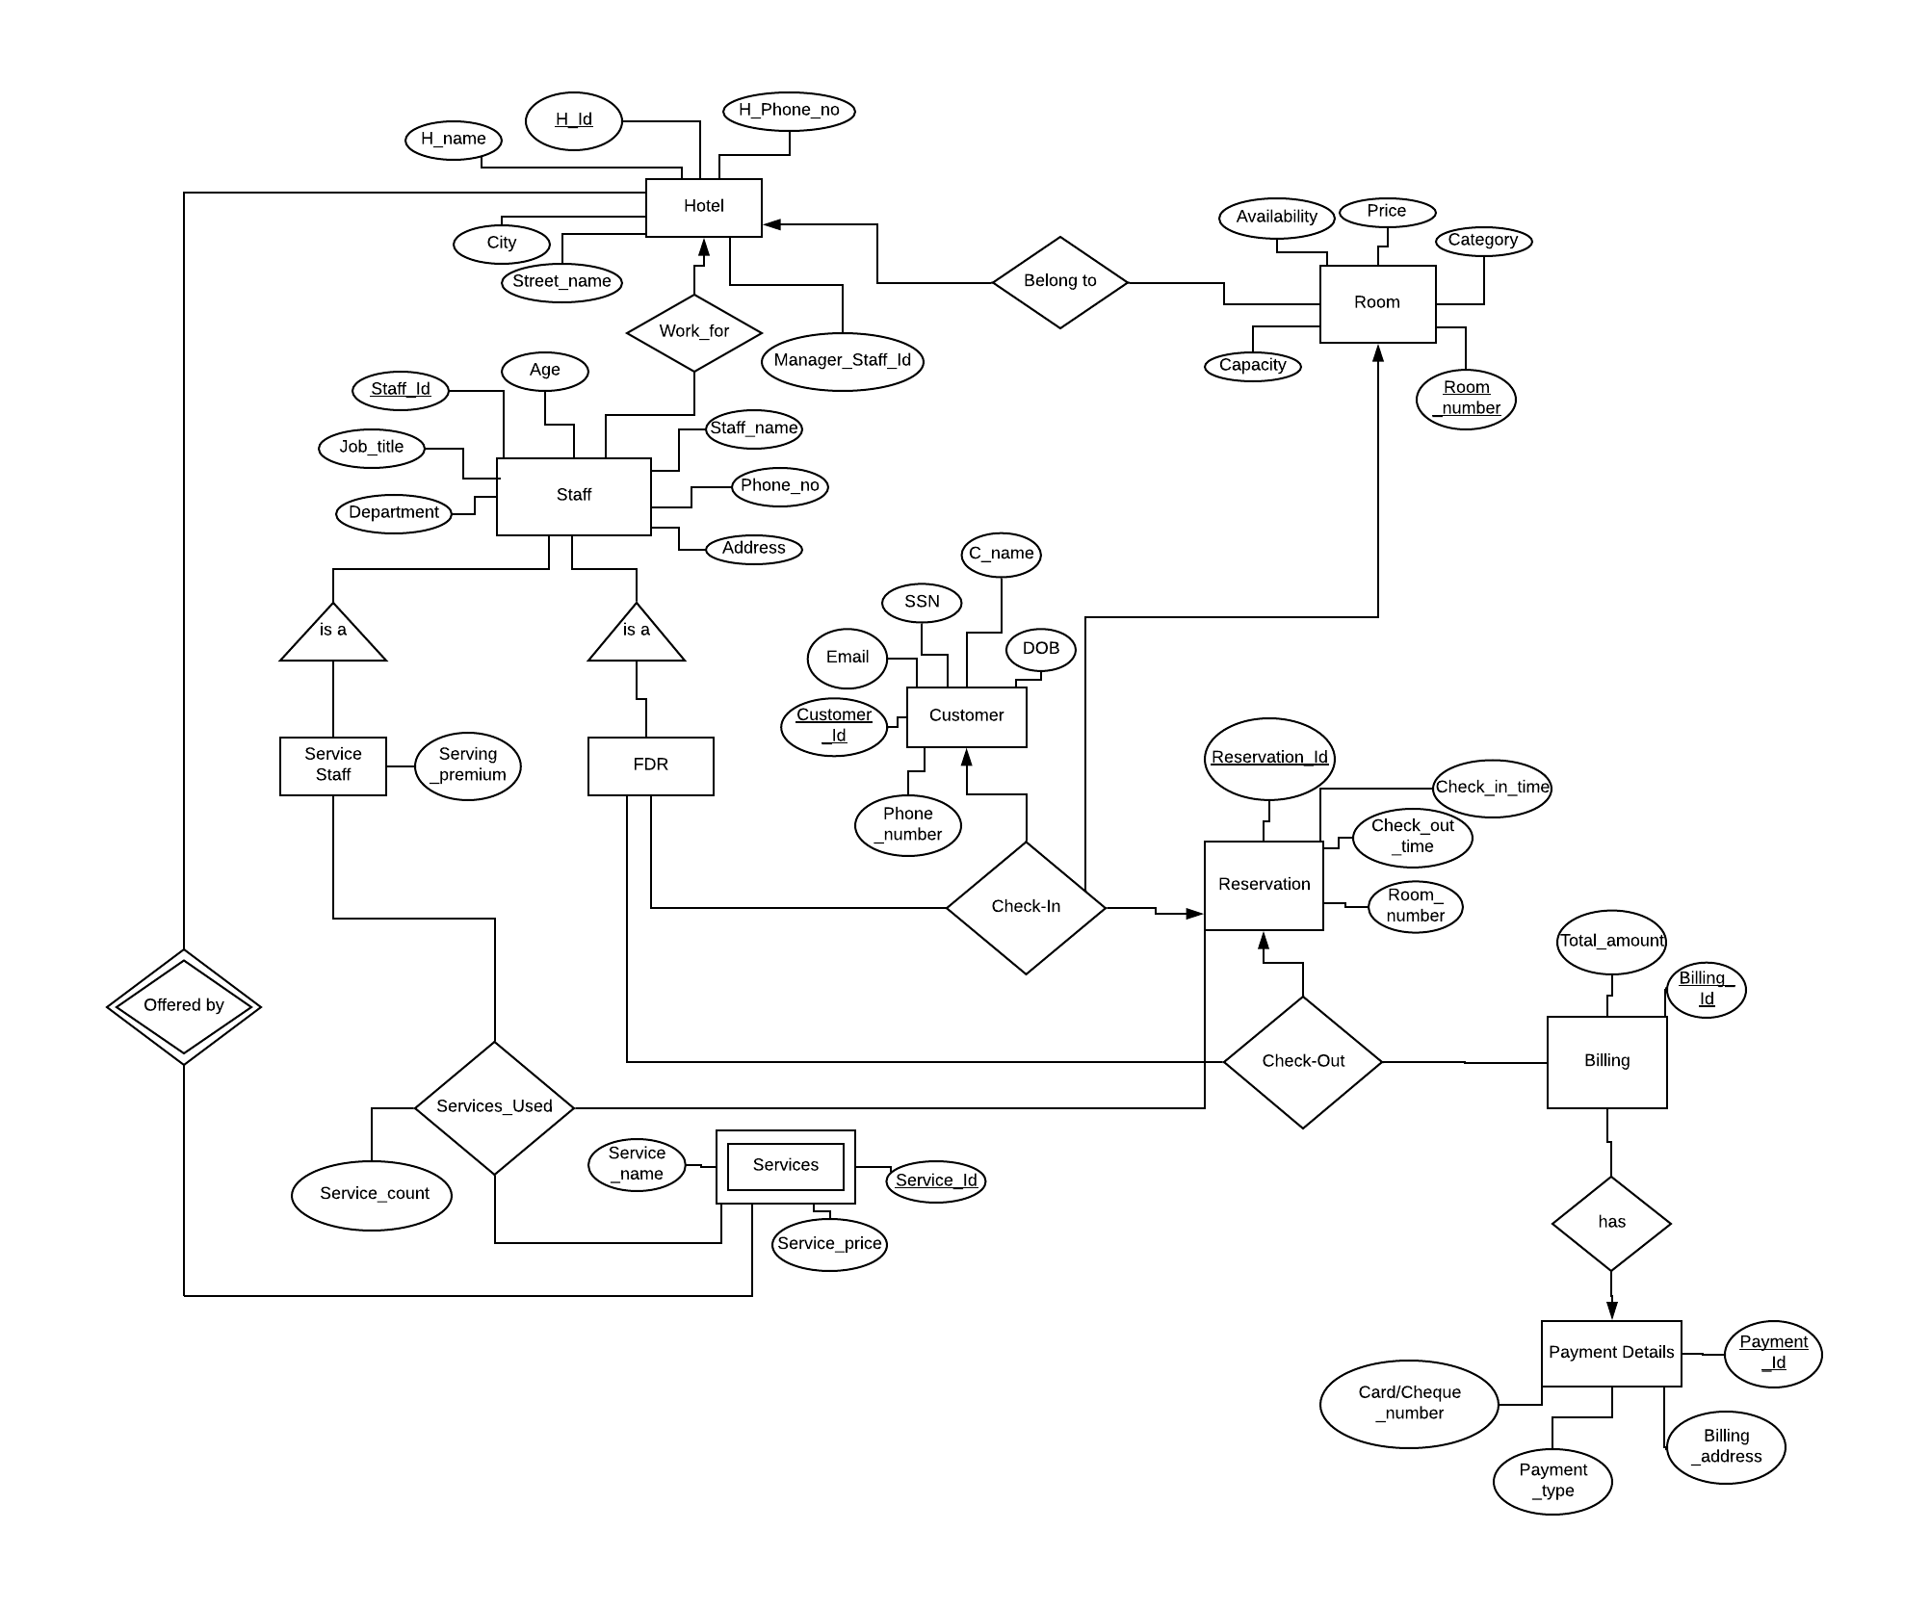

Front Desk Representatives



Service Staff

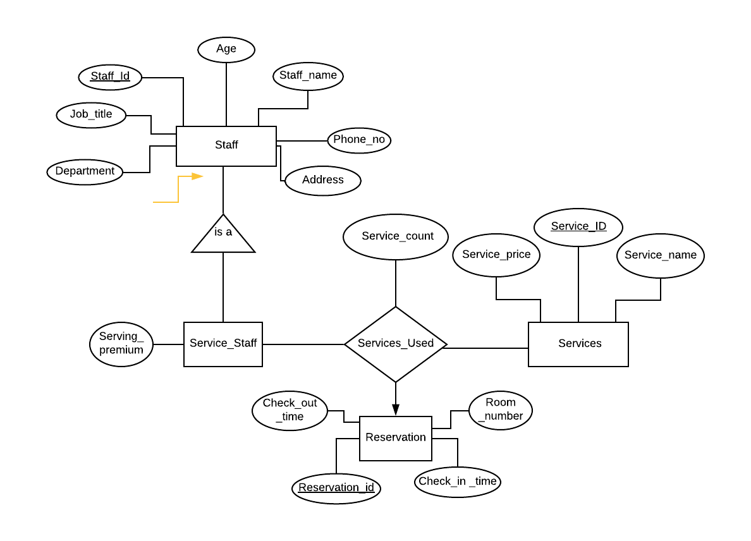

**8) Local E/R Documentation**

1. Employees working for the Wolf Inn hotels can be categorized as Executive Manager,Managers, Front Desk Representatives and Service Staff.
2. We chose to generate unique IDs as opposed to field keys in certain entities. Here are the reasons:

* *customer*: We chose to generate CID as this prevents the exposure of sensitive information such as SSN to the staff who are not authorized to see such information.
* *reservation*: A customer can make 2 reservations simultaneously, hence we have generated a unique ID for each reservation.
* *service*: We chose to generate service as there can be multiple services offered by hotel,so uniquely identifying every services helps in mapping to a reservation.

3. We made several decisions regarding relationship types and constraints:

* Work_for: Hotel can have multiple staff members working for it,staff members can work for only one hotel. It will be a weak entity-set in case of executive managers, so that staff can be uniquely identified across multiple hotels possible for executive managers.
* Services_Used: Service Staff can add many Services for a particular reservation with their staff id,a reservation with certain services can be provided by one or many service staff.
* Check-in: Front-desk representative can check-in a customer for a particular reservation,reservation for customers can be created by multiple Front-desk representatives.
* Check-out: Front-desk representative can check-out a reservation and generate bill, bill for a reservation can be generated by multiple Front-desk representatives.
* has: Bill can have only one payment details associated with it,payment details can be associated with more than one bill.
* Belong_to: Room can belong to one hotel,hotel can have more than one rooms.It will be a weak relation in case of executive managers where rooms can borrow hotel id to be uniquely identified.
* Offers: Services can be offered by a hotel, a hotel can offer certain services

**9) Local Relational Schemas**

Executive Manager:

Executive_Manager(Name)

associated_with(H_Id,EM_Name)

Hotel(H_ID, H_name, Manager_Staff_Id, H_Phone_no, City, Street_Name)

Staff(Staff_Id, H_Id, Staff_name, Age, Address, Department, Job_title, Phone_no)

Service_staff(H_Id, Staff_Id, Serving_premium)

FDR(H_Id, Staff_Id)

Customer(Customer_ID, Email, SSN, C_Name, DOB, Phone_Number)

Reservation(Reservation_ID, Check_in_time, Check_out_time, Room_number)

Room(Room_number, H_Id,Price, Category, Capacity, Room_Number,Availability)

Billing(Billing_ID, Total_amount)

Payment_details(Payment_Id, Billing_address, Payment_type, Cash/Card/Cheque_number)

has(Billing_ID, Payment_ID)

CheckIn(Staff_ID, Hotel_Id, Customer_ID, Room_number, Reservation_ID)

CheckOut(Staff_ID, Hotel_Id,Reservation_ID,Billing_ID )

Services(Service_name, Service_price, Service_Id, H_Id)

Services_Used(Staff_Id, H_Id, Service_count, Reservation_Id, Service_Id)

Manager:

Hotel(H_ID, H_name, Manager_Staff_Id, H_Phone_no, City, Street_Name)

Staff(Staff_Id, H_Id, Staff_name, Age, Address, Department, Job_title, Phone_no)

Service_staff(H_Id, Staff_Id, Serving_premium)

FDR(H_Id, Staff_Id)

Customer(Customer_ID, Email, SSN, C_Name, DOB, Phone_Number)

Reservation(Reservation_ID, Check_in_time, Check_out_time, Room_number)

Room(Room_number, H_Id,Price, Category, Capacity, Room_Number,Availability)

Billing(Billing_ID, Total_amount)

Payment_details(Payment_Id, Billing_address, Payment_type, Cash/Card/Cheque_number)

has(Billing_ID, Payment_ID)

CheckIn(Staff_ID, Hotel_Id, Customer_ID, Room_number, Reservation_ID)

CheckOut(Staff_ID, Hotel_Id,Reservation_ID,Billing_ID )

Services(Service_name, Service_price, Service_Id, H_Id)

Services_Used(Staff_Id, H_Id, Service_count, Reservation_Id, Service_Id)

Front Desk Representatives:

Hotel(H_ID, H_name, Manager_Staff_Id, H_Phone_no, City, Street_Name)

Staff(Staff_Id, H_Id, Staff_name, Age, Address, Department, Job_title, Phone_no)

Service_staff(H_Id, Staff_Id, Serving_premium)

FDR(H_Id, Staff_Id)

Customer(Customer_ID, Email, SSN, C_Name, DOB, Phone_Number)

Reservation(Reservation_ID, Check_in_time, Check_out_time, Room_number)

Room(Room_number, H_Id,Price, Category, Capacity, Room_Number,Availability)

Billing(Billing_ID, Total_amount)

Payment_details(Payment_Id, Billing_address, Payment_type, Cash/Card/Cheque_number)

has(Billing_ID, Payment_ID)

CheckIn(Staff_ID, Hotel_Id, Customer_ID, Room_number, Reservation_ID)

CheckOut(Staff_ID, Hotel_Id,Reservation_ID,Billing_ID )

Services(Service_name, Service_price, Service_Id, H_Id)

Services_Used(Staff_Id, H_Id, Service_count, Reservation_Id, Service_Id)

Service Staff:

Staff(Staff_Id, Staff_name, Age, Address, Department, Job_title, Phone_no)

Service_Staff(Staff_Id, Serving_premium)

Services(Service_price, Service_Id, Service_name)

Reservation(Reservation_Id, Room_number, Check_in_time, Check_out_time)

Services_used(Service_count, Reservation_Id, Service_Id, Staff_Id)

**10) Local Schema Documentation**

Local schemas were created to adjust the additional perspectives which will be addressed later for the project.

* Relation was composed for every entity set with the exactly same set of attributes
* Relationships were replaced by a relation whose attributes are the keys for the connected entity sets

The E/R viewpoint was used to convert the subclasses of the entity set of different users into relations. This method was used for the following reasons:

* The system can differentiate between executive manager, managers, front desk representatives and service staff
* All people including managers, front-desk representatives, and service staff can be referenced from one table which reduces join operations in most reports mentioned above.