Tigers - Panthera Tigris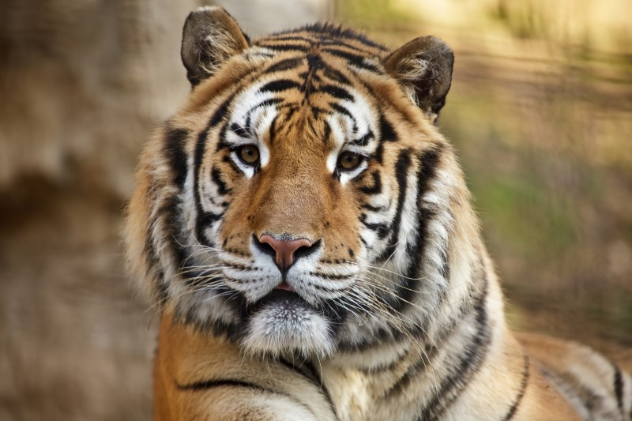

Tigers

Tigers are a carnivore, with hunter sharp teeth, muscular body, and strong jaws. They are a species of cat, which colors varies between different shades of orange and brown with black stripes and some white, each kind are unique.

Habitat

Tigers are found in many different habitats theses habitats differ in climate and by its environment. They live in rainforests, grasslands, savannas, and swamps in countries like Russia, China, India, Nepal, Vietnam, Malaysia, and Indonesia.

What Happened to Tigers?

Tigers are an Endangered species; professionals have been keeping track and realized that the population of the tigers have been decreasing.

Why are they Endangered?

Tigers have been impacted by poaching, habitat loss, climate change, human conflict, and illegal hunting.

Diet

Tigers eat pigs, deer’s, buffalo and antelope, wild tigers are known to attack and feast on humans.

Predators

Usually, tigers do not have any predators but big animals like buffalos, bears, elephants can be a threat.

Importance

Since the tigers are at the top of the food chain, they keep their preys under control, without tigers the ecosystem would be unbalanced.