DIT UNIVERSITY, DEHRADUN
School of Computing

UCF 439 – Capstone Project

Phishing Website Detection Using Machine Learning

Project Report Submitted in Partial Fulfilment of the Requirements
for the Degree of

Bachelor of Technology
in
Computer Science and Engineering

Submitted by

Shyam Kumar (SAP ID: 1000019134)
Subash Yadav (SAP ID: 1000019239)
Pintu Kumar (SAP ID: 1000019305)

Under the Supervision of
Dr. Anuj Kumar Yadav
Associate Professor, School of Computing

DECLARATION
We declare that this written submission represents our ideas in our own words and where others' ideas or words have been included, we have adequately cited and referenced the original sources. We also declare that we have adhered to all principles of academic honesty and integrity and have not misrepresented or fabricated or falsified any idea/data/fact/source in our submission. We understand that any violation of the above will be cause for disciplinary action by the University and can also evoke penal action from the sources which have thus not been properly cited or from whom proper permission has not been taken when needed. The plagiarism check report is attached at the end of this document.

Name of the Student: Shyam Kumar
Signature and Date: _____________________
Name of the Student: Subash Yadav
Signature and Date: _____________________
Name of the Student: Pintu Kumar
Signature and Date: _____________________

ACKNOWLEDGEMENT

This project has demanded significant dedication from our team, and its success would not have been achievable without the generous support and assistance of numerous individuals. Our sincere appreciation goes out to each and every person who contributed.

Foremost among our expressions of gratitude is directed to Dr. Anuj Kumar Yadav, our project guide. We extend our thanks for his invaluable guidance in propelling our study forward. His commitment of time and attention, along with a systematic approach, played a crucial role in ensuring the timely completion of our tasks.
We also extend our gratitude to all Faculty-In-Charges and the Faculty Coordinator of the Capstone Project at DIT University for their well-organised conduct of evaluations and for maintaining a structured academic environment throughout the semester.

Additionally, we extend our gratitude to all project members. Without their unwavering support and hard work, the progress achieved in this project would not have been possible.

Shyam Kumar (1000019134)
Subash Yadav (1000019239)
Pintu Kumar (1000019305)

TABLE OF CONTENTS

CHAPTER Page No.
Chapter 1: Introduction 4 - 7
1.1 Problem Statement
1.2 Objectives
1.3 Overview
Chapter 2: Literature Review 8

Chapter 3: Related Work / Survey 9 - 10
3.1 Background Related Work
3.2 Review of Existing System
3.3 Advancements in the Field

Chapter 4: Project Description
4.1 System Overview 11 - 13
4.2 Processing Workflow
4.3 Role-Based Features
4.5 User Interface Design
4.6 Scaling and Performance Considerations

Chapter 5: Implementation 14 - 21
5.1 Overview of Implementation
5.2 Backend Implementation (Flask + ML Model)
5.3 Frontend Implementation (User Interface)
5.4 Chrome Extension Implementation
5.5 URL Processing and Feature Extraction Implementation
5.6 API Integration and Communication
5.7 Integration of ML and Rule-Based Systems
5.8 Error Handling and Debugging

Chapter 6: Challenges Faced and Overcome 22 - 23
6.1 URL Processing and Data Handling Challenge
6.2 Frontend and User Experience Challenges

Chapter 7: Summary and conclusion 24-26
7.1 Technical Achievements
7.2 Training Impact
7.3 Limitations
7.4 Concluding Remarks

Chapter 8: Scope for future work 27

References 28

CHAPTER 1: INTRODUCTION

The rapid growth of internet usage has significantly increased the risk of cyber threats, among which phishing attacks are one of the most common and dangerous. Phishing is a type of cyberattack in which attackers create fraudulent websites that mimic legitimate platforms such as banking portals, social media sites, or e-commerce services. The primary goal of these attacks is to deceive users into providing sensitive information such as usernames, passwords, credit card details, and personal identification data.
Traditional phishing detection systems largely depend on blacklist-based approaches, where previously identified malicious URLs are stored and compared against incoming URLs. However, this approach has major limitations. Phishing websites are often short-lived and can be generated rapidly, making it difficult for blacklist systems to keep up. As a result, newly created phishing websites, also known as zero-day attacks, often bypass traditional detection mechanisms.
To address these challenges, the PWD AI system is designed as a real-time phishing detection solution that uses a hybrid approach combining machine learning and rule-based logic. Instead of relying solely on known malicious URLs, the system analyzes the structural and lexical characteristics of a URL to determine whether it is safe or potentially harmful. This enables the system to detect even previously unseen phishing attempts.
The system consists of a web interface and a Chrome extension that continuously monitors user activity. When a URL is entered or visited, it is analyzed using feature extraction techniques, and a trained machine learning model predicts its legitimacy. Additionally, rule-based checks are applied to detect specific phishing patterns such as brand impersonation, suspicious keywords, and credential injection attacks.
The output is presented in a user-friendly manner, including a classification (Safe, Dangerous, or Invalid), a risk score, and highlighted suspicious parts of the URL. This not only improves detection accuracy but also enhances user awareness and understanding.
Overall, PWD AI provides a fast, efficient, and explainable solution for phishing detection, making it highly suitable for real-world deployment in modern web environments.

1.1 Problem Statement
Phishing attacks pose a significant threat to internet users and organizations worldwide. Attackers exploit human psychology by creating websites that closely resemble trusted platforms, thereby tricking users into sharing confidential information. These attacks can lead to financial loss, identity theft, and unauthorized access to sensitive systems.
One of the major challenges in phishing detection is the dynamic nature of phishing websites. Attackers frequently generate new domains, modify URL structures, and use obfuscation techniques such as character substitution (e.g., replacing “o” with “0”) to evade detection. As a result, traditional detection methods, especially blacklist-based systems, are often ineffective against newly created phishing sites.
Another issue is the high rate of false positives in many detection systems. Some systems incorrectly classify legitimate websites as phishing, which reduces user trust and usability. Additionally, many existing systems lack transparency, meaning users do not understand why a particular website is flagged as unsafe.
There is also a need for real-time detection. Many users fall victim to phishing attacks because they are not warned at the exact moment they access a malicious website. Therefore, a system that can provide instant feedback during browsing is essential.
The problem, therefore, is to design a system that can:
- Detect phishing websites in real time
- Identify previously unseen (zero-day) attacks
- Minimize false positives
- Provide explainable results
- Integrate seamlessly with user browsing behavior
PWD AI aims to solve these challenges by combining machine learning with rule-based logic and integrating detection capabilities directly into the browser environment.

1.2 Objectives
The primary objective of the PWD AI system is to develop an intelligent and efficient phishing detection mechanism that operates in real time and provides accurate, reliable, and explainable results. The system is designed to overcome the limitations of traditional detection methods and enhance user safety during web browsing.
One of the main objectives is to implement a machine learning model that can analyze URL-based features and classify websites as safe or phishing. This allows the system to detect not only known phishing sites but also newly created ones that are not present in any blacklist.
Another important objective is to integrate rule-based logic to handle specific phishing patterns that may not be effectively captured by the machine learning model. These include detecting brand impersonation, suspicious keywords, and credential injection techniques.
The system also aims to provide real-time detection through a Chrome extension. This ensures that users receive immediate alerts when they visit potentially dangerous websites, reducing the risk of falling victim to phishing attacks.
Additionally, the project focuses on improving user understanding by highlighting suspicious parts of the URL. This makes the system more transparent and helps users learn to identify phishing attempts on their own.
Other objectives include:
- Minimizing false positives through validation mechanisms
- Ensuring fast response time for real-time usability
- Designing a scalable and modular system architecture
- Providing a user-friendly interface for both technical and non-technical users
Overall, the objectives of PWD AI are centered around accuracy, speed, usability, and security.

1.3 Overview
The PWD AI system is a comprehensive phishing detection platform that integrates multiple technologies to provide real-time protection against malicious websites. It consists of three main components: a frontend interface, a backend processing system, and a Chrome extension.
The frontend interface allows users to manually input URLs and view detailed analysis results. The backend, built using Flask, handles the core processing logic, including feature extraction, machine learning prediction, and rule-based evaluation. The Chrome extension enhances the system by enabling automatic detection of URLs during browsing.
The workflow of the system begins when a URL is entered or accessed. The URL is first normalized and validated to ensure it is in the correct format. It is then passed through a feature extraction module, which converts the URL into a numerical representation based on characteristics such as length, entropy, digit count, and structural patterns.
These features are fed into a trained machine learning model, which predicts the likelihood of the URL being a phishing site. Simultaneously, rule-based checks are applied to detect specific attack patterns. The final decision is made by combining both approaches, ensuring high accuracy and reliability.
The system then generates an output that includes a classification label, a risk score, and a visually highlighted URL. This helps users understand the reasoning behind the decision and increases trust in the system.
In summary, PWD AI provides a robust, efficient, and user-friendly solution for phishing detection, combining advanced technology with practical usability.

CHAPTER 2: LITERATURE REVIEW

The field of phishing detection has been widely researched over the past decade due to the increasing number of cyberattacks targeting internet users. Various approaches have been proposed, ranging from traditional blacklist-based systems to advanced machine learning and deep learning techniques. This chapter reviews the major methodologies used in phishing detection and highlights their strengths and limitations, providing a foundation for the development of the PWD AI system.
Early phishing detection systems primarily relied on blacklist-based techniques, where known malicious URLs are stored in a database and compared against incoming URLs. While these systems are simple and efficient, they suffer from a major drawback: they cannot detect newly generated phishing websites. Since phishing sites are often short-lived and constantly changing, blacklist systems quickly become outdated.
To overcome these limitations, researchers introduced heuristic-based methods, which analyze URL structures and webpage characteristics. These methods check for suspicious patterns such as long URLs, presence of special characters, or mismatched domain names. Although heuristic methods improve detection, they often produce high false positives and lack adaptability.
In recent years, machine learning approaches have gained popularity. Techniques such as Decision Trees, Random Forest, Support Vector Machines (SVM), and Logistic Regression have been used to classify URLs based on extracted features. These models can learn complex patterns from data and are capable of detecting previously unseen phishing attacks. However, their performance heavily depends on the quality of features and training data.
More advanced systems have explored deep learning techniques, including Convolutional Neural Networks (CNN) and Long Short-Term Memory (LSTM) networks. These models analyze URLs as sequences and can detect subtle patterns that traditional models may miss. Despite their high accuracy, deep learning models require large datasets and significant computational resources, making them less suitable for lightweight real-time systems.
Another emerging approach involves hybrid systems, which combine machine learning with rule-based logic. These systems aim to leverage the strengths of both methods, achieving higher accuracy while reducing false positives. They also improve explainability, which is often lacking in purely machine learning-based systems.
PWD AI is inspired by these hybrid approaches. It integrates a machine learning model with rule-based detection techniques to achieve a balance between accuracy, speed, and interpretability. Unlike deep learning models, it uses lightweight feature extraction to ensure real-time performance, making it suitable for deployment in a browser extension environment.

CHAPTER 3: RELATED WORK / SURVEY

Phishing detection has been an active area of research due to the increasing sophistication of cyberattacks. Researchers and organizations have proposed various techniques to identify and prevent phishing attempts, ranging from traditional blacklist systems to advanced machine learning and hybrid approaches. This chapter presents a detailed survey of existing work in the field, including background research, analysis of current systems, and recent advancements.

3.1 Background Related Work
The initial research in phishing detection focused on identifying malicious websites using static methods such as URL blacklists and signature-based detection. These methods were widely adopted due to their simplicity and ease of implementation. Organizations such as Google Safe Browsing and PhishTank maintain large databases of known phishing URLs, which are used by browsers and security tools to block access to malicious websites.
However, researchers soon identified the limitations of blacklist-based systems. Phishing websites are often short-lived and can be created in large numbers, making it difficult to maintain up-to-date databases. As a result, many studies shifted towards heuristic-based detection methods. These methods analyze characteristics of URLs and webpages, such as length, use of special characters, presence of IP addresses, and mismatched domain names.
Further research introduced machine learning techniques, where models are trained on datasets of phishing and legitimate URLs. Studies have shown that algorithms like Decision Trees, Random Forest, and Support Vector Machines can achieve high accuracy when trained on well-engineered features. Researchers also explored feature sets including lexical features (URL-based), host-based features (domain age, DNS records), and content-based features (HTML structure).
The evolution of phishing detection methods highlights the need for systems that are both adaptive and efficient. These studies form the foundation for modern approaches, including the hybrid model used in PWD AI.

3.2 Review of Existing System
Existing phishing detection systems can be broadly categorized into three types: blacklist-based systems, heuristic-based systems, and machine learning-based systems. Each of these approaches has its own advantages and limitations.
Blacklist-based systems are widely used due to their simplicity and speed. They compare URLs against a database of known phishing sites and block matches. While effective for known threats, they fail to detect new or modified phishing URLs. This makes them insufficient as a standalone solution.
Heuristic-based systems analyze predefined rules, such as detecting suspicious keywords, excessive URL length, or the presence of special characters like “@”. These systems are useful for identifying common phishing patterns but often lack flexibility. They may incorrectly classify legitimate websites as phishing, leading to high false positive rates.
Machine learning-based systems offer improved accuracy by learning patterns from data. These systems use feature extraction techniques and classification algorithms to predict whether a URL is malicious. While they can detect previously unseen attacks, they depend heavily on the quality of training data and feature selection. Additionally, many machine learning models act as black boxes, making it difficult to explain their decisions.
Most existing systems also lack real-time integration with user browsing activity. This limits their practical usability, as users are not always warned at the moment of accessing a phishing site.
PWD AI addresses these limitations by combining machine learning with rule-based logic and integrating detection directly into a browser extension for real-time protection.

3.3 Advancements in the Field
Recent advancements in phishing detection have focused on improving accuracy, adaptability, and real-time performance. One of the key developments is the use of deep learning techniques such as Convolutional Neural Networks (CNN) and Long Short-Term Memory (LSTM) networks. These models analyze URLs as sequences and can detect complex patterns that traditional machine learning models may miss. However, they require large datasets and high computational power, which can limit their practical deployment.
Another significant advancement is the use of hybrid detection systems. These systems combine machine learning with rule-based techniques to leverage the strengths of both approaches. Hybrid systems have been shown to reduce false positives and improve detection rates, making them more suitable for real-world applications.
Researchers have also explored the integration of external data sources, such as WHOIS information, DNS records, and SSL certificate details. These features provide additional context about a website, such as domain age and hosting location, which can help identify suspicious activity.
Furthermore, real-time detection has become a major focus, with systems being integrated into web browsers and security tools. This allows users to receive immediate warnings when visiting potentially dangerous websites.
PWD AI incorporates several of these advancements, particularly the hybrid detection approach and real-time browser integration. By using lightweight feature extraction and efficient algorithms, it achieves a balance between performance and accuracy, making it a practical solution for phishing detection.
CHAPTER 4: PROJECT DESCRIPTION

The PWD AI system is designed as a real-time phishing detection platform that integrates machine learning with rule-based analysis to identify malicious URLs. The system focuses on analyzing the structural and lexical properties of URLs instead of relying solely on external databases. This allows it to detect both known and previously unseen phishing attacks effectively.
The project consists of multiple components including a web-based interface, a backend processing system built using Flask, and a Chrome extension for real-time detection. Each component is designed to work seamlessly with the others, ensuring efficient data flow and minimal latency. The system not only classifies URLs but also provides explainable outputs through risk scores and highlighted suspicious elements.

4.1 System Overview
The PWD AI system operates as a hybrid phishing detection framework that combines machine learning predictions with rule-based logic. The system is designed to be lightweight, fast, and suitable for real-time deployment. It provides users with immediate feedback regarding the safety of a website.
The system consists of three main modules: input handling, processing, and output generation. The input module accepts URLs either through a web interface or automatically via a Chrome extension. The processing module performs validation, feature extraction, and classification using both machine learning and rule-based checks. The output module presents the results in a user-friendly format.
The machine learning model is trained on datasets containing phishing and legitimate URLs, allowing it to identify patterns that distinguish malicious websites. The rule-based engine enhances detection by identifying specific phishing indicators such as suspicious keywords, brand impersonation, and credential injection.
The system classifies URLs into three categories: Safe, Dangerous, and Invalid. It also provides a risk score and highlights suspicious parts of the URL, improving transparency and user understanding.
Overall, the system is designed to be efficient, scalable, and easy to use, making it suitable for real-world applications.

4.2 Processing Workflow
The processing workflow of the PWD AI system is structured to ensure accurate and efficient phishing detection. The workflow begins when a URL is received either from the web interface or the Chrome extension.
The first step is URL normalization, where the system ensures that the input is in a standard format. This includes adding missing protocols such as “https://”, removing extra spaces, and converting the text to lowercase. This step ensures consistency in further processing.
Next, the system performs validation checks to determine whether the input is a valid URL. It verifies the presence of a domain and a valid top-level domain while also filtering out search queries and invalid strings.
Once validated, the system extracts features from the URL. These features include length, number of dots, hyphens, digits, presence of special characters, and entropy. These values are converted into a numerical vector and passed to the machine learning model.
The model generates a probability score indicating the likelihood of the URL being phishing. Simultaneously, rule-based checks are applied to detect patterns such as suspicious keywords, credential injection, and brand impersonation.
Finally, the decision engine combines the outputs of both approaches to produce the final classification. The result is then displayed to the user along with a risk score and highlighted URL.

4.3 Role Based Features
The PWD AI system is designed with user-centric functionality, even though it primarily operates as a single-user system. The features are categorized based on user interaction levels to enhance usability and accessibility.
For general users, the system provides a simple interface where they can input a URL and receive instant feedback. The output includes a clear classification (Safe, Dangerous, or Invalid), a risk score, and highlighted suspicious elements. This helps users understand the nature of the website without requiring technical knowledge.
For advanced users or developers, the system offers deeper insights through the Chrome extension and backend API. The extension provides real-time monitoring of browsing activity and alerts users when they visit potentially dangerous websites. The API allows integration with other applications, enabling automated phishing detection in larger systems.
The system also supports explainability features, which are beneficial for both types of users. By highlighting suspicious parts of the URL, the system helps users understand why a website is considered risky.
Although the system does not implement multiple user roles such as admin or moderator, it is designed to be extensible. Future versions can include role-based access control, logging mechanisms, and analytics dashboards for enhanced functionality.

4.5 User Interface Design
The user interface of the PWD AI system is designed to be clean, intuitive, and user-friendly. The goal is to ensure that users can easily interact with the system and understand the results without confusion.
The web interface consists of a simple input field where users can enter a URL. A “Scan” button initiates the analysis process, and a loading indicator provides feedback while the system processes the input. Once the analysis is complete, the results are displayed in a structured format.
The output section includes a risk gauge, classification result, highlighted URL, and a list of detected indicators. Color coding is used to improve readability, with green representing safe websites, red indicating dangerous websites, and blue or yellow for invalid inputs.
The Chrome extension interface is designed to be minimalistic. It uses icons and notifications to provide real-time feedback without disrupting the user’s browsing experience. The popup window displays the current status of the website in a clear and concise manner.
The UI design focuses on simplicity and clarity, ensuring that users of all skill levels can effectively use the system. It also enhances user trust by providing transparent and visually appealing results.

4.6 Scaling and Performance Considerations
The PWD AI system is designed with performance and scalability in mind to ensure efficient operation in real-time environments. One of the key design decisions is the use of lightweight feature extraction, which avoids the need to fetch and analyze full webpage content. This significantly reduces processing time and resource usage.
The machine learning model is optimized for fast inference, allowing the system to generate predictions within milliseconds. This ensures that users receive immediate feedback, which is crucial for preventing phishing attacks.
The backend API is designed to be stateless, meaning it does not store session data between requests. This makes it easier to scale the system by deploying multiple instances of the API. Load balancing techniques can be used to distribute incoming requests and maintain performance under high traffic.
The Chrome extension operates asynchronously, ensuring that it does not block the user’s browsing activity. It efficiently communicates with the backend API and updates the UI without causing delays.
Future scalability improvements may include deploying the system on cloud platforms, integrating caching mechanisms, and using distributed computing techniques. These enhancements will allow the system to handle a larger number of users and provide consistent performance.
Overall, the system achieves a balance between speed, accuracy, and scalability, making it suitable for both individual users and large-scale applications.

CHAPTER 5 : IMPLEMENTATION

5.1 Overview of Implementation
The implementation of the PWD AI system focuses on developing a real-time phishing detection platform that integrates machine learning, rule-based logic, and browser-level interaction. The system is designed in a modular manner to ensure that each component performs a specific function while maintaining seamless communication with other components.
The implementation consists of three main parts: the frontend interface, the backend processing system, and the Chrome extension. The frontend provides a user-friendly interface for manual URL input, while the backend, built using Flask, handles feature extraction, machine learning prediction, and rule-based analysis. The Chrome extension enhances the system by enabling real-time detection during browsing.
The system follows a pipeline where the input URL is first normalized and validated, then processed through feature extraction and classification modules. The final output is displayed along with highlighted suspicious elements and a risk score. This ensures both accuracy and explainability.
The implementation emphasizes performance optimization, ensuring that results are generated within milliseconds. Lightweight feature extraction and efficient model usage make the system suitable for real-time applications.
5.2 Backend Implementation (Flask + ML Model)
The backend of the system is developed using Flask, a lightweight Python web framework. It serves as the core processing unit where all computations related to phishing detection take place.
The backend loads a pre-trained machine learning model stored in a .sav file. When a URL is received, it is passed through a feature extraction function that calculates various attributes such as URL length, digit count, entropy, and presence of special characters. These features are then converted into a structured format and fed into the model for prediction.
In addition to machine learning, the backend includes rule-based checks for detecting specific phishing patterns such as credential injection (presence of '@'), suspicious keywords, and brand impersonation. The decision engine combines both approaches to generate the final result.
The backend exposes an API endpoint:
POST /api/check
which accepts a URL and returns a classification result.

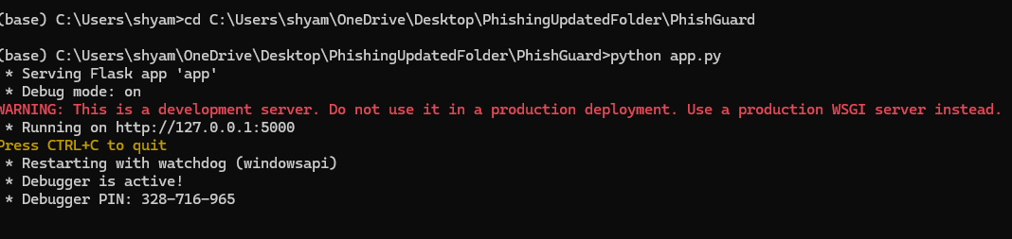
Fig 5.1: Backend Server Running Using Flask Framework

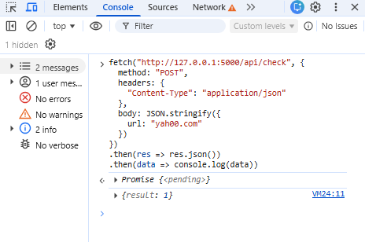
Fig 5.2: API Response Using Browser Console Showing JSON Output

5.3 Frontend Implementation (User Interface)
The frontend is developed using HTML, CSS, and basic JavaScript. It provides an interactive interface where users can enter URLs and view detailed results.
The UI includes:
- Input field for URL
- Scan button
- Loader animation during processing
- Result display section
Once the user submits a URL, the frontend sends a request to the backend and displays the response. The results include classification status, risk score, detected indicators, and highlighted URL.
Special attention is given to UI design to ensure clarity and usability. Color coding is used to represent different states:
- Green → Safe
- Red → Dangerous
- Blue → Invalid
The interface also includes a risk gauge and structured cards to display different aspects of the analysis.



Fig 5.3.1 UI

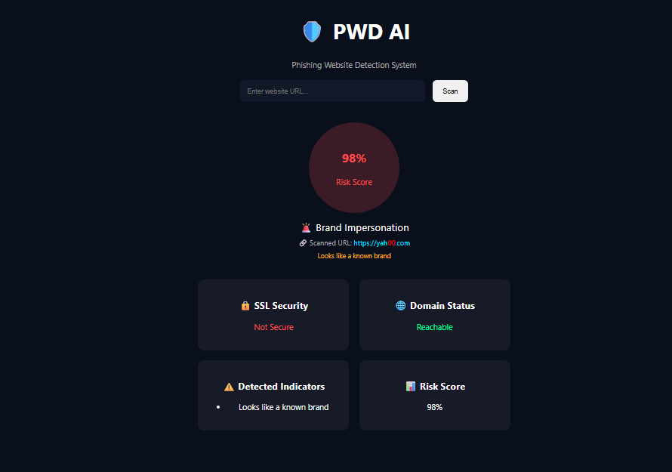
Fig 853.2 URL Scanning

5.4 Chrome Extension Implementation
The Chrome extension is developed using Manifest V3 and JavaScript. It enables real-time phishing detection by monitoring user browsing activity.
The extension listens for tab updates using Chrome APIs. When a user opens a webpage, the extension captures the URL and sends it to the backend API for analysis. Based on the response, the extension updates its icon and displays warnings if necessary.
The extension consists of:
- manifest.json (configuration file)
- background.js (handles logic)
- popup.html (UI for extension)
The extension ensures minimal performance impact by running asynchronously and only processing valid URLs.

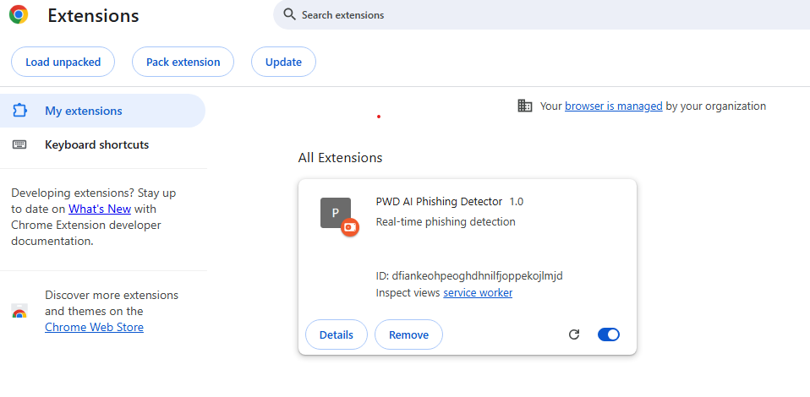

Fig 5.4.1 Extension Loaded

Fig 5.4.2 Safe URL Prediction by Extension
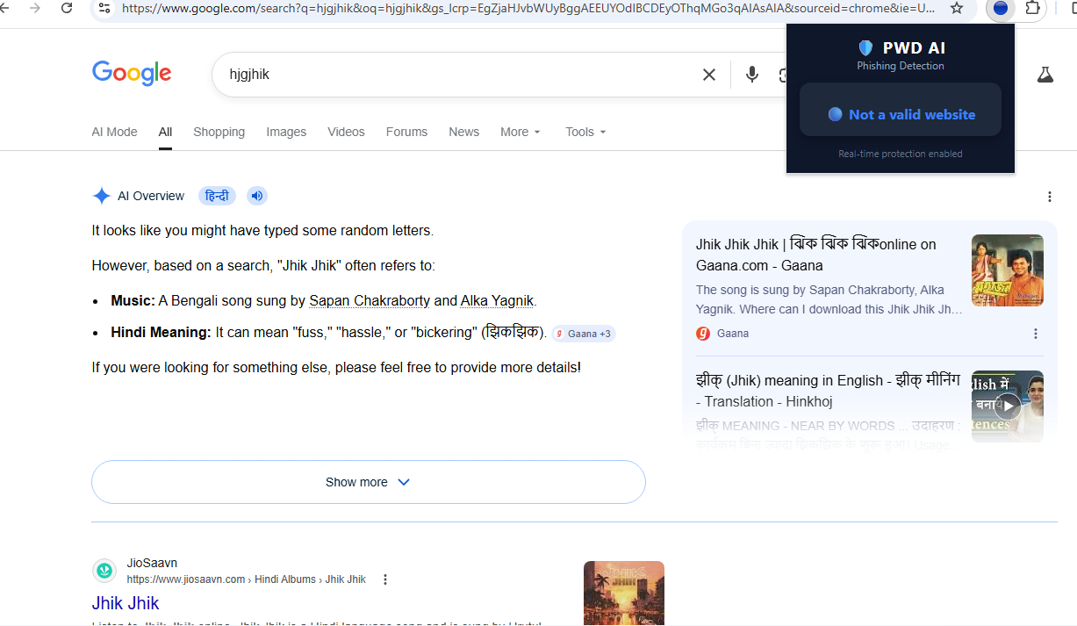

Fig 5.4.3 Random String search predicted as Invalid URL


Fig 5.4.4 Phishing Site Predicted as Dangerous
5.5 URL Processing and Feature Extraction Implementation
The system processes URLs using a structured pipeline. The first step is normalization, where missing protocols are added and the URL is standardized. Next, validation checks ensure that the input is a valid domain and not a search query.
Feature extraction is performed using custom functions that calculate numerical attributes of the URL. These include:
- Length of URL
- Number of dots
- Number of digits
- Presence of special characters
- Entropy
These features are stored in a structured format and passed to the machine learning model.
The system ensures that feature extraction is lightweight and efficient, allowing real-time processing without delays.

5.6 API Integration and Communication
The frontend and Chrome extension communicate with the backend using REST API calls. The API is designed to be simple and efficient, ensuring fast data exchange.
When a URL is submitted, it is sent to the backend in JSON format. The backend processes the request and returns a response containing the classification result.
Example request:
{
"url": "example.com"
}
Example response:
{
"result": 1
}
The system uses asynchronous communication to ensure that the UI remains responsive during processing.

5.7 Integration of ML and Rule-Based System
One of the key aspects of implementation is the integration of machine learning and rule-based logic. The system first checks for obvious phishing patterns using rules. If no rules are triggered, the machine learning model is used for prediction.
This hybrid approach improves accuracy and ensures that edge cases are handled effectively. For example, URLs with “@” are immediately flagged as dangerous, while others are evaluated using the model.

5.8 Error Handling and Debugging
During implementation, several errors were encountered, including API failures, invalid inputs, and extension issues. These were resolved using proper error handling techniques such as try-catch blocks and validation checks.
The system ensures that errors do not crash the application and provides fallback responses when necessary.

CHAPTER 6: CHALLENGES FACED AND OVERCOME

Developing the PWD AI phishing detection system involved several technical and practical challenges across different components, including data handling, model accuracy, frontend design, and real-time integration. Since the system combines machine learning with rule-based logic and browser extension functionality, ensuring smooth interaction between all modules required careful planning and debugging.
One of the major difficulties was achieving a balance between accuracy and performance. While increasing the number of features and complexity of the model could improve accuracy, it also increased processing time, which is not suitable for real-time applications. Therefore, a lightweight feature set was chosen to maintain speed without compromising detection capability.
Another challenge was handling edge cases such as invalid URLs, search queries, and browser redirections. Without proper validation, the system initially misclassified such inputs as dangerous, leading to false positives. This issue was resolved by implementing a validation layer that filters out non-URL inputs before processing.
Integration with the Chrome extension also presented challenges, particularly related to API communication, CORS policies, and handling asynchronous requests. These issues were resolved through proper configuration and testing.
Overall, each challenge contributed to improving the robustness, efficiency, and usability of the system.

6.1 URL Processing and Data Handling Challenges
One of the primary challenges in developing the PWD AI system was handling different types of URL inputs effectively. URLs entered by users or captured by the browser extension can vary significantly in structure, format, and validity. Some inputs may be incomplete, improperly formatted, or even non-URL strings that browsers automatically convert into search queries.
Initially, the system treated all inputs as valid URLs, which resulted in incorrect classifications. For example, random strings such as “jhfhkg” were interpreted as malicious URLs instead of being identified as invalid inputs. This led to a high number of false positives and reduced the reliability of the system.
To address this issue, a validation layer was introduced. This layer checks whether the input contains a proper domain structure, including a valid top-level domain (TLD) and at least one dot. It also identifies and ignores search queries generated by browsers. By filtering out invalid inputs before feature extraction, the system significantly improved its accuracy.
Another challenge was handling URLs with different formats, such as those missing protocols (“http” or “https”). This was resolved through normalization, where the system automatically adds the required protocol and standardizes the URL format.
Additionally, extracting meaningful features from URLs required careful implementation. Ensuring consistency in feature extraction was essential for maintaining the performance of the machine learning model.
Overall, these challenges were overcome by implementing robust validation, normalization, and feature extraction mechanisms, which improved both accuracy and system stability.

6.2 Frontend and User Experience Challenges
Designing an intuitive and user-friendly interface for the PWD AI system was another significant challenge. The goal was to present complex phishing detection results in a way that could be easily understood by both technical and non-technical users.
Initially, the interface displayed only the classification result (safe or dangerous), which lacked sufficient detail. Users could not understand why a particular URL was flagged as suspicious. This reduced transparency and trust in the system. To overcome this, additional elements such as risk scores, detected indicators, and highlighted URL components were introduced.
Another challenge was ensuring that the interface remained clean and uncluttered despite displaying multiple pieces of information. This was achieved by organizing the output into sections such as risk gauge, status text, and analysis cards. Color coding was also used to improve readability, with different colors representing different levels of risk.
The implementation of a loading indicator was also necessary to enhance user experience. Without it, users might assume that the system is unresponsive during processing. The loader provides visual feedback, indicating that the analysis is in progress.
For the Chrome extension, the challenge was to provide real-time feedback without interrupting the browsing experience. This was addressed by using icon changes and minimal popup design, ensuring that users receive alerts without distraction.

CHAPTER 7: SUMMARY AND CONCLUSION

The PWD AI system represents a comprehensive solution to the growing problem of phishing attacks by combining machine learning with rule-based detection techniques. The project successfully demonstrates how lightweight feature extraction and intelligent decision-making can be used to identify malicious URLs in real time. By integrating the system with a Chrome extension, it provides continuous monitoring and instant feedback to users, enhancing their online safety.
Throughout the development process, multiple components such as URL normalization, validation, feature extraction, model prediction, and rule-based analysis were carefully designed and integrated. The system not only detects phishing websites but also explains the reasoning behind its decisions through highlighted URL elements and risk scores. This improves transparency and helps users understand potential threats.
The project emphasizes efficiency, scalability, and usability, making it suitable for real-world deployment. Despite certain limitations, the system achieves a strong balance between accuracy and performance. Overall, PWD AI contributes to improving cybersecurity awareness and provides a practical approach to phishing detection.

7.1 Technical Achievements
The development of the PWD AI system led to several significant technical achievements. One of the key accomplishments is the successful implementation of a hybrid phishing detection model that combines machine learning with rule-based logic. This approach improves detection accuracy while ensuring that specific edge cases, such as credential injection and brand impersonation, are effectively handled.
Another important achievement is the design of a lightweight feature extraction mechanism. By focusing on lexical features such as URL length, digit count, and entropy, the system avoids heavy computations and achieves fast processing speeds. This makes it suitable for real-time applications.
The integration of a Chrome extension is also a major milestone. The extension captures URLs during browsing, sends them to the backend API, and displays results instantly. This real-time capability enhances user protection and makes the system more practical.
Additionally, the system provides explainable outputs by highlighting suspicious parts of URLs and displaying risk scores. This improves user understanding and trust in the system.
Overall, the project demonstrates strong technical capabilities in machine learning, web development, and system integration.

7.2 Training Impact
The development of the PWD AI system provided valuable learning experiences and significantly enhanced technical skills. The project involved working with multiple technologies, including Python, Flask, machine learning algorithms, and Chrome extension development. This helped in gaining a deeper understanding of both backend and frontend development.
One of the key learning outcomes was the practical application of machine learning concepts. Instead of focusing only on theoretical knowledge, the project required implementing a complete pipeline, including data preprocessing, feature extraction, model training, and prediction. This hands-on experience improved problem-solving skills and understanding of real-world applications of machine learning.
The project also improved knowledge of web technologies and API integration. Building a backend system and connecting it with a browser extension provided insights into client-server communication, asynchronous processing, and handling real-time data.
Another important impact was the understanding of cybersecurity concepts, particularly phishing attacks and their detection mechanisms. This knowledge is highly relevant in today’s digital world.
Overall, the project contributed to both technical and analytical skill development, making it a valuable learning experience.

7.3 Limitations
Despite its effectiveness, the PWD AI system has certain limitations that need to be addressed in future improvements. One of the primary limitations is that the system relies mainly on lexical features extracted from URLs. While these features are effective for many phishing cases, they may not capture all types of attacks, especially those involving complex webpage content or visual similarity.
Another limitation is the absence of deep learning models. Although traditional machine learning models provide good performance, deep learning techniques such as CNN or LSTM could potentially improve detection accuracy by analyzing more complex patterns.
The system also does not currently incorporate external data sources such as WHOIS information, DNS records, or SSL certificate details. These features can provide additional context about a website, such as domain age and ownership, which can further improve detection.
Additionally, the system depends on the availability of the backend API. If the server is not running or accessible, the Chrome extension cannot perform detection.
Lastly, while efforts have been made to reduce false positives, there may still be cases where legitimate websites are incorrectly flagged as suspicious.
Addressing these limitations can further enhance the system’s accuracy and reliability.

7.4 Concluding Remarks
The PWD AI project successfully demonstrates a practical and effective approach to phishing detection using a combination of machine learning and rule-based techniques. The system is capable of analyzing URLs in real time and providing accurate classifications along with explainable results.
One of the key strengths of the system is its hybrid design, which ensures that both known and unknown phishing patterns can be detected. The integration with a Chrome extension makes the system highly practical, as it provides continuous protection during browsing without requiring manual input.
The project also highlights the importance of user awareness in cybersecurity. By highlighting suspicious elements within URLs, the system not only detects threats but also educates users about common phishing techniques.
Although there are areas for improvement, such as incorporating additional features and advanced models, the current system provides a strong foundation for further development.
In conclusion, PWD AI achieves its objectives of providing a fast, accurate, and user-friendly phishing detection system. It serves as a valuable contribution to the field of cybersecurity and demonstrates the potential of combining machine learning with practical application design.

CHAPTER 8: SCOPE FOR FUTURE WORK

The PWD AI system provides a strong foundation for real-time phishing detection; however, there are several opportunities for enhancement and expansion to further improve its accuracy, scalability, and functionality. As phishing techniques continue to evolve, future developments can focus on incorporating advanced technologies and additional data sources to strengthen detection capabilities.
One of the most significant areas for improvement is the integration of deep learning models such as Convolutional Neural Networks (CNN) and Long Short-Term Memory (LSTM) networks. These models can analyze URLs as sequences and capture complex patterns that traditional machine learning models may not detect. This would enhance the system’s ability to identify sophisticated phishing attacks.
Another important enhancement is the inclusion of external data sources such as WHOIS information, DNS records, and SSL certificate details. These features can provide valuable insights into the legitimacy of a website, such as domain age and ownership, which are often indicators of phishing activity.
The system can also be extended to include content-based analysis, where the HTML structure of a webpage is examined for suspicious elements such as hidden forms, iframes, or fake login pages. This would allow the system to detect phishing attempts that rely on webpage design rather than URL structure.
In terms of usability, the project can be expanded into a mobile application, providing phishing detection capabilities on smartphones. Additionally, the Chrome extension can be enhanced with features such as real-time blocking, detailed reports, and user customization options.
Scalability can be improved by deploying the system on cloud platforms and implementing distributed processing. This would enable the system to handle a larger number of users and provide consistent performance.
Finally, future work can focus on improving explainability by integrating advanced Explainable AI (XAI) techniques such as SHAP or LIME, allowing users to better understand the model’s decisions.
Overall, these enhancements can transform PWD AI into a more powerful and comprehensive cybersecurity solution capable of addressing emerging phishing threats.

REFERENCES

- Mohammad, R. M., Thabtah, F., & McCluskey, L. (2015).
Phishing Websites Features (Dataset).
UCI Machine Learning Repository.
- Ma, J., Saul, L. K., Savage, S., & Voelker, G. M. (2009).
Beyond Blacklists: Learning to Detect Malicious Web Sites from Suspicious URLs.
Proceedings of the 15th ACM SIGKDD International Conference.
- Verma, R., & Hossain, N. (2017).
Semantic Feature Selection for Text with Application to Phishing Email Detection.
IEEE Transactions.
- Xiang, G., Hong, J., Rose, C. P., & Cranor, L. (2011).
Cantina+: A Machine Learning Framework for Detecting Phishing Websites.
ACM Transactions.
- Sahingoz, O. K., et al. (2019).
Machine Learning Based Phishing Detection from URLs.
Expert Systems with Applications.
- Tranco Top Sites List.
Tranco List – Research-Oriented Top Sites Ranking.
Available at: https://tranco-list.eu/latest_list (tranco-list.eu)
- Google. (2023).
Google Safe Browsing API Documentation.
- PhishTank. (2024).
Phishing URL Database.
- Chrome Developers. (2024).
Chrome Extension Documentation (Manifest V3).
- Pedregosa, F., et al. (2011).
Scikit-learn: Machine Learning in Python.
- Flask Documentation. (2024).
Flask Web Framework.
- Bishop, C. M. (2006).
Pattern Recognition and Machine Learning.

Plagiarism Report
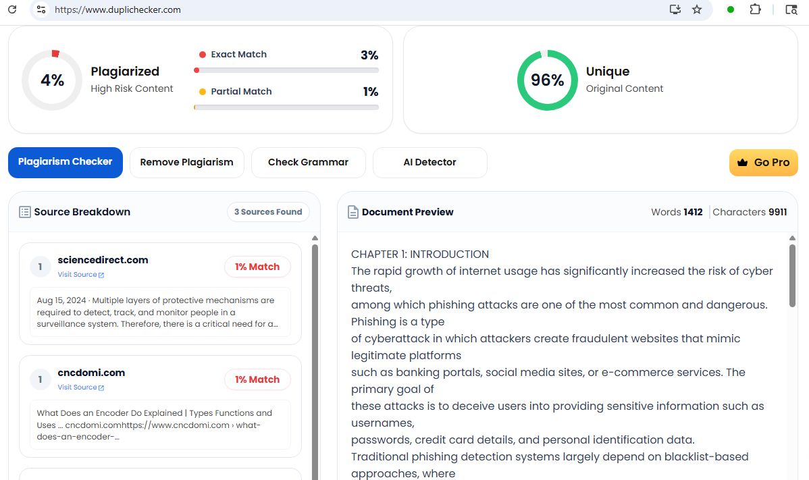
Chapters 1 and 2 report

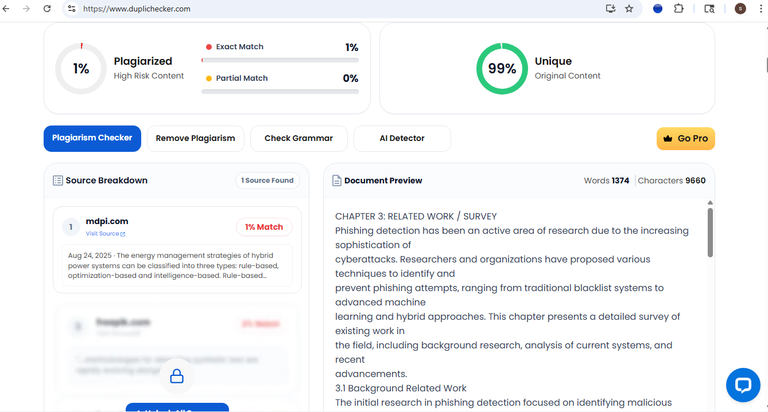
Chapters 3 and 4

Chapters 5 and 6

Chapters 7 and 8

