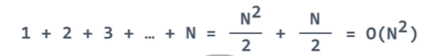



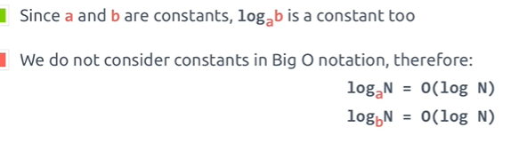

Permutation is N! 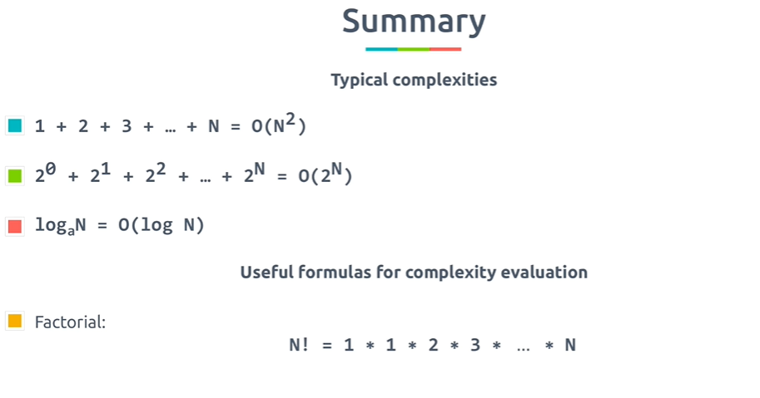

**Consecutive action is addition = O(N+N) = O(N)**

Example: for (int i=0;i<n;i++)

for (int i=0;i<n;i++)

**Nested action is multiplication = O(N*N) = O(Nsquare)**

Example: for (int i=0;i<n;i++)

{

for (int i=0;i<n;i++)

}

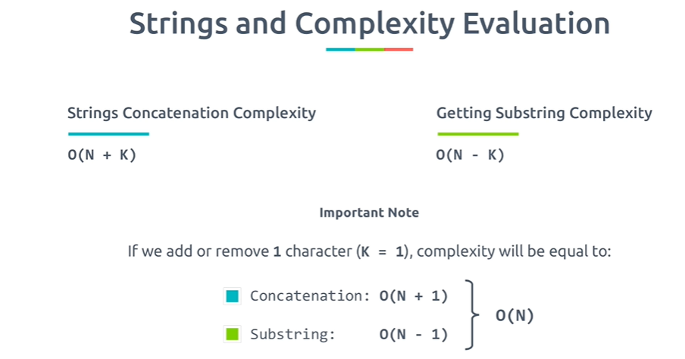

String comparison : O(N) , String concatenation: O(N),

**Space Complexity:**

Non recursive function : S(N) = 1

Recursive Function: S(N) = O(N)

String concatenation – S(N) = O(N square)

