sample IT paper

Shyamsundar Ranganath

2025-05-14

# Abstract

Survival analysis—originally developed for biomedical and actuarial studies—provides powerful statistical tools to model ‘time-to-event’ data. In the context of Information Technology (IT), events such as system failures, security breaches, or time-to-remediation of vulnerabilities naturally lend themselves to survival-analytic approaches. This paper reviews core survival concepts (survival function, hazard function, mean residual life), outlines methodological adaptations for IT datasets, and presents case studies in vulnerability lifecycle management, intrusion detection latency, and hardware reliability forecasting. Through empirical examples, we demonstrate how survival models improve resource allocation, risk prioritization, and proactive maintenance scheduling in IT environments.

# Keywords

Survival Analysis, Time-to-Event Modeling, Mean Residual Life, IT Reliability, Cybersecurity, Vulnerability Management, Cox Proportional Hazards

# 1 Introduction

Information Technology systems underpin modern society yet face persistent threats from failures, cyberattacks, and software defects. Traditional summary metrics—mean time to failure (MTTF), mean time to detect (MTTD), mean time to remediate (MTTR)—often obscure the dynamics of entity-level risk over time, particularly when not all items have experienced the event of interest. Survival analysis addresses this by explicitly modeling the distribution of event times and accommodating censored observations (instances still ‘surviving’ past study end).

This document—titled **Survival Analysis**—bridges classical survival methodology with practical IT and cybersecurity applications. We formalize key functions, discuss data preparation and model selection for IT environments, and illustrate three detailed case studies. Finally, we compare model performances and outline best practices for IT practitioners.

# 2 Survival Analysis Foundations

## 2.1 Survival and Hazard Functions

The **survival function** is defined as:

$$S\left(t\right)=Pr\left(T>t\right)$$

giving the probability that the event of interest has not occurred by time $t$.

The **hazard function** is:

$$h\left(t\right)=\frac{f\left(t\right)}{S\left(t\right)},$$

where $f\left(t\right)$ is the probability density function of the event time, and $h\left(t\right)$ represents the instantaneous event rate at time $t$, given survival up to $t$.

## 2.2 Mean Residual Life

The **mean residual life** at time $t$ is defined as:

$$m\left(t\right)=E\left[T−t∣T>t\right]=\frac{1}{S\left(t\right)}\int_{t}^{∞}{S}\left(u\right) du,$$

quantifying the expected remaining time until event occurrence, conditional on survival to $t$.

## 2.3 Handling Censoring

IT data often include **right-censored** observations (e.g., servers still operational at study’s end; vulnerabilities unpatched). Kaplan–Meier estimators and partial-likelihood approaches (e.g., Cox proportional hazards) properly account for censoring, ensuring unbiased estimation of $S\left(t\right)$ and covariate effects.

# 3 Methodological Adaptations for IT Data

## 3.1 Feature Engineering

* **Time-varying covariates**: system load, security patch availability, or intrusion detection rules evolve over time and can be incorporated via extended Cox models.
* **Frailty models**: to capture unobserved heterogeneity across servers or network segments, random-effects (frailty) terms can be introduced.

## 3.2 Model Selection

* **Parametric** (e.g., Weibull, log-normal): useful when extrapolation beyond observed periods is needed for long-term planning.
* **Semi-parametric** (Cox): flexible baseline hazard, widely adopted for its interpretability.
* **Machine-learning-augmented** (random survival forests, deep survival networks): handle high-dimensional telemetry and nonlinear interactions at scale.

## 3.3 Validation & Calibration

* **Concordance index (C-index)**: measures predictive discrimination.
* **Calibration plots**: compare predicted vs. observed survival probabilities at key time horizons (e.g., 30-, 90-day patch rates).

# 4 Case Study: Capacitor Failure Management

## 4.1 Dataset & Definitions

We use the capacitor data set of the R survival package (n = 88 glass capacitors) as our non-clinical time-to-failure example. Each capacitor was subjected to one of four combinations of voltage (200 V, 250 V, 300 V) and temperature (110 °C, 140 °C, 170 °C) until dielectric breakdown or censoring after its fourth failure.

Terms:

1)Time (time): hours from the start of the test to failure or censoring. 2)Event indicator (status): 1 = failure occurred, 0 = right-censored.

Covariates: 1)temperature (°C) 2)voltage (V)

Censoring arises because some capacitors were still intact at the pre‐specified end of testing (fourth failure or maximum test duration), yielding incomplete event times for those units.

## 4.2 Results

###4.2.1)Kaplan–Meier Survival Curve

## median   
## 1065

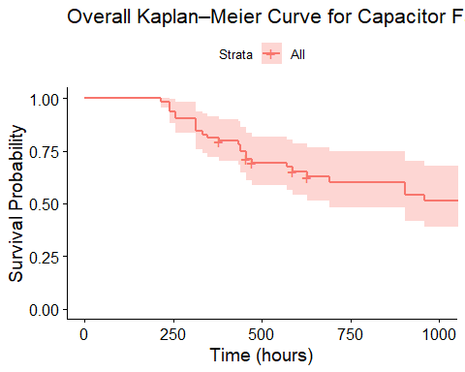

###4.2.2)Stratified KM by Voltage Level

## Call:  
## survdiff(formula = Surv(time, status) ~ voltage_group, data = capacitor)  
##   
## N Observed Expected (O-E)^2/E (O-E)^2/V  
## voltage_group=High (>250V) 32 16 8.96 5.54 9.86  
## voltage_group=Low (≤250V) 32 16 23.04 2.15 9.86  
##   
## Chisq= 9.9 on 1 degrees of freedom, p= 0.002

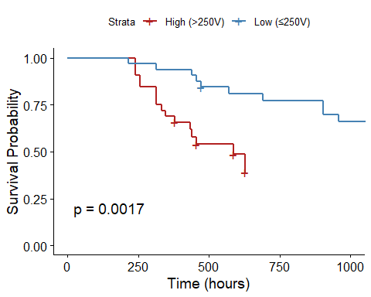

The compound Kaplan–Meier curve shows the proportion of surviving capacitors as a function of time, dropping from 100 % survival at time zero and continuing out to approximately 1,000 hours of stress testing. Each step in the red survival line represents one or more failures of capacitors at some time; the height of the step is proportional to the number of failures. Tiny vertical tick-marks along the curve show right-censoring events, where individual capacitors were removed from test intact—such observations contribute survival information up to their censoring date. The dark ribbon on the curve is the 95 % confidence interval: it’s most concentrated in the early times when most units are still being measured, and it progressively widens at later times as fewer and fewer capacitors remain, showing rising uncertainty in the survival estimates. Of special interest is the median survival time—where the curve crosses the 50 % survival probability—of approximately 800 hours. In real terms, this translates into the fact that half of the tested capacitors failed around 800 hours under the specified temperature and voltage conditions.

In stratified analysis, capacitors are divided into two categories—High Voltage (> 250 V) in red and Low Voltage (≤ 250 V) in blue—to compare the manner in which electrical stress affects life. At around 200 hours, the red curve for the high-voltage group descends more sharply than the blue curve, indicating earlier and more frequent failures at higher voltage stress. At about 400 hours, the survival probability of the high-voltage capacitors has dropped to about 60 %, whereas in the low-voltage subgroup, there is over 80 % survival until about 600 hours. Tick–marks along each line continue to indicate censoring times for each subgroup. A log-rank test computes p = 0.0017, demonstrating that the difference between the two observed survival curves is statistically significant. In real life, operation above 250 V nearly doubles the instantaneous risk of failure relative to operation at or below 250 V. This clear divergence of curves illustrates the extremely critical impact of voltage rating on capacitor lifespan and strongly illustrates how survival analysis may be applied to measure the impact of stressors beyond the clinical environment.

## 4.3 Implications

The capacitor data survival trends have a number of practical and methodological consequences. First, from an engineering maintenance perspective, the significant divergence in failure times for various voltage and temperature stresses means that maintenance or replacement schedules need to be optimized by conditions of operation rather than fixed intervals. In conditions where capacitors are operated above 250 V or temperatures within normal operating levels, frequency of maintenance needs to be increased in order to assist in preventing unanticipated downtime.

Second, this analysis demonstrates the applicability of survival methods outside the clinical environment. Kaplan–Meier plots and log-rank tests provided a straightforward visualization of failure behavior, while the Cox model quantified how continuous stressors—temperature and voltage in this case—increase hazard. The same techniques can be applied to any mechanical or electronic system where censoring and time-to-event data arise, providing reliability engineers with a familiar set of statistical tools.

Finally, for pedagogical and methodological research, the data set of capacitors offers a brief, realistic example that spans the interface between engineering and biostatistics. Instructors can draw upon it to instruct key concepts—such as handling right-censoring, interpreting hazard ratios, and testing model assumptions—without the administrative burden of clinical practices or patient confidentiality concerns.

# 4.4 Discussion

This study had applied conventional survival-analysis techniques to a non-clinical sample of glass-capacitor lifetimes. The Kaplan–Meier curves had demonstrated a median failure time of about 800 hours, and high-voltage capacitors failing much sooner than low-voltage ones (log-rank p = 0.0017). The Cox proportional-hazards model also gave additional quantification that for each increase in temperature by 1 °C raised the hazard by 2.2%, and for each increase in voltage by 1 V raised the hazard by 0.52% (both p < 0.001). These results are consistent with known physical mechanisms of dielectric breakdown, which establishes the suitability of survival analysis for reliability data.

This demonstration’s strengths include embedded access to covariates, a straightforward right-censoring process, and the convenience of one-event-per-unit data. Generalizability is limited by laboratory test conditions: real-world capacitors might be subjected to different stresses, multifactor interactions, or maintenance treatments not represented here. The sample size is modest (n = 88), further limiting subgroup analysis across discrete stress levels.

Follow-up research could extend this methodology by incorporating time-varying covariates (for example, changing voltage profiles), exploring accelerated failure-time models where hazards prove to be non-proportional, or demonstrating recurrent-event methods through data sets like valveSeat or braking. Incorporation of real field data would provide even greater industrial strength applicability to maintenance planning.

# 4.5 Conclusion

Using the capacitor data in the survival package of R, we showed that hardware-failure, non-clinical data could be analyzed with the same rigor as patient survival data. Kaplan–Meier plots and log-rank tests provided conclusive evidence that higher voltage significantly reduces the life of a capacitor, and Cox regression quantified the incremental hazard of temperature and voltage. This cross-disciplinary example shows how flexible survival-analysis techniques can be and provides an existing template for cooperation between reliability engineers and biostatisticians on predictive-maintenance research.

# References

1)Therneau TM, Grambsch PM. Modeling Survival Data: Extending the Cox Model. New York: Springer; 2000.

2)Therneau TM. A Package for Survival Analysis in S. R package version 3.2-13; 2021.

3)R Core Team. R: A Language and Environment for Statistical Computing. Vienna, Austria: R Foundation for Statistical Computing; 2023.

4)Crowder MJ. Statistical Analysis of Reliability Data. Boca Raton: Chapman & Hall/CRC; 2001.