Machine Intelligence Applications Lab

Week – 1

Aim : Extract data from different file formats and display the summary statistics.
Description :
Some of the most commonly occurring data formats are
- CSV (Comma Separated Values) :

A CSV file, as the name implies, typically separates information using commas. It's a way to exchange structured information, like the contents of a spreadsheet, among programs that can't necessarily talk to one another directly.
As long as two programs can both open a CSV file, they can exchange data.
- Excel :

Microsoft Excel is a spreadsheet program created by Microsoft that uses tables to record and analyze numerical and statistical data with formulas and functions.

- JSON (Java Script Object Notation) :
  - JSON is a lightweight format for storing and transporting data

  - JSON is often used when data is sent from a server to a web page

  - JSON is "self-describing" and easy to understand

- Text File :
A text file is a computer file that is a kind of non-executable, digital file a
has only text. It can have numbers, letters, symbols, and/or a combinationbut does not contain special formatting such as italic text, bold text, underline text, pictures, etc. A text file identifies with the .txt file extensionin Microsoft Windows computer.

- Zip File :

A file that contains one or more files compressed into the ZIP format.
Also called a "ZIP archive," "zipped file" or "zipped archive," the ZIP algorithm is the most popular compression method in use. ZIP files typically have the .zip extension and can be password protected for added security.

Implementation :
1. CSV File :-
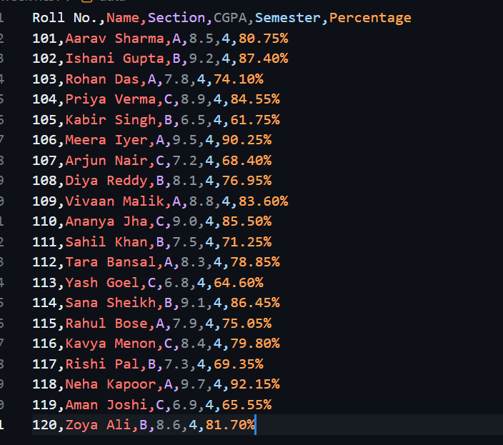

Program :

import pandas as pd
import numpy as np

f1=pd.read_csv("annual_report.csv")
print("Print full report\n")
print(f1)
print("\n")
print("f1.describe()")

print(f1.describe(),"\n")
print("f1.loc[2]")
print(f1.loc[2],"\n")

print(f1.loc[2,'Value'],"\n\n")

print(f1.info(),"\n")
print("\nMean and Standard Deviation of data :\n")
print(f1.describe().loc[['mean','std']])

Output :
Roll No. Name Section CGPA Semester Percentage
0 101 Aarav Sharma A 8.5 4 80.75%
1 102 Ishani Gupta B 9.2 4 87.40%
2 103 Rohan Das A 7.8 4 74.10%
3 104 Priya Verma C 8.9 4 84.55%
4 105 Kabir Singh B 6.5 4 61.75%
5 106 Meera Iyer A 9.5 4 90.25%
6 107 Arjun Nair C 7.2 4 68.40%
7 108 Diya Reddy B 8.1 4 76.95%
8 109 Vivaan Malik A 8.8 4 83.60%
9 110 Ananya Jha C 9.0 4 85.50%
10 111 Sahil Khan B 7.5 4 71.25%
11 112 Tara Bansal A 8.3 4 78.85%
12 113 Yash Goel C 6.8 4 64.60%
13 114 Sana Sheikh B 9.1 4 86.45%
14 115 Rahul Bose A 7.9 4 75.05%
15 116 Kavya Menon C 8.4 4 79.80%
16 117 Rishi Pal B 7.3 4 69.35%
17 118 Neha Kapoor A 9.7 4 92.15%
18 119 Aman Joshi C 6.9 4 65.55%
19 120 Zoya Ali B 8.6 4 81.70%
Summary Statistics :
Roll No. CGPA Semester
count 20.00000 20.000000 20.0
mean 110.50000 8.200000 4.0
std 5.91608 0.935836 0.0
min 101.00000 6.500000 4.0
25% 105.75000 7.450000 4.0
50% 110.50000 8.350000 4.0
75% 115.25000 8.925000 4.0
max 120.00000 9.700000 4.0
Roll No. 103
Name Rohan Das
Section A
CGPA 7.8
Semester 4
Percentage 74.10%
Name: 2, dtype: object
7.8
<class 'pandas.core.frame.DataFrame'>
RangeIndex: 20 entries, 0 to 19
Data columns (total 6 columns):
# Column Non-Null Count Dtype
--- ------ -------------- -----
0 Roll No. 20 non-null int64
1 Name 20 non-null object
2 Section 20 non-null object
3 CGPA 20 non-null float64
4 Semester 20 non-null int64
5 Percentage 20 non-null object
dtypes: float64(1), int64(2), object(3)
memory usage: 1.1+ KB
None
Mean and Standard Deviation of data :
Roll No. CGPA Semester
mean 110.50000 8.200000 4.0
std 5.91608 0.935836 0.0

2.Excel:

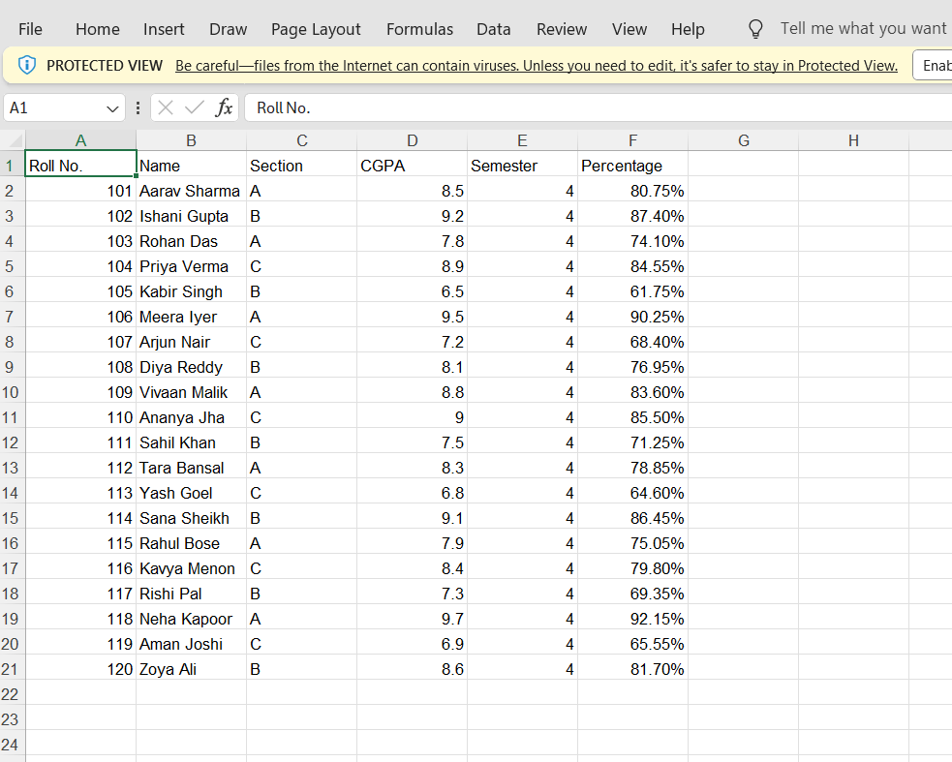
Program :
import numpy as np
import pandas as pd
data = pd.read_excel("fsi-2006.xlsx")
print(data)
print("location 3 ")
print(data.loc[3,'Country'],data.loc[3,'Rank'],"\n\n")
print("Summary Statistics :\n")
print(data.describe(),"\n\n\n")
print(data.info())

Output :
Roll No. Name Section CGPA Semester Percentage
0 101 Aarav Sharma A 8.5 4 0.8075
1 102 Ishani Gupta B 9.2 4 0.8740
2 103 Rohan Das A 7.8 4 0.7410
3 104 Priya Verma C 8.9 4 0.8455
4 105 Kabir Singh B 6.5 4 0.6175
5 106 Meera Iyer A 9.5 4 0.9025
6 107 Arjun Nair C 7.2 4 0.6840
7 108 Diya Reddy B 8.1 4 0.7695
8 109 Vivaan Malik A 8.8 4 0.8360
9 110 Ananya Jha C 9.0 4 0.8550
10 111 Sahil Khan B 7.5 4 0.7125
11 112 Tara Bansal A 8.3 4 0.7885
12 113 Yash Goel C 6.8 4 0.6460
13 114 Sana Sheikh B 9.1 4 0.8645
14 115 Rahul Bose A 7.9 4 0.7505
15 116 Kavya Menon C 8.4 4 0.7980
16 117 Rishi Pal B 7.3 4 0.6935
17 118 Neha Kapoor A 9.7 4 0.9215
18 119 Aman Joshi C 6.9 4 0.6555
19 120 Zoya Ali B 8.6 4 0.8170
Roll No. 104
Name Priya Verma
Section C
CGPA 8.9
Semester 4
Percentage 0.8455
Name: 3, dtype: object
8.9
Summary Statistics :
Roll No. CGPA Semester Percentage
count 20.00000 20.000000 20.0 20.000000
mean 110.50000 8.200000 4.0 0.779000
std 5.91608 0.935836 0.0 0.088904
min 101.00000 6.500000 4.0 0.617500
25% 105.75000 7.450000 4.0 0.707750
50% 110.50000 8.350000 4.0 0.793250
75% 115.25000 8.925000 4.0 0.847875
max 120.00000 9.700000 4.0 0.921500
<class 'pandas.core.frame.DataFrame'>
RangeIndex: 20 entries, 0 to 19
Data columns (total 6 columns):
# Column Non-Null Count Dtype
--- ------ -------------- -----
0 Roll No. 20 non-null int64
1 Name 20 non-null object
2 Section 20 non-null object
3 CGPA 20 non-null float64
4 Semester 20 non-null int64
5 Percentage 20 non-null float64
dtypes: float64(2), int64(2), object(2)
memory usage: 1.1+ KB
None

- JSON :-

[
{
"Roll_no": 101,
"Name": "Aarav Sharma",
"Section": "A",
"CGPA": 8.5,
"Semester": 4,
"Percentage": 80.75
},
{
"Roll_no": 102,
"Name": "Ishani Gupta",
"Section": "B",
"CGPA": 9.2,
"Semester": 4,
"Percentage": 87.40
},
{
"Roll_no": 103,
"Name": "Rohan Das",
"Section": "A",
"CGPA": 7.8,
"Semester": 4,
"Percentage": 74.10
},
{
"Roll_no": 104,
"Name": "Priya Verma",
"Section": "C",
"CGPA": 8.9,
"Semester": 4,
"Percentage": 84.55
},
{
"Roll_no": 105,
"Name": "Kabir Singh",
"Section": "B",
"CGPA": 6.5,
"Semester": 4,
"Percentage": 61.75
},
{
"Roll_no": 106,
"Name": "Meera Iyer",
"Section": "A",
"CGPA": 9.5,
"Semester": 4,
"Percentage": 90.25
},
{
"Roll_no": 107,
"Name": "Arjun Nair",
"Section": "C",
"CGPA": 7.2,
"Semester": 4,
"Percentage": 68.40
},
{
"Roll_no": 108,
"Name": "Diya Reddy",
"Section": "B",
"CGPA": 8.1,
"Semester": 4,
"Percentage": 76.95
},
{
"Roll_no": 109,
"Name": "Vivaan Malik",
"Section": "A",
"CGPA": 8.8,
"Semester": 4,
"Percentage": 83.60
},
{
"Roll_no": 110,
"Name": "Ananya Jha",
"Section": "C",
"CGPA": 9.0,
"Semester": 4,
"Percentage": 85.50
}
]
Program :
import pandas as pd
import numpy as np
data = pd.read_json("employees.json")
print(data)
print("location")
print(data.loc[2],"\n\n")
print("Summary Statistics")
print(data.describe(),"\n\n")
print(data.info())
Output :
Roll_no Name Section CGPA Semester Percentage
0 101 Aarav Sharma A 8.5 4 80.75
1 102 Ishani Gupta B 9.2 4 87.40
2 103 Rohan Das A 7.8 4 74.10
3 104 Priya Verma C 8.9 4 84.55
4 105 Kabir Singh B 6.5 4 61.75
5 106 Meera Iyer A 9.5 4 90.25
6 107 Arjun Nair C 7.2 4 68.40
7 108 Diya Reddy B 8.1 4 76.95
8 109 Vivaan Malik A 8.8 4 83.60
9 110 Ananya Jha C 9.0 4 85.50
Roll_no 102
Name Ishani Gupta
Section B
CGPA 9.2
Semester 4
Percentage 87.4
Name: 1, dtype: object
Summary Statistics :
Roll_no CGPA Semester Percentage
count 10.00000 10.000000 10.0 10.000000
mean 105.50000 8.350000 4.0 79.325000
std 3.02765 0.948976 0.0 9.015273
min 101.00000 6.500000 4.0 61.750000
25% 103.25000 7.875000 4.0 74.812500
50% 105.50000 8.650000 4.0 82.175000
75% 107.75000 8.975000 4.0 85.262500
max 110.00000 9.500000 4.0 90.250000
<class 'pandas.core.frame.DataFrame'>
RangeIndex: 10 entries, 0 to 9
Data columns (total 6 columns):
# Column Non-Null Count Dtype
--- ------ -------------- -----
0 Roll_no 10 non-null int64
1 Name 10 non-null object
2 Section 10 non-null object
3 CGPA 10 non-null float64
4 Semester 10 non-null int64
5 Percentage 10 non-null float64
dtypes: float64(2), int64(2), object(2)
memory usage: 612.0+ bytes
None

- Text File :-

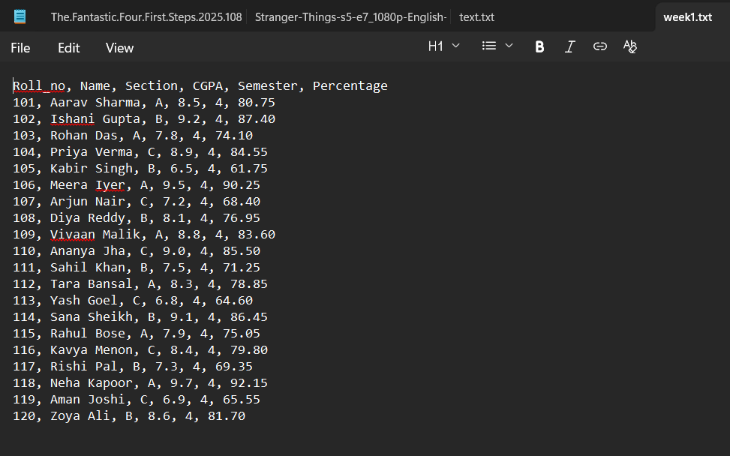

Program :
data = open("abc.txt")
data1 = data.read()
print(data1)
Output :
Roll_no, Name, Section, CGPA, Semester, Percentage
101, Aarav Sharma, A, 8.5, 4, 80.75
102, Ishani Gupta, B, 9.2, 4, 87.40
103, Rohan Das, A, 7.8, 4, 74.10
104, Priya Verma, C, 8.9, 4, 84.55
105, Kabir Singh, B, 6.5, 4, 61.75
106, Meera Iyer, A, 9.5, 4, 90.25
107, Arjun Nair, C, 7.2, 4, 68.40
108, Diya Reddy, B, 8.1, 4, 76.95
109, Vivaan Malik, A, 8.8, 4, 83.60
110, Ananya Jha, C, 9.0, 4, 85.50
111, Sahil Khan, B, 7.5, 4, 71.25
112, Tara Bansal, A, 8.3, 4, 78.85
113, Yash Goel, C, 6.8, 4, 64.60
114, Sana Sheikh, B, 9.1, 4, 86.45
115, Rahul Bose, A, 7.9, 4, 75.05
116, Kavya Menon, C, 8.4, 4, 79.80
117, Rishi Pal, B, 7.3, 4, 69.35
118, Neha Kapoor, A, 9.7, 4, 92.15
119, Aman Joshi, C, 6.9, 4, 65.55
120, Zoya Ali, B, 8.6, 4, 81.70
- Zip File :-
Program :

import zipfile as z
import pandas as pd
data = z.ZipFile('sample.zip','r')
d1 = data.read('abc.txt')
print(d1)

Output :
b'this is a sample text'

Visualization :-

import matplotlib.pyplot as plt
import numpy as np
import pandas as pd

data=pd.read_excel("fsi-2006.xlsx")

x=np.array(data['Country'])
y=np.array(data['Rank'])
plt.bar(x,y,color='red')
plt.xlabel("Country")
plt.ylabel("Rank")
plt.title("Country vs Rank")
plt.show()
Output:

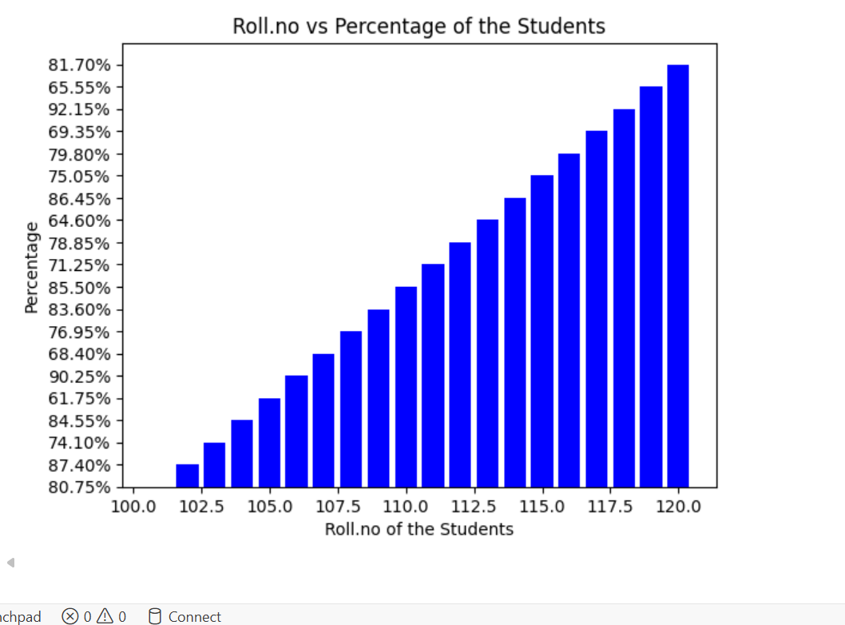

Week – 2

Aim : Write a program that extracts the words (features) used in a sentence.

Description : To extract the words (features) used in a sentence description, you can follow these steps using Python:
1. Tokenization: Split the sentence into individual words or tokens.
2. Remove Stop Words: Remove common words like "the", "is", "and”, etc., as they don't usually contribute much to meaning.
3. Lowercasing: Convert all words to lowercase to treat words with same characters as identical. We will use natural language processing libraries like nltk (Natural Language Toolkit) to handle tokenization and remove stop words (commonly used words like "the," "is," "and," etc., that often don't add much meaning to the sentence). Program : Import necessary dependencies :-

Program :

Import necessary dependencies :-

import pandas as pd
import numpy as np
import re
import nltk
nltk.download('stopwords')

Output :
[nltk_data] Downloading package stopwords to /root/nltk_data...
[nltk_data] Unzipping corpora/stopwords.zip.
True

Sample Data set :-
data = ['1. The Quick Brown Fox jumps over the lazy dog!', "2. NLP is amazing, isn't it? We're learning it at speed_of_light.", '3. DATA SCIENCE involves 10% math and 90% persistence.']
labels = ['Grammer','technology','learing']
data = np.array(data)
data_df = pd.DataFrame({'Document':data, 'Category':labels})
data_df = data_df[['Document', 'Category']]
data_df


Visualization :-

Categorical distributions :
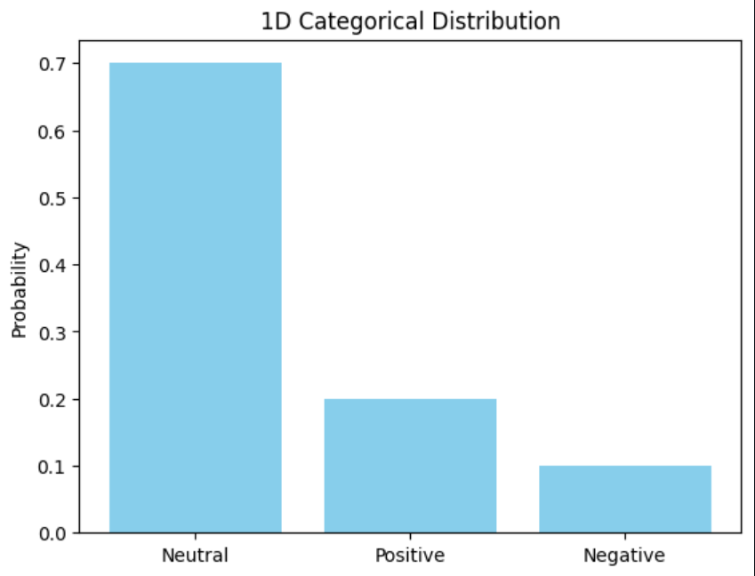

2-d categorical distributions :
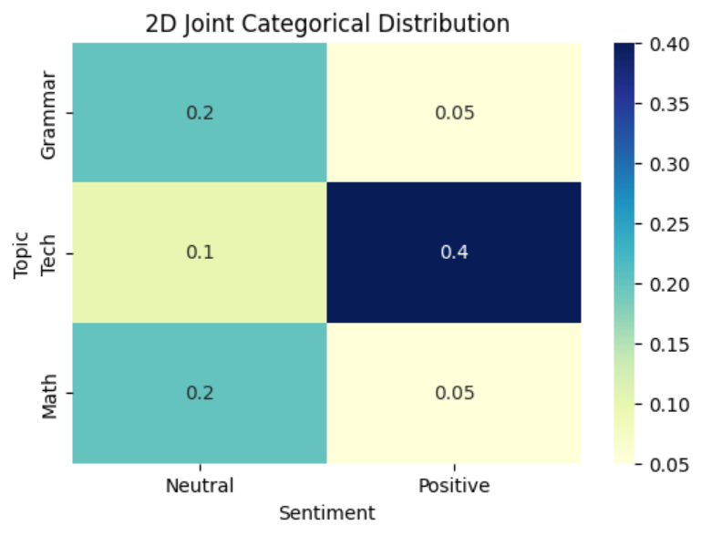
Simple text pre-processing :-

Stop Words : Removing the words that occur commonly across all the documents in the dataset.

wpt = nltk.WordPunctTokenizer()
stop_words = nltk.corpus.stopwords.words('english')
def normalize_document(doc):
doc=re.sub(r'[^a-zA-Z0-9\s]','',doc,re.I)
doc=doc.lower()
doc=doc.strip()
tokens=wpt.tokenize(doc)
filtered_tokens=[token for token in tokens if token not in stop_words]
doc=' '.join(filtered_tokens)
return doc

normalize_data=np.vectorize(normalize_document)
Normalization :-
Normalization is a scaling technique in Machine Learning applied during data preparation to change the values of numeric columns in the dataset to use a common scale. It is not necessary for all datasets in a model. It is required only when features of machine learning models have different ranges.

norm_data = normalize_data(data)
norm_data

output:
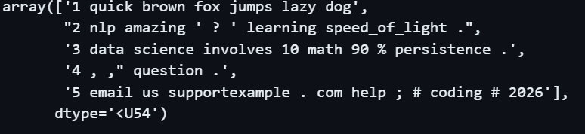
Bag of Words Model :-

from sklearn.feature_extraction.text import CountVectorizer
cv = CountVectorizer(min_df=0., max_df=1.)
cv_matrix = cv.fit_transform(norm_data)
cv_matrix = cv_matrix.toarray()
cv_matrix

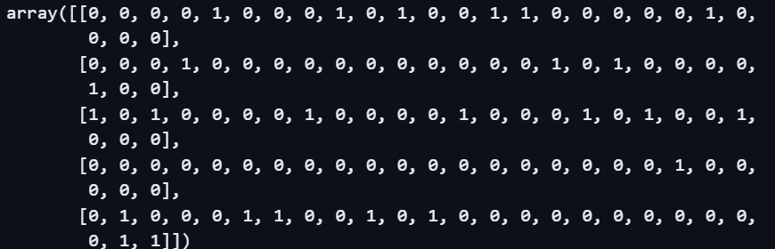
vocab = cv.get_feature_names_out()
pd.DataFrame(cv_matrix, columns=vocab)

output:
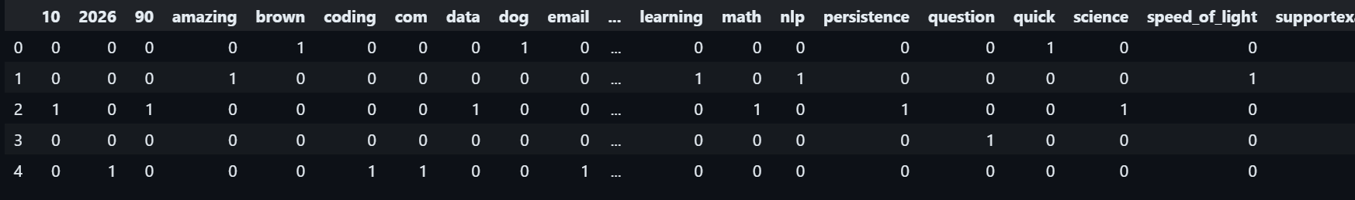
Visualization :-
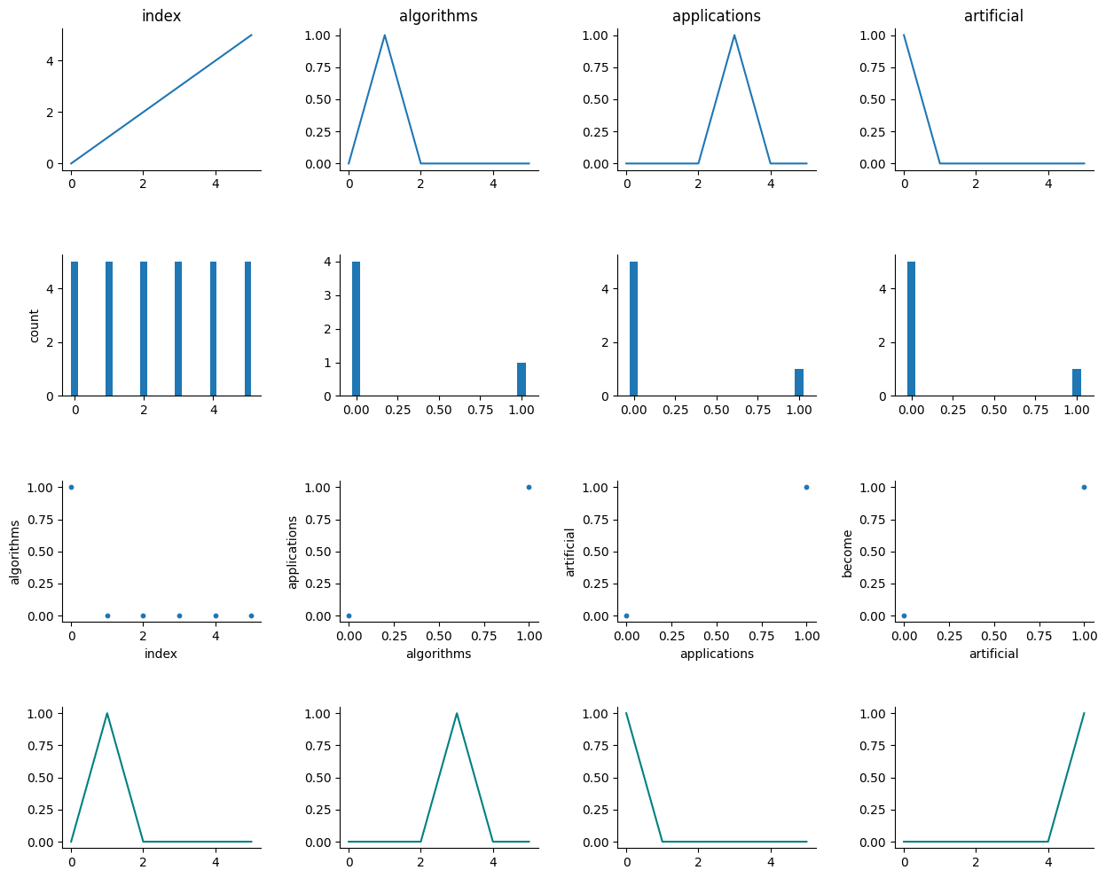

Bag of N-Grams Model :-

bv = CountVectorizer(ngram_range=(2,2))
bv_matrix = bv.fit_transform(norm_data)
bv_matrix = bv_matrix.toarray()
vocab = bv.get_feature_names_out()
pd.DataFrame(bv_matrix, columns=vocab

Output:
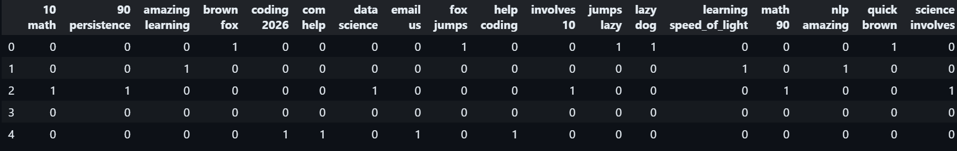
Visualization :-

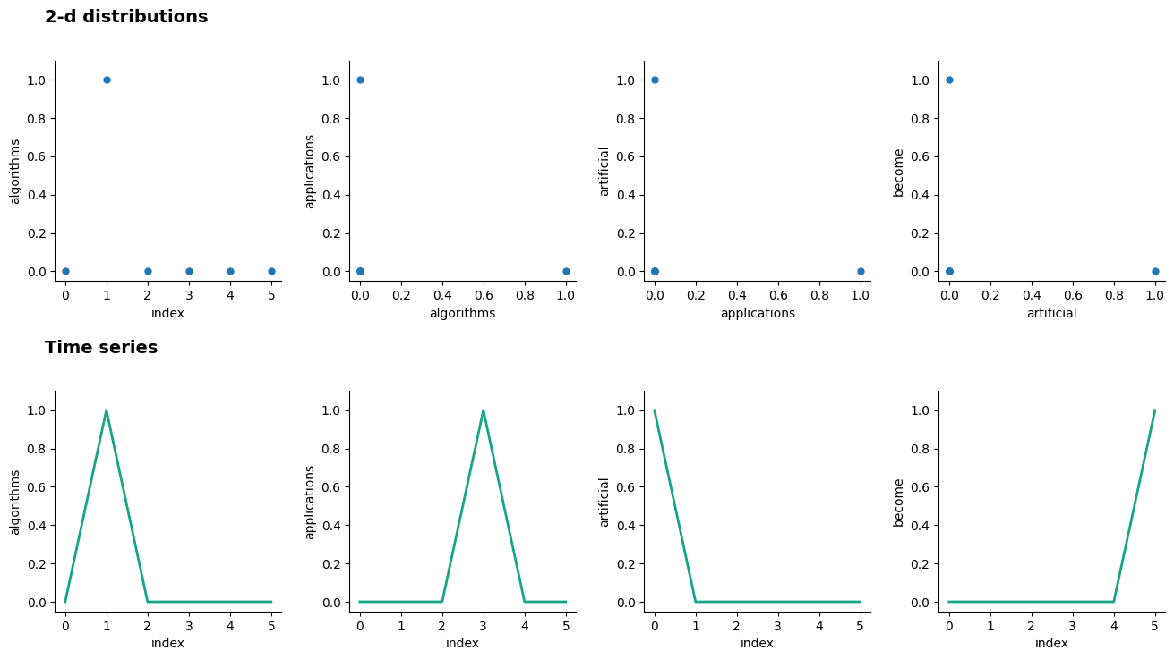

WEEK-3

Aim : Write a program for edge detection to extract edge based features from a sample image.

Description : Popular format of unstructured data is images. Sound and visual data in the form of images, video, and audio are very popular sources of data which pose a lot of challenge to data scientists in terms of processing, storage, feature extraction and modeling. However their benefits as sources of data are quite rewarding especially in the field of artificial intelligence and computer vision.

Due to the unstructured nature of data, it is not possible to directly use images for training models. There are various strategies and techniques that can be used in this case to engineer the right features from images. One of the core principles to remember when dealing with images is that any image can be represented as a matrix of numeric pixel values. You can load feature_engineering_image.py directly and start running the examples. Feature Engineering on Image Data.ipynb, for a more interactive experience.

Implementation :-

Importing Modules :

import skimage
import numpy as np
import pandas as pd
import matplotlib.pyplot as plt
from skimage import io
%matplotlib inline

Raw image and Channel pixels:
An image can be represented by the value of each of its pixels as a two dimensional array. Color images usually have three components also known as channels. The R, G, and B channels stand for the red, green, and blue channels, respectively. This can be represented as a three dimensional array (m, n, c) where m indicates the number of rows in the image, n indicates the number of columns and c indicates which channel it represents (R, G or B).

Program:

img1 = io.imread('img1.jpg')
img2 = io.imread('img2.jpg')
df=pd.DataFrame(['img1','img2'],columns=['Image'])
print(img1.shape,img2.shape)

output:
(630, 1200, 3) (350, 642, 3)

Extracting two color sample images :
Program:

fig=plt.figure(figsize=(9,3))
ax1=fig.add_subplot(1,2,1)
ax1.imshow(img1)
ax2=fig.add_subplot(1,2,2)
ax2.imshow(img2)

Output:

<matplotlib.image.AxesImage at 0x1e7d8136210>

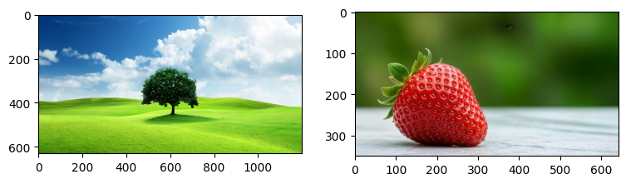
Extracting red, green, and blue channels from our color RGB image :
We can use numpy indexing to slice out and extract the three color channels separately for the sample image. The ‘R’ in RGB stands for Red and the value for ‘r’ is ‘0’. The ‘G’ in RGB stands for Green and the value for ‘g’ is ‘1’. The ‘B’ in RGB stands for Blue and the value for ‘b’ is ‘2’.

Program:

img2_r = img2.copy()
img2_r[:,:,1]=img2_r[:,:,2]=0
img2_g = img2.copy()
img2_g[:,:,0]=img2_g[:,:,2]=0
img2_b = img2.copy()
img2_b[:,:,0]=img2_b[:,:,1]=0
plot_image = np.concatenate((img2_r,img2_g,img2_b),axis=1)
plt.figure(figsize=(9,3))
plt.imshow(plot_image)
Output:

<matplotlib.image.AxesImage at 0x1e7d81c3ce0>

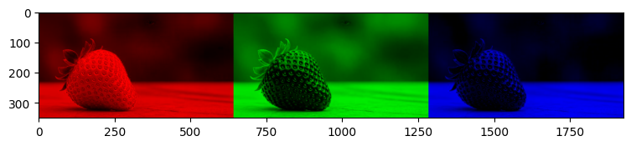
Image Pixel Matrix:

Program:

img2_r[:,:,0]

Output:

array([[ 49, 54, 54, ..., 40, 40, 40],
[ 48, 52, 52, ..., 40, 40, 40],
[ 46, 50, 50, ..., 41, 40, 40],
...,
[211, 210, 209, ..., 213, 216, 216],
[213, 212, 211, ..., 213, 216, 216],
[214, 213, 213, ..., 214, 215, 215]], dtype=uint8)

Grayscale Image Pixels :

If you are dealing with color images, it might get difficult worki ng with multiple channels and three-dimensional arrays. Hence converting imag es to grayscale is a nice way of keeping the necessary pixel intensity values but getting an easy to process two-dimensional image. Grayscale images usually ca pture the luminance or intensity of each pixel such that each pixel value can be computed using the equation.
Y = 0.2125 x R + 0.7154 x G + 0.0721 x B
Where R, G & B are the pixel values of the three channels usually ranges from 0(complete intensity absence - black) to 1(complete intensity presence - white).

Program:
from skimage.color import rgb2gray
img1_gs = rgb2gray(img1)
img2_gs = rgb2gray(img2)
print('Image shape : ',img1_gs.shape,'\n')

Output:
Image shape : (630, 1200)

program:
print('2D image pixel map')
print(np.round(img2_gs,2),'\n')

Output:

2D image pixel map
[[0.27 0.28 0.28 ... 0.31 0.3 0.3 ]
[0.26 0.28 0.28 ... 0.31 0.3 0.3 ]
[0.25 0.27 0.27 ... 0.31 0.3 0.3 ]
...
[0.85 0.85 0.84 ... 0.87 0.88 0.88]
[0.86 0.86 0.85 ... 0.86 0.87 0.87]
[0.86 0.86 0.86 ... 0.86 0.87 0.87]]

Binning Image Intensity Distribution :

Binning the image intensity distribution based on intensity values using a histogram and using the bins as features. The following code snippet shows us how the image intensity distribution looks for the two sample images.

Program:
fig = plt.figure(figsize = (6,4))
ax1 = fig.add_subplot(2,2,1)
ax1.imshow(img1_gs, cmap="gray")
ax2 = fig.add_subplot(2,2,2)
ax2.imshow(img2_gs, cmap="gray")
ax3 = fig.add_subplot(2,2,3)
p_freq, p_bins, c_patches = ax3.hist(img1_gs.flatten(), bins=30)
ax4 = fig.add_subplot(2,2,4)
l_freq, l_bins, l_patches = ax4.hist(img2_gs.flatten(), bins=30)
Output:
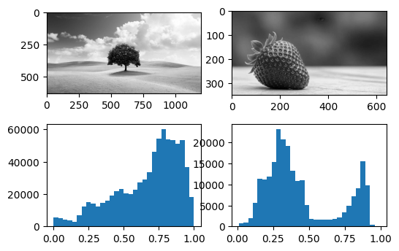

As we mentioned, image intensity ranges from 0 to 1 and is evident by the xaxes depicted in Figure. The y-axes depict the frequency of the respective bins. The variables c_freq, c_bins, and d_freq, d_bins can be used to get the numeric values pertaining to the bins and used as features.

Edge Detection :

One of the more interesting and sophisticated techniques involve detecting edges in an image. Edge detection algorithms can be used to detect sharp intensity and brightness changes in an image and find areas of interest. The canny edge detector algorithm developed by John Canny is one of the most widely used edge detector algorithms today. This algorithm typically involves using a Gaussian distribution with a specific standard deviation σ (sigma) to smoothen and denoise the image.

Then we apply a Sobel filter to extract image intensity gradients. Norm value of this gradient is used to determine the edge strength. Then we apply a Sobel filter to extract image intensity gradients. Norm value of this gradient is used to determine the edge strength.

Program:

from skimage.feature import canny
img1_edges = canny(img1_gs, sigma=1)
img2_edges = canny(img2_gs, sigma=1)
fig = plt.figure(figsize = (8,4))
ax1 = fig.add_subplot(1,2,1)
ax1.imshow(img1_edges, cmap='binary')
ax2=fig.add_subplot(1,2,2)
ax2.imshow(img2_edges, cmap='binary')

Output:
<matplotlib.image.AxesImage at 0x1e7da2b1bb0>

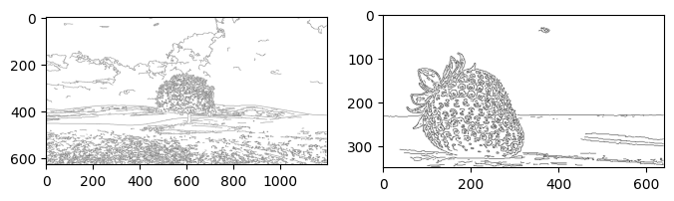

Edge Detection Filters :-

Sobel Filter :-
The Sobel filter is a mathematical operator that is used to find the edges in an image. It works by calculating the gradient of the image intensity at each pixel. The gradient is the rate of change of the image intensity in the horizontal and vertical directions. The Sobel filter can be used to detect both vertical and horizontal edges in an image.

The Sobel filter is a simple and efficient way to find edges in an image. It is often used as a preprocessing step for other image processing tasks, such as object detection and segmentation.

Implementation :-
Import Modules :

import cv2
import matplotlib.pyplot as plt
import numpy as np

Read the image:
Program:

image= cv2.imread("img2.jpg",0)
plt.imshow(image)
print(image.shape)

Output:
(350, 642)
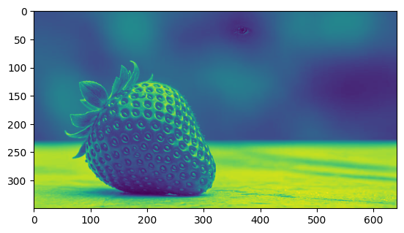

Convert BGR to RGB:
Program:

img = cv2.cvtColor(image, cv2.COLOR_BAYER_BG2BGR)
plt.imshow(img)

Output:
<matplotlib.image.AxesImage at 0x1e7dadf8740>
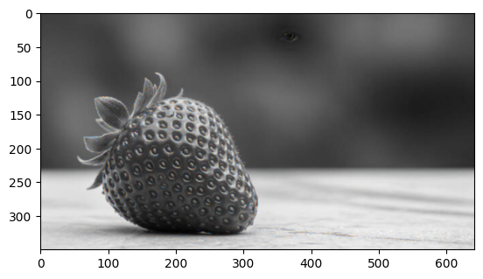

Convert image to gray:

Program:
im=cv2.imread("img2.jpg",0)
plt.imshow(img)
plt.imshow(img,cmap="gray")

Output:
<matplotlib.image.AxesImage at 0x1e7da25e960>

Sobel Filter:
Program:

img1=cv2.Sobel(im, cv2.CV_64F,1,0,5)
img2=cv2.Sobel(im, cv2.CV_64F,0,1,5)
plt.subplot(1,3,1),plt.imshow(im,cmap='gray'),plt.title("original image")
plt.subplot(1,3,2),plt.imshow(img1,cmap='gray'),plt.title("Horizontal image")
plt.subplot(1,3,3),plt.imshow(img2,cmap='gray'),plt.title("Vertical image")

Output:

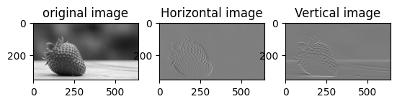

Laplacian Filter:

A Laplacian filter is a mathematical operator that is used to find the edges in an image. It is a second-order derivative filter, which means that it measures the rate of change of the image intensity in both the horizontal and vertical directions. The Laplacian filter can be used to detect both edges and corners in an image.

Program:
blurred = cv2.GaussianBlur(image, (3, 3), 0)
laplacian = cv2.Laplacian(blurred, cv2.CV_64F)
laplacian_abs = cv2.convertScaleAbs(laplacian)
plt.imshow(laplacian_abs, cmap="gray")
plt.title("Laplacian Image")

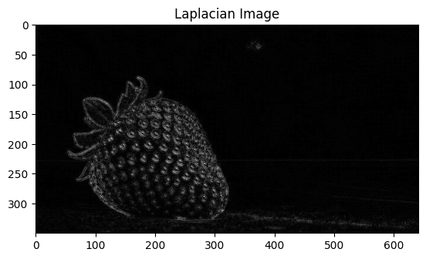
Output:

Machine Intelligence Applications Lab

Week-4
Aim:
Write a program to extract SURF/SIFT feature descriptorsfrom a sample image.

Description:
The SIFT (Scale-Invariant Feature Transform) algorithm is a computer vision technique used for feature detection and description. It detects distinctive key points or features in an image that are robust to changes in scale, rotation, and affine transformations. SIFT works by identifying keypoints based on their local intensity extrema and computing descriptors that capture the local image information around those keypoints.
“SIFT, or Scale Invariant Feature Transform, is a feature detection algorithm in Computer Vision”.
The major advantage of SIFT features, over-edge features, or hog features is that they are not affected by the size or orientation of the image.

Implementation:

Importing modules:

import skimage
import numpy as np
import pandas as pd
import matplotlib.pyplot as plt
from skimage import io
%matplotlib inline

Program:

img1 = io.imread('img1.jpg')
img2 = io.imread('img2.jpg')
df=pd.DataFrame(['img1','img2'],columns=['Image'])
print(img1.shape,img2.shape)

Output:
(630, 1200, 3) (350, 642, 3)

Extracting two color sample images:
Program:

fig=plt.figure(figsize=(9,3))
ax1=fig.add_subplot(1,2,1)
ax1.imshow(img1)
ax2=fig.add_subplot(1,2,2)
ax2.imshow(img2)

Output:
<matplotlib.image.AxesImage at 0x142f2307020>

Object Detection:

Interesting technique in the world of computer vision is object detection where features useful in highlighting specific objects in the image are detected and extracted. The histogram of oriented gradients, also known as HOG, is one of the techniques that’s extensively used in object detection. HOG algorithm works by following a sequence of steps similar to edge detection. The image is normalized and denoised to remove excess illumination effects. First order image gradients are computed to capture image attributes like contour, texture, and so on. Gradient histograms are built on top of these gradients based on specific windows called cells. Finally these cells are normalized and a flattened feature descriptor is obtained, which can be used as a feature vector for our models.

Program:
from skimage.feature import hog
from skimage import exposure
import matplotlib.pyplot as plt
import cv2
fd1, hog_vis1 = hog(img1,
orientations=8,
pixels_per_cell=(8, 8),
cells_per_block=(3, 3),
visualize=True,
channel_axis=-1)
fd2, hog_vis2 = hog(img2,
orientations=8,
pixels_per_cell=(8, 8),
cells_per_block=(3, 3),
visualize=True,
channel_axis=-1)
img1_hogs = exposure.rescale_intensity(hog_vis1, in_range=(0, 0.04))
img2_hogs = exposure.rescale_intensity(hog_vis2, in_range=(0, 0.04))
# Visualization
fig = plt.figure(figsize=(10, 4))
ax1 = fig.add_subplot(1, 2, 1)
ax1.imshow(img1_hogs, cmap='binary')
ax2 = fig.add_subplot(1, 2, 2)
ax2.imshow(img2_hogs, cmap='binary')
plt.tight_layout()
plt.show()

Output:
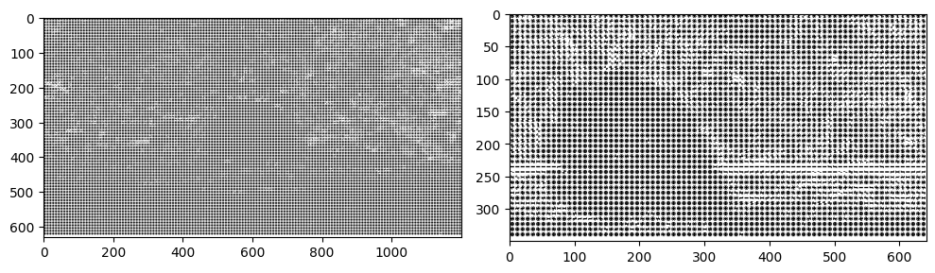

Localized Feature Extraction :

Localized feature extraction based techniques are slightly better met hods which try to detect and extract localized feature descriptors on various sma ll localized regions of our input images. This is hence rightly named localized feature extraction. We will be using the popular and patented SURF algorithm invented by Herbert Bay, et al. mages which can be used later as image features. T his algorithm is similar to the popular SIFT algorithm. There are mainly two ma jor phases in this algorithm. The first phase is to detect points of interest using s quare shaped filters and hessian matrices. The second phase is to build feature d escriptors by extracting localized features around these points of interest.

Program:

import mahotas as mh
from mahotas.features import surf
img1_mh = mh.colors.rgb2gray(img1)
img2_mh = mh.colors.rgb2gray(img2)
img1_surf = surf.surf(img1_mh, nr_octaves=8, nr_scales=16,
initial_step_size=1, threshold=0.1, max_points=50)
img2_surf = surf.surf(img2_mh, nr_octaves=8, nr_scales=16,
initial_step_size=1, threshold=0.1, max_points=50)
fig = plt.figure(figsize=(10,4))
ax1 = fig.add_subplot(1,2,1)
ax1.imshow(surf.show_surf(img1_mh, img1_surf))
ax2 = fig.add_subplot(1,2,2)
ax2.imshow(surf.show_surf(img2_mh, img2_surf))
Output:
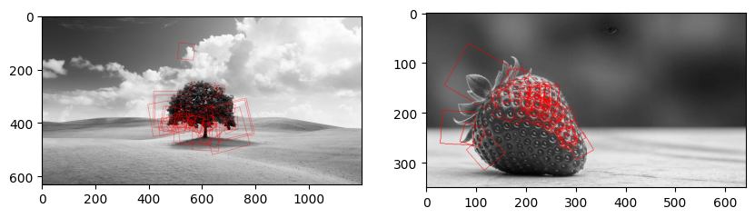
Localized feature extraction with SURF for new image :

Program:

new_img1 = io.imread('img1.jpg')
newimg1_mh = mh.colors.rgb2gray(new_img1)
newimg1_surf = surf.surf(newimg1_mh, nr_octaves=8, nr_scales=16,
initial_step_size=1, threshold=0.1, max_points=50)
fig = plt.figure(figsize=(15,10))
ax1 = fig.add_subplot(1,2,1)
ax1.imshow(surf.show_surf(newimg1_mh, newimg1_surf))

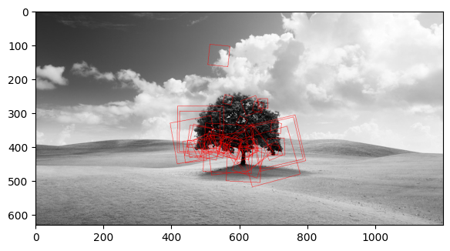
Output:

SIFT :-
Description :
SIFT stands for Scale-Invariant Feature Transform. It is a widely used computer vision algorithm that is primarily used for feature detection, description, and matching in images. SIFT was introduced by David Lowe in 1999 and has become a foundational technique in the field of computer vision. It is widely used in computer vision applications, such as:
➢ Image matching : SIFT can be used to match key points between different images. This can be used for tasks such as object recognition, 3D reconstruction, and image stitching.
➢ Object recognition : SIFT can be used to identify objects in images.
➢ 3D reconstruction : SIFT can be used to reconstruct 3D objects from a set of 2D images.

Program :

import cv2
import matplotlib.pyplot as plt
# Load the image
image = cv2.imread('img1.jpg')
# Convert the image to grayscale
gray_image = cv2.cvtColor(image, cv2.COLOR_BGR2GRAY)
# Create a SIFT object
sift = cv2.SIFT_create()
# Detect keypoints and compute descriptors
keypoints, descriptors = sift.detectAndCompute(gray_image, None)
# Draw keypoints on the image
result_image = cv2.drawKeypoints(gray_image, keypoints, None, flags=cv2.DRAW_MATCHES_FLAGS_DRAW_RICH_KEYPOINTS)
# Display the original image
plt.subplot(1, 2, 1)
plt.imshow(cv2.cvtColor(image, cv2.COLOR_BGR2RGB))
plt.title("Original Image")
# Display the image with keypoints
plt.subplot(1, 2, 2)
plt.imshow(cv2.cvtColor(result_image, cv2.COLOR_BGR2RGB))
plt.title("Image with Keypoints")
plt.tight_layout()
plt.show()

Output:
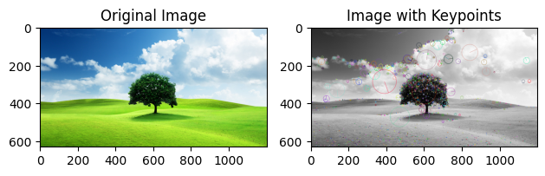

Canny Filter :-

The Canny edge detector is an edge detection algorithm that is used to find edges in images.

Program:

canny_filter=cv2.Canny(gray_image, 100,150)
plt.subplot(1,2,1),plt.imshow(gray_image,cmap='gray'),plt.title("original image")
plt.subplot(1,2,2),plt.imshow(canny_filter,cmap='gray'),plt.title("Canny image")

Output:

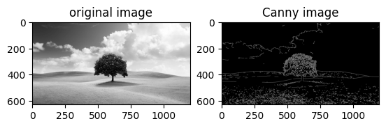

Sobel Filter :-

The Sobel filter is a mathematical operator that is used to find the edges in an image. It works by calculating the gradient of the image intensity at each pixel.

Program:

img1=cv2.Sobel(gray_image, cv2.CV_64F,1,0,5)
img2=cv2.Sobel(gray_image, cv2.CV_64F,0,1,5)
plt.subplot(1,3,1),plt.imshow(gray_image,cmap='gray'),plt.title("original image")
plt.subplot(1,3,2),plt.imshow(img1,cmap='gray'),plt.title("Horizontal image")
plt.subplot(1,3,3),plt.imshow(img2,cmap='gray'),plt.title("Vertical image")

Output:
(<Axes: title={'center': 'Vertical image'}>,
<matplotlib.image.AxesImage at 0x142813671a0>,
Text(0.5, 1.0, 'Vertical image'))
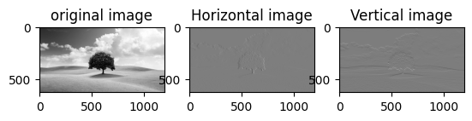

Laplacian Filter :-

The Laplacian filter is a mathematical operator that is used to find the edges in an image. It is a second-order derivative filter, which means that it measures the rate of change of the image intensity in both the horizontal and vertical directions. The Laplacian filter can be used to detect both edges and corners in an image.

Program:

# Apply Gaussian blur
blurred = cv2.GaussianBlur(gray_image, (3, 3), 0)
# Apply Laplacian filter
laplacian = cv2.Laplacian(blurred, cv2.CV_64F)
# Convert to absolute values
laplacian_abs = cv2.convertScaleAbs(laplacian)
plt.imshow(laplacian_abs, cmap="gray")
plt.title("Laplacian Image")

Output:

Text(0.5, 1.0, 'Laplacian Image')
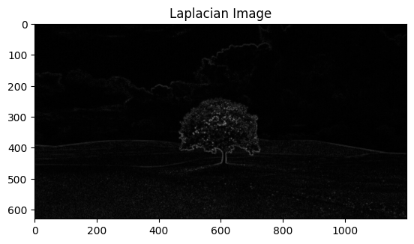

Machine Intelligence Applications Lab

Week-5
Aim:

Write a program to perform Exploratory Data Analysis on real time datasets.
a) Univariate Analysis
b) Multivariate Analysis
c) Visualization using correlation matrix

Description:

The preliminary analysis of data to discover relationships between measures in the data and to gain an insight on the trends, patterns, and relationships among various entities present in the data set with the help of statistics and visualization tools is called Exploratory Data Analysis (EDA).
Exploratory data analysis is cross-classified in two different ways where each method is either graphical or non-graphical. And then, each method is either univariate, bivariate or multivariate.

Univariate Analysis :
➢ Uni means one and variate means variable, so in univariate analysis, there is only one dependable variable.
➢ The objective of univariate analysis is to derive the data, define and summarize it, and analyze the pattern present in it.
➢ It is possible for two kinds of variables- Categorical and Numerical.
➢ Some patterns that can be easily identified with univariate analysis are Central Tendency (mean, mode and median), Dispersion (range, variance), Quartiles (interquartile range), and Standard deviation.

Bivariate Analysis :
➢ Bi means two and variate means variable, so here there are two variables. One variable here is dependent while the other is independent.
➢ The analysis is related to cause and the relationship between the two variables. Types :
1) Numerical and Numerical
2) Categorical and Categorical
3) Numerical and Categorical

Multivariate Analysis :
➢ Multivariate analysis is required when more than two variables have to be analyzed simultaneously.
➢ It is a tremendously hard task for the human brain to visualize a relationship among 4 variables in a graph and thus multivariate analysis is used to study more complex sets of data.
➢ Types of Multivariate Analysis include Cluster Analysis, Factor Analysis, Multiple Regression Analysis, Principal Component Analysis, etc.
➢ More than 20 different ways to perform multivariate analysis exist and which one to choose depends upon the type of data and the end goal to achieve.

Implementation:
Import modules:

import pandas as pd
import numpy as np
import seaborn as sns

Load the dataset:

Program:

df = pd.read_csv('credit_card.csv')
df.head()

Output:

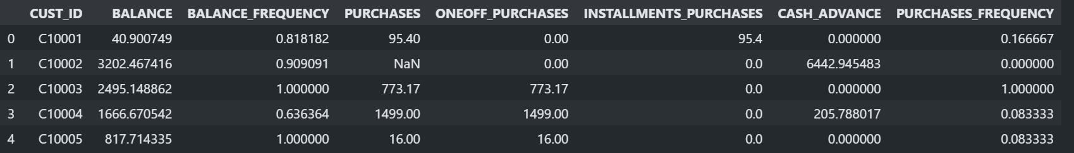
Program:
df.describe()

Output:
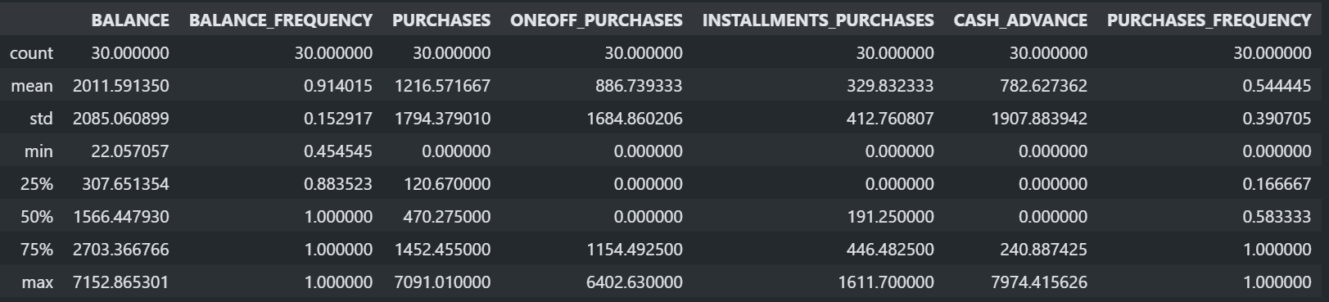
Program:
df.info()

Output:

<class 'pandas.core.frame.DataFrame'>
RangeIndex: 30 entries, 0 to 29
Data columns (total 8 columns):
# Column Non-Null Count Dtype
--- ------ -------------- -----
0 CUST_ID 30 non-null object
1 BALANCE 30 non-null float64
2 BALANCE_FREQUENCY 30 non-null float64
3 PURCHASES 30 non-null float64
4 ONEOFF_PURCHASES 30 non-null float64
5 INSTALLMENTS_PURCHASES 30 non-null float64
6 CASH_ADVANCE 30 non-null float64
7 PURCHASES_FREQUENCY 30 non-null float64
dtypes: float64(7), object(1)
memory usage: 2.0+ KB

Find the duplicates:

Program:
df.duplicated().sum()

Output:
0

Unique values:

Program:
print('PURCHASES')
print(df['PURCHASES'].unique())
print()
print('PURCHASES_FREQUENCY')
print(df['PURCHASES_FREQUENCY'].unique())
print()

Output:

PURCHASES
[ 95.4 0. 773.17 1499. 16. 1333.28 7091.01 436.2 861.49
1281.6 920.12 1492.18 3217.99 2138.73 1611.7 519. 504.35 398.64
176.68 6359.95 300. 4248.35 399.98 102. 233.28 387.05 100. ]
PURCHASES_FREQUENCY
[0.166667 0. 1. 0.083333 0.666667 0.333333 0.25 0.75
0.5 0.416667]

Plotting Unique values:

Program:

sns.countplot(x='PURCHASES',data=df)

Output:

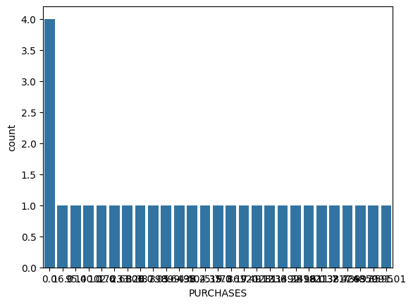

Finding Null values:

Program:

df.isnull().sum()

Output:
CUST_ID 0
BALANCE 0
BALANCE_FREQUENCY 0
PURCHASES 2
ONEOFF_PURCHASES 0
INSTALLMENTS_PURCHASES 0
CASH_ADVANCE 0
PURCHASES_FREQUENCY 0
dtype: int64

Program:

df.PURCHASES.fillna(df['PURCHASES'].mean(),inplace=True)
print(df.isnull().sum())

Output:
CUST_ID 0
BALANCE 0
BALANCE_FREQUENCY 0
PURCHASES 0
ONEOFF_PURCHASES 0
INSTALLMENTS_PURCHASES 0
CASH_ADVANCE 0
PURCHASES_FREQUENCY 0
dtype: int64
Replace Null values:

Program:
df.replace(np.nan,'0',inplace=True)
df.isnull().sum()

Output:

CUST_ID 0
BALANCE 0
BALANCE_FREQUENCY 0
PURCHASES 0
ONEOFF_PURCHASES 0
INSTALLMENTS_PURCHASES 0
CASH_ADVANCE 0
PURCHASES_FREQUENCY 0
dtype: int64

Data types:

Program:

df.types

Output:

CUST_ID object
BALANCE float64
BALANCE_FREQUENCY float64
PURCHASES float64
ONEOFF_PURCHASES float64
INSTALLMENTS_PURCHASES float64
CASH_ADVANCE float64
PURCHASES_FREQUENCY float64
dtype: object

Filter the data:

Program:

df[df['PURCHASES_FREQUENCY']==0.5].head()

output:

Boxplot:
df[["BALANCE_FREQUENCY"]].boxplot()

Output:
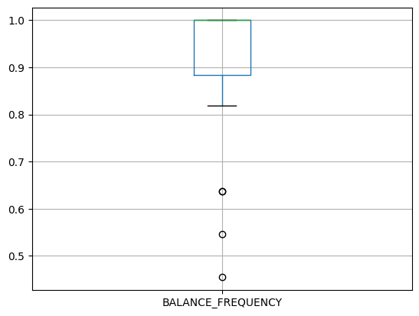

Correlation:

Program:

sns.heatmap(df.corr())

Output:
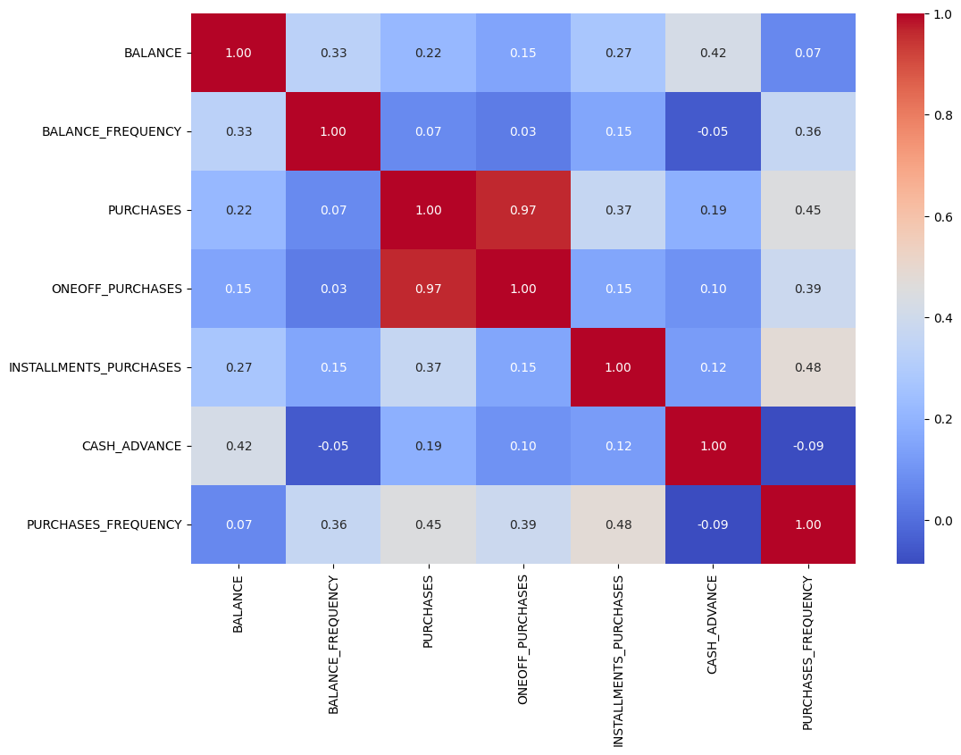
UNIVARIATE ANALYSIS:

Importing modules:

import matplotlib.pyplot as plt
import matplotlib as mpl
%matplotlib inline
Histogram:

Program:

plt.hist(df['PURCHASES_FREQUENCY'])
plt.xlabel('PURCHASES_FREQUENCY')
plt.ylabel('count')
plt.title('Histogram')

Output:

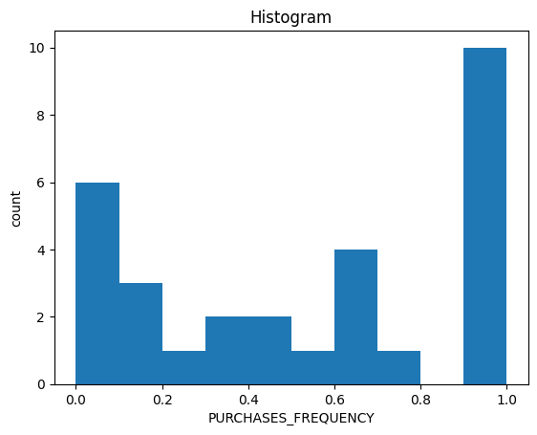

Pie Chart:

Program:
CASH_ADVANCE_LABELS = '0-1k', '1k-2k', '2k-3k', '3k-4k', '4k-5k', '5k-6k', '7k+'
plt.pie(counts, labels=CASH_ADVANCE_LABELS, autopct='%1.1f%%')
plt.title('Cash Advance Distribution')
plt.show()

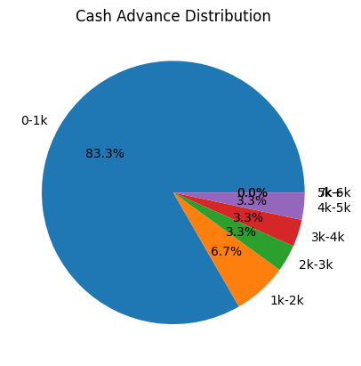
Output:

Density plot:

Program:

plt.figure()
df['CASH_ADVANCE'].plot(kind='density')

Output:

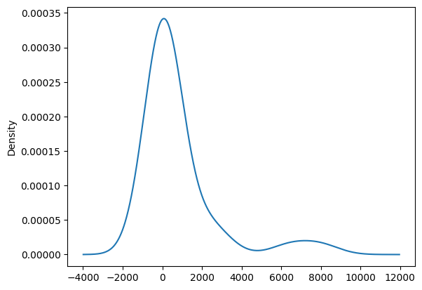

BIVATIATE ANALYSIS:

Scatter Plot:

Program:
plt.scatter('CASH_ADVANCE','PURCHASES_FREQUENCY',data=df)

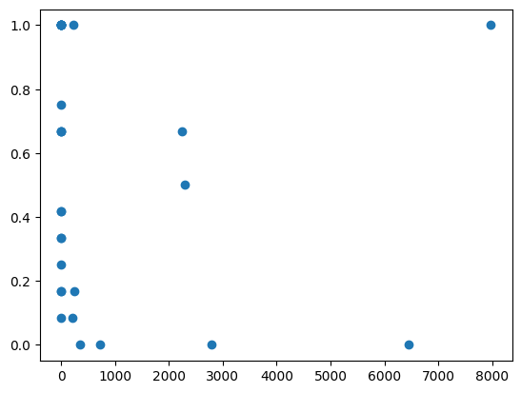
Output:

Violin Plot:

Program:

sns.violinplot(y='CASH_ADVANCE',x='PURCHASES_FREQUENCY',data=df, orient='vertical')
sns.violinplot(y='PURCHASES',x='PURCHASES_FREQUENCY',data=df, orient='vertical')

Output:
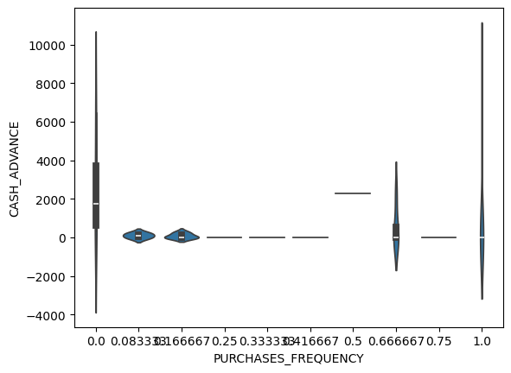

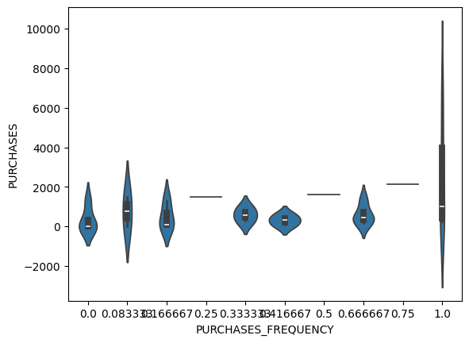

MULTIVARIATE ANALYSIS:
Program:
def multivariate_eda(df):
plt.figure(figsize=(3,4))
sns.pairplot(df)
plt.title('Multivariate EDA')
plt.show()
multivariate_eda(df)

Output:
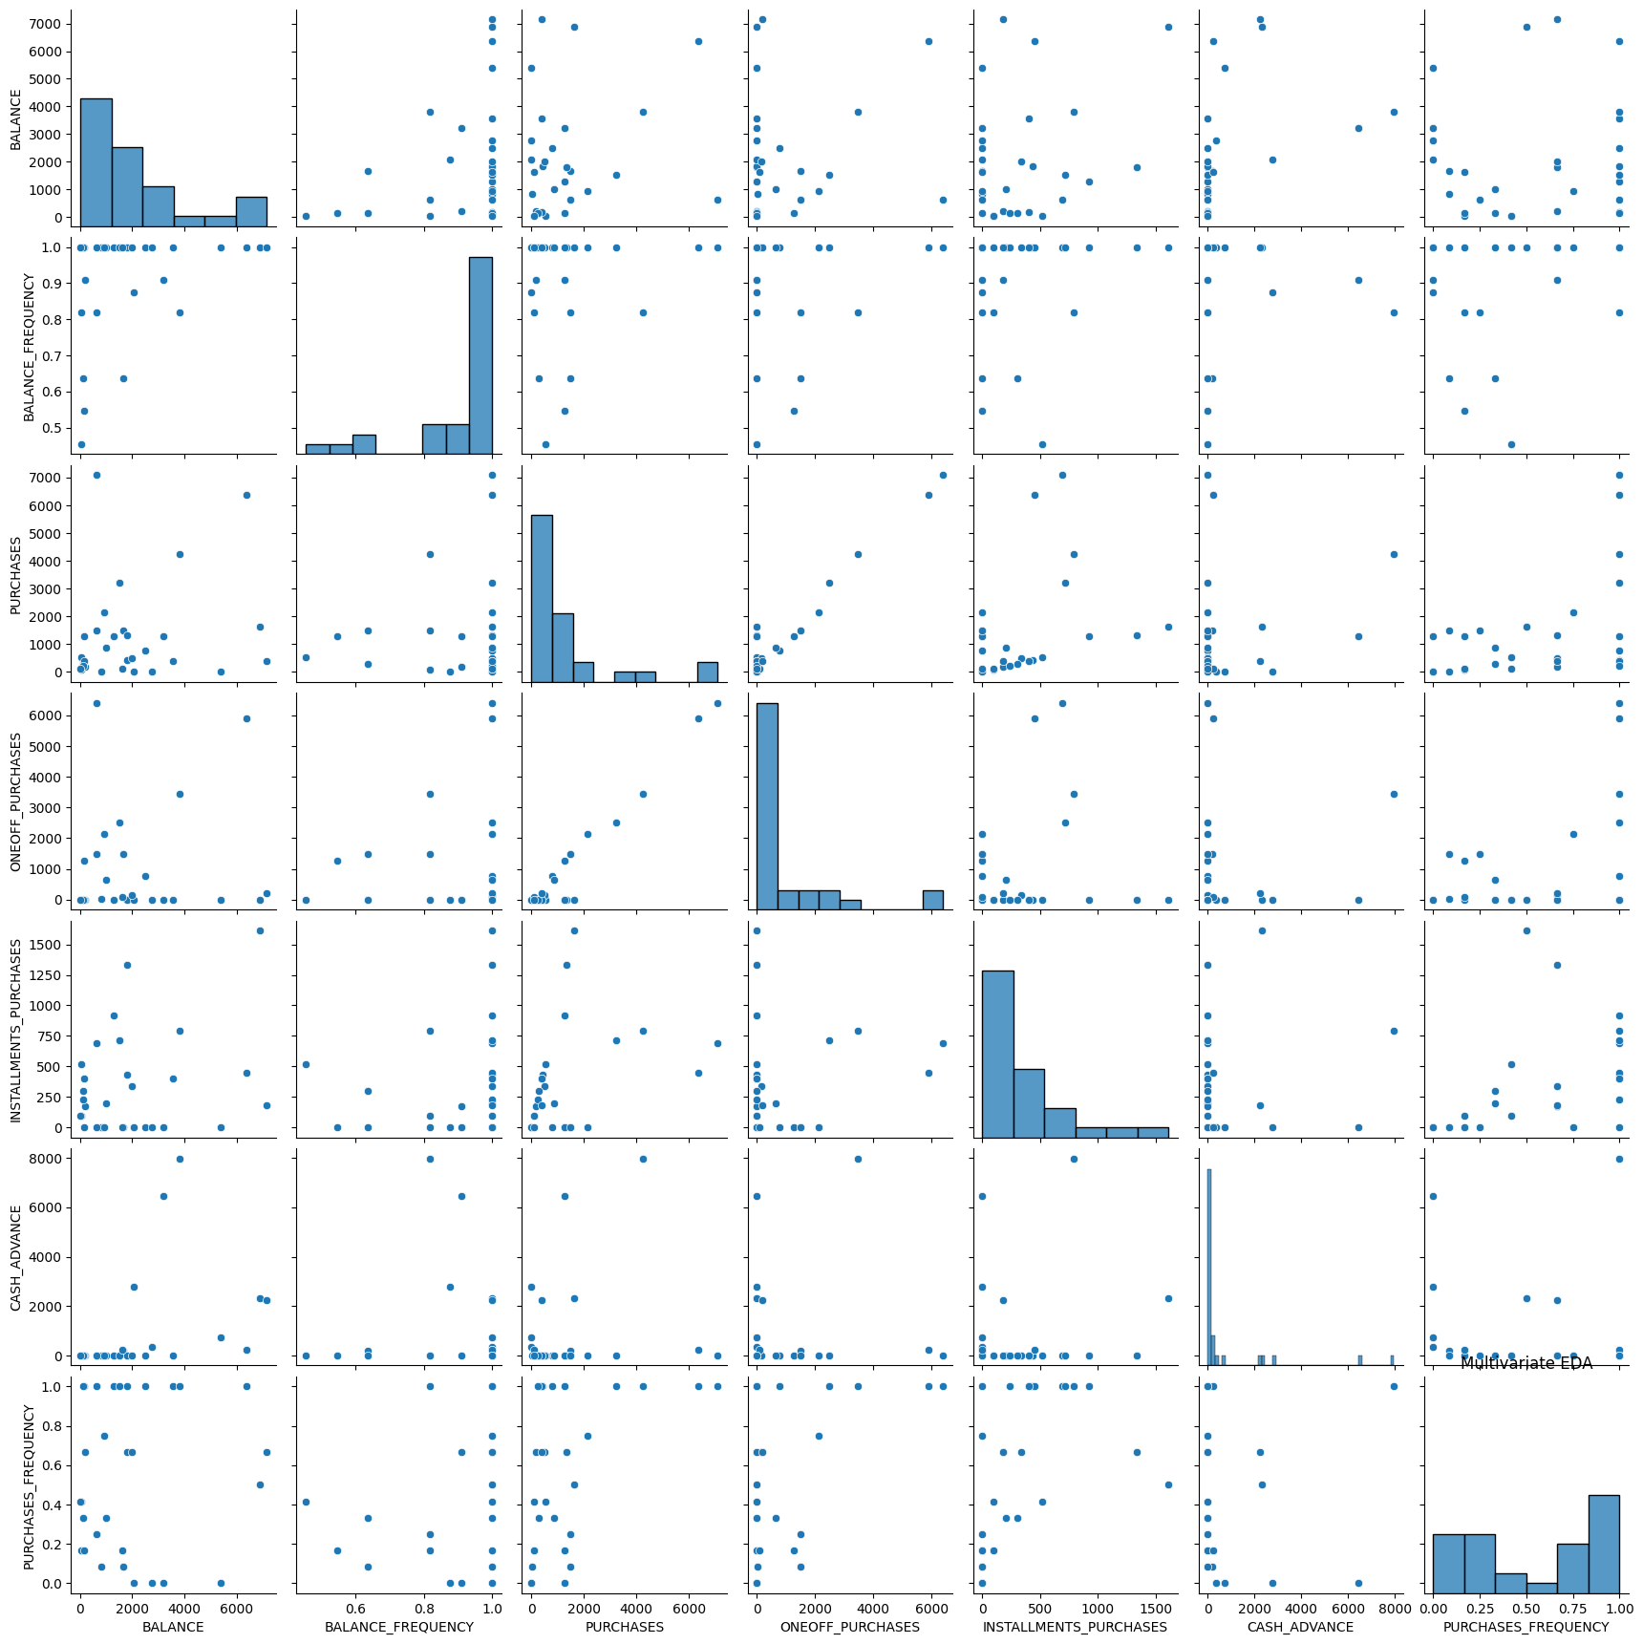

Machine Intelligence Applications Lab

Week – 6
Aim:
Write a program to perform Dimensionality Reduction using Principle Component Analysis techniques on real time datasets.

Description :-

Principal Component Analysis :

As the number of features or dimensions in a dataset increases, the amount of data required to obtain a statistically significant result increases exponentially. This can lead to issues such as overfitting, increased computation time, and reduced accuracy of machine learning models this is known as the curse of dimensionality problems that arise while working with high-dimensional data.

To address the curse of dimensionality, Feature Engineering techniques are used which include feature selection and feature extraction. Dimensionality Reduction is a type of feature extraction technique that aims to reduce the number of input features while retaining as much of the original information as possible.
One of the most popular dimensionality reduction technique is Principal Component Analysis(PCA).

➢ PCA comes under the Unsupervised Machine Learning category.
➢ Reducing the number of variables in a data collection while retaining as much information as feasible is the main goal of PCA. PCA can be mainly used for Dimensionality Reduction and also for important feature selection.
➢ Correlated features to Independent features.

Implementation:

Import modules:

import pandas as pd
import numpy as np
from sklearn.preprocessing import StandardScaler
from sklearn.decomposition import PCA
import matplotlib.pyplot as plt

Load the dataset:

Program:
data = pd.read_csv('iris.csv')
print(data.head())

Output:
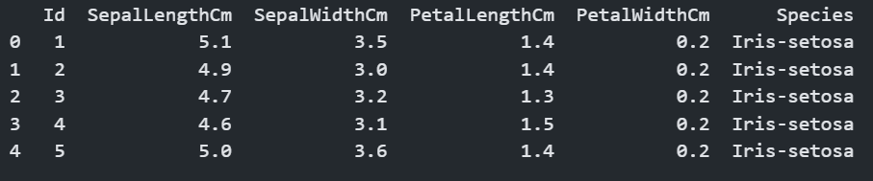
Select relevant features for analysis :

Program:
selected_features = ['SepalWidthCm', 'PetalLengthCm', 'PetalWidthCm']
data = data[selected_features].dropna()
print(data)

Output:
SepalWidthCm PetalLengthCm PetalWidthCm
0 3.5 1.4 0.2
1 3.0 1.4 0.2
2 3.2 1.3 0.2
3 3.1 1.5 0.2
4 3.6 1.4 0.2
5 3.9 1.7 0.4
6 3.2 4.7 1.4
7 3.2 4.5 1.5
8 3.1 4.9 1.5
9 2.3 4.0 1.3
10 2.8 4.6 1.5
11 2.8 4.5 1.3
12 3.3 4.7 1.6
13 3.3 6.0 2.5
14 2.7 5.1 1.9
15 3.0 5.9 2.1
16 2.9 5.6 1.8
17 3.0 5.8 2.2
18 3.0 6.6 2.1
19 2.5 4.5 1.7

Standardize the Data:

Program:

scaler = StandardScaler()
scaled_data = scaler.fit_transform(data)

Apply PCA:
Program:

pca = PCA(n_components=3)
principal_components = pca.fit_transfrom(scaled_data)

Create DataFrame:

Program:

pc_df = pd.DataFrame(data=principal_components,columns=['PC1','PC2','PC3'])
print(pc_df)

Output:
PC1 PC2 PC3
0 -2.373477 0.198623 -0.005876
1 -1.771794 -1.062047 -0.022958
2 -2.048386 -0.574382 -0.055990
3 -1.856211 -0.793310 0.020324
4 -2.493813 0.450756 -0.002460
5 -2.578197 1.340094 -0.059390
6 0.186080 0.488886 0.178778
7 0.198675 0.497243 0.005661
8 0.462689 0.311521 0.161705
9 0.933239 -1.938104 -0.037638
10 0.715940 -0.494689 0.031860
11 0.511153 -0.594419 0.178770
12 0.234611 0.824146 -0.004580
13 1.461468 1.414058 -0.326818
14 1.353609 -0.497554 -0.145779
15 1.448823 0.474799 -0.003383
16 1.208099 0.048166 0.153766
17 1.497337 0.499760 -0.136636
18 1.700258 0.591022 0.275673
19 1.209898 -1.184567 -0.205028

Bar plot:

Program:

explained_variance = pca.explained_variance_ratio_
plt.bar(['PC1', 'PC2','PC3'], explained_variance)
plt.xlabel('Principal Components')
plt.ylabel('Explained Variance Ratio')
plt.title('Explained Variance Ratio of Principal Components')
plt.show()

Output:

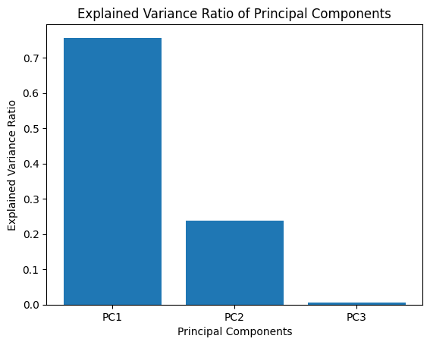

Program:

data_with_pc = pd.concat([pc_df], axis=1)
print(data_with_pc.head())

Output:

PC1 PC2 PC3
0 -2.373477 0.198623 -0.005876
1 -1.771794 -1.062047 -0.022958
2 -2.048386 -0.574382 -0.055990
3 -1.856211 -0.793310 0.020324
4 -2.493813 0.450756 -0.002460

Correlations :

Correlation is a statistical measure that indicates the extent to which two or more variables fluctuate in relation to each other. A positive correlation indicates the extent to which those variables increase or decrease in parallel; a negative correlation indicates the extent to which one variable increases as the other decreases.

Program:
import seaborn as sns
sns.heatmap(data_with_pc.corr(),annot=True)

Output:

