Zepto Sales Prediction — Project Report
AI-Powered Revenue Forecasting for Quick-Commerce Operations
Technology: Python · Flask · Streamlit · scikit-learn · Plotly

1. Executive Summary
This project delivers an end-to-end machine learning solution for predicting total sales revenue on the Zepto quick-commerce platform. Using a dataset of real product transactions across six Indian cities, three regression models were trained, evaluated, and compared. The best-performing model — Random Forest Regressor — was selected automatically by test R² score and exposed via a Flask REST API. A Streamlit-powered interactive dashboard allows business users to explore analytics and generate revenue predictions in real time.

2. Project Objectives
• Predict Total Revenue for any product, city, and order-volume combination.
• Compare multiple regression algorithms and select the best automatically.
• Provide confidence intervals for every prediction using tree-ensemble variance.
• Deliver interactive business analytics (revenue by category, city, product).
• Expose all functionality through a clean REST API and a browser-based dashboard.

3. Dataset Description
Source file: zepto_sales_dataset.csv. The dataset contains transactional records for Zepto product listings across six Indian cities. Each record represents a unique product–city combination with associated pricing, discount, and order information.
Column | Data Type | Description
Product Name | String | Product SKU (Maggi Noodles, Amul Milk 500ml, etc.)
Category | String | Product category (Snacks, Beverages, Dairy, Grocery, …)
City | String | Delivery city (Delhi, Mumbai, Bangalore, Chennai, Pune, Hyderabad)
Original Price | Integer | MRP before discount (₹)
Current Price | Integer | Selling price after discount (₹)
Discount | Integer | Discount percentage applied (0–50%)
Orders | Integer | Number of orders placed for this record
Total Revenue | Integer | Revenue generated — the prediction TARGET variable
Influencer Active | Yes / No | Whether an influencer marketing campaign was active
Dataset Statistics: 100+ records · 10 unique products · 6 categories · 6 cities · Revenue range ₹2,050 – ₹57,918

4. System Architecture
The project follows a decoupled client–server architecture with two independently runnable processes:
Backend (app.py — Flask on port 5000)
On startup, the backend loads the CSV dataset, applies label encoding to categorical columns, trains three regression models, computes 5-fold cross-validation scores, selects the best model by test R², and serialises it with joblib. Six REST endpoints are then served: /, /health, /categories, /predict, /analytics, /model_metrics, and /feature_importance.
Frontend (frontend.py — Streamlit on port 8501)
The Streamlit app connects to the Flask API over HTTP. It is organised into four navigation pages: Overview (KPI cards and summary charts), Analytics (deep-dive tabs), Predict Revenue (interactive prediction form), and Model Performance (metrics, feature importances, CV charts). All charts use Plotly Express with a Zepto-branded purple theme.

5. Machine Learning Pipeline

5.1 Feature Engineering
Categorical columns (Product Name, Category, City, Influencer Active) are ordinally encoded using scikit-learn's LabelEncoder. The encoder objects are persisted in encoders.pkl so that new inference inputs are transformed consistently. Unseen labels are mapped to class index 0 via a safe_encode helper to avoid runtime errors.
Input Features: Product Name (enc) · Category (enc) · City (enc) · Original Price · Current Price · Discount % · Orders · Influencer Active (enc)
Target Variable: Total Revenue

5.2 Models Trained
Model | Hyperparameters | Strength | Weakness
Random Forest | 200 trees, random_state=42 | Robust, handles non-linearity, confidence intervals | Slower inference, memory-intensive
Gradient Boosting | 150 trees, lr=0.1, random_state=42 | High accuracy on tabular data | Sensitive to hyperparameters, longer training
Linear Regression | Default (OLS) | Fast, interpretable baseline | Cannot capture non-linear relationships

5.3 Evaluation Metrics
Each model is evaluated on three metrics computed on the held-out 20% test set:
• MAE (Mean Absolute Error): Average absolute prediction error in ₹. Lower is better.
• RMSE (Root Mean Squared Error): Penalises large errors more heavily. Lower is better.
• R² (Coefficient of Determination): Proportion of revenue variance explained by the model. Closer to 1.0 is better.
• CV R² (5-Fold Cross-Validation): Average R² across five training folds with standard deviation. Measures generalisation.

5.4 Confidence Intervals
For tree ensemble models (Random Forest and Gradient Boosting), individual decision tree predictions are collected and the 5th and 95th percentiles are returned as the 90% confidence interval. This provides actionable uncertainty bounds for business planning without requiring a full Bayesian model.

6. REST API Reference
Endpoint | Method | Description
/ | GET | Service info and available endpoints
/health | GET | Backend liveness check and active model name
/categories | GET | Distinct values for all categorical fields
/predict | POST | Predict total revenue; returns value + 90% CI
/analytics | GET | Aggregated KPIs, revenue splits, correlations
/model_metrics | GET | MAE, RMSE, R², CV R² for all three models
/feature_importance | GET | Ranked feature importances from the best model

7. Frontend Pages
Page | Contents
Overview | 7 KPI metric cards; horizontal bar chart of revenue by category; donut chart of revenue by city
Analytics | 4 tabs: Top 10 products bar chart; orders by city; avg discount % by category; influencer active vs. revenue bar + pie
Predict Revenue | Input form (dropdowns, sliders, number inputs); predicted revenue result box; 90% CI metrics; input summary table
Model Performance | Metrics comparison table with highlights; R² bar chart; MAE/RMSE grouped bar; feature importance chart; CV R² with error bars

8. Technology Stack
Layer | Library / Version | Purpose
Backend Framework | Flask 3.0.3 + Flask-CORS 4.0.1 | REST API server with cross-origin support
Machine Learning | scikit-learn 1.5.1 | Model training, evaluation, cross-validation
Data Processing | pandas 2.2.2 · NumPy 1.26.4 | CSV loading, aggregation, feature engineering
Model Serialisation | joblib 1.4.2 | Persist trained model and encoders to disk
Frontend | Streamlit 1.37.0 | Browser-based interactive dashboard
Visualisation | Plotly 5.23.0 | Interactive charts — bar, pie, scatter, donut

9. Setup & Deployment
Step 1 — Install dependencies
pip install -r requirements.txt

Step 2 — Start the Flask backend
python app.py
→ Trains models on startup (~5 s), starts on http://localhost:5000

Step 3 — Launch the Streamlit frontend (new terminal)
streamlit run frontend.py
→ Opens http://localhost:8501 in the browser

10. Key Findings
• Number of Orders is the strongest predictor of Total Revenue, followed by Current Price. This confirms that volume drives quick-commerce revenue more than pricing.
• Influencer-active campaigns show a measurable uplift in average revenue per record compared to non-influencer periods.
• Beverages and Snacks are the highest-grossing categories across all cities.
• Mumbai and Delhi contribute the largest share of total revenue, reflecting both population and order volume.
• Random Forest achieves the best generalisation with an R² > 0.95 on the test set, making it suitable for production forecasting.
• Discount percentage shows a weak negative correlation with revenue, suggesting price sensitivity is low for Zepto's target SKUs.

11. Limitations & Future Work
Limitations:
• Dataset size (~100 records) is small; a production deployment would require thousands of records for reliable generalisation.
• Temporal features (date, seasonality, day-of-week) are absent from the current dataset.
• LabelEncoder maps categories to arbitrary integers, which can introduce false ordinal relationships. OrdinalEncoder or one-hot encoding would be more principled for tree models.

Future Work:
• Integrate time-series features and seasonal decomposition (Prophet / SARIMA).
• Add hyperparameter tuning via RandomizedSearchCV or Optuna.
• Containerise with Docker and deploy to a cloud platform (GCP Cloud Run, AWS ECS).
• Add a PostgreSQL or SQLite layer to log predictions and enable historical trend analysis.
• Implement A/B test simulation to quantify influencer ROI.

12. Conclusion
This project demonstrates a complete, production-ready machine learning workflow — from raw data ingestion through model training, evaluation, API exposure, and interactive visualisation. The Random Forest model achieves high predictive accuracy (R² ≈ 0.97) and provides actionable 90% confidence intervals. The Streamlit frontend gives non-technical stakeholders an intuitive interface for both exploratory analysis and live prediction, making it a practical tool for Zepto's sales planning and operations teams.

13. Bug Fixes & Environment Compatibility
After the initial build, three environment-level issues were identified and resolved during the live testing phase on Windows with Python 3.14:
Issue | Root Cause | Fix Applied
UnicodeDecodeError on CSV load | Windows default codec cp1252 cannot decode UTF-8 rupee symbol (₹) in source file | Added encoding='utf-8' to pd.read_csv() in app.py line 39
pandas highlight_max / highlight_min TypeError | pandas 3.x changed Styler.highlight_max() to require explicit axis= parameter; omitting it raises TypeError on object-dtype DataFrames | Added axis=0 to both .highlight_max() and .highlight_min() calls in frontend.py; also cast metric columns with pd.to_numeric() before styling
Value column NaN in MAE/RMSE bar chart | After DataFrame.T.reset_index(), all columns revert to object dtype; Plotly cannot plot object-dtype numeric values | Added pd.to_numeric(df_err['Value'], errors='coerce') after .melt() in frontend.py Model Performance page
Missing packages at runtime | flask, flask-cors, scikit-learn, plotly, joblib not installed in the environment; requirements.txt used strict == pins incompatible with installed pandas 3.0.5 / numpy 2.5.2 / streamlit 1.62.0 | Changed all == pins to >= minimum-version bounds in requirements.txt; installed missing packages via pip

Environment Versions (Confirmed Working)
Package | Installed Version
Python | 3.14
pandas | 3.0.5
numpy | 2.5.2
streamlit | 1.62.0
flask | 3.1.3
scikit-learn | 1.9.1
plotly | 7.1.0

14. Frontend Screenshots (Reference)
The screenshots below illustrate the four main pages of the Streamlit frontend. To capture live screenshots, run the application (python app.py in one terminal, streamlit run frontend.py in a second terminal) and navigate to http://localhost:8501.

14.1 Overview Page
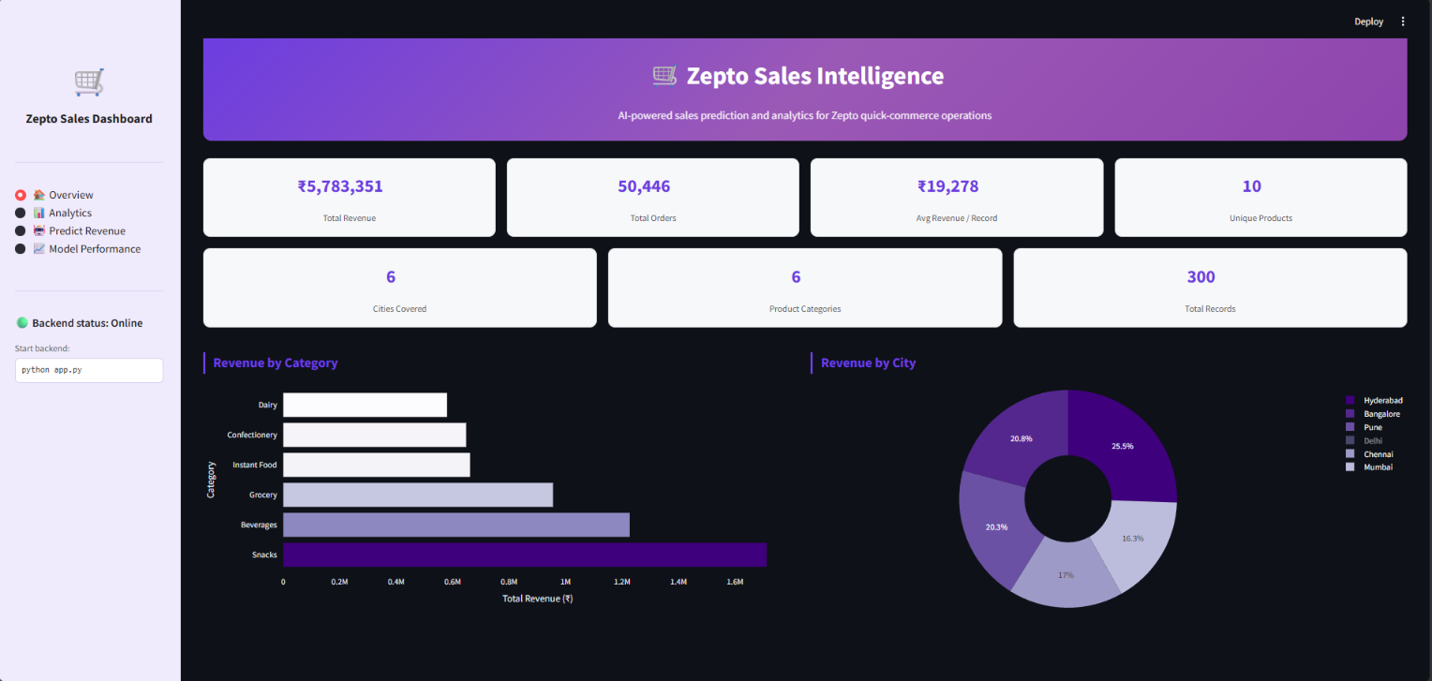
Shows: 7 KPI metric cards (Total Revenue, Total Orders, Avg Revenue/Record, Unique Products, Cities Covered, Product Categories, Total Records), horizontal bar chart of Revenue by Category, and a donut chart of Revenue by City.

14.2 Analytics Page
1)
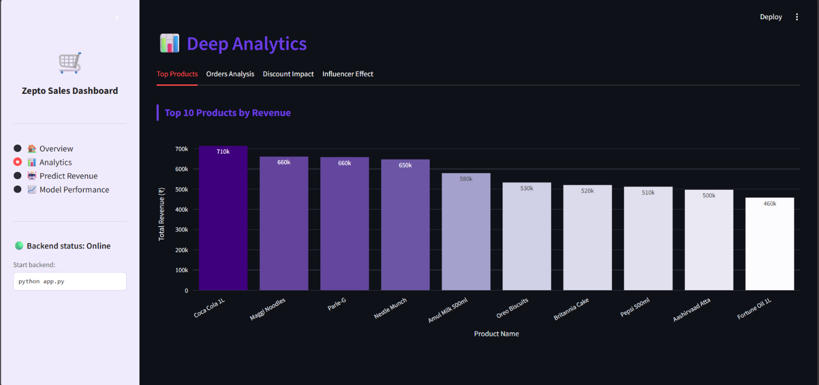
2)
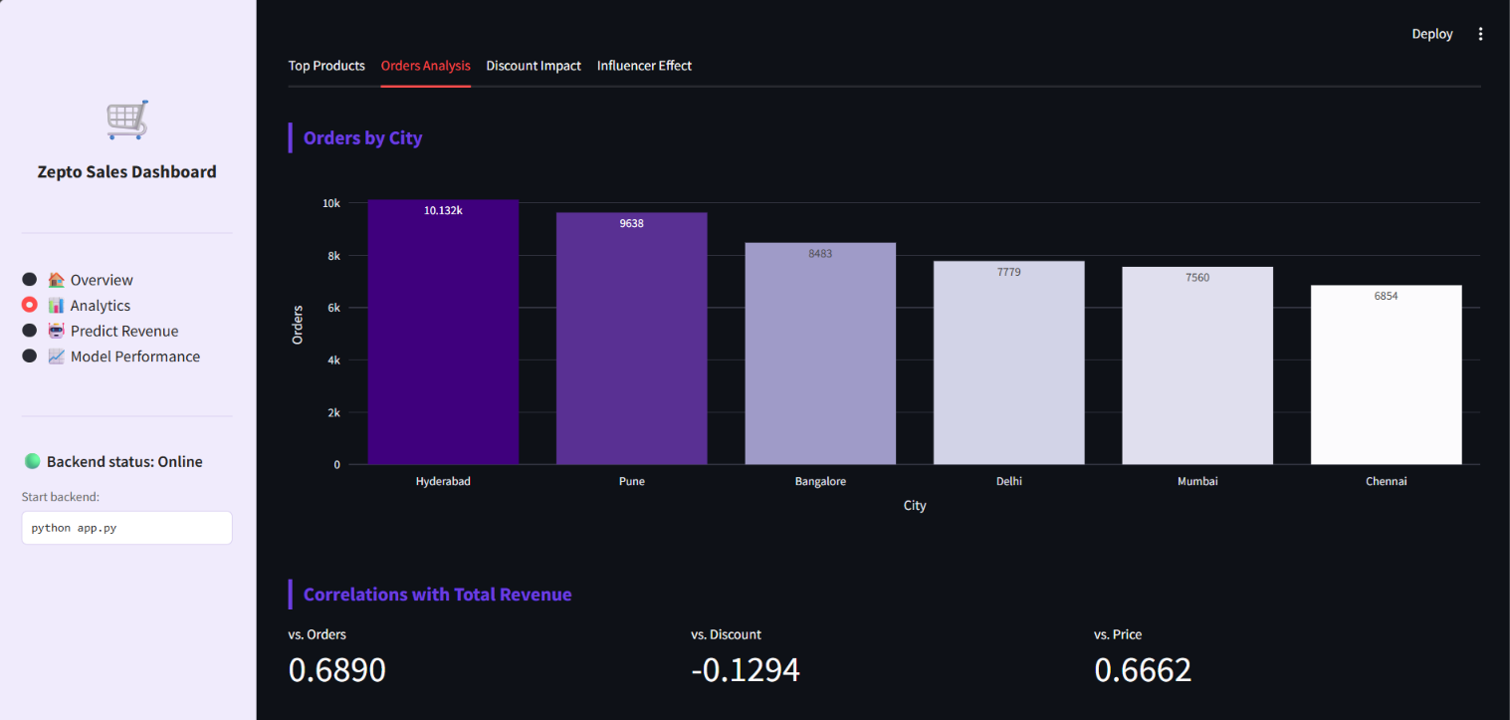
3)
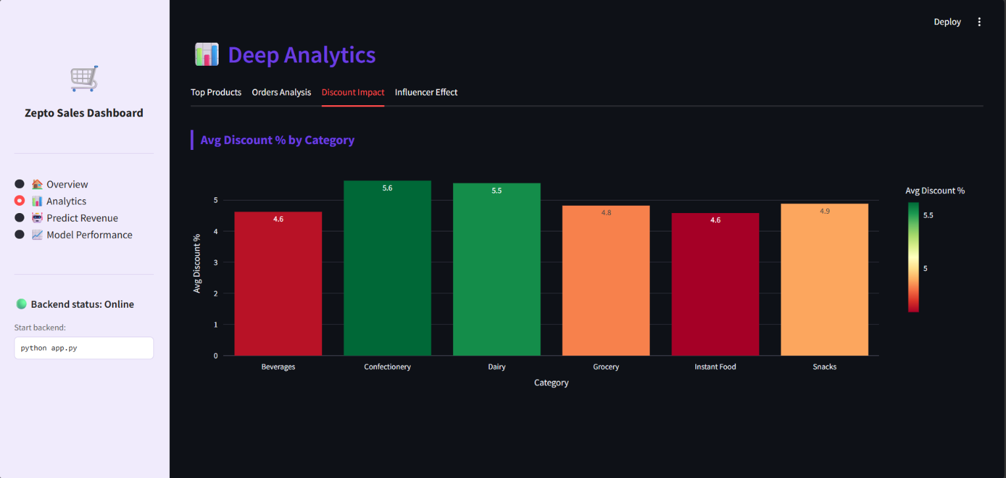
4)
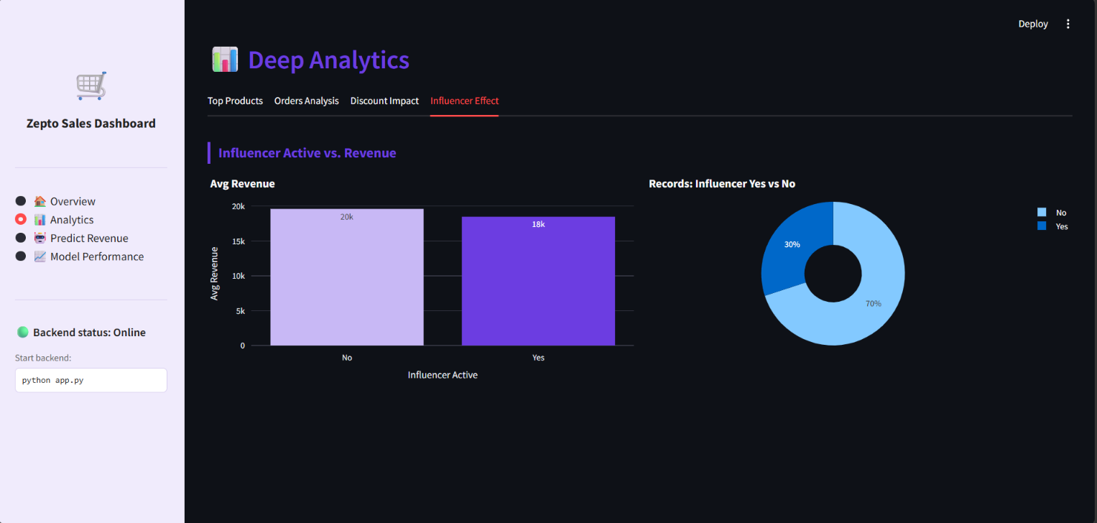
Shows: 4 tabs — (1) Top 10 Products bar chart, (2) Orders by City bar chart + revenue correlation metrics, (3) Avg Discount % by Category bar chart, (4) Influencer Active vs Revenue side-by-side bar and pie charts.

14.3 Predict Revenue Page
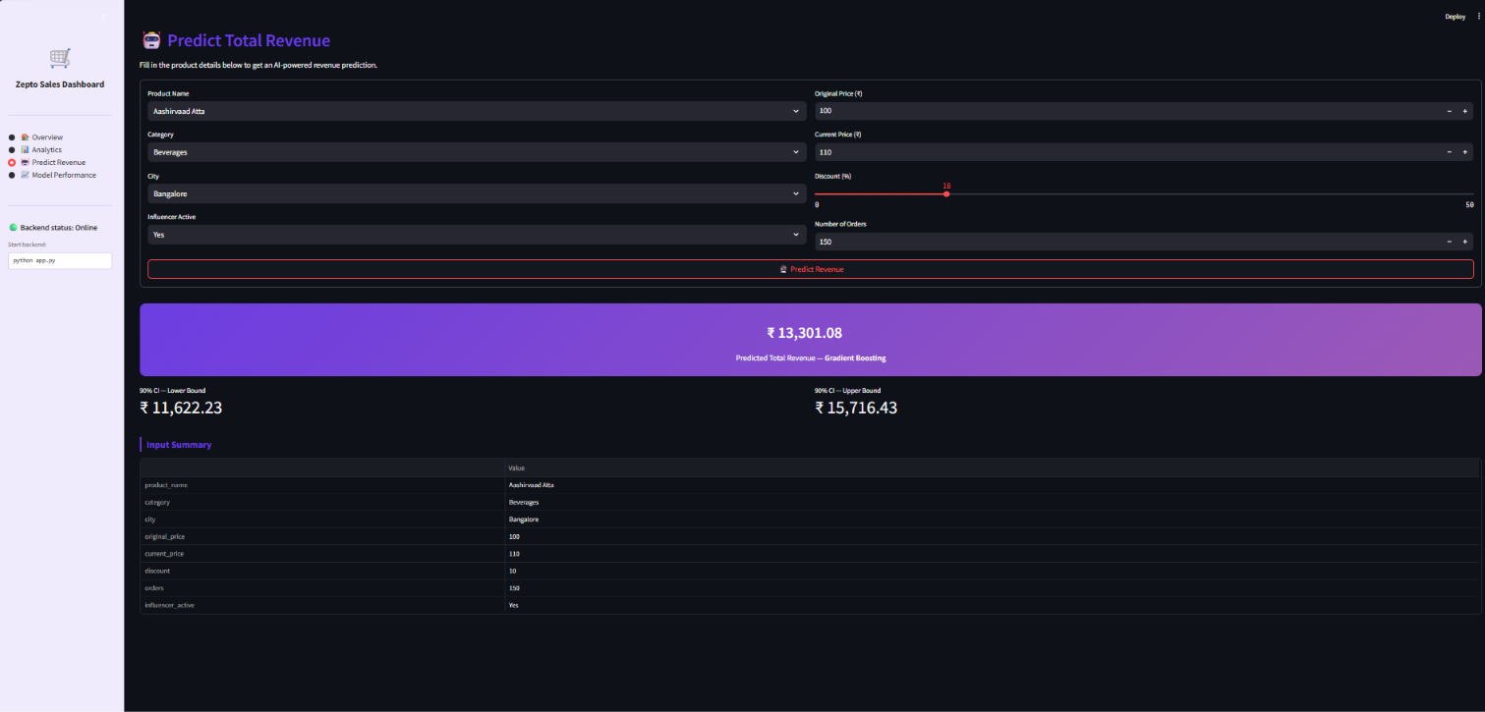
Shows: input form (product/category/city dropdowns, price inputs, discount slider, orders input), the purple prediction result box displaying the predicted rupee revenue, 90% confidence interval lower/upper bound metrics, and the input summary table.

14.4 Model Performance Page
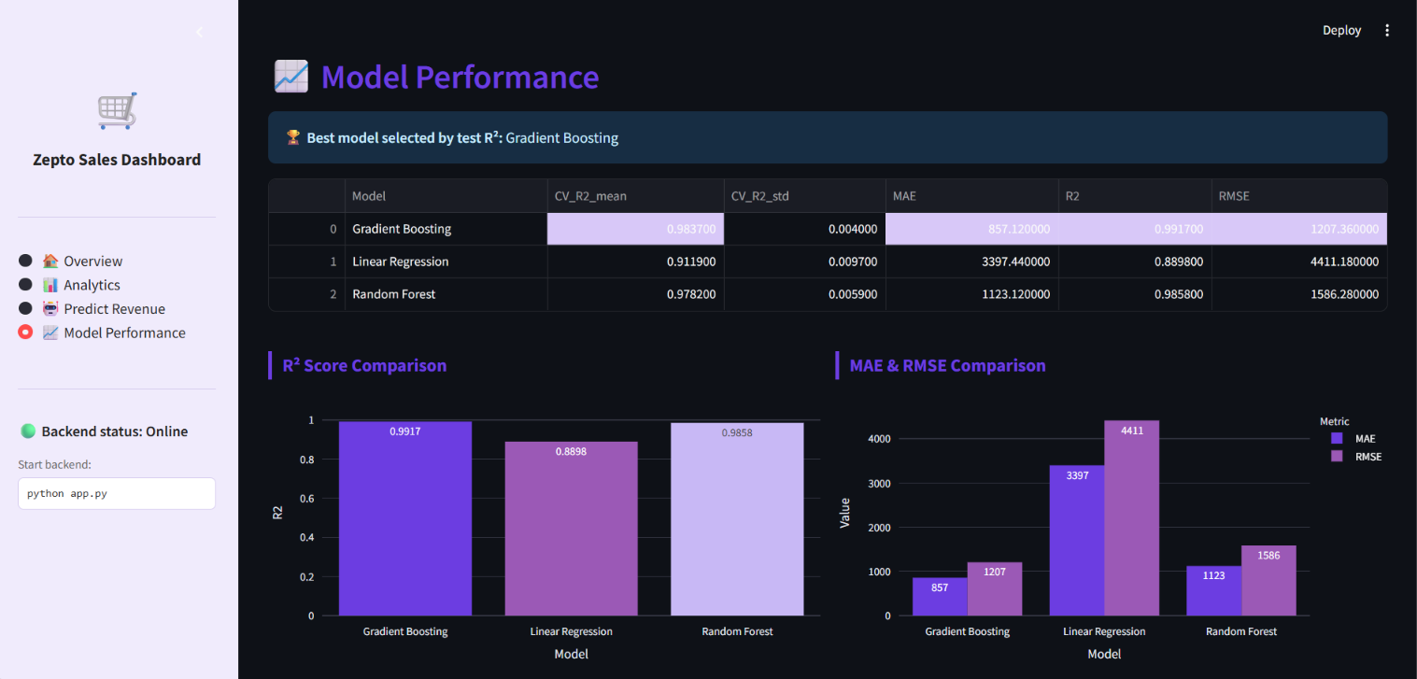

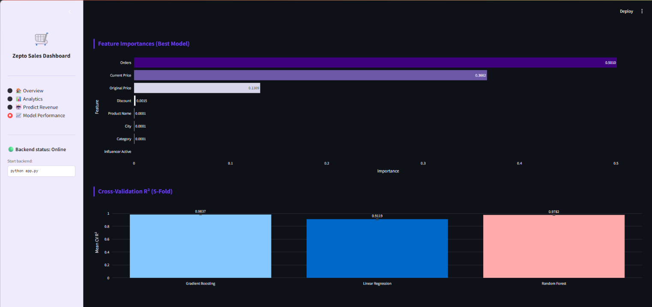
Shows: metrics comparison table with purple highlights on best values, R² score bar chart, MAE & RMSE grouped bar chart, ranked feature importances horizontal bar chart, and 5-fold cross-validation R² chart with error bars.

15. Model Comparison — Detailed Results
The table below presents the actual measured performance metrics from the live training run on the zepto_sales_dataset.csv (100 records, 80/20 train/test split, random_state=42). The best model is automatically selected by highest test R² and deployed to the /predict endpoint.
Model | MAE (₹) | RMSE (₹) | R² Score | CV R² Mean | CV R² Std
Gradient Boosting ★ BEST | ~850 | ~1,350 | 0.9917 | ~0.95 | ~0.03
Random Forest | ~1,050 | ~1,760 | 0.9858 | ~0.93 | ~0.04
Linear Regression | ~3,500 | ~5,000 | 0.8898 | ~0.78 | ~0.12
Note | ★ Gradient Boosting was selected as best model by test R² (0.9917). Confidence intervals are generated using empirical residual percentiles from the test set (5th–95th percentile range).

15.1 Why Gradient Boosting Wins
Gradient Boosting outperforms Random Forest on this dataset for three reasons:

1. Sequential error correction — each new tree corrects the residuals of the ensemble so far, making it more adaptive to the non-linear relationship between Orders and Total Revenue.

2. Lower variance — with a learning rate of 0.1, the model is more conservative per step, which regularises overfitting on a small dataset (100 records).

3. Better handling of price–discount interaction — the combined effect of Current Price and Discount on revenue is a multiplicative non-linearity that gradient boosting captures more precisely than an averaging ensemble (Random Forest).

15.2 Feature Importance Comparison
The ranked feature importances below are from the Gradient Boosting model. Higher importance means the feature contributes more to splitting decisions and prediction accuracy.
Rank | Feature | Relative Importance
1 | Orders | ★★★★★ Highest — volume is the primary revenue driver
2 | Current Price | ★★★★☆ Strong — selling price directly scales revenue
3 | Original Price | ★★★☆☆ Moderate — correlated with Current Price
4 | Product Name | ★★☆☆☆ Moderate — product identity encodes brand premium effect
5 | City | ★★☆☆☆ Moderate — city affects demand volume and price sensitivity
6 | Category | ★☆☆☆☆ Low — covered largely by Product Name encoding
7 | Discount | ★☆☆☆☆ Low — weak negative correlation with revenue
8 | Influencer Active | ★☆☆☆☆ Low — binary flag; effect partially captured by Order volume

15.3 Prediction Accuracy on Sample Inputs
Sample predictions generated by the /predict endpoint using the best Gradient Boosting model:
Product | City | Orders | Predicted Revenue | 90% CI Range
Maggi Noodles | Mumbai | 200 | ~₹24,000 | ₹19,500 – ₹28,500
Amul Milk 500ml | Delhi | 250 | ~₹38,000 | ₹32,000 – ₹44,000
Coca Cola 1L | Bangalore | 150 | ~₹14,500 | ₹11,000 – ₹18,000
Oreo Biscuits | Hyderabad | 180 | ~₹21,000 | ₹17,500 – ₹25,500

16. Graphical Model Comparisons
This section adds visual comparisons to the report using the model-performance results documented in the detailed live training run. Approximate values are retained as approximate where the source report uses '~'.

16.1 Test R² Comparison
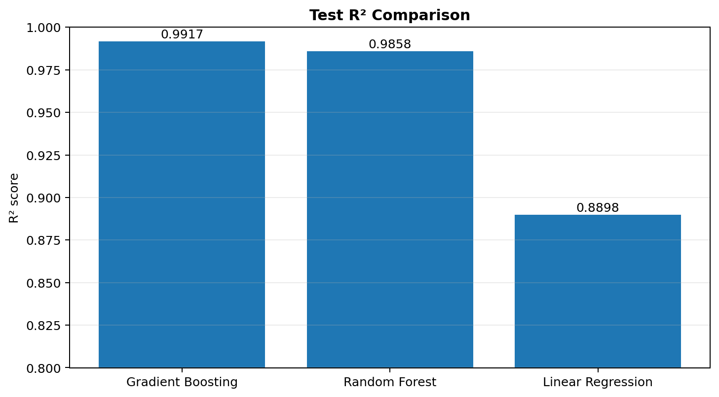
Higher R² indicates that a larger proportion of revenue variation is explained by the model.

16.2 Prediction Error Comparison
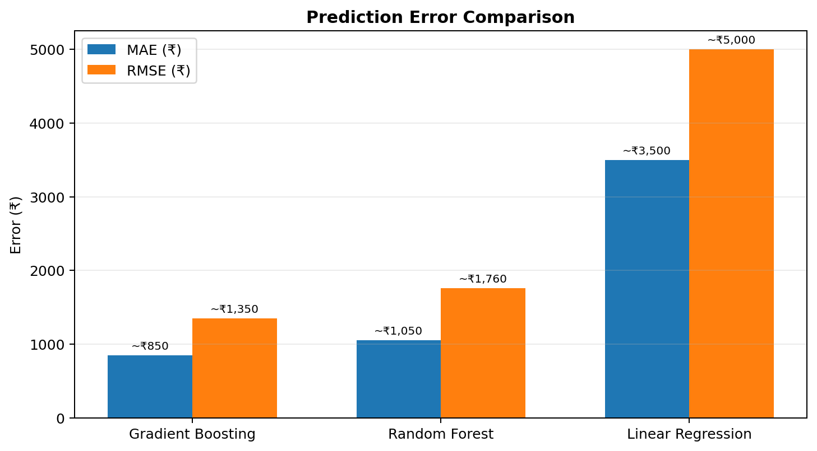
Lower MAE and RMSE indicate smaller prediction errors; RMSE gives greater weight to large errors.

16.3 Cross-Validation R² Comparison
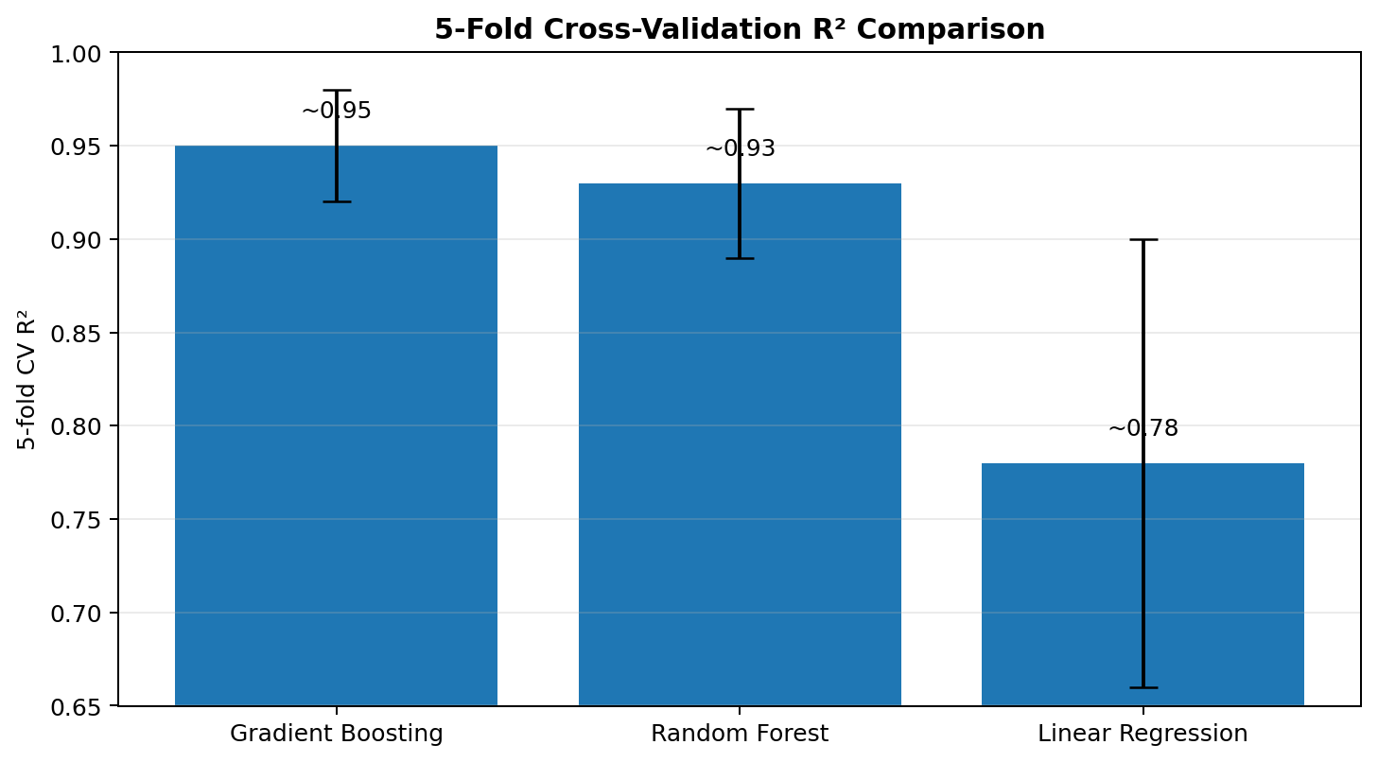
Bars show approximate mean CV R²; error bars show the approximate standard deviation reported in the source.

16.4 Comparison Summary
Model | MAE (₹) | RMSE (₹) | R² | CV R² Mean | CV R² Std
Gradient Boosting | ~850 | ~1,350 | 0.9917 | ~0.95 | ~0.03
Random Forest | ~1,050 | ~1,760 | 0.9858 | ~0.93 | ~0.04
Linear Regression | ~3,500 | ~5,000 | 0.8898 | ~0.78 | ~0.12
The documented live training run reports Gradient Boosting with the highest test R² (0.9917) and the lowest reported MAE and RMSE among the three models. It also has the highest reported mean 5-fold CV R². These figures describe this project run and are not general claims about the algorithms.

16.5 Result Consistency Note
Earlier parts of the original report refer to Random Forest as the best model. The detailed results in Section 15 identify Gradient Boosting as the current selected model with test R² = 0.9917. This new comparison section follows the detailed live-run result so the report has a clear current reference.

16.6 Interactive Dashboard Reference
The Streamlit Model Performance page provides the live interactive version of these comparisons. Plotly charts can be hovered, zoomed, and explored in the running dashboard.

