**PARALLEL AND DISTRIBUTED COMPUTING LAB**

**REPORT**

**NAME:** S Shyam Sundaram

**REG NO:** 19BCE1560

**PROGRAMMING ENVIRONMENT:** OpenMP

**PROBLEM:** Vector and Matrix Addition

**DATE:** 25th August, 2021

**HARDWARE CONFIGURATION:**

|  |  |  |  |
| --- | --- | --- | --- |
| CPU NAME | | : | Intel core i5 – 1035G1 @ 1.00 Ghz |
| Number of Sockets: | | : | 1 |
| Cores per Socket | | : | 4 |
| Threads per core | | : | 1 |
| L1 | Cache size | : | 320KB |
| L2 | Cache size | : | 2MB |
| L3 | Cache size (Shared): | | 6MB |
| RAM | | : | 8 GB |

**VECTOR ADDITION**

**CODE**

#include <stdio.h>

#include "omp.h"

#include<time.h>

#define N 600000

int main()

{

float a[N],b[N],c[N];

int i;

float start,end,exec;

printf("Name: Shyam Sundaram\nReg num: 19BCE1560\nPDC Lab:\n\n");

for(i=0;i<N;++i)

{

a[i]=(i+1)*1.0;

b[i]=(i+1)*2.0;

}

int thread[]={1,2,4,8,16,32,64,128,256,512};

float serial;

for(int t=0;t<10;++t)

{

omp_set_num_threads(thread[t]);

start=omp_get_wtime();

#pragma omp parallel default(none), private(i,m), shared(a,b,c)

{

#pragma omp for

for(i=0;i<N;++i)

{

for(int j=0;j<1000;++j) //m is 1000 here to increase workload

c[i]=a[i]+b[i];

}

}

end=omp_get_wtime();

exec=end-start;

if(t==0) serial=exec;

printf("Thread count: %d Time taken is: %f ",thread[t],exec);

float pf=(1-(exec/serial))/(1-(1/thread[t]));

printf(" PF = %f ",pf);

float s=1-pf;

float speedup=1/(s+(pf/thread[t]));

printf(" Speedup = %f\n",speedup);

}

return 0;

}

**COMPILATION AND EXECUTION**

gcc -fopenmp three.c

./a.out

**OBSERVATIONS**

|  |  |  |
| --- | --- | --- |
| **NUMBER OF THREADS** | **EXECUTION TIME** | **SPEED-UP** |
| 1 | 6.472656 | 1 |
| 2 | 0.729736 | 1.797363 |
| 4 | 0.367920 | 3.417265 |
| 8 | 0.351318 | 5.797349 |
| 16 | 0.358398 | 8.740459 |
| 32 | 0.353760 | 11.876975 |
| 64 | 0.357178 | 14.296876 |
| 128 | 0.357422 | 15.974100 |
| 256 | 0.363037 | 16.729416 |
| 512 | 0.363770 | 17.228210 |

**ASSUMPTION**

Following extra for loop is added to increase the number of operations in the parallel region to visualize the effect of multi-threading in vector addition.

for(int j=0;j<m;j++)

c[i] = a[i] + b[i];

**SCREENSHOT**

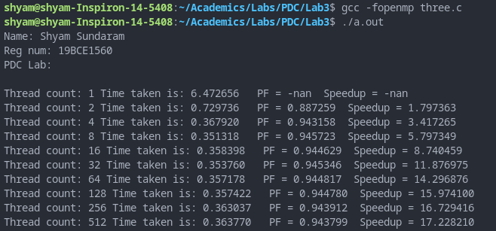

**PLOTS**

**INFERENCE**

The addition of the extra for loop increased the workload. Thus, as a greater number of threads work on it, the lower the execution time is and higher the Speed-Up, but up to a certain point, after which it is near constant.

**MATRIX ADDITION**

**CODE**

#include <stdio.h>

#include "omp.h"

#include<time.h>

#define ROWS 2500

#define COLS 250

int main()

{

float a[ROWS][COLS],b[ROWS][COLS],c[ROWS][COLS];

printf("Name: Shyam Sundaram\nReg num: 19BCE1560\nPDC Lab:\n\n");

for(int i=0;i<ROWS;++i)

for(int j=0;j<COLS;++j)

{

a[i][j]=i*10+j;

b[i][j]=j*10+i;

}

int thread[]={1,2,4,8,16,32,64,128,256,512};

float serial;

for(int t=0;t<10;++t)

{

omp_set_num_threads(thread[t]);

float start=omp_get_wtime();

#pragma omp parallel for shared(a,b,c) //reduction(+: c)

for(int i=0;i<ROWS;++i)

for(int j=0;j<COLS;++j)

{

for(int j=0;j<1000;++j)

c[i][j]=a[i][j]+b[i][j];

}

float end=omp_get_wtime();

float exec=end-start;

if(t==0) serial=exec;

printf("Thread count: %d Time taken is: %f",thread[t],exec);

float pf=(1-(exec/serial))/(1-(1/thread[t]));

printf(" PF = %f ",pf);

float s=1-pf;

float speedup=1/(s+(pf/thread[t]));

printf(" Speedup = %f\n",speedup);

}

return 0;

}

**COMPILATION AND EXECUTION**

gcc -fopenmp matadd.c

./a.out

**OBSERVATIONS**

|  |  |  |
| --- | --- | --- |
| **NUMBER OF THREADS** | **EXECUTION TIME** | **SPEED-UP** |
| 1 | 8.358765 | 1 |
| 2 | 2.782715 | 1.500477 |
| 4 | 0.533691 | 3.356988 |
| 8 | 0.492065 | 5.665413 |
| 16 | 0.508057 | 8.369429 |
| 32 | 0.503052 | 11.166713 |
| 64 | 0.512817 | 13.154904 |
| 128 | 0.507690 | 14.689577 |
| 256 | 0.515747 | 15.298335 |
| 512 | 0.520386 | 15.603592 |

**ASSUMPTION**

Following extra for loop is added to increase the number of operations in the parallel region to visualize the effect of multi-threading in vector addition.

for(int j=0;j<m;j++)

c[i] = a[i] + b[i];

**SCREENSHOT**

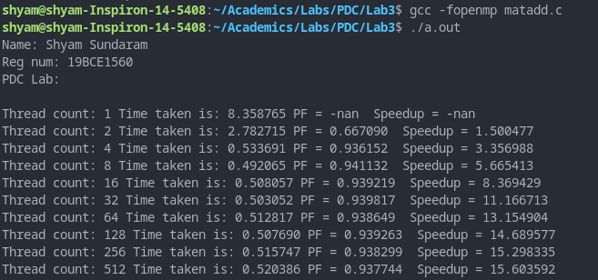

**PLOTS**

**INFERENCE**

The addition of the extra for loop increased the workload. Thus, as a greater number of threads work on it, the lower the execution time is and higher the Speed-Up, but up to a certain point, after which it is near constant.