SUPPLY PRESCRIPT
Closed-Loop Prescriptive Analytics for Supply Chain Operations
Project Report

Item | Details
Organization | Axlero Solutions
Project | Project 3 — Supply Prescript
Team Lead | Shyam Varmora
Contributors | Chetan — Backend • Yoshita — UI / Frontend • Prashant — QA / Documentation • Mansi — Data / Database • Shyam --- Daily Task Distribute / Manage Repo / Review PRs & Marge Decision
Repository branch | devops

This report records the implemented system and the final verification state. It separates current release evidence from historical test runs so that older issues are not presented as current results.

Contents
1. Executive Summary
2. Project Background and Objectives
3. Requirements and Scope
4. Solution Architecture
5. Data and Database Design
6. Predictive Model
7. Prescriptive Optimization
8. Operational UI and UX
9. Closed-Loop Decision Workflow
10. API Surface
11. Testing and Quality Assurance
12. CI/CD and Final Release Verification
13. Team Contributions and GitHub Delivery
14. Results and Observed Evidence
15. Limitations and Verification Notes
16. Conclusion
Appendix A — Requirement Coverage
Appendix B — Verification Checklist

1. Executive Summary
Supply Prescript is a closed-loop prescriptive analytics application for supply-chain operations. The system starts with a real shipment record, predicts shipment-delay risk, generates constrained recommendations, lets an operator execute one recommendation, stores the decision, records the actual outcome, evaluates the result and uses large discrepancies to trigger model retraining.
The final release is built with React on the frontend, FastAPI/Python on the backend, PostgreSQL for operational storage, XGBoost for prediction and SciPy for constrained optimization. The application exposes REST endpoints for prediction, recommendation, decision write-back, outcome capture, evaluation, history and ROI analytics.
Release result
The final release reached the engineering acceptance gate: 15/15 backend tests passed in CI, the real PostgreSQL tests are included in CI with 2/2 passing, frontend lint/build passed, and there are no open pull requests.
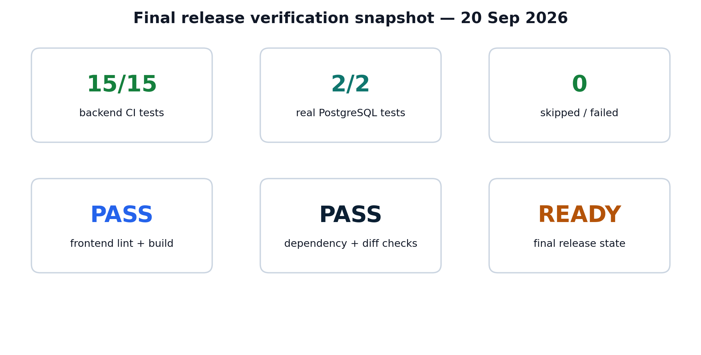
Figure 1. Final release verification snapshot based on the 20 September 2026 audit.

2. Project Background and Objectives

2.1 Business problem
Predictive analytics can warn a supply-chain operator that a shipment is likely to be delayed, but a prediction alone does not answer the next operational question: what action should be taken? Supply Prescript addresses that gap by connecting prediction with constrained recommendation, operational execution and feedback.

2.2 Objectives
- Train and use an XGBoost model for shipment-delay prediction.
- Run a SciPy optimization workflow subject to budget, time and capacity constraints.
- Generate three actionable alternatives and show the trade-off between cost and time.
- Allow an operator to execute one feasible recommendation and persist it to PostgreSQL.
- Capture the actual outcome and calculate decision evaluation and ROI.
- Use detected discrepancies to trigger XGBoost retraining.

2.3 Final release principles
- Real data and real database writes are preferred over placeholders.
- PASS is used only when execution evidence supports the requirement.
- Historical test failures are kept separate from the current release state.
- The final documentation matches the implemented PostgreSQL architecture.

3. Requirements and Scope
The Project 3 brief organizes the implementation into four weekly phases. Week 1 focuses on the predictive baseline and application scaffolding; Week 2 adds constrained optimization and the recommendation UI; the Mid Review checks hard-budget behavior and Execute Decision write-back; Week 3 adds outcome evaluation and Decision ROI; Week 4 adds discrepancy-triggered retraining.
Phase | Required outcome | Release status
Week 1 | XGBoost prediction, historical data, React scaffolding, PostgreSQL/Snowflake connection | PASS
Week 2 | SciPy optimization, Budget/Time/Capacity constraints, three alternatives, cost-vs-speed UI | PASS
Mid Review | Hard budget never violated; Execute Decision performs a real DB INSERT | PASS
Week 3 | Predicted-vs-actual evaluation, Decision ROI and feedback UI | PASS
Week 4 | Discrepancy detection triggers XGBoost retraining | PASS
Scope note
The source brief permits PostgreSQL or Snowflake for application scaffolding. The final implementation uses PostgreSQL and does not claim Snowflake.

4. Solution Architecture
The final architecture is intentionally simple: the browser collects the operational constraints, FastAPI coordinates the model and solver, PostgreSQL stores the operational state, and the evaluation layer closes the feedback loop.
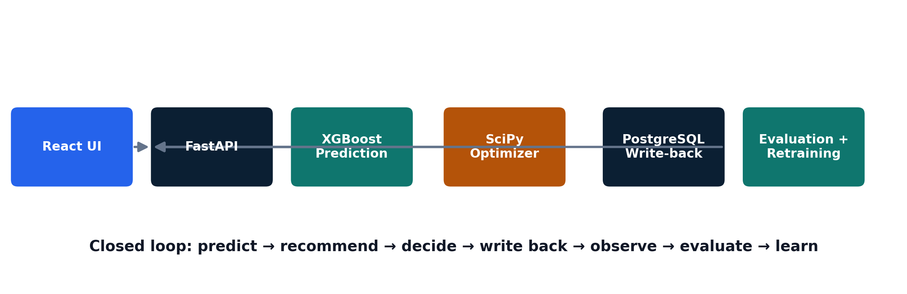
Figure 2. Supply Prescript release architecture.

4.1 Technology stack
Layer | Technology | Role
Frontend | React + Vite | Operational dashboard and user interactions
Backend | FastAPI / Python | REST API, orchestration and validation
Prediction | XGBoost | Shipment-delay prediction
Optimization | SciPy | Constraint-aware recommendation generation
Database | PostgreSQL | Operational records, predictions, recommendations and outcomes
Testing | pytest + real PostgreSQL fixtures | Automated verification
CI | GitHub Actions | Repeatable test/build gate

5. Data and Database Design
The operational schema is PostgreSQL. The release schema contains the five tables needed to support the closed loop and includes supporting indexes, foreign keys and recommendation-batch fields.
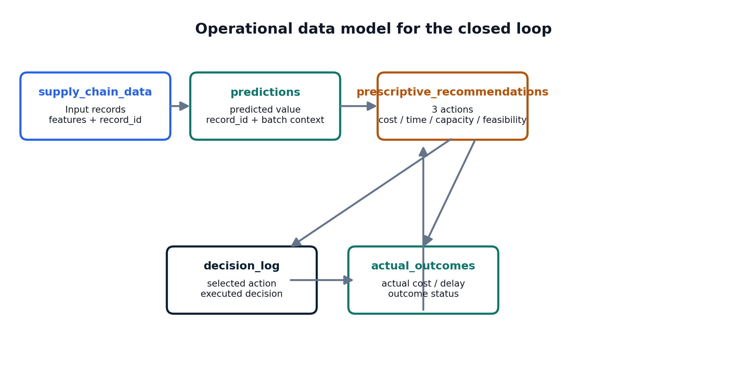
Figure 3. Main operational tables and data movement.
Table | Purpose
supply_chain_data | Source shipment records and model features
predictions | Persisted prediction results tied to source records
prescriptive_recommendations | Three solver-generated action alternatives
decision_log | Executed operational decisions
actual_outcomes | Observed cost, delay and outcome status

5.1 Database reliability in the final release
- CI creates PostgreSQL 16.4 from scratch.
- The schema is loaded before the real integration tests execute.
- Two real PostgreSQL integration tests run with RUN_REAL_DB=1.
- No real-database test is skipped in the final CI release.

6. Predictive Model
The prediction layer uses XGBoost and the historical supply-chain dataset. The release verification records 113,097 rows with 90,477 training samples and 22,620 testing samples in the final training evidence.

6.1 Prediction workflow
- Load a real supply-chain record from PostgreSQL.
- Build the approved feature set used by the shipment-delay model.
- Run the XGBoost model.
- Return the prediction to the API caller.
- Persist the prediction for downstream recommendation and evaluation.

6.2 Example observed prediction
Representative live browser evidence
A 12 September 2026 browser run returned prediction target delivery_time_deviation with a predicted value of 5.67630672454834. This is retained as dated runtime evidence; the later release verification relied on automated CI and database tests as well.

6.3 Release-level verification
- XGBoost model artifact present in the release.
- Real PostgreSQL test path invokes the recommendation workflow using stored shipment data.
- Prediction persistence is covered by the real integration tests.

7. Prescriptive Optimization
After prediction, the optimizer evaluates operational actions against budget, allowed time and available capacity. The application returns three alternatives and presents their cost/time trade-off in the UI.
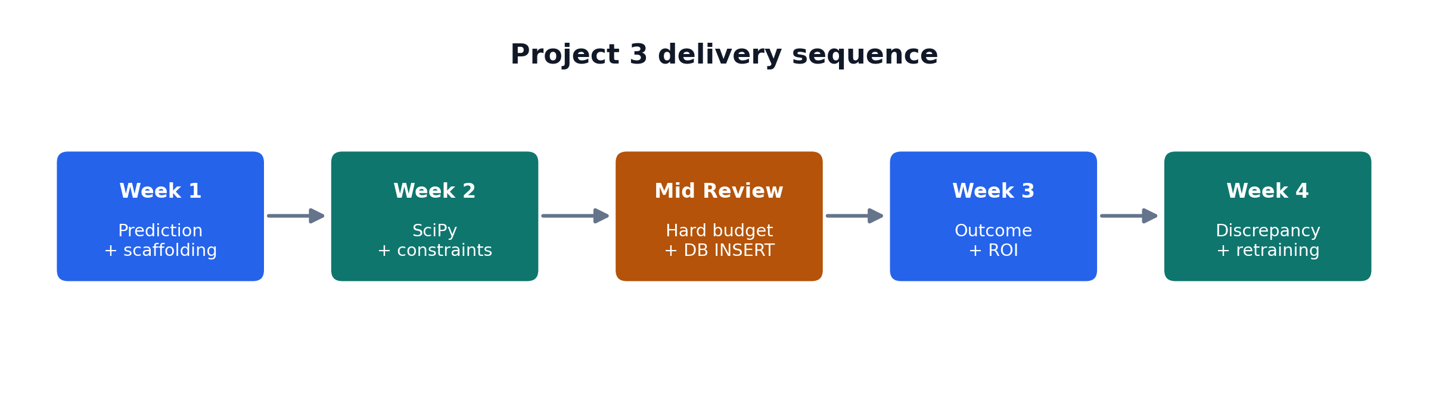
Figure 4. Weekly implementation sequence and review gates.

7.1 Three-alternative output
Alternative | Observed role in UI
Air Freight | Higher cost, faster route option
Secondary Supplier | Alternative supplier route
Delay Launch | Lower direct cost, slower operational response

7.2 Constraint verification
- All-feasible scenario was executed with a normal budget and operating limits.
- A budget-fail scenario was executed with budget = 40; all three alternatives were shown as infeasible/unavailable.
- Time and capacity constraint paths are covered by the optimizer and automated test suite.
- An infeasible recommendation cannot be selected or executed by the UI.

8. Operational UI and UX
The final frontend is intentionally organized around the operator workflow rather than around separate technical modules. The user enters a record and a small set of operational constraints, then moves through recommendation, decision and feedback sections.
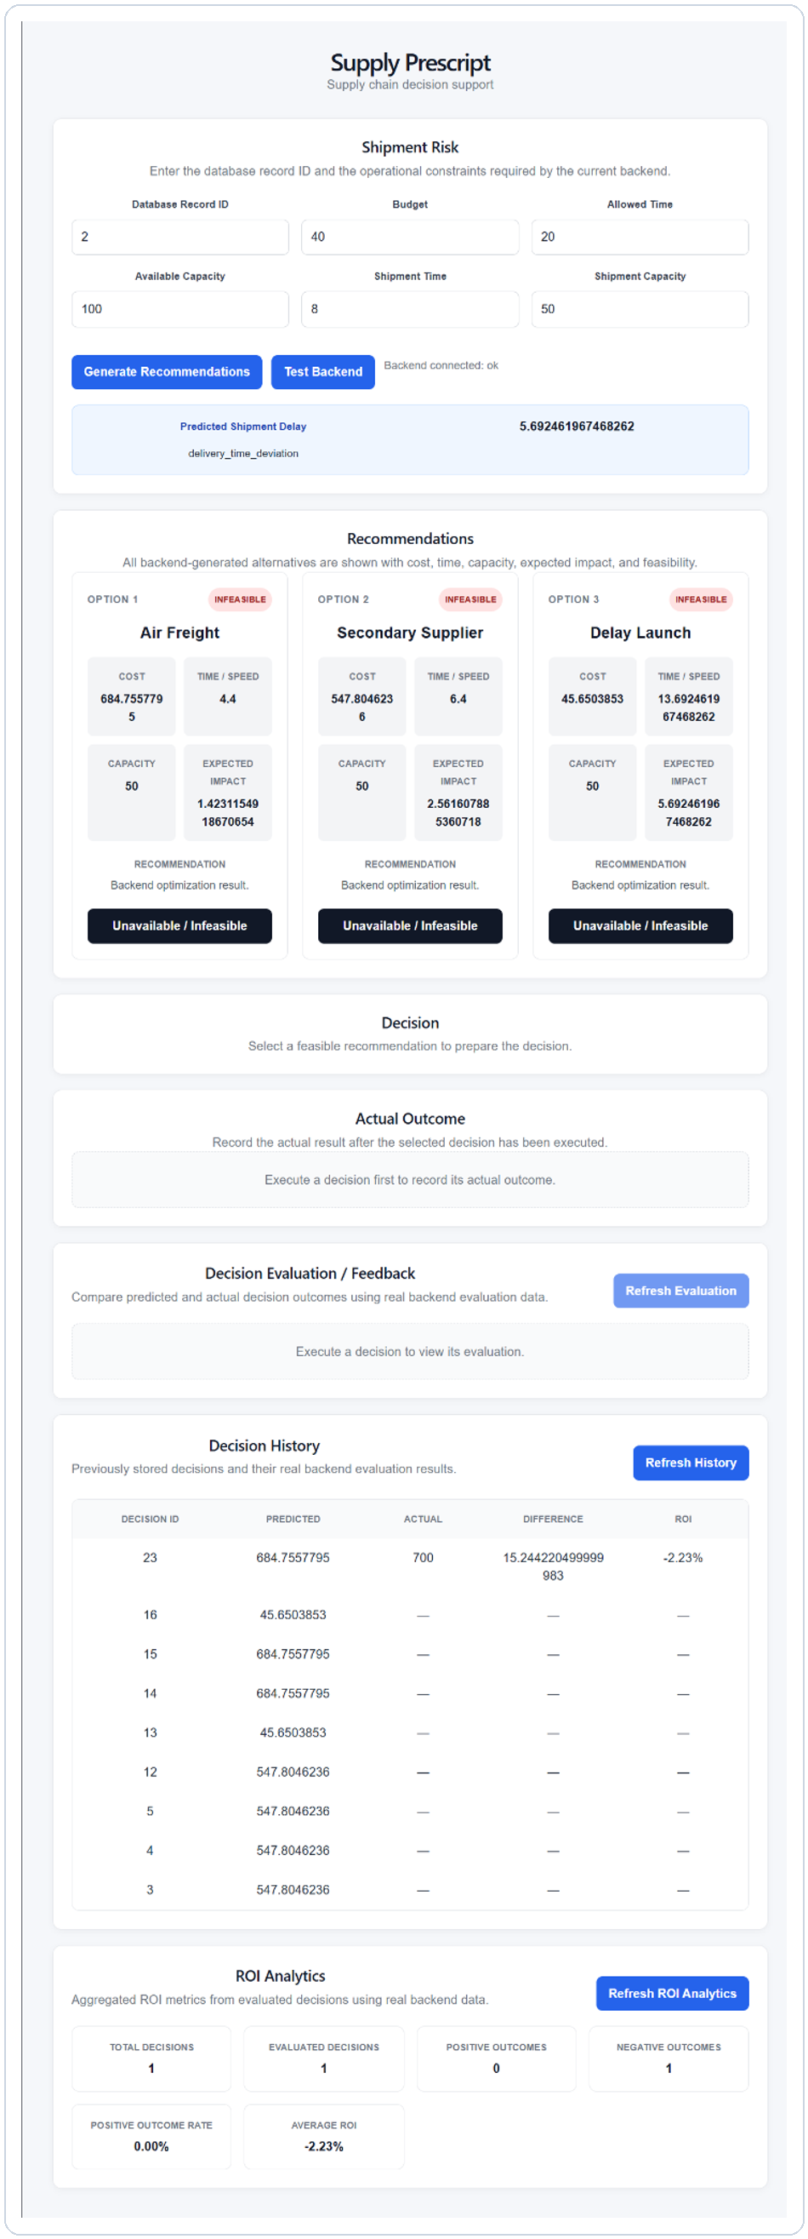
Figure 5. Representative browser evidence from the integrated workflow

8.1 Main UI sections
- Shipment Risk — record and operational constraints.
- Recommendations — three backend-generated alternatives with feasibility state.
- Decision — selected recommendation and Execute Decision.
- Actual Outcome — observed cost, delay and outcome status.
- Decision Evaluation / Feedback — predicted vs actual and ROI.
- Decision History — stored decisions and evaluation values.
- ROI Analytics — aggregate decision and outcome metrics.

8.2 UI quality
- Clear section separation and readable cards.
- Explicit feasible/infeasible state.
- Active and disabled button styling.
- Responsive layout for smaller screens.
- Loading, error and empty states.
- No hard-coded ROI implementation in the current release.

9. Closed-Loop Decision Workflow
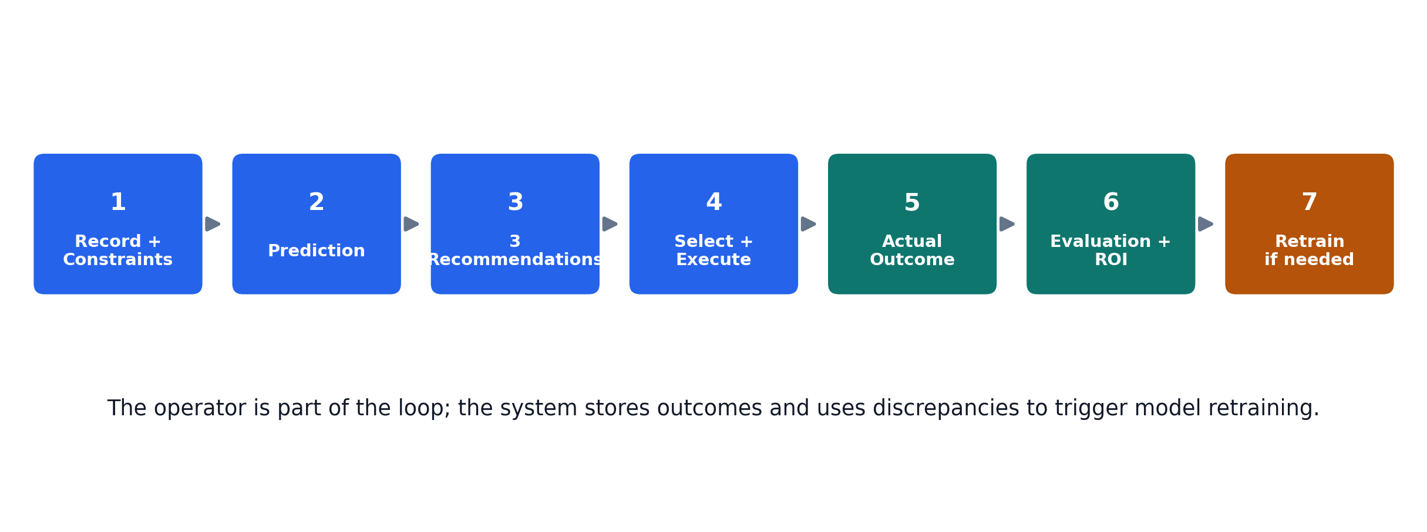
Figure 6. End-to-end operational workflow.
The defining feature of Supply Prescript is that the decision is not the end of the workflow. An executed recommendation becomes a stored operational decision. The actual outcome can then be recorded and compared with the prediction. A sufficiently large discrepancy is treated as feedback and can trigger XGBoost retraining.
Stage | Evidence in release
Predict | XGBoost model + /recommend response
Recommend | SciPy optimizer returns three alternatives
Select | Feasible recommendation selected in React UI
Execute | POST /decisions returns real Decision ID
Observe | POST /decisions/{id}/outcome stores actual result
Evaluate | GET /decisions/{id}/evaluation returns comparison
Learn | Discrepancy detection can trigger XGBoost retraining

10. API Surface
Method | Endpoint | Purpose
GET | /health | Backend health check
POST | /predict/shipment-delay | Direct shipment-delay prediction
POST | /recommend | Prediction + constrained recommendation generation
POST | /decisions | Execute and persist a selected recommendation
GET | /decisions/history | Return stored decisions
POST | /decisions/{id}/outcome | Store actual operational outcome
GET | /decisions/{id}/evaluation | Evaluate predicted vs actual outcome
GET | /decisions/analytics/roi | Return aggregate ROI analytics

10.1 Validation
- Invalid record IDs are rejected.
- Invalid recommendation IDs are rejected.
- Cross-record recommendation use is rejected.
- Wrong selected actions are rejected.
- Infeasible recommendations cannot be executed.
- Outcome inputs are validated for valid numeric values.

11. Testing and Quality Assurance
The final release uses three levels of evidence: automated backend tests, real PostgreSQL integration tests, and browser-level workflow evidence. The intent is to distinguish “the code exists” from “the workflow actually works.”
Check | Final release result
Backend test suite | 15/15 passed
Real PostgreSQL integration tests | 2/2 passed
Skipped real-DB tests | 0
Python test warnings | 0
Frontend ESLint | PASS
Frontend production build | PASS
Dependency check (pip check) | PASS
git diff --check | PASS
CI backend job | SUCCESS
CI frontend job | SUCCESS
Figure 7. Final automated QA status.

11.1 Browser evidence note
The integrated browser screenshots were captured during the 12 September 2026 release exercise. Later code changes, including ROI semantic corrections, were re-verified through updated unit/integration tests and the final CI pipeline. This report therefore does not present a later automated result as though it were a later manual screenshot.

12. CI/CD and Final Release Verification
The final CI pipeline was strengthened compared with the earlier development setup. It now provisions PostgreSQL 16.4, loads the release schema and CI fixtures, enables RUN_REAL_DB=1, and runs pytest with warnings treated as errors.

12.1 Final sequence
- PostgreSQL container started.
- Application schema applied.
- CI fixture data loaded.
- RUN_REAL_DB=1 enabled.
- Backend tests executed with warnings treated as errors.
- Frontend dependencies installed and production build executed.
Final release result
The latest release commit is 93be9fb (docs: sync final release verification). The release audit records 15/15 backend tests, 2/2 real PostgreSQL tests included in CI, 0 skipped tests, 0 Python test warnings, and successful frontend lint/build.

13. Team Contributions and GitHub Delivery
Member | Release responsibility | Final state
Shyam | Team lead, DevOps, integration, review and release coordination | Complete
Chetan | Backend, model/orchestration and write-back | Complete
Yoshita | UI / frontend and decision workflow | Complete
Prashant | QA, traceability, testing and documentation | Complete
Mansi | Data/database contribution during development | No active release task

13.1 Release history
Commit | Purpose
6e972e5 | Finalize ROI analytics and QA documentation
918ec4a | Merge final QA documentation cleanup
02c2369 | Finalize release audit corrections
a5693cf | Enable real PostgreSQL integration tests
05e01aa | Align release dependencies and CI runtime
93be9fb | Sync final release verification
PR #34 (Chetan), PR #33 (Yoshita) and PR #39 (Prashant final QA) are part of the release history. The obsolete PR #29 and old MySQL database work are not part of the final release.

14. Results and Observed Evidence

14.1 Representative browser test
In the 12 September 2026 integrated run, the UI used a real record and generated three recommendations. A normal-budget case allowed feasible options; a low-budget case with budget = 40 marked all alternatives infeasible. A selected recommendation was executed and returned a real Decision ID. An actual outcome was then stored and evaluated.
Observed item | Example from dated browser evidence
Prediction target | delivery_time_deviation
Representative predicted delay | 5.67630672454834
Recommendation 1 | Air Freight
Recommendation 2 | Secondary Supplier
Recommendation 3 | Delay Launch
Hard-budget case | Budget = 40 → all options infeasible
Evaluation example | Actual cost 700 vs predicted cost 45.6503853
Evaluation status | discrepancy_detected
Representative ROI | -1433.39%

14.2 Interpretation
The negative ROI in the representative run is not a defect in itself. It is the result of comparing the stored predicted cost with the recorded actual cost under the implemented ROI formula. The project is designed to expose this difference and feed significant discrepancies into the learning loop.

15. Limitations and Verification Notes
- The final browser screenshots available for this report are dated 12 September 2026; later release corrections were validated through automated tests and CI.
- UI polish could still be taken further from a product-design perspective, but the current interface meets the documented project workflow and quality gate.
- The project does not claim Snowflake; PostgreSQL is the implemented operational database.
- The report records the repository state and verification evidence; it does not guarantee an external reviewer score.
- Historical failed CI runs remain useful as development history but are not treated as current release failures.
Engineering posture
The final release separates historical development problems from current verified behavior instead of deleting or rewriting earlier evidence.

16. Conclusion
Supply Prescript moved the project beyond a prediction-only dashboard into a closed-loop operational workflow. The released system predicts shipment-delay risk, compares constrained alternatives, allows an operator to execute a decision, stores the decision and actual result, evaluates the outcome, reports ROI and uses discrepancies to trigger retraining.
The final release verification shows a stable engineering state: backend and real PostgreSQL tests pass in CI, the frontend builds cleanly, the PostgreSQL schema is created automatically in the CI environment, and the QA documentation aligns with the final implementation.
Final status
Submission-ready release. No additional Chetan or Yoshita feature work is required. The remaining project activity is normal internship submission/review work.

Appendix A — Requirement Coverage
Requirement | Implementation evidence | Status
XGBoost prediction | Model artifact + live prediction path | PASS
Historical data | 113,097-row dataset used in training evidence | PASS
PostgreSQL app scaffolding | psycopg + CI PostgreSQL 16.4 | PASS
SciPy constrained optimization | linprog-based recommendation engine | PASS
Three recommendations | Air Freight / Secondary Supplier / Delay Launch | PASS
Budget / Time / Capacity | Feasibility checks and negative cases | PASS
Execute Decision | POST /decisions + decision_log persistence | PASS
Actual outcome | POST /decisions/{id}/outcome + actual_outcomes | PASS
Evaluation + ROI | Evaluation API and ROI analytics UI | PASS
Discrepancy detection | Evaluation threshold path | PASS
Retraining | XGBoost retraining trigger and model update path | PASS
Final CI | 15/15 tests, 0 skipped, 0 warnings | PASS

Appendix B — Verification Checklist
1. Current devops branch verified.
2. No open pull requests in final release state.
3. PostgreSQL schema created in CI.
4. Real PostgreSQL integration tests enabled in CI.
5. Prediction path verified.
6. Recommendation path verified.
7. Budget/time/capacity constraints verified.
8. Execute Decision write-back verified.
9. Outcome capture verified.
10. Evaluation and ROI verified.
11. Discrepancy-triggered retraining verified.
12. Frontend lint/build verified.
13. Final documentation synchronized.

Sources used for this report
- Axlero Solutions — Project Document, Advanced Data Analytics, Project 3: Supply Prescript.
- Axlero Solutions — Standard Operating Procedures for Intern Projects, Version 1.1.
- Final release verification audit, current state as of 20 September 2026.
- Current GitHub release history, CI results and representative browser evidence recorded during the development process.

