1. Create a new branch named **feature/authentication**

Implement the authentication endpoint functionality on the **feature/authentication** branch

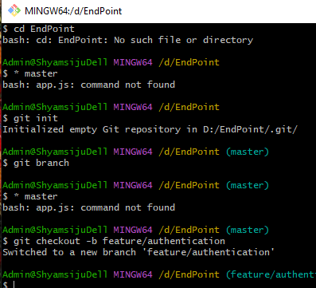

2) Commit the changes with an appropriate commit message

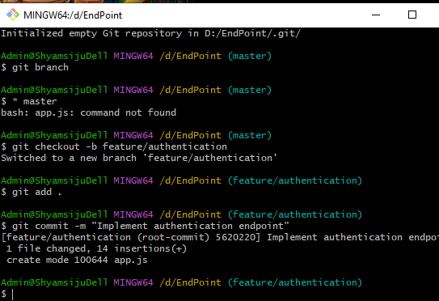

3) Simulate changes made by another team member on the **master** branch.

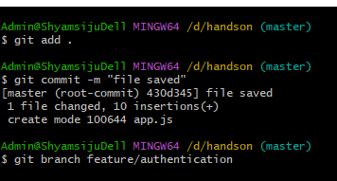

4) Merge changes from **master** into **feature/authentication** branch

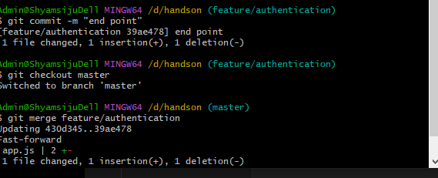

5,Verify that the authentication endpoint works correctly.

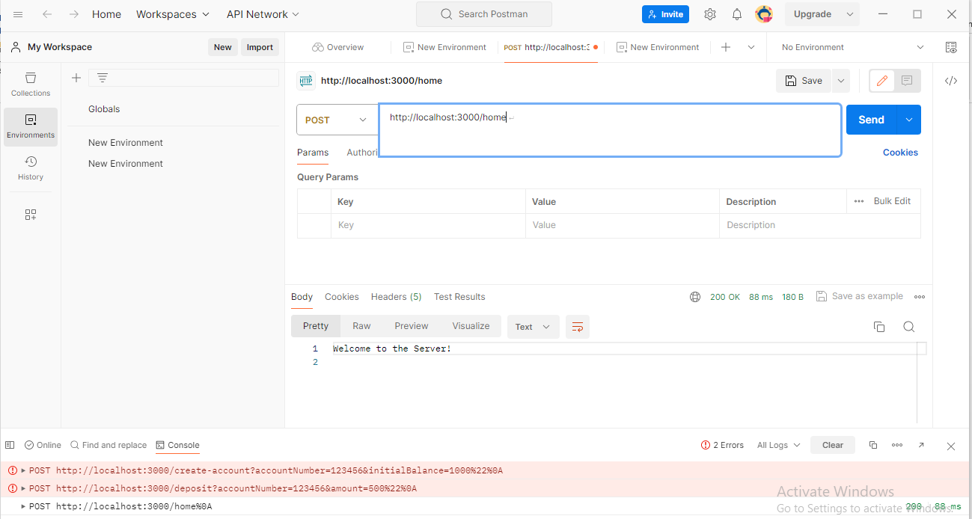

6. Merge changes from **master** into **feature/authentication** branch.

