**Network : Introduction**

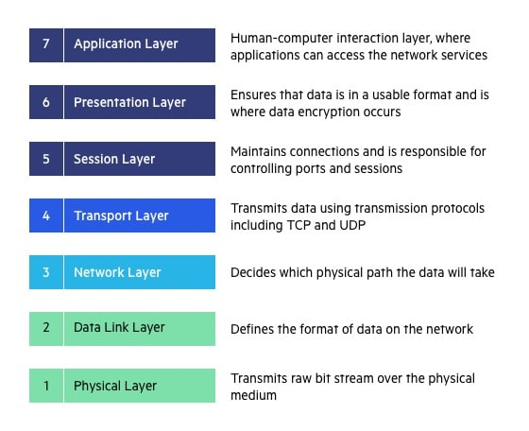

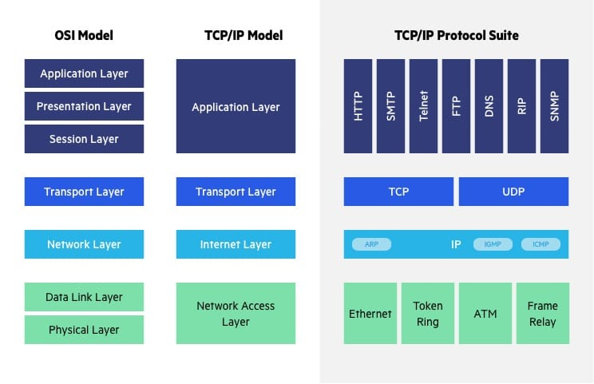

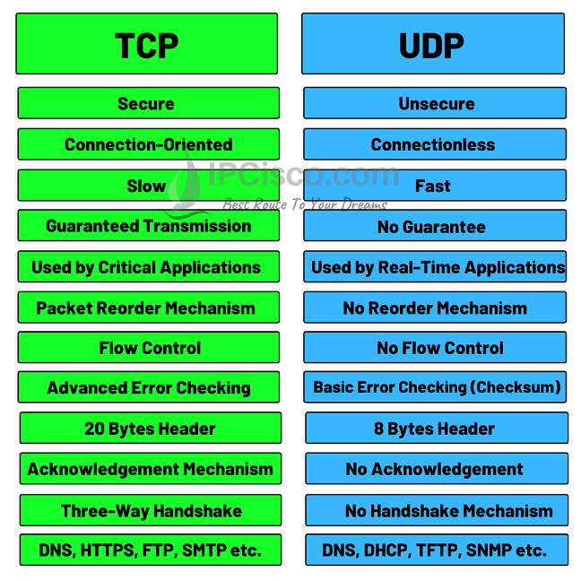

We have to access than

https\https: 80 /443

For sending mail - SMTP(Simple ) 25

For receiving mail - pop (Post office protcol)

For file transfer - FTP (file transfer protcol) 21

SFTP - for securing the file transfer protocol 22

TCP/UDP DNS -for domain name system 53

RDP (sharing request window to window) 3389

SSH (sharing request window to LINUX) 22