- It is very fascinating to understand the nitty-gritties of the technology trends and along with innovations in this space and no denying that we also get a chance to grow. Be it a change in the career profiles or the roles, we all have a role to play in defining the solution in this constantly changing space.

- Recently I completed my certification on Cloud Architect with a learning platform, which provides us the infrastructure and enables us to experiment, explore and learn various concepts with a very well-designed curriculum suited for the enterprise needs.

- In the recent past, I did get a chance to explore on OAuth and OpenID standards and use them in addressing a technical challenge. Employing Okta as Identity Provider and using it to establish identity across multiple services. Auth code with PKCE is the standard to address the space of security where security has been always an interesting topic by itself.

- With an application hosted on AWS and accessed with the domain name purchased on GoDaddy, I was able to make the application publicly accessible.

- This is helping me to address the issues faced by the customer project I am part of, and I can feel the energy and involvement that is needed to help the customer succeed in the journey of technology transformation. With this skill upgrade, I feel enabled to address the challenges found in the architecture and design space of the cloud native application.

- 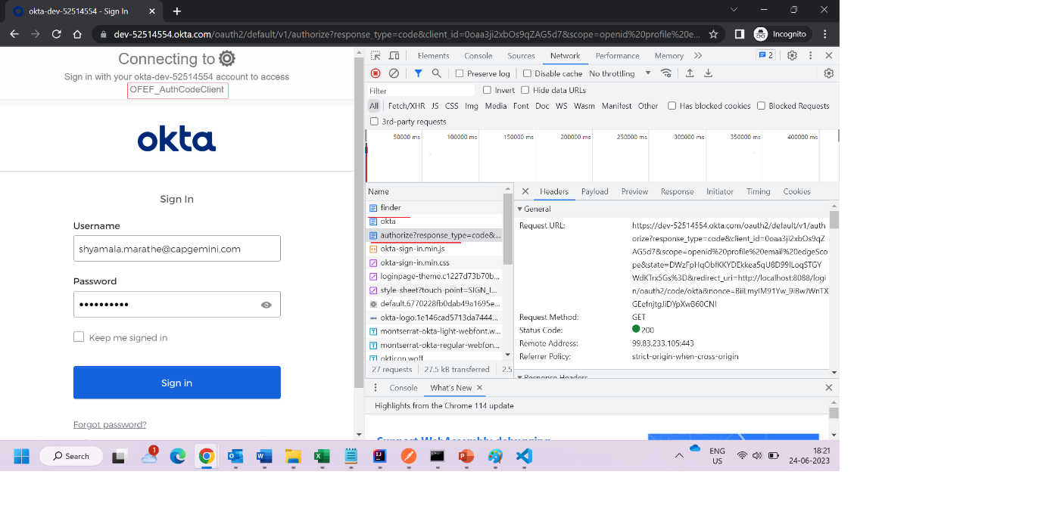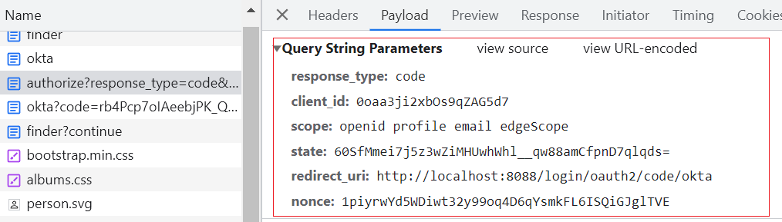

- Sample configuration with Okta, with a valid Client ID, we are authorizing the API Server for the requests from the clients like Web Applications for grant type Authorization Code.

- With an application hosted on AWS and linked with the domain name purchased on GoDaddy, I was able to make the application publicly accessible:
- 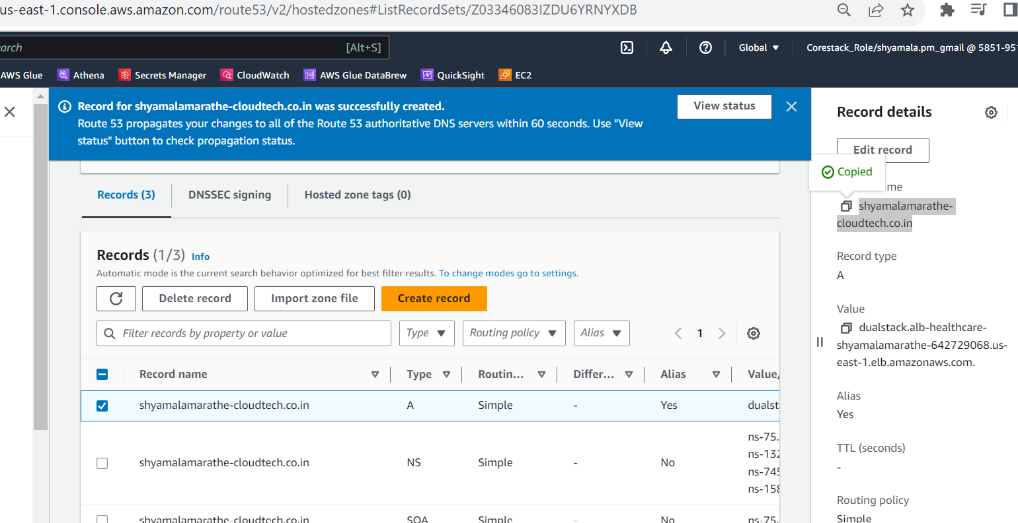

- Below is the application that is deployed on AWS:

- 