**SQL OUTPUTS SCREENSHORTS**

-- Selects the city and state for all customers

SELECT customer_city, customer_state

FROM customers;

1. .**Use SELECT, WHERE, ORDER BY, GROUP BY**

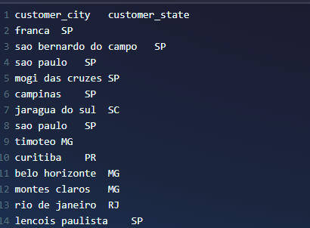

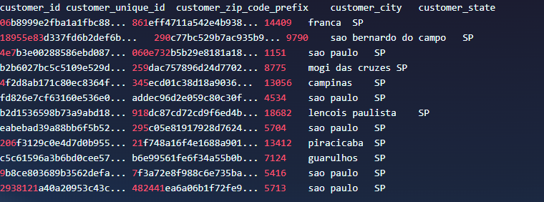

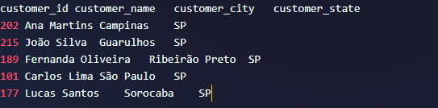

1. .**Use JOINS (INNER, LEFT, RIGHT)**

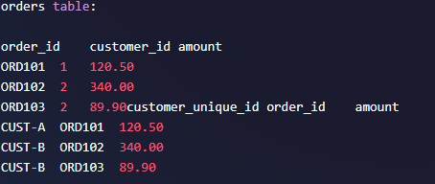

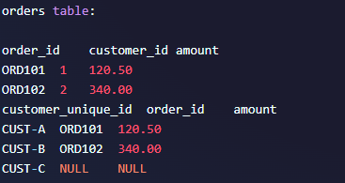

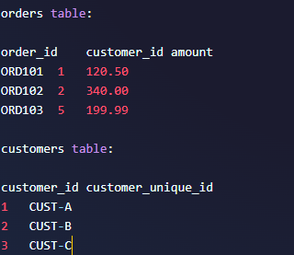

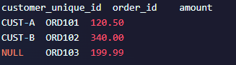

1. **Write subqueries:-**



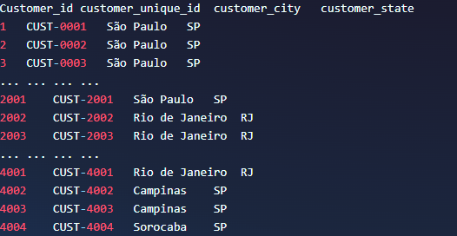

1. **Use aggregate functions (SUM, AVG):-**

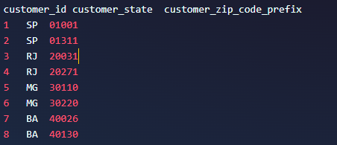



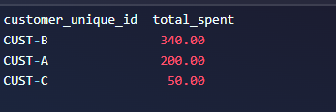

1. **Create views for analysis:-**

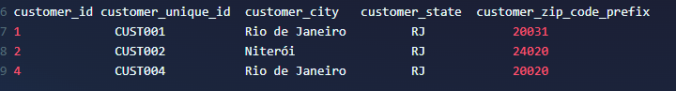

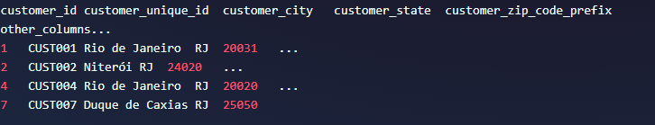

1. **Optimize queries with indexes:-**



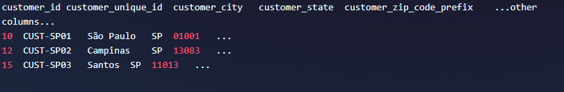

1. **Difference between WHERE and HAVING?**
   * **WHERE** filters rows *before* grouping.
   * **HAVING** filters groups *after* GROUP BY.
2. **Different types of joins?**
   * INNER JOIN, LEFT JOIN, RIGHT JOIN, FULL OUTER JOIN, CROSS JOIN.
3. **Calculate average revenue per user in SQL?**

sql

Copy-edit

SELECT AVG (total_revenue) FROM (

SELECT user_id, SUM (revenue) AS total_revenue

FROM sales

GROUP BY user_id

);

1. **What are sub queries?**
   * Queries nested inside another query to filter or calculate intermediate results.
2. **How do you optimize a SQL query?**
   * Use indexes, avoid SELECT *, limit data, use joins efficiently, analyse query plans.
3. **What is a view in SQL?**
   * A virtual table representing the result of a stored query.
4. **How to handle NULL values in SQL?**
   * Use IS NULL or IS NOT NULL to filter, use functions like COALESCE () or IFNULL () to replace NULLs.