**DATA ANALYST INTERNSHIP**

**Task 4: Dashboard Design:-**

**Objective: Design an interactive dashboard for business stakeholders.**

**Hints/Mini Guide:**

A. Choose **right KPIs (Sales, Profit, and Growth)**

B. Use **slicers/filters for interactivity**

c. **Include time-series analysis**

D.Add **cards for totals/summary**

E.Apply **consistent colour theme**

f. **Create navigation menu (if possible)**

**Interactive Dashboard Screenshots:-**

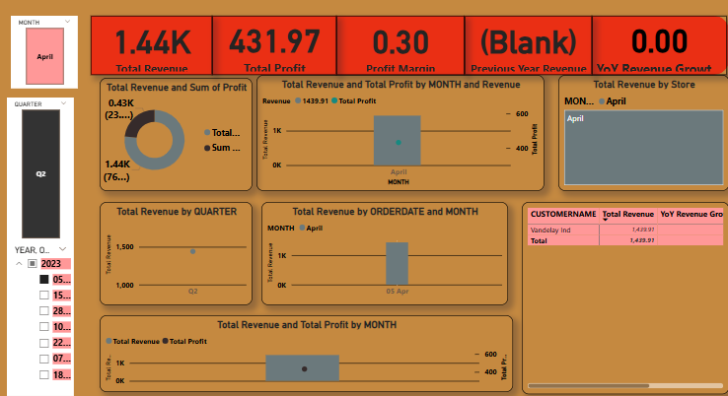

**Designing Your Interactive Power BI Dashboard**

Now, let's translate these insights into a powerful and interactive Power BI dashboard, incorporating all your hints:

**1. Choose Right KPIs (Sales, Profit, Growth)**

In Power BI, you'll create **measures** for these KPIs:

* **Total Revenue:**

Code snippet

Total Revenue = SUM( 'YourTableName'[Revenue] )

* **Total Profit:**

Code snippet

Total Profit = SUM( 'YourTableName'[Profit] )

* **Profit Margin %:**

Code snippet

Profit Margin % = DIVIDE( [Total Profit], [Total Revenue], 0 )

* **Year-over-Year Growth (Example for Revenue - requires multi-year data):** First, calculate Previous Year Revenue:

Code snippet

Previous Year Revenue = CALCULATE( [Total Revenue], SAMEPERIODLASTYEAR( 'YourTableName'[ORDERDATE].[Date] ) )

Then, calculate YoY Revenue Growth %:

Code snippet

YoY Revenue Growth % = DIVIDE( ( [Total Revenue] - [Previous Year Revenue] ), [Previous Year Revenue], 0 )

(Repeat similar logic for Profit Growth)

**2. Use Slicers/Filters for Interactivity**

Slicers are essential for dynamic analysis. Drag these fields onto your report page and configure them as slicers:

* **Date Slicer:** Use the ORDERDATE field. You can set it to a date range, relative date, or specific year/month options.
* **Territory Slicer:** Use the TERRITORY field.
* **Product Line Slicer:** Use the PRODUCTLINE field.

Ensure all your visuals are linked to these slicers in the "Edit Interactions" menu.

**3. Include Time-Series Analysis**

* **Visual Type:** Use **Line Charts** or **Area Charts** for time-series analysis.
* **X-axis:** Use the date hierarchy (YEAR, QUARTER, MONTH, DAY) from your ORDERDATE column.
* **Y-axis:** Drag your Total Revenue and Total Profit measures.
* **Drill-down:** Enable drill-down/up functionality on the date hierarchy to allow stakeholders to see trends at different granularities (e.g., from year to quarter to month).

**4. Add Cards for Totals/Summary**

Cards are perfect for displaying the overall values of your key KPIs prominently.

* **Visual Type:** Use **Card** visuals.
* **Measures:** Drag your Total Revenue, Total Profit, and Profit Margin % measures into separate card visuals.
* **Formatting:** Make them stand out with larger font sizes and clear labels.

**5. Apply Consistent Color Theme**

* **Branding:** If your company has brand guidelines, try to align the dashboard colors with them.
* **Readability:** Choose a color palette that is easy on the eyes and provides good contrast. Avoid too many bright or clashing colors.
* **Consistency:** Use the same color for the same category across different visuals (e.g., if 'North America' is blue in one chart, keep it blue in others).
* **Power BI Themes:** Go to the View tab in Power BI Desktop and explore built-in themes, or create a custom theme JSON file for precise control.

**6. Create Navigation Menu (if possible)**

For multi-page dashboards, a navigation menu significantly improves user experience.

* **Pages:** Create separate pages for different aspects of your analysis (e.g., "Overview," "Territory Analysis," "Product Performance," "Historical Trends").
* **Buttons:** On your main page, insert Buttons (under the Insert tab).
* **Bookmarks:** For each button, create a Bookmark (under the View tab -> Bookmarks pane) that links to a specific page.
* **Actions:** Assign the bookmarks to the buttons using the Action property in the button's formatting pane (Type: Bookmark, Bookmark: [Your Page Bookmark]).
* **Shapes/Icons:** You can also use shapes or images as buttons for a more visually appealing menu.

**Structure of Your Dashboard (Suggestion)**

**Page 1: Executive Overview**

* **Cards:** Total Revenue, Total Profit, Overall Profit Margin.
* **Line Chart:** Revenue & Profit over time (Year/Quarter/Month).
* **Bar Charts:** Revenue by Territory, Profit by Product Line.
* **Slicers:** Date range, Year, Territory, Product Line.
* **Navigation Buttons:** To other detailed pages.

**Page 2: Territory Deep Dive**

* **Slicers:** Territory, Year.
* **Table/Matrix:** Detailed Revenue and Profit metrics by Territory.
* **Map Visual (if location data is available):** Revenue/Profit by geographical area.
* **Bar Charts:** Revenue/Profit per PRODUCTLINE within selected TERRITORY.

**Page 3: Product Performance**

* **Slicers:** Product Line, Year.
* **Table/Matrix:** Detailed Revenue and Profit metrics by Product Line.
* **Bar Charts:** Revenue/Profit per TERRITORY for selected PRODUCTLINE.

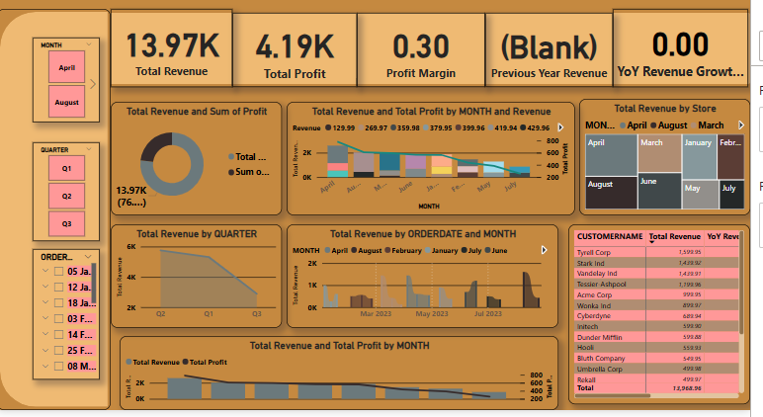

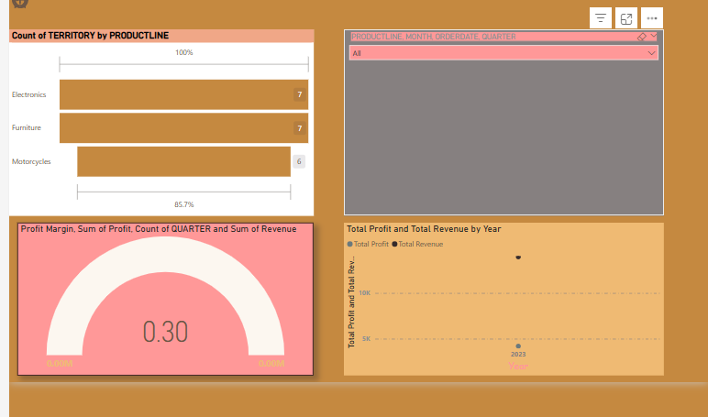

INTERVIEW QUESTIONS:-

1) **What are the key elements of a dashboard?**

* + **KPIs (Key Performance Indicators):** Measurable values showing progress towards business goals.
  + **Visualizations:** Charts, graphs, and tables to present data visually.
  + **Filters/Slicers:** Interactive controls for data segmentation.
  + **Clear Layout & Design:** Intuitive organization for readability and user experience.
  + **Interactivity:** Features that allow users to explore data dynamically.
  + **Navigation:** (For multi-page dashboards) Easy ways to move between sections.

1. **What is a KPI?**
   * A **KPI (Key Performance Indicator)** is a measurable value that demonstrates how effectively a company or individual is achieving key business objectives. Examples include Total Sales, Profit Margin, Customer Acquisition Cost, or Website Conversion Rate.
2. **What are slicers in Power BI?**
   * **Slicers** in Power BI are on-canvas visual filters that allow users to interactively filter and segment data displayed in a report. They provide a quick and direct way to see how selecting specific categories (e.g., Territory, Product Line) impacts all connected visuals.
3. **Difference between Power BI and Tableau?**
   * **Power BI** is generally recognized for its strong integration with the Microsoft ecosystem (Excel, Azure), more accessible pricing, and a user-friendly interface often favoured by Excel users.
   * **Tableau** is often lauded for its advanced visual analytics capabilities, intuitive drag-and-drop interface, and powerful visualization options, often preferred by dedicated data analysts.
4. **How do you make a dashboard interactive?**
   * Implement **slicers and filters** for dynamic data selection.
   * Utilize **drill-down/drill-up** capabilities on hierarchies (e.g., date, geography).
   * Add **buttons and bookmarks** for navigation between pages or different data views.
   * Use **tooltips** to reveal more details on hover.
   * Enable **cross-filtering/cross-highlighting** between visuals.
5. **How do you deal with large datasets in dashboards?**
   * **Efficient Data Modelling:** Optimize data relationships and minimize unnecessary columns.
   * **Aggregation:** Summarize data at a higher level (e.g., daily instead of hourly) if granular detail isn't always needed.
   * **Direct Query/Live Connection:** Process data at the source rather than importing it all (Power BI).
   * **Incremental Refresh:** Only update new or changed data, not the entire dataset.
   * **Performance Analyser:** Identify slow visuals or calculations to optimize them.
6. **What chart types do you use for trend analysis?**
   * **Line Charts:** Best for showing trends over continuous time periods (e.g., sales over months, stock prices over days).
   * **Area Charts:** Similar to line charts, but the area below the line is filled, which can be useful for showing volume or cumulative trends.