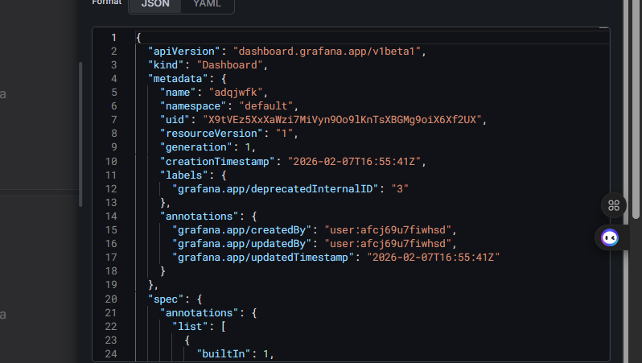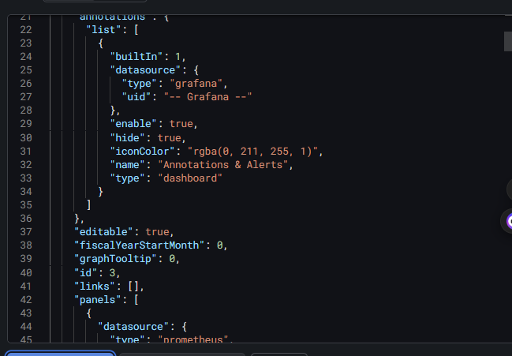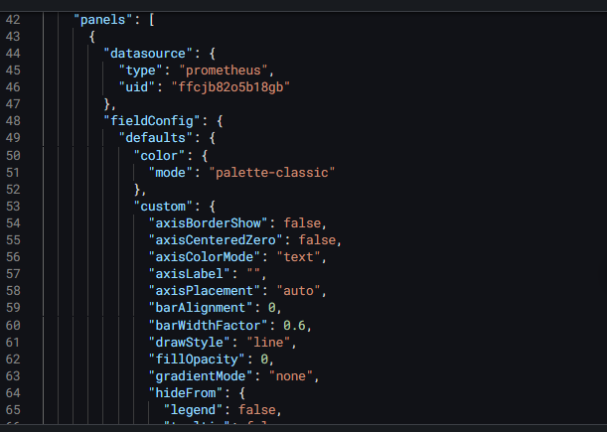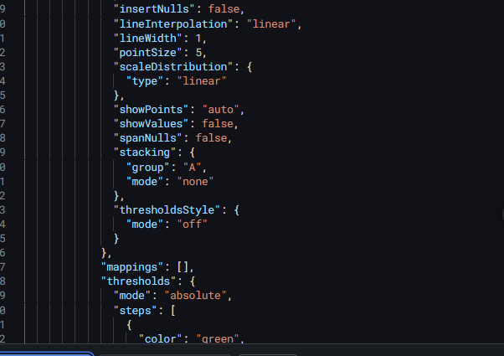{
"apiVersion": "dashboard.grafana.app/v1beta1",
"kind": "Dashboard",
"metadata": {
"name": "adqjwfk",
"namespace": "default",
"uid": "X9tVEz5XxXaWzi7MiVyn9Oo9lKnTsXBGMg9oiX6Xf2UX",
"resourceVersion": "1",
"generation": 1,
"creationTimestamp": "2026-02-07T16:55:41Z",
"labels": {
"grafana.app/deprecatedInternalID": "3"
},
"annotations": {
"grafana.app/createdBy": "user:afcj69u7fiwhsd",
"grafana.app/updatedBy": "user:afcj69u7fiwhsd",
"grafana.app/updatedTimestamp": "2026-02-07T16:55:41Z"
}
},
"spec": {
"annotations": {
"list": [
{
"builtIn": 1,
"datasource": {
"type": "grafana",
"uid": "-- Grafana --"
},
"enable": true,
"hide": true,
"iconColor": "rgba(0, 211, 255, 1)",
"name": "Annotations & Alerts",
"type": "dashboard"
}
]
},
"editable": true,
"fiscalYearStartMonth": 0,
"graphTooltip": 0,
"id": 3,
"links": [],
"panels": [
{
"datasource": {
"type": "prometheus",
"uid": "ffcjb82o5b18gb"
},
"fieldConfig": {
"defaults": {
"color": {
"mode": "palette-classic"
},
"custom": {
"axisBorderShow": false,
"axisCenteredZero": false,
"axisColorMode": "text",
"axisLabel": "",
"axisPlacement": "auto",
"barAlignment": 0,
"barWidthFactor": 0.6,
"drawStyle": "line",
"fillOpacity": 0,
"gradientMode": "none",
"hideFrom": {
"legend": false,
"tooltip": false,
"viz": false
},
"insertNulls": false,
"lineInterpolation": "linear",
"lineWidth": 1,
"pointSize": 5,
"scaleDistribution": {
"type": "linear"
},
"showPoints": "auto",
"showValues": false,
"spanNulls": false,
"stacking": {
"group": "A",
"mode": "none"
},
"thresholdsStyle": {
"mode": "off"
}
},
"mappings": [],
"thresholds": {
"mode": "absolute",
"steps": [
{
"color": "green",
"value": 0
},
{
"color": "red",
"value": 80
}
]
}
},
"overrides": []
},
"gridPos": {
"h": 8,
"w": 12,
"x": 0,
"y": 0
},
"id": 3,
"options": {
"legend": {
"calcs": [],
"displayMode": "list",
"placement": "bottom",
"showLegend": true
},
"tooltip": {
"hideZeros": false,
"mode": "single",
"sort": "none"
}
},
"pluginVersion": "12.3.2",
"targets": [
{
"datasource": {
"type": "prometheus",
"uid": "ffcjb82o5b18gb"
},
"editorMode": "builder",
"expr": "{\" 100 - (avg(rate(node_cpu_seconds_total{mode=\"idle\"}[5m]))) * 100\"}",
"instant": false,
"legendFormat": "__auto",
"range": true,
"refId": "A"
}
],
"title": "CPU Usage (%)",
"type": "timeseries"
},
{
"datasource": {
"type": "prometheus",
"uid": "afcjb830za96ob"
},
"fieldConfig": {
"defaults": {
"color": {
"mode": "palette-classic"
},
"custom": {
"axisBorderShow": false,
"axisCenteredZero": false,
"axisColorMode": "text",
"axisLabel": "",
"axisPlacement": "auto",
"barAlignment": 0,
"barWidthFactor": 0.6,
"drawStyle": "line",
"fillOpacity": 0,
"gradientMode": "none",
"hideFrom": {
"legend": false,
"tooltip": false,
"viz": false
},
"insertNulls": false,
"lineInterpolation": "linear",
"lineWidth": 1,
"pointSize": 5,
"scaleDistribution": {
"type": "linear"
},
"showPoints": "auto",
"showValues": false,
"spanNulls": false,
"stacking": {
"group": "A",
"mode": "none"
},
"thresholdsStyle": {
"mode": "off"
}
},
"mappings": [],
"thresholds": {
"mode": "absolute",
"steps": [
{
"color": "green",
"value": 0
},
{
"color": "red",
"value": 80
}
]
}
},
"overrides": []
},
"gridPos": {
"h": 8,
"w": 12,
"x": 0,
"y": 8
},
"id": 2,
"options": {
"legend": {
"calcs": [],
"displayMode": "list",
"placement": "bottom",
"showLegend": true
},
"tooltip": {
"hideZeros": false,
"mode": "single",
"sort": "none"
}
},
"pluginVersion": "12.3.2",
"targets": [
{
"editorMode": "builder",
"expr": "{\"100 * (1 - node_memory_MemAvailable_bytes / node_memory_MemTotal_bytes)\"}",
"legendFormat": "__auto",
"range": true,
"refId": "A"
}
],
"title": " Memory Usage (%)",
"type": "timeseries"
},
{
"datasource": {
"type": "prometheus",
"uid": "afcjb830za96ob"
},
"description": "",
"fieldConfig": {
"defaults": {
"color": {
"mode": "palette-classic"
},
"custom": {
"axisBorderShow": false,
"axisCenteredZero": false,
"axisColorMode": "text",
"axisLabel": "",
"axisPlacement": "auto",
"barAlignment": 0,
"barWidthFactor": 0.6,
"drawStyle": "line",
"fillOpacity": 0,
"gradientMode": "none",
"hideFrom": {
"legend": false,
"tooltip": false,
"viz": false
},
"insertNulls": false,
"lineInterpolation": "linear",
"lineWidth": 1,
"pointSize": 5,
"scaleDistribution": {
"type": "linear"
},
"showPoints": "auto",
"showValues": false,
"spanNulls": false,
"stacking": {
"group": "A",
"mode": "none"
},
"thresholdsStyle": {
"mode": "off"
}
},
"mappings": [],
"thresholds": {
"mode": "absolute",
"steps": [
{
"color": "green",
"value": 0
},
{
"color": "red",
"value": 80
}
]
}
},
"overrides": []
},
"gridPos": {
"h": 8,
"w": 12,
"x": 0,
"y": 16
},
"id": 1,
"options": {
"legend": {
"calcs": [],
"displayMode": "list",
"placement": "bottom",
"showLegend": false
},
"tooltip": {
"hideZeros": false,
"mode": "single",
"sort": "none"
}
},
"pluginVersion": "12.3.2",
"targets": [
{
"datasource": {
"type": "prometheus",
"uid": "afcjb830za96ob"
},
"editorMode": "builder",
"expr": "{\"100 - avg(rate(node_cpu_seconds_total{mode=\"idle\"}[5m])) * 100100 * (1 - node_memory_MemAvailable_bytes / node_memory_MemTotal_bytes)100 * (1 - node_filesystem_avail_bytes{fstype!=\"tmpfs\"} / node_filesystem_size_bytes{fstype!=\"tmpfs\"})\"}",
"legendFormat": "__auto",
"range": true,
"refId": "A"
},
{
"datasource": {
"type": "prometheus",
"uid": "afcjb830za96ob"
},
"editorMode": "builder",
"expr": "{\"avg by(instance) (1 - rate(node_cpu_seconds_total{mode=\"idle\"}[5m])) * 100\"}",
"hide": false,
"instant": false,
"legendFormat": "__auto",
"range": true,
"refId": "B"
}
],
"title": "Disk Usage (%)",
"transparent": true,
"type": "timeseries"
}
],
"preload": false,
"refresh": "auto",
"schemaVersion": 42,
"tags": [],
"templating": {
"list": []
},
"time": {
"from": "2026-02-07T07:06:06.563Z",
"to": "2026-02-07T13:06:06.563Z"
},
"timepicker": {},
"timezone": "browser",
"title": "New dashboard Copy",
"uid": "adqjwfk",
"version": 1
},
"status": {}
}