**PREMIUM CALCULATION PROJECT Documentation**

**High Level Design:**

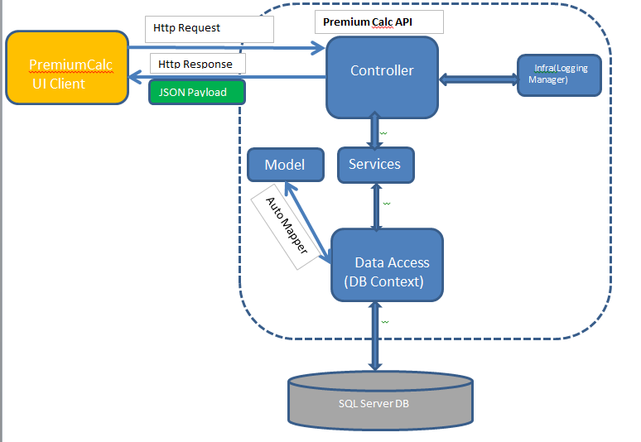

**Database Design:**

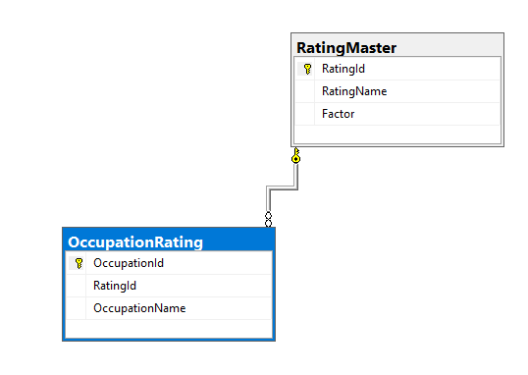

**UI Wireframe:**

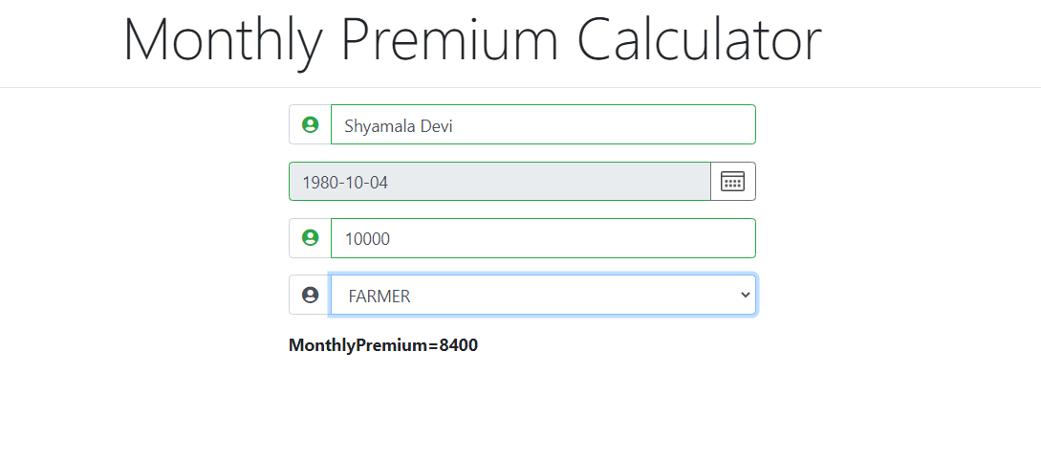

**Approach Used:**

* .Net Core API and Database First Approach
* Angular Framework for UI

**Best Practices used in API:**

1. Used Automapper to map business object and data object
2. Request validation has been done using ValidationAttribute.
3. Logging mechanism has been implemented to capture the activities in the application and the exception
4. Generic exception handler mechanism has been implemented.
5. Unit test methods have been written using NUnit framework, Moq & AutoFixture packages and tested for all important functions.

**Best Practices used in UI:**

1. 1. Bootstrap is used for UI design
2. 2. UI functionalities are validated
3. 2. ToastrService package is used for error message display