AI STUDYBUDDY
AI-POWERED BACKEND REST API FOR INTELLIGENT STUDY MATERIAL SUMMARIZATION, FLASHCARDS, QUIZZES AND PERSONALIZED STUDY PLANS
PROJECT DOCUMENTATION
Submitted By:
Team ID: SWTID-2026-5712

Team Leader: Shyam Kumar R
Team Member: Thiyagaraj S
Team Member: Surendhar M
Team Member: Sathishwaran S

Course: AI Augmented Backend Development
College: DRBCCC Hindu College
University: University of Madras
Academic Year: 2024-2027

1. ABSTRACT
AI StudyBuddy is an AI-powered backend REST API developed to simplify the study process for students. The application is developed using Node.js, Express.js, MongoDB, Mongoose, JWT authentication, bcryptjs password hashing, and the Google Gemini AI API.
The system supports two user roles: Student and Administrator. Students can upload study materials and use AI-powered features to generate summaries, flashcards, multiple-choice quizzes, personalized study plans, contextual answers to their questions, and progressive learning tasks. Administrators can monitor registered users, remove user accounts, and view system-wide usage statistics.
Google Gemini 2.5 Flash is integrated into the application to dynamically generate educational content from the material uploaded by the student, instead of relying on predefined templates. Quiz submissions are graded automatically and the weak topics of the student are identified using AI. A dashboard statistics module tracks study streaks, task completion, average quiz score, and a mastery tier.
The application follows a modular MVC architecture divided into models, controllers, routes, middleware, and utilities. Postman is used to test and demonstrate the REST APIs. The system combines conventional backend development with Generative AI, secure authentication, and role-based authorization.

2. INTRODUCTION
Students today handle large volumes of study material in the form of notes, slides, and documents. Converting this material into revision-friendly formats such as summaries, flashcards, and practice quizzes is time-consuming, and many students skip these steps entirely. As a result, revision is often limited to repeatedly re-reading the same material.
Traditional study tools require the student to create summaries, flashcards, and test questions manually. They also rarely provide a personalized plan that fits the time a student actually has before an examination, or feedback about which topics need more attention.
AI StudyBuddy addresses these challenges by combining backend development with Generative AI. Google Gemini is used to transform uploaded study material into summaries, flashcards, quizzes, study plans, and learning tasks, while the backend tracks the progress of the student through quiz attempts, task completion, and dashboard statistics.
The project is implemented as a backend REST API and can be accessed through tools such as Postman or any frontend client that consumes the API.

3. PROJECT TITLE

AI StudyBuddy
Project Theme
AI-Powered Backend REST API for Intelligent Study Material Summarization, Flashcards, Quizzes and Personalized Study Plans

4. PROJECT DESCRIPTION
AI StudyBuddy is a secure and intelligent REST API platform designed to support student learning.
The system uses Node.js and Express.js for backend development and MongoDB with Mongoose for database management. Google Gemini AI is integrated to provide AI-assisted summarization, flashcard generation, quiz generation, study planning, contextual question answering, and task generation.
The application supports two user roles:
- Student
- Administrator
Students upload their own study materials and use the AI features on them, and can only access their own resources. Administrators have system-level privileges to view all users and materials, remove users, and monitor platform usage.

5. PROBLEM STATEMENT
Traditional study methods present several challenges.

5.1 Manual Summarization
Condensing long chapters into concise revision notes takes significant time and effort.

5.2 Manual Flashcard and Quiz Creation
Active-recall techniques are effective, but creating flashcards and test questions by hand is tedious, so most students do not do it.

5.3 Lack of Personalized Planning
Students rarely have a study schedule based on their goals, the time available per day, and the number of days left before the examination.

5.4 Poor Self-Assessment
Without regular testing, students cannot identify the topics in which they are weak, which leads to inefficient revision.

5.5 Difficulty Tracking Progress
Study streaks, completed tasks, and quiz performance are not tracked in one place, which reduces motivation and consistency.

5.6 Security Issues
A backend that stores personal study material requires authentication, authorization, password protection, and protection of one student's data from other users.

6. PROPOSED SOLUTION
AI StudyBuddy provides a centralized backend platform that combines study material management with Artificial Intelligence.
The proposed system provides:
- Secure user registration and login
- JWT access and refresh token authentication
- Role-Based Access Control
- Study material upload and management
- AI-powered summary generation
- AI-powered flashcard generation
- AI-powered multiple-choice quiz generation
- Automatic quiz grading with weak-topic analysis
- Personalized AI study plan generation
- Contextual question answering on study material
- AI-generated and manual learning task management
- Dashboard statistics, mastery tier and notifications
- Administrator user management and system statistics

7. OBJECTIVES

7.1 Primary Objectives
- To develop a backend REST API for AI-assisted learning.
- To implement secure authentication using JWT with refresh tokens.
- To implement role-based authorization for Students and Administrators.
- To allow students to upload and manage study materials.
- To integrate the Google Gemini AI API.
- To generate summaries, flashcards and quizzes from study material.
- To grade quizzes automatically and identify weak topics.
- To generate personalized study plans based on goals and available time.

7.2 Secondary Objectives
- To reduce the manual effort students spend preparing revision material.
- To improve self-assessment through quizzes and feedback.
- To motivate students through streaks, tasks and mastery tiers.
- To maintain a secure backend environment.
- To provide a testable and modular REST API.

8. SCOPE OF THE PROJECT
The scope of AI StudyBuddy covers the backend REST API for authentication, study material management, AI-based content generation, quiz evaluation, task tracking, user statistics, and administration. The project is delivered as a headless backend service that any web or mobile frontend can consume. A graphical frontend is outside the scope of the current implementation.

9. SYSTEM REQUIREMENTS

9.1 Software Requirements
Component | Requirement
Operating System | Windows 10/11, macOS or Linux
Runtime | Node.js
Backend Framework | Express.js
Database | MongoDB
ODM | Mongoose
Authentication | JWT (access and refresh tokens)
Password Security | bcryptjs
AI Service | Google Gemini 2.5 Flash API
File Upload | Multer-based upload middleware
API Testing | Postman
IDE | Visual Studio Code

9.2 Hardware Requirements
- Intel Core i5 8th Generation or above, or equivalent
- Minimum 8 GB RAM
- Recommended 16 GB RAM
- Minimum 1 GB available project storage
- Internet connection for the database and AI services

10. TECHNOLOGY USED

10.1 Node.js
Node.js provides the runtime environment for executing the backend application.

10.2 Express.js
Express.js is used to create REST APIs, route requests, and handle middleware.

10.3 MongoDB
MongoDB is the NoSQL database used to store users, study materials, tasks, and quiz attempts.

10.4 Mongoose
Mongoose is used to define schemas, models, validation rules, and database operations.

10.5 JWT
JSON Web Tokens are used for authentication. Short-lived access tokens protect routes and refresh tokens issue new token pairs.

10.6 bcryptjs
bcryptjs is used to securely hash user passwords before storage.

10.7 Google Gemini
Google Gemini 2.5 Flash provides the Generative AI functionality for all learning features.

10.8 Multer
The upload middleware handles study material file uploads and validates them before processing.

10.9 Postman
Postman is used for REST API testing and demonstration.

11. SYSTEM ARCHITECTURE
The application follows a layered backend architecture. A client request passes through the Express router and the authentication and upload middleware, reaches a controller, and is then served from MongoDB through Mongoose and, for AI features, through the Gemini utility that calls the Google Gemini API.
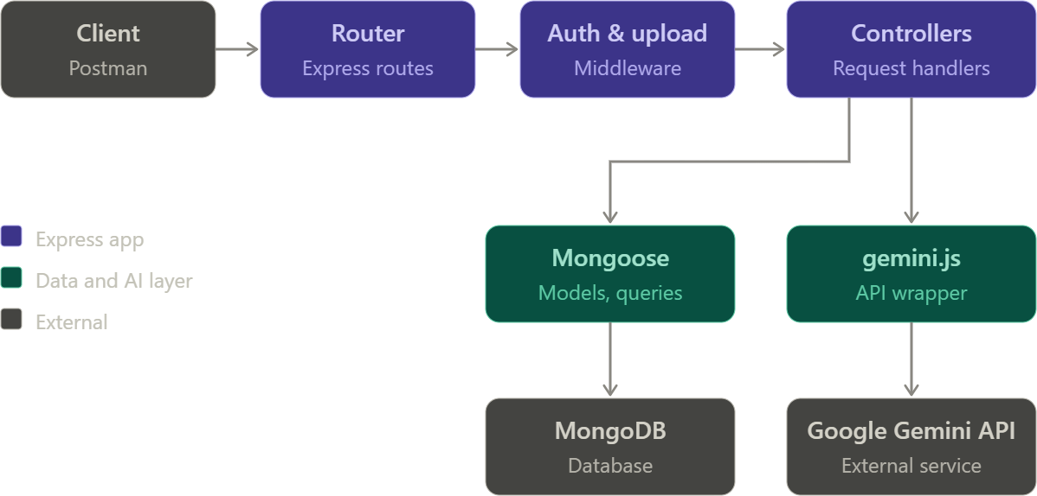
Figure 1: System Architecture of AI StudyBuddy

12. MVC ARCHITECTURE
AI StudyBuddy follows the MVC design pattern with a utility layer.

12.1 Model Layer
The Model layer defines the structure of the application's data. Models include:
- User
- Material
- Task
- QuizAttempt

12.2 Controller Layer
The Controller layer receives HTTP requests, processes parameters, calls the database and AI utility, and returns responses. Controllers include:
- Authentication Controller (authController.js)
- User Controller (userController.js)
- Material Controller (materialController.js)
- Quiz Controller (quizController.js)
- Task Controller (taskController.js)
- Admin Controller (adminController.js)

12.3 Routing Layer
The Routing Layer defines the REST API endpoints and connects requests to controller functions.

12.4 Middleware and Utility Layer
This layer contains reusable components:
- index.js - application entry point that loads environment variables, configures middleware, connects to MongoDB, registers routes and starts the server
- src/utils/db.js - MongoDB connection using Mongoose
- src/middleware/auth.js - JWT verification and role-based authorization
- src/middleware/upload.js - study material upload handling and validation
- src/utils/gemini.js - Google Gemini 2.5 Flash integration through the askGemini helper
- src/utils/tokens.js - access and refresh token generation
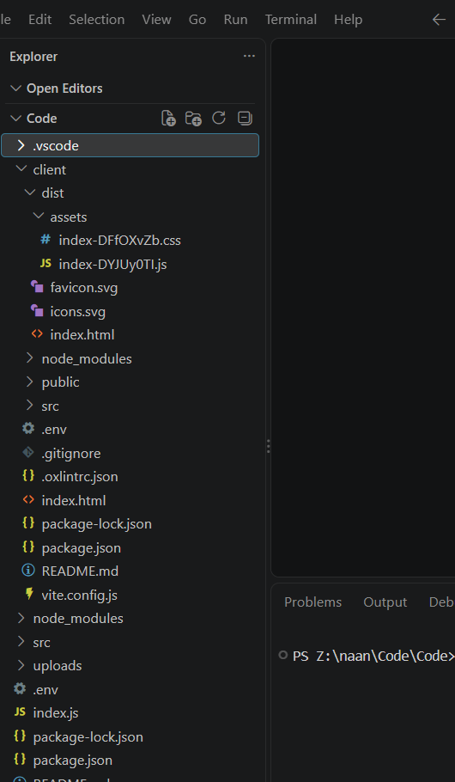
Figure 2: MVC-based project structure

13. DATABASE DESIGN
MongoDB is used as the primary database. The main collections are:
Users
Materials
Tasks
QuizAttempts

14. USER ENTITY
The User entity stores information about registered users.
Field | Description
_id | Unique user identifier
name | User name
email | Unique email address
password | Hashed password (bcryptjs)
role | User access role (student or admin)
avatar | Profile picture information
streak | Number of consecutive study days
studyGoalHours | Daily study goal in hours
createdAt | Creation time

15. MATERIAL ENTITY
The Material entity stores uploaded study content together with the AI-generated learning resources created from it.
Field | Description
_id | Material identifier
user | Owner reference (User)
title | Material title
filename | Original uploaded file name
content | Extracted text of the study material
summary | AI-generated summary
flashcards | AI-generated question and answer flashcards
quiz | AI-generated multiple-choice questions (question, options, answer)
studyPlan | AI-generated study plan
createdAt | Creation time

16. TASK ENTITY
The Task entity stores learning tasks created manually or generated by AI from a material.
Field | Description
_id | Task identifier
user | Owner reference (User)
material | Related material reference (optional)
title / description | Task details
difficulty | Beginner, Intermediate or Advanced
estimatedMinutes | Estimated time to complete
completed / completedAt | Completion status and time
dueDate | Optional due date
createdAt | Creation time

17. QUIZ ATTEMPT ENTITY
The QuizAttempt entity stores the result of every quiz submission.
Field | Description
_id | Attempt identifier
user | Student reference (User)
material | Material reference
score | Number of correct answers
totalQuestions | Total number of questions
percentage | Score percentage
answers | Graded answers (selected answer, correct answer, isCorrect)
weakTopics | AI-identified topics to review
createdAt | Attempt time

18. ENTITY RELATIONSHIP DIAGRAM
The main relationships are:
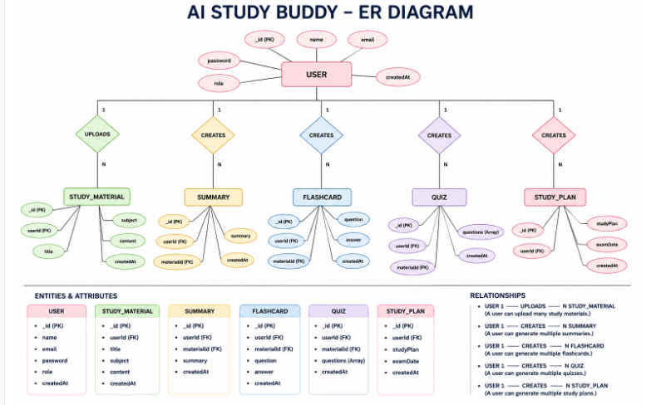
Figure: Entity Relationship Diagram of AI StudyBuddy

Relationship Explanation
- One user can upload multiple study materials.
- One user can generate multiple summaries, flashcard sets, quizzes and study plans.
- Each generated resource is linked to the material it was created from.
- One user can have multiple tasks and multiple quiz attempts.
- One material can have multiple tasks and quiz attempts.
Note: in the implemented system, the summary, flashcards, quiz and study plan are stored as fields of the Material document, while tasks and quiz attempts are stored as separate collections.

19. USER ROLES AND RESPONSIBILITIES
AI StudyBuddy implements two user roles.

19.1 Student
The Student is the primary user of the system. Students register, log in securely, upload study materials, and use the AI features to generate summaries, flashcards, quizzes, study plans and tasks. They can ask questions about their material, attempt quizzes, track tasks, and view their dashboard statistics and previously generated resources.

19.2 Administrator
The Administrator manages the overall system. Administrators view all registered users, remove user accounts together with their materials, view all materials, and monitor system-wide usage statistics.
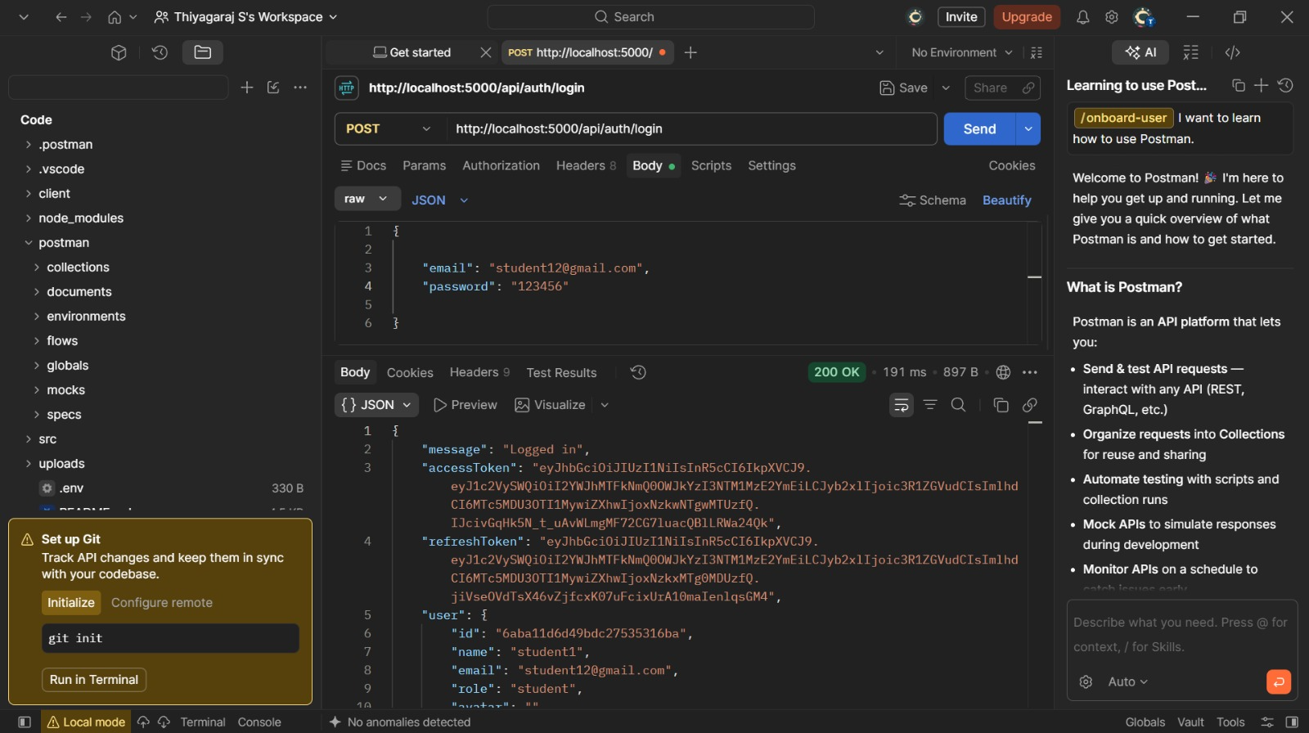

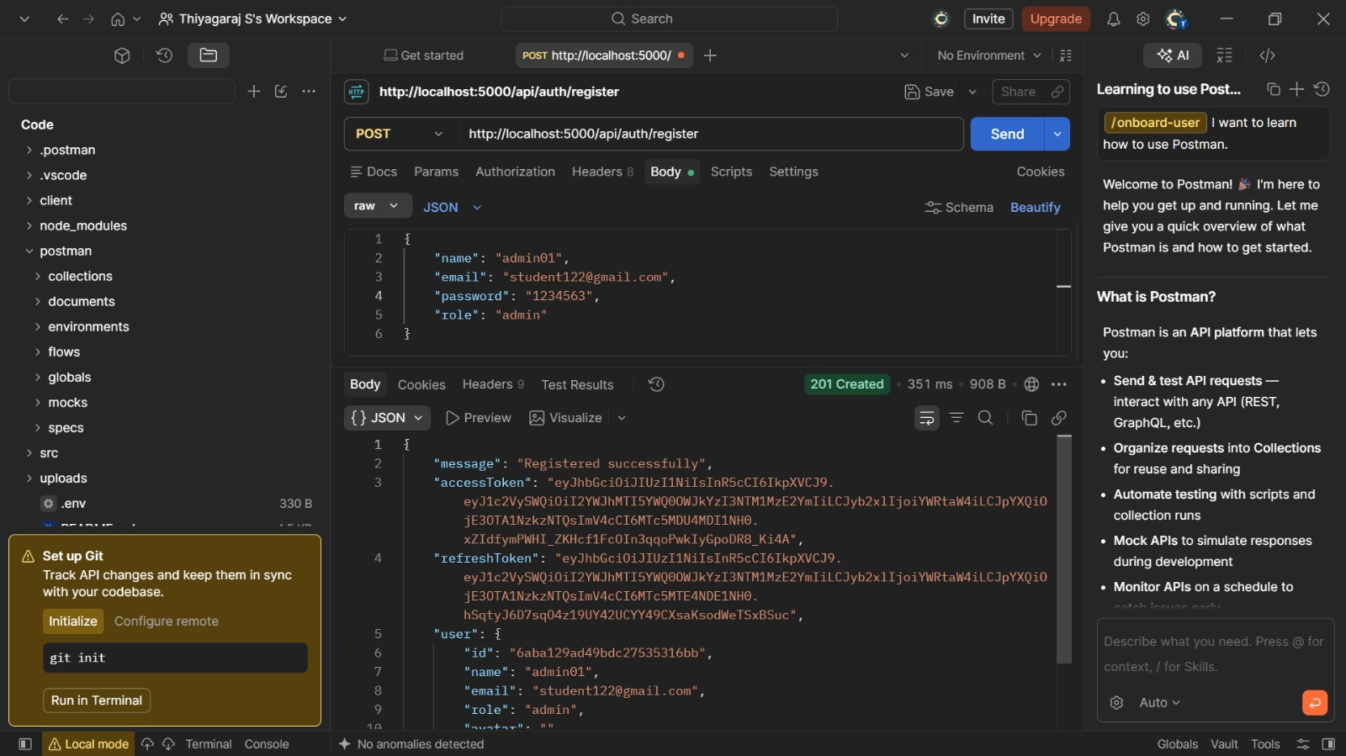

Figure 3: Role-based access control in AI StudyBuddy

20. ROLE-BASED ACCESS CONTROL
Role-Based Access Control (RBAC) restricts operations according to the authenticated user's role.
Operation | Student | Admin
Register / Login | ✓ | ✓
Upload study material | ✓ | ✓
View own materials | ✓ | ✓
View all users' materials | ✗ | ✓
Delete own material | ✓ | ✓
Delete any material | ✗ | ✓
Generate AI content (summary, flashcards, quiz, plan) | ✓ | ✓
Attempt quizzes and view own history | ✓ | ✓
Manage own tasks | ✓ | ✓
View all users | ✗ | ✓
Delete a user | ✗ | ✓
View system statistics | ✗ | ✓
The implemented project uses the authentication middleware and ownership checks in the controllers to enforce these permissions.

21. AUTHENTICATION AND JWT
AI StudyBuddy uses JWT-based authentication with access and refresh tokens.

Registration
POST /api/auth/register
A new account is created and the password is securely hashed before storage. An access token and a refresh token are returned.

Login
POST /api/auth/login
The system verifies the credentials and generates a token pair.

Token Refresh
POST /api/auth/refresh
The client sends the refresh token in the x-refresh-token header and receives a new access and refresh token pair.

Protected Requests
Authenticated requests use:
Authorization: Bearer <JWT_ACCESS_TOKEN>
The JWT identifies the authenticated user and allows protected operations to be accessed according to role permissions.
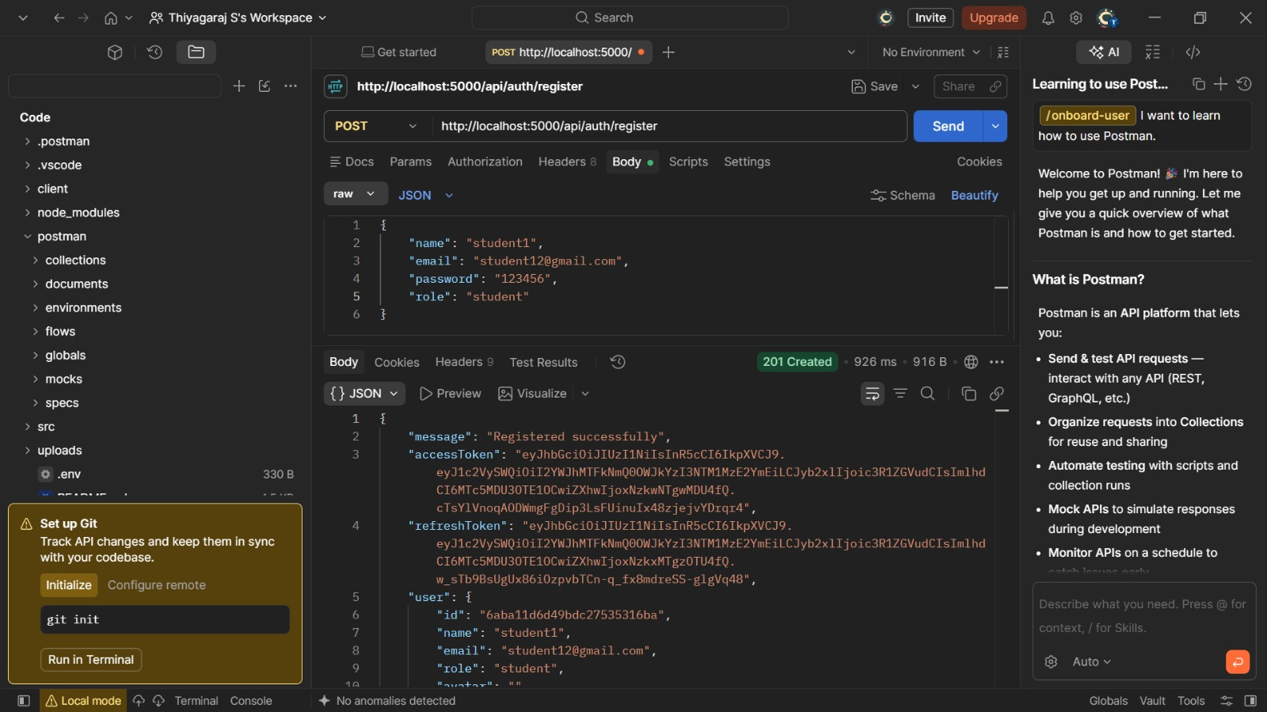
Figure 5: User registration

22. STUDY MATERIAL MANAGEMENT
Students upload study material files. The backend reads the file text, stores it in MongoDB linked to the user, and removes the temporary file from disk.

Material APIs
POST /api/materials/upload
GET /api/materials
GET /api/materials/:id
DELETE /api/materials/:id
Students can only access their own materials, while administrators can access all materials.

23. AI SUMMARY GENERATION
The summary endpoint sends the material content to Google Gemini and returns a concise bullet-point summary, which is also saved on the material.
POST /api/materials/:id/summarize
Response:
{ "summary": "• Key point 1 ... • Key point 2 ..." }
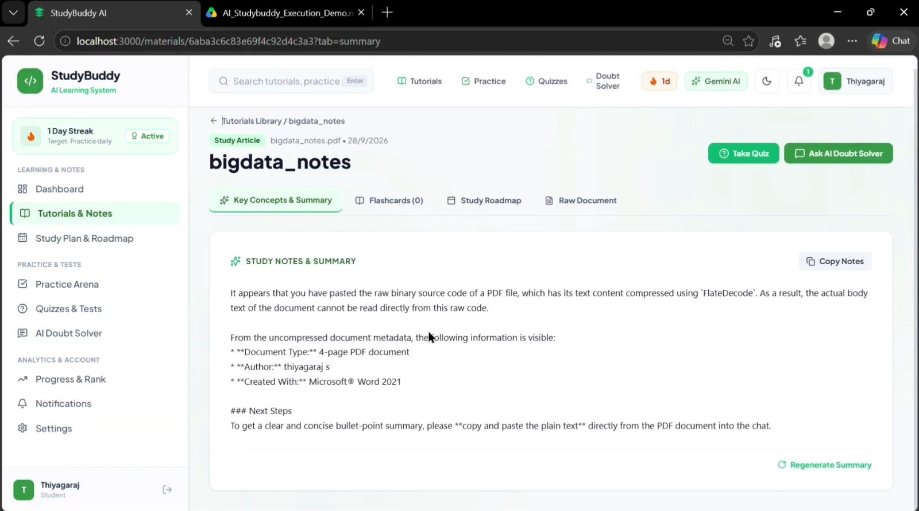
Figure 11: AI-powered summary generation

24. AI FLASHCARD GENERATION
The flashcard endpoint generates a configurable number of question and answer pairs (default 5) from the material for active recall.
POST /api/materials/:id/flashcards
Request:
{ "count": 5 }
Response:
{ "flashcards": [ { "question": "...", "answer": "..." } ] }
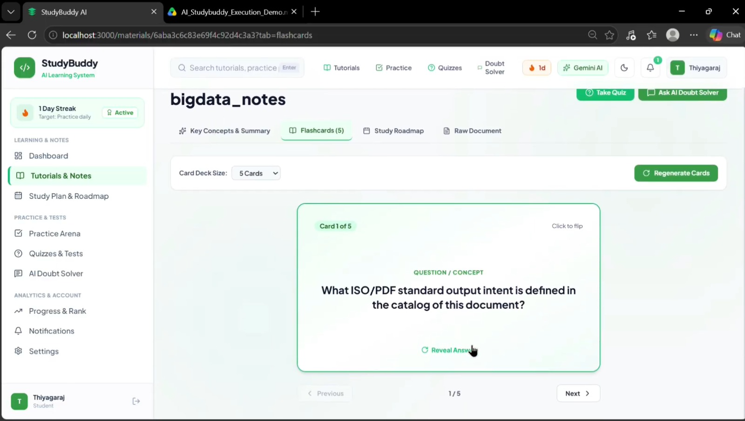Figure 12: AI-powered flashcard generation

25. AI QUIZ GENERATION
The quiz endpoint generates multiple-choice questions, each with four options and one correct answer, and stores them on the material.
POST /api/materials/:id/quiz
Response:
{ "quiz": [ { "question": "...", "options": ["A","B","C","D"], "answer": "A" } ] }
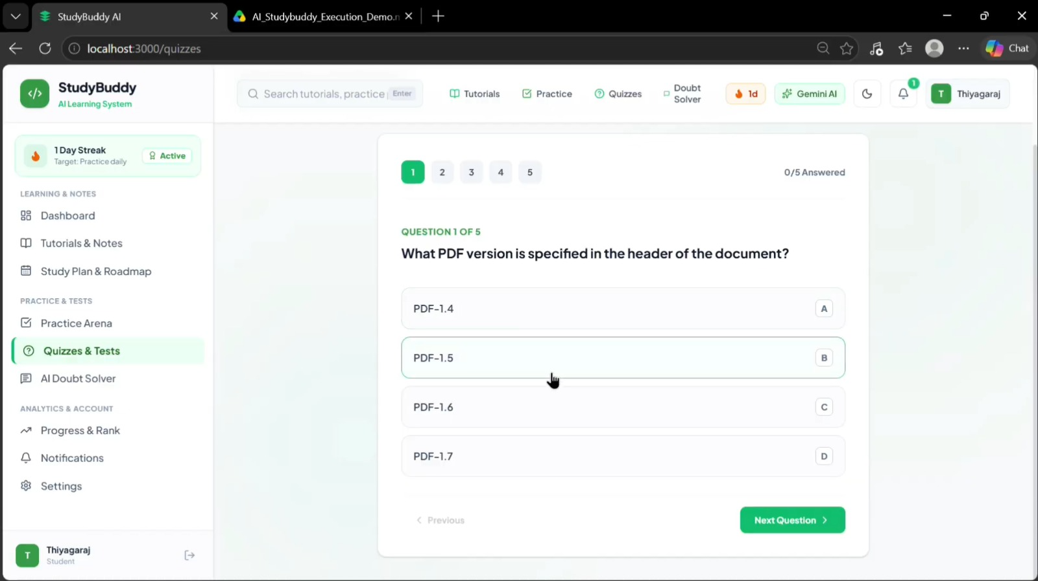Figure 13: AI-powered quiz generation

26. QUIZ SUBMISSION AND WEAK-TOPIC ANALYSIS
The student submits answers for the generated quiz. The backend grades each answer, calculates the score and percentage, and for the incorrect answers asks Google Gemini to identify one to three weak topics to review. The result is saved as a quiz attempt.
POST /api/materials/:id/quiz/submit
GET /api/quizzes/history
GET /api/quizzes/:id
Request:
{ "answers": [ { "questionIndex": 0, "selectedAnswer": "A" } ] }
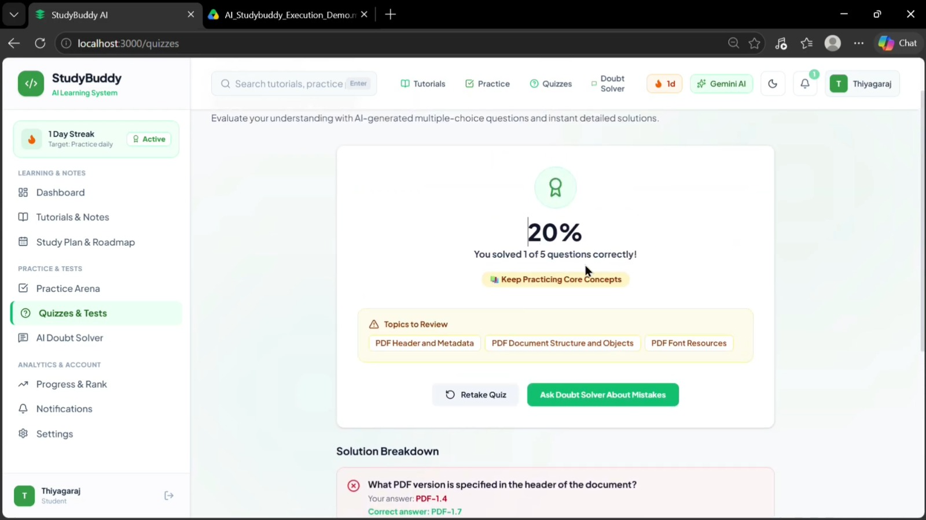
Figure 14: Quiz submission and grading

27. AI STUDY PLAN GENERATION
The study plan endpoint creates a personalized day-by-day plan from the material, based on the goal of the student, the hours available per day, and the number of days (default 7 days and 2 hours per day).
POST /api/materials/:id/study-plan
Request:
{ "goal": "Prepare for the final exam", "hoursPerDay": 2, "days": 7 }
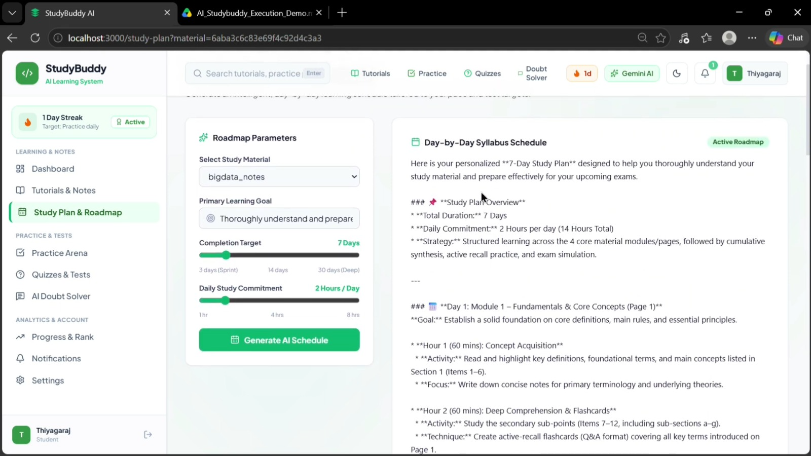Figure 16: AI-powered personalized study plan

28. CONTEXTUAL QUESTION ANSWERING
Students can ask questions about a material. The backend sends the material content (limited to the first 15,000 characters) and the earlier conversation history to Gemini so that follow-up questions are answered in context.
POST /api/materials/:id/ask
Request:
{ "question": "...", "history": [ { "role": "user", "content": "..." } ] }
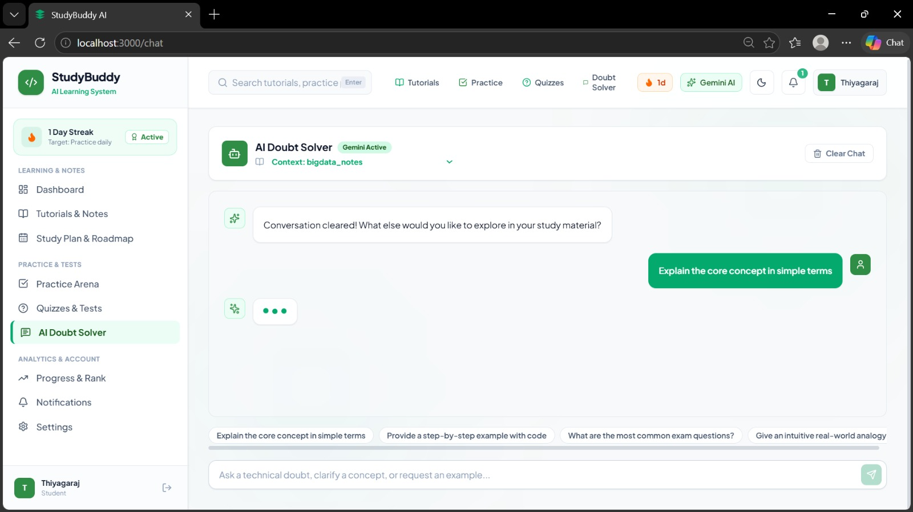
Figure 17: Asking questions about a study material

29. TASK MANAGEMENT
Learning tasks can be generated by AI from a material (four to six progressive tasks with difficulty and estimated time) or created manually. If the AI response cannot be parsed, a fallback set of tasks is created so that the request still succeeds.
POST /api/materials/:id/tasks
GET /api/tasks
POST /api/tasks
PATCH /api/tasks/:id
DELETE /api/tasks/:id
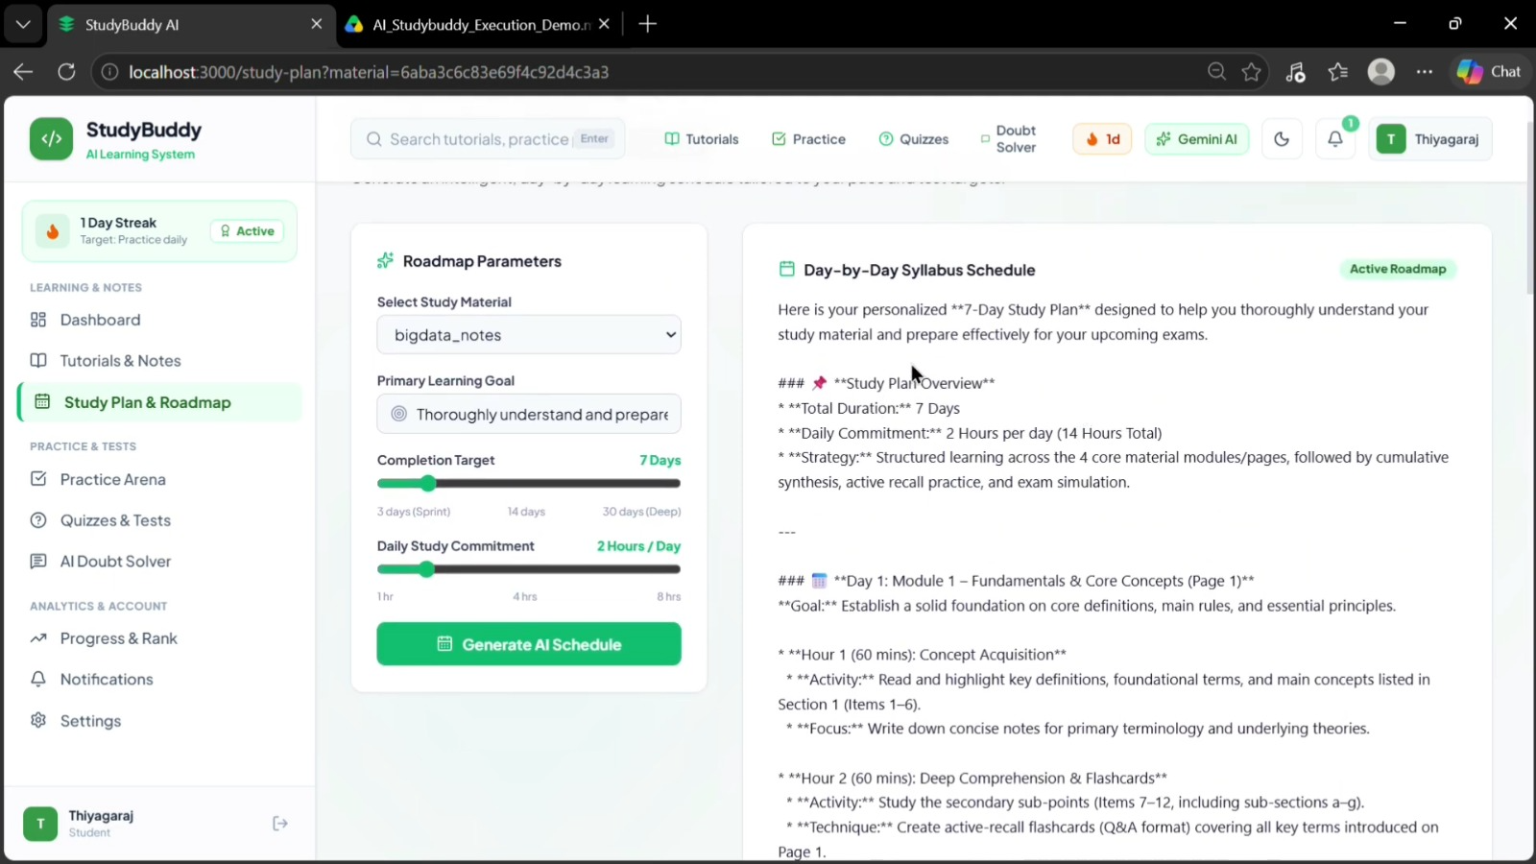
Figure 18: AI-generated learning tasks

30. DASHBOARD STATISTICS AND NOTIFICATIONS
The statistics endpoint calculates the study streak, total materials, task completion rate, number of quizzes, average quiz score, weak topics, the most recent material, and a mastery tier. The tier rises from Beginner to Basic, Intermediate, Advanced and Mastery according to the completed tasks, materials, and average quiz score.
The notifications endpoint builds a dynamic feed containing the streak reminder, pending tasks, the latest quiz score, and a welcome message for new users.
GET /api/user/stats
GET /api/user/notifications
GET /api/user/me
PUT /api/user/profile
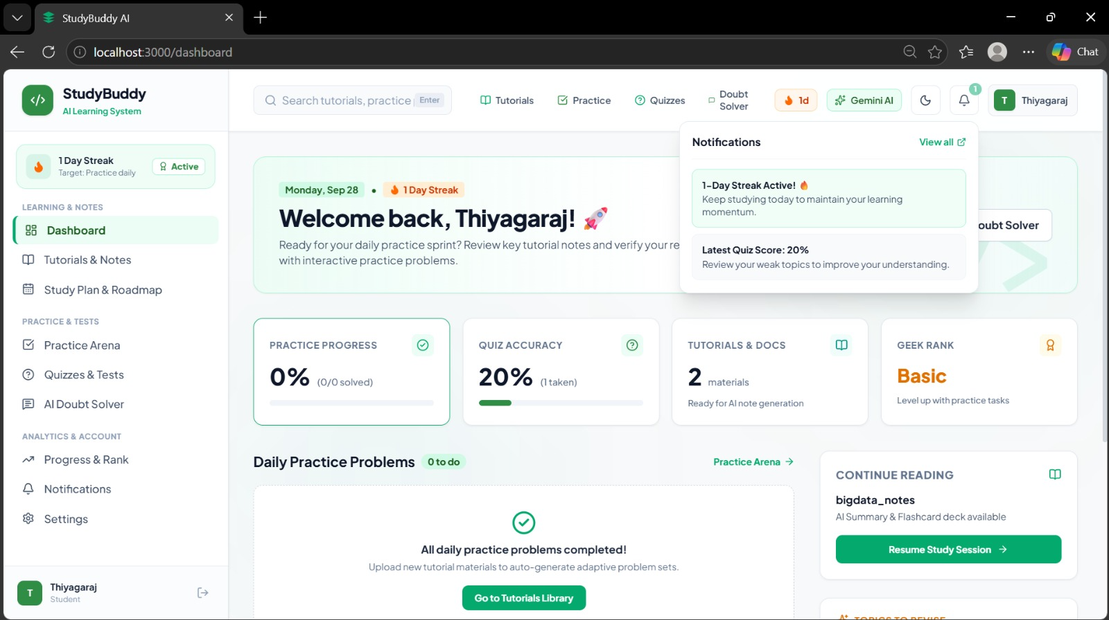
Figure 20: Dashboard statistics
Figure 21: User notifications

31. GOOGLE GEMINI AI INTEGRATION
Google Gemini 2.5 Flash is integrated through the gemini.js utility. Every AI feature builds a purpose-specific prompt and calls a shared askGemini function that sends the prompt to the model and returns the generated text.
Prompt engineering is used to give Gemini structured instructions. For flashcards, quizzes, tasks, and weak topics, the prompt asks for a strict JSON format only. The backend then removes markdown code fences and parses the JSON, with a fallback where necessary.
Processing Flow
Study Material → Structured Prompt → Google Gemini → Parsed Response → Saved in MongoDB → API Response

32. ADMINISTRATION
Administrators can manage users and monitor platform usage. Deleting a user also deletes all materials owned by that user.
GET /api/admin/users
DELETE /api/admin/users/:id
GET /api/admin/stats

33. SECURITY FEATURES
AI StudyBuddy implements the following security mechanisms:

Password Security
Passwords are hashed using bcryptjs and are never returned in API responses.

JWT Security
Short-lived access tokens protect authenticated routes and refresh tokens are verified using a separate secret.

Role Authorization
RBAC prevents students from using administrator operations.

Ownership Protection
Students can only read, modify or delete their own materials, tasks and quiz attempts.

Upload Validation
Uploaded files are validated by the upload middleware, and the temporary file is deleted after its content is stored.

Sensitive Data Protection
Secrets such as the JWT secrets, database URI and Gemini API key are stored in environment variables.

34. API MODULE SUMMARY

Authentication
Method | Endpoint | Purpose
POST | /api/auth/register | Register user
POST | /api/auth/login | Login
POST | /api/auth/refresh | Refresh tokens
POST | /api/auth/logout | Logout
GET | /api/auth/me | Current user
PUT | /api/auth/profile | Update profile

Materials
Method | Endpoint | Purpose
POST | /api/materials/upload | Upload material
GET | /api/materials | List materials
GET | /api/materials/:id | View material
DELETE | /api/materials/:id | Delete material

AI Generation
Method | Endpoint | Purpose
POST | /api/materials/:id/summarize | Generate summary
POST | /api/materials/:id/flashcards | Generate flashcards
POST | /api/materials/:id/quiz | Generate quiz
POST | /api/materials/:id/study-plan | Generate study plan
POST | /api/materials/:id/ask | Ask a question
POST | /api/materials/:id/tasks | Generate tasks

Quiz
Method | Endpoint | Purpose
POST | /api/materials/:id/quiz/submit | Submit and grade quiz
GET | /api/quizzes/history | Quiz history
GET | /api/quizzes/:id | View quiz attempt

Tasks
Method | Endpoint | Purpose
GET | /api/tasks | List tasks
POST | /api/tasks | Create task
PATCH | /api/tasks/:id | Update task
DELETE | /api/tasks/:id | Delete task

User
Method | Endpoint | Purpose
GET | /api/user/me | View profile
PUT | /api/user/profile | Update profile
GET | /api/user/stats | Dashboard statistics
GET | /api/user/notifications | Notifications

Admin
Method | Endpoint | Purpose
GET | /api/admin/users | View all users
DELETE | /api/admin/users/:id | Delete user
GET | /api/admin/stats | System statistics

35. API TESTING
The backend APIs are tested using Postman. The main testing sequence is: register, login, upload a material, generate a summary, flashcards, quiz and study plan, submit the quiz, generate and complete tasks, view dashboard statistics, and finally test the administrator endpoints.

36. TESTING RESULTS
The testing verified authentication, role authorization, material management, all AI generation features, quiz grading, task management, dashboard statistics, ownership protection, and administrator operations.
[TEST RESULT: - update with your final result]
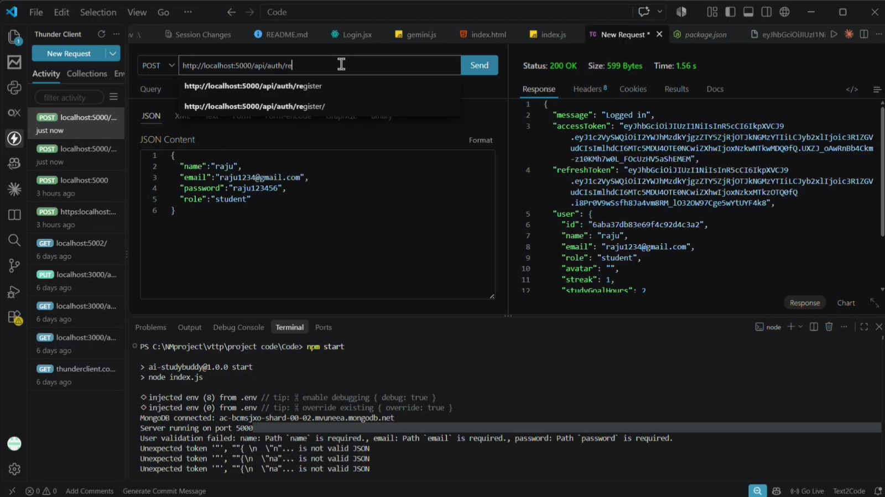Figure 27: API testing results

37. MONGODB CONNECTION
The server starts listening only after the MongoDB connection is established.
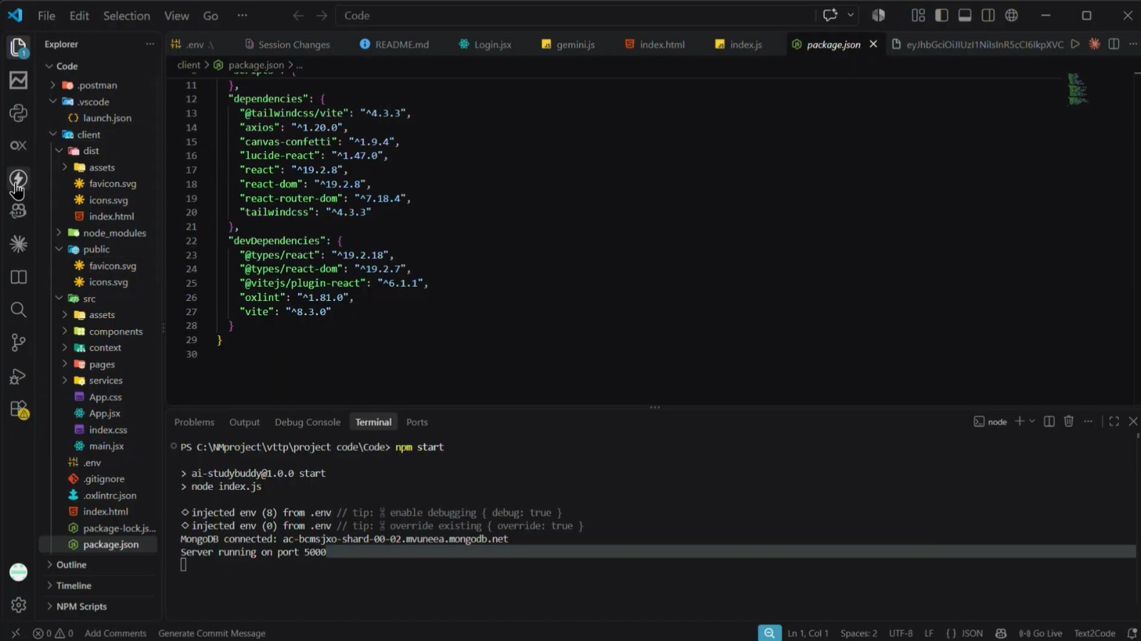
Figure 28: Server start and database connection

38. SYSTEM FUNCTIONALITY SUMMARY
Module | Main Functionality
Authentication | Registration, Login, JWT access and refresh tokens
Authorization | Student and Administrator roles
Materials | Upload, list, view, delete
Gemini AI | Summaries, flashcards, quizzes, study plans, Q&A, tasks
Quiz | Grading, weak-topic analysis, attempt history
Tasks | AI-generated and manual task tracking
Dashboard | Streak, statistics, mastery tier, notifications
Admin | User management and system statistics
Security | Password hashing, JWT, ownership checks, upload validation
Testing | Postman API testing

39. ADVANTAGES
- AI-assisted generation reduces the manual effort of preparing revision material.
- Automatic quizzes with weak-topic analysis give students targeted feedback.
- Personalized study plans fit the time a student actually has.
- Role-based permissions and ownership checks protect user data.
- Streaks, tasks and mastery tiers keep students motivated.
- The MVC architecture provides modular separation of responsibilities.
- Postman enables direct backend API testing.

40. LIMITATIONS
- The current system is backend-focused and has no graphical frontend.
- AI functionality depends on Google Gemini availability.
- Uploaded files are read as plain text, so complex formats may not be supported.
- The quality of generated content depends on the quality of the uploaded material.
- A larger production deployment would require additional infrastructure.

41. FUTURE ENHANCEMENTS
The system can be extended with:
- Web and mobile frontend
- Support for PDF, DOCX and image (OCR) uploads
- Spaced-repetition scheduling for flashcards
- Study analytics and progress charts
- Rate limiting and request validation
- Multi-language content generation
- Voice-based question answering

42. CONCLUSION
AI StudyBuddy combines backend development, secure authentication, role-based authorization, database management, and Generative AI in a single REST API platform.
The system provides practical APIs that convert student-provided study material into summaries, flashcards, quizzes, personalized study plans, and learning tasks using Google Gemini, while tracking progress through quiz attempts, task completion, and dashboard statistics. JWT and RBAC provide controlled access to system operations.
The project demonstrates the application of modern backend and AI technologies in an intelligent learning assistance system and satisfies the major functional and technical requirements defined for the project.

