PROJECT DESIGN PHASE
Project Design
AI StudyBuddy
Team ID | SWTID-2026-5712
Date | 27/09/2026
Project Name | AI StudyBuddy

1. Design Overview
AI StudyBuddy is designed as a modular backend REST API for AI-assisted learning. The design separates API routing, request validation, authentication, authorization, business logic, database operations, and AI processing into independent layers.
The system uses Node.js and Express.js as the backend platform and MongoDB (via Mongoose) as the database. Google Gemini (Gemini 2.5 Flash) provides the generative AI capabilities behind summaries, flashcards, quizzes, study plans, contextual Q&A, and task generation.
The design follows the MVC pattern: routes map HTTP endpoints to controllers, controllers hold the business logic, and Mongoose models define and validate the data. A dedicated utility layer (gemini.js) isolates all AI prompt construction and API calls, keeping controllers focused on request handling and persistence.

2. Technical Architecture
Layer | Responsibility
Entry Point (index.js) | Initializes Express, loads environment variables, wires middleware, connects to MongoDB, registers routes, starts server
Middleware | auth.js (JWT verification + role authorization), upload.js (file validation for study material uploads)
Routes | Map HTTP verbs/paths to controller functions per resource (auth, materials, quizzes, tasks, user, admin)
Controllers | authController, materialController, quizController, taskController, userController, adminController — business logic
Models (Mongoose) | User, Material, Task, QuizAttempt — schema, validation, relationships
Utilities | db.js (MongoDB connection), gemini.js (Gemini API integration), tokens.js (JWT generation)
External Service | Google Gemini 2.5 Flash API for all generative AI content
Architecture flow: Client → Express Router → Auth/Upload Middleware → Controller → (Mongoose ↔ MongoDB) and/or (gemini.js ↔ Google Gemini API) → JSON Response.

3. Database Design (ER Diagram)
The data model centers on the User entity, which owns study materials and the AI-generated resources derived from them.
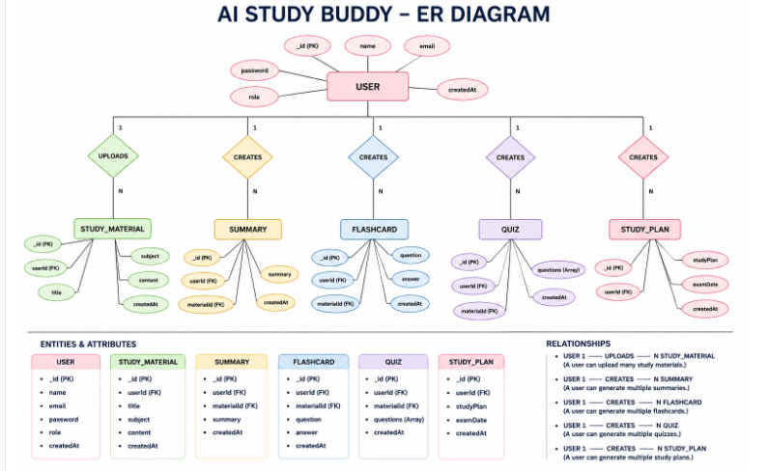
Figure: AI StudyBuddy — Entity Relationship Diagram

3.1 Entities & Relationships
Relationship | Cardinality | Description
USER — STUDY_MATERIAL | 1 : N | A user can upload many study materials
USER — SUMMARY | 1 : N | A user can generate multiple summaries
USER — FLASHCARD | 1 : N | A user can generate multiple flashcard sets
USER — QUIZ | 1 : N | A user can generate multiple quizzes
USER — STUDY_PLAN | 1 : N | A user can generate multiple study plans

3.2 Key Schema Fields (as implemented)
Model | Key Fields
User | _id, name, email, password (hashed), role (student/admin), avatar, streak, studyGoalHours, createdAt
Material | _id, user (FK), title, filename, content, summary, flashcards[], quiz[], studyPlan, createdAt
Task | _id, user (FK), material (FK), title, description, difficulty, estimatedMinutes, completed, completedAt, dueDate, createdAt
QuizAttempt | _id, user (FK), material (FK), score, totalQuestions, percentage, answers[], weakTopics[], createdAt
Note: Summary, Flashcard, Quiz and Study Plan are modeled as AI-generated fields embedded within the Material document (summary, flashcards, quiz, studyPlan) rather than as fully separate top-level collections, which keeps each material's generated resources co-located and simplifies retrieval.

4. Design Principles Applied
- Separation of concerns: routing, auth, business logic, and data access are kept in distinct files/layers.
- Least-privilege access: role-based middleware ensures Students and Administrators only reach the endpoints they are authorized for.
- Fail-safe AI parsing: JSON responses from Gemini are cleaned and parsed defensively, with fallback content generated if parsing fails (see Task generation).
- Statelessness: JWT-based auth avoids server-side session storage, supporting horizontal scaling.

