PROJECT DOCUMENTATION PHASE
Project Documentation
AI StudyBuddy
Team ID | SWTID-2026-5712
Date | 27/09/2026
Project Name | AI StudyBuddy
Team Leader | Shyam Kumar R
Team Members | Thiyagaraj S, Surendhar M, Sathishwaran S

1. Introduction
AI StudyBuddy is an AI-powered learning assistance platform developed to simplify the study process for students by leveraging modern web technologies and Generative AI. The application provides an intelligent backend system that enables students to upload study materials, generate concise summaries, create flashcards, produce quizzes, and receive personalized study plans through AI-generated responses.
The backend is developed using Node.js and Express.js, following a RESTful API architecture that ensures scalability, maintainability, and secure communication between the frontend and backend services. MongoDB serves as the primary NoSQL database, while Mongoose ODM provides schema validation, data modeling, and efficient database interactions.
To secure user information and protected resources, the application implements JWT-based authentication along with Role-Based Access Control (RBAC). Users are authenticated before accessing AI-powered features, ensuring that only authorized users can utilize premium learning services. Passwords are securely encrypted using bcryptjs.
A key highlight of AI StudyBuddy is its integration with the Google Gemini AI API, enabling advanced natural language processing. Instead of relying on predefined templates, the backend dynamically communicates with the Gemini model to generate high-quality educational content based on the study material the user provides.

2. Features
- Secure User Authentication — JWT-based authentication with bcrypt-encrypted passwords.
- Study Material Management — upload and manage study materials as input for AI features.
- AI Summary Generation — concise, easy-to-understand summaries via Google Gemini.
- AI Flashcard Generation — automatic flashcards for revision and active recall.
- AI Quiz Generation — multiple-choice quizzes with automatic scoring and weak-topic detection.
- AI Study Plan Generation — personalized plans based on learning goals and available time.
- Role-Based Access Control — distinct privileges for Students and Administrators.
- MongoDB Data Storage — efficient storage of users, materials and AI-generated resources.

3. Roles and Responsibilities

3.1 Student
Students are the primary users of the system. They can register, log in securely, upload study materials, and utilize AI-powered features such as summary generation, flashcard creation, quiz generation, and personalized study plans. Students can also view and manage their previously generated learning resources.

3.2 Administrator
Administrators manage the overall system and ensure its smooth operation. They monitor registered users, manage user accounts, oversee application usage, maintain system integrity, and ensure that AI-powered services function correctly. Administrators also have permission to perform system-level management tasks and resolve user-related issues.

4. User Flow
The AI StudyBuddy application begins with the user registering or logging into the system. After successful JWT-based authentication, the user is redirected to the dashboard, where they can upload study materials and access AI-powered features. Based on the uploaded content, the system generates summaries, flashcards, quizzes, or personalized study plans using the Google Gemini API. All generated resources are displayed to the user and can be saved for future reference. Users can also manage their profile and view their previously generated learning resources through the dashboard.

5. System Architecture & Development
The backend follows an MVC-style layered architecture:
- index.js — application entry point; initializes Express, loads env vars, connects MongoDB, registers routes, starts the server.
- src/utils/db.js — establishes the MongoDB connection via Mongoose before the app serves requests.
- src/middleware/auth.js — verifies JWT access tokens and enforces role-based authorization.
- src/utils/gemini.js — integrates with Google Gemini 2.5 Flash, sending prompts and returning generated content.
- src/middleware/upload.js — validates study material uploads before processing.
- Controllers — authController, materialController, quizController, taskController, userController, adminController implement all business logic (see Project Development Phase document for full endpoint-by-endpoint detail).

6. Database Design
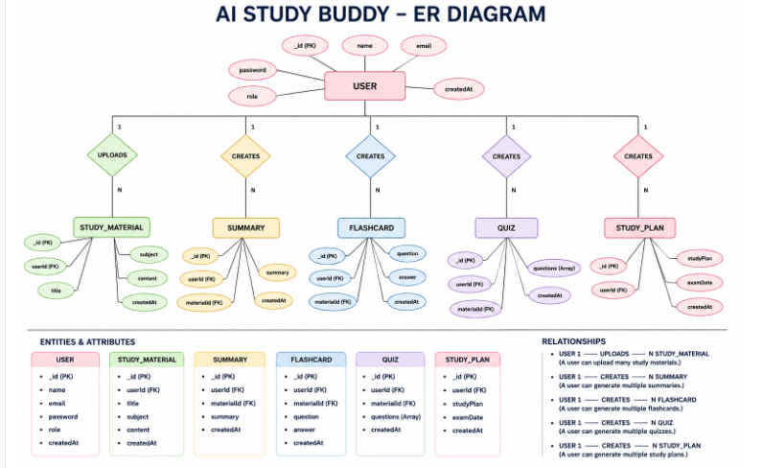
Figure: AI StudyBuddy — Entity Relationship Diagram
USER is the central entity, related 1:N to STUDY_MATERIAL (uploads) and 1:N each to SUMMARY, FLASHCARD, QUIZ and STUDY_PLAN (creates). In the current implementation, summary/flashcards/quiz/study-plan are stored as fields on the owning Material document; QuizAttempt and Task are separate collections capturing scoring history and learning tasks respectively.

7. API Surface (Summary)
Area | Representative Endpoints
Auth | POST /api/auth/register, /login, /refresh, /logout · GET /api/auth/me · PUT /api/auth/profile
Materials | POST /api/materials/upload · GET /api/materials, /api/materials/:id · DELETE /api/materials/:id
AI Generation | POST /api/materials/:id/summarize, /flashcards, /quiz, /study-plan, /ask, /tasks
Quizzes | POST /api/materials/:id/quiz/submit · GET /api/quizzes/history, /api/quizzes/:id
Tasks | GET/POST /api/tasks · PATCH/DELETE /api/tasks/:id
User | GET /api/user/me, /api/user/stats, /api/user/notifications · PUT /api/user/profile
Admin | GET /api/admin/users, /api/admin/stats · DELETE /api/admin/users/:id

8. Conclusion
AI StudyBuddy demonstrates how Generative AI can be embedded directly into a secure, well-structured backend to meaningfully reduce the manual effort students spend on note-taking, revision material creation, and self-assessment — while giving them a personalized, trackable view of their study progress through streaks, mastery tiers, and weak-topic identification.

