**ASSIGNMENT**

**Data Flow Diagram**

**Submitted by**

**Shyam Mohan**

**M4c**

**Rollno : 14**

**Data Flow Diagram**

**Context Diagram**

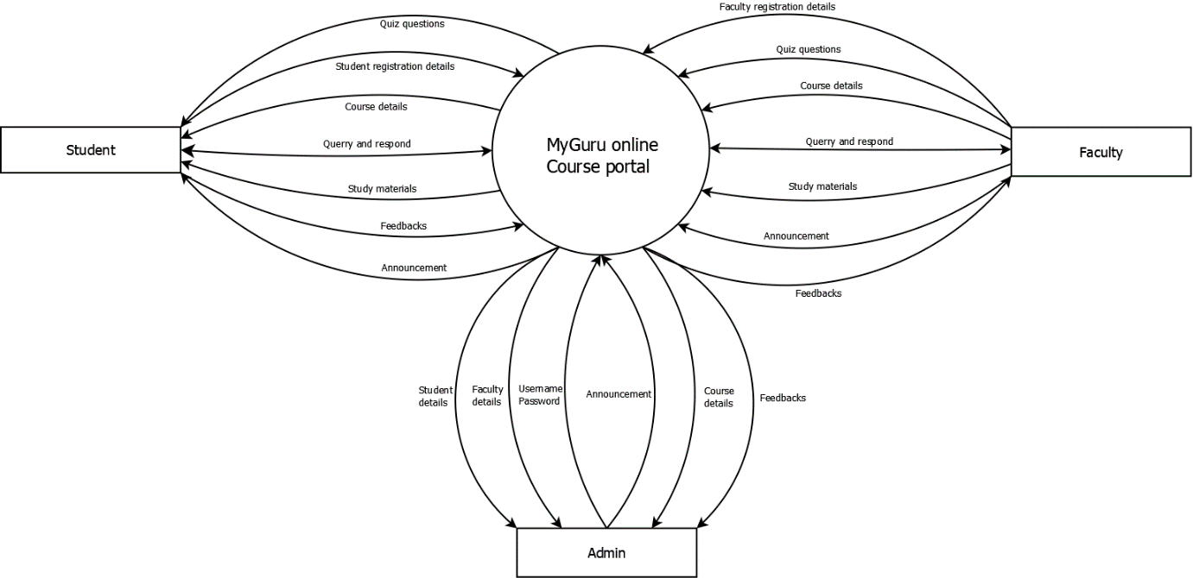

**Level 1 DFD**

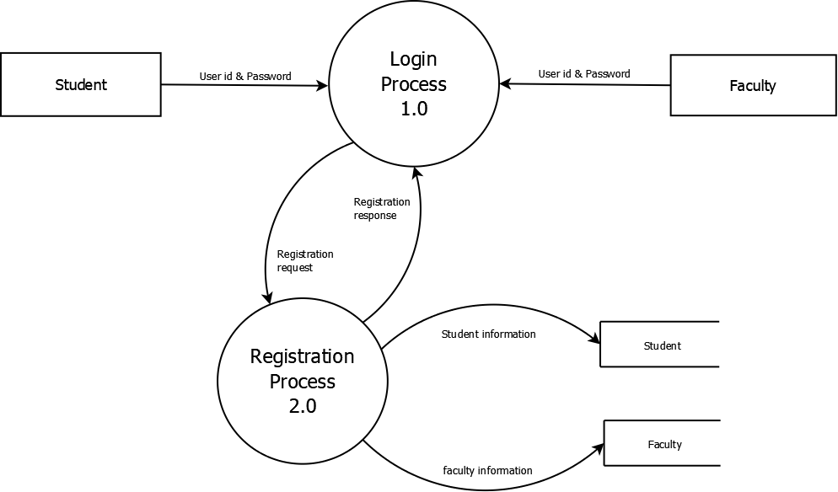

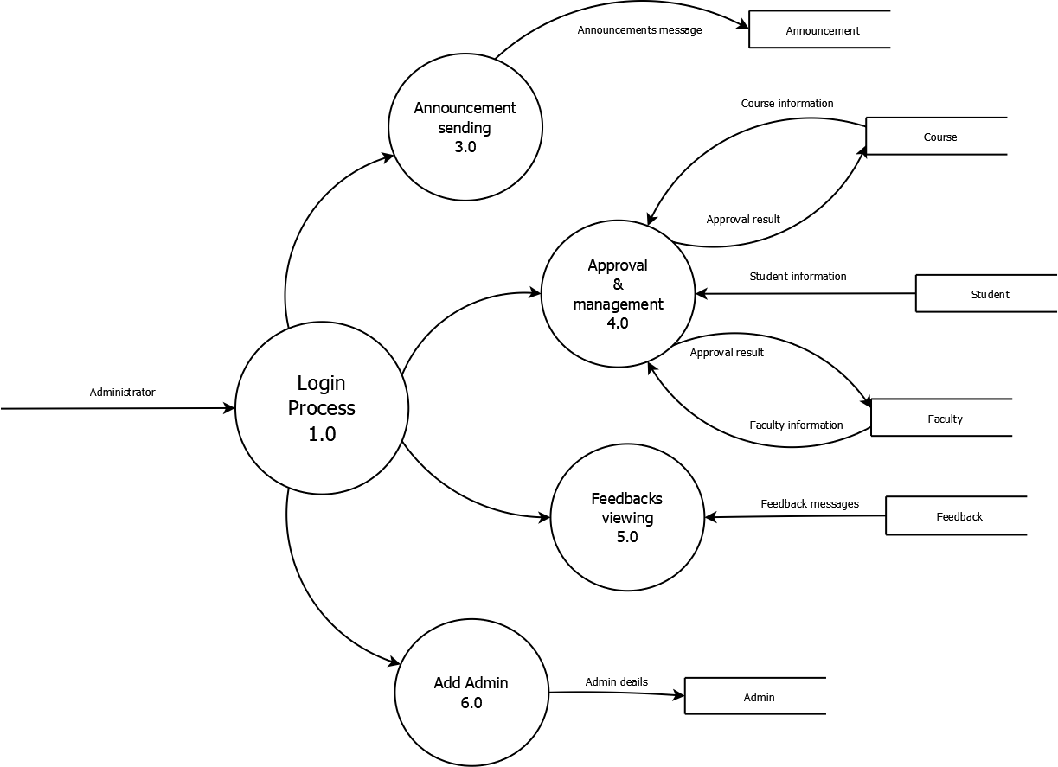

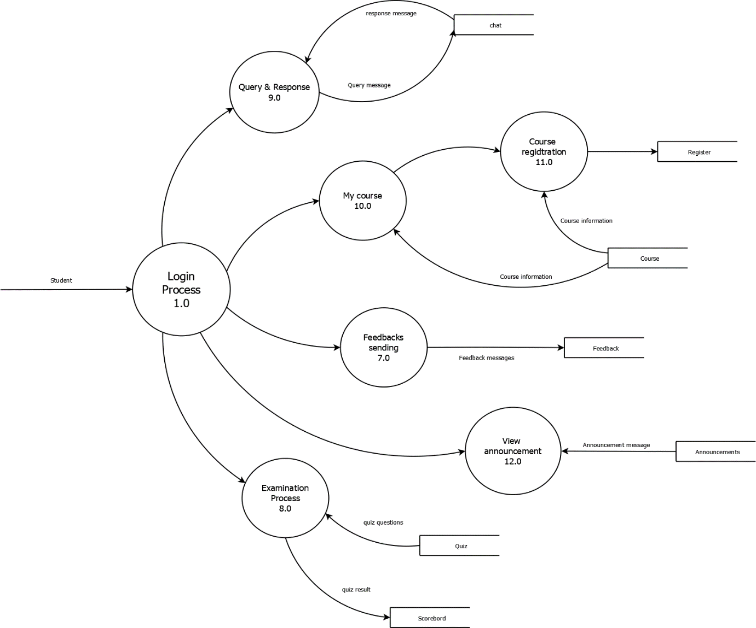

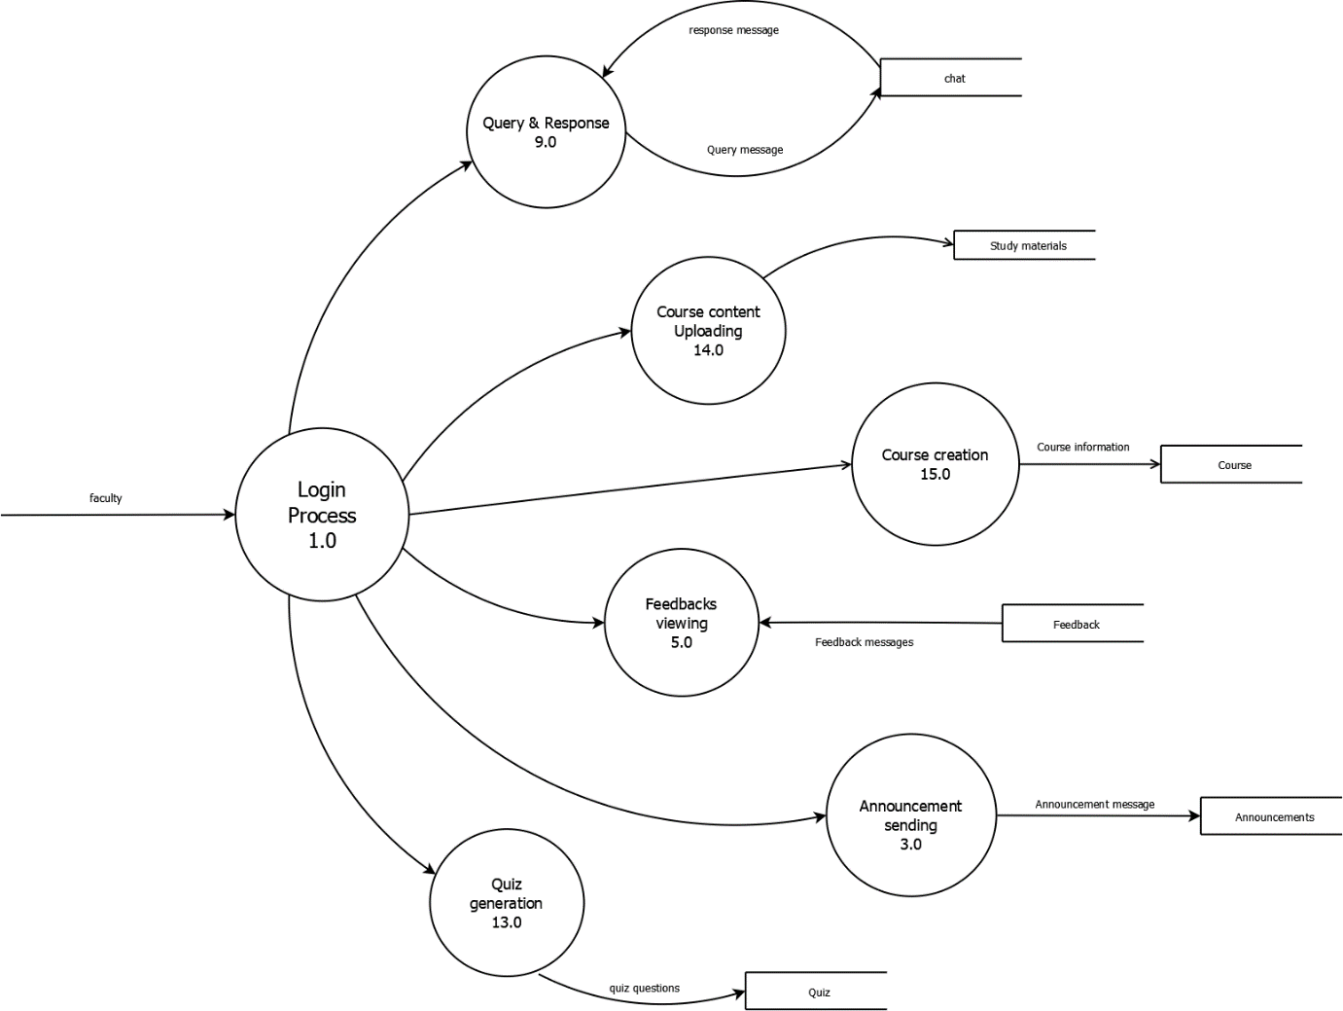

**Level 2 of My course**

