AWS
PROJECT DOCUMENTATION
QuickLoan – Scalable Loan Application Web Platform on AWS
End-to-End Deployment on Amazon Web Services (AWS)
Prepared by
Shyam Nair
Category: Cloud Computing / DevOps | Platform: Amazon Web Services

Table of Contents
1. Project Overview
2. Project Workflow Diagram
3. Network Architecture Diagram
4. AWS Services Used
5. Prerequisites
6. Step-by-Step Implementation Guide
6.1 Create the VPC and Networking Components
6.2 Create Security Groups
6.3 Launch the EC2 Instances
6.4 Connect All Servers via the Jump Server
6.5 Configure the Application Server (Nginx + PHP)
6.6 Deploy the Application Code
6.7 Create and Configure the Amazon S3 Bucket
6.8 Point the Application to the S3 Bucket
6.9 Set Up the Database (Amazon RDS)
6.10 Connect the Application Server to the Database
6.11 Configure a Custom Domain Name
6.12 Configure the Nginx Server Block for the Domain
6.13 Final End-to-End Testing
7. Production Scaling: AMI, Auto Scaling, Load Balancer & Monitoring
7.1 Create an AMI (Amazon Machine Image)
7.2 Create a Launch Template and Auto Scaling Group
7.3 Attach an Application Load Balancer
7.4 Set Up SNS Notifications
7.5 Set Up CloudWatch Alarms & Scaling Policies
7.6 Test the Auto Scaling Group
8. Security Best Practices Applied
9. Project Folder Structure
10. Troubleshooting Guide
11. Cleanup Guide — Deleting Every Resource, In Order
12. Conclusion
13. Appendix: Interview & Resume Talking Points

1. Project Overview
QuickLoan is a cloud-hosted loan application platform that allows customers to browse loan categories (Personal Loan, Home Loan, Vehicle Loan and Gold Loan) and submit loan applications online. The platform is built with a PHP backend, a MySQL-compatible relational database (Amazon RDS), and a static HTML/CSS/JavaScript frontend.
The objective of this project is to design and deploy QuickLoan as a highly available, secure and scalable web application using core AWS infrastructure services. The project was implemented end-to-end — from designing a custom Virtual Private Cloud (VPC) network, to provisioning compute and database resources, to serving static assets from Amazon S3, exposing the application through a custom domain name, and finally wiring up Auto Scaling, load balancing, and CloudWatch/SNS monitoring for production readiness.

1.1 Objectives
- Design a secure, multi-tier network architecture (public and private subnets) inside a custom VPC.
- Host the QuickLoan PHP application on Amazon EC2 using Nginx and PHP-FPM.
- Store and serve static assets (logo and loan category images) from Amazon S3.
- Persist loan application submissions in an Amazon RDS (MySQL) database running in a private subnet.
- Restrict network access using Security Groups following the principle of least privilege.
- Map a human-readable custom domain name to the application.
- Achieve production-readiness using an Auto Scaling Group, an Application Load Balancer, CloudWatch alarms, and SNS email notifications.
- Document a complete, safe teardown procedure so every billable resource can be removed cleanly.

1.2 Technology Stack
Layer | Technology
Frontend | HTML5, CSS3, JavaScript
Backend | PHP 8.2 (PHP-FPM)
Web / Reverse Proxy Server | Nginx
Database | Amazon RDS (MySQL)
Static Asset Storage | Amazon S3
Compute | Amazon EC2 (Amazon Linux 2023)
Networking | Custom VPC, Public & Private Subnets, IGW, Route Tables, NAT Gateway
Scaling & Availability | Auto Scaling Group + Application Load Balancer
Monitoring & Alerting | Amazon CloudWatch Alarms + Amazon SNS
DNS | Custom domain via a registrar, with a Route 53 hosted zone

2. Project Workflow Diagram
The diagram below summarizes the entire build in the exact order it was carried out — from the very first VPC through to CloudWatch and SNS monitoring. Each numbered card is one stage of the deployment, and the arrows trace the actual sequence followed in Section 6 and Section 7 of this document.
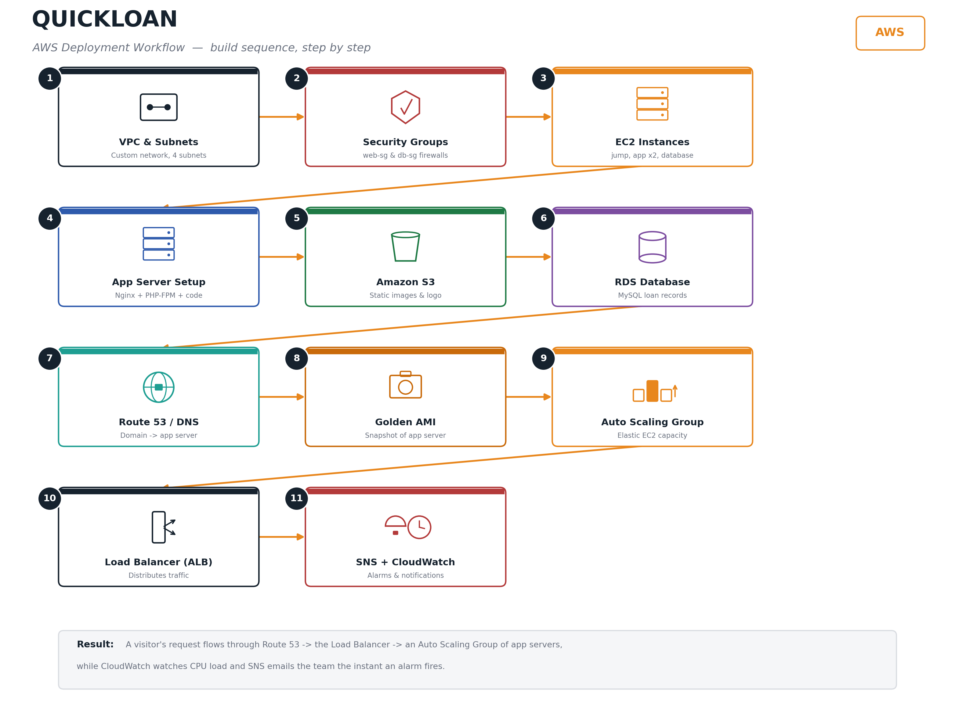
Figure 1 — QuickLoan AWS deployment workflow, step by step

3. Network Architecture Diagram
The diagram below shows the network layout used for this deployment: a custom VPC spanning four subnets, a jump server for secure administrative access, application servers behind a load balancer, and a private database subnet.
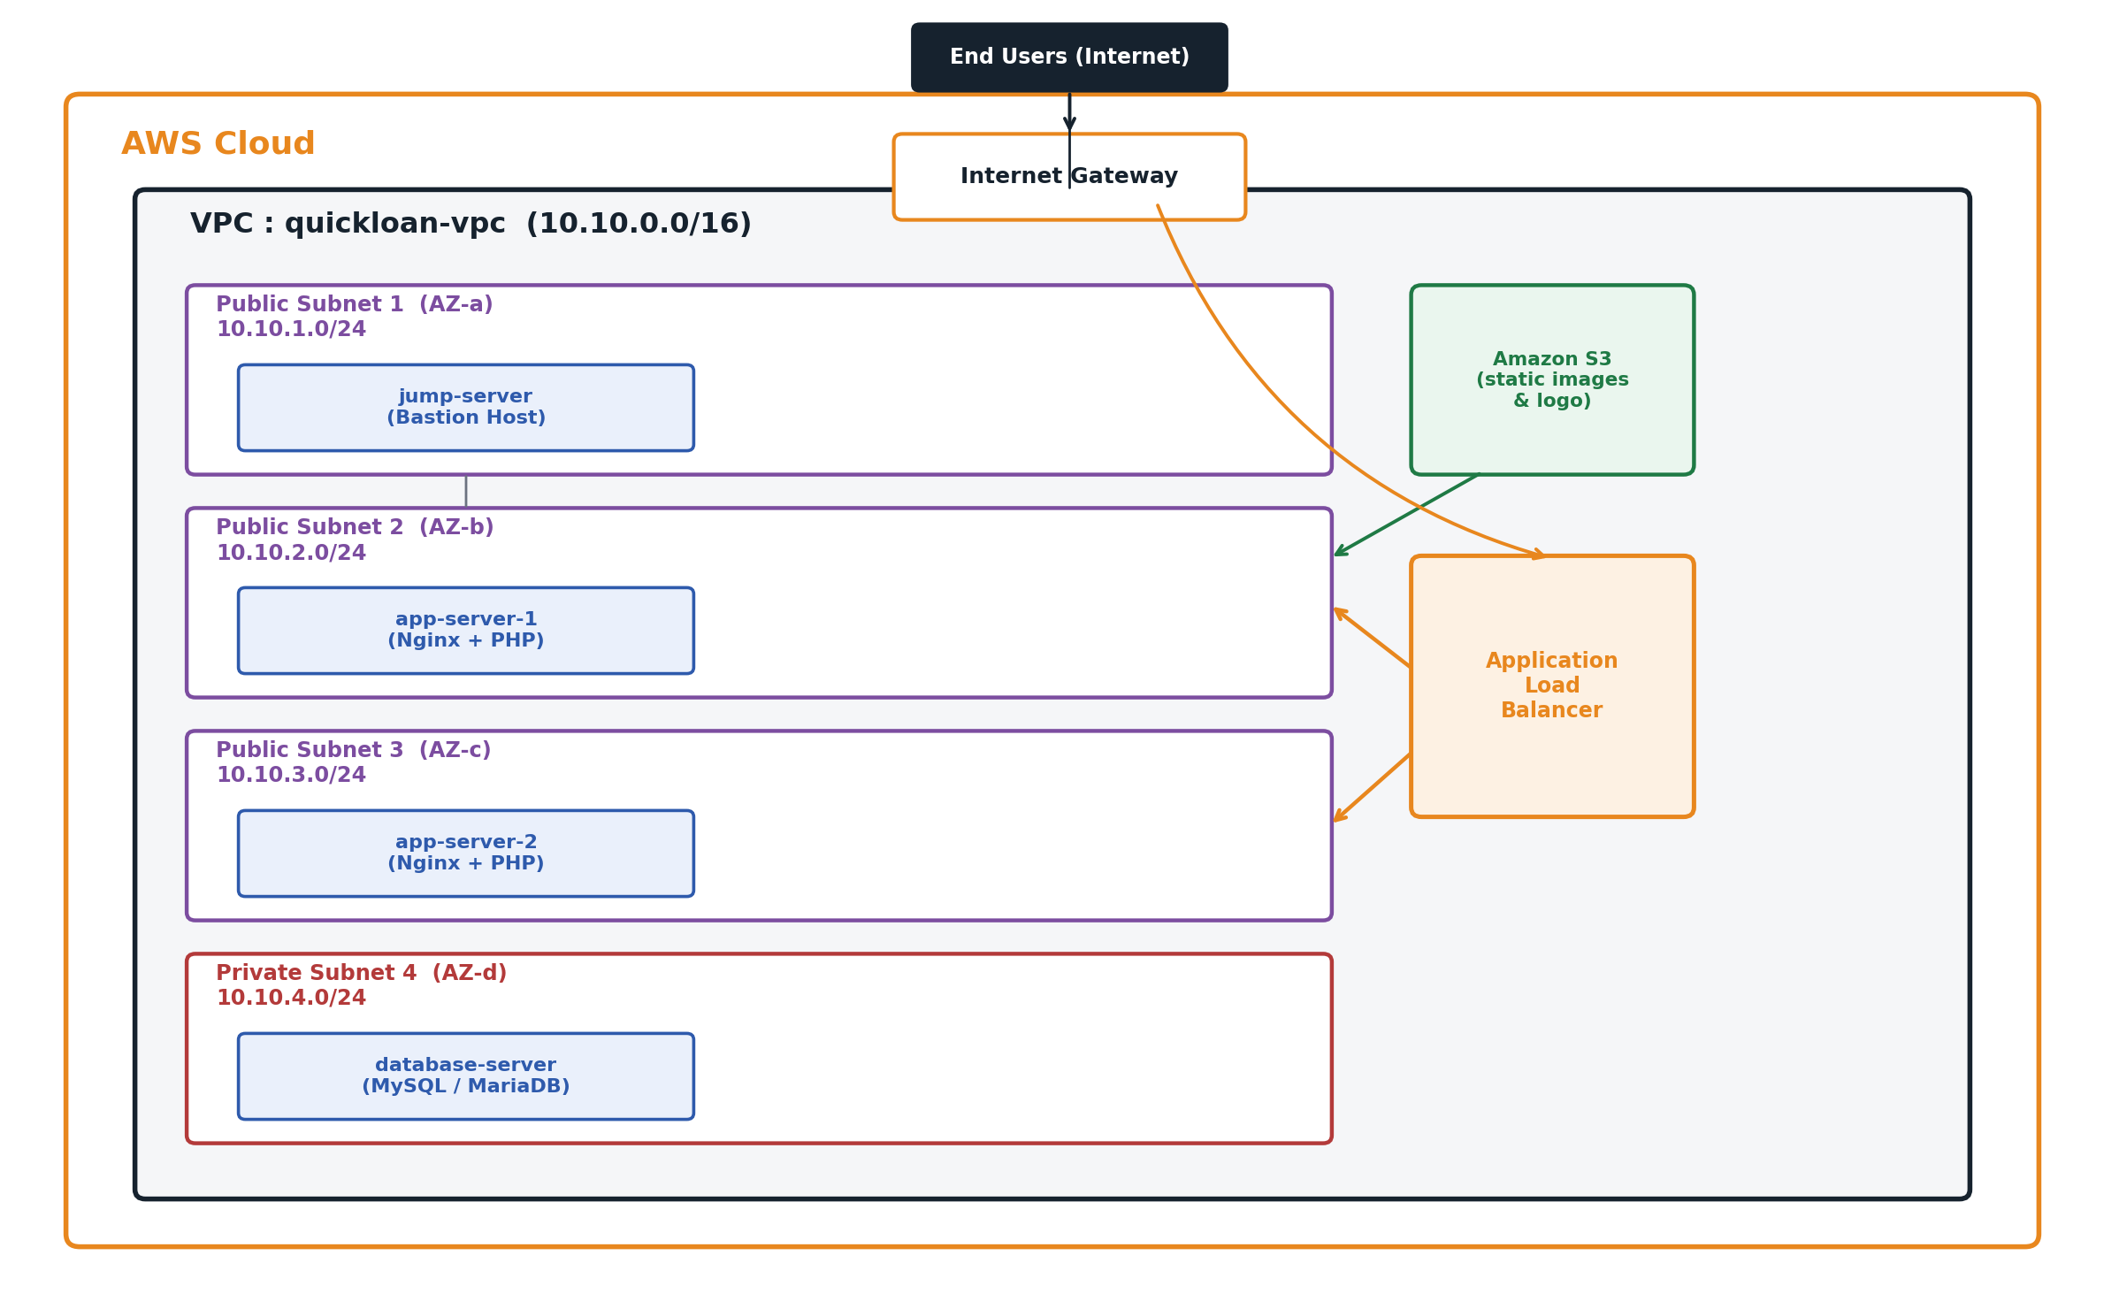
Figure 2 — QuickLoan network architecture
Design Note
The jump-server is the only instance reachable directly from the internet over SSH. Administrators hop from there to the app servers and the database using private IP addresses — the database is never exposed publicly.

4. AWS Services Used
AWS Service | Purpose in this Project
Amazon VPC | Provides an isolated custom network with public and private subnets.
Amazon EC2 | Hosts the jump server and the application (web) servers.
Internet Gateway (IGW) | Allows resources in public subnets to communicate with the internet.
NAT Gateway | Gives the private subnet outbound-only internet access (e.g. package updates).
Route Tables | Direct traffic from public subnets to the IGW and private subnet traffic to the NAT Gateway.
Security Groups | Act as virtual firewalls controlling inbound/outbound traffic per instance role.
Amazon S3 | Stores and serves static images and the QuickLoan logo used across the site.
Amazon RDS (MySQL) | Managed relational database storing loan application data.
Amazon Machine Images (AMI) | A reusable, ready-to-run snapshot of the configured app server.
Auto Scaling Group (ASG) | Automatically launches or terminates app-server instances based on demand.
Application Load Balancer (ALB) | Distributes incoming traffic across all healthy app servers.
Amazon CloudWatch | Monitors CPU utilization and triggers scaling policies and alarms.
Amazon SNS | Sends email notifications the moment a CloudWatch alarm changes state.
DNS (Registrar + Route 53) | Maps a human-readable domain name to the load balancer / app server.

5. Prerequisites
- An active AWS account with administrative (or sufficiently scoped) IAM permissions.
- Basic familiarity with the AWS Management Console, Linux commands, and SSH.
- An SSH client and key pairs generated/downloaded for each server role (jump, app, database).
- WinSCP (or an equivalent SCP/SFTP client) to transfer application files to the app server.
- A registered domain name (any registrar) if a custom domain is required.
- The QuickLoan application source code: the includes, nginx and public folders provided in this project.

6. Step-by-Step Implementation Guide

6.1 Create the VPC and Networking Components
Begin by building the isolated network that will host every resource in this project. Open the VPC console and create a new VPC.
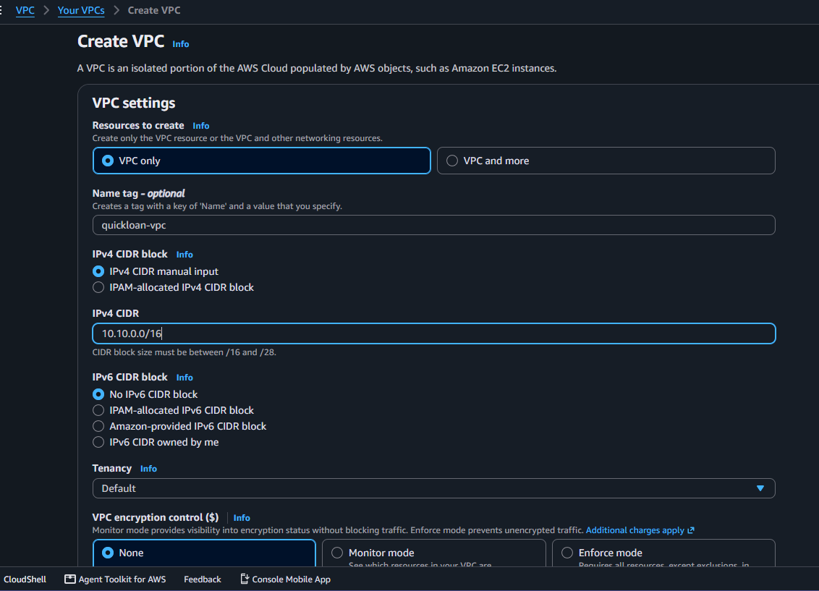
Creating the VPC with a custom IPv4 CIDR block
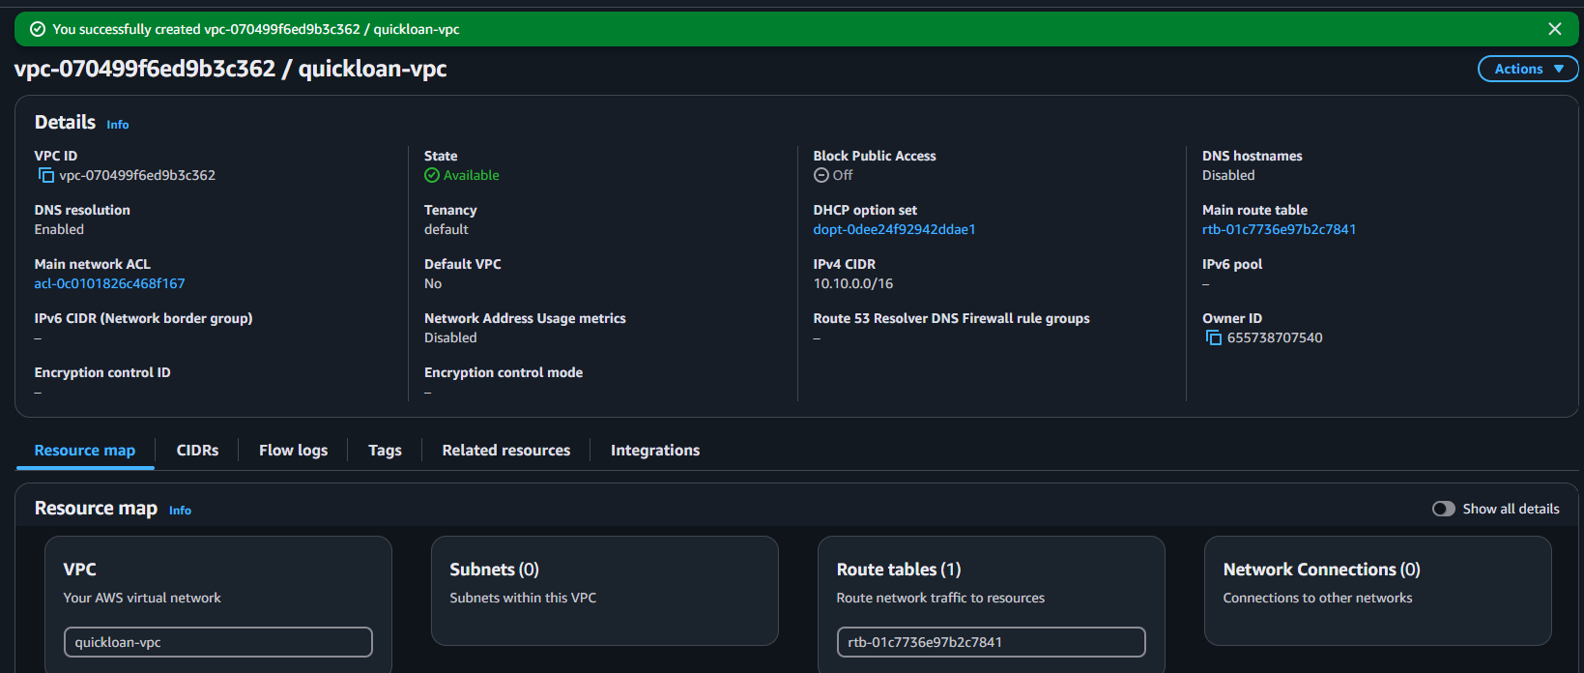
The VPC after creation, showing its resource map
Create four subnets inside the VPC:
Subnet Name | CIDR Block | Availability Zone | Type
public-subnet-1 | 10.10.1.0/24 | AZ-a | Public (jump-server)
public-subnet-2 | 10.10.2.0/24 | AZ-b | Public (app-server-1)
public-subnet-3 | 10.10.3.0/24 | AZ-c | Public (app-server-2)
private-subnet-4 | 10.10.4.0/24 | AZ-d | Private (database-server)
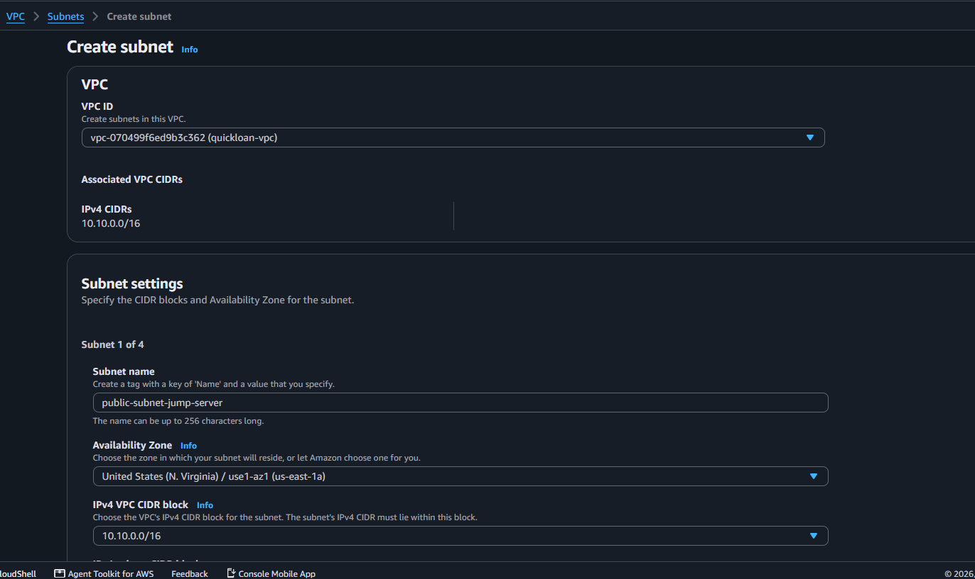
Creating a subnet within the VPC
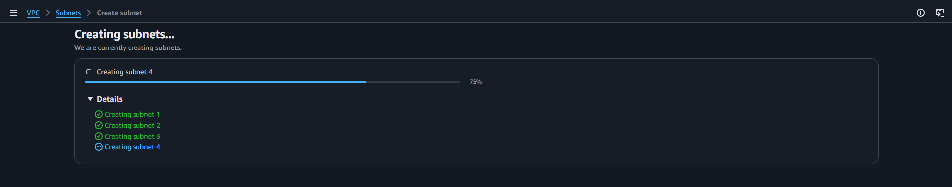
Subnet creation in progress
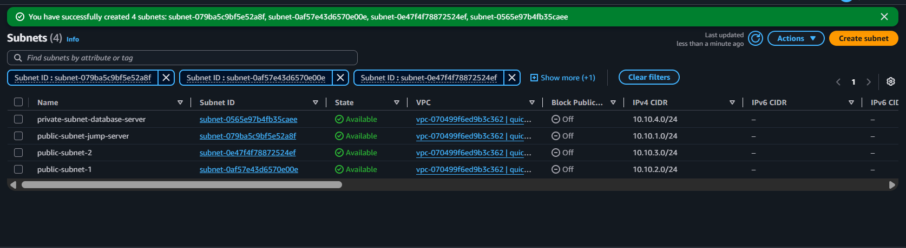
All four subnets created and listed
Create and attach an Internet Gateway (IGW) to the VPC:
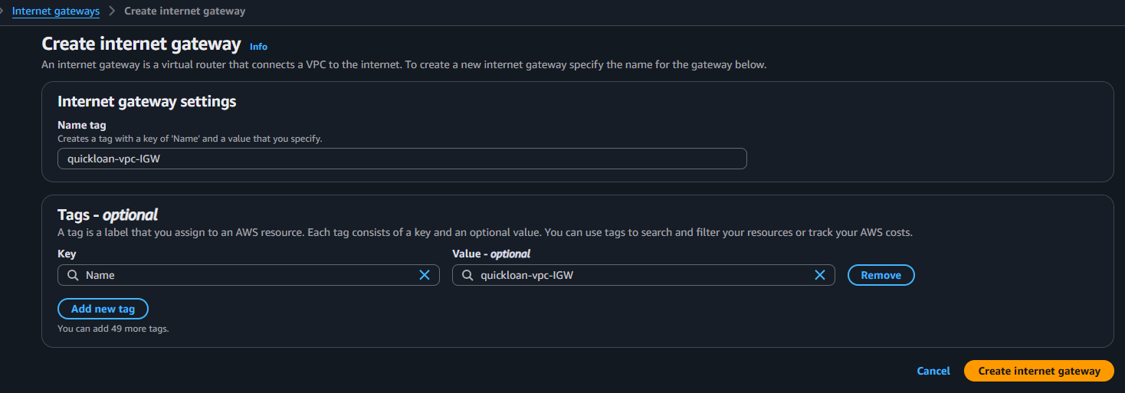
Creating the Internet Gateway
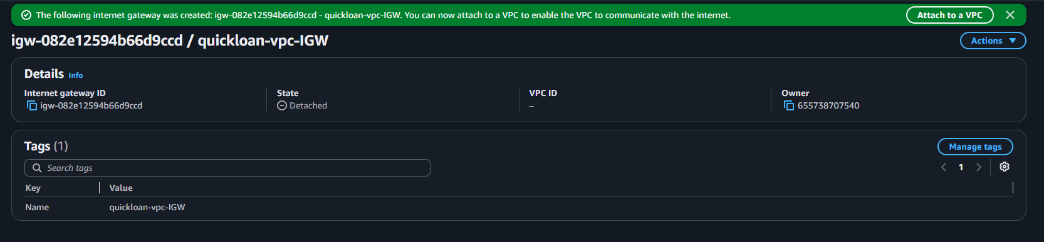
Internet Gateway created, not yet attached
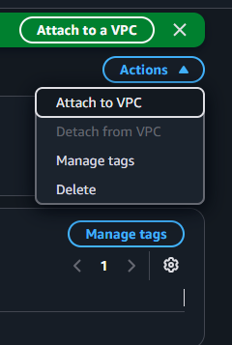
Selecting "Attach to VPC" from the Actions menu
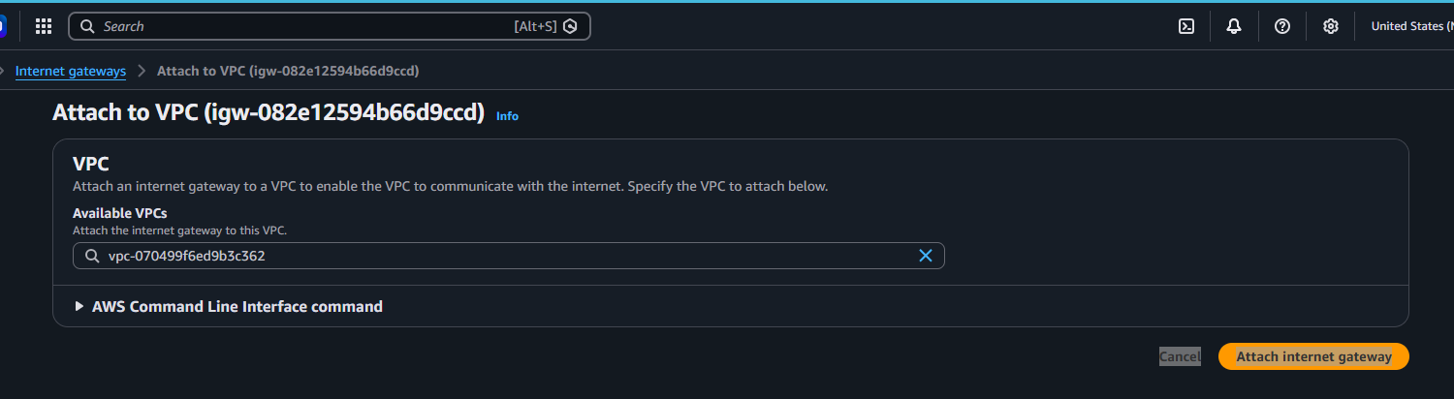
Attaching the Internet Gateway to the VPC
Create a public route table and associate it with the three public subnets:
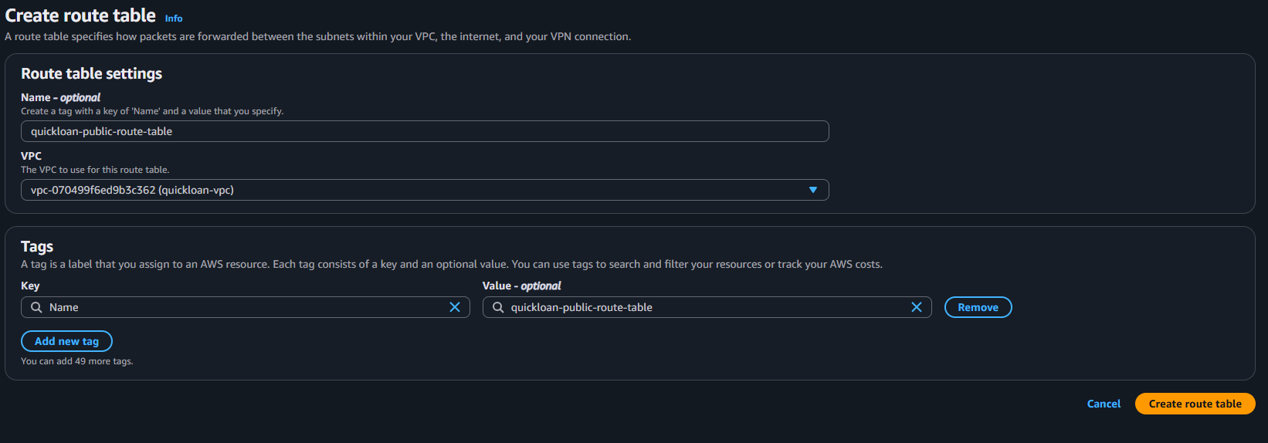
Creating the public route table
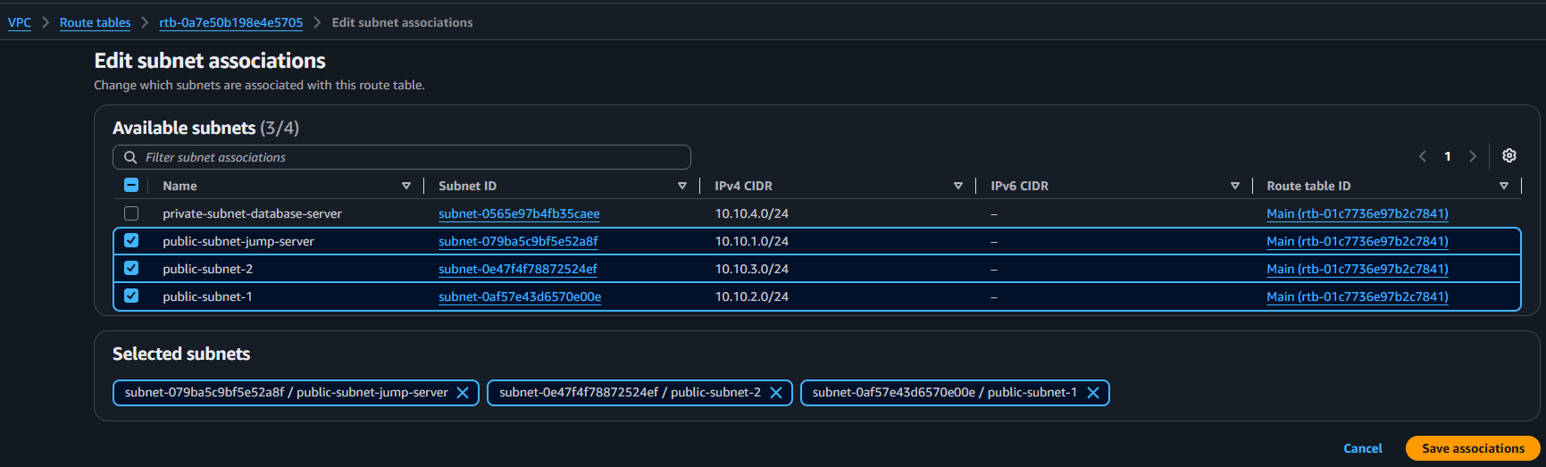
Associating the public subnets with the public route table
Leave the private subnet associated with a separate, private route table so the database has no direct route to the internet:
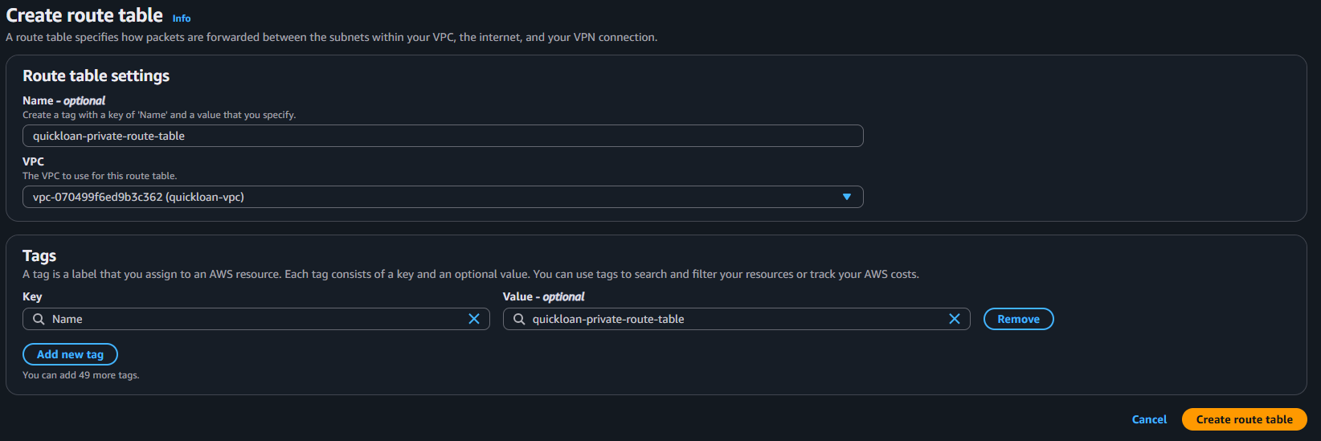
Creating the private route table
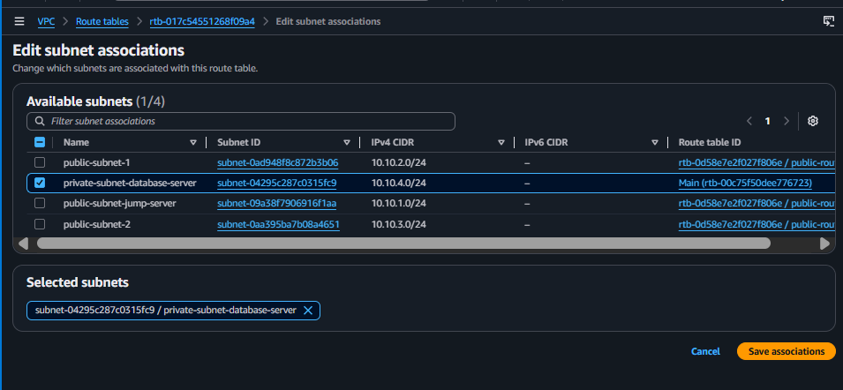
Associating the private subnet with the private route table
(Optional, for outbound package updates from the private subnet) Create a NAT Gateway in a public subnet:
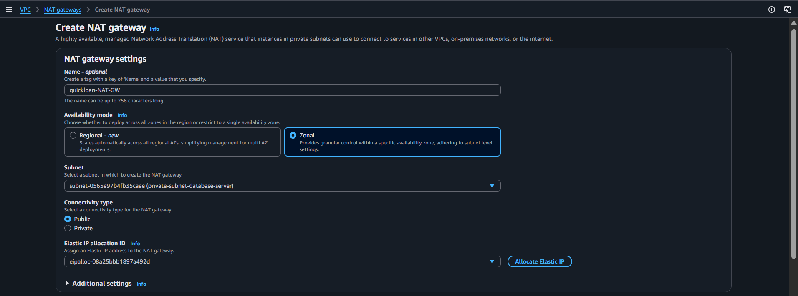
Creating a NAT Gateway
Finally, add the routes that make everything reachable — a 0.0.0.0/0 route to the Internet Gateway in the public route table, and a 0.0.0.0/0 route to the NAT Gateway in the private route table:
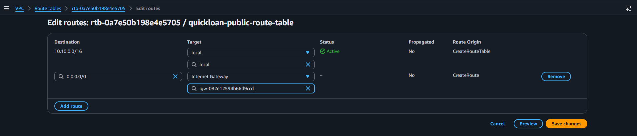
Public route table: 0.0.0.0/0 -> Internet Gateway
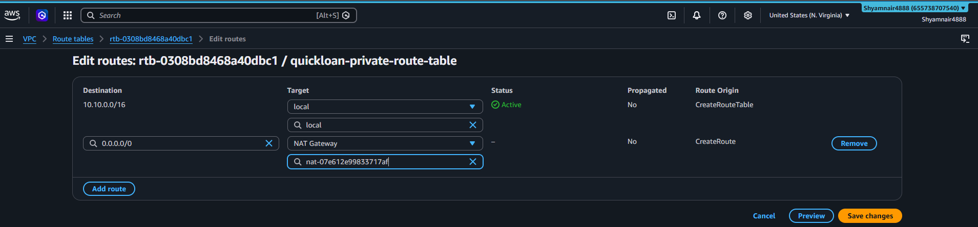
Private route table: 0.0.0.0/0 -> NAT Gateway

6.2 Create Security Groups
Two security groups isolate traffic by role, following the principle of least privilege.
Security Group | Inbound Rules | Attached To
web-sg | 22 (SSH) from admin IP/jump-server SG · 80 (HTTP) & 443 (HTTPS) from 0.0.0.0/0 | jump-server, app-server-1, app-server-2
db-sg | 3306 (MySQL) from web-sg only · 22 (SSH) from jump-server SG only | database-server (RDS)
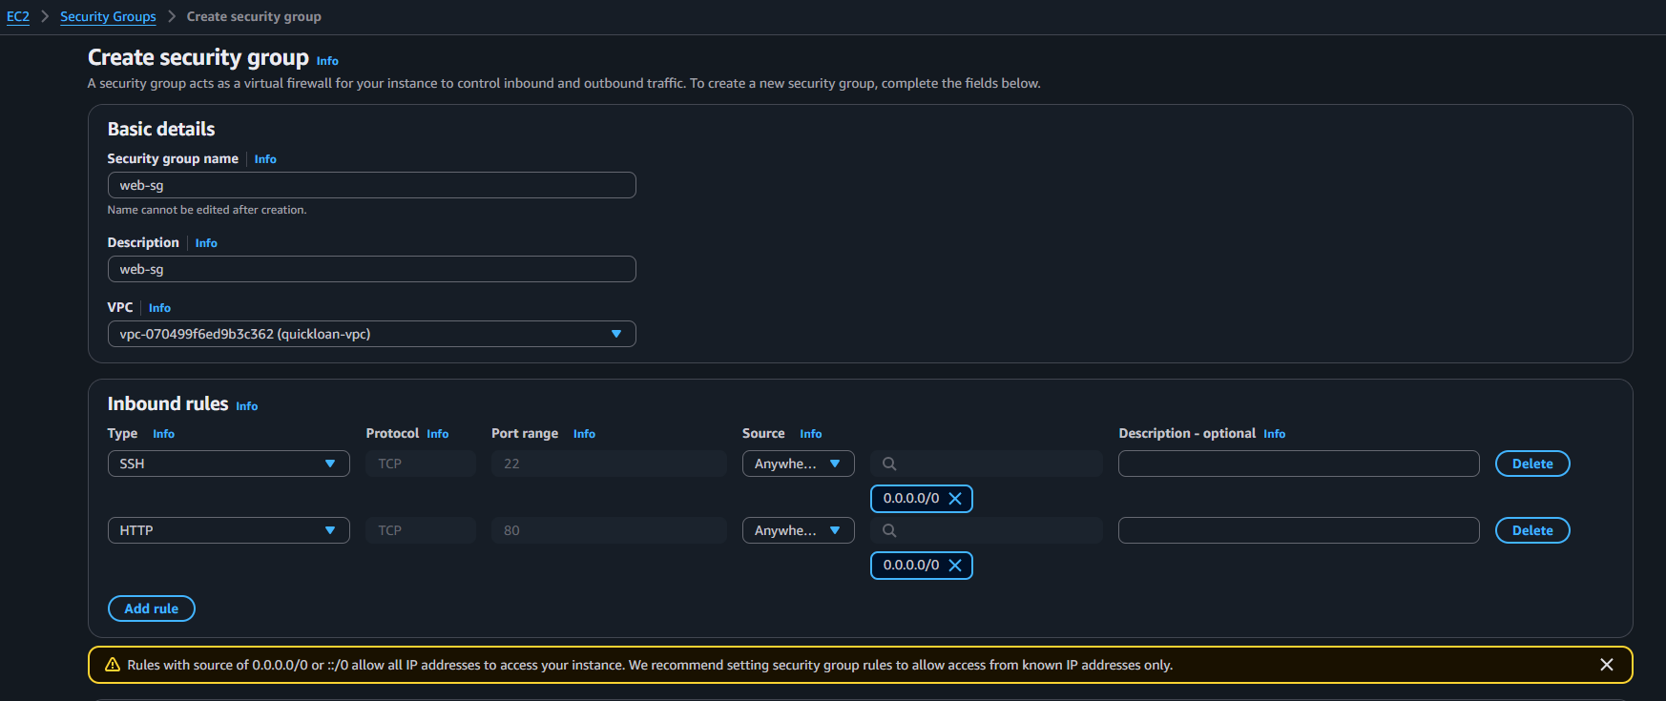
Creating web-sg with inbound rules for SSH/HTTP/HTTPS
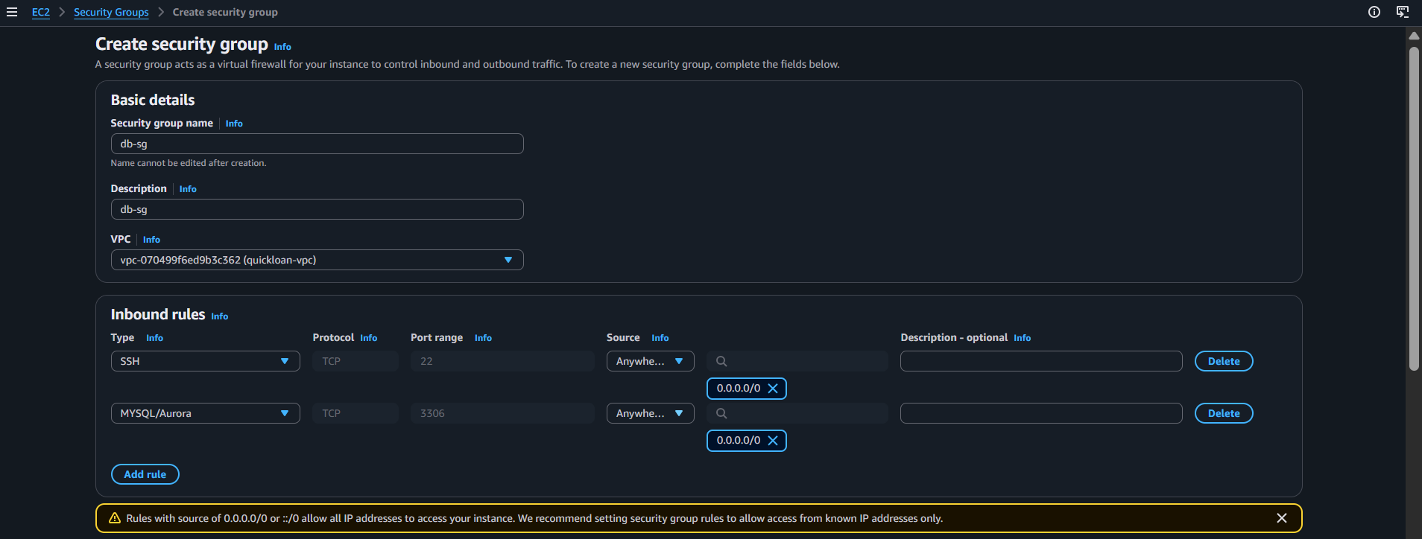
Creating db-sg, restricted to the web tier

6.3 Launch the EC2 Instances
Launch Amazon Linux EC2 instances, one per role, each in its designated subnet: jump-server (public-subnet-1), app-server (public-subnet-2), and, if not using RDS, a database-server (private-subnet-4).
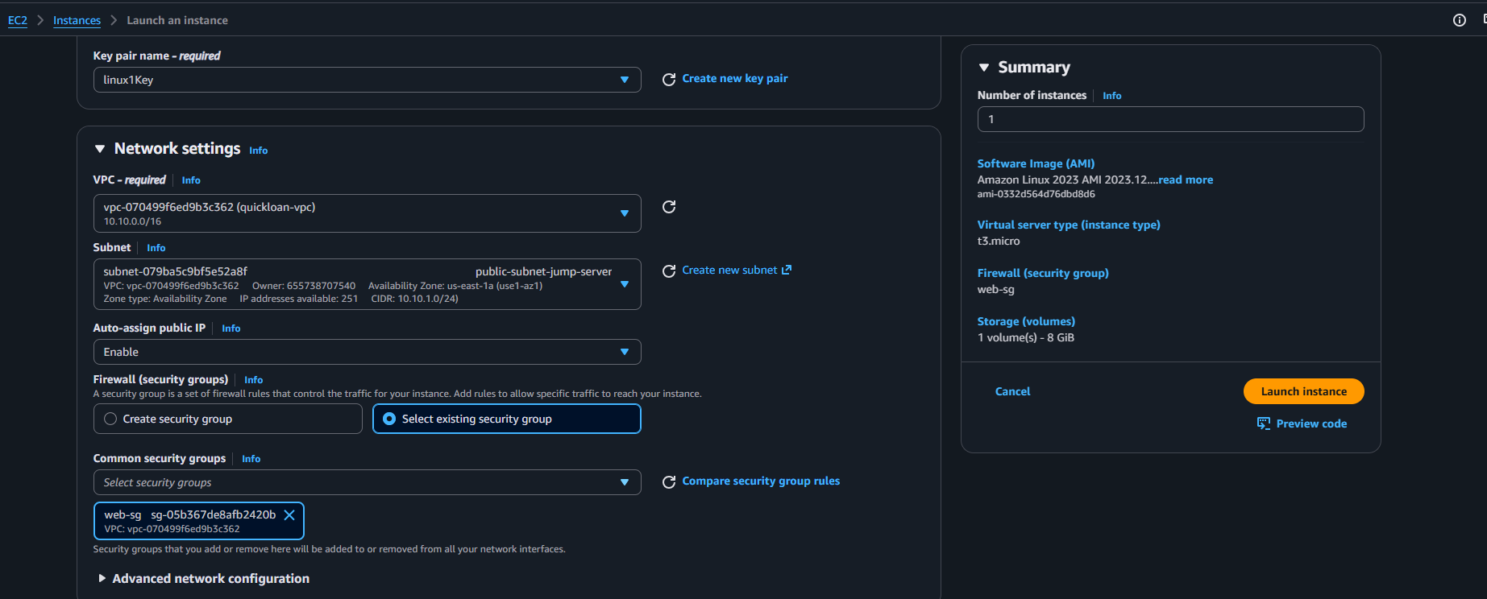
Network settings during instance launch
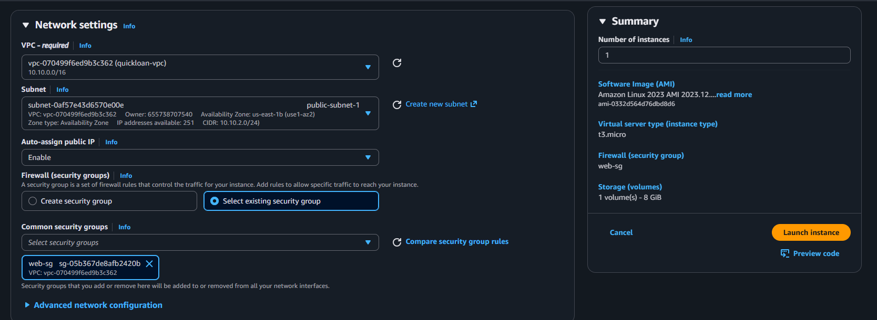
Launch summary before creating the instance
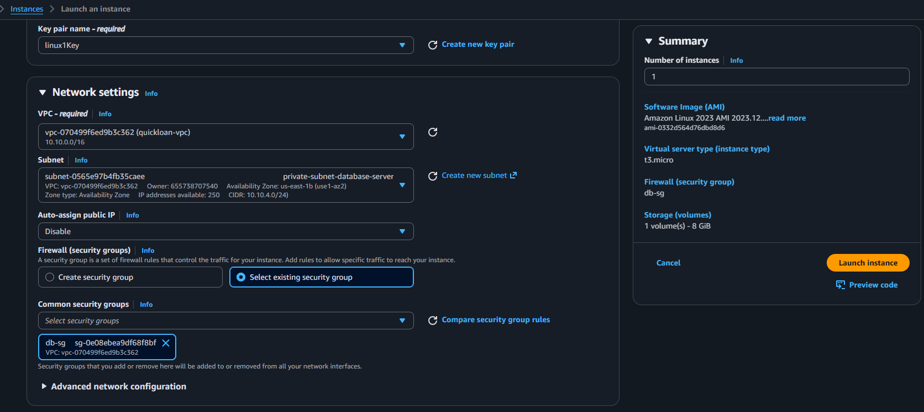
Key pair and network settings for a second instance
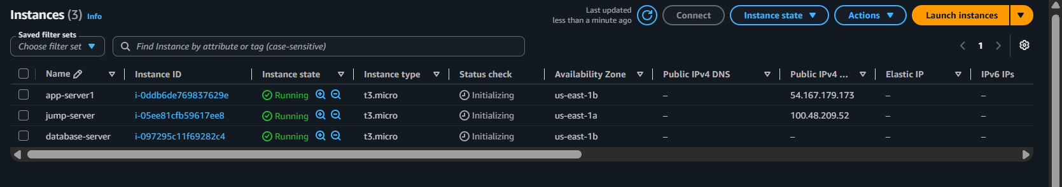
All instances shown Running in the EC2 console
Tip
Create and download a separate .pem key pair for each server role (e.g. jump-keypair.pem, app-keypair.pem) and store them safely — they cannot be re-downloaded once created.
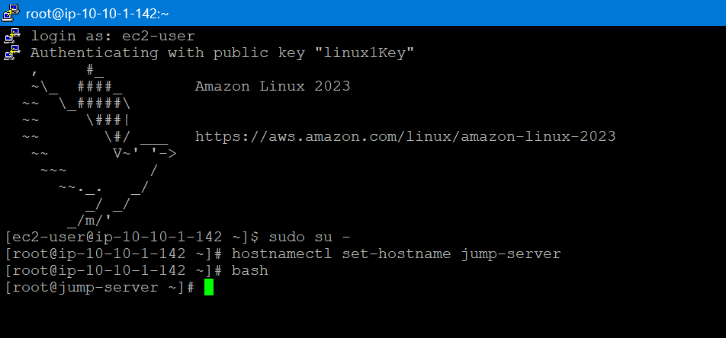
First SSH login to the jump-server and hostname setup

6.4 Connect All Servers via the Jump Server
Copy each server's private key onto the jump server so it can be used to hop to the app and database servers without exposing the keys to the public internet:
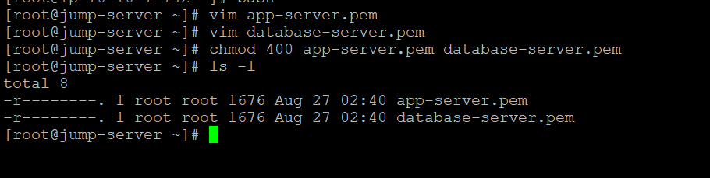
Copying key files onto the jump server and setting permissions
# On your local machine, copy the keys to the jump server
scp -i jump-keypair.pem app-server.pem ec2-user@<jump-server-public-ip>:~
scp -i jump-keypair.pem database-server.pem ec2-user@<jump-server-public-ip>:~

# On the jump server, lock down permissions
chmod 400 app-server.pem database-server.pem

6.5 Configure the Application Server (Nginx + PHP)
Connect to the app server via SSH through the jump server and install the web stack:
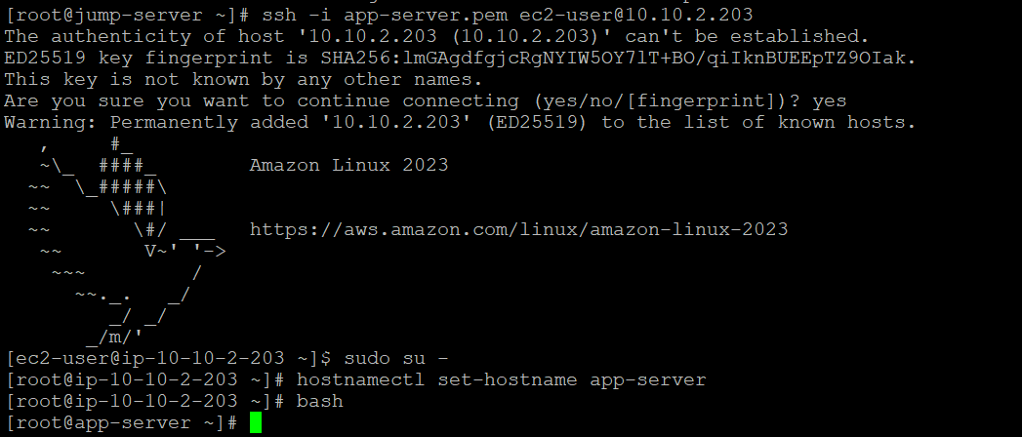
SSH-ing from the jump server into the app server
# From the jump server, hop into the app server
ssh -i app-server.pem ec2-user@10.10.2.203

# Update all OS packages
sudo yum update -y

# Install and start Nginx
sudo yum install -y nginx
sudo systemctl start nginx
sudo chkconfig nginx on

# Install PHP 8.2 and the extensions required by QuickLoan
sudo yum install -y php8.2 php-fpm php-mysqlnd php-pdo php-mbstring
sudo systemctl start php-fpm
sudo chkconfig php-fpm on
sudo systemctl restart nginx
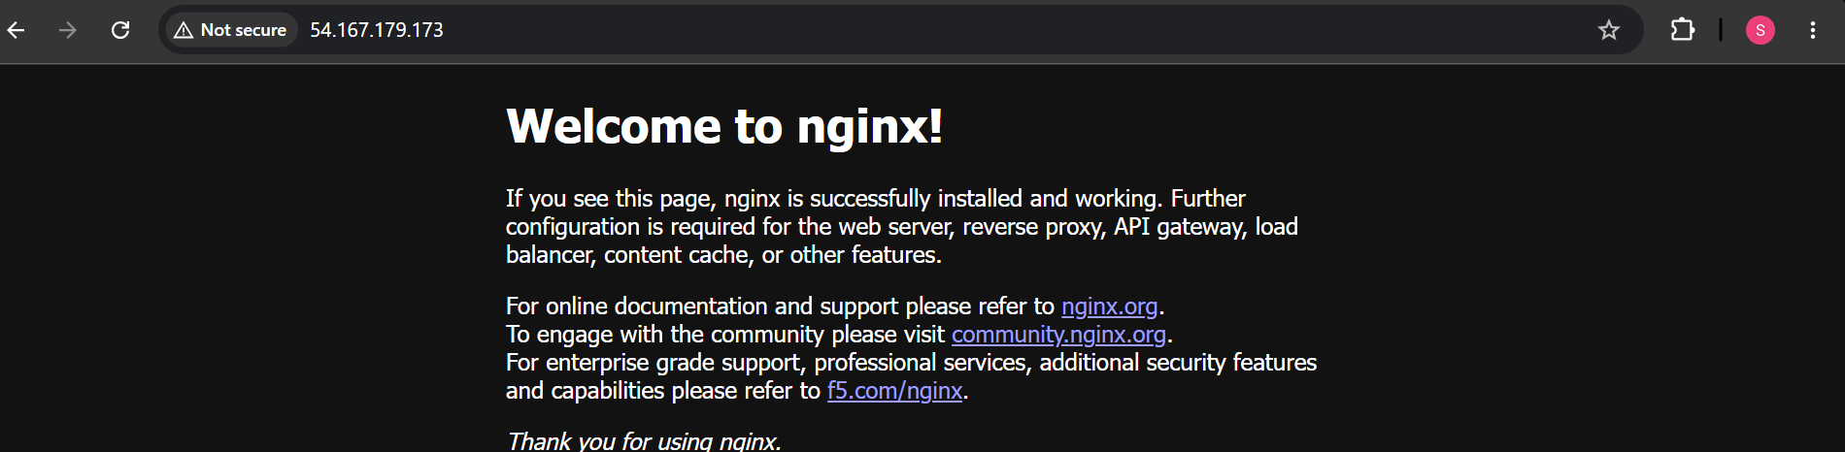
Default Nginx welcome page, confirming the web stack is healthy

6.6 Deploy the Application Code
Copy the includes, nginx and public folders from your local machine to the app server using WinSCP:
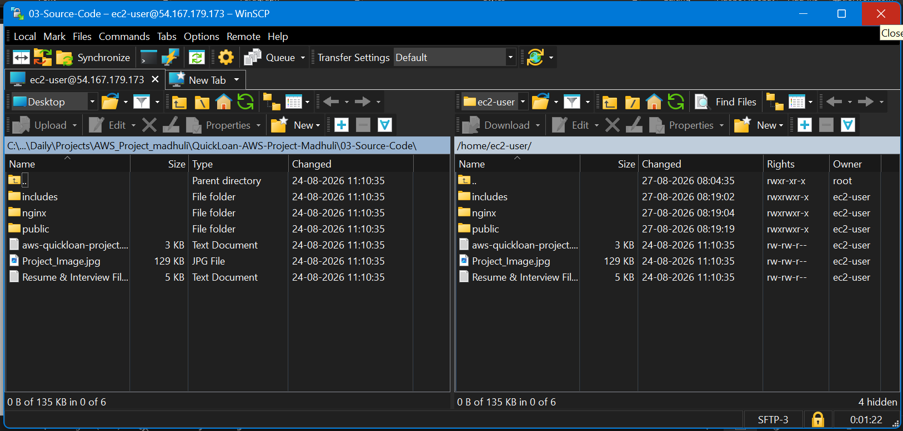
Uploading the application folders with WinSCP
# On the app server, move the uploaded folders into the Nginx web root
sudo mv /home/ec2-user/includes /usr/share/nginx/html
sudo mv /home/ec2-user/public /usr/share/nginx/html

# Set correct ownership and permissions so Nginx can read the files
sudo chown -R nginx:nginx /usr/share/nginx/html/public
sudo chmod -R 755 /usr/share/nginx/html/public
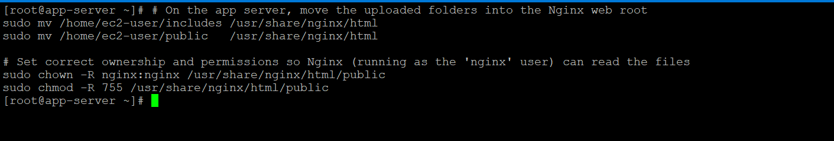
Moving files into the Nginx web root and fixing permissions

6.7 Create and Configure the Amazon S3 Bucket
- Open the S3 console and create a new bucket with a globally-unique name.
- Upload the entire images/ folder (found inside public/) to the bucket, preserving the folder structure.
- Configure the bucket (or the individual objects) with public-read access so images load correctly in visitors' browsers.
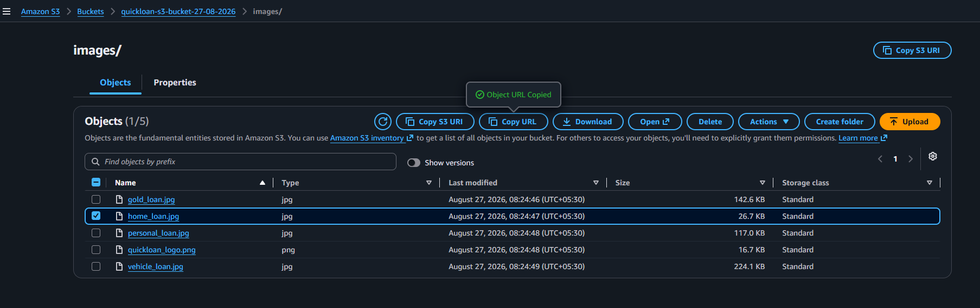
Loan category and logo images uploaded to the S3 bucket

6.8 Point the Application to the S3 Bucket
Update the image URL references in the application code to point at your S3 bucket:
vim /usr/share/nginx/html/public/index.html
:%s/<old-bucket-domain>/<your-bucket>.s3.<region>.amazonaws.com/g

vim /usr/share/nginx/html/public/apply.php
<img src="https://<your-bucket>.s3.<region>.amazonaws.com/images/quickloan_logo.png" alt="QuickLoan Logo">
Updated logo URL pointing at the S3 bucket

6.9 Set Up the Database (Amazon RDS)
This deployment uses Amazon RDS for a fully managed MySQL database rather than a self-hosted database server.
- Open the RDS console and create a new database.
- Choose the MySQL engine, set a master username and a strong password, and select an instance size appropriate for the workload.
- Place the RDS instance in the private subnet group and attach db-sg so only the app tier can reach it.
- Wait 3–5 minutes for the instance to finish provisioning, then copy its endpoint from the RDS console.
From the jump server (or the app server), connect to the RDS endpoint and create the schema:
mysql -h <rds-endpoint> -u admin -p

CREATE DATABASE quickloan_db;
USE quickloan_db;

CREATE TABLE applications (
id INT AUTO_INCREMENT PRIMARY KEY,
name VARCHAR(255) NOT NULL,
contact VARCHAR(20) NOT NULL,
email VARCHAR(255) NOT NULL,
loan_type VARCHAR(50) NOT NULL
);

6.10 Connect the Application Server to the Database
On the app server, update the database credentials so the PHP application can reach the RDS endpoint:
cd /usr/share/nginx/html/includes
vim db_connect.php

$servername = "<rds-endpoint>";
$username = "admin";
$password = "<your-rds-password>";
Security Reminder
Never commit real database credentials to source control. In a production environment, store them in AWS Secrets Manager or as environment variables instead of hard-coding them in db_connect.php.

6.11 Configure a Custom Domain Name
- Register or use an existing domain with any domain registrar.
- Update the domain's nameservers or DNS records to point at your AWS resources — either directly at the app server's public IP with an A record, or by delegating to a Route 53 hosted zone for more control.
- Verify propagation by pinging the new domain name and confirming it resolves to the correct IP address.
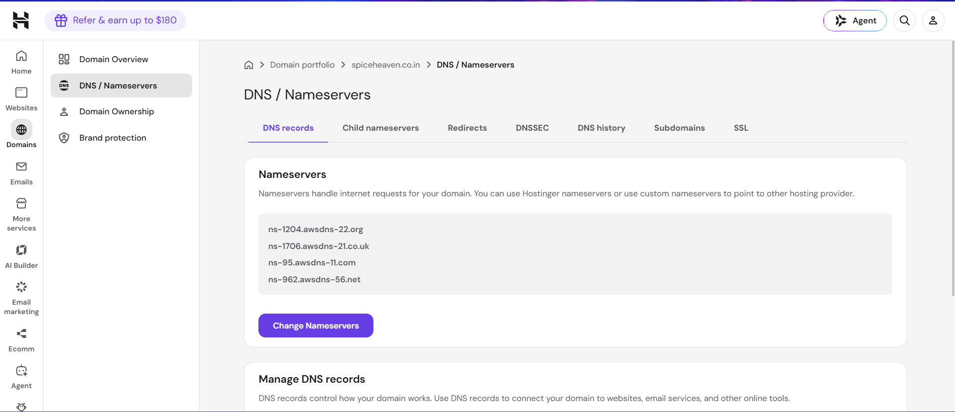
Managing DNS / nameserver records at the domain registrar

6.12 Configure the Nginx Server Block for the Domain
Edit the quickloan.conf server block so Nginx recognises requests for your domain, then activate it:
vim /home/ec2-user/nginx/quickloan.conf
server_name yourdomain.example; # replace with your domain

sudo mv /home/ec2-user/nginx/quickloan.conf /etc/nginx/conf.d/
sudo nginx -t
sudo systemctl restart nginx

6.13 Final End-to-End Testing
- Browse to the custom domain and confirm the QuickLoan homepage loads with all images served from S3.
- Click through to the application form and confirm the QuickLoan logo loads correctly.
- Submit a test loan application and confirm it redirects back to the homepage without errors.
- Connect to the RDS database and confirm the submitted record was saved.
- Test from a second device / network to confirm the site is reachable publicly.
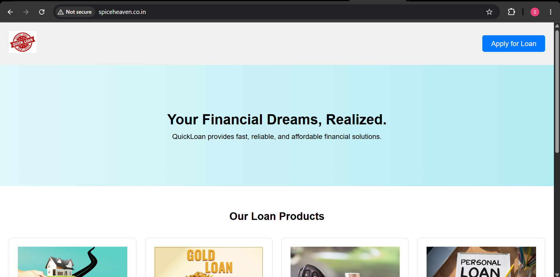
Live QuickLoan homepage on the deployed domain

Loan categories and About section rendering with S3-hosted images
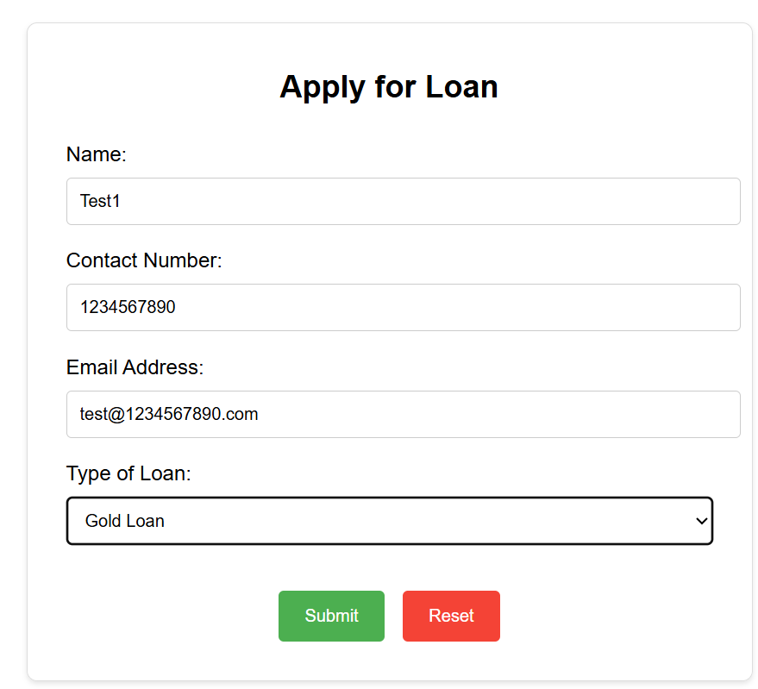
The loan application form
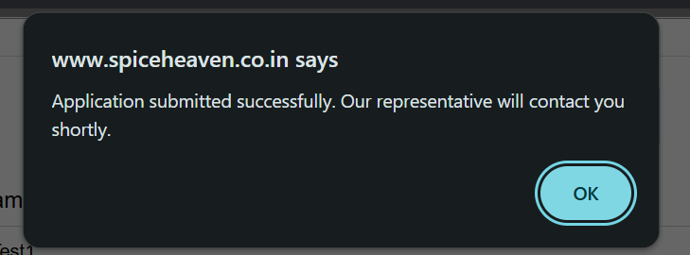
Successful submission confirmation
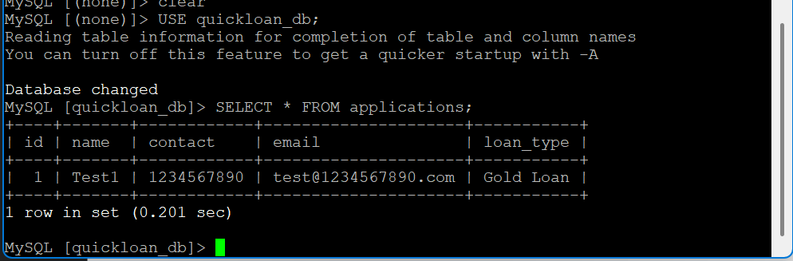
The submitted application confirmed inside the RDS database

7. Production Scaling: AMI, Auto Scaling, Load Balancer & Monitoring
Once the single-server deployment above is verified, the same architecture can be made highly available and elastic using AWS's scaling and monitoring services. This section covers the full production setup, including the CloudWatch alarms and SNS notifications used to actually operate it.

7.1 Create an AMI (Amazon Machine Image)
After the app server is fully configured and tested (Nginx, PHP, application code, S3 URLs), create an AMI from that instance. This AMI becomes a reusable, ready-to-run snapshot of a fully configured QuickLoan web server.
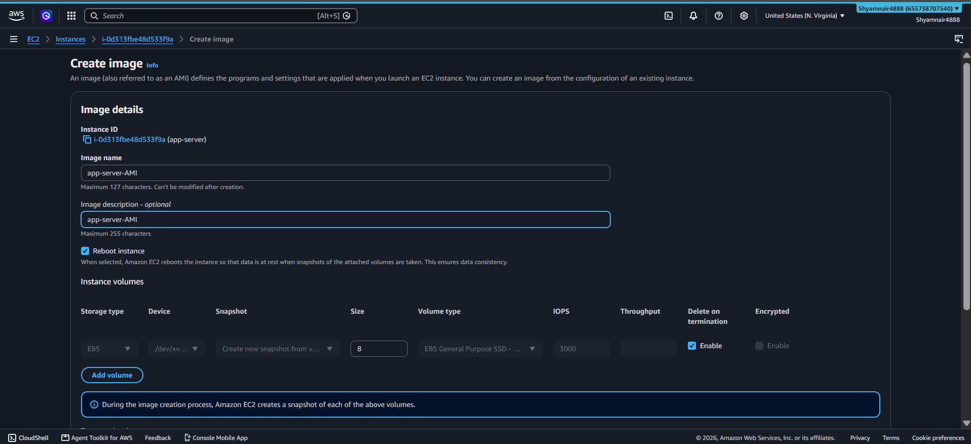
Creating an AMI from the validated app server
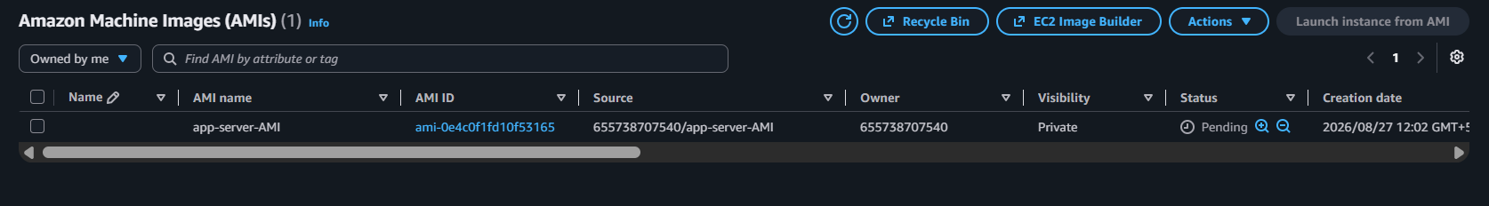
The AMI available in the AMI console

7.2 Create a Launch Template and Auto Scaling Group
Create a Launch Template that uses the AMI captured above, the web-sg security group, and the correct key pair:
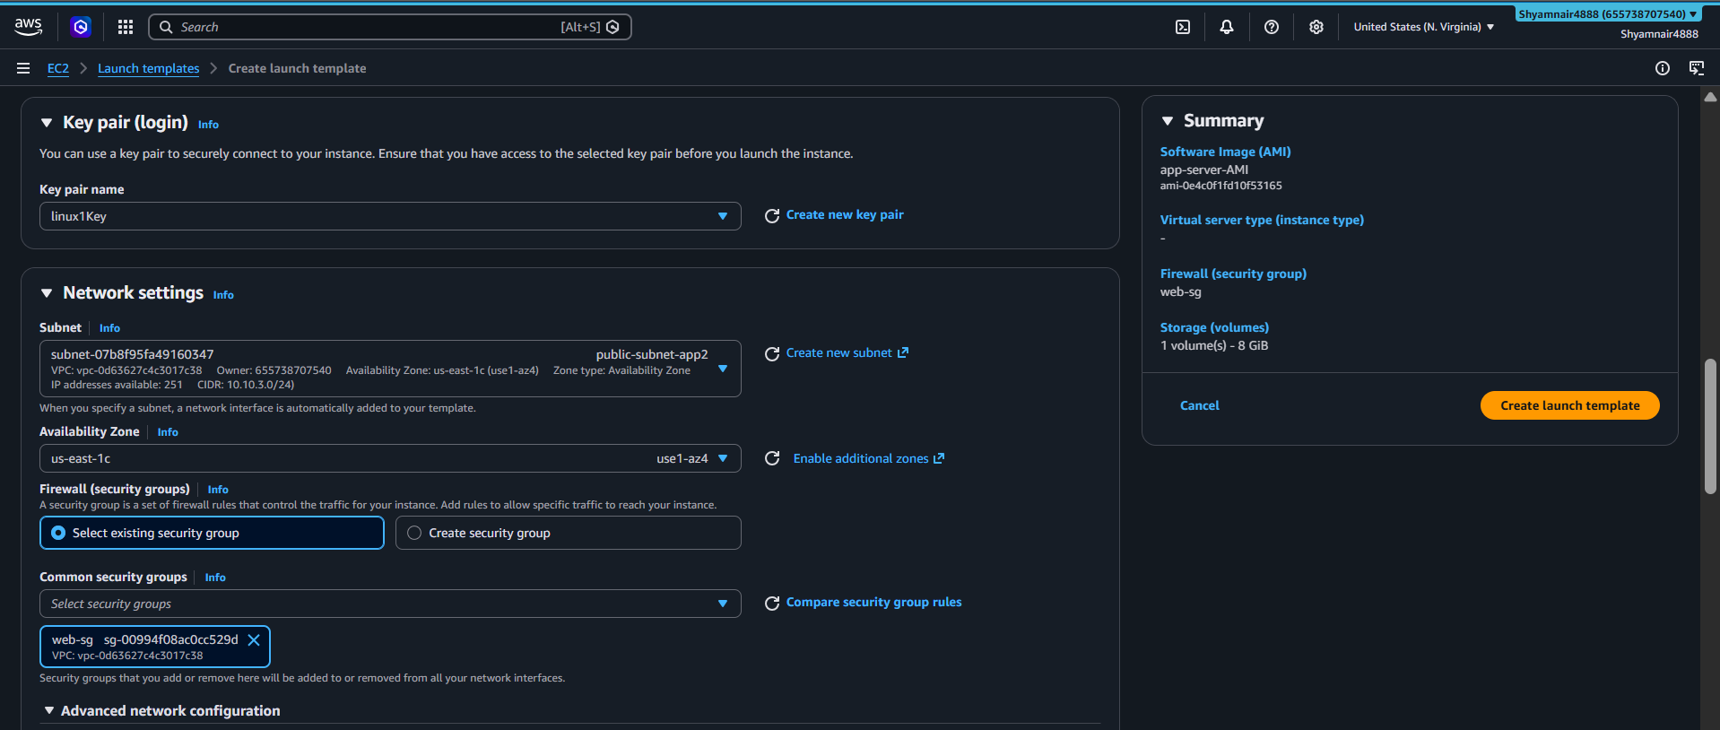
Launch Template: key pair and network settings
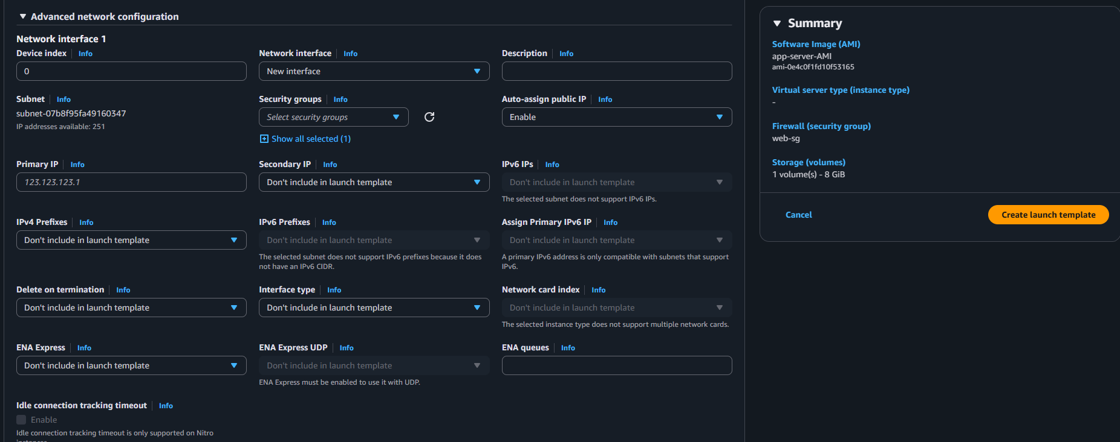
Launch Template: advanced network configuration
Create an Auto Scaling Group (ASG) across the public application subnets, using the Launch Template, with a scaling policy based on average CPU utilization:
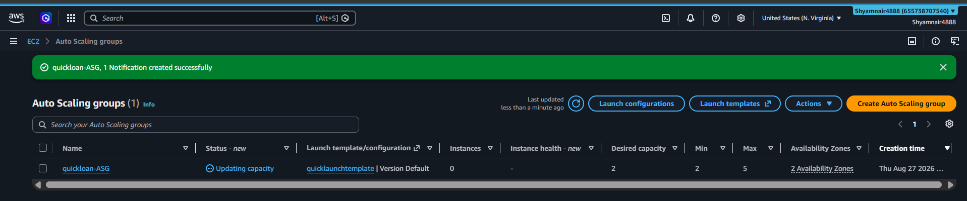
Creating the Auto Scaling Group
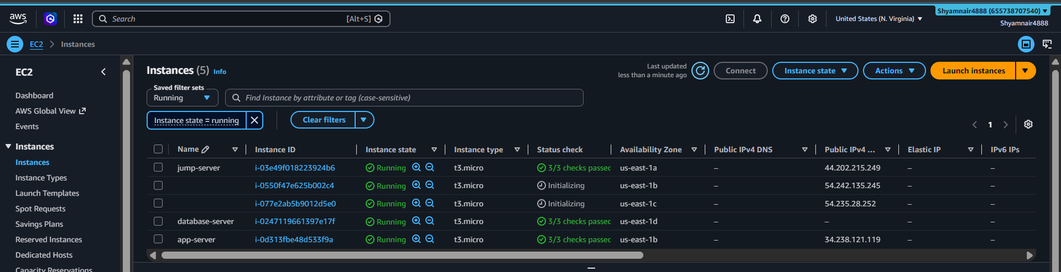
ASG-managed instances appearing in the EC2 console
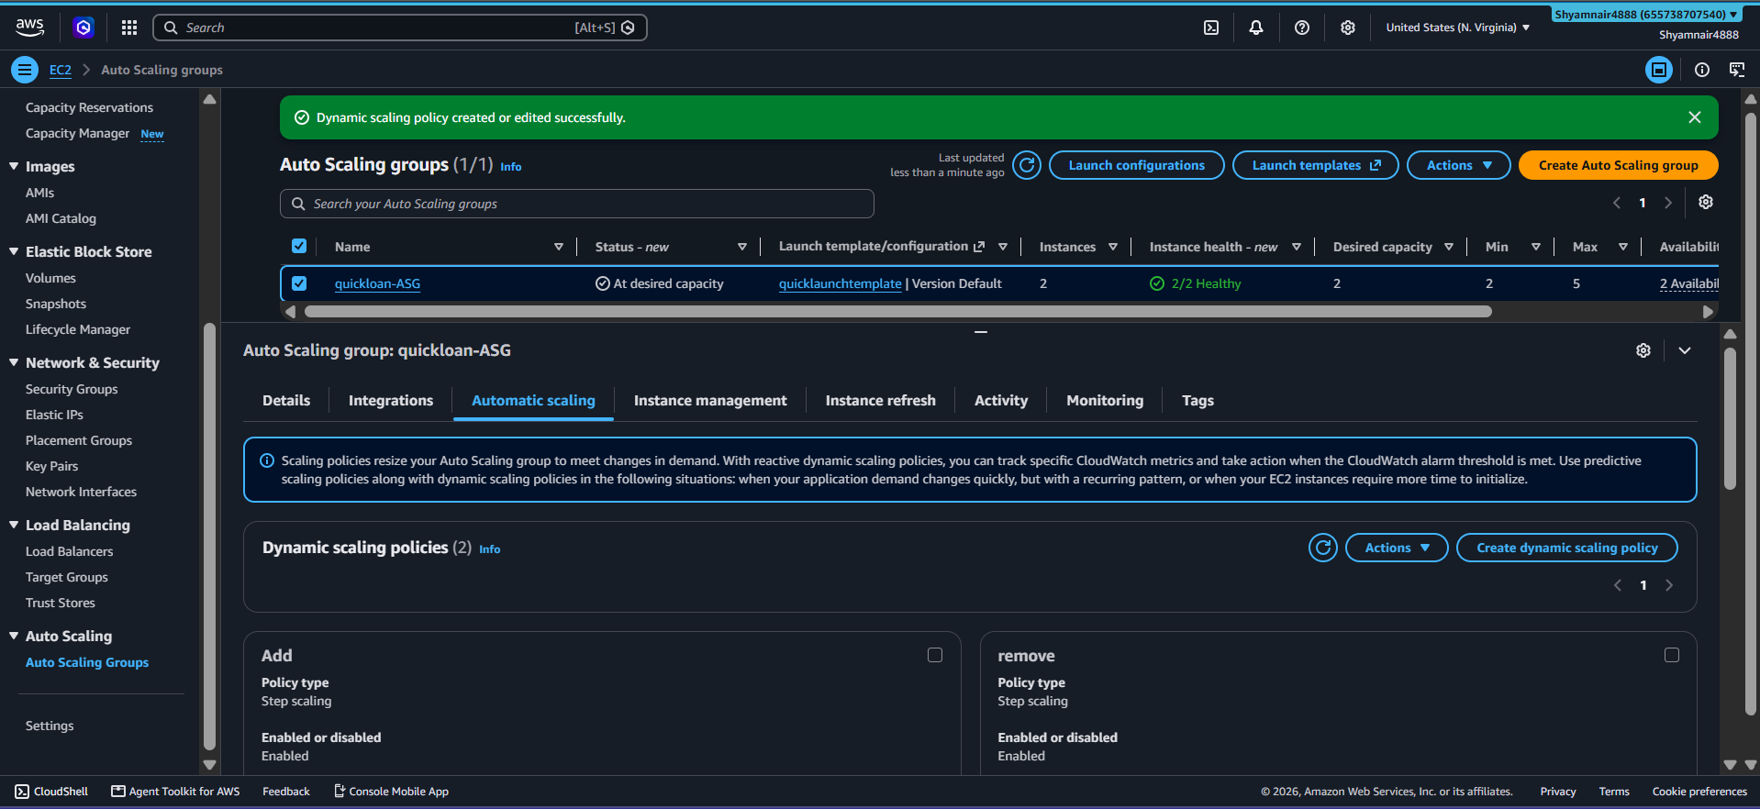
Auto Scaling Group dynamic scaling policies

7.3 Attach an Application Load Balancer
- Create a target group in the project VPC and register the existing app-server instance(s).
- Create an Application Load Balancer (ALB) spanning the public subnets, listening on port 80.
- Configure the listener to forward traffic to the target group, and review the default action.
- Register the target group with the Auto Scaling Group so new instances are added to the load balancer automatically.
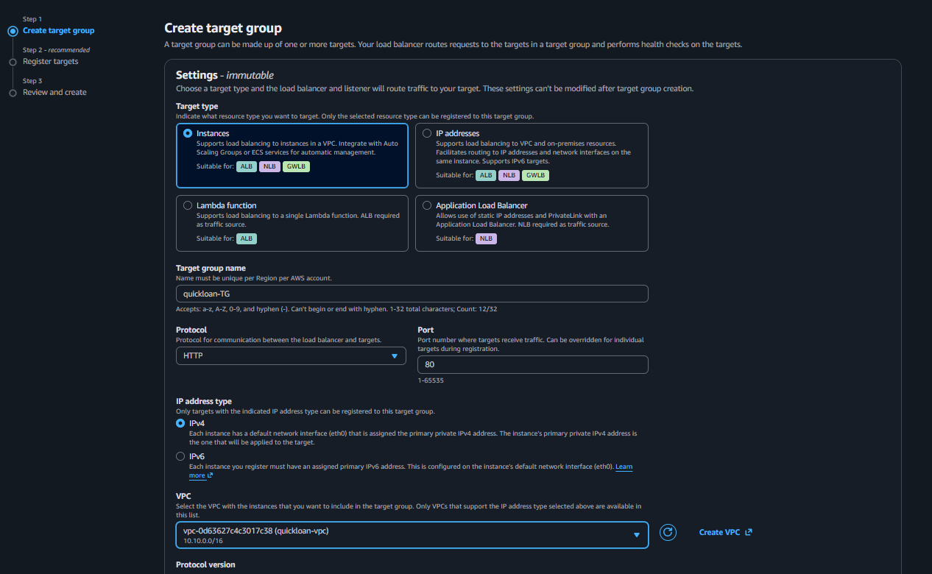
Creating the target group
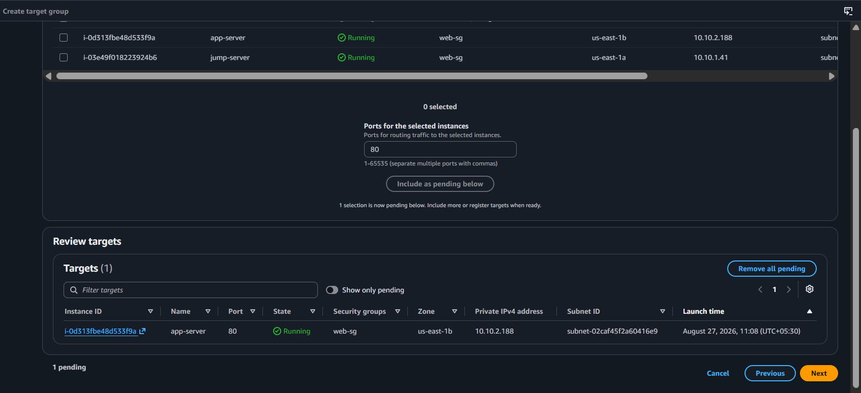
Reviewing registered targets before creation
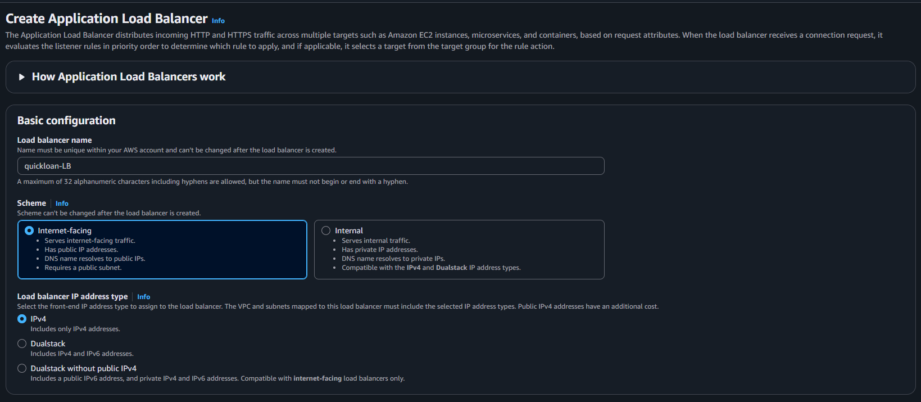
Application Load Balancer basic configuration
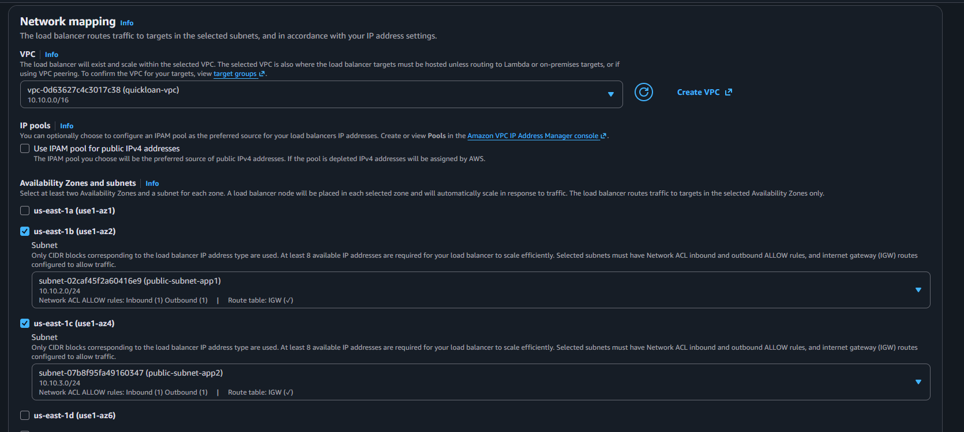
Mapping the ALB to public subnets across Availability Zones
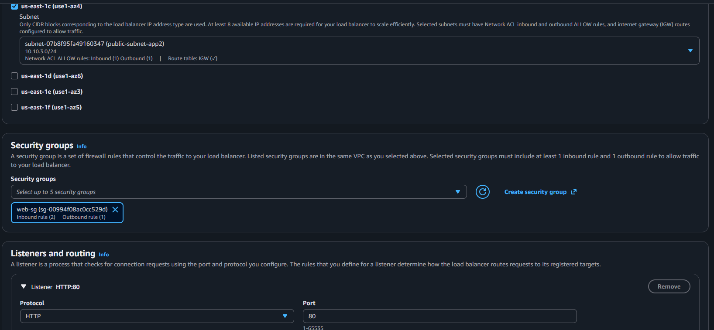
Security groups and listener/routing configuration
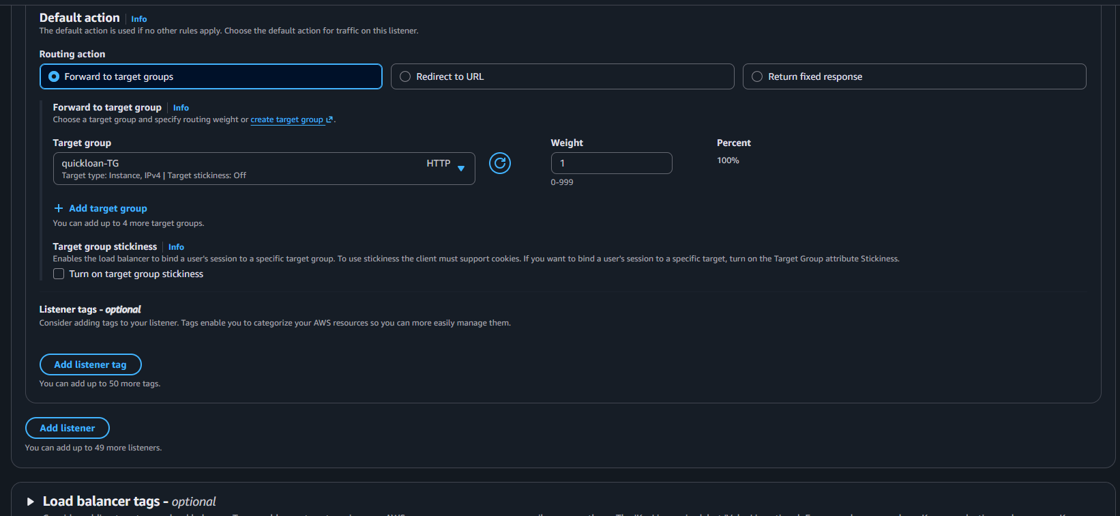
Listener default action forwarding to the target group
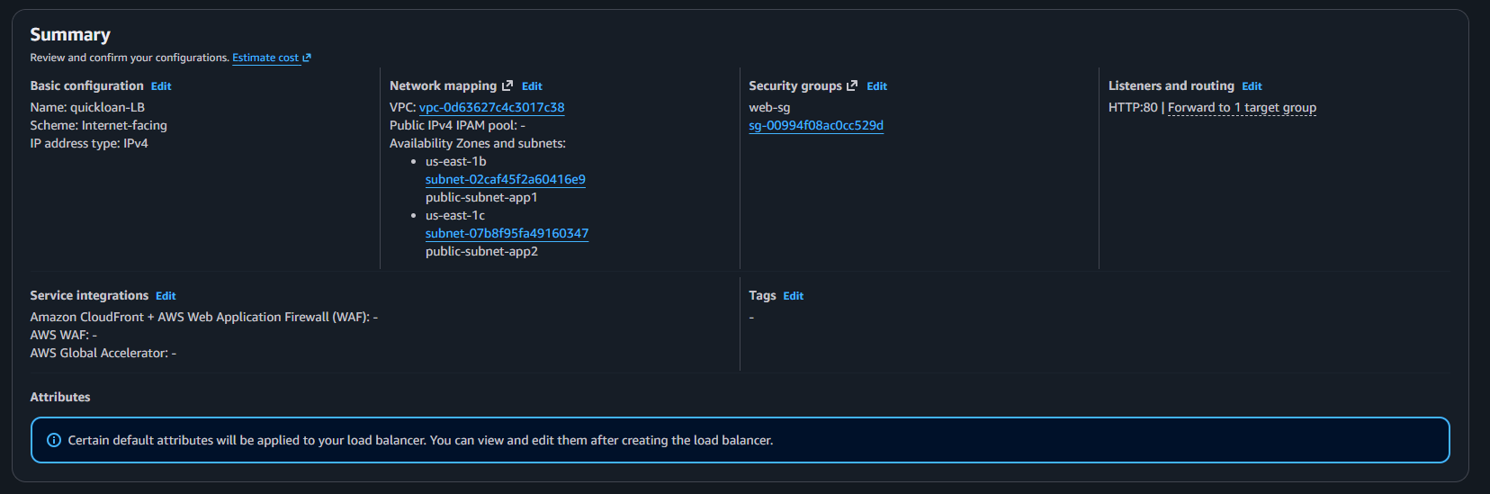
Final review before creating the Load Balancer
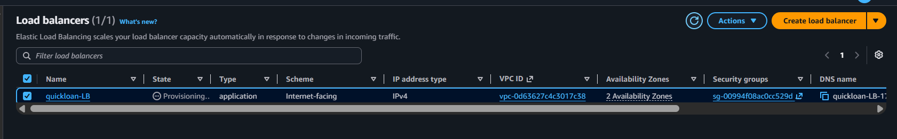
The Load Balancer showing state: Active
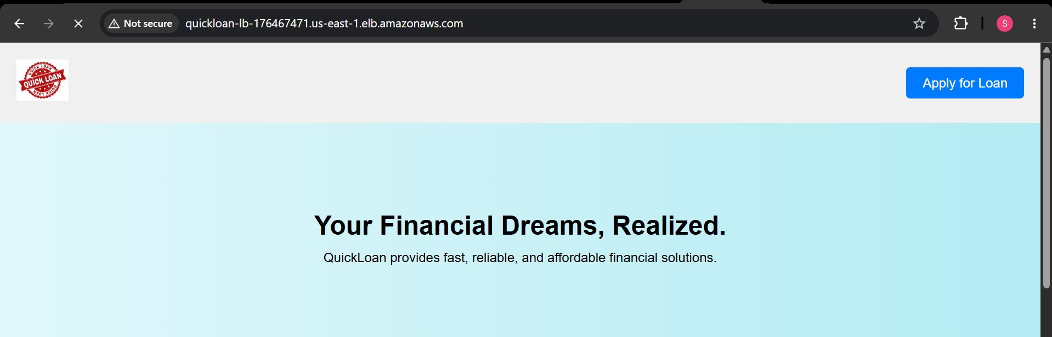
QuickLoan reachable via the Load Balancer's DNS name

7.4 Set Up SNS Notifications
Before wiring up CloudWatch alarms, create an SNS topic so the team is notified by email whenever the Auto Scaling Group scales, or an alarm changes state.
- Open the SNS console and create a new Standard topic (e.g. quickloan-asg-alerts).
- Create a subscription on that topic with protocol Email, and enter the team's notification address.
- Check the inbox and confirm the subscription using the link AWS emails automatically.
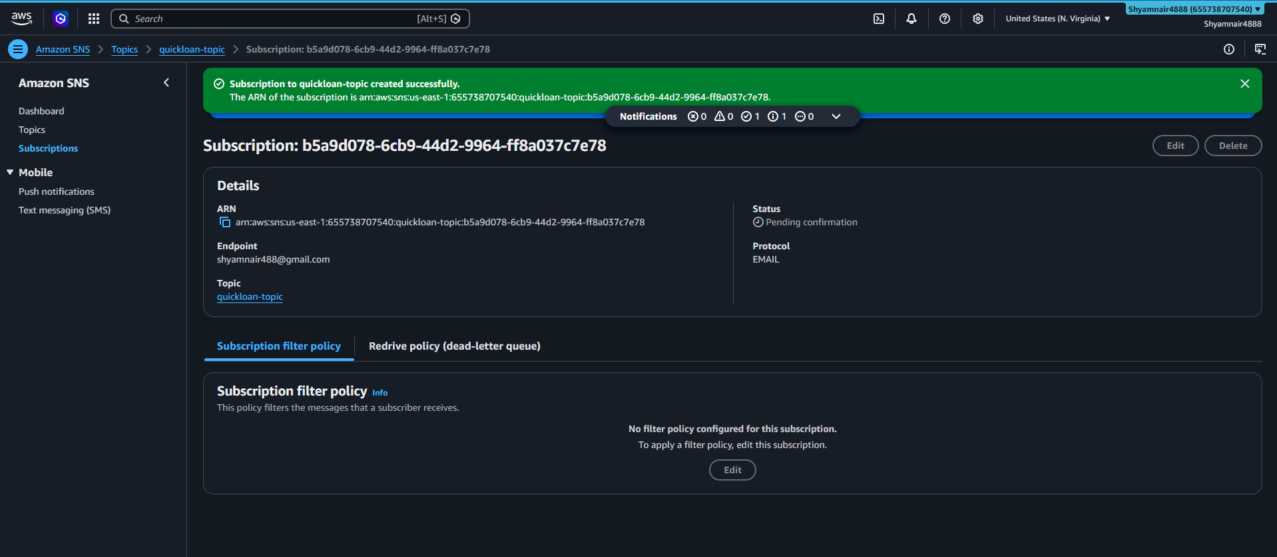
Email subscription confirmed successfully
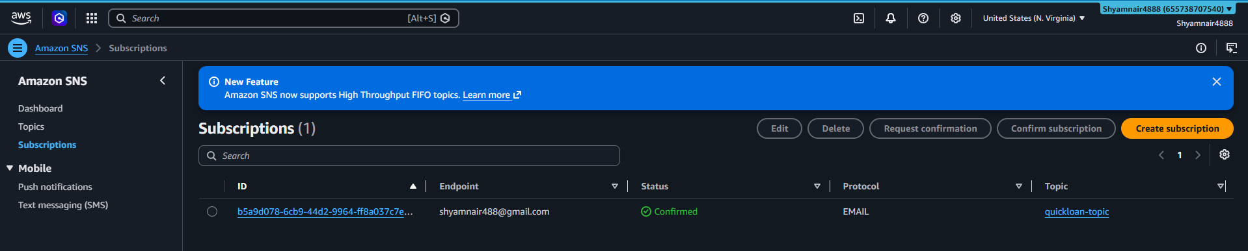
The SNS topic with its confirmed subscription
Why This Matters
Without a confirmed SNS subscription, CloudWatch alarms can still fire and drive scaling — but nobody is told when it happens. Confirming the subscription is what turns a silent alarm into an actionable email alert.

7.5 Set Up CloudWatch Alarms & Scaling Policies
With the SNS topic ready, create CloudWatch alarms tied to the Auto Scaling Group's average CPU utilization, and connect the ASG's dynamic scaling policy to react automatically:
- In the Auto Scaling Group's Automatic scaling tab, create a target tracking (or step) scaling policy: scale OUT (add an instance) when average CPU exceeds 80%, and scale IN (remove an instance) when average CPU drops below 20%.
- This automatically provisions two CloudWatch alarms behind the scenes — a high-CPU alarm and a low-CPU alarm.
- Open the CloudWatch console -> Alarms, and attach the SNS topic created in Section 7.4 to both alarms so an email fires on every state change (OK -> In Alarm and back).
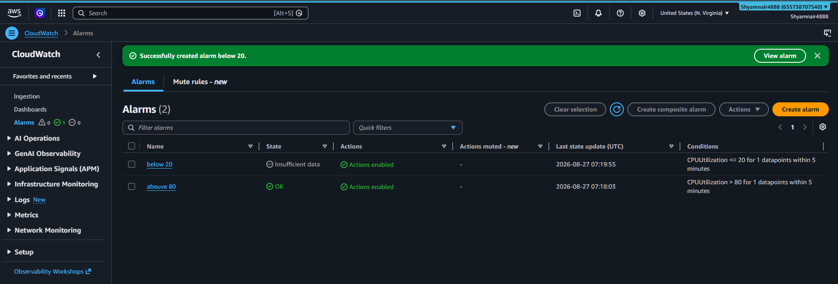
The two CloudWatch alarms created for the Auto Scaling Group
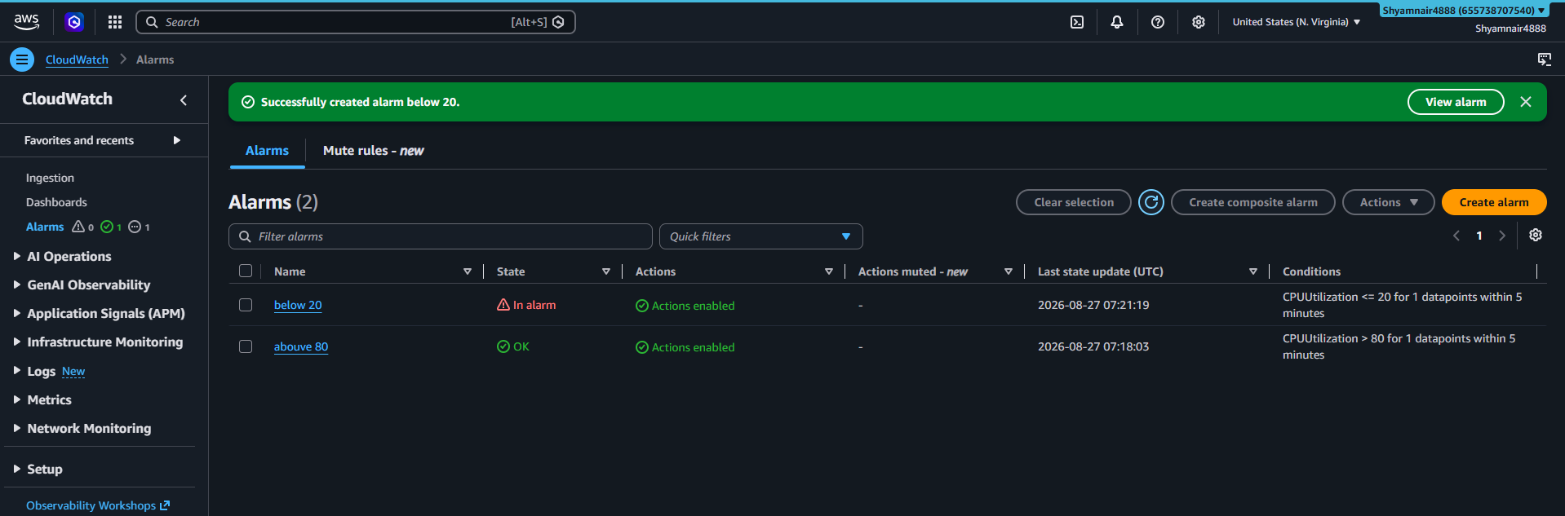
An alarm transitioning into the "In alarm" state during a load test

7.6 Test the Auto Scaling Group
An Auto Scaling Group is only proven once it has actually scaled under load. This is how the setup above was verified end to end:
- SSH into one of the running app-server instances (through the jump server).
- Generate synthetic CPU load to push utilization above the scale-out threshold, e.g. using the stress-ng tool:
sudo amazon-linux-extras install epel -y
sudo yum install -y stress-ng

# Load all CPU cores for 10 minutes — long enough for CloudWatch to evaluate the alarm
stress-ng --cpu $(nproc) --timeout 600s
- Watch the CloudWatch alarm move from OK to In alarm (typically within a few minutes, depending on the alarm's evaluation period).
- Confirm an SNS email notification arrives the moment the alarm state changes.
- Watch the Auto Scaling Group's Activity tab — a new instance should launch automatically from the AMI/Launch Template.
- Confirm the new instance registers as healthy in the ALB target group and starts receiving traffic.
- Stop the stress-ng load and confirm CPU utilization drops; after the cooldown period, the low-CPU alarm should fire, another SNS email should arrive, and the ASG should terminate the extra instance to scale back in.
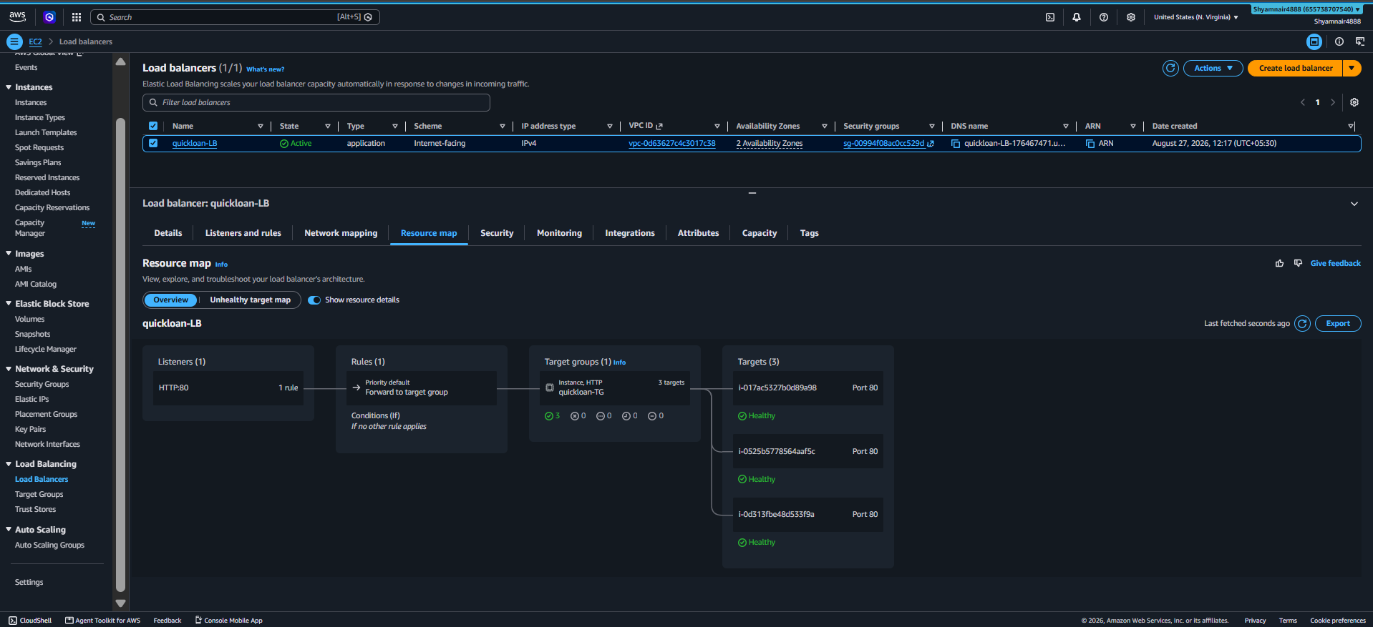
Auto Scaling Group activity history showing a scale-out event
Verified Result
This confirms the full loop works end-to-end: CloudWatch detects load -> the scaling policy launches a new instance from the AMI -> the ALB starts routing traffic to it -> SNS emails the team at every step -> and the ASG safely scales back in once load subsides.

8. Security Best Practices Applied
- Database placed in a private subnet (or an RDS instance with no public accessibility) with no direct route to the internet.
- Security Groups scoped per role — the database only accepts connections from the web tier, not from the whole internet.
- A single jump host is the only entry point for SSH administration, reducing the exposed attack surface.
- Separate key pairs per server role, so a compromised key cannot be used to access every server.
- File permissions on the web root restricted to what Nginx needs (755) and owned by the nginx service user.
- Database credentials isolated in a single include file — recommended migration path is AWS Secrets Manager for production use.
- CloudWatch + SNS provide visibility into scaling events instead of silent, unmonitored infrastructure changes.

9. Project Folder Structure
QuickLoan-AWS-Project-ShyamNair/
├── 01-Documentation/
│ └── QuickLoan_AWS_Project_Documentation.docx (this document)
├── 02-Presentation/
│ └── QuickLoan_AWS_Project_Presentation.pptx
├── 03-Source-Code/
│ ├── includes/db_connect.php
│ ├── nginx/quickloan.conf
│ └── public/ (index.html, apply.php, submit_application.php, styles.css, images/)
├── 04-Architecture-Diagram/
│ ├── quickloan_workflow.png (NEW — numbered service workflow)
│ └── network-architecture-diagram.png
├── 05-Screenshots/ (58 real screenshots, organized by stage)
│ ├── 01-VPC-Networking/ … 14-Route53-DNS/
└── README.md

10. Troubleshooting Guide
Symptom | Likely Cause | Fix
502 Bad Gateway | PHP-FPM not running or Nginx can't reach its socket | sudo systemctl status php-fpm; sudo systemctl restart php-fpm nginx
Images / logo not loading | S3 URL not updated, or bucket/object not public | Re-check index.html / apply.php URLs; verify bucket permissions
"Connection failed" on form submit | Wrong RDS endpoint/credentials, or db-sg blocking 3306 | Verify db_connect.php; confirm db-sg allows inbound 3306 from web-sg
Site unreachable on custom domain | DNS not propagated, or web-sg blocking 80/443 | Re-check DNS records; confirm web-sg allows inbound 80/443
ASG never scales out | Scaling policy threshold not reached, or alarm misconfigured | Re-check the CloudWatch alarm's threshold and evaluation period
No SNS email received | Subscription not confirmed, or alarm not linked to the topic | Re-check SNS subscription status; re-attach the topic to the alarm action

11. Cleanup Guide — Deleting Every Resource, In Order
AWS resources in this project bill by the hour (or by usage) even when idle. Once you're done demonstrating or testing QuickLoan, tear it down completely using the order below — deleting out of order causes dependency errors (for example, AWS will refuse to delete a VPC that still has an attached Internet Gateway or active subnets).
Before You Start
Take any screenshots, exports, or database backups you want to keep — this process is irreversible. If you want to preserve the database, take a final RDS snapshot before deleting the instance.
# | Delete | How / Why
1 | Delete the CloudWatch Alarms | CloudWatch console -> Alarms -> select both alarms -> Actions -> Delete. Do this first so nothing tries to re-trigger scaling while you tear down the rest.
2 | Delete the SNS subscription and topic | SNS console -> Subscriptions -> select the confirmed subscription -> Delete. Then Topics -> select the topic -> Delete.
3 | Scale the Auto Scaling Group down to zero, then delete it | ASG console -> Edit -> set Desired/Min/Max capacity to 0 and save (this safely terminates managed instances first). Once the instance count reaches 0, select the ASG -> Delete.
4 | Delete the Application Load Balancer | EC2 console -> Load Balancers -> select the ALB -> Actions -> Delete. Confirm — this cannot be undone.
5 | Delete the Target Group | EC2 console -> Target Groups -> select the group used by the ALB -> Actions -> Delete.
6 | Delete the Launch Template | EC2 console -> Launch Templates -> select the template -> Actions -> Delete template.
7 | Deregister the AMI and delete its snapshot | EC2 console -> AMIs -> select the AMI -> Actions -> Deregister AMI. Then go to Snapshots, find the associated snapshot, and delete it too (deregistering the AMI does NOT delete the underlying snapshot automatically).
8 | Terminate any remaining EC2 instances | EC2 console -> Instances -> select the jump-server (and any app/database server not already removed by the ASG) -> Instance State -> Terminate.
9 | Delete the RDS database instance | RDS console -> Databases -> select the instance -> Actions -> Delete. Disable deletion protection first if enabled, and choose whether to take a final snapshot.
10 | Empty and delete the S3 bucket | S3 console -> select the bucket -> Empty (permanently deletes every object) -> then Delete the now-empty bucket. A bucket with objects in it cannot be deleted directly.
11 | Release any Elastic IP addresses | EC2 console -> Elastic IPs -> select any address allocated for this project -> Actions -> Release Elastic IP address. Unassociated Elastic IPs are billed hourly, so don't skip this.
12 | Delete the Security Groups | VPC console -> Security Groups -> delete db-sg first, then web-sg (db-sg often references web-sg as a source, so it must go first).
13 | Delete the NAT Gateway | VPC console -> NAT Gateways -> select it -> Actions -> Delete NAT gateway. Wait for it to finish deleting before the next step (it holds an Elastic IP).
14 | Release the NAT Gateway's Elastic IP | EC2 console -> Elastic IPs -> release the address that was attached to the NAT Gateway, now that it's deleted.
15 | Delete the custom Route Tables | VPC console -> Route Tables -> delete the public and private route tables you created (never delete the VPC's default/main route table directly — it's removed automatically with the VPC).
16 | Detach and delete the Internet Gateway | VPC console -> Internet Gateways -> select it -> Actions -> Detach from VPC, then Actions -> Delete internet gateway.
17 | Delete the Subnets | VPC console -> Subnets -> select all four project subnets -> Actions -> Delete subnet.
18 | Delete the VPC | VPC console -> Your VPCs -> select quickloan-vpc -> Actions -> Delete VPC. AWS will warn you if any dependency was missed.
19 | Delete the Route 53 hosted zone (if one was created) | Route 53 console -> Hosted zones -> delete any non-default records you added, then delete the hosted zone itself.
20 | Revert or remove the domain's DNS records at the registrar | Log in to your domain registrar and remove/reset the A records or nameservers that pointed at AWS, if the domain will no longer be used for this project.
21 | Delete unused key pairs (optional) | EC2 console -> Key Pairs -> delete the .pem key pairs created for this project once you're certain you no longer need SSH access to anything.

Sanity Check
After finishing, open Billing -> Bill Details (or Cost Explorer) after 24 hours and confirm no unexpected charges are still accruing from this project — a missed Elastic IP or NAT Gateway is the most common leftover cost.

12. Conclusion
This project demonstrates a complete, real-world AWS deployment: a custom VPC with segmented public and private subnets, role-based EC2 instances, a decoupled static-asset layer on S3, a managed RDS database tier, and full production readiness through AMIs, Auto Scaling, load balancing, and CloudWatch/SNS monitoring — verified with an actual load test that triggered a real scale-out and scale-in event. A complete, ordered teardown procedure ensures the environment can also be safely and fully decommissioned.

13. Appendix: Interview & Resume Talking Points

13.1 Project Summary (for a Resume)
QuickLoan – Scalable Web Application on AWS: Designed and deployed a PHP-based loan application platform on a custom AWS VPC with public/private subnets, EC2, S3, and Amazon RDS; implemented Auto Scaling, an Application Load Balancer, and CloudWatch/SNS monitoring for high availability, verified with a live load test.

13.2 How to Explain This Project in an Interview
I worked on a project called QuickLoan, a PHP-based web application with an HTML/CSS/JS frontend. I designed a custom VPC with public and private subnets, security groups, and used EC2 to host the application behind Nginx and PHP-FPM. Static assets are served from an S3 bucket, and loan applications are stored in an Amazon RDS MySQL database that's only reachable from the application tier. Once the base deployment was validated, I captured an AMI of the configured web server and used it in a Launch Template and Auto Scaling Group, fronted by an Application Load Balancer. I also wired up CloudWatch alarms tied to CPU utilization and an SNS topic so the team gets an email the moment the environment scales — and I proved the whole loop works by generating synthetic CPU load with stress-ng and watching it scale out, notify, and scale back in automatically. Finally, I documented a full, dependency-ordered teardown procedure so the entire environment can be decommissioned cleanly.

13.3 Key Roles & Responsibilities
- Designed and created the VPC, subnets, route tables, Internet Gateway, and NAT Gateway.
- Configured Security Groups to allow only necessary traffic between tiers.
- Deployed and tested the PHP application on EC2 with Nginx and PHP-FPM.
- Provisioned and connected an Amazon RDS MySQL database.
- Created an AMI from the validated application server for repeatable deployments.
- Configured Launch Templates, an Auto Scaling Group, and an Application Load Balancer.
- Set up CloudWatch alarms and an SNS topic, and validated the full scaling loop with a live load test.
- Documented a complete, ordered AWS resource teardown procedure.

