KubeLab
Kubernetes Learning Project on AWS EKS
Docker | ECR | EKS | ReplicaSet | Deployment | DaemonSet | HPA | GitHub Actions
Name: ____________________ Date: ____________________
GitHub: ____________________________________

Contents
1. Project Overview 1
2. Architecture 1
3. Application and UI 1
4. Testing 1
5. Docker and Docker Compose 1
6. EKS Cluster 1
7. Amazon ECR 1
8. Kubernetes Objects 1
9. Experiments 1
10. CI/CD with GitHub Actions 1
11. Cleanup 1
12. Challenges and Learnings 1
13. Conclusion and Next Steps 1

1. Project Overview
KubeLab is a Node.js web application built to learn the full path from code to a running Kubernetes workload on Amazon EKS. Its dashboard shows which pod, node and namespace served each request and provides experiments for load balancing, self-healing and autoscaling.
- Build and test an application with npm, Jest and Supertest.
- Containerize with a multi-stage Dockerfile; run with Docker Compose behind nginx.
- Push images to Amazon ECR.
- Deploy to EKS: ReplicaSet, Deployment, DaemonSet, Service, ConfigMap, Secret, Job, CronJob, HPA.
- Automate with GitHub Actions.
Layer | Technology
Application | Node.js 20, Express, HTML/CSS/JS
Testing | Jest, Supertest (8 tests)
Containers | Docker, Docker Compose, nginx
Registry | Amazon ECR
Cluster | EKS, 2 x t3.small, us-east-1, managed node group
CI/CD | GitHub Actions

2. Architecture
GitHub Actions tests the code, builds the image, pushes it to ECR and updates the Deployment on EKS. A LoadBalancer Service exposes the pods to users. Numbers 1-8 in the diagram follow one change from git push to a user request.
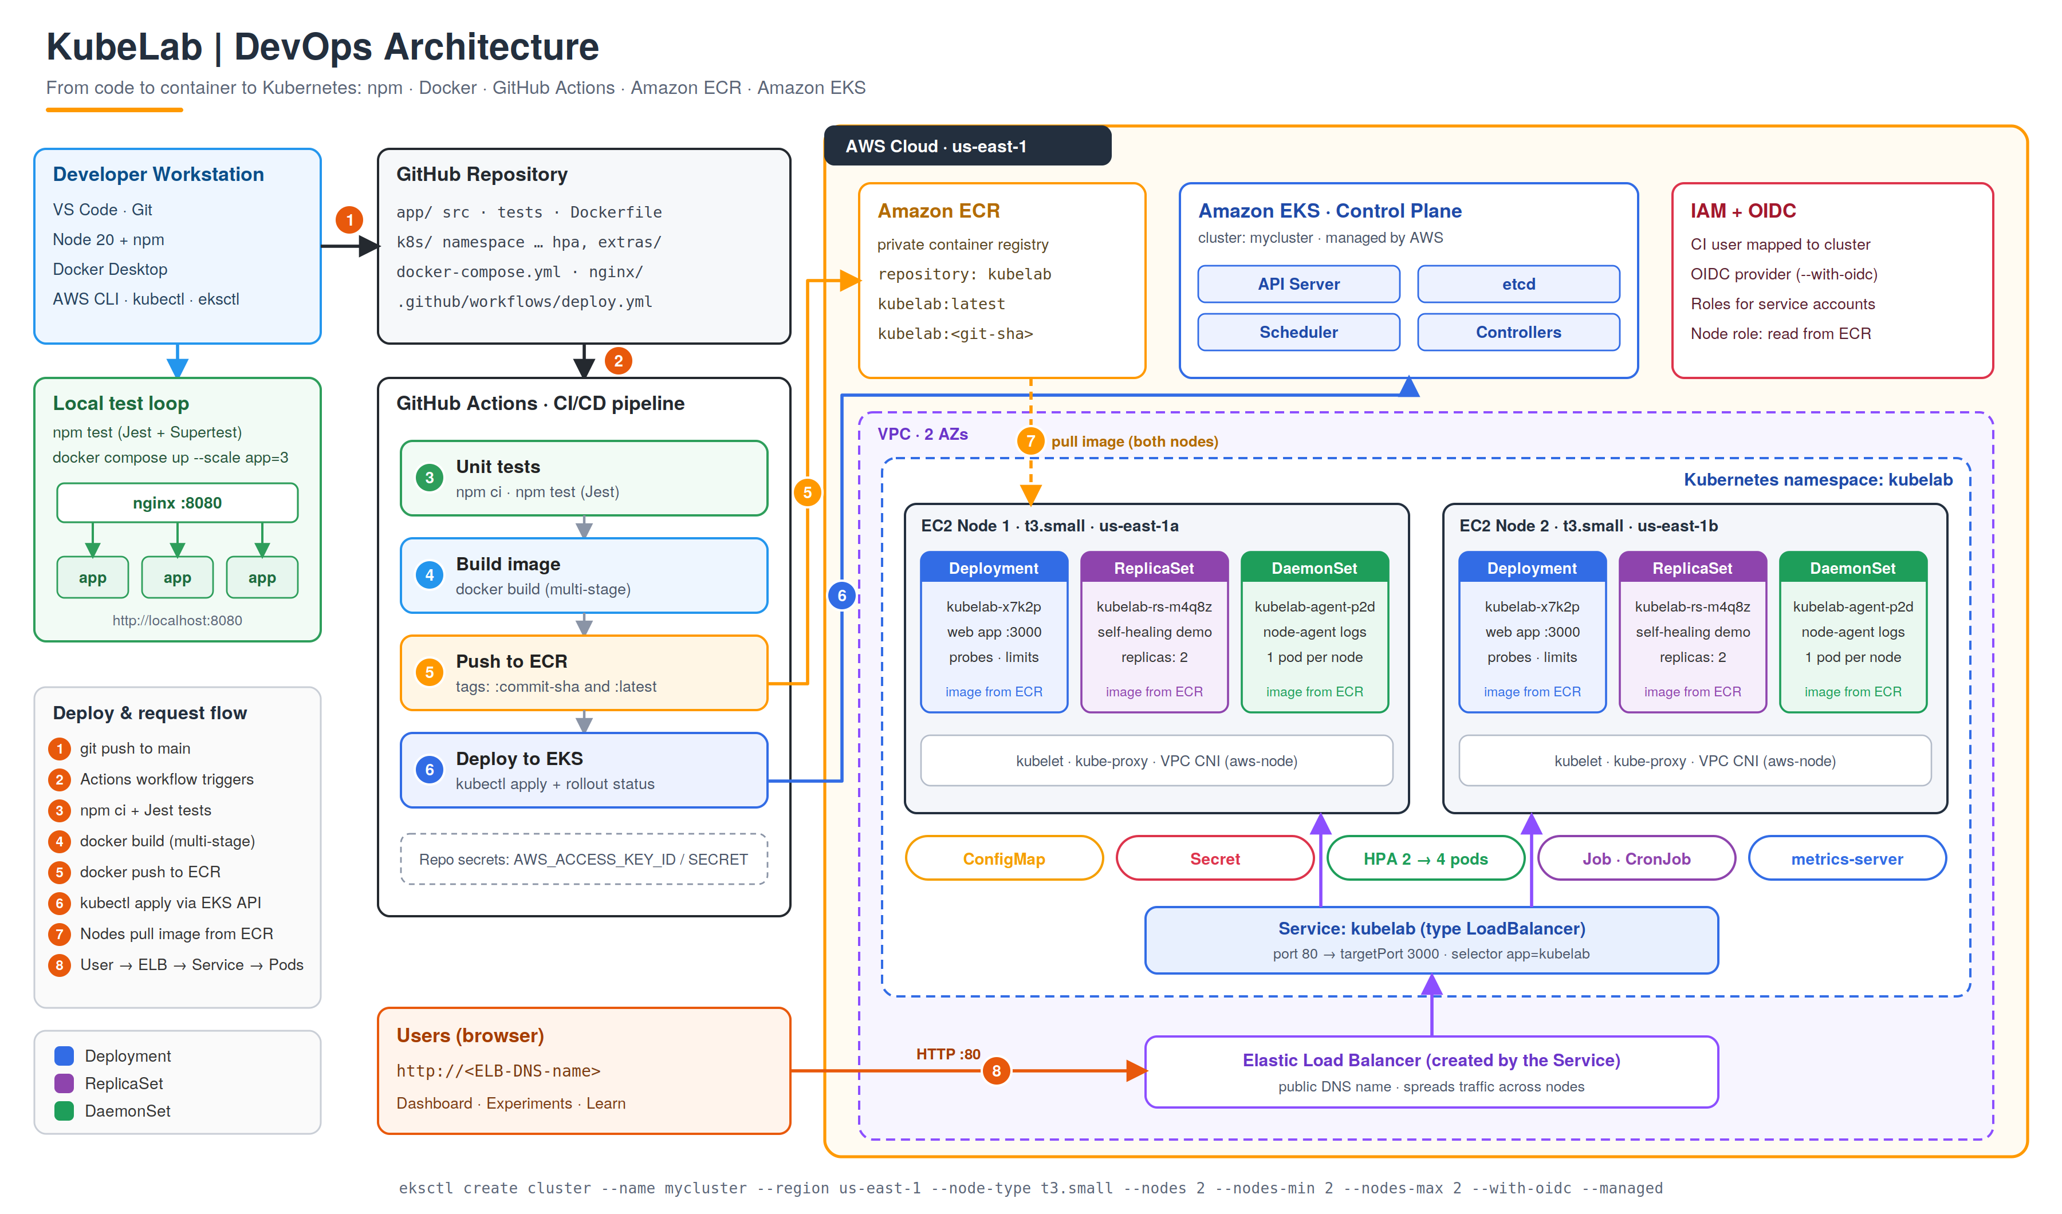
Figure 1: KubeLab DevOps architecture (also in docs/architecture.png and .svg)

3. Application and UI
[ PASTE SCREENSHOT HERE ]
Dashboard tab: pod, node, namespace, ConfigMap message
Save a copy as docs/screenshots/02-ui-dashboard.png
Figure 2: Dashboard tab: pod, node, namespace, ConfigMap message
[ PASTE SCREENSHOT HERE ]
Experiments tab: load-balancing distribution bars
Save a copy as docs/screenshots/03-ui-experiments.png
Figure 3: Experiments tab: load-balancing distribution bars
[ PASTE SCREENSHOT HERE ]
Learn tab with Kubernetes concept cards
Save a copy as docs/screenshots/04-ui-learn.png
Figure 4: Learn tab with Kubernetes concept cards

4. Testing
cd app && npm install & npm start
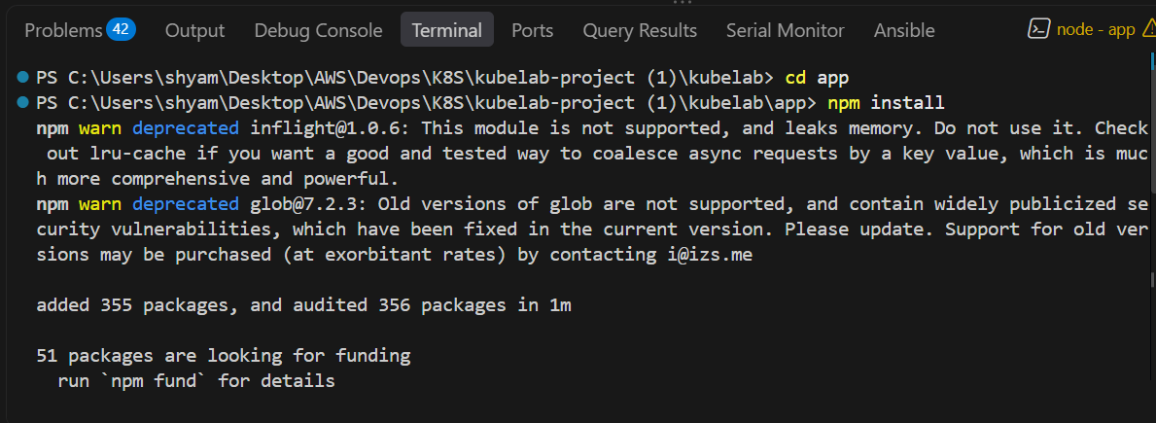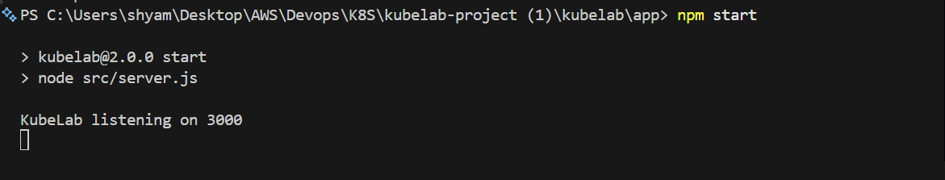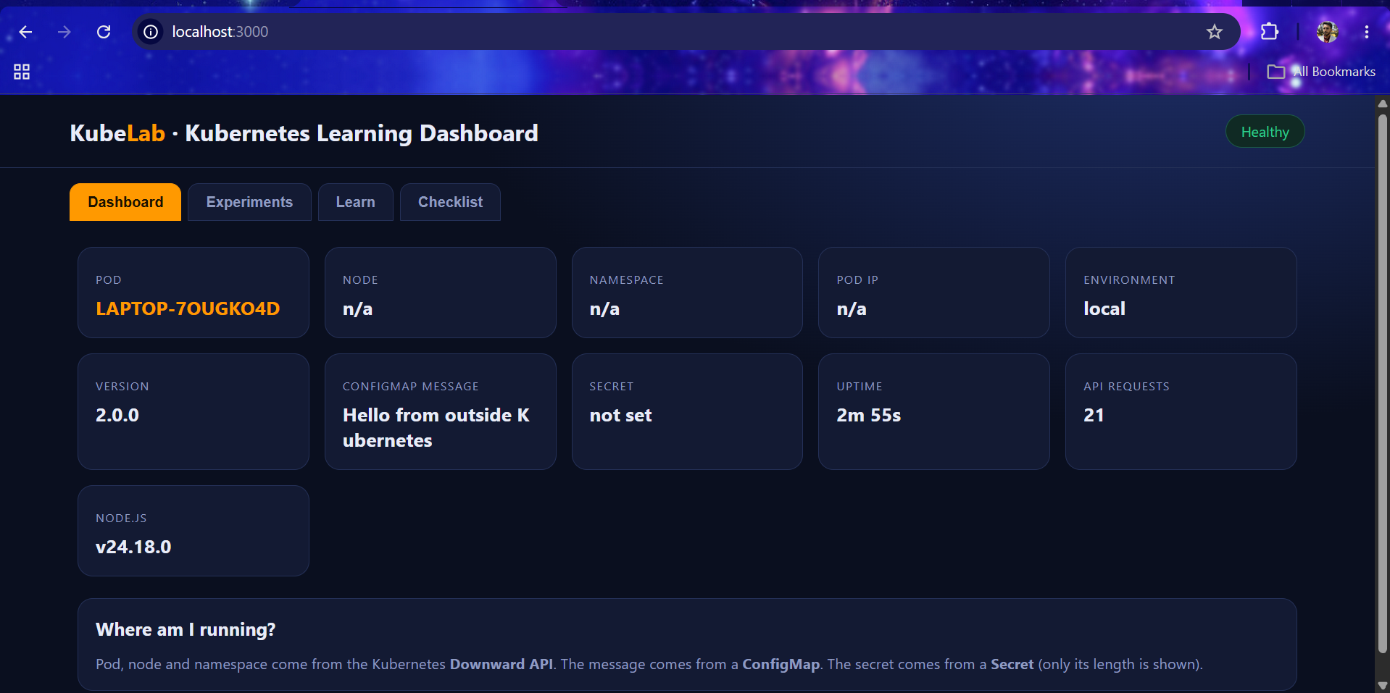
Figure 5: npm test output with all 8 tests and coverage

5. Docker and Docker Compose
docker compose up --build --scale app=3
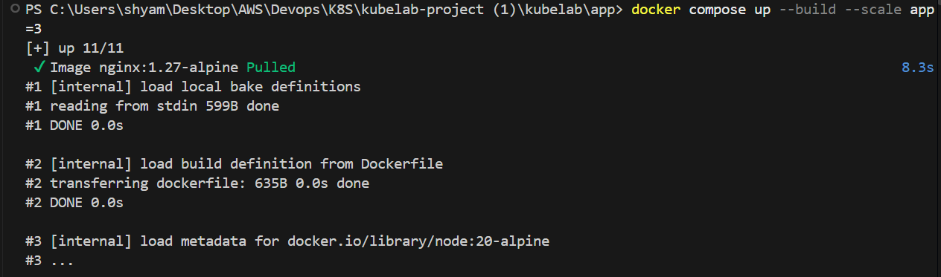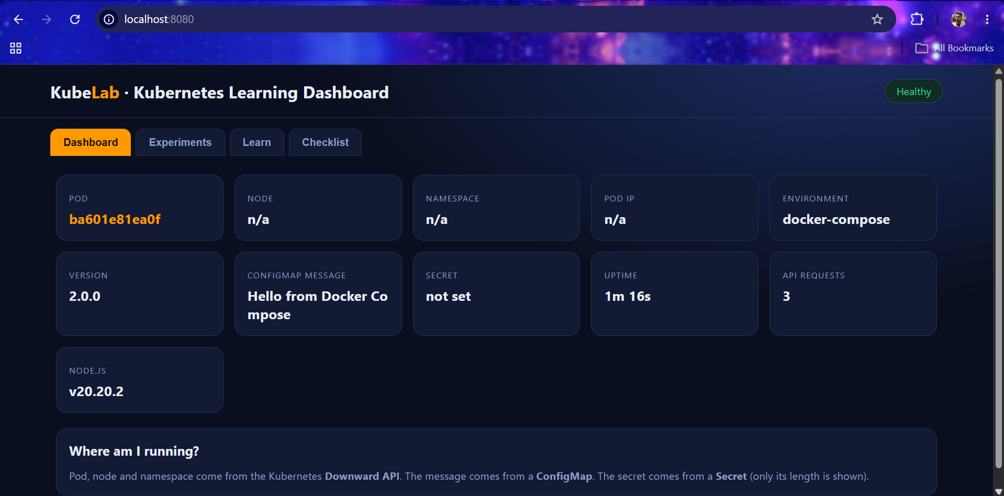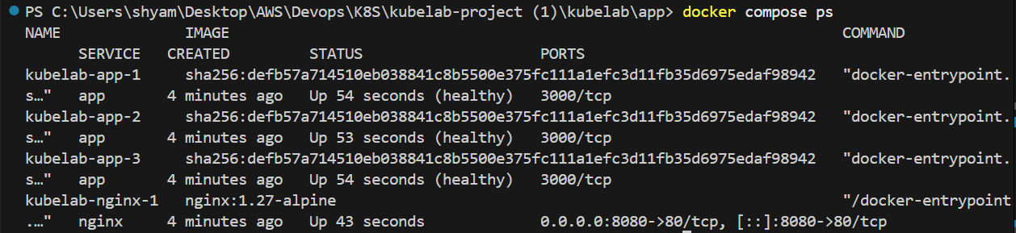
Figure 6: docker compose ps showing 3 app containers + nginx
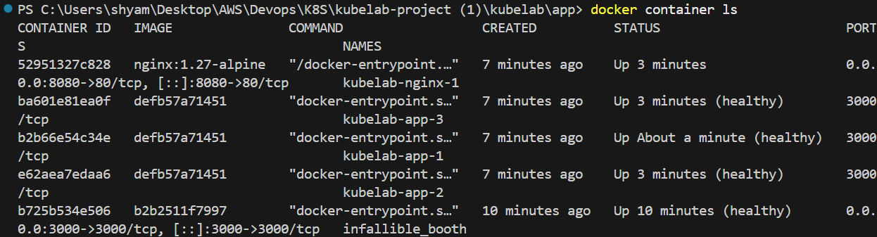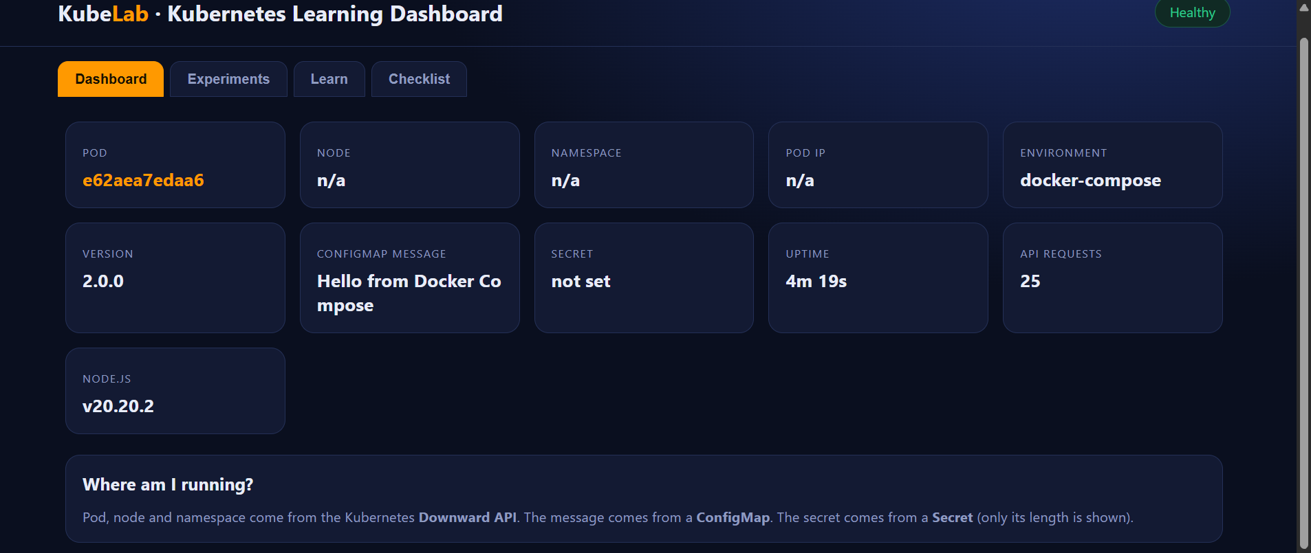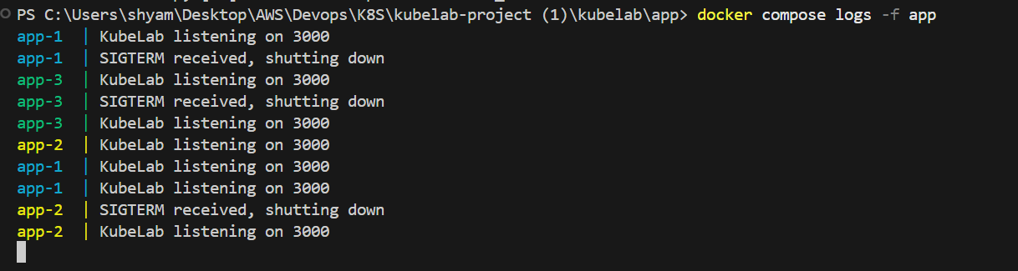
Figure 7: UI on localhost:8080 with traffic spread over 3 containers

6. EKS Cluster
eksctl create cluster --name mycluster --region us-east-1 --node-type t3.small --nodes 2 --nodes-min 2 --nodes-max 2 --with-oidc --managed
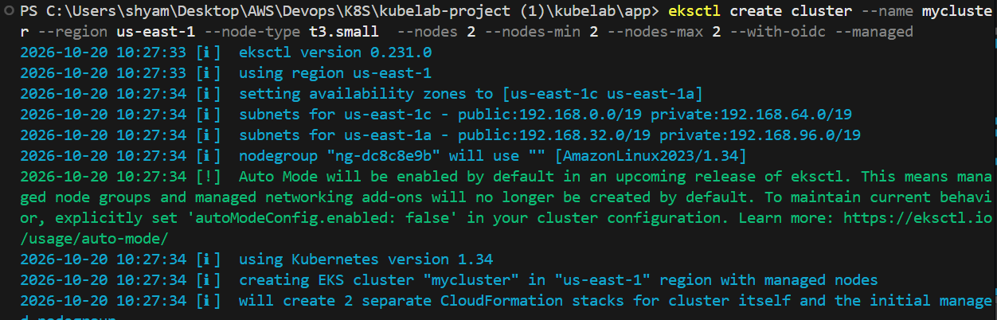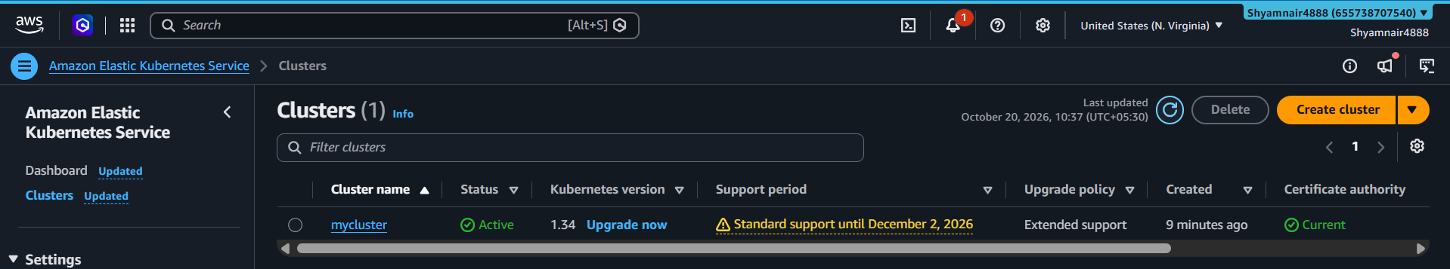
Figure 8: eksctl create cluster finished
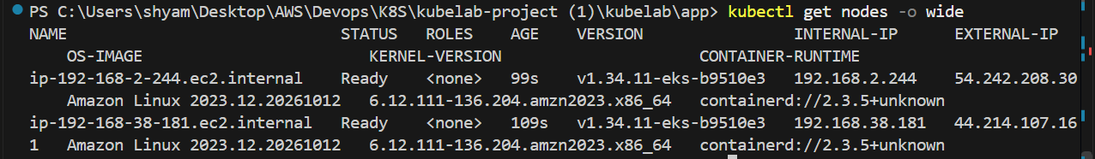
Figure 9: kubectl get nodes -o wide
[ PASTE SCREENSHOT HERE ]
AWS Console: EKS cluster overview
Save a copy as docs/screenshots/10-eks-console.png
Figure 10: AWS Console: EKS cluster overview

7. Amazon ECR
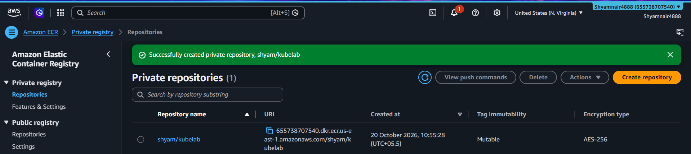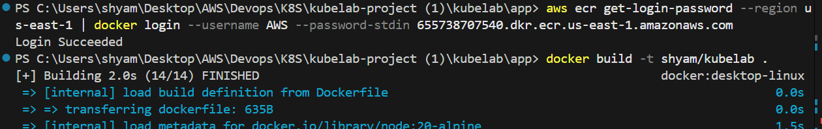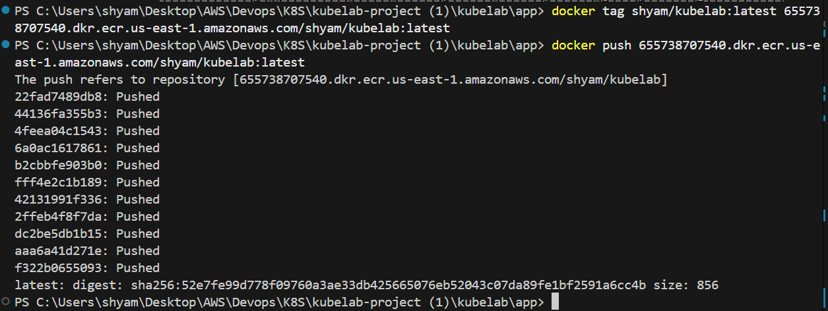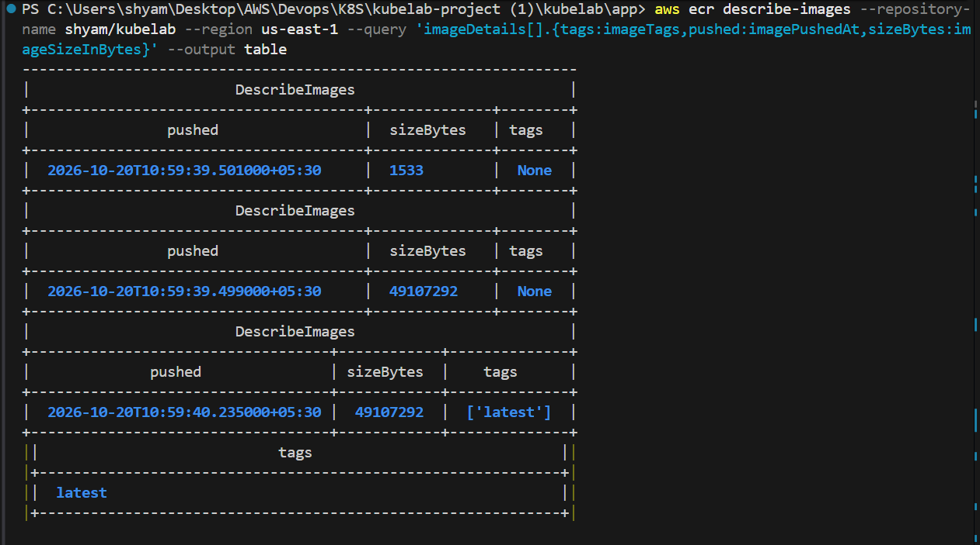
Figure 11: ECR repository kubelab with pushed image

8. Kubernetes Objects
Object | What it demonstrates
Namespace | Isolation of lab resources (kubelab)
ConfigMap / Secret | Config and sensitive values injected as environment variables
Deployment | Replicas, rolling updates, rollback, probes, resource limits
ReplicaSet | Keeps N pods alive; self-healing when a pod is deleted
DaemonSet | One agent pod per node
Service (LoadBalancer) | Stable address and AWS load balancer
Job / CronJob | Run-to-completion and scheduled tasks
HPA | CPU-based autoscaling 2 to 4 pods

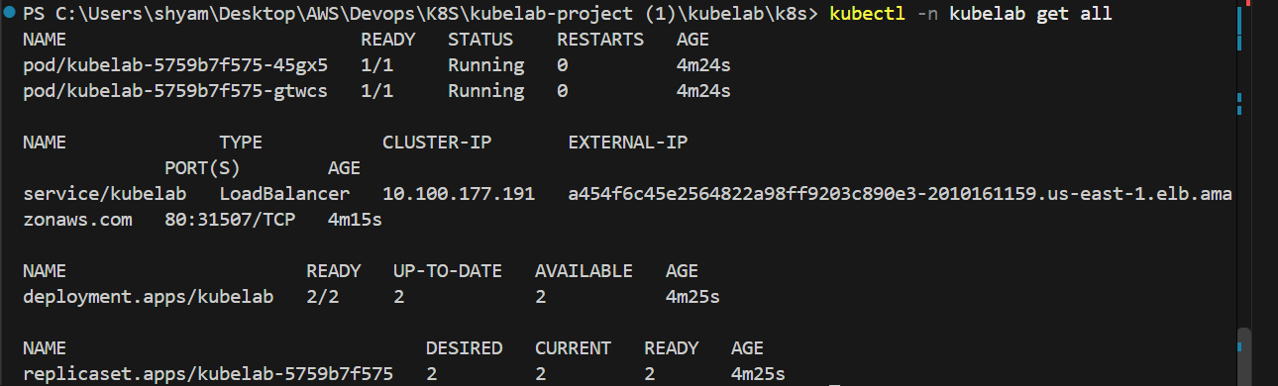
Figure 12: kubectl -n kubelab get all
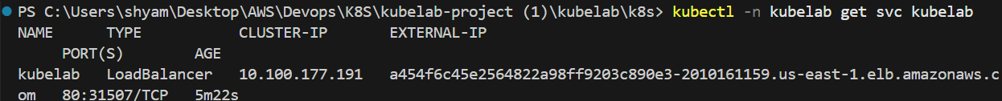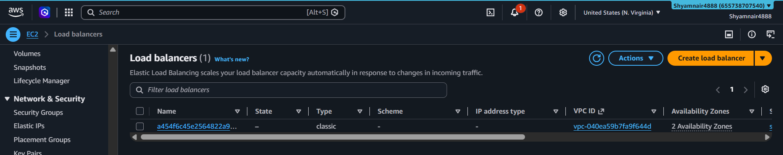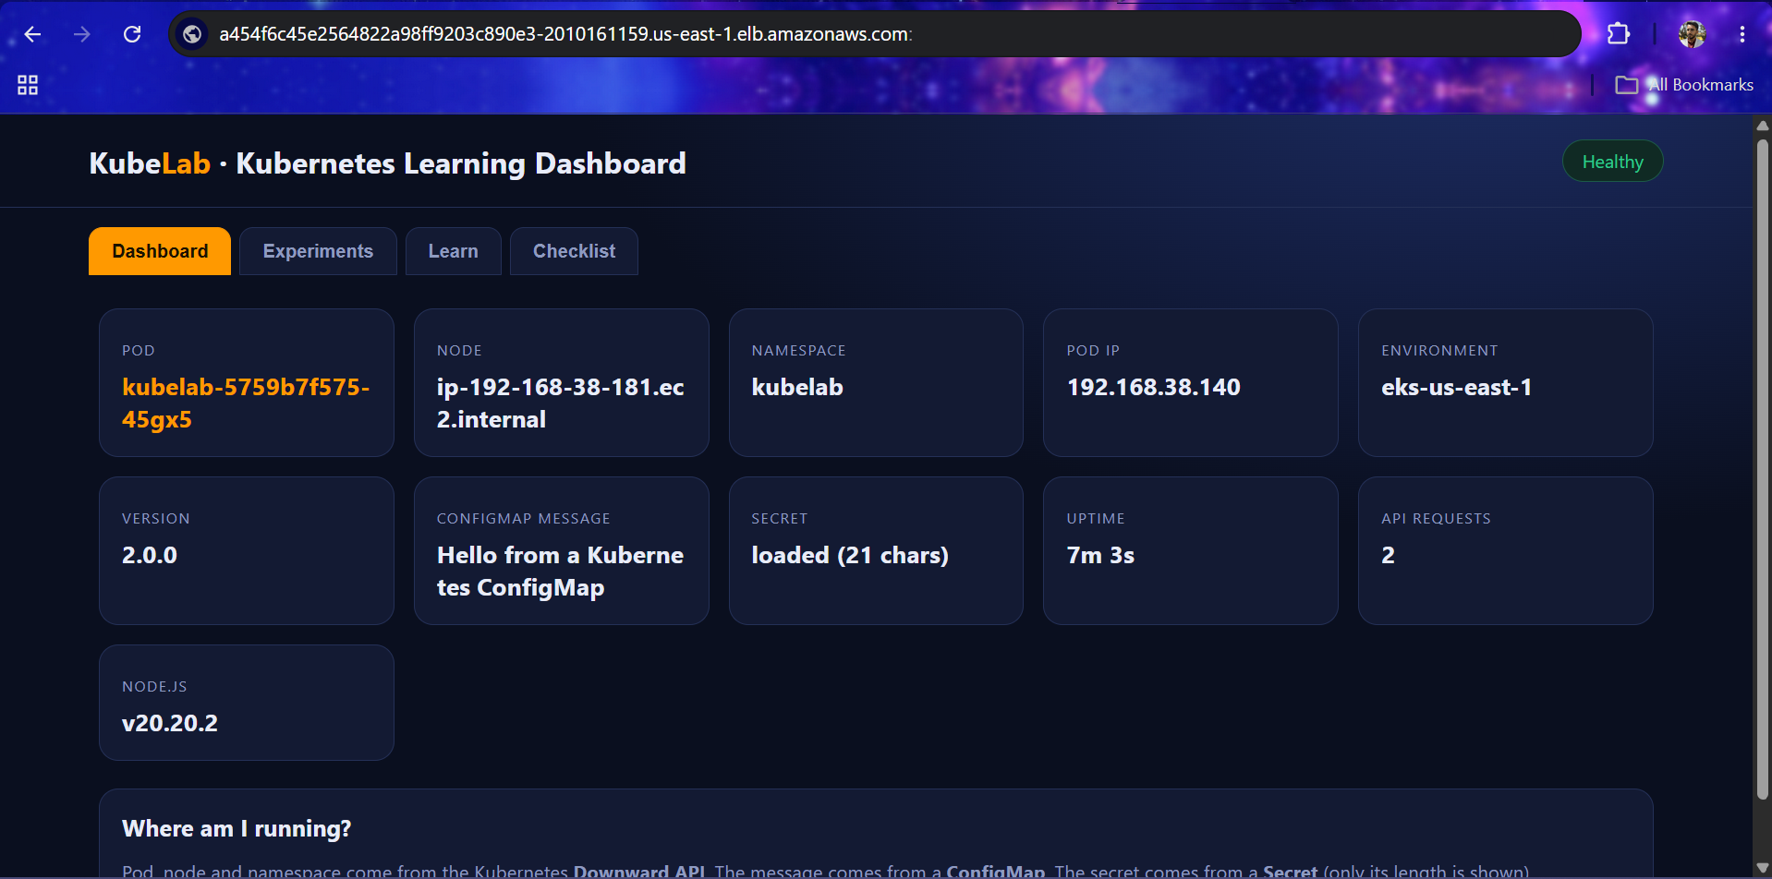
Figure 13: App opened via the load balancer URL

9. Experiments
For each experiment paste the command output and write one sentence on what happened and why.
Figure 14: ReplicaSet: deleted a pod and a new one was created
Observation: ____________________________________________
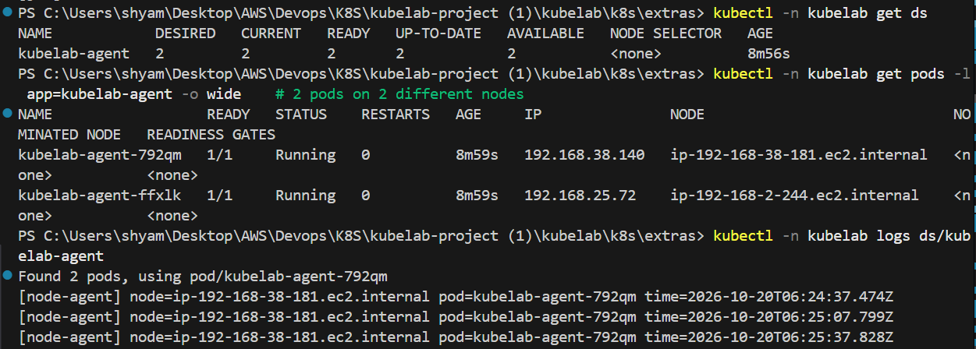
Figure 15: DaemonSet: get pods -o wide showing one pod per node

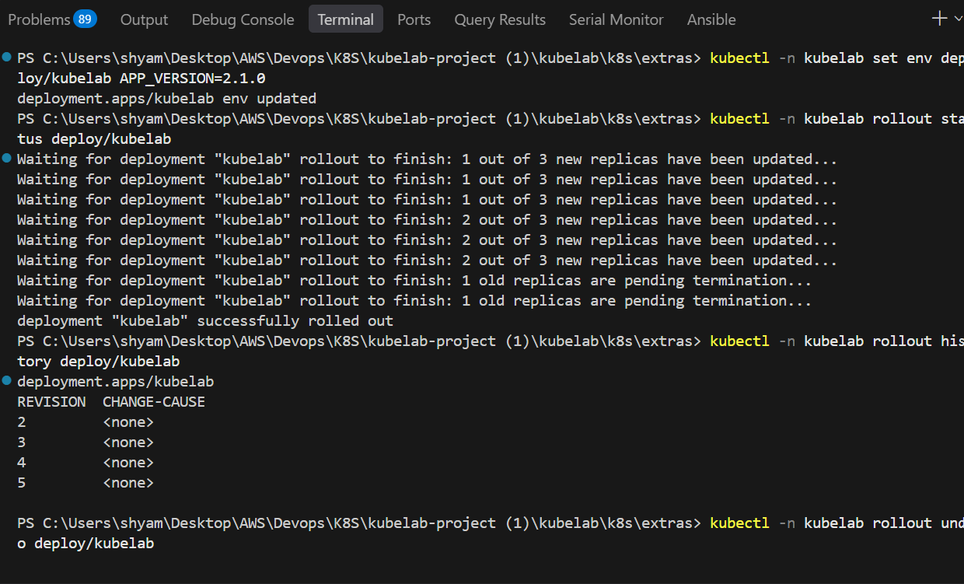
Figure 16: Rolling update (set env APP_VERSION) and rollout status
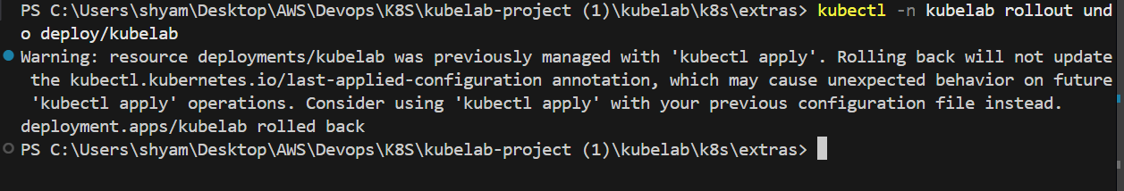
Figure 17: Rollback with rollout undo
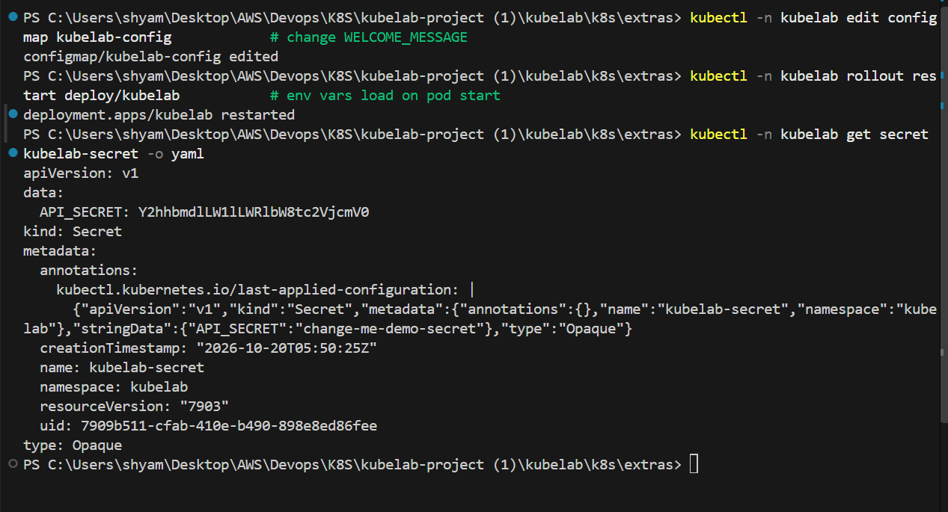
Figure 18: ConfigMap change visible in the UI after rollout restart
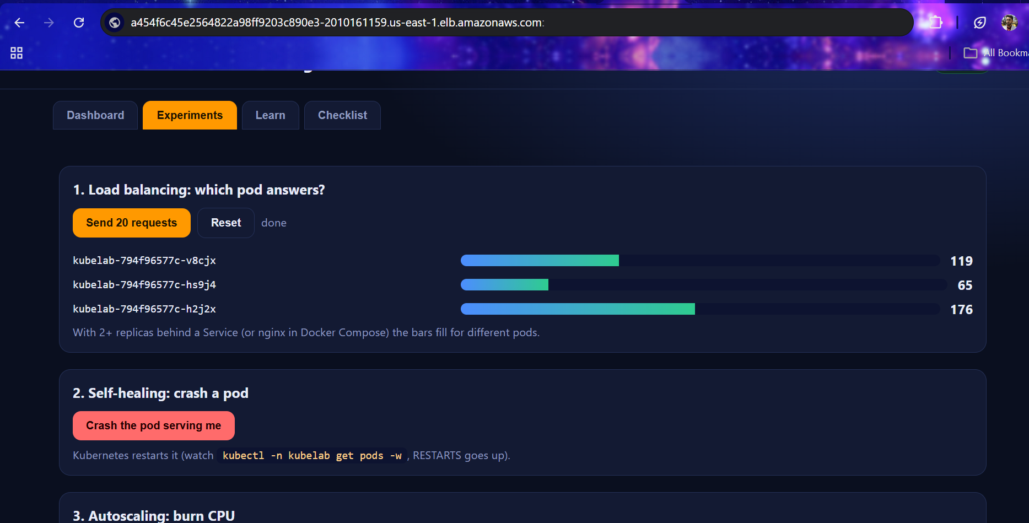
Figure 19: Crash experiment: RESTARTS count increased
Figure 20: Load balancing across EKS pods in the Experiments tab
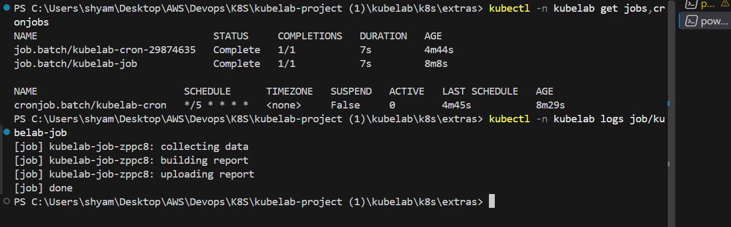
Figure 21: Job logs and CronJob listing
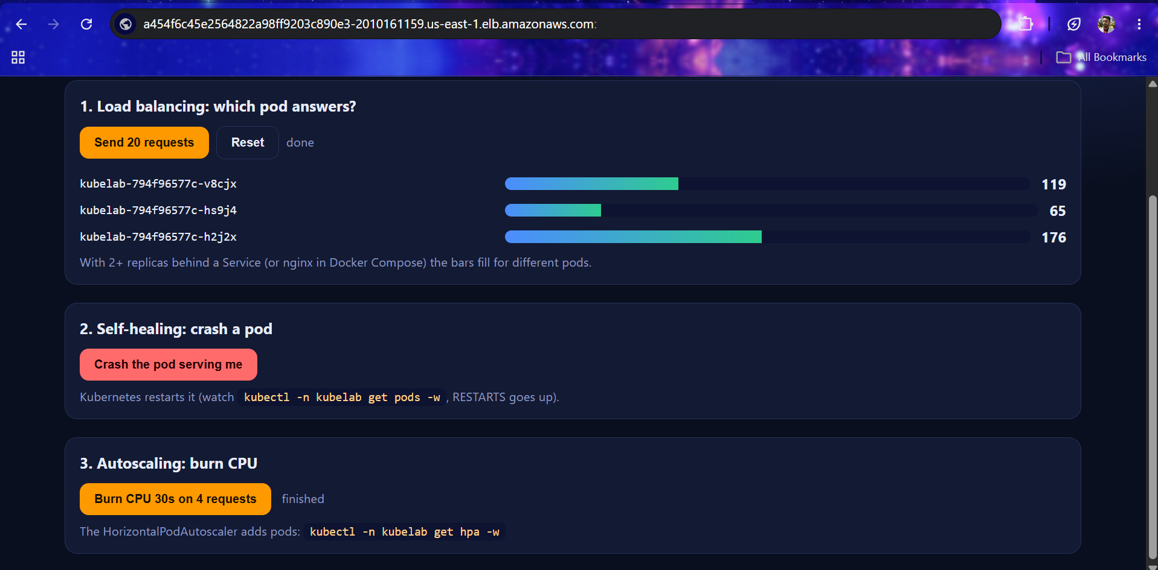
Figure 22: HPA scaling up during the CPU burn (get hpa -w)

10. CI/CD with GitHub Actions
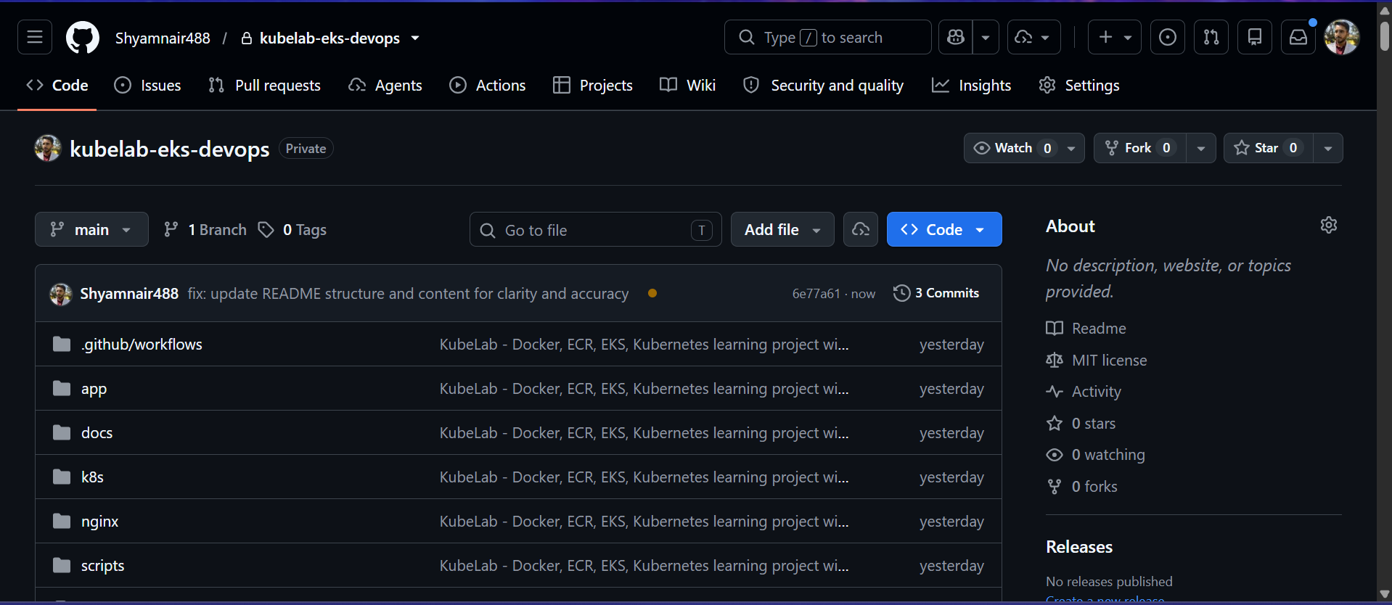
Figure 23: GitHub Actions run with green test and deploy jobs

11. Cleanup
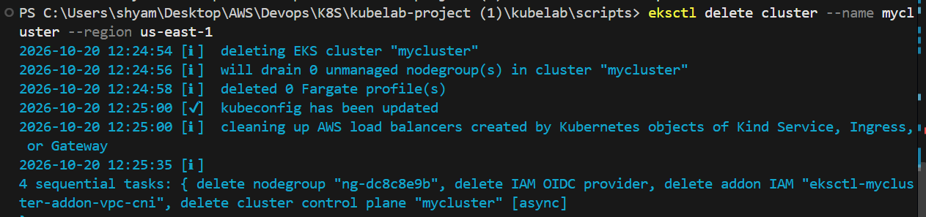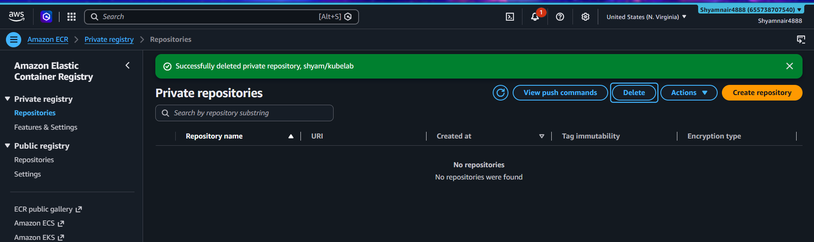
Figure 24: Cluster, load balancer and ECR repo deleted

12. Challenges and Learnings
Describe problems you met (ImagePullBackOff, Pending pods, pending load balancer), how you debugged them with describe/logs/events, and what you learned.
________________________________________________________________
________________________________________________________________

13. Conclusion and Next Steps
Summarise the project. Possible extensions: Ingress with the AWS Load Balancer Controller, HTTPS with ACM, StatefulSet with EBS, Helm, Terraform, Prometheus and Grafana.

