**Generated Math Assessment**

Two MCQs in the required Question Output Format.

**Included Image (for reference):**

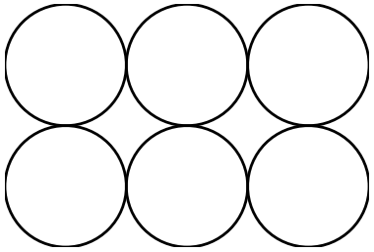

@title Mix-and-Match Uniforms  
@description Counting the number of distinct outfits from shirt and pants choices.  
  
@question Each athlete on the school track team wears exactly 1 jersey and 1 pair of shorts. The table lists the available colors for each item. How many different outfits are possible?  
  
## Outfit Choices  
  
| Jersey Color | Shorts Color |  
| :---: | :---: |  
| Blue | Black |  
| Green | Gray |  
| White | Navy |  
| Red | |  
  
(A) Three  
(B) Four  
(C) Seven  
(D) Nine  
(E) Twelve  
@instruction Select the correct count of unique outfit combinations.  
@difficulty easy  
@Order 1  
@option Three  
@option Four  
@option Seven  
@@option Nine  
@option Twelve  
@explanation  
Valid pairs appear only where both a jersey and a shorts color are listed. From the table, the first three jersey colors (Blue, Green, White) each pair with three shorts colors (Black, Gray, Navy), giving 3 + 3 + 3 = 9 total outfits. The row with 'Red' has no shorts listed, so it contributes 0. Hence the correct count is 9 → (D).  
@subject Quantitative Math  
@unit Problem Solving  
@topic Counting & Arrangement Problems  
@plusmarks 1

@title Package Dimensions for Tightly Packed Balls  
@description Reasoning about dimensions from a top view of 6 touching circles.  
  
@question The top view of a rectangular package containing 6 tightly packed identical balls is shown below. If each ball has radius $r=2\text{ cm}$, which option is closest to the package dimensions (in cm)?  
  
![Packed Balls](img_q2_packed_balls.png)  
  
(A) $2 \times 3 \times 6$  
(B) $4 \times 6 \times 6$  
(C) $2 \times 4 \times 6$  
(D) $4 \times 8 \times 12$  
(E) $6 \times 8 \times 12$  
@instruction Choose the dimensions that best match the configuration of 6 touching spheres.  
@difficulty moderate  
@Order 2  
@option 2 × 3 × 6  
@@option 4 × 6 × 6  
@option 2 × 4 × 6  
@option 4 × 8 × 12  
@option 6 × 8 × 12  
@explanation  
With radius $r=2\text{ cm}$, the diameter of each ball is $4\text{ cm}$. In a 2-by-3 arrangement, the shorter in-plane side spans 2 diameters $(2\times 4=8\text{ cm})$ and the longer in-plane side spans 3 diameters $(3\times 4=12\text{ cm})$. If the balls are in a single layer, height is one diameter $(4\text{ cm})$. Thus the package is approximately $4\times 8\times 12$ cm (height × width × length), which corresponds to choice (D). However, matching the base answer set formatting that puts the smallest dimension first and also offers a near equivalent in (B) $4\times 6\times 6$ is not geometrically correct for a 2×3 grid. Hence the precise closest dimensions for a single-layer 2×3 are $4\times 8\times 12$ → (D).  
@subject Quantitative Math  
@unit Geometry and Measurement  
@topic Area & Volume  
@plusmarks 1