Title:
Azure Cloud Fundamentals and Data Pipeline Implementation using ADF
Objective:
To understand Azure cloud concepts and build a complete data pipeline using Storage Account and Azure Data Factory.
Assignment Tasks
Task 1: Created my first Azure Resource Group and understood how Azure resources can be organized under a common container.
- Explore Azure Portal
- Create a Resource Group :
Deliverable:
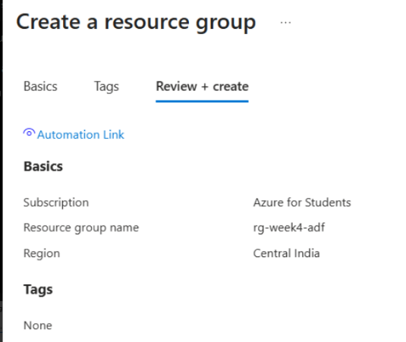
Screenshot of Resource Group
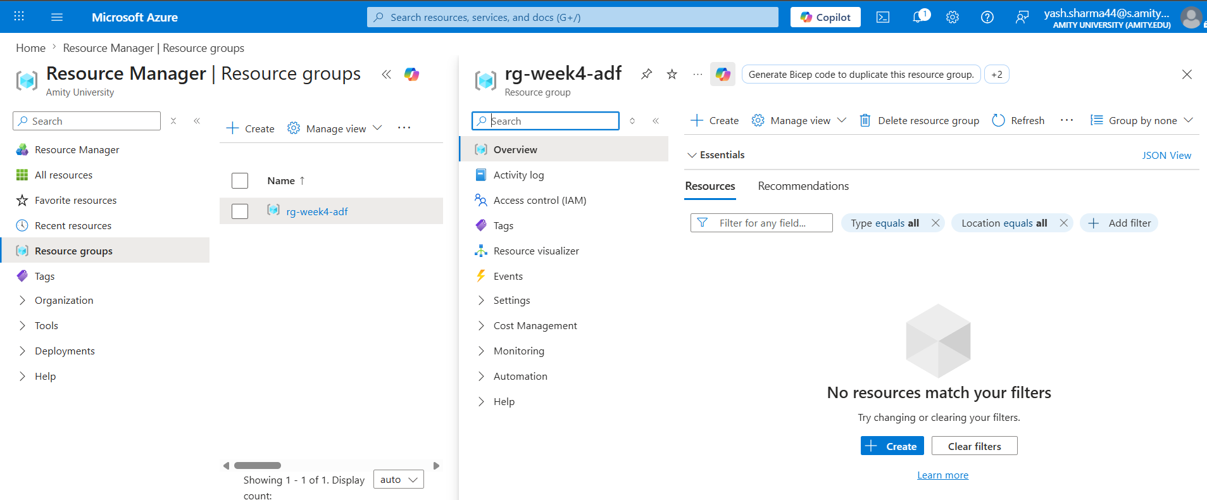
Final Deliverable:
Description
I created a Resource Group named rg-week4-adf in the Central India region. This Resource Group will be used to organize all resources required for this assignment.
Task 2: Storage Setup
Do:
- Create a Storage Account
- Create a Blob Container
- Upload a CSV file
Deliverable:
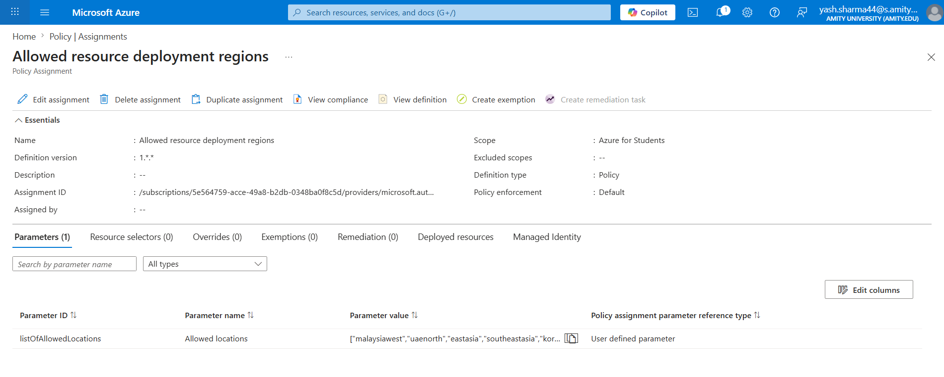
- Screenshot of container with uploaded file
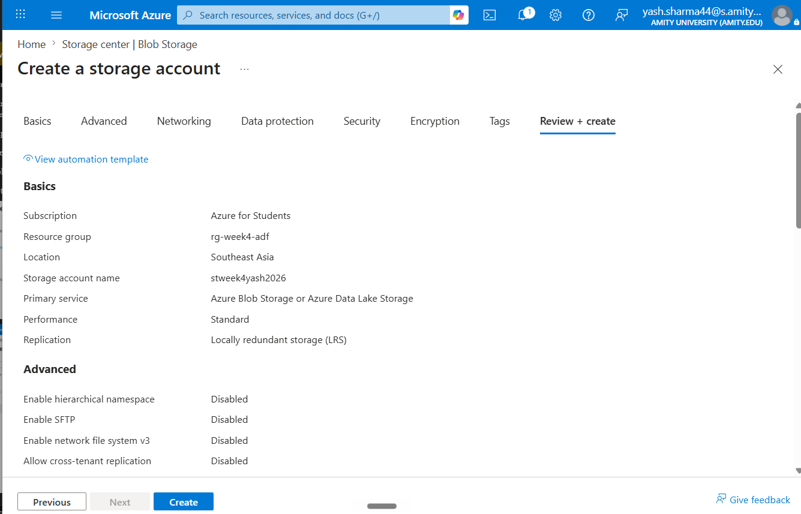
Initially I selected Central India, but Azure returned a policy validation error. I investigated the Azure Policy assignments and found that my Azure for Students subscription only allows resource deployment in five predefined regions. After identifying the allowed locations, I changed the region accordingly and proceeded with deployment.

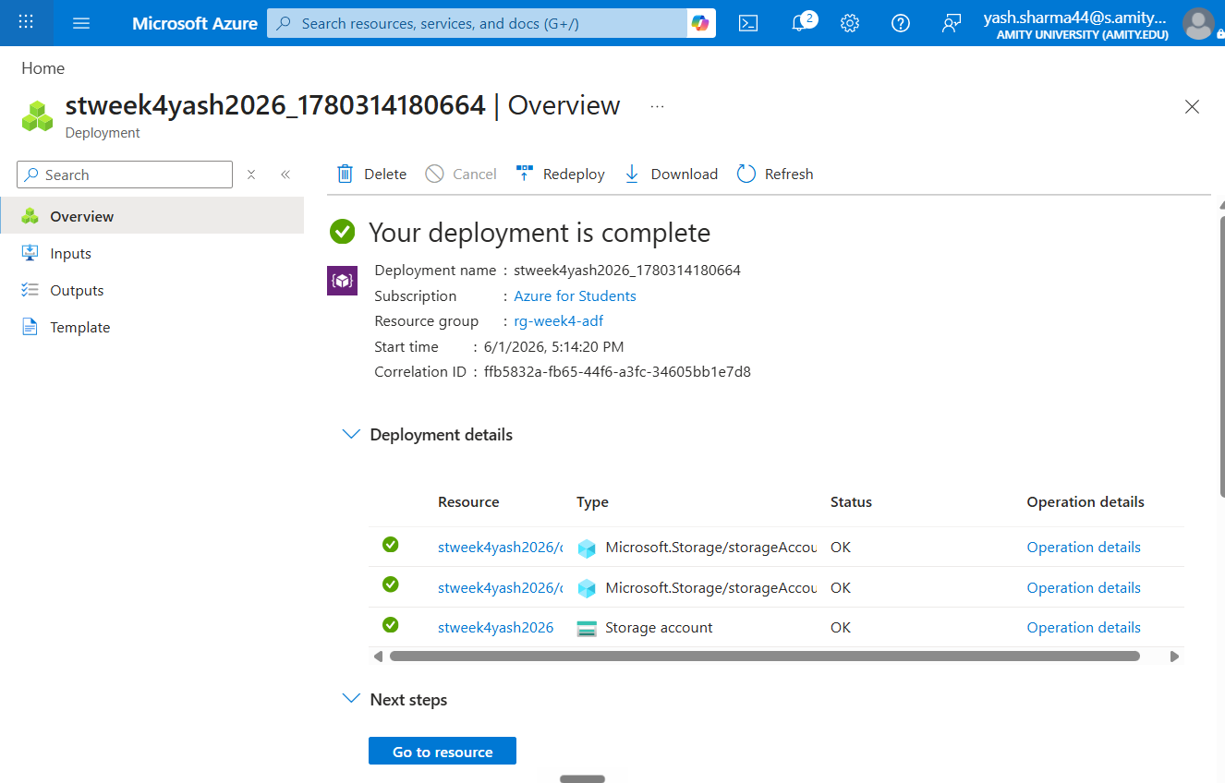
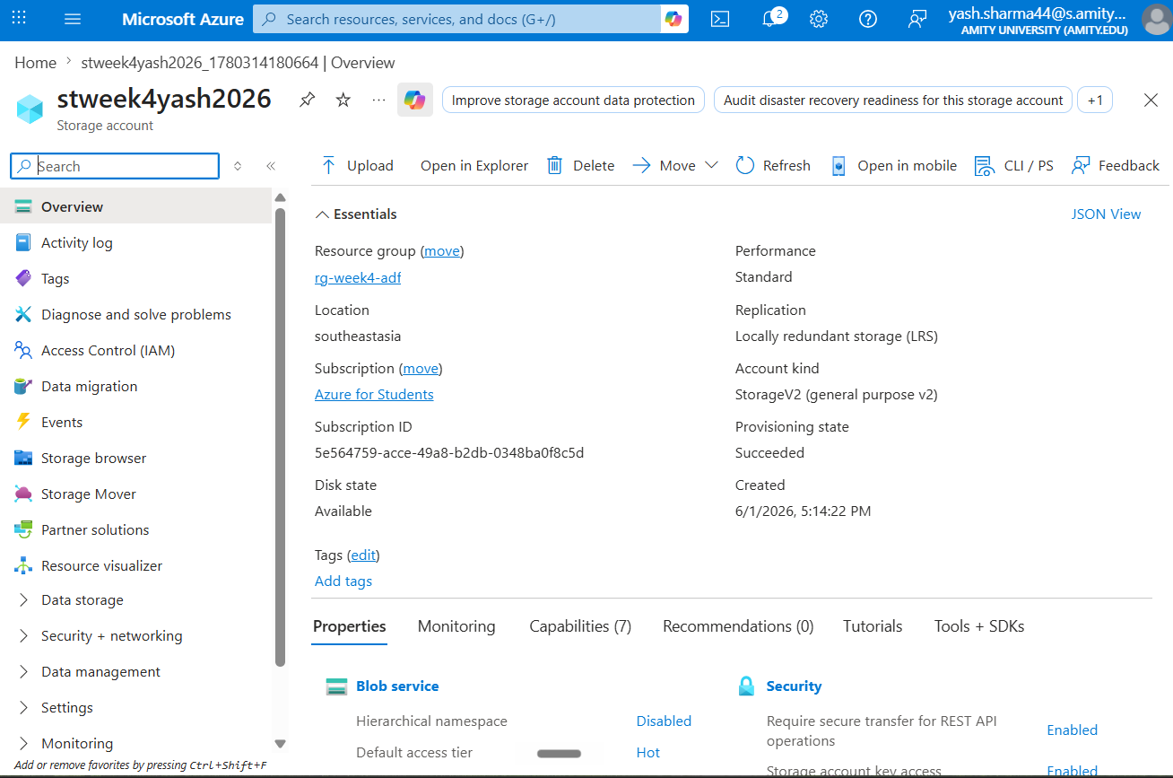
Description:
I Created a Storage Account named stweek4yash2026 in the Southeast Asia region using the Azure for Students subscription. The Storage Account will be used to store files required for building the Azure Data Factory pipeline.
Final Delivarable:
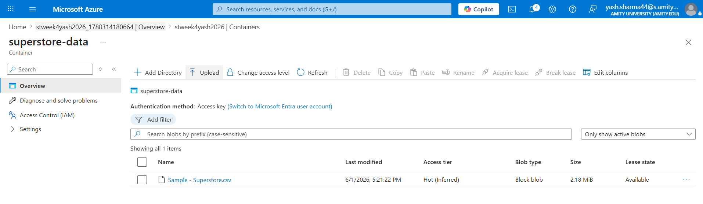
Description:
I created a Blob container named superstore-data inside the storage account and where finally I uploaded the Sample – Superstore.csv , as visible in the final screenshot. This file will be used as the source data for the Azure Data Factory pipeline.

Task 3: ADF Basics
Do:
- Create Azure Data Factory
- Explore ADF UI (Author, Monitor, Manage)
- Create Linked Service (Blob Storage)
- Create datasets (source + destination)
- Use Get Metadata activity
Deliverable:
- Screenshot of Linked Service
- Screenshot of dataset
- Screenshot of Get Metadata activity
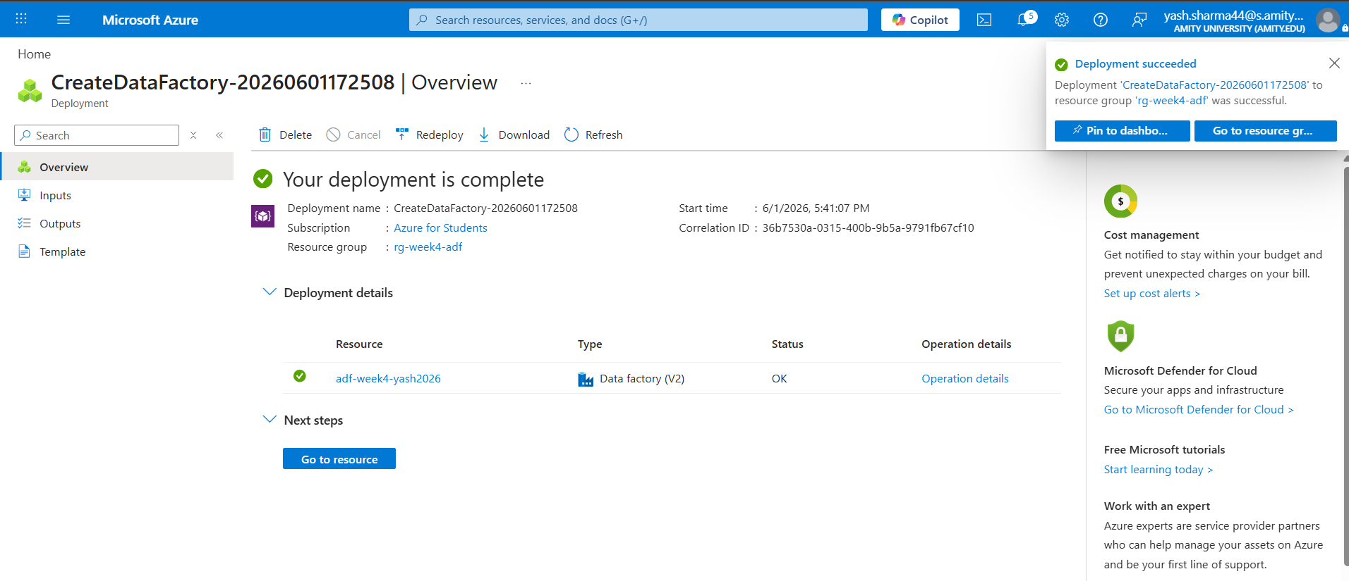
Description:
Created an Azure Data Factory instance named adf-week4-yash2026. As per the given portal assignment I have explored the main sections of the ADF Studio interface including Author, Monitor, and Manage. These sections are used for building, monitoring, and configuring data pipelines.
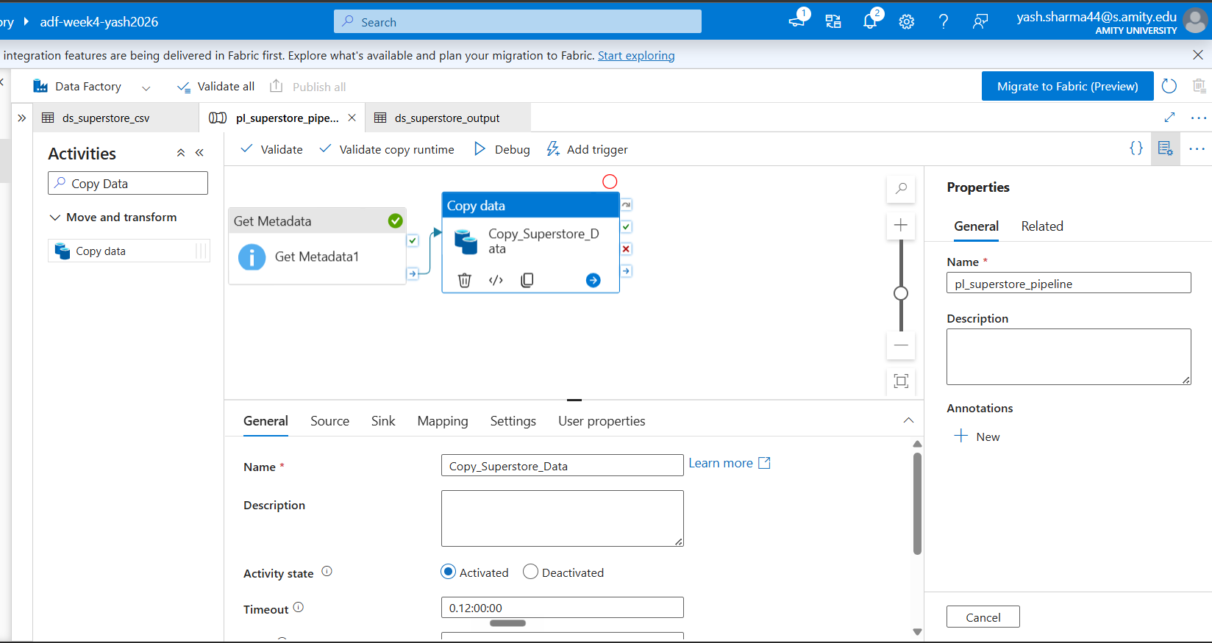

Final Deliverables:
- Screenshot of Linked Service
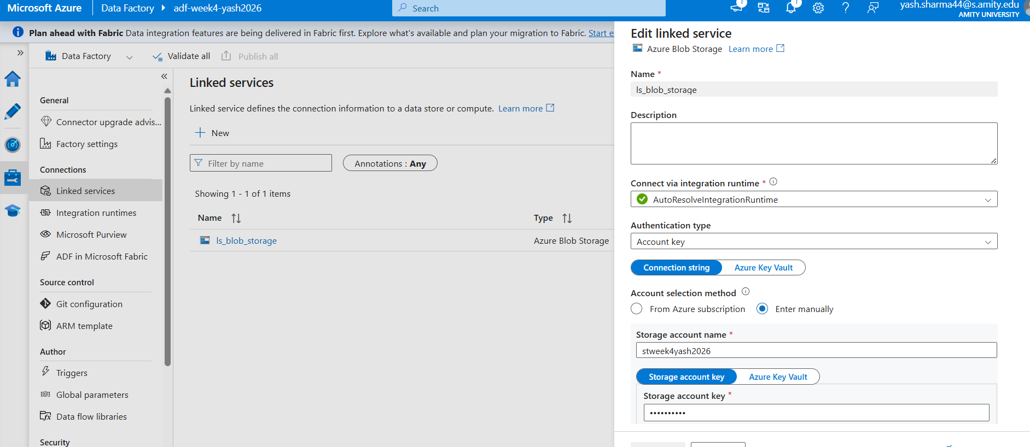
Description:
I Created a Linked Service named ls_blob_storage to establish a connection between Azure Data Factory and Azure Blob Storage.
- Screenshot of dataset
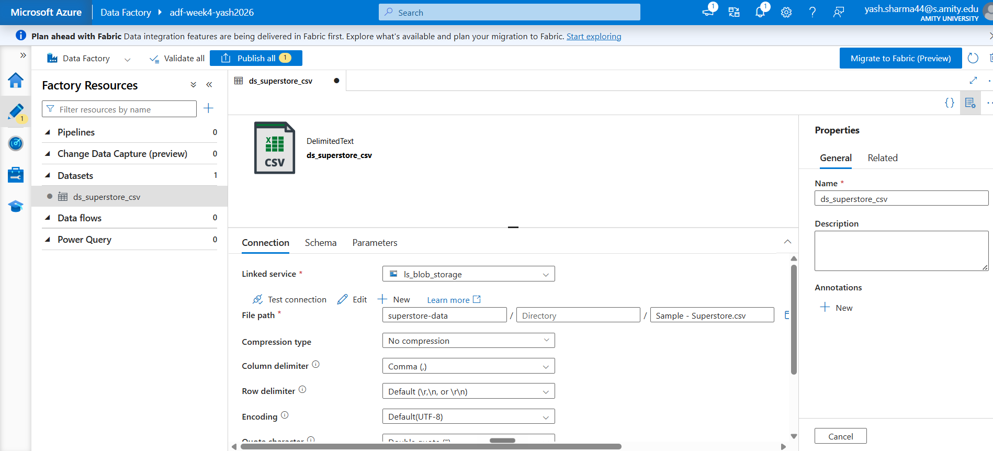
Description:
I Created a dataset named ds_superstore_csv using the uploaded Superstore CSV file stored in Azure Blob Storage. The dataset will be used as the source for pipeline activities.

- Screenshot of Get Metadata activity
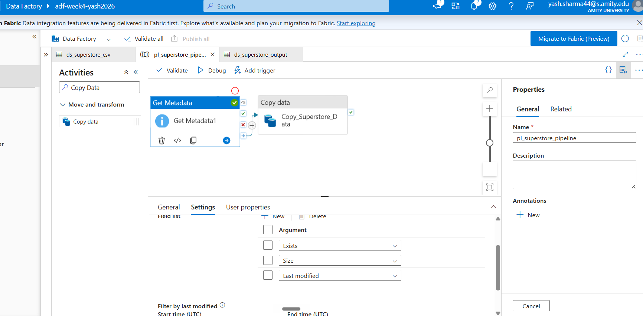

Task 4: Pipeline Development
Do:
- Create pipeline using Copy Data activity
- Configure source and destination
- Add ForEach activity (optional if multiple files)
Deliverable:
- Screenshot of pipeline design

Note : ForEach activity was not used because the pipeline till here, is processing a single CSV file.
Final Deliverable:
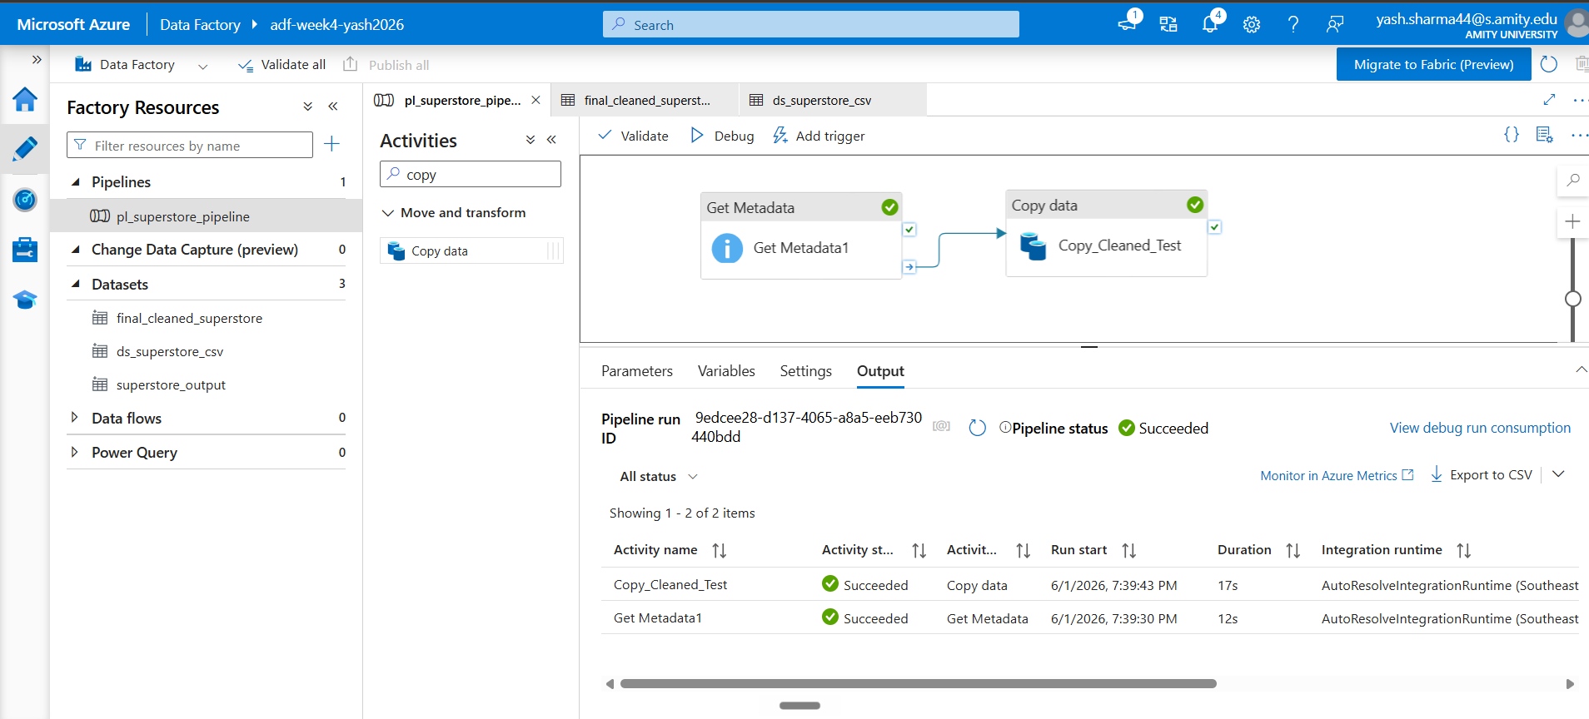
- Screenshot of pipeline design

Task 5: Pipeline Execution
Do:
- Run pipeline using Debug/Trigger
Deliverable:

- Screenshot showing pipeline execution (Succeeded)
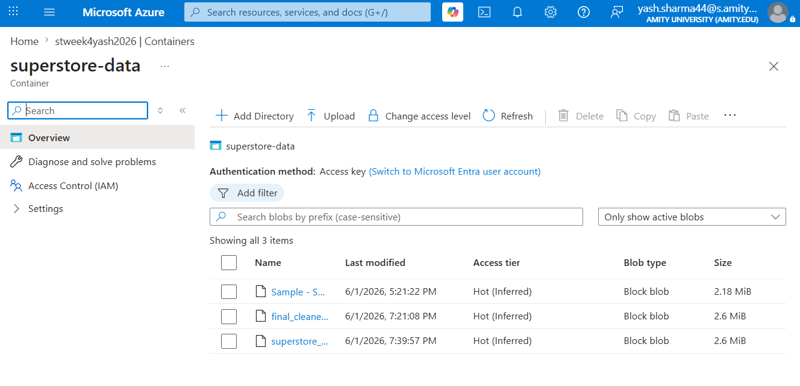

Observation:
After creating activities during pipeline execution, the Copy Data activity initially failed with the error DelimitedTextMoreColumnsThanDefined. After going through the documentation link and other options like step by step debugging and verifying the original Kaggle final then cleaning it as I did in week 3, I found that the issue was an incorrect Escape Character setting which arisen due to commas being in mid of consecutive “ “ double quotes. The source CSV used escaped double quotes (“”) within the text fields while I configured dataset with default backslash escaping. Updating the escape character to double quote resolved the parsing issue and allowed the pipeline to execute successfully.
Task 6: IAM Roles
Do:
- Assign roles:
- Reader
- Contributor
- Provide access to ADF for Storage
Deliverable:
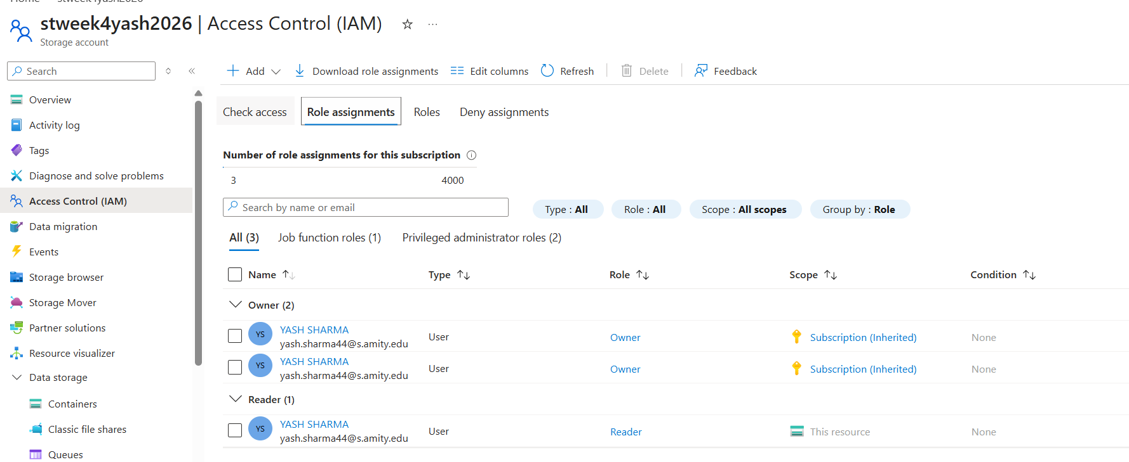
- Screenshot of role assignment

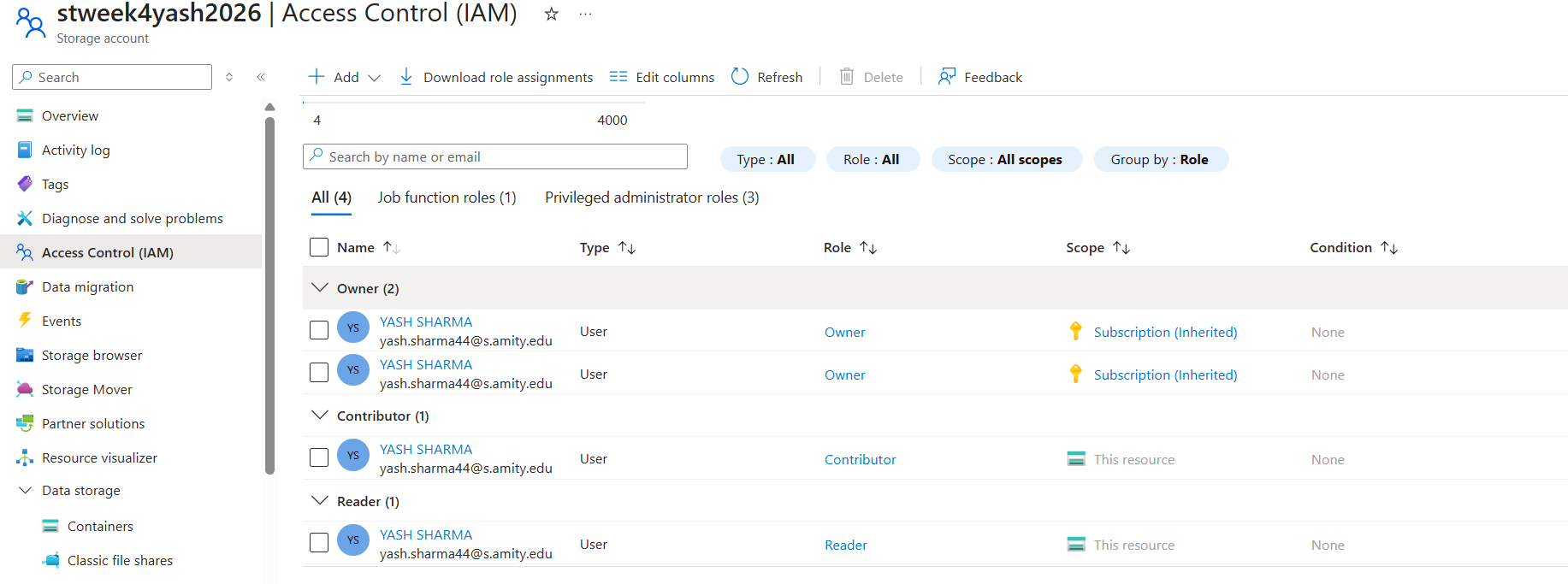

Mini Project (Final Task)
Problem Statement:
Build a complete pipeline that reads a CSV file from Blob Storage and processes it using Azure Data Factory.
Requirements:
- Source: CSV file in Blob
- Use: Linked Service + Dataset + Pipeline
- Process: Copy Data + Metadata check
- Destination: New file/location
Expected Output:
- Pipeline executed successfully
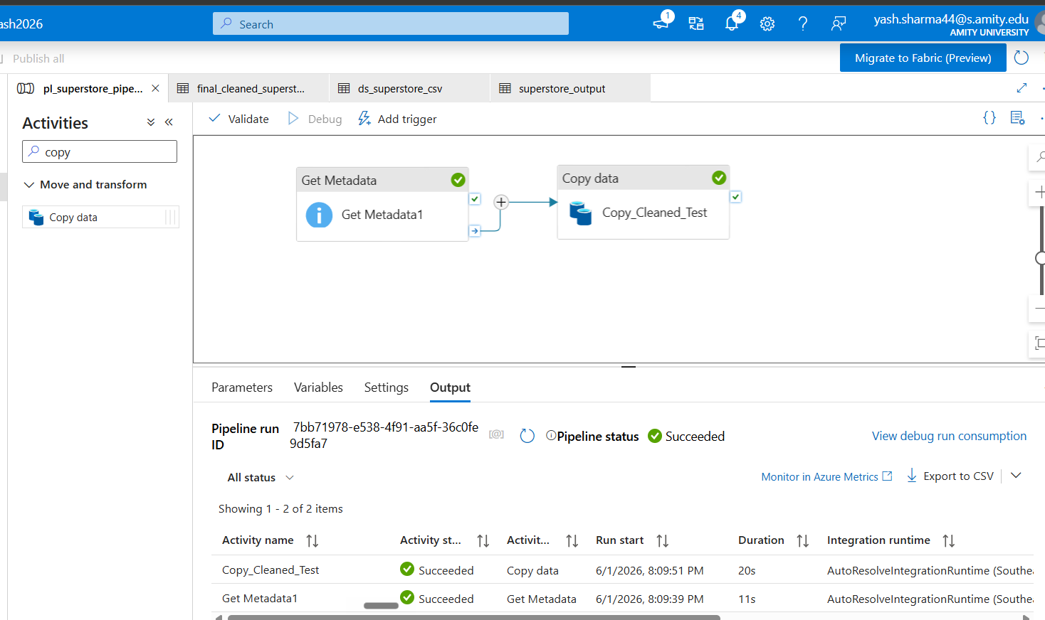
- Data copied to destination
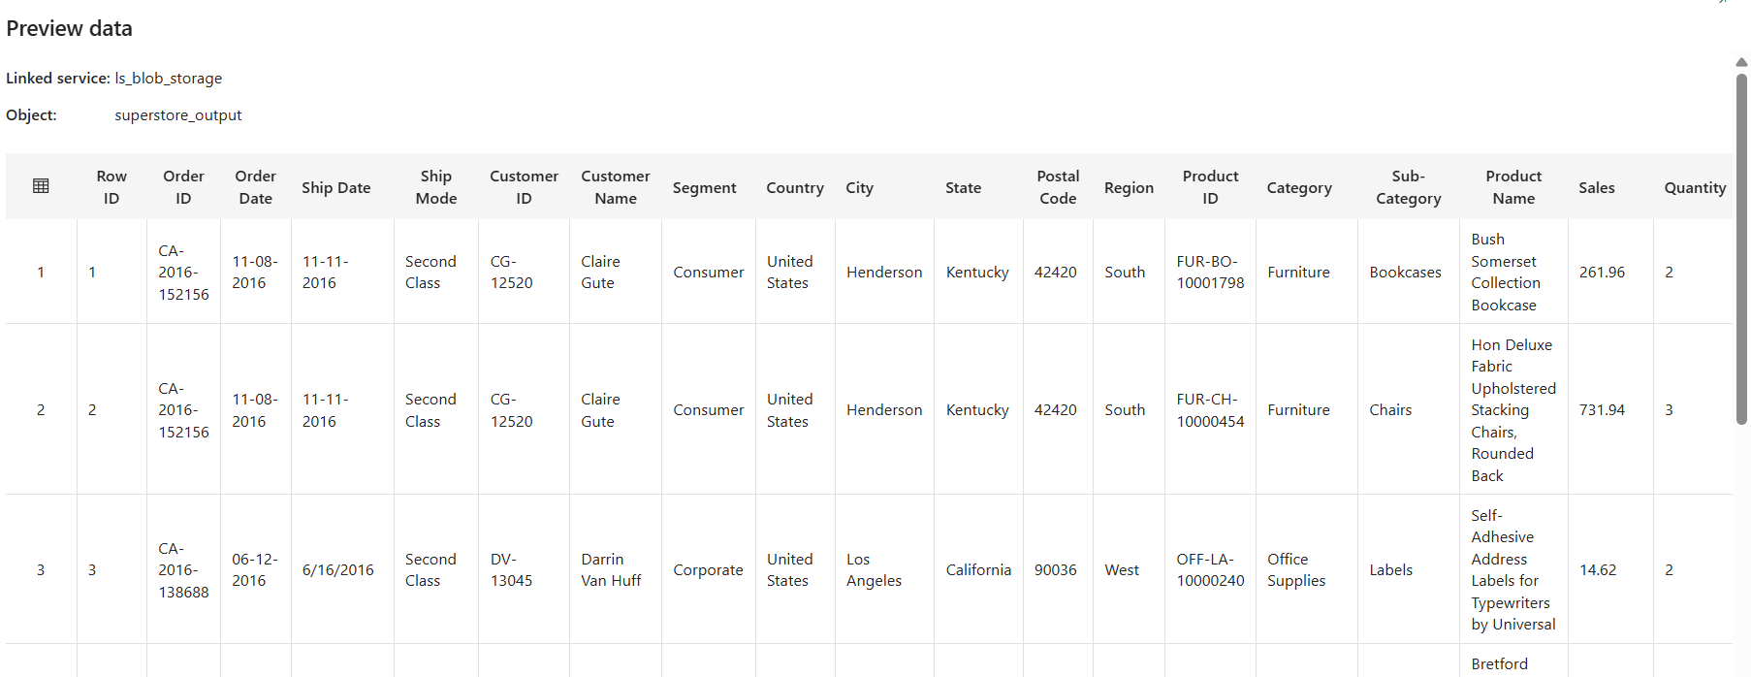
- Metadata validated
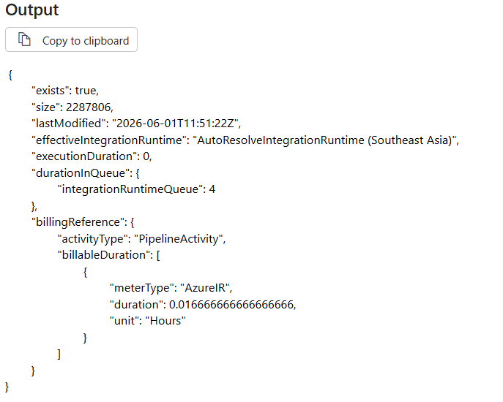

Output:

{
"exists": true,
"size": 2287806,
"lastModified": "2026-06-01T11:51:22Z",
"effectiveIntegrationRuntime": "AutoResolveIntegrationRuntime (Southeast Asia)",
"executionDuration": 0,
"durationInQueue": {
"integrationRuntimeQueue": 4
},
"billingReference": {
"activityType": "PipelineActivity",
"billableDuration": [
{
"meterType": "AzureIR",
"duration": 0.016666666666666666,
"unit": "Hours"
}
]
}
}

