SECURE RETAIL DATA LAKEHOUSE
A Layered ETL Pipeline for Privacy-Preserving Retail Data Processing
FINAL PROJECT REPORT
Submitted in Partial Fulfilment of the Requirements for
Celebal Technologies Data Engineering Internship
under the Celebal Excellence Internship Program 2026
Submitted By
Yash Sharma
B.Tech Computer Science & Engineering (Data Science)
Amity School of Engineering and Technology
Amity University Uttar Pradesh
Internship Organisation: Celebal Technologies
Duration: 04 May 2026 – 04 July 2026

Executive Summary
Modern retail organizations generate massive volumes of transactional and customer data every day. While this data is essential for business analytics, recommendation systems, customer behavior analysis, and operational reporting, it frequently contains Personally Identifiable Information (PII) such as customer names, phone numbers, email addresses, home addresses, and payment-related information. Directly exposing such information to downstream analytical systems introduces significant privacy, security, and regulatory risks.
The Secure Retail Data Lakehouse project addresses this challenge by implementing a secure, layered Extract-Transform-Load (ETL) pipeline inspired by the Medallion Architecture. The pipeline demonstrates how raw retail datasets can be progressively transformed into analytics-ready datasets while ensuring that sensitive customer information is appropriately protected before reaching analytical consumers.
The project begins by generating realistic synthetic retail datasets consisting of customer records, product master data, and transaction information. These datasets are validated to ensure structural integrity before entering the ETL pipeline. The pipeline is divided into four logical layers:
- Raw Layer stores the original generated datasets without modification.
- Bronze Layer performs initial ingestion and removes highly sensitive information through a hard-drop strategy.
- Silver Layer applies privacy-preserving transformations such as masking and redaction of personally identifiable information.
- Gold Layer prepares analytics-ready datasets through feature engineering, customer segmentation, transaction bucketing, and summary generation.
The processed datasets are subsequently loaded into PostgreSQL, where they are organized into structured relational tables suitable for querying and business analysis. Finally, the project automatically generates validation reports, pipeline metrics, and HTML summaries to verify successful pipeline execution and data quality.
This project demonstrates practical implementation of Data Engineering concepts including layered ETL architecture, data validation, privacy-aware transformations, relational database integration, modular Python development, and automated reporting. It reflects real-world industry practices while remaining aligned with the objectives of the Celebal Technologies Data Engineering Internship.
CHAPTER 1

Introduction
Data has become one of the most valuable assets for modern organizations. Retail companies, in particular, rely heavily on customer and transaction data to understand purchasing behavior, optimize inventory, improve marketing strategies, and enhance customer experience. However, as the volume of collected data increases, so does the responsibility to protect sensitive customer information from unauthorized access and misuse.
Operational retail systems routinely store Personally Identifiable Information (PII) including customer names, contact details, residential addresses, and payment information. While this information is necessary for business operations, analysts and reporting systems generally do not require direct access to these sensitive attributes. Providing unrestricted access to operational data can lead to privacy violations, security vulnerabilities, and non-compliance with modern data protection regulations.
To address these challenges, organizations commonly implement layered data architectures where data is progressively transformed before being consumed by downstream applications. Such architectures separate operational data from analytical data, allowing sensitive information to be removed or anonymized while preserving the business value of the dataset.
The Secure Retail Data Lakehouse project demonstrates this approach by implementing a complete ETL pipeline using Python, Pandas, PostgreSQL, and SQLAlchemy. The project emphasizes secure data processing by incorporating data validation, hard-drop mechanisms, masking techniques, feature engineering, and aggregation before storing the processed data in an analytical database.
Rather than focusing solely on data movement, this project highlights how Data Engineering practices can contribute to data security, compliance, maintainability, and analytical readiness. The modular architecture adopted throughout the implementation also improves scalability and simplifies future enhancements such as cloud migration, orchestration, and distributed processing.
CHAPTER 2

Problem Statement
Retail organizations continuously collect large amounts of customer and transactional data through e-commerce platforms, point-of-sale systems, loyalty programs, and digital payment systems. These operational datasets frequently contain sensitive information including customer identities, contact information, addresses, and payment details.
Storing and exposing such information without adequate protection creates several challenges:
- Increased risk of unauthorized access and data breaches.
- Exposure of Personally Identifiable Information (PII) to analytical users who do not require direct access to customer identities.
- Difficulty in complying with privacy regulations and organizational data governance policies.
- Reduced trust in analytical datasets due to inconsistent validation and lack of standardized processing.
- Absence of a structured pipeline for progressively transforming operational data into analytics-ready datasets.
To address these issues, there is a need for a secure, automated, and modular data engineering pipeline capable of validating raw retail data, protecting sensitive information through privacy-preserving transformations, organizing data into layered storage, and delivering high-quality analytical datasets suitable for downstream reporting and business intelligence.
The Secure Retail Data Lakehouse project has been developed to meet these requirements by implementing a Medallion-inspired ETL architecture consisting of Raw, Bronze, Silver, and Gold layers, followed by PostgreSQL integration and automated reporting. The resulting pipeline demonstrates how secure and reliable data processing can be achieved while maintaining analytical usefulness and protecting customer privacy.
CHAPTER 3

Project Objectives
The Secure Retail Data Lakehouse project was developed with the objective of demonstrating the implementation of a secure and structured Data Engineering pipeline capable of processing retail data while protecting sensitive customer information. The project emphasizes modular ETL development, data quality, privacy preservation, and analytical readiness.
The primary objectives of this project are:
- To generate realistic synthetic retail datasets representing customers, products, and transactions.
- To validate generated datasets by performing schema validation, duplicate detection, missing value checks, and business rule verification.
- To design and implement a layered ETL architecture following the Medallion approach (Raw, Bronze, Silver, and Gold).
- To apply Hard Drop techniques for permanently removing highly sensitive information such as CVV values.
- To implement data masking and redaction techniques for Personally Identifiable Information (PII).
- To engineer business-ready features including customer age, age groups, transaction amount buckets, and summary datasets.
- To store transformed datasets in PostgreSQL for analytical querying and reporting.
- To automate report generation for pipeline execution, validation, and data quality monitoring.
- To demonstrate industry-inspired Data Engineering practices using Python, Pandas, SQLAlchemy, and PostgreSQL.
The project aims to simulate a real-world retail data processing workflow while maintaining simplicity and modularity suitable for internship-level implementation.
CHAPTER 4

Technology Stack
The project integrates multiple technologies to demonstrate an end-to-end Data Engineering pipeline. Each technology has been selected based on its relevance to modern data processing workflows.
Technology | Purpose
Python 3 | Primary programming language used for implementing the ETL pipeline.
Pandas | Data loading, validation, transformation, aggregation, and CSV processing.
Faker | Generation of realistic synthetic customer and transaction data.
PostgreSQL | Storage of analytics-ready datasets in relational tables.
SQLAlchemy | Database connectivity and automated loading of processed datasets into PostgreSQL.
Visual Studio Code | Development environment for writing and testing Python scripts.
Git & GitHub | Version control and repository management.
HTML | Generation of the pipeline summary report.
Text Reports | Validation, pipeline metrics, and data quality reporting.

The selected technology stack provides a practical combination of open-source tools widely adopted in modern Data Engineering projects.
CHAPTER 5

System Architecture
The Secure Retail Data Lakehouse follows a layered architecture inspired by the Medallion architecture commonly used in enterprise Data Engineering solutions. The pipeline processes data through multiple stages, where each stage performs a specific responsibility before passing the processed data to the next layer.
The overall architecture consists of the following stages:

1. Synthetic Data Generation
The pipeline begins by generating realistic retail datasets, including customer information, product master data, and transaction records. Synthetic data allows the project to simulate real-world business scenarios while avoiding the use of sensitive production data.

2. Data Validation
Before entering the ETL pipeline, the generated datasets are validated to ensure structural integrity. Validation checks include duplicate detection, missing value analysis, schema verification, and business rule validation.

3. Raw Layer
The Raw Layer stores the original generated datasets without modification. It acts as the source of truth for the entire pipeline, ensuring that the original data is always available if reprocessing is required.

4. Bronze Layer
The Bronze Layer performs the first level of transformation by removing highly sensitive information through a Hard Drop strategy. Additional metadata, including ingestion timestamps and pipeline identifiers, is added to support data lineage and traceability.

5. Silver Layer
The Silver Layer focuses on protecting Personally Identifiable Information (PII). Sensitive customer attributes such as names, phone numbers, email addresses, payment card numbers, and addresses are masked or redacted while preserving analytical usefulness.

6. Gold Layer
The Gold Layer prepares analytics-ready datasets by performing feature engineering and aggregation. Customer age groups, transaction amount buckets, and summary datasets are generated to support downstream reporting and analysis.

7. PostgreSQL Integration
The final processed datasets are loaded into PostgreSQL, where they are organized into relational tables suitable for SQL queries and business analytics.

8. Automated Reporting
After successful pipeline execution, automated reports are generated to summarize pipeline metrics, validate data quality, and provide an HTML overview of the pipeline execution.
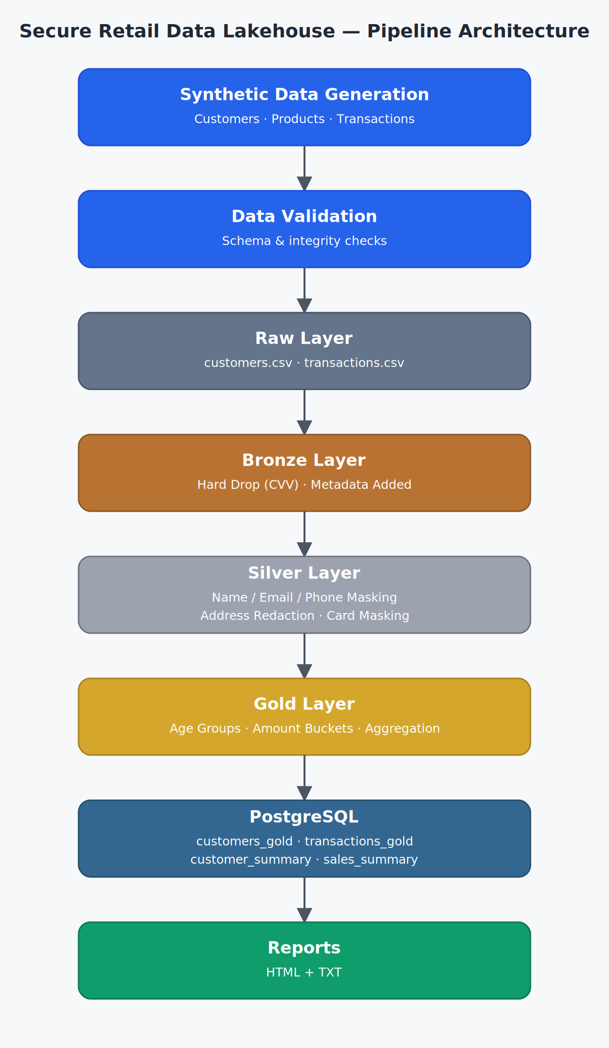
Figure 1: Pipeline Architecture — Raw to Reports
Figure 1 illustrates the complete end-to-end architecture of the Secure Retail Data Lakehouse, beginning with synthetic data generation and ending with PostgreSQL storage and automated report generation.
CHAPTER 6

Project Workflow
The project follows a sequential execution model in which each stage depends on the successful completion of the previous stage. This modular workflow ensures that data quality is verified at every checkpoint before the dataset advances to the next processing layer, preventing malformed or unvalidated data from propagating downstream.
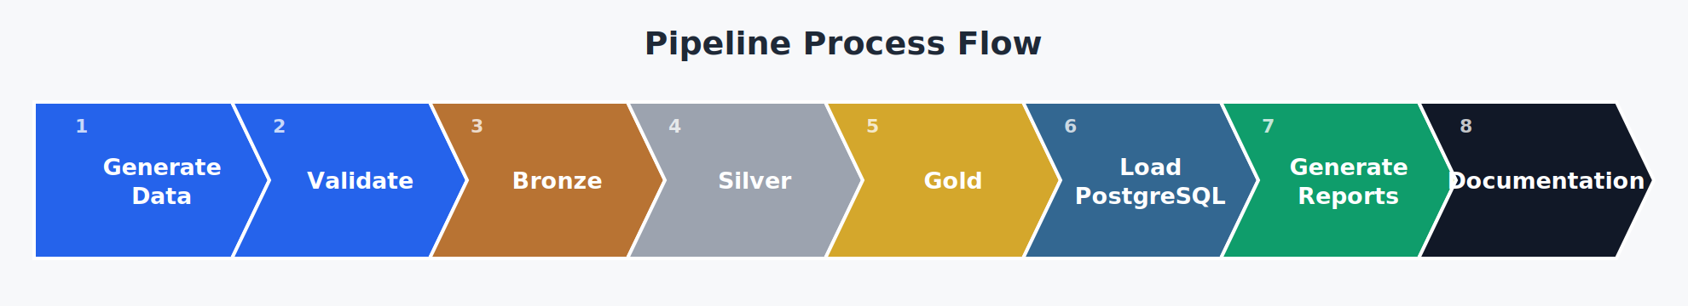
Figure 2: Pipeline Execution Workflow
As shown in Figure 2, the pipeline executes in eight sequential stages: data generation, validation, Bronze processing, Silver processing, Gold processing, PostgreSQL loading, report generation, and documentation. Each stage is implemented as an independent, callable module, which allows the pipeline to be re-run from any intermediate stage during debugging without regenerating the entire dataset.
CHAPTER 7

Implementation
The Secure Retail Data Lakehouse was implemented as a modular Python-based ETL pipeline. Each stage of the pipeline has a clearly defined responsibility, ensuring separation of concerns, maintainability, and scalability. The project follows a layered architecture in which data progressively becomes cleaner, more secure, and better suited for analytical processing.
The implementation consists of five major components:
- Synthetic Data Generation
- Data Validation
- Layered ETL Pipeline
- PostgreSQL Integration
- Automated Report Generation
Each component is described below.

7.1 Synthetic Data Generation
The first stage of the project focuses on generating realistic retail datasets using the Faker library and custom business logic.
Three primary datasets are generated:
- Customer Dataset
- Product Master Dataset
- Transaction Dataset
The customer dataset contains demographic information, loyalty details, and Personally Identifiable Information (PII). The product master dataset stores product categories and pricing ranges. The transaction dataset simulates retail purchases by linking customers with randomly selected products, payment methods, stores, and order statuses.
To improve realism, the project generates:
- 750 customer records
- 40 product records
- 8,000 transaction records
Transaction allocation is performed separately to ensure that customers have varying purchase frequencies rather than identical transaction counts, thereby simulating realistic customer purchasing behavior.

7.2 Data Validation
Before data enters the ETL pipeline, all generated datasets undergo validation.
The validation module performs the following checks:
- Duplicate Customer ID detection
- Duplicate Transaction ID detection
- Missing value analysis
- Loyalty tier validation
- Gender validation
- Customer reference validation
- Quantity validation
- Price validation
- Transaction amount verification
- Card number and CVV validation
A validation report is automatically generated after successful execution. This validation process ensures that only high-quality datasets proceed through the transformation pipeline.

7.3 Raw Layer
The Raw Layer stores the generated datasets exactly as they were produced. No transformations are applied at this stage. The Raw Layer acts as the source of truth and preserves the original datasets for future auditing or reprocessing.
Files stored in this layer include:
- customers.csv
- transactions.csv
Maintaining the raw datasets separately follows a common industry practice where original data remains unchanged throughout the ETL lifecycle.

7.4 Bronze Layer
The Bronze Layer performs the first stage of transformation. Its primary objective is to remove highly sensitive information while preserving the remaining business data.
The following transformations are applied:
- Hard Drop of the CVV column
- Addition of ingestion timestamp
- Addition of pipeline run identifier
The Bronze Layer represents the initial ingestion stage where raw operational data begins transitioning into a managed analytical pipeline.
The output generated consists of:
- customers_bronze.csv
- transactions_bronze.csv

7.5 Silver Layer
The Silver Layer focuses on protecting customer privacy. Sensitive customer information is transformed using masking and redaction techniques before becoming available for analytical use.
The following privacy transformations are implemented:
Sensitive Field | Transformation
Customer Name | Masked
Email Address | Masked
Phone Number | Masked
Home Address | Redacted
Card Number | Masked
CVV | Removed in Bronze Layer

These transformations ensure that downstream users cannot identify individual customers while preserving the analytical value of the dataset.
The Silver Layer generates:
- customers_silver.csv
- transactions_silver.csv

7.6 Gold Layer
The Gold Layer prepares business-ready datasets. This stage focuses on feature engineering and aggregation.
The following analytical transformations are performed:
- Customer age calculation
- Age group generation
- Transaction amount bucketing
- Customer summary generation
- Sales summary generation
These transformations convert operational retail data into datasets suitable for reporting, dashboarding, and business intelligence.
The Gold Layer outputs include:
- customers_gold.csv
- transactions_gold.csv
- customer_summary.csv
- sales_summary.csv
CHAPTER 8

PostgreSQL Integration
After completion of the Gold Layer, the processed datasets are loaded into PostgreSQL using SQLAlchemy. The database serves as the analytical storage layer of the project.
The following tables are created automatically:
- customers_gold
- transactions_gold
- customer_summary
- sales_summary
SQLAlchemy is used to establish the database connection and automate the loading process. Each DataFrame generated by the Gold Layer is inserted into its corresponding PostgreSQL table.
After loading, SQL queries are executed to verify successful insertion by comparing database record counts with the generated CSV files.
This integration demonstrates how processed data can be transferred from flat files into a structured relational database for analytical querying.
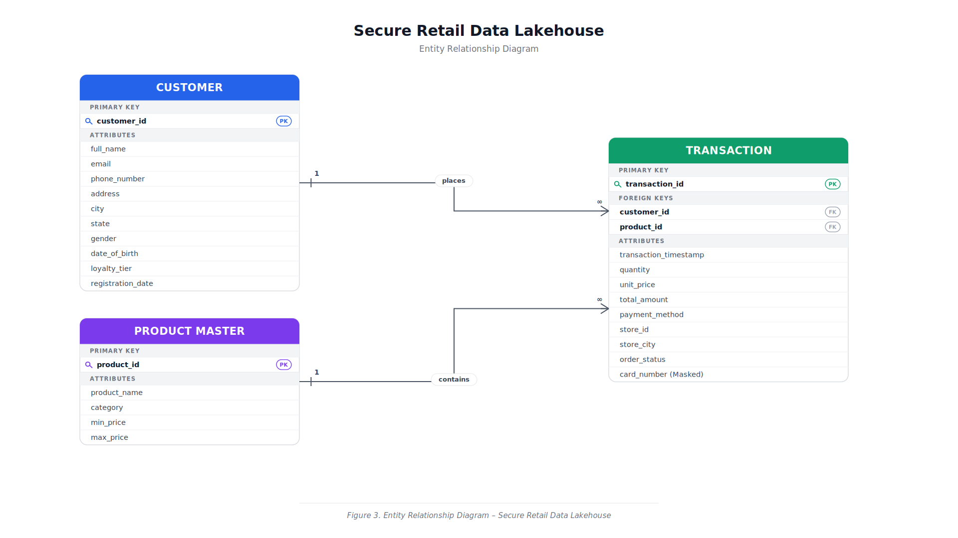
Figure 3: Entity Relationship Diagram — Secure Retail Data Lakehouse
Figure 3 shows the relational structure underlying the Gold Layer tables. The Customer entity maintains a one-to-many relationship with Transaction through customer_id, and the Product Master entity similarly maintains a one-to-many relationship with Transaction through product_id. Card numbers persist into the Transaction table only in masked form, consistent with the Silver Layer masking rules.
CHAPTER 9

Automated Reports
To improve pipeline transparency and simplify validation, the project automatically generates multiple reports after successful execution.
The generated reports include:

Validation Report
Summarizes dataset validation results including duplicate detection, missing values, and business rule verification.

Data Quality Report
Provides an overview of dataset quality by reporting missing values, duplicate records, and validation outcomes.

Pipeline Metrics Report
Summarizes record counts across Raw, Bronze, Silver, and Gold layers while reporting pipeline execution status.

Pipeline Summary Report
An HTML report that presents an overview of the entire pipeline, including data flow, processing stages, and execution metrics.
The automated reporting module provides immediate feedback regarding pipeline health and supports easier debugging and monitoring.
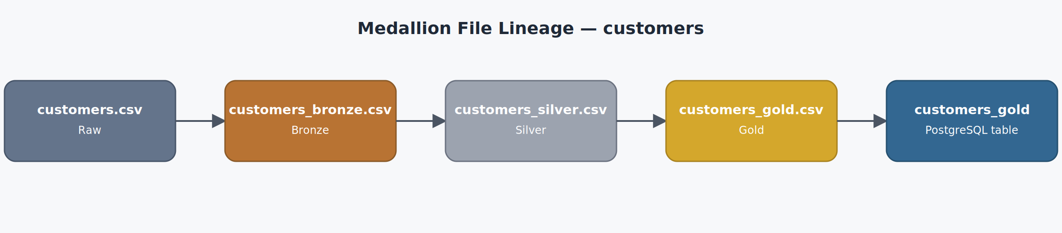
Figure 4: Medallion File Lineage — Customers Dataset
Figure 4 traces a single dataset, customers.csv, through every stage of the pipeline — from the Raw Layer through Bronze and Silver processing, into the Gold Layer, and finally into the customers_gold table in PostgreSQL — illustrating the full lineage and traceability built into the pipeline.
CHAPTER 10

Results and Discussion
The Secure Retail Data Lakehouse project was successfully implemented according to the defined objectives. The ETL pipeline processed synthetic retail datasets through four transformation layers while ensuring data quality, privacy protection, and analytical readiness.
The project generated realistic retail datasets consisting of 750 customer records, 40 product records, and 8,000 transaction records. Each dataset successfully passed the validation stage before entering the ETL pipeline.
The Bronze Layer removed highly sensitive payment information and enriched the datasets with ingestion metadata. The Silver Layer applied masking and redaction techniques to protect Personally Identifiable Information (PII), ensuring that customer identities remained confidential while preserving analytical value. Finally, the Gold Layer generated business-ready datasets by performing feature engineering and aggregation.
The processed datasets were successfully loaded into PostgreSQL using SQLAlchemy, where they were stored in relational tables for analytical querying. Automated validation, data quality, and pipeline summary reports were also generated, confirming successful execution of the pipeline.
The implementation demonstrates how a structured ETL pipeline can transform operational retail data into secure and analytics-ready datasets suitable for business intelligence applications.

Output Summary
Component | Status
Customer Data Generation | Successful
Product Master Generation | Successful
Transaction Generation | Successful
Dataset Validation | Successful
Bronze Layer Processing | Successful
Silver Layer Processing | Successful
Gold Layer Processing | Successful
PostgreSQL Loading | Successful
Automated Report Generation | Successful

Generated Outputs

Raw Layer
- customers.csv
- transactions.csv

Bronze Layer
- customers_bronze.csv
- transactions_bronze.csv

Silver Layer
- customers_silver.csv
- transactions_silver.csv

Gold Layer
- customers_gold.csv
- transactions_gold.csv
- customer_summary.csv
- sales_summary.csv

Database Tables
- customers_gold
- transactions_gold
- customer_summary
- sales_summary

Reports
- validation_report.txt
- data_quality_report.txt
- pipeline_metrics_report.txt
- pipeline_summary.html
CHAPTER 11

Challenges Faced
During the development of the Secure Retail Data Lakehouse project, several practical challenges were encountered that required careful analysis and resolution.

Multi-line Address Generation
Initially, customer addresses generated by the Faker library contained embedded newline characters. While spreadsheet applications interpreted these values correctly, text editors and CSV readers treated the embedded line breaks as new records, resulting in incorrect row counts and malformed datasets. This issue was resolved by sanitizing address values before writing them to the CSV files, ensuring consistent formatting across all tools.

Transaction Distribution
A realistic retail dataset requires customers to have different purchasing frequencies. Instead of assigning an equal number of transactions to every customer, a dedicated transaction allocation module was implemented to distribute transactions more naturally across customers.

Data Consistency
Maintaining consistency between generated customer records and transaction records required careful validation. Additional checks were implemented to verify customer references, transaction totals, and business rules before processing the data further.

Privacy Preservation
Implementing data masking while preserving analytical usefulness required balancing security and business requirements. Sensitive customer information was masked or redacted without affecting downstream aggregation and reporting.
CHAPTER 12

Learning Outcomes
This project provided practical exposure to several core concepts in Data Engineering.
The major learning outcomes include:
- Designing a modular ETL pipeline.
- Implementing a layered Data Lakehouse architecture.
- Generating realistic synthetic datasets.
- Applying data validation techniques.
- Protecting Personally Identifiable Information (PII).
- Implementing Hard Drop, Masking, and Redaction strategies.
- Performing feature engineering and aggregation.
- Integrating Python applications with PostgreSQL.
- Automating report generation.
- Organizing a production-style Python project.
The project also strengthened practical skills in Python programming, Pandas, SQLAlchemy, PostgreSQL, GitHub, and project documentation.
CHAPTER 13

Future Scope
Although the current implementation satisfies the objectives of the internship project, several enhancements can further extend its capabilities.
Possible future improvements include:
- Integration with Apache Spark for distributed data processing.
- Cloud storage using Azure Data Lake Storage (ADLS).
- Pipeline orchestration using Azure Data Factory or Apache Airflow.
- Incremental data loading and Change Data Capture (CDC).
- Docker-based containerization for easier deployment.
- CI/CD integration using GitHub Actions.
- Interactive dashboards using Power BI or Tableau.
- Real-time data ingestion using Apache Kafka.
- Automated monitoring and alerting mechanisms.
- Deployment on cloud platforms such as Microsoft Azure.
These enhancements would improve scalability, automation, and suitability for enterprise-level deployments.
CHAPTER 14

Conclusion
The Secure Retail Data Lakehouse project successfully demonstrates the implementation of a secure and modular Data Engineering pipeline for processing retail data while protecting sensitive customer information.
The project begins with the generation of realistic synthetic retail datasets and progresses through validation, layered ETL processing, PostgreSQL integration, and automated report generation. By implementing the Raw, Bronze, Silver, and Gold layers, the pipeline demonstrates how operational retail data can be transformed into analytics-ready datasets without exposing Personally Identifiable Information.
The project highlights the importance of data quality, privacy preservation, modular architecture, and automation in modern Data Engineering workflows. The use of Python, Pandas, SQLAlchemy, and PostgreSQL provides a practical demonstration of commonly used industry tools while maintaining simplicity suitable for an internship project.
Overall, the Secure Retail Data Lakehouse achieves the defined project objectives and provides a strong foundation for future enhancements involving cloud technologies, distributed processing, and workflow orchestration.
References
- Celebal Technologies — Data Engineering Internship Documentation.
- Python Software Foundation. Python 3 Documentation. docs.python.org
- Pandas Documentation. pandas.pydata.org
- PostgreSQL Documentation. postgresql.org/docs
- SQLAlchemy Documentation. docs.sqlalchemy.org
- Faker Documentation. faker.readthedocs.io
- Git Documentation. git-scm.com/doc
- Microsoft Azure Architecture Center — Data Lake Architecture.

