**SMART PARKING**

**PHASE-4 WEB DEVELOPMENT**

In this phase, we have developed a embedded HTML page of our Wowki simulation, which would show whether the parking lot is available or not with a distance.

**HTML CODE:**

html

<!DOCTYPE html>

<html>

<head>

<title>Wokwi App Embed</title>

</head>

<body>

<h1>SMART PARKING USING IOT</h1>

<!-- Replace the URL in the src attribute with the URL of your Wokwi app -->

<iframe src="https://wokwi.com/projects/380023077302077441" width="800" height="600" frameborder="0"></iframe>

</body>

</html>

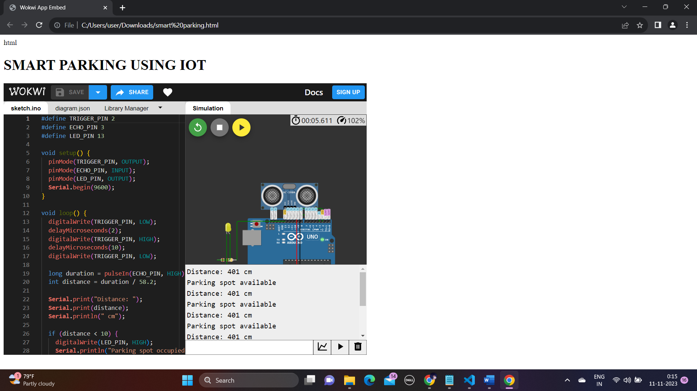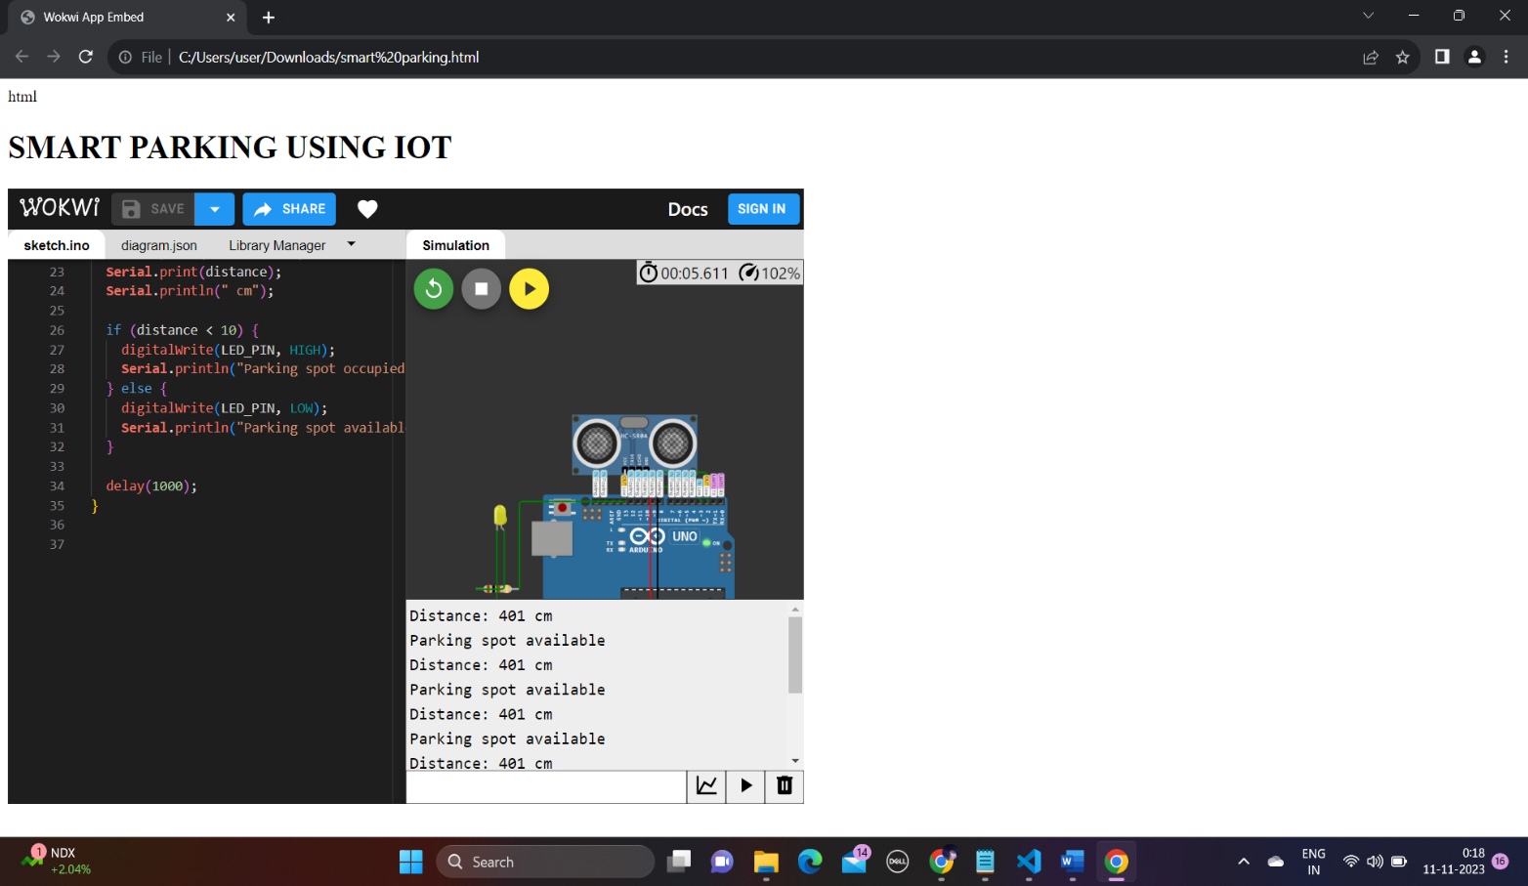**WEBPAGE:**

