OUTPUT screen

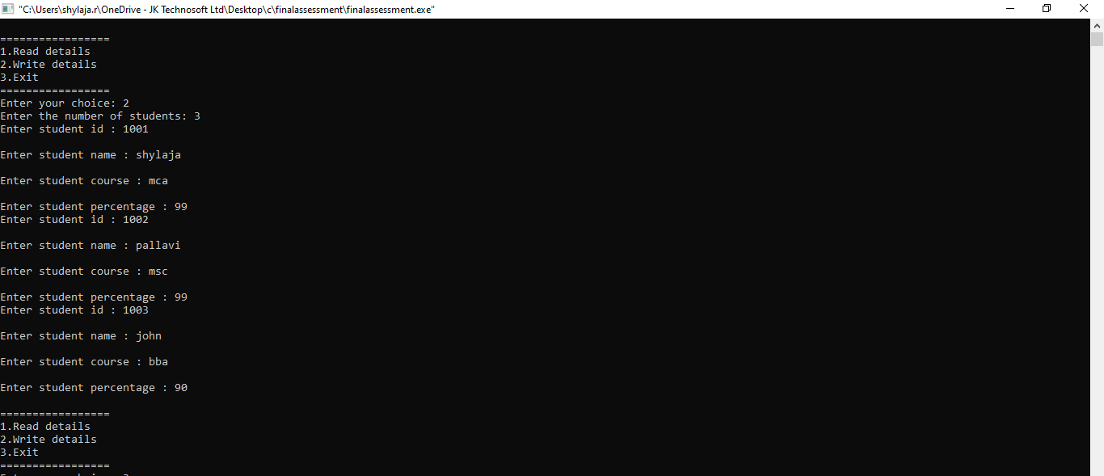

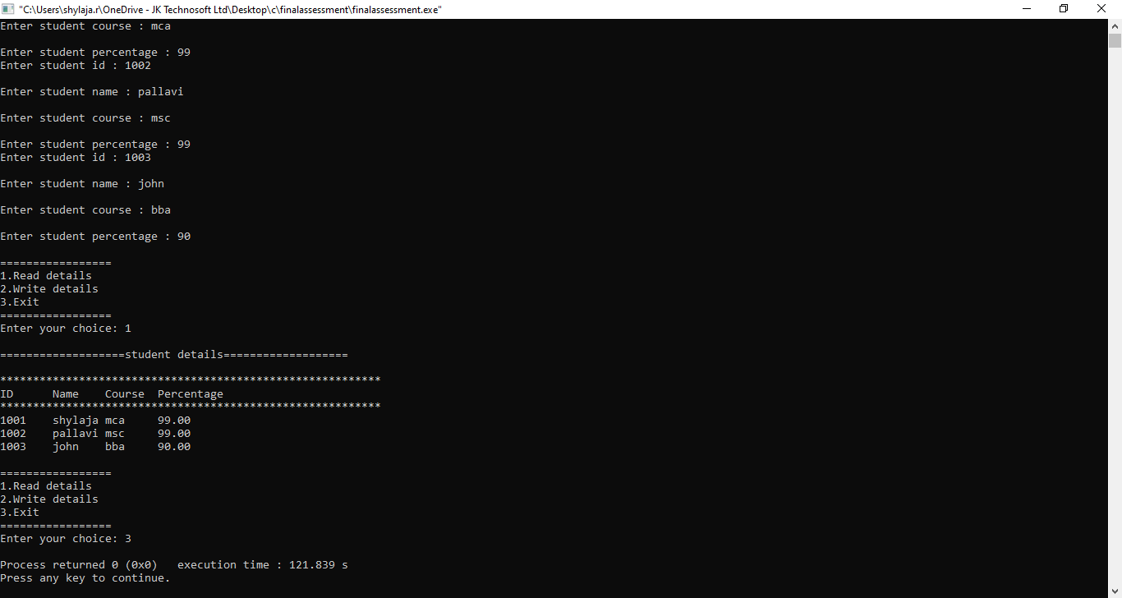

Student file

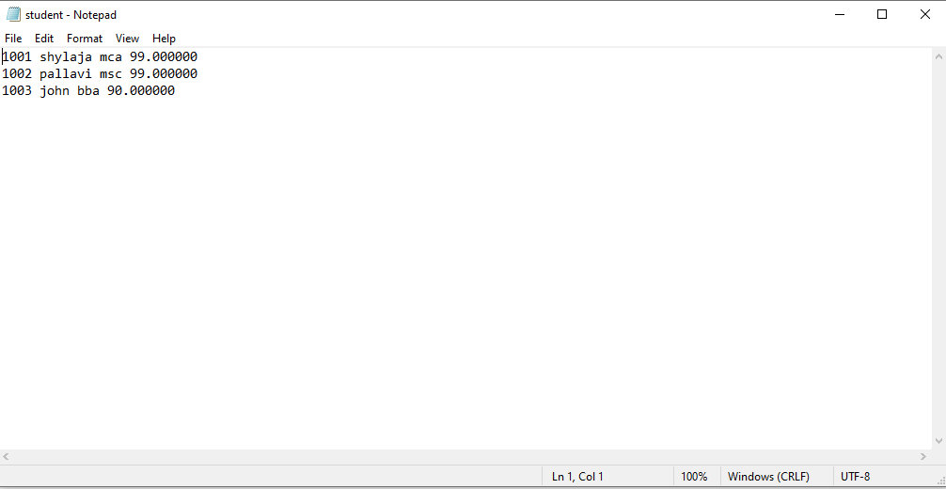

Code:

#include<stdio.h>

#include<stdlib.h>

struct student{

int id;

char name[100];

char course[100];

float percentage;

};

struct Admin{

struct student s[10];

};

void read(struct Admin \*ptr)

{

FILE \*fptr;

fptr=fopen("student","r");

int i=0;

printf("\n===================student details===================\n");

printf("\n\*\*\*\*\*\*\*\*\*\*\*\*\*\*\*\*\*\*\*\*\*\*\*\*\*\*\*\*\*\*\*\*\*\*\*\*\*\*\*\*\*\*\*\*\*\*\*\*\*\*\*\*\*\*\*\*\*\*\nID\tName\tCourse\tPercentage\n\*\*\*\*\*\*\*\*\*\*\*\*\*\*\*\*\*\*\*\*\*\*\*\*\*\*\*\*\*\*\*\*\*\*\*\*\*\*\*\*\*\*\*\*\*\*\*\*\*\*\*\*\*\*\*\*\*\*\n");

while(fscanf(fptr,"%d %s %s %f",&ptr->s[i].id,ptr->s[i].name,ptr->s[i].course,&ptr->s[i].percentage)!=EOF)

{

printf("%d\t",ptr->s[i].id);

printf("%s\t",ptr->s[i].name);

printf("%s\t",ptr->s[i].course);

printf("%0.2f\n",ptr->s[i].percentage);

i++;

}

fclose(fptr);

}

void write(struct Admin \*ptr)

{

int n;

FILE \*fptr;

fflush(stdin);

fptr=fopen("student","w");

printf("Enter the number of students: ");

scanf("%d",&n);

for(int i=0;i<n;i++)

{

printf("Enter student id : ");

scanf("%d",&ptr->s[i].id);

printf("\nEnter student name : ");

scanf("%s",ptr->s[i].name);

printf("\nEnter student course : ");

scanf("%s",ptr->s[i].course);

printf("\nEnter student percentage : ");

scanf("%f",&ptr->s[i].percentage);

fprintf(fptr,"%d %s %s %f\n",ptr->s[i].id,ptr->s[i].name,ptr->s[i].course,ptr->s[i].percentage);

}

fclose(fptr);

}

void main()

{

int ch;

struct Admin a;

struct Admin \*ptr=&a;

while(1){

printf("\n=================\n1.Read details\n2.Write details\n3.Exit\n=================");

printf("\nEnter your choice: ");

scanf("%d",&ch);

switch(ch){

case 1:read(ptr);

break;

case 2:write(ptr);

break;

case 3:exit(0);

break;

default:printf("invalid choice");

}

}

}