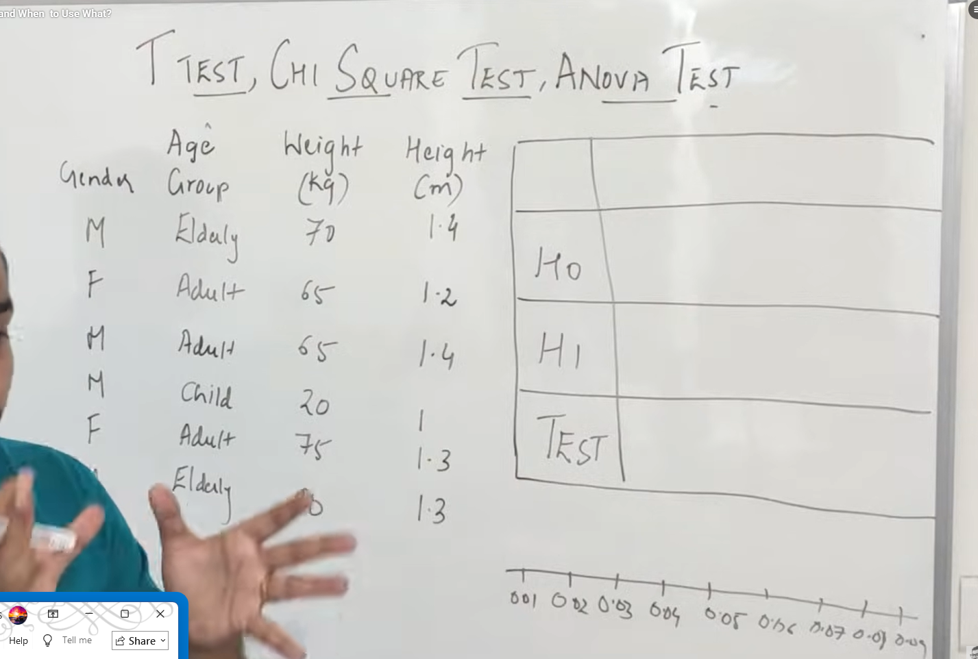
1.were there is propotion in male and female
, found by using bar chart -H1
2.so the alternate hypothesis is the reverse -H0
3. Test we apply is One Sample Proportion
4. this abt one categorical.

Two Categorigal
H0 – there is no diff
H1 – there is diff
Test – Chi squared test – the value should be less that 0.5

Continus variable
H0 – there is no diff
H1 – there is diff
Test – Correlation
If corelation is 0 then it is said to have no relationship

Anovo Test:
If we have both numerical and categorical variable we apply this .
If we two category we use Aonovo test.
If we two numerical we use Aonovo test.

T Test:
If we to category we use T – Test

