Histogram:
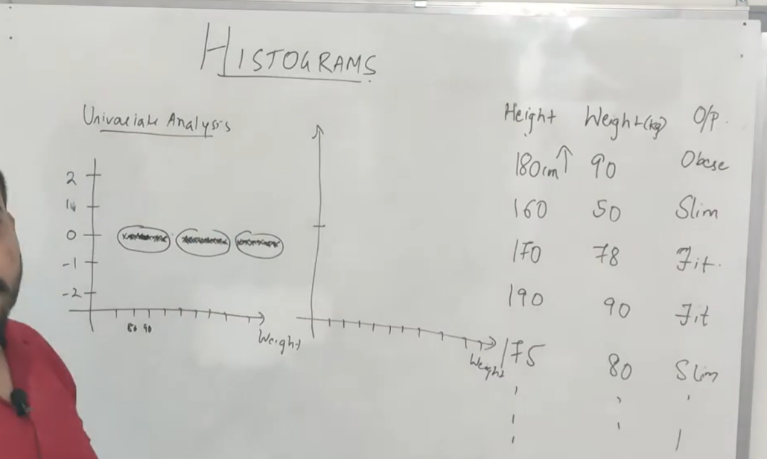

Similar to bar graph with the bins
Bins can be changed
Y axis shows the count
Can be based on one feature
We get a bell curve is created above it so we can get a distribution on it
Pdf – can be created on it

