P-Value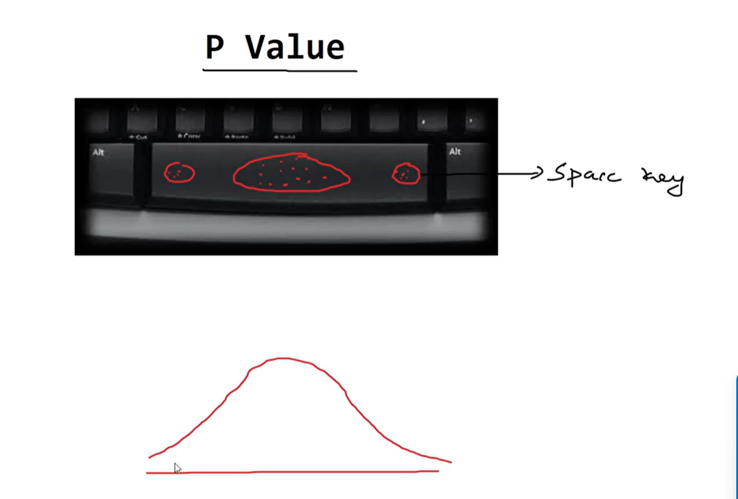
The p=0.01 if we repeate is experiment 100 times the the p value is 1
Is at one end of bell curve .
P-value : It is the prob for the “null hypothesis “ to be true .

Null hypothesis :
It reads every thing same or equal .
Toss Experiment :
If I toss the coin for 100 times and I get head for 50times I get either head or tail then it is null hypothesis.
To find the SD we have
Z test
T test
F test
